University Of Wales Trinity Saint David
Module Code: BMSW5106
Module Name: Knowledge and Information Management Skills for the Workplace
Programme: BA Leadership and Management Skills for the workplace Level 5
Tutor Name: Dr Mohamed Kalam
Student Name: Manuela Mahwera
Student Number: 1713706

Contents
1. Introduction 1
2. Overview of Waitrose and Partners 1
3. Analysis 2
3.1 The relationship between knowledge, information, and data 2
3.2 The relationship between organisational and individual knowledge 3
3.3 Analysis and modelling techniques to identify knowledge assets 4
3.4 An evaluation of potential and actual knowledge assets 6
3.5 The requirements for creating, storing, applying and integrating knowledge 8
3.6 The importance of Intellectual Property rights 9
3.7 The contribution of knowledge assets to Waitrose and Partners 10
3.8 The knowledge requirements for Waitrose and Partners 11
3.9 The framework for enabling knowledge sharing within Waitrose and Partners 13
3.10 Recommend improvements to the current framework 14
Conclusion 15
References 16

1. Introduction
Today, the competitive and dynamic business environment requires an organisation to develop knowledge assets that can act as a source of competitive advantage. However, developing knowledge assets is not that easy because it requires a range of useful data, information, skills, and experiences to base the knowledge asset (Bergeron, 2013). Besides, there must be an efficient process that can help transform the individual knowledge into organisational knowledge. To get an in-depth understanding of the knowledge assets from an organisational perspective, this report has been prepared based on Waitrose and Partners which is a UK based supermarket chain. The report starts with a basic understanding of individual knowledge assets and how it relates to data, information, and organisational knowledge assets. The later section shows how knowledge assets can be identified by applying analysis and modelling techniques. Then through a range of relevant discussions over the knowledge assets, it reaches to the knowledge sharing frame of Waitrose and Partners. The final section shows some recommended improvements that can help the company to strengthen its knowledge sharing framework.

2. Overview of Waitrose and Partners
Waitrose and Partners is considered as one of the largest supermarket chains in the UK’s supermarket industry. The company was founded as a small grocery store by Wallace Waite, David Taylor, and Arthur Taylor back in 1904 in West London. Over time, the company has become a large supermarket chain and now it has 338 stores across the UK. At present, the company holds around 5.1% market share of the industry. The company employs more than 52,000 employees for its stores all over the UK and generates a revenue of around £5,400 million (Waitrose & Partners, 2020). However, the dynamic business environment of the UK’s supermarket industry is making it difficult for the company to keep up its competitive advantage. This report will help the company to strengthen its completive advantage by extending its focus on different types of knowledge assets.

3. Analysis

3.1 The relationship between knowledge, information, and data
In general, an organisation has to largely rely on a range of data, information, and knowledge while making business decisions. The data basically refers to the raw observations or facts that cannot be used in decision making until they have been processed into information (Holsapple, 2017). This indicates that the information refers to the processed data that are meaningful and can be used in decision making. On the other hand, knowledge refers to the mixture of organised information, experiences, insights, and values that can be used for judgment, evaluation, and action (Bergeron, 2013). The definition of data, information, and knowledge shows that there is a link between them. However, the following section will help to get a better picture of the relationship between them:
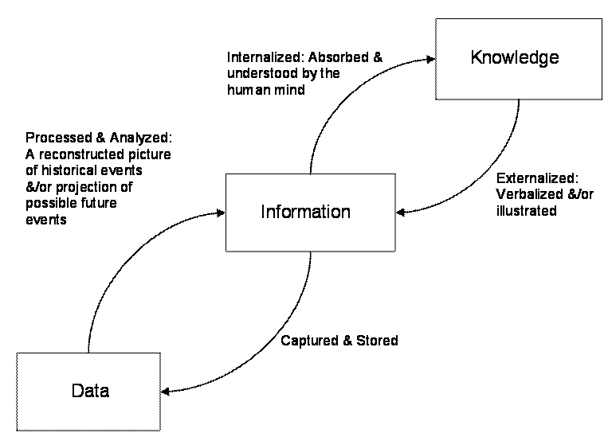
Figure 1: The link between knowledge, information, and data (Bergeron, 2013).
The above figure clearly shows the relationship that knowledge, information, and data have between them. To be more specific, the historical or projected data helps to generate information. In other words, they are analysed and processed to create information that is used in making decisions. On the other hand, information is captured and stored in storage devices in the form of data or it is absorbed and understood by the human mind in the form of knowledge such as know-how, know-what, and know-why. On the other hand, knowledge resides in the human mind is shared or illustrated with others in the form of information. Therefore, we can see that data, information, and knowledge are interconnected. The relationship carries an important insight to organisations like Waitrose & Partners. To be more specific, they need to understand that generating knowledge requires useful information and generating useful information requires having adequate data regarding the past and future events. Therefore, to strengthen the organisational knowledge base, Waitrose and Partners need to focus more and more relevant data and information.

3.2 The relationship between organisational and individual knowledge
To understand the relationship between organisational and individual knowledge, first, we need to understand the basic concept of individual knowledge and organisational knowledge. In general, individual knowledge refers to the knowledge which basically stems from useful information, interpretation, observations, and experiences (Lytras, 2010). On the other hand, individual knowledge creates the basis of organisational knowledge which basically refers to the collective knowledge possessed by an organisation and its employees (Wiig, 2011). This indicates that there is an important link between individual and organisational knowledge. The following figure presents the relationship between them in a better way:
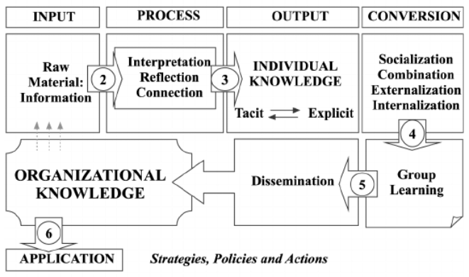
Figure 2: Link between organisational and individual knowledge (Lustri, Miura, and Takahashi, 2016).
The above figure shows a complex relationship between data, information, individual knowledge, and organisational knowledge. However, our focal point is to find out the relationship between individual and organisational knowledge. According to the above figure, individual knowledge stems from new and existing information and it is possessed by an individual in the form of tacit and explicit knowledge. Then the individual knowledge, both tacit and explicit, is transferred through socialisation, externalisation, combination, and internalisation to facilitate group learning. The individual knowledge transfer may take place from person to person or a person to a group or within the group. Group learning, in turn, is disseminated throughout the organisation to create organisational knowledge. To put it simply, the individual knowledge is transformed into organisational knowledge over time. Therefore, organisations like Waitrose and Partners should encourage its employee to generate individual knowledge so that it can transform that individual knowledge into organisational knowledge and use it as one of the sources of competitive advantage. Besides, encouraging individual knowledge, it should also make the process that transforms individual knowledge into organisational knowledge as smooth and effective as possible.

3.3 Analysis and modelling techniques to identify knowledge assets
Different organisations may have different analysis and modelling techniques for the purpose of identifying the knowledge assets. Though there are a number of analysis and modelling techniques, an organisation does not require implementing all of them. However, most of the techniques help an organisation to identify the knowledge assets that are necessary to help the organisation towards its goals and objectives (Lytras, 2010). To identify the necessary knowledge assets, Waitrose and Partners can apply the following techniques:
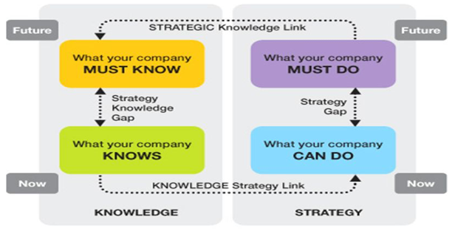
Figure 3: Knowledge needs analysis model (Collison and Parcell, 2004).
The above model shows that an organisation like Waitrose and Partners can identify the necessary knowledge assets by applying the knowledge needs analysis model. The model basically identifies the necessary knowledge asset by determining what an organisation knows and what an organisation must know. Then by comparing what is known and what is required to be known, it identifies a gap, called the knowledge gap. In a similar way, Waitrose and Partners can identify the knowledge gap and then based on the knowledge gap it can undertake appropriate strategies to develop the necessary knowledge and fill up the knowledge gap.
Other than the model presented above, the company can also use the following three-step technique to identify the knowledge assets that it needs to possess and develop for improving its overall performance:

Figure 4: Three-step technique to identify knowledge assets (Cheema, 2014).
- Evaluating the previous years: In the first step, the company should evaluate the previous year's performance with a view to identifying the knowledge assets that played a critical role in improving the overall performance. In this step, the goal is to identify the potential knowledge assets that can help in future performance.
- Setting goals for the next year: The second step involves setting performance goals for the next year with a view to identifying the knowledge assets that an organisation lacks. After identifying the knowledge assets that an organisation lacks, the organisation can take appropriate steps for developing them.
- Comparing the results of two focus groups: The step basically determines the effectiveness of the knowledge assets that have been identified in the prior steps. The effectiveness is determined with the help of two focus groups where one performs with the application of the knowledge assets and the other group performs without the application of the knowledge assets (Cheema, 2014). If the former group performs significantly better than the other group, then the knowledge assets are identified to be effective and potential.

3.4 An evaluation of potential and actual knowledge assets
In most cases, the proper utilisation of the knowledge assets largely depends on how well an organisation understands its potential and actual knowledge assets. In this case, an organisation carries out an in-depth evaluation of its potential and actual knowledge assets. The potential knowledge assets are those are yet to be developed whereas the actual knowledge assets are those which already exist (Debowski, 2016). To help Waitrose and Partners gather an in-depth understanding, the following section will present an evaluation of its actual and potential knowledge assets:
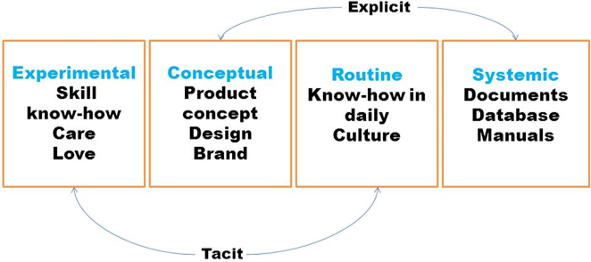
Figure 5: Types of knowledge assets (Frappaolo, 2013).
As the above figure shows there are four types of knowledge assets which are systematic, routine, conceptual, and experimental knowledge assets. Therefore, the potential and actual knowledge assets that an organisation can have should also fall under these categories. Therefore, the potential and actual knowledge assets of Waitrose and Partners will be evaluated under these categories.
- Experimental knowledge assets: As the figure shows that experimental knowledge asset consists of skills, know-how, care, love, and passion of the employees of an organisation. Almost all of the experimental knowledge assets of Waitrose and Partners can be considered as actual knowledge assets because they have been realised already (Easterby-Smith and Lyles, 2003). To be more specific, the workforce of the company is well-skilled and they know how to best perform their duties. Besides, they are passionate about their duties as well. Together the actual knowledge assets of this category play a vital role in the overall success of the company.
- Conceptual knowledge assets: The conceptual knowledge consists of product concepts, designs, and brand equity. The product concepts, designs, and brand equity can be both actual and potential knowledge (Frappaolo, 2013). To be more specific, the existing product concepts, designs, and brand equity of Waitrose and Partners are actual knowledge assets. On the other hand, the new product concepts, designs, and brand equity to be improved or developed in the future can be considered as the potential knowledge asset of the company. Considering the existing position of Waitrose and Partners it can be said that the company has still scope to improve its position in the market by improving its product concepts, designs, and the brand. Therefore, the company should focus more and more on its potential knowledge assets in this category of knowledge assets.
- Routine knowledge assets: The routine knowledge asset consists of the know-how in daily operation and culture. The knowledge assets of this category can be considered as actual knowledge assets because they already exist in the company (Holsapple, 2017). The know-how in daily operation and culture of Waitrose and Partners can be considered as the factor behind its effective and efficient operation. This indicates that the company has been able to utilise its routine knowledge assets in generating a competitive edge in the market.
- Systematic knowledge assets: The systematic knowledge assets basically consist of documents, databases, patents, and manuals which can be actual or potential knowledge assets. The documents, database, patents, and manuals that Waitrose and Partners already have are actual knowledge assets whereas documents, databases, patents, and manuals to be developed in the future can be considered as the potential knowledge asset of the company (Frappaolo, 2013). The company has been able to create documents, databases, manuals, and patents to facilitate its daily operation and management decision-making process. This indicates that it is successfully utilising almost all the actual knowledge assets of this particular category. However, the advancement in technology and changes in the external environment requires the company to keep its focus on potential knowledge assets of this category.

3.5 The requirements for creating, storing, applying and integrating knowledge
In general, knowledge assets can largely help an organisation to improve its overall performance in different ways, they are considered as important resources for an organisation (Debowski, 2016). That is why it is important for an organisation like Waitrose and Partners to identify the elements that help in creating, storing, applying, and integrating knowledge. So, the following discussion will help Waitrose and Patterns identify the elements that help in creating, storing, applying, and integrating knowledge:
The necessary elements for creating knowledge:
The first and foremost factor that helps in knowledge creation is the creativity and innovation. Therefore, the organisations that encourage employee creativity and innovation can create comparatively more knowledge than others. Other major factors that can help an organisation like Waitrose and Partners create knowledge to include new employees coming with new knowledge, existing employees gathering new knowledge from both internal and external environment, mergers and acquisitions providing new knowledge for improving the existing performance, and external training programs developing the knowledge base of employees (Griseri, 2002). Therefore, organisations like Waitrose and Partners have the opportunity to create knowledge in this way.
The necessary elements for storing knowledge:
Once knowledge is created, it needs to be stored so that it does destroy or deteriorate over time. Besides, to protect the knowledge from being lost or widespread dissemination, it needs to be stored. In ancient times, natural human memory was used to store knowledge but it was a very time-consuming process because it requires memorising a range of information (Easterby-Smith and Lyles, 2003). Then the writing system evolves to store the knowledge by creating written documents that contain all the information based on which the knowledge has been generated. However, with the advancement of technology, computer-based database system has evolved which can be used to store a large volume of knowledge-generating information can be electronically stored. That is why today the database system is largely used by organisations like Waitrose and Partners to store their valuable knowledge.
The necessary elements for applying and integrating knowledge:
It has been earlier mentioned that organisational knowledge is considered as one of the major resources that helps an organisation generate a competitive edge. So, if an organisation fails to successfully integrate and apply and the stored knowledge, it may lose its potential competitive edge. That is why there must an appropriate way to apply and integrate knowledge. In most cases, to integrate and apply the knowledge, organisations use several different systems such as Executive Support Systems (ESS), Decision Support Systems (DSS), Expert Systems (ES), and so on (Debowski, 2016). These systems are basically computer-based systems which allow an organisation to integrate the knowledge generated from different area and provide feasible ways to apply them in an appropriate. Besides, these systems also apply the knowledge while assisting the management decisions. Therefore, an organisation like Waitrose and Partners can take into account systems such as ESS, DSS, and ES to integrate and apply the knowledge.

3.6 The importance of Intellectual Property rights
The legal rights that protect the creation of human intellect, such as inventions, scientific findings, and artistic work, are called intellectual property rights. It has been already mentioned that knowledge assets can be a valuable source of an organisation’s competitive advantage if the can be protected from being stolen and widespread. To protect such knowledge assets, an organisation can create intellectual property rights on those knowledge assets (Jones, 2001). However, the following section will help Waitrose and Partners understand the importance of intellectual property rights in more detail:
- Intellectual property rights legally protect an organisation’s knowledge assets such as new inventions, product concepts, product design, brand name, and so on. The protection of such knowledge assets is important for an organisation because it largely helps an organisation to create a competitive advantage over the competitors.
- The protection of intellectual property also encourages the employees of an organisation to come up with new ideas, concepts, and designs because the protection allows them to get the due recombination and reward.
- The intellectual property rights also ensure the availability of the original products/services because it legally prohibits the competitors from copying the original products/services of an organisation.
The above section clearly shows that intellectual property rights play a critical role in helping an organisation like Waitrose and Partners to achieve a competitive advantage in different ways.

3.7 The contribution of knowledge assets to Waitrose and Partners
It has been mentioned multiple times that knowledge assets largely contribute to the overall performance of an organisation. In general, they largely help an organisation to build, maintain, and strengthen competitive advantages which are crucial for an outstanding performance, especially when the market is very competitive (Makewita, 2010). Today, the UK supermarket industry has become more competitive than ever before with the presence of a large number of competitors in the industry. Even though the industry is very completive, Waitrose and Partners are performing well enough in the industry. The knowledge assets of the company can be considered as one of the major drivers of such performance of the company. However, the following section provides detailed information about the contribution of knowledge assets (KA) to the company:
- KA contributes to innovation and creativity: In general, the organisations with plausible knowledge assets are good at creativity and innovation (Makewita, 2010). Overtime Waitrose and Partners has brought different types of creative and innovative products and services which largely helped the company to reach its current position. In this case, the knowledge assets of the company, especially the conceptual knowledge assets, played the most crucial role in bringing those creative and innovative products and services.
- KA contributes to core competencies: The core competencies are basically resources and capabilities that help an organisation generate a competitive advantage (Holsapple, 2017). In general, the knowledge assets of Waitrose and Partners, especially the conceptual and systematic knowledge assets, are the major sources of its core competencies based on which it has generated a competitive advantage over most of its competitors in the industry. Therefore, the knowledge assets largely contribute to developing the core competencies of the company.
- KA contributes to operational efficiency: An organisation is said to have operational efficiency if it can provide its customers with products/services in the most cost-effective manner possible while maintaining the quality of the products/services (Davenport and Prusak, 2000). Waitrose and Partners have been able to maintain its competitive advantage in the market partly because of their competitive price points for its products and services. In this case, the knowledge assets of the company, especially the experimental and routine knowledge assets, largely contribute to achieving operational efficiency.
- KA contributes to competitive advantage: The prior points have revealed that the knowledge assets of Waitrose and Partners largely contribute to its creativity and innovation, core competencies, and operation efficiency. Together all of them largely help the company to maintain and strengthen its competitive advantage in the industry. This means that the knowledge assets of the company have a significant contribution to its competitive advantage in the industry.
The points discussed clearly indicate that the knowledge assets can have a significant contribution to different areas of an organisation like the Waitrose and Partners.

3.8 The knowledge requirements for Waitrose and Partners
Waitrose and Partners have many of the knowledge assets that it needs to maintain and even strengthen its competitive advantage in the industry. However, it does not have all the knowledge assets that have been discussed in the four categories of knowledge assets. Therefore, the company has a good opportunity to focus on developing the knowledge assets that are not in a good position at present. However, the following section evaluates the knowledge requirements of the company:
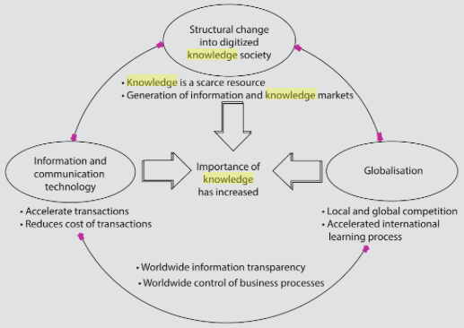
Figure 6: Three driving forces increasing the importance of knowledge as a factor of competition (North and Kumta, 2018).
The above figure shows that information and communication technology, globalisation, and structural changes into digitalised knowledge society are the major three forces that have made them a source of competition. Therefore, Waitrose and Partners requires knowledge with respect to those driving forces to make its competitive position better than its competitors. To be more specific, the knowledge requirements of the company include the followings:
- Knowledge about communication and information technology: The overall performance of an organisation like Waitrose and Partners largely depends on how well it can utilise the advantage of communication and information technology in achieving operational efficiency. Besides, in most cases, the development of new communication and information technologies increases the industry competition (Davenport and Prusak, 2000). Therefore, Waitrose and Partners should have adequate knowledge regarding the communication and information technology that can help it achieve operational efficiency.
- Knowledge about structural changes into digitalised knowledge society: The structural changes taking place in the digitalised knowledge society have also a significant impact on the competitive environment of the UK’s supermarket industry (Bergeron, 2013). Therefore, Waitrose and Partners also require having enough knowledge about such changes so that they can identify potential threats and opportunities emerging from those changes. More importantly, it should focus on generating knowledge that is scarce and can be a source of competitive advantage.
- Knowledge about the globalisation: As a result of the globalisation, Today, Waitrose and Partners have to compete with the global competitors along with the local competitors. Though the globalisation increases the market competition, it accelerates the international learning process which plays an important role in generating knowledge that can help attract international customers (Al-Shammari, 2011). Therefore, the company must gather adequate knowledge about the globalisation and global competitors in order to have a strong position in the market.
Other than the knowledge requirements discussed above, there might be others that can help Waitrose and Partners to maintain and improve its competitive position in the industry. However, the above mentioned are the most critical knowledge requirements for the particular company.

3.9 The framework for enabling knowledge sharing within Waitrose and Partners
In most cases, the employees of an organisation are major sources of generating knowledge which is transformed into organisational knowledge that can play a crucial role as a source of competitive advantage. However, to transform the knowledge of the employees into organisational knowledge, there must be a workable knowledge sharing framework that basically facilitates the flow of knowledge within the organisation (Easterby-Smith, and Lyles, 2003). The analysis of the knowledge management approaches of Waitrose and Partners revealed the following framework that enables knowledge sharing within the workplace:
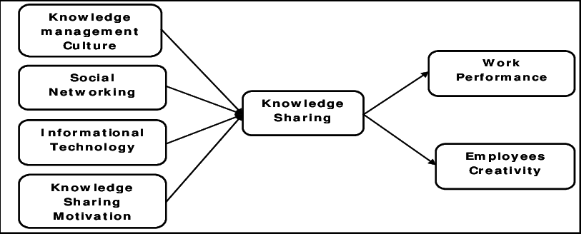
Figure 7: Knowledge sharing framework of Waitrose and Partners (Fazlollahtabar, Shirazi, and Ganji, 2015).
It is worth mentioning that the framework shown above is basically a conceptual framework for knowledge sharing within an organisation. However, the data and information collected from the analysis indicate that Waitrose and Partners has established a similar framework to enable knowledge sharing within the workplace. The knowledge sharing framework of the company shows that it emphasises on the following four aspects to enable the knowledge sharing:
- Knowledge management culture: Waitrose and Partners has built a knowledge management culture that encourages the employees to share their knowledge while they are in a group discussion or participating in teamwork. This, in turn, allows the company to integrate new knowledge of the employees with the existing knowledge base and strengthen the existing knowledge base (Debowski, 2016).
- Social networking: The knowledge sharing framework of the company also encourages social networking among the employees. Through social networking, the employees get the chance to share their knowledge with each other which in turn helps them form constructive knowledge for the company (Davenport and Prusak, 2000).
- Informational technology: To enable knowledge sharing, the company has also introduced a range of computer-based information technology such as servers, routers, bridges, and hubs. The idea is to allow the employees to share their knowledge through digital technology.
- Knowledge sharing motivation: The management of the company has introduced a range of incentive packages to motivate the employees in sharing their knowledge that can help the company improve its knowledge base.
As the figure shows the knowledge sharing of the company plays an important role in increasing the performance and creativity of the employees. The knowledge sharing framework of the company has been successful to a large extent which is evident from the performance and creativity level of the employees.

3.10 Recommend improvements to the current framework
Though the current knowledge sharing framework of the company is working well, there are some improvements that the company can make in the framework to make it more effective and efficient. So, the following section shows some recommendations that can help make the current framework more effective:
- There are many environmental factors except for the knowledge management culture such as organisational structure and leadership style that should be incorporated in the knowledge sharing framework to make it even better.
- The framework does not take into account the characteristics and personality traits of the employees. The personality traits and characteristics of the employees can play an important role in encouraging them to share knowledge within the workplace that is why they should be distinctively considered in the framework.
- The framework should also clearly indicates the perceived benefits and rewards for the employees who contribute to the knowledge base of the company. When the employees are aware of their potential benefits and rewards for sharing their knowledge, they will be encouraged and motivated to contribute to the knowledge base of the company.
The above improvements can largely help the company to make its sharing framework better than ever. So, it should draw an adequate focus on improving its current knowledge sharing framework by considering the given recommendations.

Conclusion
The report concludes that it is essential for an organisation like Waitrose and Partners to enrich its knowledge base to keep up its competitive advantage. However, to enrich the knowledge base, an organisation needs to draw adequate focus on its data and information management systems because they play a crucial role in creating a base for knowledge assets. Besides, by applying different analysis and modelling techniques, an organisation must be aware of the knowledge assets that are required to reach the ultimate goal of the organisation. In the creation of knowledge assets, the knowledge sharing framework plays an important that is why organisations like Waitrose and Partners must develop and implement an appropriate knowledge sharing framework considering different aspects of the company as well as the employees.

References
Al-Shammari, M., 2011. Knowledge Management In Emerging Economies. Hershey, Pa.: IGI Global (701 E. Chocolate Avenue, Hershey, Pennsylvania, 17033, USA).
Amine Chatti, M., 2012. Knowledge management: a personal knowledge network perspective. Journal of Knowledge Management, 16(5), pp.829-844.
Bergeron, B., 2013. Essentials Of Knowledge Management. Hoboken, N.J.: J. Wiley.
Cheema, D., 2014. Knowledge Management. New Delhi: Abhishek Publications.
Collison, C. and Parcell, G., 2004. Learning To Fly: Practical Knowledge Management From Leading And Learning Organizations. Capstone, England: John Wiley & Sons.
Davenport, T. and Prusak, L., 2000. Working Knowledge. Harvard Business School Press, Boston, Mass.
Debowski, S., 2016. Knowledge Management. New Delhi: Willey India.
Easterby-Smith, M. and Lyles, M. A. (2003). The Blackwell Handbook of Organizational Learning and Knowledge Management. Malden, MA: Blackwell Pub.
Fazlollahtabar, H. & Shirazi, B. & Ganji. (2015). A Framework for Knowledge Sharing of Enterprise Resources. International Journal of Information and Computer Science. 4. 10.14355/ijics.2015.04.002.
Frappaolo, C., 2013. Knowledge Management. Oxford: Capstone.
Griseri, P. (2002). Management Knowledge: A Critical View. Houndmills, Basingstoke, Hampshire: Palgrave.
Holsapple, C., 2017. Handbook On Knowledge Management. Berlin: Springer.
Ichijō, K. and Nonaka, I., 2007. Knowledge Creation And Management New Challenges for Managers. Oxford: Oxford University Press.
Jones, B. (2001). Knowledge Capitalism. Oxford: Oxford University Press Pl.
Lips, M. (2014). Transforming Government—by Default? In Society and the Internet (p. Society and the Internet, Chapter 12). Oxford University Press.
Lustri, D. Miura, I. & Takahashi, S. (2016). Knowledge management model: Practical application for competency development. Learning Organization, The. 14. 186-202. 10.1108/09696470710727023.
Lytras, M., 2010. Knowledge Management, Information Systems, E-Learning, And Sustainability Research. Berlin: Springer.
Makewita, S. (2010). Potential knowledge versus realised knowledge: a theory for the effectiveness of knowledge networks.
Muqadas, F. & Aslam, H. (2016). Antecedents of Knowledge Sharing and Knowledge Sharing Impact on Employees' Creativity and Work Performance. Pakistan Business Review. 18. 655-674.
Newell, S. et al. (2009). Managing Knowledge Work and Innovation. 2nd ed. Basingstoke: Palgrave Macmillan.
O’Dell, C and Hubert, C (2011) The New Edge in Knowledge: How Knowledge Management Is Changing the Way We Do Business, John Wiley, New Jersey
Okpala, I., 2018. Knowledge Management. Malden, Mass.: Blackwell Pub.
Tidd, J., 2016. From Knowledge Management To Strategic Competence. London: Imperial College Press.
Waitrose.com. 2020. Waitrose & Partners. [online] Available at: <https://www.waitrose.com/ecom/shop/featured/groceries/about-us> [Accessed 11 April 2020].
Wickramasinghe, N., 2009. Essentials Of Knowledge Management. New York: Routledge.
Wiig, K., 2011. Knowledge Management. Arlington, Tex.: Schema Press.

