Resizing Images for Digital Submission
At various times, we will ask you to submit images: for tutorials, critiques, online exhibitions and, in the form of PowerPoint or similar, presentations.
To do this, you need to optimise the file size of your images so that they are appropriate for these various purposes.
For example, the current standard for many DSLR and mirrorless cameras, is 24 Megapixels (MP), resulting from an image (usually) 6,000 by 4,000 pixels. Raw file sizes will vary, but an 8-bit tiff of that size will be between 60 and 70 megabytes in size; too large for both the screen and easy transfer.
Large images have their uses. If you are sending an image off to get it printed for example, you will require a large, high-quality file. For the screen however, you will need to reduce the size of your images.
Optimum sizes vary slightly depending on use but for easy upload, you should be working with files from below to just slightly greater than 1 megabyte (MB). We will conduct further workshops on workflow, but for simplicity I will base my recommendations around using Adobe Bridge and Adobe Camera Raw (ACR). There are methods straight from Photoshop, Lightroom and various other processing software.

Some of you will be experienced in these matters and have your own method, which is fine. But we still get students turning up for tutorials with unprocessed raw files and submitting PDFs and PowerPoints that are hundreds of megabytes in size, take ages to load, and crash at will.
Original Files

Start with the best files. Shoot raw so as to preserve all the information your camera is capable of yielding. Set the best quality (whether shooting jpeg, or if your camera has a reduced-size raw setting – use full-sized raw instead).
You may all work in different ways but generally, you should be taking a lot of pictures. You will edit these down and then work on your submission, which may be a large selection for a tutorial, or a smaller edit for a critique, competition, exhibition etc. To this end, it is best to use a batch-resizing method in order to save time.
I often edit and export from Lightroom but I will discuss using Adobe Camera Raw and Bridge directly, as all of our computers have these programmes and you can download them onto your own computer if you don’t already have them.
Adobe Camera Raw
I open images from Bridge (as my file browser of choice) directly into ACR. You can open not only raw files but also jpegs and tiffs (useful with images scanned from negative or print which you may have saved as such).

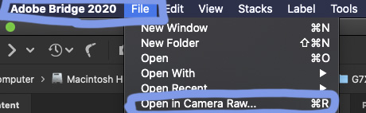

I will usually do some ‘global’ editing (adjustment or process) to 1 image, select all of the images and apply those edits, or copy the edit and apply it to selected images. When happy with the adjustments I’ve made, with all images selected, I go to save.
An ‘Export’ dialogue box appears. You can name your files, decide where to put them, save them as jpegs, set them to the ‘web’ colour space (sRGB) and size them for purpose.
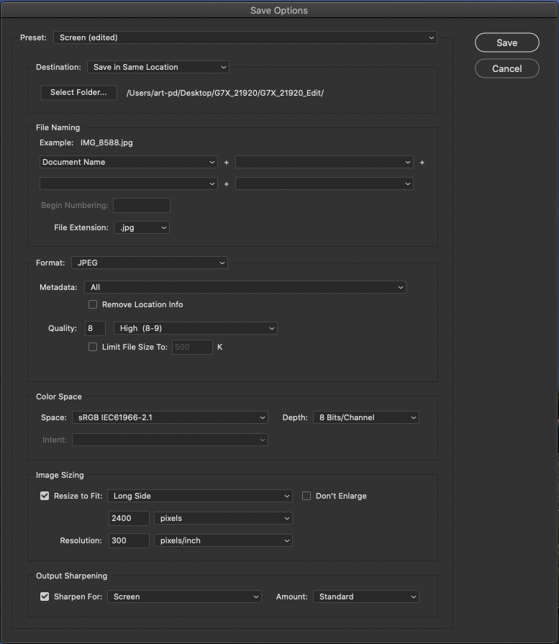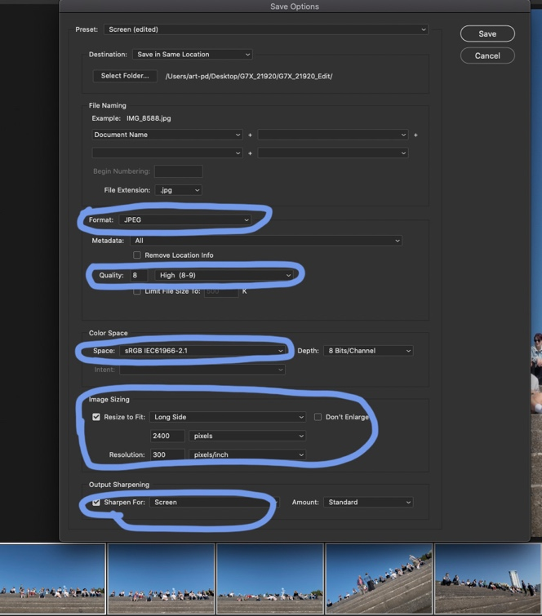
Consider the end user. How will they look at your images? If sending images to a client, they may be looking at them on a hi-res monitor (Retina display, 4K Ultra HD etc.). Most websites also allow full-screen images. An HD or Ultra-HD projector will show up poor files. For good screen presentation, I usually save images at 1600 pixels wide. This also works well for my website, Instagram and slide shows. Higher resolution screens might work better with images at, say, 2400 pixels width (with a 1600-pixel height).

To keep file sizes under control I may choose a slightly lower jpeg quality. A 2400px-wide image saved at jpeg quality 8, might be the same file-size as a 1600px-wide image saved at 10.
A 2400px image at quality 12 opens to exactly the same size as a 2400px image at quality 8, or 5; the pixel dimension governs how big the image will open.

The quality (either 10 down to 1, or 12 down to 1) governs the intrinsic image quality – ability to be resaved, presence of artifacts etc. On screen, the difference between a 12 and 10 is minimal, or a 10 and an 8. Jpegs allow reduced file size by means of compression; they throw information out. This does not always matter when the files are for online display only.

Batch Resizing in Bridge
Another automated method allows you to select and batch-resize images directly from Bridge. Select the images you want to process. From the top-menu select Tools – Photoshop – Image Processor. A similar (if slightly more basic) dialogue box appears and you can process your files directly (see below).

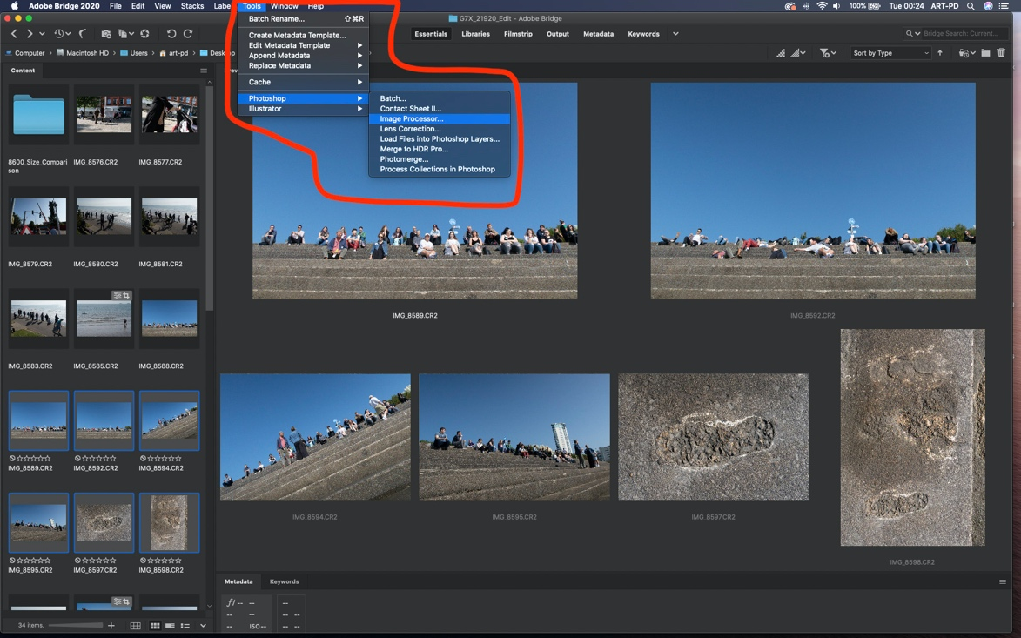

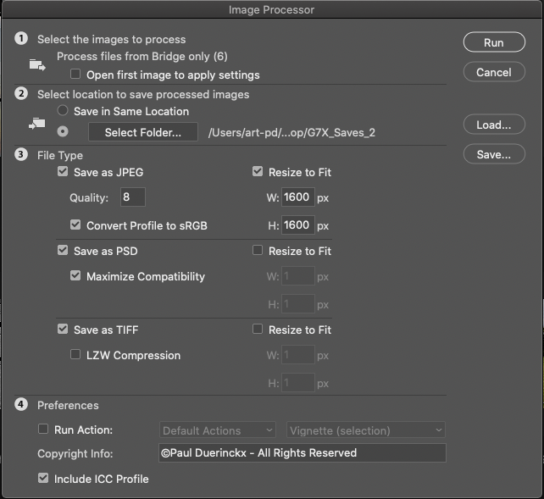

(Note that in the above example, JPEG, TIFF and PSD are all checked. When you run the process, you will end up with 3 lots of the same images all in separate, annotated folders. If you only want jpegs, check only the jpeg box).

At the university, everything is based around working with Adobe. However, you can resize images on any Mac using Preview, which comes bundled with the OS, or any PC using an App such as Resize Image.
Preview

Select and open images in Preview. Go to Tools in top menu bar and select Adjust Size from the drop-down menu. This will give you a full range of resizing options. If you need to then save images as jpegs, go to Export and then save the image or images as jpegs.

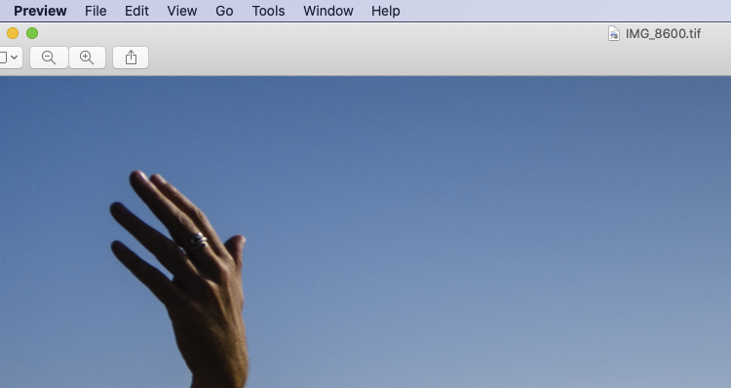

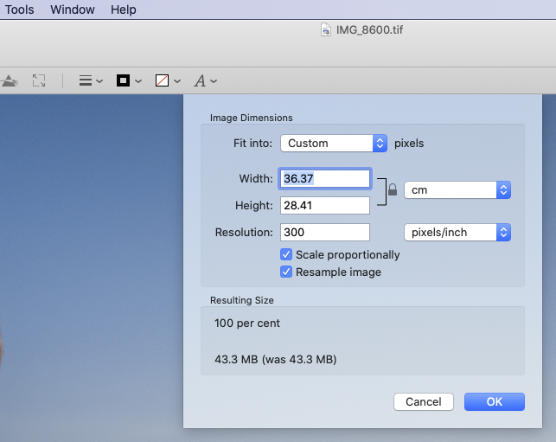
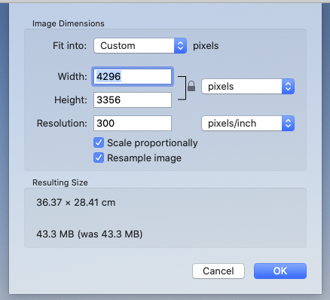

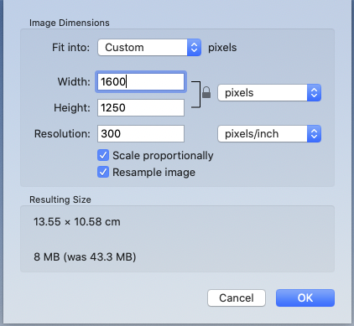

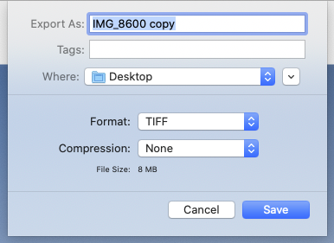

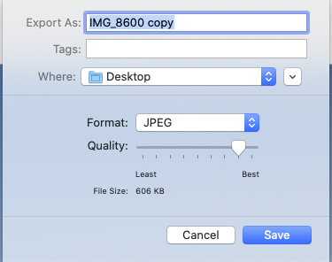

Note the changes in file size as I make the adjustments: the 43.3MB original (tiff) becomes an 8MB tiff once reduced to 1600 pixels. When I export it as a good quality jpeg, it is reduced to 606KB

