Introduction

This report presents the initial user research and wireframe design for a cooperative strategy game based on Pandemic, redesigned for the University of Wales Trinity Saint David (UWTSD). Players assume different university roles and collaborate to control the spread of digital security incidents and student well-being crises across campus buildings. The report follows a user-centred design process involving user research, persona creation, wireframe prototyping and prototype evaluation.
Pandemic is a cooperative strategy board game in which players act together to stop the spread of pandemics or diseases around the campus. Contrasting competitive board games, everyone either wins together or loses together. The objective is to discover cures for the disease outbreak before they get out of hand. Players lose when outbreaks occur, the supply of disease cubes runs out, or the player's deck is exhausted before cures are discovered.
Each player takes a specialist role like a medic, scientist, researcher or dispatcher. In this case, they move between campuses, treat diseases, build research stations, share cards and discover cures. The objective is to work together, share resources, decide how to stop the outbreak and balance between short-term and long-term actions.
Most students, lecturers and staff of the UWTSD carry smartphones all day, running on Android or iOS; therefore, it should be designed as a mobile app. This is strategic for being convenient for them to play short cooperative game sessions between breaks and lectures. Implementing it for a mobile platform calls for the interface to be intuitive, simple and optimised for similar screens. It will use large touch-friendly buttons, minimal text and clear icons to reduce navigation and cognitive loads. Thereby aiding easy navigation and allowing playing easy action of moving from one end to the other, better treatment of diseases, testing outbreaks and collaborating with teammates.
The game also supports online multiplayer, where players can join the game online from their locations, irrespective of London, Birmingham or Wales.
A set of four detailed personas with associated scenarios and an indication of the main user experience requirements relating to each persona;
Four Personas
Accessibility User Interface requires that a user of the game or system should be able to have full access and control. The design rule ensures that every player has a fair opportunity without regard to any disability, device, or context. There should not be a hindrance or barrier to the user or player in performing to their full potential. Accessibility enables game elements to be easy to use or see and distinguish, particularly those with colour blindness, dyslexia, low vision, cognitive clarity, and those playing on mobile screens and outdoors.
The user interface must be understandable, operable, perceivable and usable for all users, including those with low vision, motor impairments, colour blindness, ESL backgrounds, dyslexia and varied cognitive loads.
The pandemic game style relies heavily on crisis alert, infection indicators, turn-order cues, role abilities and map icons.
Critical icons, text, labels, moves, and actions, such as forward, play, delete, and other critical moves, must be highlighted and bolded. High-contrast buttons for actions like admission, treatment, and diagnosis can trigger pop-ups and alarms for urgent action.
Perceivable – Game must have high-contrast colour palettes so that icons and texts remain visible and consistent to the players in visible conditions. Colour blind safe design can be implemented using shapes, labels and patterns instead of just colours. Dyslexia-friendly typography, such as Verdana and Open Dyslexic, with increased spacing. Scalable text that users can reduce or enlarge according to their needs without breaking the layout. An icon-driven user interface to reduce reliance on text, specifically for ESL users. Implement clear visual levels so that infection rates, turn order, and crisis alerts stand out. A high contrast palette uses differences in brightness and hue between background and foreground elements so users can reliably understand information in all conditions.
Operable – keyboard for laptop operators, large touch target for mobile ergonomics. Operate undo and confirmation actions to avoid accidental moves. Thumb zone placement and motion-reduced mode for user sensitivity for animation. Avoid time-critical actions so that motor-impaired users are not punished or penalised.
Use colour, shape and text together to describe the severity of infection levels, such as colour – red for severity, label – high risk and triangle shapes with low, medium or high with associated colours, for example green colour for a normal healthy person. A high-contrast alert will signify infection spikes or a crisis alert; medium contrast will signify secondary or map labels, while low contrast will signify background or campus outlines.
Navigation must be consistent across the screens, with plain language text for non-English speakers and ESL users. There must be a step-by-step guide or tutorial for users, irrespective of their physical or emotional situations. There must be a predictable reaction for any action and a clear feedback loop, such as ‘Crisis resolved’ or ‘Action successful’.
User Interface must work across settings, devices and assistive technologies. The UI must be cross-platform compatible or responsive on laptops, desktops, mobile devices and screen sizes. Supported with screen reader, alt-text and labelled buttons, and works in offline mode in rural campuses, such as Lampeter. Implement iconography that is meaningful and stable across cultures.
How Accessible UI Supports My Personas
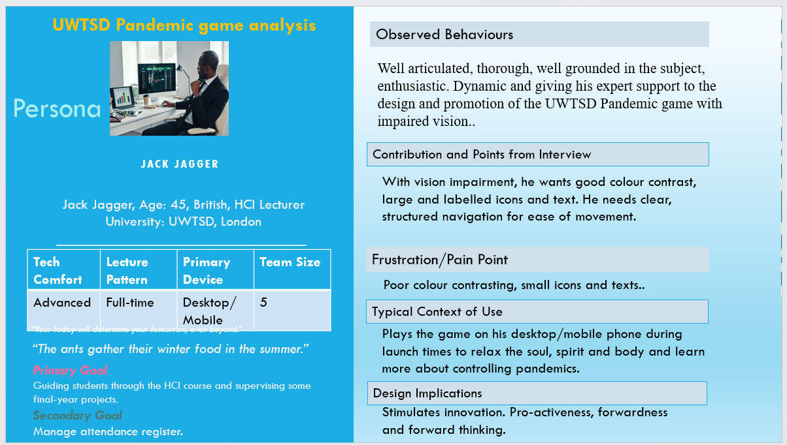
Jack Jagger (Lecturer) - low cognitive load and readable dashboards. Requires a big difference in brightness and hue between foreground and background so that he can perceive information well. Apply high contrasts to ensure crisis alerts are clear even at low brightness, icons remain visible outdoors, and map elements are readable on small screens. Goals and objectives, contextual information
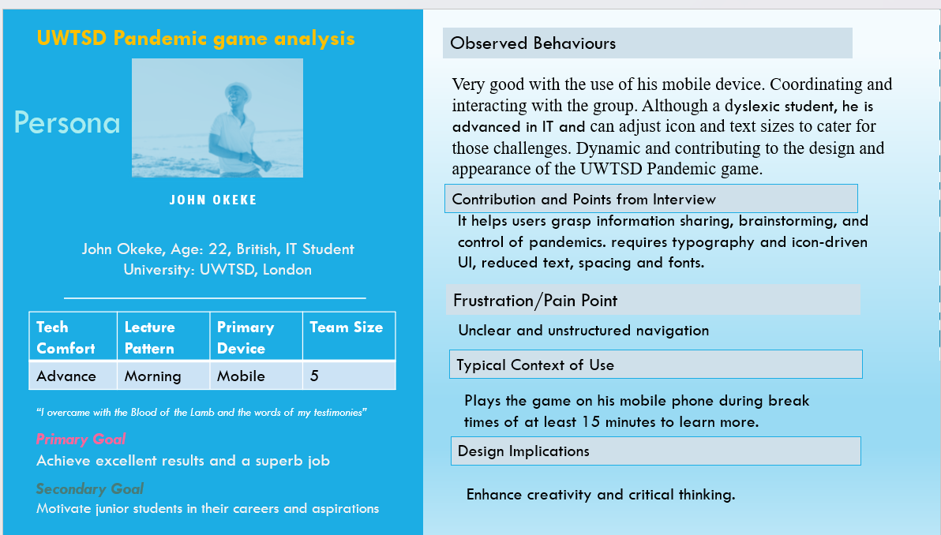
- Justina Cox (Dyslexic student) - requires typography and icon-driven UI, reduced text, spacing and fonts.
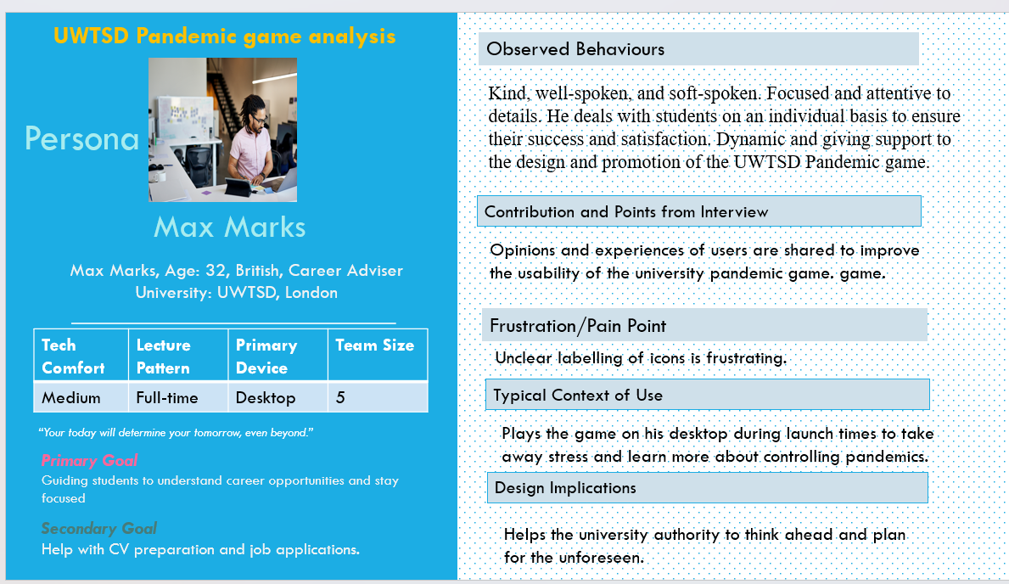
- Max Marks (Career Adviser) - needs clear maps and offline reliability.
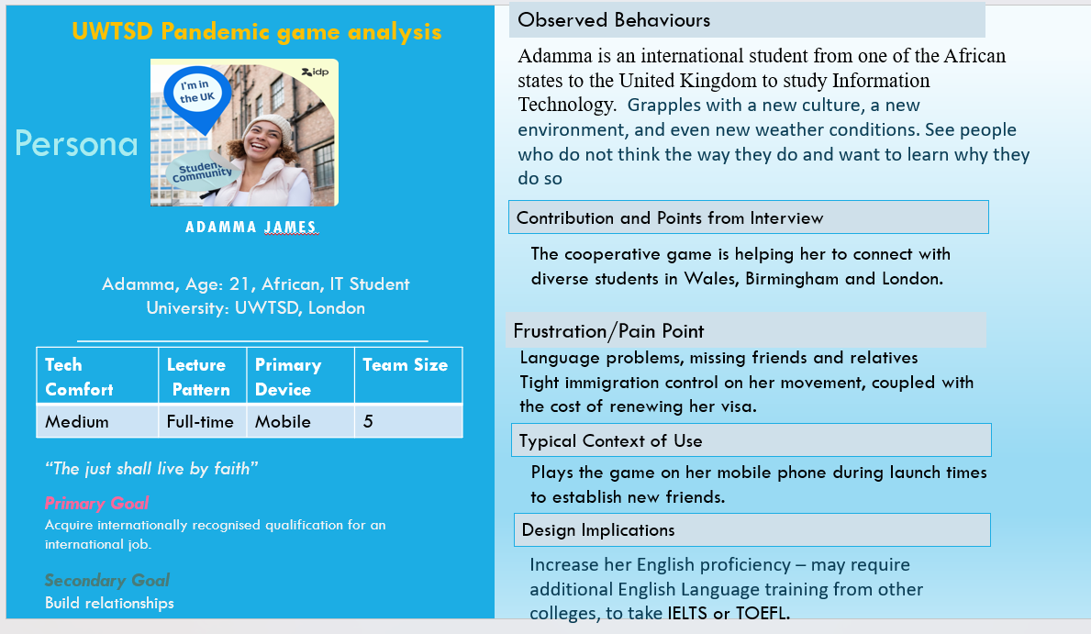
Adamma James (International student) - needs multilingual support and reduced text.
.

Initial set of wireframe storyboards;
This wireframe storyboard describes a static blueprint of the screen of the pandemic game of UWTSD, organised chronologically throughout the design of the game design journey. It demonstrates how the screen design connects from one step to the other. It is a static, low-fidelity blueprint outlining the structure of a single screen, including buttons, texts, images and their positions. The focus is on functions and layout without colours and complexities.
The storyboard illustrates how the stakeholder interacts with the game. The focus is often on pain points, the user’s context and sequential steps, who is next and the screen that leads to the next step. In all, the wireframe and storyboard are the dynamic maps that will lead me to design and validate the user flow, identify any missing steps or functions and collect feedback from stakeholders early in the design process. Thereby reducing the development process time and cost before the actual production.

Wireframe Storyboards

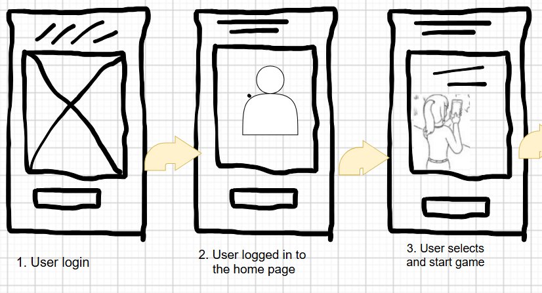
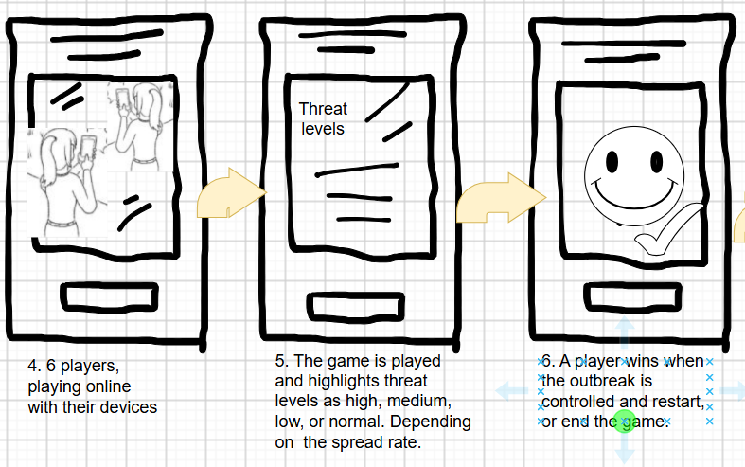
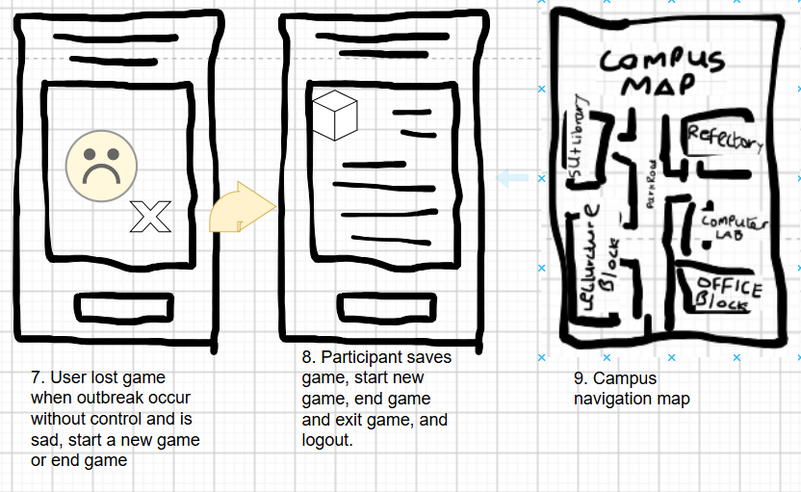

How to play Pandemic: board game’s rules, setup and how to win explained | Dicebreaker
• A description of the process used to collect feedback on your storyboard prototypes and a summary of the positive and negative feedback elicited.
Data collection by the UWTSD Pandemic users is often conducted through primary sources, from team members, students, players, doctors, nurses, patients, and researchers. We collect through face-to-face interviews, email, online and offline questionnaires. The survey is to gather useful information from participants on how the services or the usability of the cooperative game.
The questions were set in MS Word with provision for participants to answer, and distributed through email, conducted some face-to-face interviews, and gave some forms to some class groups. The responses were collected within one week, analysed, and communicated. I made up standard questions such as:
- How often do you play mobile games?
- Does the game help you to understand how the pandemic spread?
- What device do you use for your game (mobile phone, laptop, desktop)?
- Which game features do you enjoy most?
- What frustrates you when using mobile apps?
- Do you require any accessibility features (e.g., larger text, colour-blind mode)?

The strategy is to help us collect data for analysis; it is easy to distribute, particularly via email, and can also be distributed by hand. However, we did not get any responses from our online form. The form allows for comparison of participants’ opinions on how to improve the services. The information will provide an opportunity to understand users' motivations and frustrations with the game, gather opinions on their accessibility needs, and explore further ways to improve the interface design.
Participants were selected from the postgraduate school, undergraduates, former students, lecturers and other non-academic staff. Semi-structured interviews were also conducted with these participants, who expressed their opinions. Interviews of about 3-5 minutes were conducted, recorded with the consent of participants and common themes were identified.
Many participants confirmed that they are using mobile phones for their games, their motivations and information on features that they are enjoying and those that are frustrating, describing which interfaces are confusing or not working properly. However, they prefer communication or coordination with teammates, and which features are critical.
A focus group encourage discussion between the users or the user group. The idea is to explore gameplay, observe agreement and disagreement between the players and understand the group opinions and cohesion. The process is for 5 – 6 students and presents the game concept to them. Put a discussion question and get them to discuss it. Document or record the discussion and summarise the recurring themes. The discussion centres on opinions of the UWTSD game theme, accessibility suggestions, interface expectations and favourite cooperative mechanics. The benefit of this brainstorming strategy builds ideas and leverages each other's comments, while the setback is that some participants may dominate discussions, and this strategy is difficult to analyse.
Observation is another sure way of conducting research to understand behaviours. In the scenario, I observed participants to understand how they interact with the game with their consent. The objective was to identify any usability issues and to observe their natural behaviours. I observed how they navigate the game and handle errors or mistakes, completing simply with keyboard, touchscreen and joysticks. The benefits are that it revealed usability issues that were not mentioned and actual behaviour rather than reported behaviour. The drawback is that only a small number of participants.
Data Collection Summary

Method | Participants | Data Collected | Purpose
Questionnaire | 10 participants | Quantitative | Gaming preferences and accessibility needs
Interviews | 4 participants | Qualitative | User goals, frustrations and expectations
Focus Group | 5 students | Qualitative | Opinions on gameplay and interface ideas
Observation | 5 participants | Behavioural | Navigation and usability issues
Actual Summary
40 questionnaires were sent out, and only 10 participants completed and returned their forms, representing 25 per cent of the population under review. We targeted to interview 10 students, but only 4 responded, representing 40 per cent of the population. The focus group was 6, but 5 out of the six attended, representing 83.3 per cent of the population, and 5 participants were observed while in action, and we saw at first hand their natural behaviour rather than reported behaviours.
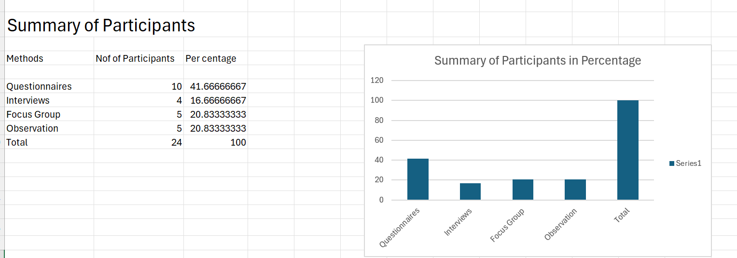
The analysis indicates that out of the 24 participants, 10 (41.66 per cent completed their questionnaire forms, 4 were interviewed, which represents 16.66 per cent, and 20.83 per cent were each from the Focus Group and the observation group.

• A collection of feedback from Peer Evaluators on your design prototypes and other artifacts along with your justifications on how you will make improvements on your resulting designs based on this feedback.
Peer Evaluation
During a workshop, my wireframe prototypes, user requirements, and personas were shared with three peer evaluators. The evaluators each completed a feedback form based on navigation, accessibility, usability, visual clarity and overall user experience. They also provided suggestions and open-ended comments on how I can improve my prototypes.
Peer No. 1: Here is the answer
Q 1. Why is the pandemic game necessary for the university?
Ans: It educates students and staff about pandemic prevention in an interactive and engaging way.
Q2. What type of people would use the game?
Ans: University students, staff, visitors, and anyone interested in learning about pandemic safety.
Q3. What improvement can the game contribute to the control of the pandemic?
Ans: It increases awareness, promotes safe behaviour, and improves preparedness during outbreaks.
Q4. How do you think the game should be designed to achieve the maximum benefits?
Ans: It should be simple, interactive, easy to use, and provide clear feedback and realistic scenarios.
Q5. What measures should be incorporated to allow accessibility to some physically or emotionally disadvantaged people?
Ans: Include adjustable text size, high-contrast colours, subtitles, voice guidance, and simple navigation.
Q6. Is it a good idea to develop such a game, and for what reason in terms of icons and visual texts?
Ans: Yes. Clear icons and visual text make the game easier to understand and more accessible for all users.
Q7. How can this game development project help your education at UWTSD?
Ans: It helps me apply my knowledge, improve my technical skills, and gain practical project experience.
Peer No. 2: Here is the answer
Q1. Why is the pandemic game necessary for the university?
Ans: It helps with student learning ability.
Q2. What type of people would use the game?
Ans: Students with disabilities.
Q3. What improvement can the game contribute to the control of the pandemic?
Ans: Teaching students how to contact on outbreak if it should occur in real life.
Q4. How do you think the game should be designed to achieve the maximum benefits?
Ans: The game should be designed with instructions on how to play and directions on the start game screen.
Q5. What measures should be incorporated to allow accessibility to some physically or emotionally disadvantaged people?
Ans: Create to suit all user backgrounds.
Q6. Is it a good idea to develop such a game, and for what reason?
Ans: To help users grasp information and control the pandemic.
Q7. How can this game development project help your education at UWTSD?
Ans: It helps with creative and critical thinking skills.

Peer No. 3: Answers:
1. The pandemic game is necessary because it can teach university students and staff how to work together during a health crisis.
2. The game could be used by students, lecturers, administrative staff, security staff and university management.
3. The game can improve pandemic control by increasing awareness, teamwork, planning and quick decision-making.
4. The game should be simple, interactive, realistic and designed around challenges that may occur on a university campus.
5. It should include subtitles, adjustable text sizes, colour-blind modes, simple controls, audio guidance and options to reduce stressful content.
6. Yes, it is a good idea because it can educate users about pandemic safety enjoyably and practical way.
7. The project can improve my skills in research, user-centred design, teamwork, problem-solving and computer game development at UWTSD.

Feedback - The persona design has a diverse range of users represented, including accessibility and room for improvement. They agreed that the campus map layout was understood, but the icons for the infected buildings were similar. They approved the navigation buttons, but the end turn buttons were too close to each other, and actions were difficult to perform. The tutorial has a good introduction, but it needs more interactive guidance.
Proposed improvement – replace some icons with clearer labels and symbols to reduce confusion and improve recognition. Improve spacing and button sizes to enhance interface visibility on mobile phones and reduce accidental taps. Implement step-by-step interactive instructions to help new users to learn the game mechanics more easily, and implement adjustable text sizes and colour-blind mode to support a wider range of users by inclusive design principles. Improve the campus map design appearance by reducing cognitive load and improving readability.
Reflection – The peer evaluation revealed some usability issues that were not revealed at the time of the initial design stage. Most comments focused on improving accessibility, navigation and interface clarity. The idea is to incorporate the above-suggested improvements into the next prototype to improve user experience.
Conclusion
The report presented an overview of user-centred design based on the mobile adaptation of the UWTSD cooperative’s board Pandemic game. The process began with research involving potential users to identify gaming accessibility needs, gaming preferences and usability expectations. The report discovered a diverse range of university users by ensuring that it considers different abilities, backgrounds and playing styles. The design follows a guided wireframe storyboard that focuses on clear information presentation, intuitive navigation and cooperative gameplay for mobile devices, with an established human-computer interface based on usability principles.
The peer feedback and prototype evaluation highlighted areas of improvement in interface design clarity, navigation, accessibility improvement and button sizing. Their comment will be carefully considered and implemented in the next phase. Overall, the research highlights the need to involve users through a design process.

