Name: Vaishnavi Odedra

Enrolment id: 2541605

Module: Social Epidemiology and Public Health Development

Module code: LCHS7000

Index:
Contents | Page
Title Page | 1
Table of Contents | 2–3
Task 1: Social Epidemiological Analysis | 4
Introduction | 4
Disease Inequality 1: Thalassaemia – Unequal Access to Lifelong Specialist Care | 4
Figure 1. Overview of Thalassaemia and its Impact on Red Blood Cells | 5
Disease Inequality 2: Asthma – Inequalities in Respiratory Health Outcomes | 5
Figure 2. Healthy Airway vs Asthma-Affected Airway | 6
Disease Inequality 3: COPD – Health Inequalities in Chronic Respiratory Disease | 6
Figure 3. Structural Changes in the Lungs Associated with COPD | 7
Social Isolation and Loneliness | 7
Figure 4. Long-Term Conditions and Social Isolation | 8
Poverty and Financial Inequality | 8
Figure 5. Disability, Socioeconomic Disadvantage and Health Inequality | 9
Poor Housing and Environmental Inequalities | 9
Figure 6. Poor Housing and Respiratory Health Inequalities | 10
National Response to Reduce Health Inequalities | 10
Asthma + Lung UK: Supporting People Living with Respiratory Conditions | 10
Conclusion (Task 1) | 11
Task 2: Epidemiological Analysis | 12
Introduction | 12
Figure 1. Global Prevalence and Projected Increase of Dementia Cases | 12
Disease Burden and Biological Mechanisms of Dementia | 13
Figure 2. Structural Changes in the Brain Associated with Alzheimer's Disease | 13
Prevention, Protection and Health Promotion | 13
Figure 3. Modifiable Risk Factors Contributing to Dementia Development | 14
Epidemiological Risk Factors and Determinants | 14
Epidemiological Studies | 14
Health Needs Assessment | 15
Figure 4. Relationship Between Social Determinants and Dementia Inequalities | 16
Identification of At-Risk Populations | 16
Surveillance and Monitoring | 16
Public Health Impact | 16
Intervention Programme and Evaluation | 16–17
Strengths and Weaknesses of the Epidemiological Approach | 17–18
Conclusion (Task 2) | 18
Harvard References | 18–21

Task 1: Social Epidemiological Analysis
Introduction
Disability Inequality and Health: An Analysis of Health Inequalities Among People Living with Long-Term Conditions in the United Kingdom
Disability-related health inequalities remain a significant public health challenge in the United Kingdom because people living with long-term conditions experience avoidable differences in health outcomes, healthcare access and social participation. Health inequalities are defined as systematic and unfair differences in health between population groups, which are largely shaped by social, economic and environmental conditions rather than biological factors alone (Marmot et al., 2020). The Equality Act 2010 defines disability as a physical or mental impairment that has a substantial and long-term negative effect on an individual’s ability to undertake normal daily activities (UK Government, 2010). This report focuses on individuals living with thalassaemia, asthma and chronic obstructive pulmonary disease (COPD). Although these conditions have different clinical causes, their impact is strongly influenced by wider determinants including poverty, housing, employment and healthcare access. Therefore, disability inequalities should be understood as socially produced inequalities requiring action beyond healthcare provision (Marmot et al., 2020).
Disease Inequality 1: Thalassaemia – Unequal Access to Lifelong Specialist Care
Thalassaemia is an inherited haemoglobin disorder that reduces the body's ability to produce healthy red blood cells, resulting in chronic anaemia and lifelong healthcare needs (NHS, 2024). In England, approximately 1,300 people live with transfusion-dependent thalassaemia, with the condition occurring most frequently among individuals of South Asian, Mediterranean, Middle Eastern and African heritage due to inherited genetic factors (NHS England, 2024). People with severe forms of thalassaemia require regular blood transfusions every three to five weeks and iron chelation therapy throughout their lives, making continuous access to specialist healthcare essential (National Institute for Health and Care Excellence (NICE), 2024).
Health inequalities arise because access to specialist haemoglobinopathy centres, genetic counselling and culturally appropriate healthcare is not always consistent across the UK. Individuals from ethnic minority communities may also experience language barriers, reduced awareness of carrier screening and delayed diagnosis, increasing the risk of disease complications (Office for Health Improvement and Disparities, 2023). Furthermore, lifelong treatment can affect education, employment and psychological wellbeing, contributing to wider social disadvantage (Marmot et al., 2020). Reducing these inequalities requires equitable access to specialist services, expanded genetic screening programmes, culturally sensitive health education and multidisciplinary care that addresses both the medical and social needs of affected individuals.

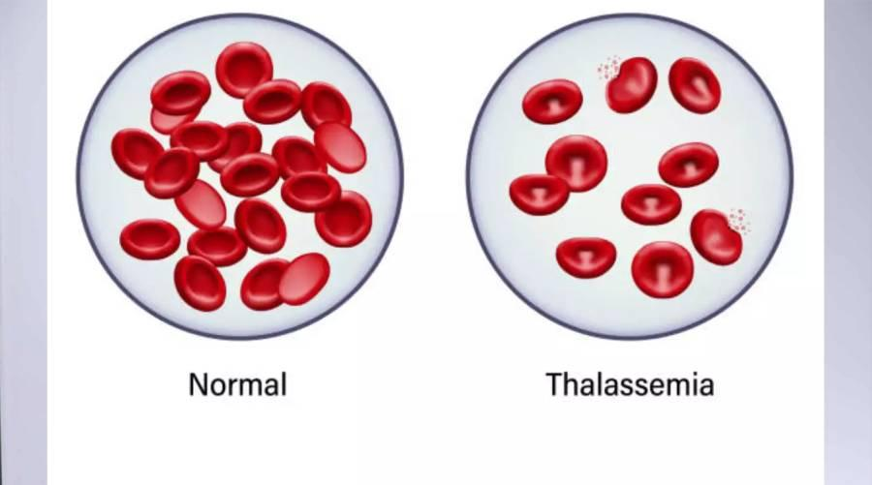

Figure 1. Overview of thalassaemia and its impact on red blood cells. (Adapted from NHS England, 2024).

Disease Inequality 2: Asthma – Inequalities in Respiratory Health Outcomes
Asthma is a common long-term respiratory condition characterised by inflammation and narrowing of the airways, leading to symptoms including wheezing, coughing, chest tightness and breathlessness (National Institute for Health and Care Excellence (NICE), 2024). In the United Kingdom, approximately 5.4 million people are currently receiving asthma treatment, including around 4.5 million adults and 1.1 million children, demonstrating its substantial public health impact (Asthma + Lung UK, 2024). However, asthma outcomes are not equally distributed across the population, with individuals living in deprived communities experiencing higher rates of emergency admissions, poorer symptom control and increased exposure to environmental risk factors (Office for Health Improvement and Disparities (OHID), 2023).
Health inequalities in asthma are strongly associated with wider social determinants of health. People living in low-income households are more likely to experience poor-quality housing conditions, including dampness, mould and inadequate ventilation, which can worsen asthma symptoms and increase exacerbations (Marmot et al., 2020). Additionally, exposure to outdoor air pollution, particularly nitrogen dioxide and particulate matter from traffic emissions, disproportionately affects disadvantaged urban communities and contributes to respiratory disease burden (World Health Organization (WHO), 2024).
Furthermore, inequalities may occur through differences in access to preventative healthcare, including asthma reviews, inhaler education and personalised asthma management plans. Delayed diagnosis and inadequate disease control can increase hospital admissions and reduce quality of life. Addressing asthma inequalities requires improved access to primary care, better housing conditions, reduction of environmental exposures and targeted respiratory health interventions for vulnerable populations (NHS England, 2023).

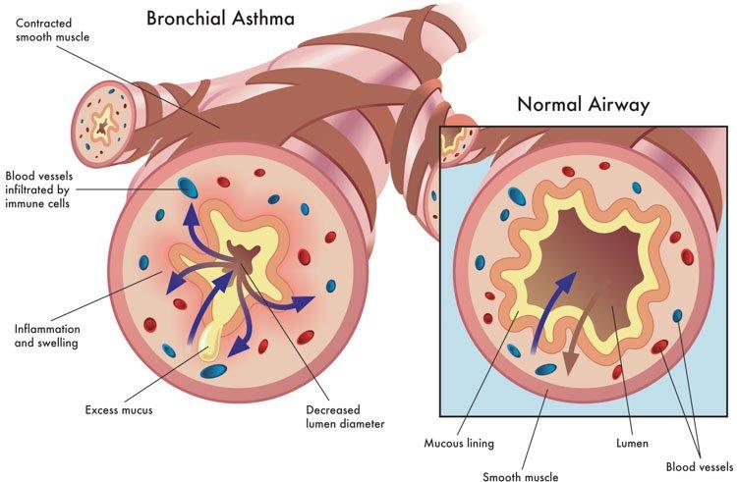
Figure 2. Comparison between a healthy airway and an asthma-affected airway showing inflammation and narrowing of the bronchial tubes. (Adapted from Asthma + Lung UK, 2024).

Disease Inequality 3: COPD – Health Inequalities in Chronic Respiratory Disease
Chronic obstructive pulmonary disease (COPD) is a progressive respiratory condition characterised by persistent airflow limitation, airway inflammation and lung damage, causing symptoms including breathlessness, chronic cough and reduced exercise capacity (NICE, 2023). COPD affects approximately 1.17 million diagnosed people in the UK, although many cases remain undiagnosed due to delayed recognition of symptoms (British Lung Foundation, 2024).
COPD demonstrates significant health inequalities, with a greater burden among people living in deprived communities. Although smoking is the main risk factor, occupational exposure, air pollution, poor housing and socioeconomic disadvantage also contribute to unequal disease outcomes (WHO, 2024). Deprived populations often experience higher exposure to risks, delayed diagnosis and poorer access to preventative healthcare, resulting in increased hospital admissions and premature mortality (Marmot et al., 2020).
COPD can lead to long-term disability through reduced independence, employment limitations and social isolation. Reducing inequalities requires early diagnosis, smoking cessation support, pulmonary rehabilitation and equitable access to respiratory services (NHS England, 2023).
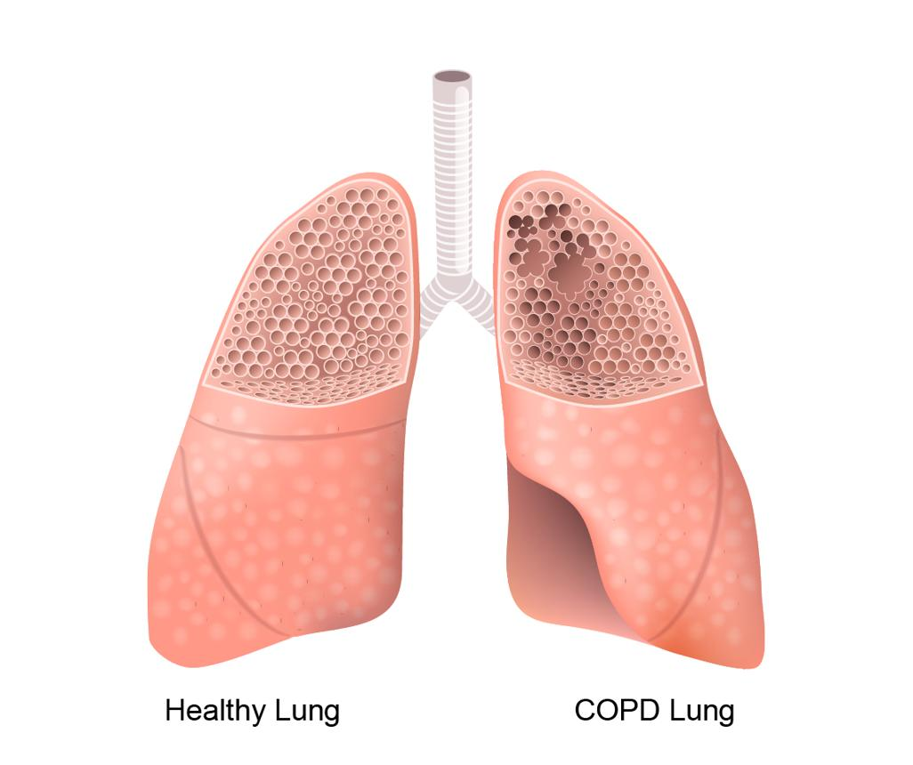
Figure 3. Structural changes in the lungs associated with chronic obstructive pulmonary disease (COPD), including airway narrowing and reduced airflow. (Adapted from NICE, 2023).
Social Isolation and Loneliness
People living with long-term disabilities are at increased risk of social isolation due to fatigue, breathlessness, reduced mobility and limitations in daily activities (Marmot et al., 2020). The Office for National Statistics reports higher loneliness levels among disabled adults compared with non-disabled adults, reflecting barriers to independence, employment and community participation (ONS, 2023).
However, isolation should not be considered only a consequence of illness. It is also created by wider social barriers, including inaccessible environments and limited community support. Therefore, reducing loneliness requires inclusive communities, peer-support programmes, rehabilitation services and improved accessibility rather than healthcare interventions alone (Asthma + Lung UK, 2024).

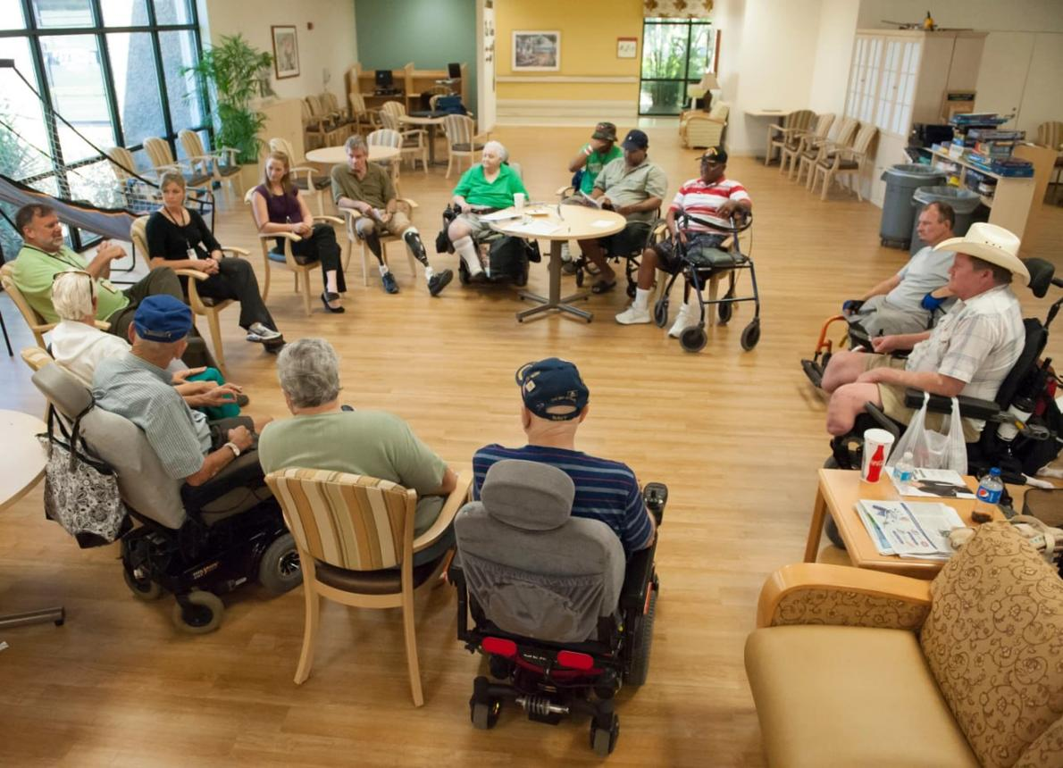
Figure 4. The relationship between long-term conditions, reduced social participation and social isolation. (Adapted from Marmot et al., 2020).
Poverty and Financial Inequality
Economic disadvantage is a major driver of disability inequality because long-term conditions create additional costs through medication, transport, specialist appointments and reduced employment opportunities (Marmot et al., 2020). Disabled adults in the UK have lower employment rates compared with non-disabled adults, increasing vulnerability to financial insecurity (ONS, 2024).
Although disability benefits and employment support programmes provide assistance, they do not remove all inequalities. A wider approach addressing income security, workplace inclusion and social protection is required to improve health outcomes (Department for Work and Pensions, 2023).


Figure 5. Relationship between disability, socioeconomic disadvantage and health inequality. (Adapted from Marmot et al., 2020).
Poor Housing and Environmental Inequalities
Poor housing contributes significantly to respiratory inequalities because dampness, mould, cold homes and indoor pollutants worsen asthma and COPD symptoms (OHID, 2023). People experiencing socioeconomic deprivation are more likely to live in poor-quality housing and experience fuel poverty, increasing exposure to health risks (Department for Energy Security and Net Zero, 2023).
Therefore, improving health requires action beyond clinical care. Housing regulation, energy efficiency programmes and environmental improvements are essential components of reducing respiratory disability inequalities (Marmot et al., 2020).

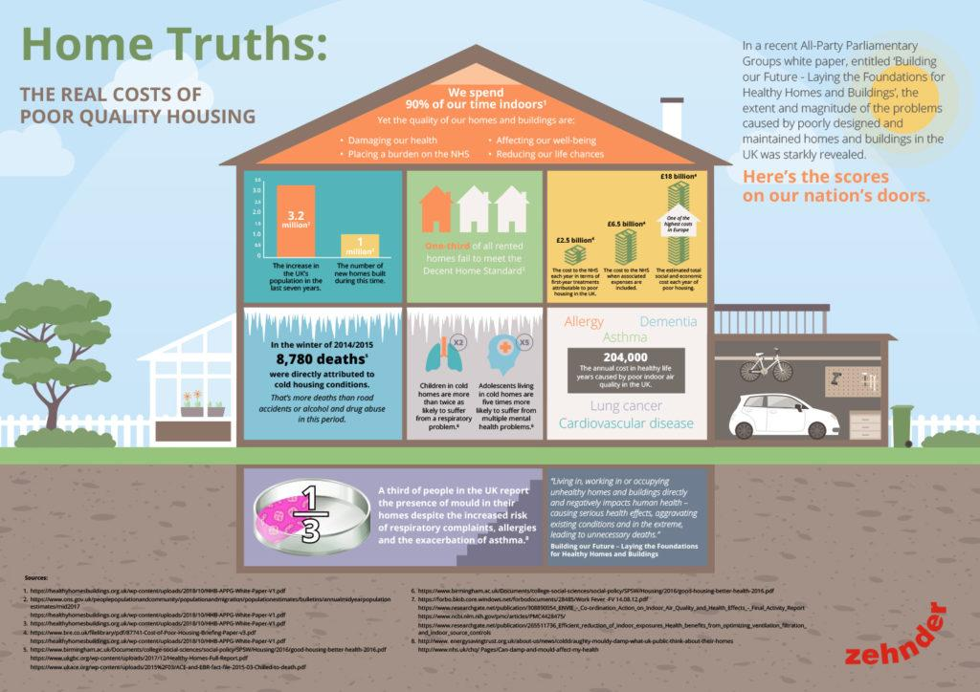
Figure 6. The relationship between poor housing conditions, environmental exposure and respiratory health inequalities. (Adapted from OHID, 2023).
National Response to Reduce Health Inequalities
The NHS Long Term Plan aims to reduce inequalities through personalised care, prevention, earlier diagnosis and improved management of long-term conditions (NHS England, 2019). However, universal healthcare does not automatically create equal outcomes because social disadvantage continues to influence health experiences (Marmot et al., 2020).
The Core20PLUS5 programme focuses on the most deprived 20% of the population and identifies respiratory disease as a priority area for reducing healthcare inequalities (NHS England, 2023). Although these initiatives represent progress, their effectiveness depends on addressing wider social determinants including housing, income and employment.
Asthma + Lung UK: Supporting People Living with Respiratory Conditions
asthma + Lung UK supports people living with respiratory diseases through education, research, advocacy and patient support services (Asthma + Lung UK, 2024). The charity aims to improve diagnosis, treatment access and disease awareness while campaigning against inequalities caused by poor housing and environmental exposure. However, charities alone cannot eliminate structural inequalities and require collaboration with healthcare providers and policymakers to achieve sustainable improvements.

Conclusion
Disability inequalities among people living with thalassaemia, asthma and COPD are shaped by both disease burden and wider social determinants of health. Although national policies and charities have improved support, persistent inequalities demonstrate that healthcare solutions alone are insufficient. Reducing disability inequality requires coordinated action addressing healthcare access, poverty, housing, employment and social inclusion.

Task 2: Epidemiological Analysis
Epidemiological Analysis of Dementia Among Older Adults Living in the United Kingdom
1. Introduction
Dementia represents one of the most significant public health challenges affecting ageing populations worldwide. Dementia is a progressive neurological condition characterised by decline in memory, cognitive ability, behaviour and functional independence (WHO, 2023). Alzheimer’s disease is the most common form of dementia, accounting for approximately 60–70% of dementia cases globally (WHO, 2023).
Globally, more than 55 million people live with dementia, with nearly 10 million new cases occurring every year. Due to increasing life expectancy, the global dementia burden is projected to reach approximately 139 million people by 2050 (WHO, 2023).
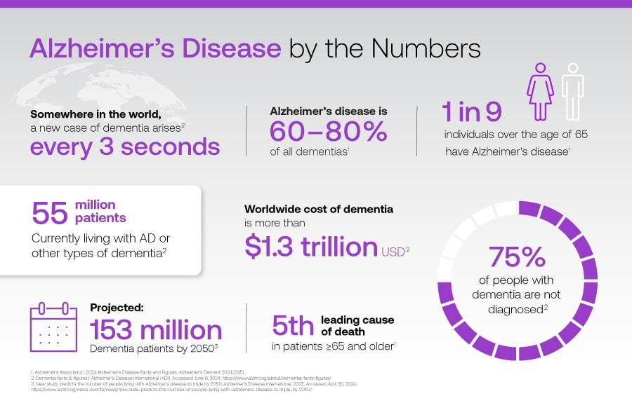
Figure 1: Global prevalence and projected increase of dementia cases.
(Source: World Health Organization, 2023)
The United Kingdom faces a growing dementia burden, with more than 900,000 people currently living with dementia, and this number is expected to exceed one million by 2025 due to population ageing (Alzheimer’s Society, 2024). Dementia is also one of the leading causes of death in England and Wales, demonstrating its major impact on public health systems, families and social care services (Office for National Statistics, 2024).
This epidemiological analysis focuses on older adults aged 65 years and above living in the UK, as increasing age remains the strongest risk factor for dementia. However, dementia should not be viewed as an inevitable consequence of ageing because evidence demonstrates that social, economic and environmental factors influence dementia risk throughout the life course (Livingston et al., 2024).
Disease Burden and Biological Mechanisms of Dementia
Dementia develops due to progressive damage to brain cells, affecting areas responsible for memory, reasoning and behaviour. Alzheimer’s disease is associated with abnormal accumulation of amyloid-beta plaques and tau protein tangles, which contribute to neuronal destruction and brain shrinkage (National Institute on Aging, 2023).
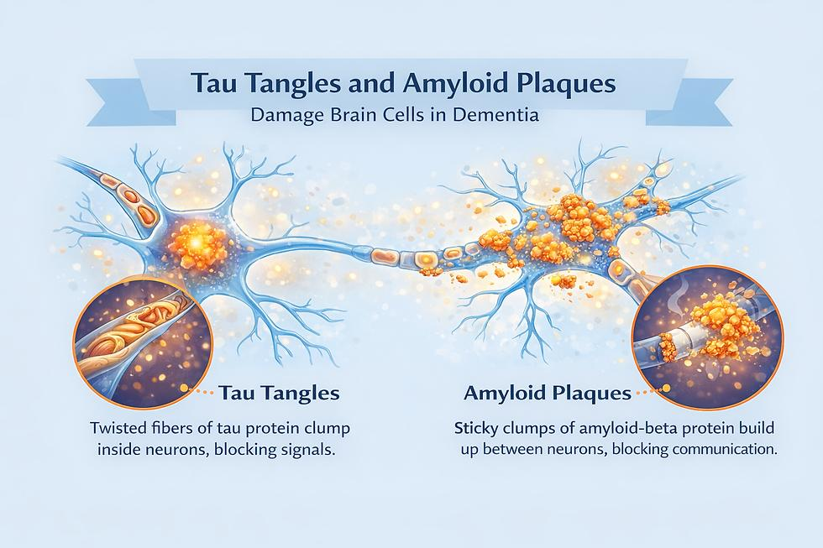
Figure 2: Structural changes in the brain associated with Alzheimer’s disease.
(Source: National Institute on Aging, 2023)
Although biological ageing increases dementia risk, epidemiological evidence shows that dementia occurrence varies significantly between populations. This suggests that dementia is influenced not only by biological mechanisms but also by social determinants such as education, income, healthcare access and lifestyle opportunities (Marmot et al., 2020).
Prevention, Protection and Health Promotion
Public health approaches to dementia prevention include primary prevention, secondary prevention and tertiary prevention strategies.
Primary prevention aims to reduce dementia risk before cognitive decline occurs. The Lancet Commission identifies 14 potentially modifiable dementia risk factors, including hypertension, hearing loss, smoking, obesity, depression, physical inactivity, diabetes and social isolation (Livingston et al., 2024).
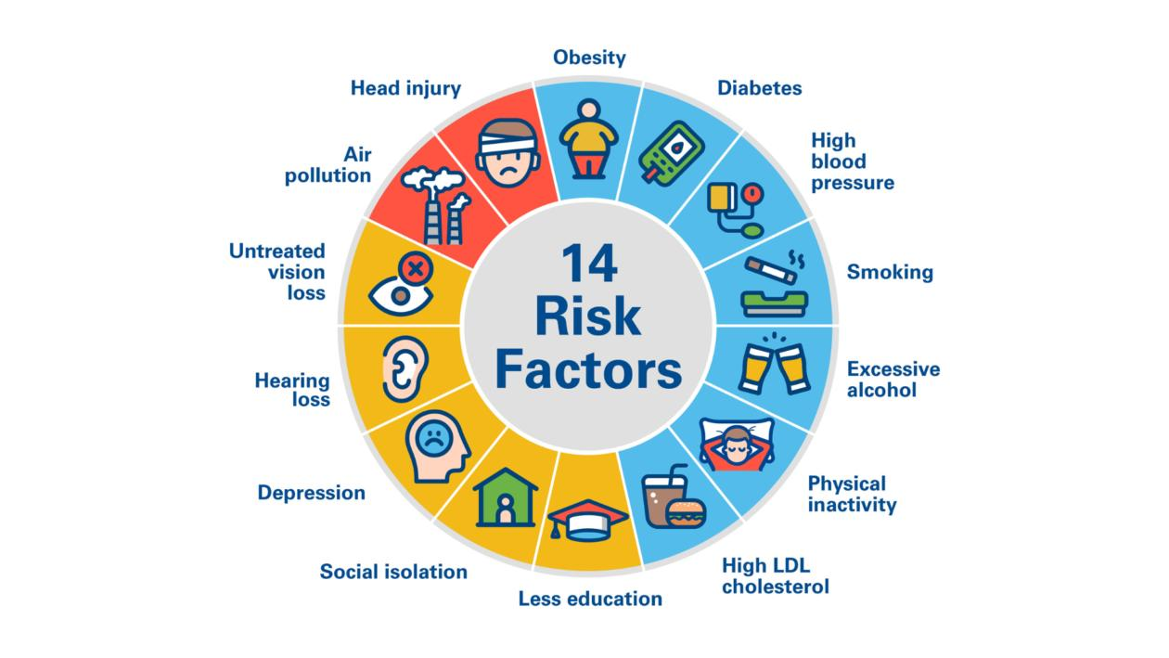

Figure 3: Modifiable risk factors contributing to dementia development.
(Source: Livingston et al., 2024)
However, a critical epidemiological perspective highlights that dementia prevention cannot rely only on individual behaviour change. For example, encouraging physical activity or healthy eating may be less achievable among individuals experiencing poverty, unsafe environments or limited access to healthcare resources (Marmot et al., 2020). Therefore, prevention strategies must address structural inequalities alongside lifestyle factors.
Epidemiological Risk Factors and Determinants
Dementia risk is influenced by a combination of biological, behavioural and social determinants.Age remains the strongest risk factor, with dementia prevalence increasing dramatically after 65 years. However, socioeconomic inequalities strongly influence dementia outcomes. People living in deprived communities often experience higher exposure to cardiovascular risk factors, lower educational opportunities and reduced access to preventative healthcare (Marmot et al., 2020).
Epidemiological Studies
Epidemiology provides essential evidence on dementia distribution, risk factors and disease progression, supporting prevention strategies and healthcare planning (NICE, 2018). Cross-sectional studies estimate dementia prevalence across populations and identify groups requiring targeted interventions; however, they cannot establish causal relationships due to simultaneous measurement of exposure and disease (Livingston et al., 2024; Rothman, Greenland and Lash, 2021).
Prospective cohort and longitudinal studies provide stronger evidence by tracking individuals over time and have identified major dementia risk factors, including hypertension, diabetes, obesity, smoking, hearing loss, physical inactivity and low educational attainment (Livingston et al., 2024). Case-control studies are useful for investigating previous exposures but may be affected by recall and selection bias (Rothman, Greenland and Lash, 2021).
In the UK, approximately 982,000 people live with dementia, with numbers expected to increase to around 1.4 million by 2040 due to population ageing (Alzheimer’s Society, 2024). Overall, combining different epidemiological approaches provides a stronger evidence base for dementia prevention, policy development and resource planning (NICE, 2018).

Health Needs Assessment
Health Needs Assessment (HNA) identifies population health needs, inequalities and service gaps to support evidence-based healthcare planning (NICE, 2018). Adults aged over 65 years and individuals with cardiovascular disease, diabetes, obesity, hearing loss and depression represent priority groups (WHO, 2025; Livingston et al., 2024). HNA uses GP dementia registers, NHS datasets and mortality statistics to monitor prevalence, diagnosis rates and regional inequalities. However, delayed diagnosis remains a significant challenge, emphasising the need for accessible memory services and proportionate universalism to reduce health inequalities (Marmot et al., 2020).
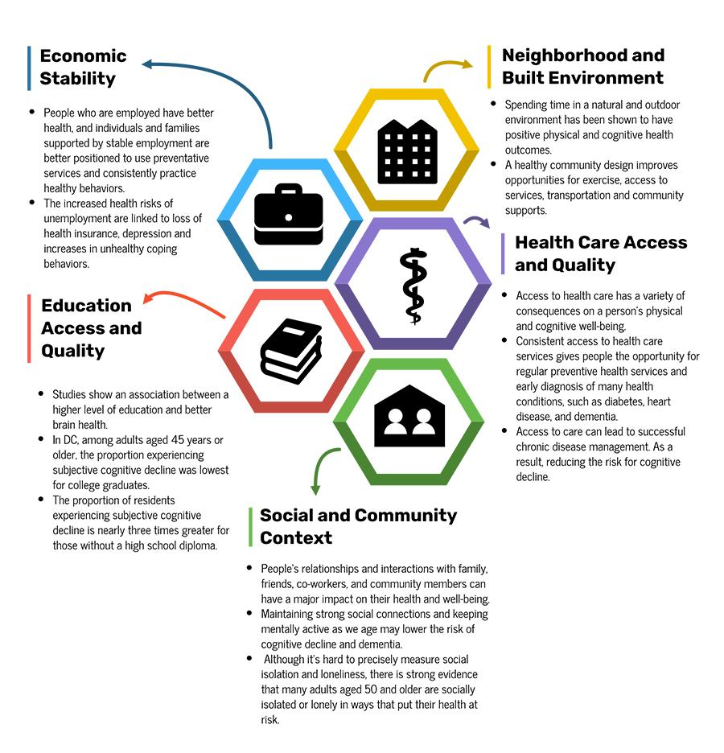

Figure 4: Relationship between social determinants and dementia inequalities.
(Source: Marmot et al., 2020).
Identification of At-Risk Populations
Identifying dementia risk groups supports targeted prevention and equitable resource allocation (NICE, 2018). Age remains the strongest risk factor, with approximately 1 in 11 UK adults aged over 65 years living with dementia (Alzheimer’s Society, 2024). However, dementia risk is also influenced by modifiable factors such as hypertension, diabetes, obesity, hearing loss, smoking and physical inactivity, with around 45% of cases potentially linked to preventable risk factors (Livingston et al., 2024).
A critical public health perspective recognises that these risks are shaped by social inequalities. Deprivation, limited healthcare access, lower health literacy and cultural barriers can increase dementia risk and delay diagnosis, particularly among disadvantaged and ethnic minority populations (Marmot et al., 2020; Alzheimer’s Society, 2024).

Surveillance and Monitoring
Dementia surveillance enables monitoring of prevalence, diagnosis rates, mortality and healthcare needs. In England, data from NHS dementia registers, Hospital Episode Statistics, ONS mortality records and Quality and Outcomes Framework support service planning (NHS England, 2024).
However, underdiagnosis and delayed assessment remain key challenges, meaning current estimates may underestimate true disease burden. Improving early diagnosis and accurate monitoring is therefore essential for effective dementia planning (NICE, 2018).

Public Health Impact
Dementia affects approximately 982,000 people in the UK, with numbers expected to rise to around 1.4 million by 2040 due to population ageing (Alzheimer’s Society, 2024). It contributes to disability, loss of independence, reduced quality of life and increased mortality (ONS, 2024).
The condition costs the UK economy over £42 billion annually, including healthcare, social care and unpaid caregiving costs (Alzheimer’s Society, 2024). Therefore, dementia requires a population-level response focusing on prevention, early diagnosis and integrated health and social care support (WHO, 2025).
Intervention Programme and Evaluation
A comprehensive dementia prevention programme should adopt a life-course approach focusing on reducing modifiable risks.
Key interventions include:
- Promoting physical activity
- Supporting healthy diets
- Smoking cessation programmes
- Cardiovascular disease management
- Diabetes prevention
- Hearing screening
- Increasing social participation
(Livingston et al., 2024)
Interventions should be delivered through GP practices, community organisations, local authorities and dementia-friendly communities.
Evaluation should include both process and outcome measures.
Process indicators:
- Participation rates
- Healthcare professional training
- Community engagement levels
Outcome indicators:
- Increased dementia awareness
- Earlier diagnosis rates
- Improved cardiovascular health
- Improved quality of life
Long-term evaluation should assess whether interventions reduce dementia incidence, delay disease progression and decrease healthcare costs

Strengths and Weaknesses of the Epidemiological Approach

Strengths | Weaknesses
Provides reliable evidence regarding dementia prevalence, incidence, mortality, and disease trends, supporting evidence-based decision-making (WHO, 2025). | Observational studies cannot always establish direct causal relationships because multiple biological, environmental, and social factors interact in dementia development (Rothman, Greenland and Lash, 2021).
Identifies high-risk populations, allowing targeted prevention programmes and efficient allocation of healthcare resources (NICE, 2018). | Dementia is frequently underdiagnosed, particularly during its early stages, leading to incomplete surveillance data and underestimated disease prevalence (Alzheimer's Society, 2024).
Supports continuous surveillance and evaluation of national dementia policies and healthcare services (NHS England, 2024). | Quantitative epidemiological data often fail to capture patient experiences, cultural beliefs, and psychosocial factors influencing dementia care (Marmot et al., 2020).

Conclusion
Dementia continues to represent a significant public health challenge because of its increasing prevalence, ageing population, and substantial social and economic consequences (WHO, 2025). Epidemiological evidence has demonstrated that many dementia cases are associated with modifiable risk factors, including cardiovascular disease, diabetes, smoking, obesity, hearing loss, and physical inactivity (Livingston et al., 2024). Identifying high-risk populations, conducting comprehensive health needs assessments, and maintaining effective surveillance systems are essential for improving early diagnosis, reducing health inequalities, and enhancing service delivery (NICE, 2018). Implementing evidence-based prevention programmes alongside continuous evaluation will contribute to delaying dementia onset, improving quality of life, reducing healthcare costs, and supporting sustainable public health systems in the United Kingdom (Alzheimer's Society, 2024).

Harvard References
- Department of Health and Social Care (2019) The NHS Long Term Plan. London: Department of Health and Social Care.
- Marmot, M., Allen, J., Boyce, T., Goldblatt, P. and Morrison, J. (2020) Health Equity in England: The Marmot Review 10 Years On. London: Institute of Health Equity.
- Office for Health Improvement and Disparities (2023) Health Profile for England 2023. London: OHID.
- UK Government (2010) Equality Act 2010. London: The Stationery Office.
- Department of Health and Social Care (2019) The NHS Long Term Plan. London: Department of Health and Social Care.
- Marmot, M., Allen, J., Boyce, T., Goldblatt, P. and Morrison, J. (2020) Health Equity in England: The Marmot Review 10 Years On. London: Institute of Health Equity.
- National Institute for Health and Care Excellence (NICE) (2024) Thalassaemia: Clinical Knowledge Summary. London: NICE.
- NHS (2024) Thalassaemia. London: NHS.
- NHS England (2024) National Haemoglobinopathy Programme. London: NHS England.
- Office for Health Improvement and Disparities (2023) Health Profile for England 2023. London: OHID
- Asthma + Lung UK (2024) Asthma statistics. Available at: https://www.asthmaandlung.org.uk (Accessed: 22 July 2026).
- Marmot, M., Allen, J., Boyce, T., Goldblatt, P. and Morrison, J. (2020) Health Equity in England: The Marmot Review 10 Years On. London: Institute of Health Equity.
- National Institute for Health and Care Excellence (NICE) (2024) Asthma: diagnosis, monitoring and chronic asthma management (NG245). London: NICE.
- NHS England (2023) Core20PLUS5: An approach to reducing healthcare inequalities. London: NHS England.
- Office for Health Improvement and Disparities (OHID) (2023) Health Profile for England 2023. London: OHID.
- World Health Organization (WHO) (2024) Air pollution and health. Geneva: WHO.
- British Lung Foundation (2024) COPD statistics and facts. London: British Lung Foundation.
- Marmot, M., Allen, J., Boyce, T., Goldblatt, P. and Morrison, J. (2020) Health Equity in England: The Marmot Review 10 Years On. London: Institute of Health Equity.
- National Institute for Health and Care Excellence (NICE) (2023) Chronic obstructive pulmonary disease in over 16s: diagnosis and management (NG115). London: NICE.
- NHS England (2023) Core20PLUS5: An approach to reducing healthcare inequalities. London: NHS England.
- World Health Organization (WHO) (2024) Chronic obstructive pulmonary disease (COPD). Geneva: WHO.
- Asthma + Lung UK (2024) Living with a lung condition: Support and wellbeing. Available at: https://www.asthmaandlung.org.uk (Accessed: 22 July 2026).
- Marmot, M., Allen, J., Boyce, T., Goldblatt, P. and Morrison, J. (2020) Health Equity in England: The Marmot Review 10 Years On. London: Institute of Health Equity.
- Office for National Statistics (ONS) (2023) Disability and loneliness in adults, UK. Newport: ONS.
- Department for Work and Pensions (2023) Family Resources Survey: Disability and economic circumstances. London: DWP.
- Marmot, M., Allen, J., Boyce, T., Goldblatt, P. and Morrison, J. (2020) Health Equity in England: The Marmot Review 10 Years On. London: Institute of Health Equity.
- Office for Health Improvement and Disparities (OHID) (2023) Health Profile for England 2023. London: OHID.
- Office for National Statistics (ONS) (2024) Outcomes for disabled people in the UK: 2024. Newport: ONS.
- Asthma + Lung UK (2024) Asthma and lung health: Housing and air quality. Available at: https://www.asthmaandlung.org.uk (Accessed: 22 July 2026).
- Department for Energy Security and Net Zero (2023) Annual Fuel Poverty Statistics Report 2023. London: Department for Energy Security and Net Zero.
- Marmot, M., Allen, J., Boyce, T., Goldblatt, P. and Morrison, J. (2020) Health Equity in England: The Marmot Review 10 Years On. London: Institute of Health Equity.
- Office for Health Improvement and Disparities (OHID) (2023) Health Profile for England 2023. London: OHID.
- NHS England (2019) The NHS Long Term Plan. London: NHS England.
- NHS England (2023) Core20PLUS5: An approach to reducing healthcare inequalities. London: NHS England.
- Asthma + Lung UK (2024) About us: Improving lung health and supporting people with respiratory conditions. Available at: https://www.asthmaandlung.org.uk (Accessed: 22 July 2026).
- Alzheimer’s Society (2024) Dementia statistics. Available at: https://www.alzheimers.org.uk/about-us/policy-and-influencing/dementia-statistics (Accessed: 22 July 2026).
- Livingston, G., Huntley, J., Liu, K.Y., Costafreda, S.G., Selbæk, G., Alladi, S., Ames, D., Banerjee, S., Burns, A., Brayne, C., Fox, N.C., Ferri, C.P., Gitlin, L.N., Howard, R., Kivimäki, M., Larson, E.B., Nakasujja, N., Rockwood, K., Sampson, E.L., Schneider, L.S., Walsh, S., Sommerlad, A. and Mukadam, N. (2024) ‘Dementia prevention, intervention, and care: 2024 report of the Lancet standing Commission’, The Lancet, 404(10452), pp. 572–628.
- Marmot, M., Allen, J., Boyce, T., Goldblatt, P. and Morrison, J. (2020) Health equity in England: The Marmot Review 10 years on. London: Institute of Health Equity.
- National Institute on Aging (2023) What happens to the brain in Alzheimer’s disease? Available at: https://www.nia.nih.gov/health/alzheimers-and-dementia (Accessed: 22 July 2026).
- National Institute for Health and Care Excellence (NICE) (2018) Dementia: assessment, management and support for people living with dementia and their carers (NG97). Available at: https://www.nice.org.uk/guidance/ng97 (Accessed: 22 July 2026).
- NHS England (2024) Dementia: diagnosis and support data. Available at: https://www.england.nhs.uk/mental-health/dementia/ (Accessed: 22 July 2026).
- Office for National Statistics (ONS) (2024) Deaths registered in England and Wales: 2023. Available at: https://www.ons.gov.uk/peoplepopulationandcommunity/birthsdeathsandmarriages/deaths (Accessed: 22 July 2026).
- Rothman, K.J., Greenland, S. and Lash, T.L. (2021) Modern Epidemiology. 4th edn. Philadelphia: Wolters Kluwer.
- World Health Organization (WHO) (2023) Dementia. Available at: https://www.who.int/news-room/fact-sheets/detail/dementia (Accessed: 22 July 2026).
- World Health Organization (WHO) (2025) Global status report on the public health response to dementia. Geneva: World Health Organization.
- Alzheimer’s Disease International (2023) World Alzheimer Report 2023: Reducing dementia risk: never too early, never too late. London: Alzheimer’s Disease International.
- Department of Health and Social Care (2022) National dementia mission: a plan for dementia research and innovation. London: DHSC.
- Department of Health and Social Care (2024) Major conditions strategy: case for change and strategic framework. London: UK Government.
- Public Health England (2018) Dementia: applying All Our Health. London: Public Health England.
- Prince, M., Wimo, A., Guerchet, M., Ali, G.C., Wu, Y.T. and Prina, M. (2015) World Alzheimer Report 2015: The global impact of dementia. London: Alzheimer’s Disease International.
- Sampson, E.L., Candy, B. and Davis, S. (2020) ‘Living well with dementia: evidence-based approaches to improving quality of life’, Age and Ageing, 49(6), pp. 852–859.
- Wu, Y.T., Beiser, A.S., Breteler, M.M.B., Fratiglioni, L., Helmer, C., Hendrie, H.C., Honda, H., Jorm, A.F., Katz, M.J., McGrath, J.J., et al. (2017) ‘The changing prevalence and incidence of dementia over time: current evidence’, Nature Reviews Neurology, 13, pp. 327–339.

