A comparison of the marketing methods of two multinational hotel brands
Six Senses and Moxy

Student name: Maria-Victoria Lazar
Student ID number: 2235531
Lecturer’s name: Chris Wilkin
Date: 12.02.2023
Module code: BMIH4005
Module: Marketing Essentials
Effective marketing strategies are considered essential for ensuring the growth and long-term success of the business because it helps set out the specific goals of the company. This shall also include identifying the ideal customers and strategies that must be adopted to reach the target audience (Ferrell, Hartline and Hochstein 2021). Marketing strategies are the plan of action and the specific blueprint related to the marketing activities the business will adopt in the following months and years to ensure the company's growth (Vieira et al., 2019). In the following essay discussion related to the marketing strategies of Six Senses and Moxy will be done. Along with this, marketing analysis, segmentation and sustainability strategies of the companies will also be focused on. This shall help assess the effectiveness of the different marketing strategies adopted by the companies and highlight the significant factors that are beneficial in ensuring a strong position in the market.
According to Latan et al. (2018), some of the significant external factors, such as competition, politics, economic conditions and customers, have a considerable impact on the overall performance and success of the company. With that, at the time, they are beyond the control of the business and hence need to be focused on to ensure success. In the case of Six Sense and Moxy, political factors play a significant role in ensuring the smooth functioning of the business. In the case of the hotel and hospitality industry, the stable political condition and decisions taken by the country's government play a significant role. In the case of the United Kingdom, the country has an everyday political necessity, and with that, the government also support the industry because of the revenue it generates for the economy.
Furthermore, in terms of economic conditions, some significant factors that can impact the company's performance include unemployment, inflation, and exchange rates (Chuang and Huang 2018). Due to the recent pandemic, there was a decline in terms of sales within the hospitality industry, but the situation has been improving. In addition, Epstein (2018) states that with the ease of travelling, tourism has increased across the globe. With that, there is a slight change in people's perception as now people are looking for hotels which provide a safe environment in terms of hygiene. Furthermore, technology helps improve the way businesses operate and work. Within the hospitality industry adoption of advanced technology would be beneficial in improving the overall customer experience.
A marketing mix is an effective tool adopted by the company to produce a desirable response from the target market. Following is the marketing mix applied for Six Senses and Moxy.

 | Six Senses | Moxy
Product | - The services provided, including Hotels, Hospitability, management, Resorts, and lodgings by the brand, are the total product (Zhang, Xiong and Lee 2020). | - The unique services and experience provided by the brand are the core product.
Price | - The brand provides services with different rooms and suite ranges; therefore, prices differ. With that, the company adopts a premium pricing strategy. | - As the brand is associated with Marriot hotel groups, therefore, adopted a premium pricing strategy.
Place | - Currently, the brand is operating in different countries across the globe. | - Similarly, Moxy hotels are also available in different countries (Carvalho and Pinto 2018).
Promotion | - The brand uses digital media for its promotional strategies. | - Moxy is majorly using its official website for promotional strategies.

The brand's Six Senses and Moxy segmented customers who prefer luxurious and comfortable rooms. With that, the target market for the companies includes families, couples, professionals and millennials. In addition, Six senses are positioned as a business that provides a luxurious stay and, at the same time, also emphasizes the guests' well-being. On the other hand, in the case of Moxy, the brand focuses on positioning itself as a business that emphasizes providing a unique and fun experience to its guests (Xiong and King 2019).
In the view of Katsikeas, Leonidou and Zeriti (2020), marketing choices play a significant role in the overall success and growth of the company. With the analysis of the marketing strategies adopted by Six Sense and Moxy, it has been identified that both brands have a significant audience present on their website. With the statistics presented (refer to appendix 1), it has been determined that in comparison to Moxy, Six senses have more traffic engagement, with that total number of visits also on the Six Senses website. In addition, a monthly visit to the website is much higher in the case of Six senses than in Moxy (refer to appendix 2). Furthermore, among the different channels for searching for the hotel, organic searches are most common, which is frequent in Moxy's case rather than Six senses (Refer to appendix 3).
Moreover, in terms of communication, Six Senses, in comparison to Moxy, is performing much more efficiently, and with that, the focus is also given to using different digital mediums. In the case of Moxy, the priority is majorly given to websites. With that, Six Senses also emphasizes sharing the different strategies adopted by the brand, for example, in terms of sustainability; contradictory to this, in the case of Moxy, there needs to be more information on the different channels. Overall, in terms of communication, the Six senses are performing relatively well and are using other mediums efficiently (Similar web. 2023).
Brand positioning is crucial for efficiently targeting the audience and accomplishing the developed goals (Akbari et al., 2020). In the case of Six Senses, the brand is positioned as a brand that emphasizes providing comfort through a peaceful environment. The brand also focuses on the guests' well-being and the community (Six senses, 2023). Contradictory to this, Moxy focuses on providing its services in a much play whole manner; to do so, the brand focuses on eliminating the conventional environment from the hotel. For example, the guests are welcome with a cocktail glass at the bar rather than at the front desk. In terms of market positions, both the brands offered services which are contradictory to each other, but with that, the core focus is on providing high-quality services and ensuring that guests have a memorable experience while staying at the hotel (Moxy 2023).
The core messages communicated by both brands are related to the services provided. Six Senses' primary news is related to the importance of well-being, which the brand focuses on and therefore ensure that it should be incorporated at all levels. In addition, the brand emphasizes sustainability and has developed different goals, such as a plastic-free 2022 (Six senses 2023b). On the other hand, in the case of Moxy, the brand focuses on communicating the fun and unique environment the guests can experience. In addition, the focus is also on ensuring that customers are satisfied with the services and have a high-quality experience while engaging with the brands. Companies emphasize the value of tackling geopolitical, social, and contemporary themes in their marketing initiatives. They want to use marketing to demonstrate their commitment to good governance, ethical corporate conduct, a sustainable environment, and current societal issues. Sustainability-focused marketing emphasizes green programs and projects, such as eliminating waste, resource conservation, and promoting renewable energy. This advertising enables businesses to stand out from rivals and attract customers who value eco-friendly products.
As businesses work to solve general societal top environmental problems, marketing and sustainability are becoming more and more integrated. Marketing spreads the word about a business's sustainability dedication and advertises environmentally friendly services and procedures. Promoting eco-friendly goods, waste reduction, resource conservation, and developing renewable energy are a few examples of this (Dangelico and Vocalelli, 2017). Businesses may stand out from rivals and draw in customers seeking environmentally friendly items by highlighting their dedication to sustainability. Furthermore, companies may utilize marketing to inform people about sustainability, increase consciousness of environmental challenges, and spur constructive change. To sum up, advertising and sustainability are essential elements in advocating for a more sustainable future and solving the problems that our world is now undergoing.
Establishing moral and just corporate practices is the primary goal of social issue marketing. This entails boosting ethical trading methods, ethical manufacturing, and aiding localized economies. A coffee corporation may emphasize its initiatives to assist coffee growers by providing them with a fair rate for their harvest. Organizations may draw customers to seek items that reflect their beliefs by showcasing their dedication to social responsibility. Organizations are utilizing marketing to support political stability as geopolitical stability becomes vital in the global economy. This involves working to advance human rights, safety, and harmony.
Additionally, businesses are addressing contemporary issues like diversity, gender equality, and inclusiveness through marketing. This kind of advertising frequently focuses on advancing gender and racial equality, helping marginalized populations, and encouraging diversity and equality within the workplace. For instance, a tech corporation may emphasize its initiatives to advocate for equal wages for equal labour and enhance inclusiveness in its workplace. Organizations may draw clients who respect these principles and search for companies that adhere to their convictions by solving these contemporary issues.
With the discussion mentioned earlier, it is concluded that adopting effective marketing strategies is essential for the brand's success. In the case of Six Senses and Moxy, both brands focus on providing high-quality service to the guests. Although the approaches of both brands differ, the core emphasis is on ensuring customer satisfaction.

Akbari, M., Mehrali, M., SeyyedAmiri, N., Rezaei, N. and Pourjam, A., 2020. Corporate social responsibility, customer loyalty and brand positioning. Social Responsibility Journal, 16(5), pp.671-689.
Carvalho, C. and Pinto, A., 2018. Case Study: Moxy Hotel Bored Piles Wall. In Proceedings of China-Europe Conference on Geotechnical Engineering: Volume 2 pp. 906-909.
Chuang, S.P. and Huang, S.J., 2018. The effect of environmental corporate social responsibility on environmental performance and business competitiveness: The mediation of green information technology capital. Journal of business ethics, 150, pp.991-1009.
Epstein, M.J., 2018. Making sustainability work: Best practices in managing and measuring corporate social, environmental and economic impacts. Routledge.
Ferrell, O.C., Hartline, M. and Hochstein, B.W., 2021. Marketing strategy. Cengage Learning.
Katsikeas, C., Leonidou, L. and Zeriti, A., 2020. Revisiting international marketing strategy in a digital era: Opportunities, challenges, and research directions. International Marketing Review, 37(3), pp.405-424.
Latan, H., Jabbour, C.J.C., de Sousa Jabbour, A.B.L., Wamba, S.F. and Shahbaz, M., 2018. Effects of environmental strategy, environmental uncertainty and top management's commitment on corporate environmental performance: The role of environmental management accounting. Journal of cleaner production, 180, pp.297-306.
Moxy. 2023. About us. [Online]. Available at < https://tradingeconomics.com/united-kingdom/inflation-cpihttps://pro.similarweb.com/#/digitalsuite/https://moxy-hotels.marriott.com/explore/>. [Accessed on 25 Jan. 2023].
Similar web. 2023. Website performance. [Online]. Available at < https://pro.similarweb.com/#/digitalsuite/websiteanalysis/overview/website-performance/*/999/3m?webSource=Desktop&key=sixsenses.com,moxy-hotels.marriott.com>. [Accessed on 25 Jan. 2023].
Six senses 2023. About us. [Online]. Available at < https://www.sixsenses.com/en/>. [Accessed on 25 Jan. 2023].
Six senses 2023b. Sustainability. [Online]. Available at < https://www.sixsenses.com/en/sustainability>. [Accessed on 25 Jan. 2023].
Vieira, V.A., de Almeida, M.I.S., Agnihotri, R., da Silva, N.S.D.A.C. and Arunachalam, S., 2019. In pursuit of an effective B2B digital marketing strategy in an emerging market. Journal of the Academy of Marketing Science, 47, pp.1085-1108.
Xiong, L. and King, C., 2019. Aligning employees' attitudes and behaviour with hospitality brands: The role of employee brand internalization. Journal of Hospitality and Tourism Management, 40, pp.67-76.
Zhang, Y., Xiong, Y. and Lee, T.J., 2020. A culture-oriented model of consumers’ hedonic experiences in luxury hotels. Journal of Hospitality and Tourism Management, 45, pp.399-409.
Dangelico, R.M. and Vocalelli, D., 2017. "Green Marketing": An analysis of definitions, strategy steps, and tools through a systematic literature review. Journal of Cleaner Production, 165, pp.1263-1279.

Appendix 1

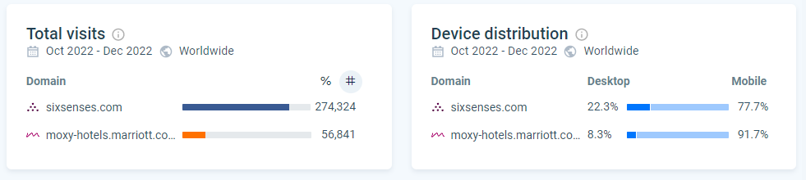

Appendix 2

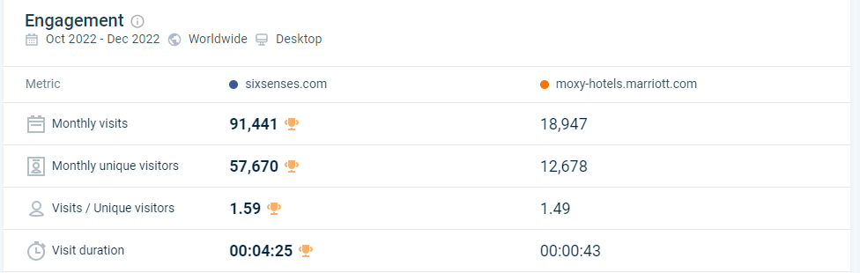

Appendix 3



