Use of Energy Carriers; Legislation & practicality approach
Automotive materials & sustainability (ACHA6012)
2022 - 2023

Figure 1: Motorcycle Racer
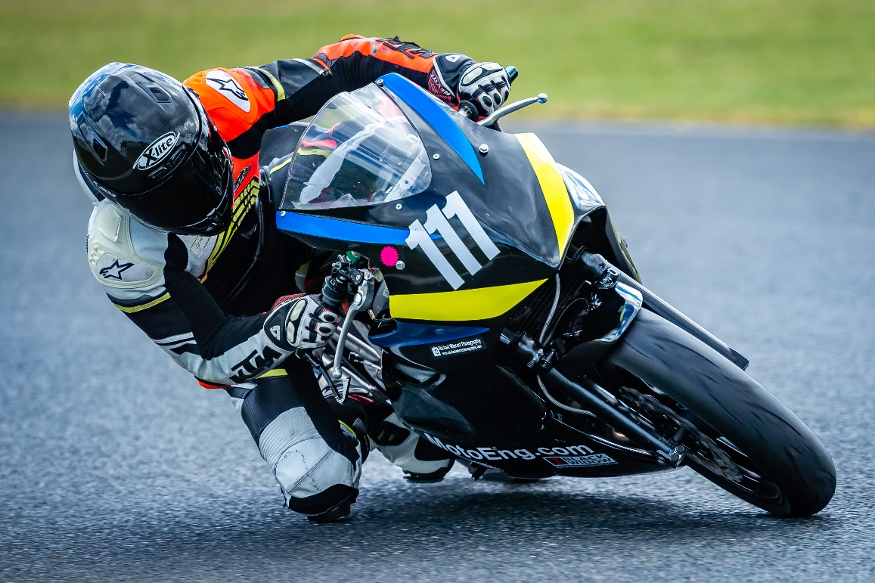

Ilias Gideon Iatrakis (2011922)
Lecturer: DR Kerry Tudor

Contents
Contents 2
Introduction 3
1 Alternative Energy Carriers 5
2 Energy Recovery Systems 9
3 Automotive Technology In Motorsport use 9
Conclusion 11
References. 12
Appendices 12

Introduction
The following technical report presented to the FIM board suggests a critical evaluation of the impact of legislation and public opinion on motorsport events and the development of sustainable technologies. The report advocates for the implementation of alternative energy carriers, including electric and hybrid propulsion, and the use of energy recovery systems to reduce the environmental impact. It also highlights the progress made by the automotive industry and advises the FIM on what direction they should take in terms of supporting infrastructure and safety considerations.

EU Fit For 55 Regulations

The European council adopted a new set of regulations on March 28, 2023, setting stricter CO2 emission performance standards for new cars and vans. The new rules aim to reduce emissions from road transport and provide a push to shift the automotive industry towards zero-emission mobility, while ensuring continued innovation in the industry. (1)

The new rules set following targets:

- 55% & 50% CO2 emission reductions for new cars and vans respectively, from 2030 to 2034, compared to 2021 levels.
- 100% CO2 emission reductions for both new cars and vans from 2035.

The regulation also mentions e-fuels, whereby following a consultation with stake holders, the commission will make a proposal for registering vehicles running exclusively on CO2-Neutral fuels, after 2035. The regulation adds other provision such as decreasing the cap of emission credits a manufacturer can receive for eco-innovations. By 2025, the commission is developing a method to asses the full life cycle of CO2 emissions of cars and vans placed on the EU market, as well as for the fuels and energy consumed by these vehicles.

This last methodology will allow proper assessment of different energy sources, propulsion types, fuels, fuel production etc. and ensure the development and future direction of the automotive sector is aimed towards complete sustainability instead of political agendas.

MotoGP Fuel of the Future

MotoGP is focusing on being the leader in the sustainable fuel revolution. MotoGP is launching a new “era” of Zero-Carbon fuels.
The goal is to provide a racing laboratory and test field for the development of sustainable, non-fossil, drop-in fuels. Using renewable energy, these fuels will be lab-created or derived from waste material. In 2024, MotoGP class fuels will be required to consist of a minimum of 40% non-fossil origin. In 2027, fuel across all GP classes will be 100% non-Fossil origin. Different suppliers, manufactures and thus different approaches will create a selection of sustainable fuels, that can be used in a standard IC engine. Reaching fuel pumps on the street, reaching real people, and making a real change. (2, 3)

Dakar Rally

in the 2023 edition, a number of teams have decided to use biofuels, which will reduce the carbon footprint of their vehicles by about 40%. The Dakar Rally requires elite crews to field low-emission vehicles by 2026. The introduction of their new T1-U prototype class for prototypes running on low-carbon fuels, brings competition to the development of these prototypes, from which new technologies will evolve to the consumer sector. By 2030, all categories will have to be racing in low-emission prototypes. Dakar has also been offsetting 100% of carbon emissions resulting from the organisation of the event since 2009.
(4,5)

World SBK & BMW Motorrad

In conjunction with the MotoGP championship, the FIM World Superbike championship has decided that the fuels used, must consist of at least 40% non fossil components from the coming 2024 season. BMW Motorrad is preparing intensively for this and is closely involved in the development of such alternative fuels, as a partner with NORDOEL as a part of the German DeCarTrans project.

DeCarTrans, “Demonstrating a Circular Carbon Economy in Transport Along the Value Chain”, will investigate the continuous production of synthetic gasoline in a demonstration plant on an industrial scale of up to 380.000 liters total production volume. (6)

The BMW Motorrad department is provided with alternative fuels by NORDOEL, which they test on their engine test bench under different conditions, currently focusing on their M1000RR WorldSBK engine, in which these fuels will be raced in 2024. Analyses is carried out, fuel experts evaluate the fuels from the chemical side, on the engine side, the combustion process, mixture information, performance, consumption and emissions is analysed. The info is fed back to NORDOEL which then make appropriate adjustments. The Aim of the development is a fuel that complies with the regulations posed by the FIM and at the same time achieve the best possible performance and consumption values in the racing engines. – Thomas von Westberg, BMW Motorrad Motorsport Project leader. (7)

First Official MotoE World Championship

Dorna Sports has announced that starting in 2023, the MotoE Series will become an official world Championship, racing during more MotoGP rounds in more countries, with more manufacturer than ever before. The series was first introduced in 2019 as a support series to the MotoGP World Championship, racing identical spec motorcycles developed by Energica Motor Company, with the aim of showcasing the potential of electric motorcycle technology and promoting sustainable motorsport. At the first round in 2019, the charging station caught fire and destroyed all the equipment and bikes. In 2020, 5 rounds were raced. The 2023 Season has welcomed Ducati as a new supplier. (8)

The FIM’s environmental code Specifies that for electrically powered machined, consideration must be given to the “whole life” impact of this type of motive power on the environment. Consideration must be given to the production of the batteries, and their eventual disposal or re-use. (9)

It’s important that a sustainable source of energy for charging the electric vehicles is provided

Alternative Energy Carriers
‘Alternative Fuels’ means fuels or power sources which serve, at least partly, as a substitute for fossil oil sources in the energy supply to transport and which have the potential to contribute to its decarbonisation and enhance the environmental performance of the transport sector. (10)

They include:
- Electricity,
- Hydrogen,
- biofuels’ meaning liquid or gaseous fuel for transport produced from biomass, (11)
- Synthetic and paraffinic fuels,
- Natural gas, including biomethane, in gaseous form (CNG) and liquified Form (LNG), and
- Liquified petroleum gas (LPG)

FIM Fuel Regulations

The following part shortly describes the current FIM Fuel Regulations. (12)

Regular fuels:

The regular fuel regulations state that if not specified in the Technical Rules of the Championships, Cup, or Prize or in the Supplementary Regulation of the event, regular fuel from public fuel stations can be used, with an octane not exceeding 98.

Race Fuels:
Fuel companies that supply "race" fuels (fuels other than those obtained at public pump stations) must test their fuel against all the FIM specifications set out in Art. D of the regulation. If the specifications of the fuel are in conformity with Art. D of the regulation, a certificate will be issued to the fuel company, and a list of fuels that are in conformity with FIM specifications are listed in Art. I of the regulation. In the case of an appointed supplier for a specific event or the entire World Championship, Prize, or Cup, the fuel must have been previously tested in an FIM-appointed laboratory to ensure conformity with the FIM specifications as set out in Art. D of the regulation. If the conformity is not achieved, the FMN of the organizing country/the organizer/the promoter must ask the FIM for a waiver to enable the use of fuel that does not correspond to FIM specifications.

In regards to the current FIM fuel regulations, it is important to note that fuels used in MotoGP have no limit on the amount of oxygenates or alternative fuels that can be used, but there is currently no minimum amount required. However, this will change in 2024 with a new rule that mandates 40% of the fuel must be of non-fossil origin. On the other hand, competitions outside of the GP classes have limits on the amount of oxygenates that can be used, which restricts the usage of alternative fuels and decreases the potential for development in other classes. Figure 2 shows the percentages allowed of possible alternative fuels in non GP-Classes.

Figure 2: FIM Non-GP-Class additive regs

Methanol, ethanol, isopropanol, isobutanol, and ethers can all be considered as alternative fuels because they can be used as a substitute for gasoline or diesel fuel.
Methanol and ethanol are commonly used as alternative fuels in racing and other applications due to their high-octane rating and ability to reduce emissions. Isopropanol and isobutanol are also being developed as alternative fuels, with research showing that they can be blended with gasoline to reduce emissions and improve performance. Ethers, such as methyl tert-butyl ether (MTBE) and ethyl tert-butyl ether (ETBE), have also been used as fuel additives to increase octane rating and reduce emissions.

Tert-butanol, on the other hand, is not commonly used as an alternative fuel due to its low energy density and high cost of production. However, it can be used as a fuel additive to increase octane rating and reduce emissions.

Electric Energy, Hybrid Vehicles

As an important trend in the automotive industry, electrification of propulsion systems has potential to significantly reduce greenhouse-gas emissions of the transportation sector. Whereas electric vehicles do not produce exhaust emissions during driving, the impact of electricity provision for charging batteries, as well as the impact of vehicle production play an essential role in a holistic consideration of the carbon footprint. (13)

Mario Hirz and Thu Trang Nguyen (13) have conducted a comprehensive evaluation of CO2 equivalent emissions throughout the lifetime of cars driven by different propulsion technologies, including internal-combustion-engines (ICEV), hybrid vehicles (HEV) and battery-electric vehicles (BEV).

Figure 3 shows a comparison between the LCA-based production-related CO2-equivalent-emission impacts for Common Class C Compact cars. The emissions caused by production of BEV compared to ICEV is significantly larger, at 14 and 7.5 Tonnes respectively, with the main contributor to emissions being the battery system. Bio Fuels are not considered in this research.

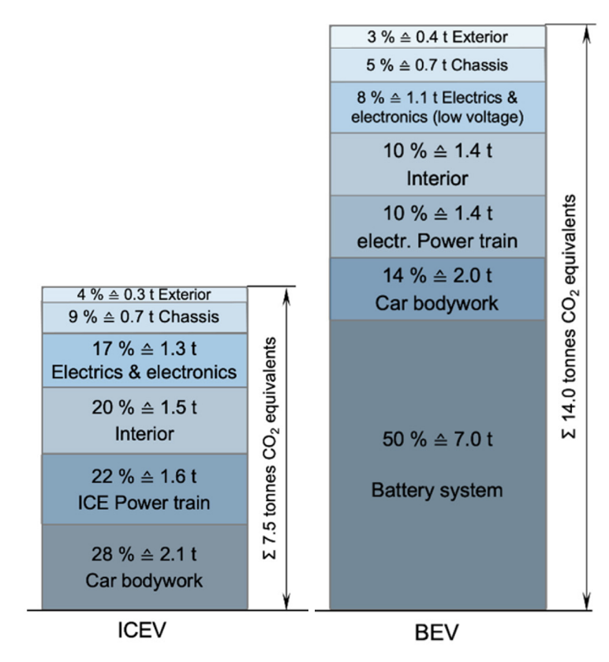
Figure 3: CO2 release during production (Mario Hirz et al.)
The LCA-based evaluation of the car’s use phase, includes CO2 equivalent emissions during driving, as well as the impacts of maintenance, service and wear parts. The diagram in figure 4 shows the well-to-wheel C02 equivalent emissions of the investigated compact cars with different propulsion systems and varied carbon footprint of the electricity production. It is visible that hybrid technology can decrease the carbon footprint by about 25% in comparison to conventional Internal combustion engines. Considering electric cars, the importance of low-carbon electricyty production is clearly demonstrated. When electric power is generated in countries with extremely low carbon intensity, the overall CO2-equivalent-emission impact from well-to-wheel can significantly decrease to as low as 7.5% in France or even 4% in Norway, as compared to the emission impact of Internal Combustion Engine Vehicles (ICEV).

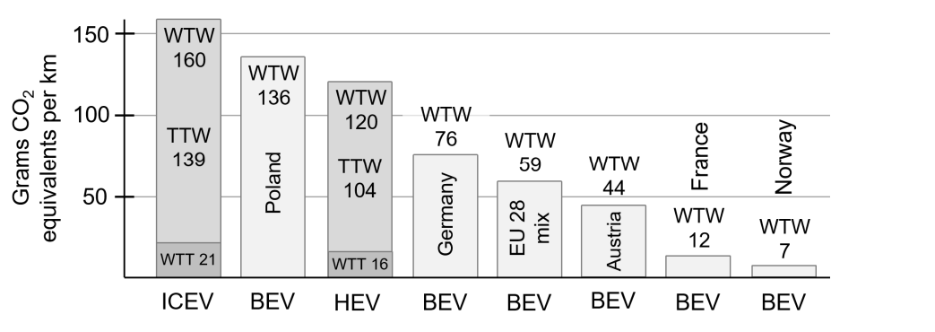
Figure 4: Well-to-Wheel CO2 Equivalent emissions of selected cars with different propulsion systems and varied carbon footprint of electricity production. (Mario Hirz Et al.)
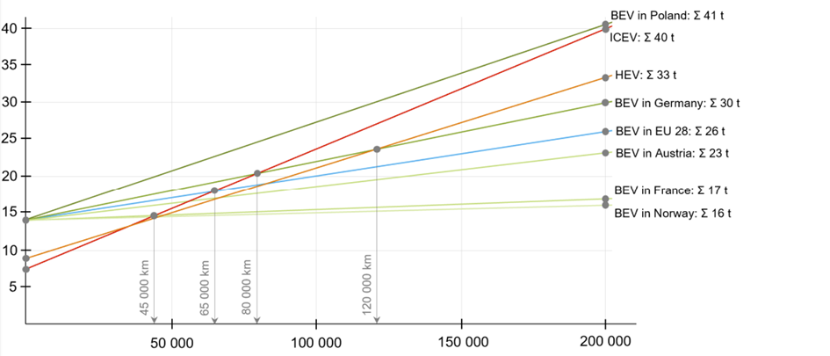
Figure 5: Life Cycle C02-Equivalent emissions of compact cars with different propulsion systems and exemplarily varied carbon footprints of electric power generation. (Mario Hirz et al.)
The high CO2 emissions from BEV production can be offset in countries with low-carbon electricity production like Norway. With the average EU 28 electricity mix, the break-even point with ICEV is reached at around 65,000 km. In high-carbon electricity production countries like Poland, the break-even point won't be reached within 200,000 km. HEVs have a 20% higher carbon footprint during production but significantly lower CO2 emissions during operation, making them a better choice for lifetime CO2-equivalent emissions. However, BEVs charged with low-carbon electricity have advantages that cannot be matched by combustion-engine-based technologies. (Figure 5)

Additionally, it should be noted that while BEVs charged with low-carbon electricity have a lower lifetime CO2-equivalent-emission impact than ICEVs or HEVs, this is primarily applicable to road-going vehicles that are driven for a significant amount of distance. For racing vehicles, which typically have a much shorter lifespan and are not driven for the distance required to break even on emissions, BEVs may not be a feasible option at the moment.

The difference in weight also plays a significant role, electric vehicles in the same class tend to be significantly heavier than conventionally powered vehicles, which in a motorsports environment significantly decreases handling capabilities.

A 2023 MotoE race bike weighs 225kg at 150hp (14), while a power equivalent Moto2 bike weighs in at 15kg for 140hp (15).

Current batteries used in electric vehicles have limitations in terms of power density, which affects their performance and range. While the energy density has improved over the years, the power density has not kept up at the same pace. This means that the batteries can discharge quickly, leading to a shorter span of usage. While this may not be a significant issue for sprint events, which are typically shorter, it can still be a concern for GP and endurance events. It’s also important to note that power supply and the grid must be able to supply enough electricity to be able to charge the vehicles, especially at a fast enough rate, which currently is also a large limitation.

E-Fuels

E-fuels, such as e-methane, e-kerosene, and e-methanol, are gas or liquid fuels produced from renewable or decarbonized electricity, distinguishing them from biofuels that are mainly derived from biomass. These fuels have a crucial role in decarbonization plans by significantly reducing harmful emissions from combustion engines. In terms of their entire production cycle, e-fuels have a lower carbon footprint than oil-based fuels. (16)

E-fuels like e-methane, e-methanol, e-diesel, and e-kerosene are produced from renewable or decarbonized electricity, which differentiates them from biofuels. The production process involves hydrogen production through a Power-to-Gas or Power-to-Liquid process, combined with either CO2 or N2 to produce synthetic hydrocarbons. CO2 can be sourced from the atmosphere or industrial plants, impacting the fuel's lifecycle analysis, environmental benefits, and production cost. High-temperature H2O/CO2 co-electrolysis is a newer, shorter process that can improve productivity and reduce investment costs, but it is not yet widely used.
E-fuels have the advantage of using the same infrastructure as their fossil equivalents (petrol, diesel, kerosene, methanol or natural gas). Putting them in competition with biofuels, which offer the same advantage. E-fuels have the same amount of tailpipe emissions as fossil fuels (17), although the difference in production offsets this significantly. E fuels would allow for a reduction of 85% in CO2 emissions (18)

A current problem is that E-fuels are predicted to cost 50% more than regular fuels in 2030, E-Fuels could also cause a fuel dependency as they are imported from abroad, while batteries and electricity can be dispersed around the world. (19)

at a time when electricity would appear to be the future of road transport, e-fuels have a key role to play, particularly in the maritime and air transport sectors for which decarbonisation cannot be achieved solely through electrification.
Choosing E-fuels as a main focus in the future, could also disperse other Zero-Emissions alternatives development.

Bio-Fuels

Biofuels are liquid or gaseous transport fuels, such as biodiesel and bioethanol, made from biomass. They serve as a renewable alternative to fossil fuels in the EU's transport sector, helping to reduce greenhouse gas emissions and improve the EU's security of supply. (20)

Biofuels have a higher octane rating, burn cleaner than fossil fuels and will significantly decrease the emissions produced during combustion.
The decrease in production emissions between bio-fuels depends on the type of fuel and cultivation method, it is important to evaluate chemicals etc that might be used during the cultivation of the needed crops, the production on its own can decrease by 20% to 86% depending on the feedstock and type of energy used in processing. (21)

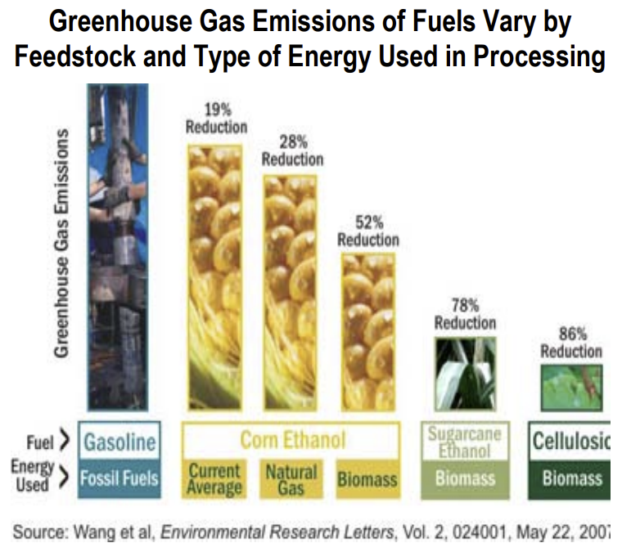
It is important to note that E-Fuels and Bio-Fuels have a lower calorific value, thus produce less energy for the same volume, meaning fuel consumption will be higher if the same energy release is required. Figure 6, shows a comparison between E10 and E85, the emissions production was calculated through a combustion, lean burn calculator made by the author for the Contemporary Powertrain Design Module. It’s seen that a 34% increase in fuel consumption would occur, meaning race vehicles will have to carry more fuel at the start of a race, increasing starting weight, weight fluctuation, thus a significant handling difference between start & end, and requiring larger fuel tanks & packaging. CO2 Emissions production decreases by 11.9% at matched energy release.

Figure 6: E10 vs E85 comparison

Hydrogen

Hydrogen is a clean energy carrier that produces only water when consumed in a fuel cell. It can be made from natural gas, nuclear power, biomass, solar and wind, making it an attractive option for transport and electricity generation. It's versatile and can be used in cars, homes, portable power and other applications. (22)

One of the major challenges in the use of hydrogen as an energy source is its storage. However, advancements in materials science and engineering have led to the development of efficient storage solutions such as high-pressure tanks and solid-state storage. Hydrogen fuel cells produce electrical energy by combining hydrogen and oxygen, and are highly efficient, with a potential to produce 2-3 times more power than traditional combustion engines. Despite the availability of hydrogen from multiple domestic resources, its commercial availability remains limited due to a lack of refuelling infrastructure. Additionally, the cost of hydrogen production, distribution, and storage is still relatively high compared to conventional fuels, although it is expected to decrease with technological advancements and increased adoption. While refuelling time for hydrogen vehicles is similar to that of conventional fuels, around five minutes, the current infrastructure has some limitations. Some fuelling stations can only fuel two to five vehicles before going offline for up to 30 minutes to repressurize the vessel, causing inconvenience for drivers who may have to wait or travel further to find an available fuelling station. In motorsport this would require multiple tanks to be installed in order to be able to refuel enough vehicles fast enough. (23)

CNG, LNG, LPG

The author has to focus mainly on the previous energy carriers as these have been the most discussed in media, development and political aims recently. The extraction of natural gas through mining or drilling can have negative impacts on the environment, leading to soil erosion, water pollution, release of methane during the production and transportation, and more, these gasses are also a finite resource and will run out eventually. (24)

Compared to conventional fuels, these gases generally have lower prices, but they require heavier and larger tanks, and energy delivery is lower. Emissions released during combustion are also lower. Despite their lower emissions, the disadvantages outweigh the benefits, making them unfeasible as a long-term alternative fuel. (25)

Energy Recovery Systems
Energy recovery systems, or ERS, are becoming increasingly common in motorsport racing as a way to improve the efficiency of vehicles and reduce their environmental impact. ERS work by capturing and storing energy that is normally lost during braking or deceleration and then reusing it to provide additional power to the vehicle. This can lead to improved performance and reduced fuel consumption. One example of ERS in motorsport is the Kinetic Energy Recovery System (KERS) used in Formula One racing. However, there are some drawbacks to ERS, including increased weight and complexity, and some argue that they can take away from the skill and strategy of racing. ERS is not currently used in motorcycle racing due to the challenges of integrating it into a bike's design and the potential safety risks. However, it may be possible to use ERS in motorcycle racing in the future with further advancements in technology and safety measures.

Automotive Technology In Motorsport use

Due to the push of governments and world leaders, pushing the automotive energy to become more sustainable and environmentally friendly, especially on the emissions side. This causes manufacturers to have been pushing towards environmentally cleaner energy carriers, sources, fuels and propulsion systems/ engines, motors… since motorsport has been further behind in legislations considering emissions, fuel carriers, thus OEM industry and their efforts in developing these technologies can be adapted for motorsport applications.

The automotive engineering industry has been at the forefront of developing technology to reduce tailpipe emissions and promote sustainability in transportation. The industry has been heavily regulated by government legislation and has had to constantly adapt to meet increasingly stringent emissions standards. As a result, automotive manufacturers have invested heavily in developing new propulsion systems, engines, and cleaner energy carriers such as E-Fuels, Bio Fuels, electric and hydrogen fuel cell technology.

However, in contrast, motorsport has been less regulated in terms of emissions and fuel carriers, and has lagged behind the automotive industry in terms of sustainability efforts. This has led to a disconnect between the technologies being developed in the automotive industry and their application in motorsport.

To bridge this gap, it is essential that motorsport moves towards adopting more sustainable energy carriers, to reduce its environmental impact. By doing so, motorsport can not only promote sustainability but also align itself with the direction of the automotive industry and leverage the technological advancements that have been developed for OEM applications.

The development of new technology and energy carriers in the automotive industry can be directly applicable to motorsport applications. This can lead to greater efficiency, reduced emissions, and better performance for racing teams, as well as contribute to the overall sustainability efforts of the sport.

Furthermore, the automotive industry's efforts in developing sustainable energy carriers and propulsion systems are not only driven by regulatory pressure but also by consumer demand for cleaner and more sustainable modes of transportation. As such, the adoption of sustainable energy carriers in motorsport can also help to promote and drive consumer demand for more sustainable modes of transportation.

To ensure the long-term viability and growth of motorsport, it is critical that the sport embraces sustainability and adopts more environmentally-friendly energy carriers. By doing so, motorsport can not only reduce its environmental impact but also align itself with the direction of the automotive industry and contribute to the overall sustainability efforts of the transportation sector.

Conclusion
Comparing the results and regulations before, it seems that the FIM is going in the right direction aiming towards an increase of E-fuels and bio fuels in racing, with the main advantages, of being able to use the same infrastructure, decreasing emissions significantly, preserving internal combustion engines and the spirit, the feeling, the sound of motor racing. The availability of these fuels are good, a downside would be that CO2 is still a product and these fuels aren’t quite at net zero yet, given more development of the production process and more efficient engines, this could be a good option, it is important that the sourcing and production can be done world wide in order to avoid energy dependence and crises.

Electric powertrains seem promising as well given power density, emissions caused by production and mining resources of batteries can be improved significantly, especially when green energy is used as an electricity supply. Upgrades to the power grid would be necessary as it is currently unable to charge enough cars fast enough in a paddock where dozens to hundreds of vehicles are racing, especially given the current range. Although this is a promising energy carrier to focus on for further development in all areas.

Hydrogen is in a similar stage as electric, there is a large change in infrastructure and development needed in fuelling technologies, it is a energy carrier to focus on and keep developing towards the future.

A proposal for the FIM is to create an open alternative powertrain class, where manufacturers can develop motorcycles that run on different kinds of alternative fuels, being able to prove these technologies and compete with other technologies, manufacturers, also boosting the development as motorsports can get involved and catch up to the automotive guys.

References.

[1] Europa.eu. [Online]. Available: https://www.consilium.europa.eu/en/press/press-releases/2023/03/28/fit-for-55-council-adopts-regulation-on-co2-emissions-for-new-cars-and-vans/. [Accessed: 02-Apr-2023].
[2] ‘Dorna Sports CEO believes new era will benefit everyone’, Motogp.com. [Online]. Available: https://www.motogp.com/en/videos/2021/11/24/dorna-sports-ceo-believes-new-era-will-benefit-everyone/403157. [Accessed: 02-Apr-2023].
[3] ‘A new global era of zero carbon fuels is ready to begin’, Motogp.com. [Online]. Available: https://www.motogp.com/en/videos/2021/11/24/a-new-global-era-of-zero-carbon-fuels-is-ready-to-begin/403140. [Accessed: 02-Apr-2023].
[4] ‘Dakar future’, Dakar.com. [Online]. Available: https://www.dakar.com/en/dakar-world/therace/commitment/dakar-futur. [Accessed: 02-Apr-2023].
[5] ‘Dakar responsible’, Dakar.com. [Online]. Available: https://www.dakar.com/en/dakar-world/therace/commitment/dakar-responsible. [Accessed: 02-Apr-2023].
[6] ‘BMW Motorrad Motorsport partners with NORDOEL in DeCarTrans alternative fuels project’, Green Car Congress. [Online]. Available: https://www.greencarcongress.com/2023/03/20230330-motorad.html. [Accessed: 02-Apr-2023].
[7] C. Brook-Jones, ‘BMW Motorrad Motorsport and NORDOEL collaborate on DeCarTrans alternative fuels project’, Automotive Powertrain Technology International, 30-Mar-2023. [Online]. Available: https://www.automotivepowertraintechnologyinternational.com/news/fuels-lubricants/bmw-motorrad-motorsport-and-nordoel-collaborate-on-decartrans-alternative-fuels-project.html. [Accessed: 02-Apr-2023].
[8] J. Jitchotvisut, ‘2023 ducati V21L prototype MotoE electric race bike officially presented’, Rideapart.com, 20-Mar-2023. [Online]. Available: https://www.rideapart.com/news/658128/ducati-v21l-prototype-motoe-introduced/. [Accessed: 02-Apr-2023].
[9] D. Sports, ‘FIM enel MotoETM world championship presented in Vallelunga’, MotoGPTM, 17-Mar-2023. [Online]. Available: https://www.motogp.com/en/news/2023/03/17/fim-enel-motoe-world-championship-presented-in-vallelunga/449689. [Accessed: 02-Apr-2023].
[10] ‘EUR-Lex - 32014L0094 - EN - EUR-Lex’, Europa.eu. [Online]. Available: https://eur-lex.europa.eu/legal-content/EN/TXT/?uri=celex%3A32014L0094. [Accessed: 02-Apr-2023]. [11] du 23 Avril, ‘DIRECTIVE 2009/28/CE DU PARLEMENT EUROPÉEN ET DU CONSEIL’, Europa.eu, 2009. [Online]. Available: https://eur-lex.europa.eu/LexUriServ/LexUriServ.do?uri=OJ:L:2009:140:0016:0062:FR:PDF. [Accessed: 02-Apr-2023].
[12] ‘FIM Fuels Regulation’, Fim-moto.com. [Online]. Available: https://www.fim-moto.com/fileadmin/user_upload/Documents/2021/FIM_Fuels_Regulation.pdf. [Accessed: 02-Apr-2023].
[13] M. Hirz and T. T. Nguyen, ‘Life-cycle CO2-equivalent emissions of cars driven by conventional and electric propulsion systems’, World Electric Veh. J., vol. 13, no. 4, p. 61, 2022. [14] Ducati.com. [Online]. Available: https://www.ducati.com/ww/en/company/innovation/moto-e/prototype. [Accessed: 02-Apr-2023]
[15] T. Motorcycles, ‘Moto2TM’, Triumph Motorcycles. [Online]. Available: https://www.triumphmotorcycles.com/for-the-ride/racing/moto2. [Accessed: 02-Apr-2023]. [16] ‘E-fuels, what are they?’, Engie.com. [Online]. Available: https://www.engie.com/en/news/e-fuels-what-are-they. [Accessed: 02-Apr-2023].
[17] ‘E-Fuels: CO2-neutral fuels of the future’, Bdi.eu. [Online]. Available: https://english.bdi.eu/article/news/e-fuels-co2-neutral-fuels-of-the-future/. [Accessed: 02-Apr-2023].
[18] ‘Porsche’s synthetic fuel’, Porsche.com. [Online]. Available: https://dealer.porsche.com/ca/lauzon/en-CA/News-and-Events/Carburant-efuel. [Accessed: 02-Apr-2023].
[19] ‘Scholz is fuelled with illusions How costly e-fuels are threatening the EUʼs climate targets’, Transportenvironment.org, 2023. [Online]. Available: https://www.transportenvironment.org/wp-content/uploads/2023/03/2023_03_DE_e-fuel_paper.pdf. [Accessed: 02-Apr-2023].
[20] ‘Biofuels’, Energy. [Online]. Available: https://energy.ec.europa.eu/topics/renewable-energy/bioenergy/biofuels_en. [Accessed: 02-Apr-2023].
[21] ‘Biofuels & greenhouse gas emissions: Myths versus facts’, Energy.gov. [Online]. Available: https://www.energy.gov/articles/biofuels-greenhouse-gas-emissions-myths-versus-facts-0#:~:text=MYTH%3A%20In%20terms%20of%20emissions,biodegradable%2C%20unlike%20some%20fuel%20additives.&text=Cellulosic%20ethanol%20has%20the%20potential,emissions%20by%20up%20to%2086%25. [Accessed: 02-Apr-2023].
[22] ‘Hydrogen fuel basics’, Energy.gov. [Online]. Available: https://www.energy.gov/eere/fuelcells/hydrogen-fuel-basics. [Accessed: 02-Apr-2023].
[23] ‘The biggest advantages and disadvantages of natural gas’, Met.com. [Online]. Available: https://group.met.com/en/media/energy-insight/advantages-and-disadvantages-of-natural-gas. [Accessed: 02-Apr-2023].
[24] J. Voelcker, ‘Hydrogen fuel-cell vehicles: Everything you need to know’, Car and Driver, 26-Sep-2022. [Online]. Available: https://www.caranddriver.com/features/a41103863/hydrogen-cars-fcev/. [Accessed: 02-Apr-2023].
[25] ‘Natural gas fuel basics’, Energy.gov. [Online]. Available: https://afdc.energy.gov/fuels/natural_gas_basics.html. [Accessed: 02-Apr-2023].

Appendices

