
Assignment 1
Applied Quantitative Business Research

Name: Akina Limbu
Student ID: 2014849

Contents
Blog 1: Analysing and Expectation of the Module .....................................................................3
Blog 2: Biggest Challenges of Employing Quantitative Research Methods in Organisations ...6
Blog 3: Sampling as the Foundation of Robust Quantitative Research ....................................9
Blog 4: Ethical Issues of Netflix’s Approach to Utilising Big Data and Machine Learning to Improve Click Rates ................................................................................................................13
Blog 5: Thoughts on the Quote ................................................................................................16
Blog6: E-commerce: Artificial Intelligence’s (AI) Impact on Online Shopping...................................................................................................................................18
Blog 7: Quantitative Approaches for DBA Study Based on My Abilities and Competences ..................................................................................................................................................21

List of Figures:
Figure 1: Kolb’s Cycle of Experiential Learning (Serc Carleton Edu, 2018)
Figure 2: Statistical Sampling (Pedamkar, 2020)
Figure 3: The five V’s of Big Data (Gutta, 2021)
Figure 4: Artificial Intelligence’s (AI) Impact on Online Shopping (Samsukha, 2020)
Figure 5: Kolb’s Learning Cycle (Expert Program Management, 2020)

Figure 6: (The Competency Framework: A Guide for IAEA Managers and Staffs, 2021)

2994 Words

BLOG LINK: https://akinalimbu1991.wordpress.com/2021/11/19/blog-1-analysing-and-expectation-of-the-module/

Blog 1: Analysing and Expectation of the Module
The purpose of the blog 1 is to critically reflect on my vision and expectations of this module. I will be using the Kolb's learning cycle. As stated by (Kolb, 1984), it is the processes through which knowledge is formed, by learning through experience. Knowledge is the product of comprehending and interpreting information and experience.

Through the four phases of the learning cycle, Kolb's theory supports learning and integrates what was learnt into knowledge acquisition and understanding. It aids in my perception of learning trajectory as a novice researcher and provides me with direction, equipping as a theoretical foundation for my introspection and development.

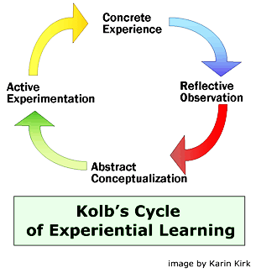
Figure 1: Kolb’s Cycle of Experiential Learning (Serc Carleton Edu, 2018)

Concrete Experience
As a beginner on my doctoral journey, I am constantly perplexed and pressured by the lack of prior knowledge and experience required in becoming a credentialed scholar. Nevertheless, I am intrigued on what understanding and expertise I will obtain along the way. The concrete encounter of gaining competency, through prior and current blogging and content writing allowed me to recognize and observe the start of my doctoral journey.

Reflective Observation
As stated by (Garcia et al., 2019), reflective observation is the process of closely analysing what has been taught and evaluating the effect of what has been understood. This is precisely what I have been doing. After each class, Dr. Opute fosters a reflective discourse in which I and my fellow course mates’ debate, reflect and engage with what we have learnt. He guides us through the process by detailing on how to do a quantitative study comprehensively.

I will apply the skills I have gained, such as using the SPSS software, quantitative techniques application, and the transfer of these skills to practice. Prior to this quantitative module, I had little knowledge in these elements. Writing this blog is critical since it has helped me to put what I have learnt into execution and reflect how it could help me achieve my longer-term researcher and scholastic ambitions.

Abstract Conceptualization
This is an internal and distinctive cognitive process. It is critical that I strive to comprehend what I have learned and how to utilize it to complete the assignment two of this module. This assignment demands me to think rationally and integrate past and current learning experiences in order to develop a distinctive perspective and strategy.

Active Experimentation
During this point, I am required to develop and implement my approach to completing the module tasks, as well as whether I am prepared to do a mixed qualitative and quantitative research with any prior constructive learning mechanisms in my DBA study. This is the most difficult task for me as I am still contemplating on which research methodologies I should undertake for my thesis.

References:
Garcia, E., Moizer, J., Wilkins, S. and Haddoud, M.Y. (2019). Student Learning in Higher Education through Blogging in the Classroom. Computers & Education, [online] 136, pp.61–74. Available at: https://www.sciencedirect.com/science/article/pii/S0360131519300776.
Kolb, D. 1984. Experiential learning. Prentice-Hall, Englewood Cliffs, NJ.
Serc Carleton Edu (2018). What Is experience-based learning? [online] Experience-Based Environmental Projects. Available at: https://serc.carleton.edu/introgeo/enviroprojects/what.html [Accessed 14 Nov. 2021].

Blog 2: Biggest Challenges of Employing Quantitative Research Methods in Organisations
A research methodology is the framework used for carrying out a study and serves as the main component of a quantitative research study. It allows the analysis of the data to reveal the various facets of a population. A successful quantitative research study is dependent on the quality and quantity of data collected. The main goal of a quantitative study is to obtain an accurate and detailed representation of the population and it is contingent on the planning and implementation elements (Maula and Stam, 2019). As a result, it is plausible that there will be limits that are outside of our regulation during these two periods.

Examples of some of the major limitations of quantitative research methods in organisations:

Insufﬁcient representatives of the key target demographic:
The study's effectiveness to attain its specified aims and goals may be impaired if the target market is not well represented. Regardless of whether a suitable sample plan is used, the representation of the subjects is determined by the probability distribution of the observed data. This could result in a misrepresentation of the probability distribution and a fallacy in the hypothesis.

For instance, one study seeks to determine the proportion of females aged 18 to 35 who use foreign brands of cosmetics. In this example, the target market is women in their teens and mid-thirties, from both professional and non-professional professions, who live in Swansea. The selected demographic based on the probability distribution must be compared to the entire female population of the city (e.g., 500 sampled out 146,117 female populations). Hence, due to the sample's small size in comparison to the overall population, there is a possibility of obtaining incomplete data regarding the variety of cosmetic items. As a result, the study's findings cannot be generalised to a wider population, although it could be inferred.

Findings are limited in a quantitative study:
In quantitative research, a structured questionnaire containing closed-ended questions is utilised. C onsequently, the findings of the study endeavour are limited. As a result, the findings might not correctly indicate the current incidence in a wide context. Furthermore, according to the study's classification, the participants' answer options are limited (Edwards and Holland, 2020).

For instance, a multiple-choice answers such as a Yes/No or Likert scale of Strongly Agree to Strongly Disagree to the question "Has management encouraged you to face new challenges?" However, knowing what approaches the management uses to encourage the employees or what factors the employee does not feel encouraged (if replied No) is important. The researcher needs to address more specific questions, which are restricted in close-ended surveys.

References:
Edwards, R. and Holland, J. (2020). Reviewing Challenges and the Future for Qualitative Interviewing. International Journal of Social Research Methodology, 23(5), pp.581–592.
Maula, M. and Stam, W. (2019). Enhancing Rigor in Quantitative Entrepreneurship Research. Entrepreneurship Theory and Practice, 44(6), p.104225871989138.

Blog 3: Sampling as the Foundation of Robust Quantitative Research

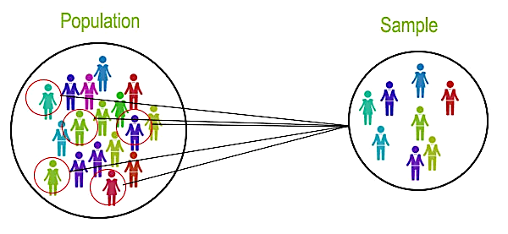
Figure 2: Statistical sampling (Pedamkar, 2020)

When drawing conclusions from data processing, the sample plays an essential role. Any study sample should be chosen according to a specific sample design. For instance, to examine the influence of television advertising of Baby Formula on viewer purchasing tendency, a target audience would be families and new to-be parents of youngsters aged 6 years or younger in the city of London. Nevertheless, it is nearly impossible to collect data from all of the TV audiences in London who either are parents or new-be parents.

As a result, the investigator must choose a sample from the total population cantered on a certain region and location. It is also vital to highlight that the sampling and target demographics must be comparable (Hollin et al., 2019). This contributes to providing a robust and generalised inference at the conclusion of the investigation while also avoiding bias in the data.

Two varieties of sampling methods
The sampling method is categorised as probability sampling and non-probability sampling. In the probability sampling approach, the chances of being chosen for a sample is the same for each member of the population. However, in the situation of non-probability approach, each individual's chances of being chosen from a sample is not equivalent and samples could be selected on the researcher's subjective judgement (Castro-Martín, Rueda and Ferri-García, 2021).

Probability sampling
All items in the demographic have an equal chance of being selected when using random selection. To choose the samples, random numbers are drawn from an ordered sequence.

Stratified sampling
Stratified sampling necessitates dividing the demographic into subgroups defined as strata and conducting separate probability sampling for every stratum. For example, in this approach, the investigator divides the demographic into groups such as gender, occupation, locality, and other factors and then conducts random sampling for every grouping.

Systematic random sampling
Each component in Systematic Random has a certain chance of being chosen. When components are mixed, however, their probability vary. If the database is excessively random or chaotic, the error rate of choosing a sample is the same as simple random sampling (Eichner et al., 2019).

Non-probability sampling
The convenience sampling plan entails choosing a sample that is easily accessible, and convenient. The drawback of this strategy is that it's challenging to make conclusions since the sample size is not wide enough.

Snowball sampling
Snowballing is a convenience approach in which the current sample participants are used to get new subjects for research. This strategy is frequently used by investigators to locate people that are difficult to reach via conventional means.
For example, patients with HIV/AIDS, drug abusers, and vulnerable people.

Purposeful sampling
Purposive sampling is when a researcher selects a sample based on their judgement, that is, who they believe is suitable for the study. When there are few subjects with competence in the field being investigated, this strategy is utilised (Creswell and Guetterman, 2019).

References:
Castro-Martín, L., Rueda, M. del M. and Ferri-García, R. (2021). Combining Statistical Matching and Propensity Score Adjustment for Inference from non-probability Surveys. Journal of Computational and Applied Mathematics, 404, p.113414.
Creswell, J.W. and Guetterman, T.C. (2019). Educational Research : planning, conducting, and Evaluating Quantitative and Qualitative Research. 6th ed. New York, Ny: Pearson.
Eichner, F.A., Groenwold, R.H.H., Grobbee, D.E. and Oude Rengerink, K. (2019). Systematic Review Showed That stepped-wedge Cluster Randomized Trials Often Did Not Reach Their Planned Sample Size. Journal of Clinical Epidemiology, 107, pp.89–100.
Hollin, I.L., Craig, B.M., Coast, J., Beusterien, K., Vass, C., DiSantostefano, R. and Peay, H. (2019). Reporting Formative Qualitative Research to Support the Development of Quantitative Preference Study Protocols and Corresponding Survey Instruments: Guidelines for Authors and Reviewers. The Patient - Patient-Centered Outcomes Research, 13(1), pp.121–136.
Pedamkar, P. (2020). Statistics for Machine Learning | Types of Statistics for Machine Learning. [online] EDUCBA. Available at: https://www.educba.com/statistics-for-machine-learning/ [Accessed 18 Nov. 2021].

Blog 4: Ethical Issues of Netflix’s Approach to Utilising Big Data and Machine Learning to Improve Click Rates
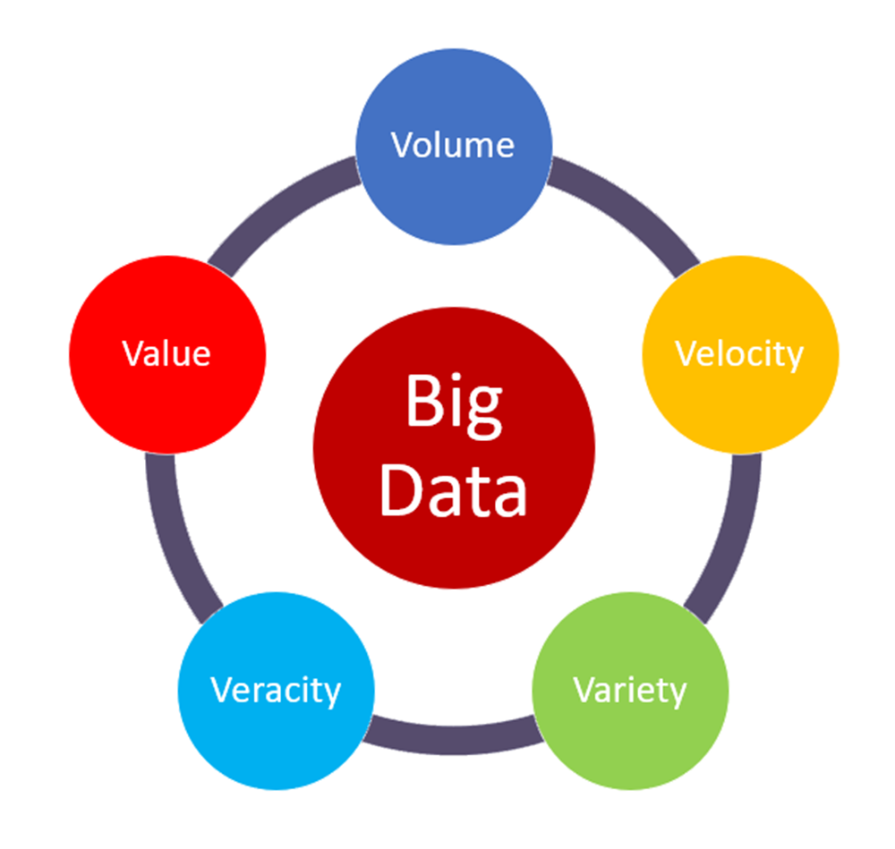
Figure 3: The five V’s of Big Data (Gutta, 2021)

Netflix is the largest and most popular premium subscription multimedia provider, with over 214 million registered subscriptions in over 190 nations, where users could watch TV shows, movies, and documentaries in a wide range of genres and languages. One of the strategies that has propelled Netflix to the top of the streaming platform industry is the usage of an AI (artificial intelligence) tracking solution to algorithmically identify what viewers would want to stream, in order to increase click rates (Kasula, 2020). This implementation may be questioned, ethically.

Netflix should make apparent on what the system could obtain, according to the AI design principles, it indicates that the platform should allow people to recognise what the AI system is capable of. Netflix, in actuality, do not notify viewers in prior. The AI system employs whatever activities the users do on it to generate relevant impact. The system, for instance, may advertise what the viewer might stream next. Through the usage of big data and machine learning, the algorithm would continue to promote the content that would most likely pique the users’ interests gathered from previous activities. As a consequence, users could not resist clicking, and are guided by the program.

Netflix's algorithm to select, uses a collection of billions of reviews from its users, where over a million additional ratings are posted each day (Patel, 2019). In many ways, Netflix employs a popular statistic mechanism and compute it. They furthermore analyse their member clusters, geographically or based on other clustering algorithms (Biddle, 2021).

Despite Netflix’s efforts to protect privacy of its database and users' confidentiality, several privacy issues occurred surrounding the data linked with Netflix. The users in the Netflix database were identified by obtaining their reviews on the Internet Movie Database, charging that it breached the US fair trade standards and the Video Privacy Protection Laws (Chaturvedi, 2021).

Human ethics, regulation, legislation, and other factors find it hard to maintain with technological advancements (Stahl et al., 2021). The dilemma of how to create a balance between the collecting and exploitation of behavioural big data and privacy protection concerns remains perpetually debatable.

References:
Biddle, G. (2021). A Brief History of Netflix Personalization. [online] Medium. Available at: https://gibsonbiddle.medium.com/a-brief-history-of-netflix-personalization-1f2debf010a1 [Accessed 15 Nov. 2021].
Chaturvedi, M. (2021). How Useful Was the Netflix Prize Really? [online] Analytics India Magazine. Available at: https://analyticsindiamag.com/how-useful-was-the-netflix-prize-really/ [Accessed 15 Nov. 2021].
Gutta, S. (2021). The 5 V’s of Big Data. [online] Medium. Available at: https://medium.com/analytics-vidhya/the-5-vs-of-big-data-2758bfcc51d.
Kasula, C.P. (2020). Netflix Recommender System — A Big Data Case Study. [online] Medium. Available at: https://towardsdatascience.com/netflix-recommender-system-a-big-data-case-study-19cfa6d56ff5 [Accessed 15 Nov. 2021].
Patel, N. (2019). How Netflix Uses Analytics to Select Movies, Create Content, & Make Multimillion Dollar Decisions. [online] Neil Patel. Available at: https://neilpatel.com/blog/how-netflix-uses-analytics/ [Accessed 15 Nov. 2021].
Stahl, B.C., Andreou, A., Brey, P., Hatzakis, T., Kirichenko, A., Macnish, K., Laulhé Shaelou, S., Patel, A., Ryan, M. and Wright, D. (2021). Artificial Intelligence for Human Flourishing – beyond Principles for Machine Learning. Journal of Business Research, 124, pp.374–388.

Blog 5: Thoughts on the Quote
“A statistically significant finding gives you a clue, suggesting a promising place to focus your research energy. The significance test is the detective, not the judge”

As a novice researcher, some thoughts that emerged when I analysed the quotation are that a statistically significance discovery provides us a pointer, indicating a feasible ideology, a direction of a prospective area for us to concentrate our research advancements.

Statistical significance is a measure that could be used to determine if a finding is likely attributable to chance or a variable of value. When a result is significant, it essentially implies that it may be certain that it is genuine, not that it was fortunate or unfortunate in selecting the sample. For example, when we do an investigation, conduct a survey, a poll, or analyse data, we are selecting a sample of a population of interests, rather than examining each and every data point.

To illustrate: a promotional campaign. A company has developed a fresh idea and would want to evaluate if it performs better than the present version. Practically, we cannot show or display it to every single potential consumer, so the company could choose a representative sample group to see how it is perceived.

The procedure for determining significance is the same, and we begin with a null hypothesis. In the aforementioned promotional campaign, the null hypothesis could be "On average, consumers are not in favour of the new campaign over the previous one." Before we start, we should give an alternative hypothesis, like, "In general, consumers favour the new one," as well as a targeted significance cut-off point. On the premise that the null hypothesis is true, the significance level indicates how uncommon the findings are. It is commonly stated as a ‘p-value,’ with the lower the p-value, the lesser probable the findings are due to chance.

Additionally, as stated by (Ellenberg, 2015), if a discovery is original and significant, various researchers should verify and re-evaluate the phenomena and its variations to see if it was just a coincidence or not. It is what researchers refer to as validity; if an effect cannot be repeated despite numerous tests, it is not valid (Bo and Galiani, 2021). The replication mechanism is designed to act as science's innate immunity.

Organizations utilize statistical significance to determine how significantly the findings of an experimentation, research, or survey would impact their decisions. Furthermore, the significance test acts as a detective rather than a judge. Thus, what I understand of the quote is, the remarkable and statically relevant discovery is not the end of the systematic processing, but rather the starting.

References:
Bo, H. and Galiani, S. (2021). Assessing external validity. Research in Economics, 75(3).
Ellenberg, J. (2015a). How Not to Be Wrong: The Power of Mathematical Thinking. New York, New York: Penguin Books.

Blog 6: E-commerce: Artificial Intelligence’s (AI) Impact on Online Shopping


Figure 4: Artificial Intelligence’s (AI) Impact on Online Shopping (Samsukha, 2020)

Artificial Intelligence is rapidly gaining traction in a variety of fields and the e-commerce industry is not exempt. Artificial intelligence, namely the machine learning component of the technology, is creating a significant influence on ecommerce firms. Machine learning has several uses in the e-commerce business. Machine learning is a branch of artificial intelligence that encompasses a wide range of technologies and entails the development of algorithms or programmes capable of accessing and learning from data, all without the need for human programming.

E-commerce Machine Learning's Business Advantages
Machine learning, like other cutting-edge technologies like augmented technology, has several commercial advantages. This is particularly evident for online retailers. Algorithms' capacity to percept massive amounts of data is remarkable. Machine learning technologies such as software are available for practically every aspect of ecommerce operational processes (Wang, Cai and Zhao, 2020). Ecommerce machine intelligence offers on everything from inventory management to consumer experience.

Enhanced search results
Algorithms based on machine learning can produce more advanced search results. It has the potential to boost on-site search terms as well as item recommendations. It could comprehend what is entered in the search field attributable to language modelling. It would then apply what has been learnt through prior searches to display the search engine exactly what it is they are looking for even if customers do not input the item's label or even a complete description (Vanneschi et al., 2018).

Smarter Product Recommendations
Algorithms could assess the behaviour of ecommerce site users. Sensors will recognise the goods that a customer frequents or purchases, as well as the items with which they engage. When a customer returns, they are offered with goods that are comparable to those in which they had previously indicated interest. This is how when we browse Amazon, we discover a slew of items linked to ones we have previously purchased or browsed at.

Increase internal operational efficiency
Not all of the advantages of e-commerce machine learning are related to consumer operations. Algorithms could additionally provide real-time data to assist businesses to improve the efficiency and productivity of other functions (Zhang, Pee and Cui, 2021). For example, consider stock management and inventories accountancy, machine learning speeds up and improves the accuracy of such evaluations. A software could calculate ecommerce sales, storage expenses, tax liabilities, and other factors (Perez-Vega et al., 2020). It could furthermore aid in forecasting the future demands. As a result, e-commerce businesses get all of the information needed to implement the most comprehensive approaches to operate.

References:
Perez-Vega, R., Kaartemo, V., Lages, C.R., Razavi, N.B. and Männistö, J. (2020). Reshaping the Contexts of Online Customer Engagement Behavior via Artificial intelligence: a Conceptual Framework. Journal of Business Research, [online] 129. Available at: https://www.sciencedirect.com/science/article/pii/S0148296320307463.
Samsukha, A. (2020). How Artificial Intelligence Is Driving eCommerce Industry. [online] Blog | Emizentech. Available at: https://www.emizentech.com/blog/artificial-intelligence-impact-ecommerce-industry.html [Accessed 18 Nov. 2021].
Vanneschi, L., Horn, D.M., Castelli, M. and Popovič, A. (2018). An Artificial Intelligence System for Predicting Customer Default in e-commerce. Expert Systems with Applications, [online] 104, pp.1–21. Available at: https://www.sciencedirect.com/science/article/abs/pii/S0957417418301702 [Accessed 7 Nov. 2020].
Wang, Q., Cai, R. and Zhao, M. (2020). E-commerce Brand Marketing Based on FPGA and Machine Learning. Microprocessors and Microsystems, 87, p.103446.
Zhang, D., Pee, L.G. and Cui, L. (2021). Artificial Intelligence in E-commerce fulfillment: a Case Study of Resource Orchestration at Alibaba’s Smart Warehouse. International Journal of Information Management, 57, p.102304.

Blog 7: Quantitative Approaches for DBA Study Based on My Abilities and Competences
I would be employing the Kolb's learning cycle to evaluate my understanding and capabilities in using quantitative approaches in my DBA studies. Kolb defines learning as the acquisition of abstract concepts that may be applied in diverse settings, and fresh experiences provide the impetus for the creation of new conceptualisations.

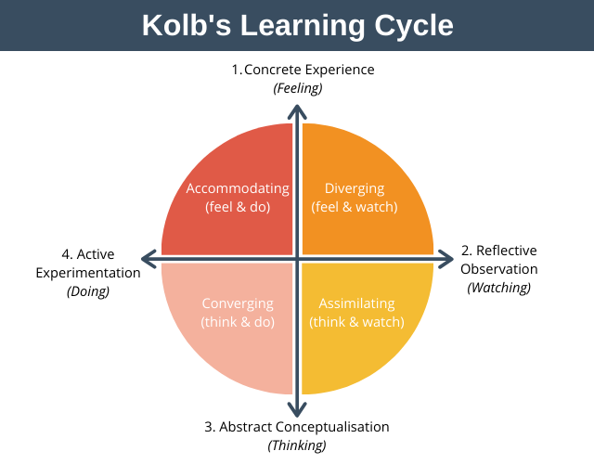
Figure 5: Kolb’s Learning Cycle (Expert Program Management, 2020)

Concrete Experience

The apprehension that I initially had of the doctoral path crept on me and grew even stronger as I learnt more about the quantitative business research. I did not have much pre-existing understanding of statistics and am afraid of numerical, however I do understand that it is a requisite to learn and know how to evaluate data at the doctoral level. The experiences on this session have taught me that having trust in myself, and others is critical, irrespective of the hurdles we face.

Reflective Observation

Certainly, the quantitative business research module has been more comprehensible to me now, though I am not sure that I will be able to gain a deeper knowledge of this subject and the SPSS software in this brief duration. I have trust upon myself that I am here to continue pushing on this doctorial path, owing to the essential support of my professors, IT staffs, and fellow classmates serving as my supporters.

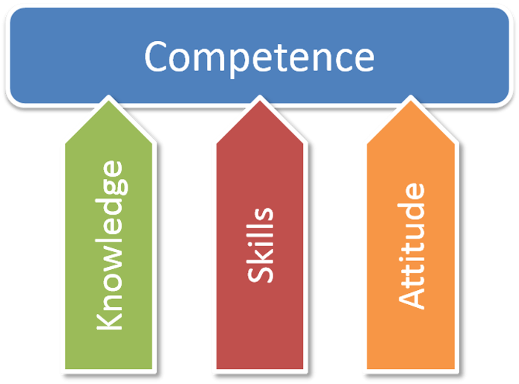

Figure 6: (The Competency Framework: A Guide for IAEA Managers and Staffs, 2021)

Abstract Conceptualization

The six-week lectures, which integrated research theory and practice with SPSS software made me realize how much quantitative theories, frameworks and understanding I ought to gain to perform strong quantitative research, and that my learning just touches the base of it. Having just the knowledge and skills are not enough, one must have a positive attitude to achieve our goals and objectives.

Active Experimentation

I am still very much a novice researcher but with more thorough learning and practice in the other subjects and my doctoral dissertation, I may be able to attain to be a qualified and capable scholar. Years of practice are required for a researcher to become fully competent, and eventually an expert, in a particular area, which I am working towards.

Mcleod, S. (2017). Kolb’s Learning Styles and Experiential Learning Cycle. [online] simplypsychology.org. Available at: https://www.simplypsychology.org/learning-kolb.html [Accessed 14 Nov. 2021].
Expert Program Management. (2020). Expert Program Management. [online] Available at: https://expertprogrammanagement.com/2020/10/kolbs-learning-cycle/ [Accessed 13 Nov. 2021].
Kalk, K., Luik, P. and Taimalu, M. (2019). The Characteristics of students, Blog Groups and Blogging That Predict Reflection in Blogs during Teaching Practice and Induction Year. Teaching and Teacher Education, 86, p.102900.
Rahman, S. (2016). The Advantages and Disadvantages of Using Qualitative and Quantitative Approaches and Methods in Language “Testing and Assessment” Research: A Literature Review. Journal of Education and Learning, [online] 6(1), p.102. Available at: https://files.eric.ed.gov/fulltext/EJ1120221.pdf [Accessed 14 Nov. 2021].
Edwards, J.R. (2019). The Peaceful Coexistence of Ethics and Quantitative Research. Journal of Business Ethics, 167, pp.31–40.
Spyropoulos, T.S. and Papageorgiou, M., (2021), May. Sampling Issues and Eco-networks on Innovation Management, Quantitative Research Studies Challenges. In of the 13th International Conference (p. 38).
Mayer, S.J. and Scholaske, L. (2021). Using Mixed-Methods Designs for Improving Data Quality -The Case of Quantitative Surveys among Hard-to-Survey Populations.
Bryman, A. (2015). Business Research Methods. Oxford: Oxford Univ. Press.
Wilcox, R.R. (2022). A Foundation for Robust Methods. Introduction to Robust Estimation and Hypothesis Testing, pp.25–44.
Conti, P.L., Mecatti, F. and Nicolussi, F. (2022). Efficient Unequal Probability Resampling from Finite Populations. Computational Statistics & Data Analysis, 167, p.107366.
Li, H.-S., Wang, X.-W., Nan, H. and Liu, M. (2021). Application of a sampling-based Method for Estimation of Cumulative Failure Probability Functions of Mechanisms. Mechanism and Machine Theory, 155, p.104050.
Saegusa, T. (2021). Nonparametric Inference for Distribution Functions with Stratified Samples. Journal of Statistical Planning and Inference, 215, pp.356–367.
Ryu, J. and Kamata, S. (2021). An Efficient Computational Algorithm for Hausdorff Distance Based on points-ruling-out and Systematic Random Sampling. Pattern Recognition, 114, p.107857.
Berndt, A.E. (2020). Sampling Methods. Journal of Human Lactation, 36(2), p.089033442090685.
Staicu, D. (2021). Identifying Circular Business Models through Traditional and Snowball Sampling. Business Revolution in a Digital Era, pp.115–131.
Netflix (2020). Netflix Research. [online] Netflix.com. Available at: https://research.netflix.com/research-area/machine-learning [Accessed 15 Nov. 2021].
Wang, B. and Wang, Y. (2021). Big Data in Safety management: an Overview. Safety Science, 143, p.105414.
Ibrahim, A.E.A., Elamer, A.A. and Ezat, A.N. (2021). The Convergence of Big Data and accounting: Innovative Research Opportunities. Technological Forecasting and Social Change, [online] 173, p.121171. Available at: https://www.sciencedirect.com/science/article/abs/pii/S0040162521006041 [Accessed 15 Nov. 2021].
Wedel, F. and Marx, S. (2022). Application of Machine Learning Methods on Real Bridge Monitoring Data. Engineering Structures, 250, p.113365.
Hallinan, B. and Striphas, T. (2014). Recommended for you: the Netflix Prize and the Production of Algorithmic Culture. New Media & Society, 18(1), pp.117–137.
Gallo, A. (2016). A Refresher on Statistical Significance. [online] Harvard Business Review. Available at: https://hbr.org/2016/02/a-refresher-on-statistical-significance.
Gelman, A. and Stern, H. (2006). The Difference between “Significant” and “Not Significant” Is Not Itself Statistically Significant. The American Statistician, 60(4), pp.328–331.
Gelman, A. (2017). The Failure of Null Hypothesis Significance Testing When Studying Incremental Changes, and What to Do about It. Personality and Social Psychology Bulletin, 44(1), pp.16–23.
Szucs, D. and Ioannidis, J.P.A. (2017). When Null Hypothesis Significance Testing Is Unsuitable for Research: a Reassessment. Frontiers in Human Neuroscience, [online] 11. Available at: https://www.ncbi.nlm.nih.gov/pmc/articles/PMC5540883/.
Pallathadka, H., Ramirez-Asis, E.H., Loli-Poma, T.P., Kaliyaperumal, K., Ventayen, R.J.M. and Naved, M. (2021). Applications of Artificial Intelligence in Business Management, E-commerce and Finance. Materials Today: Proceedings, 47(19).
Paullada, A., Raji, I.D., Bender, E.M., Denton, E. and Hanna, A. (2021). Data and Its (dis)contents: A Survey of Dataset Development and Use in Machine Learning Research. Patterns, 2(11), p.100336.
Zhao, H., Liu, Z., Yao, X. and Yang, Q. (2021). A Machine learning-based Sentiment Analysis of Online Product Reviews with a Novel Term Weighting and Feature Selection Approach. Information Processing & Management, 58(5), p.102656.
Tripathi, A., Singh, A.K., Singh, K.K., Choudhary, P. and Vashist, P.C. (2021). Machine Learning Architecture and Framework. Machine Learning and the Internet of Medical Things in Healthcare, [online] pp.1–22. Available at: https://www.sciencedirect.com/science/article/pii/B9780128212295000057.
Chinchanachokchai, S., Thontirawong, P. and Chinchanachokchai, P. (2021). A Tale of Two Recommender systems: the Moderating Role of Consumer Expertise on Artificial Intelligence Based Product Recommendations. Journal of Retailing and Consumer Services, [online] 61, p.102528. Available at: https://www.sciencedirect.com/science/article/pii/S0969698921000941.
Micol Policarpo, L., da Silveira, D.E., da Rosa Righi, R., Antunes Stoffel, R., da Costa, C.A., Victória Barbosa, J.L., Scorsatto, R. and Arcot, T. (2021). Machine Learning through the Lens of E-commerce Initiatives: An up-to-date Systematic Literature Review. Computer Science Review, 41, p.100414.
Institute of Experiential Learning (2020). What Is Experiential learning? [online] Institute for Experiential Learning. Available at: https://experientiallearninginstitute.org/resources/what-is-experiential-learning/ [Accessed 18 Nov. 2021].
The Competency Framework: A guide for IAEA Managers and Staffs. (2021). [online] Available at: https://www.iaea.org/sites/default/files/18/03/competency-framework.pdf [Accessed 18 Nov. 2021].
CIPD (2020). Competence & Competency Frameworks | Factsheets. [online] CIPD. Available at: https://www.cipd.co.uk/knowledge/fundamentals/people/performance/competency-factsheet#gref [Accessed 18 Nov. 2021].

