SEARCH
ACCA6011

1706594@student.uwtsd.ac.uk
Asgar Ali
School of Applied Computing
University of Wales Trinity Saint David
Supervisor: Gordan Dickers
26nd Feb 2020
1000 Words

TABLE OF CONTENTS
1. INTRODUCTION 1
2. DFS MAZE AGENT CONSOLE APPLICATION 1
2.1 IMPLEMENTATION 1
2.1.1 DESCRIPTION 1
2.1.2 ALGORITHM 1
2.1.3 CODE 1
3. 8 PUZZLE CONSOLE APPLICATION 2
3.1 THE HILL CLIMBING SEARCH 2
3.2 IMPLEMENTATION 3
3.2.1 DESCRIPTION 3
3.2.2 ALGORITHM 3
3.2.3 CODE 4
4. CONCLUSION 7
5. REFERENCES 7
6. APPENDIX A (TEST SCHEDULE) 7
6.1 MAZE 7
6.2 8-TILE PUZZLE 10
7. APPENDIX B (USER GUIDE) 13
7.1 MAZE USER GUIDE 13
7.2 8 TILE PUZZLE USER GUIDE 13
8. APPENDIX B (MAZE AGENT CODE) 14
9. APPENDIX C (8 TILE PUZZLE CODE) 20

TABLE OF FIGURES

Figure 1 - Characters representing the maze wall, path, agent and object. 1
Figure 2 - UML class diagram for DFS Maze application. 2
Figure 3 – Authors written solution to the 8-tile puzzle which was solved in 5 steps. 4
Figure 4 – UML class diagram for 8- tile puzzle application, which has one Class. 4
Figure 5 - Method to solve puzzle automatically. 5
Figure 6 - generating a randomised, solvable starting arrangement. 5
Figure 7 – identifying when the puzzle has been solved. 6
Figure 8 - keeping track of the number of moves made. 6
Figure 9 - automatically solving the puzzle using the hill climbing method. 7
Figure 10 - Loading from the 16x16good.txt file and beginning of the search. 9
Figure 11- starting a new search. 9
Figure 12 – No objects found. 10
Figure 13 – The 16x16bad.txt file loads successfully. 10
Figure 14 - Successful ending of the search and column, row route prints out. 10
Figure 15 - Manual solution of the puzzle. 12
Figure 16 - Automatic mode cannot solve the puzzle (flat local maxia) [1]. 13
Figure 17 - Auto solved puzzle. 13
Figure 18 -entering random characters does not break game loop. 14

TABLE OF TABLES

Table 1 - The starting state of the 8-tiles. 2
Table 2 – The goal state. 2
Table 3 - Test Schedule 1. 7
Table 4 - Test schedule 2. 10

SEARCH

INTRODUCTION

This report will discuss the implementation of two C++ console applications to solve classic search optimisation problems. An object-oriented Maze Agent using the Depth-First-Search algorithm and an 8-Tile Puzzle application using the Hill Climbing algorithm were developed. AI Hill-climbing will be evaluated. Tests and user guides have been included in the appendices.

DFS MAZE AGENT CONSOLE APPLICATION

IMPLEMENTATION

2.1.1 DESCRIPTION
- The maze details are read in from one of two text files. A display of the agent searching a 16*16 maze will appear on screen as the search is executed, one square at a time. The agent discovers the maze as it searches.
Figure 1 - Characters representing the maze: wall; path; agent and final object.
- The user is given the option of loading a new maze, starting a new search or stopping the application.
- Upon successfully finding the object (goal), the agent will report success and list the route taken [1].

- In the second file, the agent hits a dead end, and fails [1].
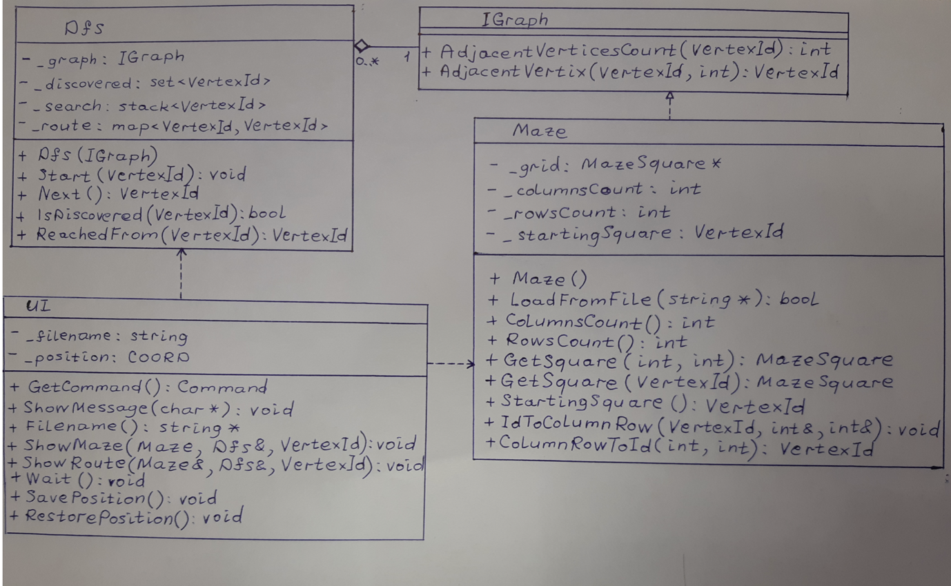

Figure 2 - UML class diagram for DFS Maze application.

2.1.2 ALGORITHM

To perform a search the maze is represented as an undirected graph. Its vertices are corridor squares (including containing the object and the agent). If two corridor squares have a common side, then the graph vertices, corresponding to these squares, are connected by an edge [2]. There is no static data structure. Instead, a list of vertices, adjacent to a given one, is created dynamically using AdjacentVertex (). Number, equal to the appropriate square offset in a two-dimensional array, is used as a vertex identifier: <row> * <columns count> + <column>, where row and column are zero-based [2].

The search algorithm is divided into separate steps and interaction with a user occurs between them. The non-recursive version of Depth-First Search is used for convenience of this separation [3]. Therefore, the algorithm uses the stack Dfs::_search instead of a queue [2]. The set Dfs::_discovered is used for remembering discovered vertices. Dfs::_route is used for remembering the route. For every vertex x, excluding the starting one, the pair <x, y> is saved, where y is the vertex, from which the agent came into x.

2.1.3 CODE

- Abstract class IGraph - provides an interface for a graph adjacent vertices traversal.
- Class Maze - loads maze data from an input file and provides this data to other parts of the program by implementing the IGraph interface.
- Class Dfs - performs traversal through vertices of a graph, represented by the IGraph interface, by the depth first search algorithm. The design of the DFS follows software engineering practices as this is easily reusable. It needs only two types for its work: type VertexId and interface IGraph. They can both easily be redefined to match any existing graph.
- Class UI – used for data input and output to console, i.e. interaction with the user using methods of classes Maze and Dfs to get data.

8 PUZZLE CONSOLE APPLICATION

HILL CLIMBING SEARCH
In the field of Artificial Intelligence, Hill-climbing is a greedy search algorithm[4]. It was used to solve an 8-tile puzzle board lab exercise. The idea of the 3*3 puzzle is to loop one numbered tile (node) at a time into the adjacent free neighbour space until the final solved combination of tiles (nodes) is found. A heuristic function (h) will rank all possible routes and alternatives in a search algorithm [2].
Table 1 - The starting state of the 8-tiles.
3 | 1 | 2
6 | 5
7 | 4 | 8

Table 2 – The objective (global maximum) is to reach this goal state. The path (or how it was solved) itself is irrelevant [4].
 | 1 | 2
3 | 4 | 5
6 | 7 | 8
(
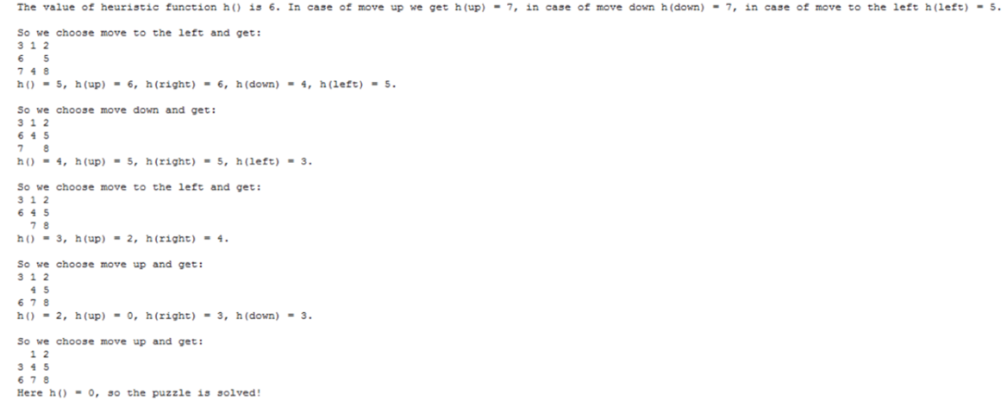
Figure 3 – Authors written solution to the 8-tile puzzle which was solved in 5 steps.

The lower the value of heuristic function, the better the current arrangement of the puzzle. Hill Climbing can seldom find a perfect solution for solvable puzzles (completeness), due to the way the finishing arrangement may go through temporary degradation of the heuristic function [5]. It may not find the optimal solution, but a good solution in a reasonable amount of time (Time complexity) [2] [6].

IMPLEMENTATION

3.2.1 DESCRIPTION

A C++ template was provided, and a console application was developed to allow a user to play the random eight-tiles puzzle [7].

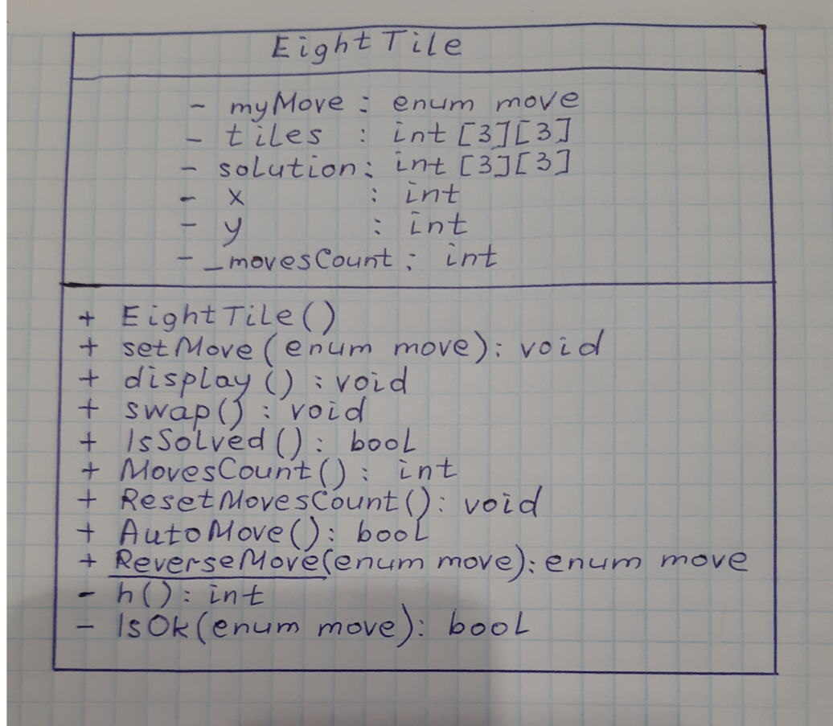

Figure 4 – UML class diagram for 8- tile puzzle application, which has one Class.

3.2.2 ALGORITHM

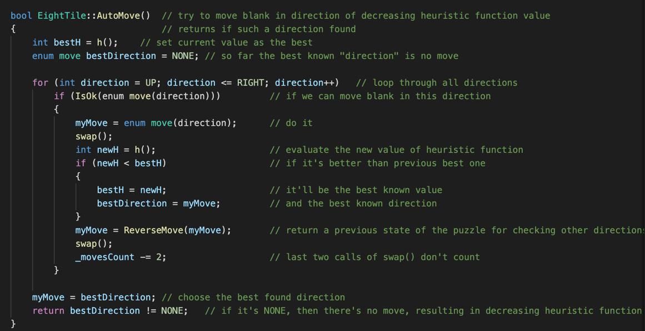

Figure 5 - Method to solve puzzle automatically by decreasing heuristic function’s value.

3.2.3 CODE

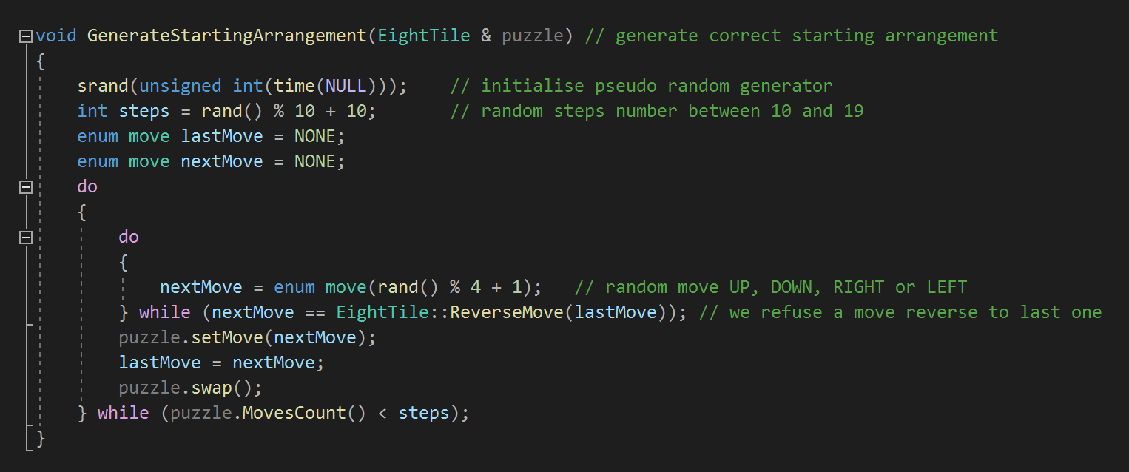
Figure 6 - generating a randomised, solvable starting arrangement.

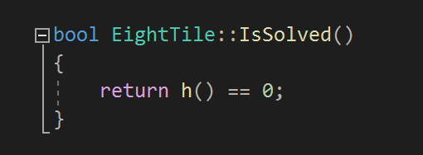
Figure 7 – identifying when the puzzle has been solved.

Figure 8 - keeping track of the number of moves made.

Figure 9 - automatically solving the puzzle using the hill climbing method.

The class EightTile contains the data structure that provides an interface to perform a manual move, an automatic move using the Hill Climbing algorithm, to detect if the puzzle is solved, number of moves taken, and displaying the puzzle on the screen.

The function GenerateStartingArrangement generates a random correct starting arrangement of the puzzle. It creates finished puzzle and applies to it random number of random moves by calling methods of EightTile.

The function main (), calls GenerateStartingArrangement and then loop performs user commands for manual moves or turning on automatic mode.

A two-dimensional array of 3*3 integers is used to represent the puzzle. The blank position is marked by number 0. EightTiles::tiles is used for representing the current arrangement, and EightTiles::solution for the finished arrangement. For convenience there is EightTiles::x and EightTiles::y, keeping position of the blank.

CONCLUSION

The author feels the problem-solving performance of both search agents was challenging to implement, although was developed appropriately. Space complexity performance in regard to memory usage was not investigated [4].

REFERENCES

[1] “Recursion: Solving a Maze.” [Online]. Available: https://www.cs.bu.edu/teaching/alg/maze/. [Accessed: 26-Feb-2020].
[2] S. Edelkamp, Stefan, Schroel, Heuristic Search - Theory and applications. Elsevier, 2012.
[3] R. Tarjan and R. Tarjan, “Depth first search and linear graph algorithms,” SIAM J. Comput., vol. 1, no. 2, 1972.
[4] P. Russell, Stuart Norvig, Artificial Intelligence - A Modern Approach, Third. Essex: Pearson Education Ltd, 2016.
[5] A. Temporel, A. Temporel, and T. Kovacs, “A heuristic hill climbing algorithm for Mastermind.”
[6] N. Christofides, “Worst-case analysis of a new heuristic for the travelling salesman problem.”
[7] A. Schaerf, A. Schaerf, M. Lenzerini, and M. Cadoli, “Local++: A C++ Framework for Local Search Algorithms,” SOFTW. Pr. EXP, vol. 30, pp. 233--256, 1999.

APPENDIX A (TEST SCHEDULE)

MAZE

Table 3 - Test Schedule 1.

STEP | DESCRIPTION | EXPECTED RESULT | ACTUAL RESULT | PASS / FAIL
 | Option – input ‘L 16x16good.txt’. | 16x16good.txt file loads. | See figure 9. | PASS.
 | Option – input ‘S’. | Start a new search. | See figure 10. | PASS.
 | Option – input “Enter”. | The agent will move through maze. Eventually report success then list the route taken. | See figure 11. | PASS.
 | Option – input ‘L 16x16bad.txt’. | 16x16bad.txt file loads. | See figure 12. | PASS.
 | Option – input ‘S’. | Start a new search. | See figure 13. | PASS.
 | Option – input “Enter”. | The agent will move through maze. | See figure 14. | PASS.
 | Option – input ‘Q’. | Application stops. | See figure 15. | PASS.

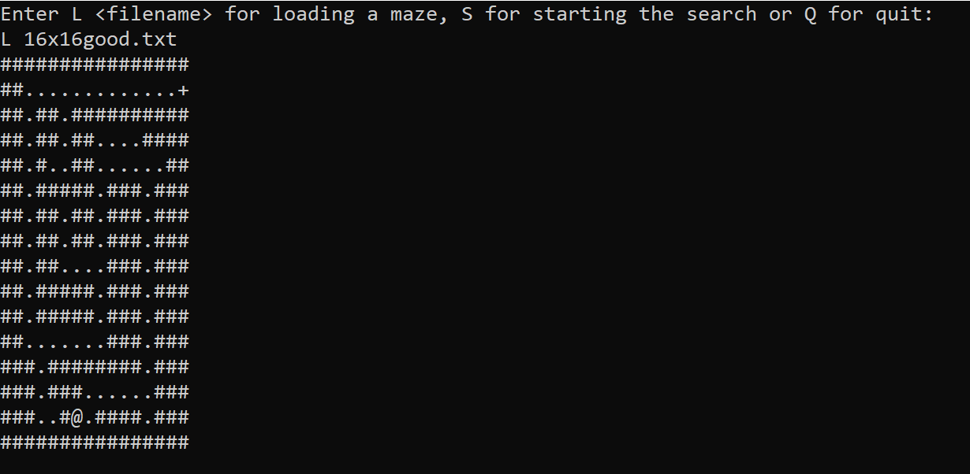

Figure 10 - Loading from the 16x16good.txt file and beginning of the search.

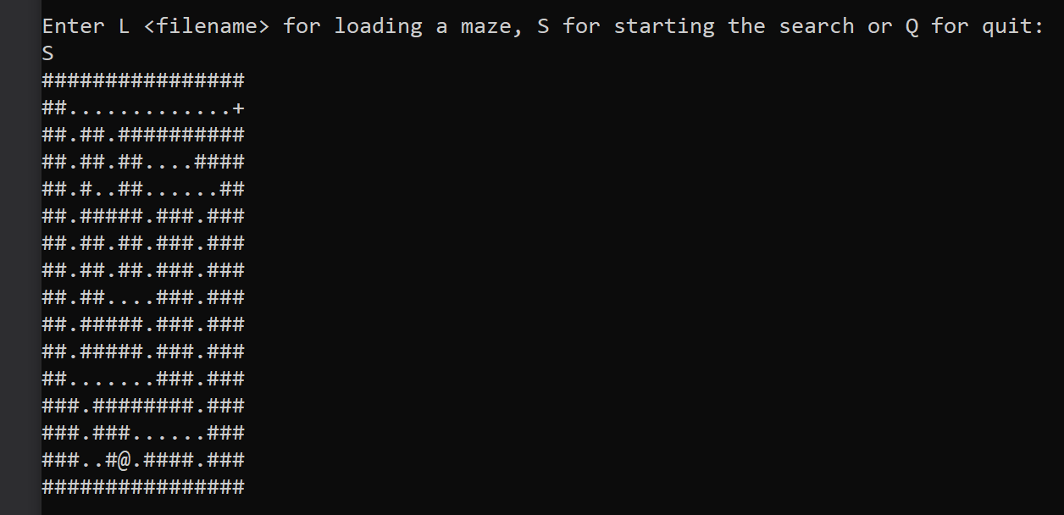

Figure 11- starting a new search.
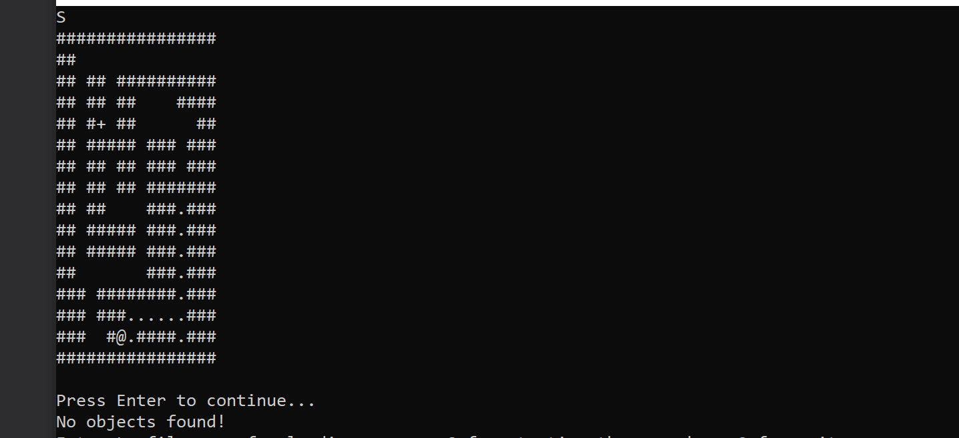

Figure 12 – No objects found.

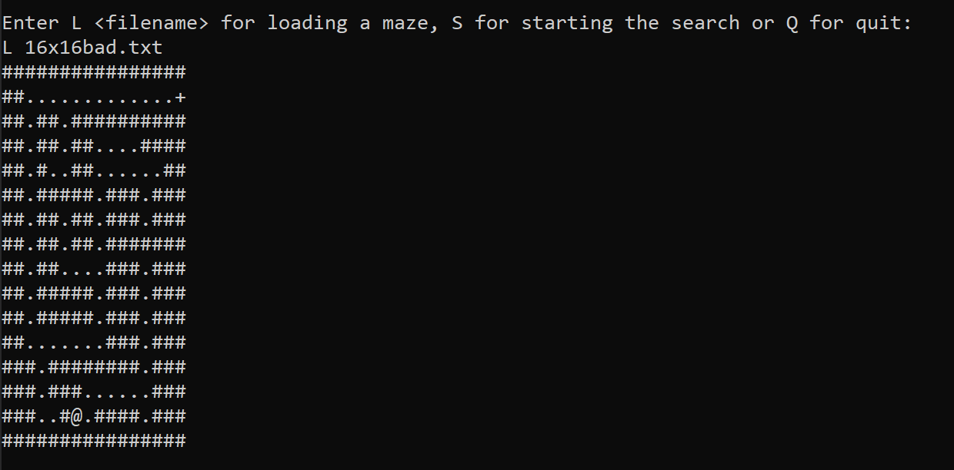

Figure 13 – The 16x16bad.txt file loads successfully.

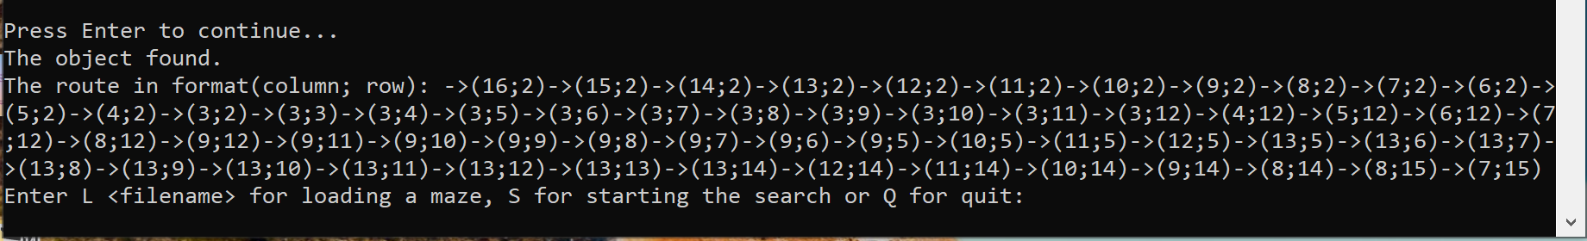

Figure 14 - Successful ending of the search and column, row route prints out.

8-TILE PUZZLE

Table 4 - Test schedule 2.

TEST NUMBER | DESCRIPTION | EXPECTED RESULT | ACTUAL RESULT | PASS / FAIL
 | Option – enter ‘a’. | Swap the blank with a tile on the left. | See figure 14. | PASS.
 | Option – enter ‘w’. | Swap the blank with a tile above. | See figure 14. | PASS.
 | Option – enter ‘d’. | Swap the blank with a tile on the right. | See figure 14. | PASS.
 | Option – enter ‘s’. | Swap the blank with a tile below. | See figure 14. | PASS.
 | Option – enter “auto”. | Puzzle board should change. | See figure 15 or 16. | PASS.
 | Option – enter a random character. | Program does not break. | See figure 17. | PASS.

Since the program generates the random starting arrangement on every run, there is no predetermined test case. The tester should apply the Hill Climbing algorithm by itself to check correctness of the programs output.
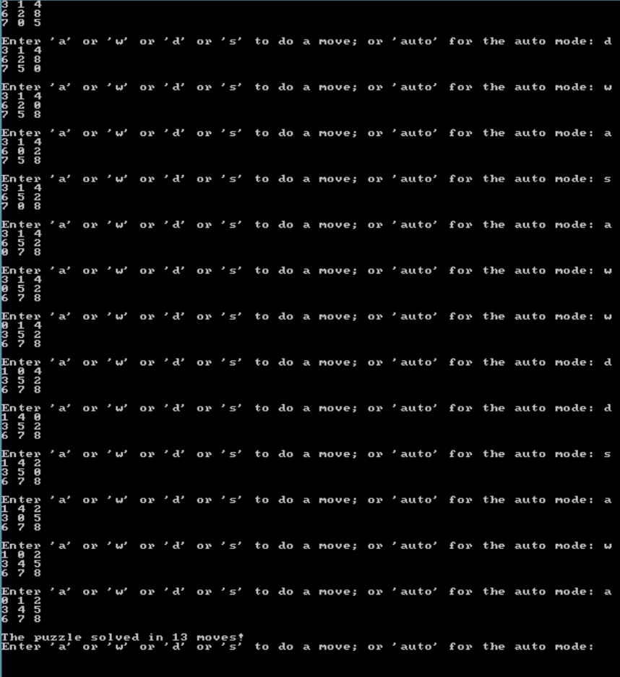
Figure 15 - Manual solution of the puzzle.

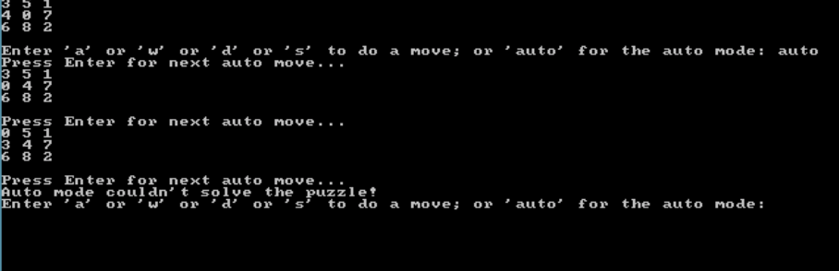
Figure 16 - Automatic mode cannot solve the puzzle (flat local maxia) [4].

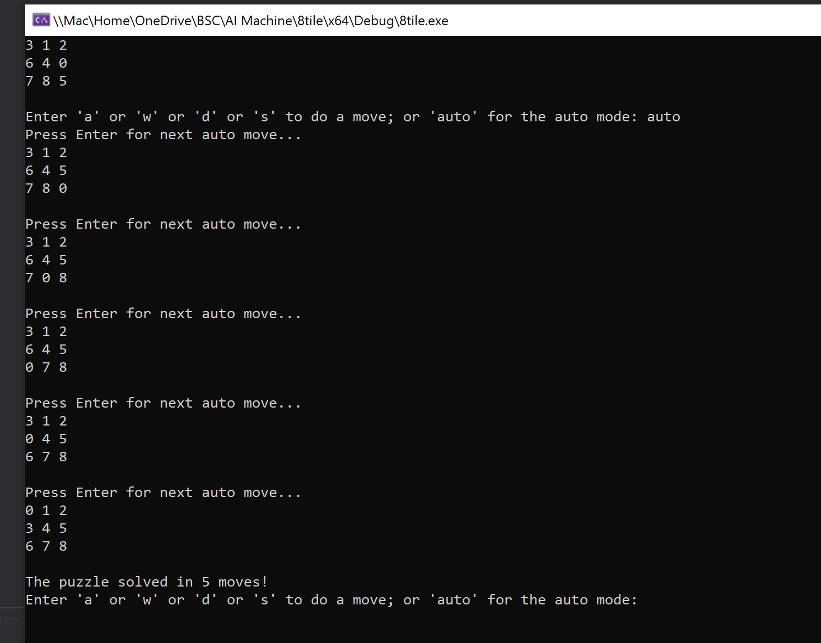

Figure 17 - Auto solved puzzle.

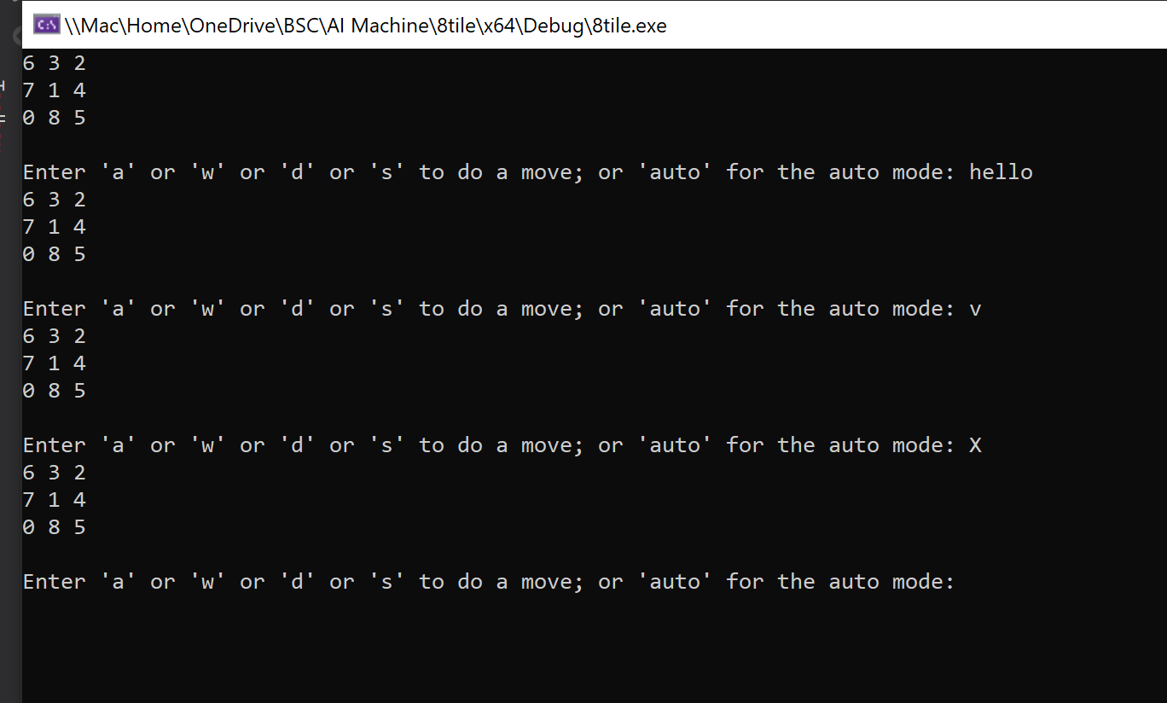

Figure 18 -entering random characters does not break game loop.

APPENDIX B (USER GUIDE)

MAZE USER GUIDE

In the maze agent there are one of 3 commands available in an infinite loop:

- To load a maze from a file type ‘L’ and either ‘16x16good.txt’ or ‘16x16bad.txt” then press Enter. Here <filename> is the path from the current directory to input file and its name. The input file must contain at least one line, all lines must have same length at least two characters.

- To start the search in the maze type ‘S’ and press Enter. For every move, enter must be pressed. With every move the agent discovers one corridors square, and it starts to appear as ' ' instead of '.'. The search is ended if the object is discovered, or all available squares are discovered. If the search is successful, a message and the route from starting position to the object will be printed. If the search fails, a console message will be printed.

- To close the program type “Q" and press Enter.

8 TILE PUZZLE USER GUIDE

The 8-tile puzzle generates and displays a random puzzle arrangement. A user can make a manual move by characters 'w' (to swap the blank with a tile above), 'a' (to swap the blank with a tile on the left), 's' (to swap the blank with a tile below) or 'd' (to swap the blank with a tile on the right). Automatic mode is used by typing 'auto', where the program chooses moves by itself, and Enter should be pressed for every step. If the Hill Climbing algorithm does not find a move, decreasing the value of the heuristic function, a console message will be printed – ‘auto mode cannot solve the puzzle’. If the puzzle is solved, there is an appropriate message with the number of moves taken.

APPENDIX B (MAZE AGENT CODE)

8.1 DFS.h

#pragma once

#include <set>
#include <stack>
#include <map>
#include <sstream>

#include "IGraph.h"

class Dfs // Depth-First Search
{
public:
Dfs(IGraph & graph);
void Start(VertexId vertex);
VertexId Next();
bool IsDiscovered(VertexId vertex);
VertexId ReachedFrom(VertexId vertex);
private:
IGraph & _graph; // search will be apply to this graph
std::set<VertexId> _discovered; // set of discovered vertices
std::stack<VertexId> _search; // stack for non-recurive Depth-First Search
std::map<VertexId, VertexId> _route; // pair <A, B> means that the vertex A was reached from vertex B
};

8.2 DFS.cpp

#include "stdafx.h"

#include "DFS.h"

Dfs::Dfs(
IGraph & graph // search will be apply to this graph
)
: _graph(graph)
{
}

void Dfs::Start( // start new search
VertexId vertex // from this vertex
)
{
_search = std::stack<int>(); // clear the stack
_search.push(vertex); // and put there the starting vertex
_discovered.clear(); // there are no discovered vertices yet
_route.clear(); // there are no vertices reached from another vertex yet
}

VertexId Dfs::Next() // next step - discover one more vertex, return its id, or -1 if there are no more vertices
{
if (!_search.empty()) // if there are vertices in the stack
{
int vertex = _search.top(); // get top of them
_search.pop(); // remove it from the stack
_discovered.insert(vertex); // mark it as discovered
int vertices = _graph.AdjacentVerticesCount(vertex); // get the number of adjacent vertices
for (int edge = 0; edge < vertices; edge++) // for each of them
{
VertexId vertexToAdd = _graph.AdjacentVertex(vertex, edge); // get the vertex
if (!IsDiscovered(vertexToAdd)) // if it's not discovered
{
_search.push(vertexToAdd); // push it to stack
_route[vertexToAdd] = vertex; // remember from wich vertex it was reached
}
}
return vertex;
}
return -1; // if stack's empty there are no more vertices to find
}

bool Dfs::IsDiscovered(VertexId vertex)
{
return _discovered.find(vertex) != _discovered.end();
}

VertexId Dfs::ReachedFrom(VertexId vertex)
{
if (_route.find(vertex) == _route.end())
return -1;
return _route[vertex];
}

8.3 IGraph.h

#pragma once

typedef int VertexId; // type - unique identifier for graph vertices (not obliged to be consecutive)

class IGraph // interface for search through a graph
{
public:
virtual int AdjacentVerticesCount(VertexId vertex) = 0; // number of vertices adjacent to given vertex
virtual VertexId AdjacentVertex(VertexId vertex, int n) = 0; // n'th vertex adjacent to given one
};

8.4 Maze.cpp

#include "stdafx.h"
#include "Maze.h"
#include <string>
#include <fstream>

using namespace std;

MazeSquare Char2MazeSquare( // convert an input file symbol into type or content of a maze square
char input)
{
switch (input)
{
case '#':
return MazeSquare::Wall;
case ' ':
case '.':
return MazeSquare::Path;
case 'A':
case 'a':
case '+':
return MazeSquare::Agent;
case 'O':
case 'o':
case '@':
return MazeSquare::Object;
default:
throw 0;
}
};

Maze::Maze() :
_grid(NULL),
_columnsCount(0),
_rowsCount(0),
_startingSquare(-1)
{
}

bool Maze::LoadFromFile( // try to load a maze from the file, return success or not
string * filename // name of the input file (in the current directory)
)
{
_columnsCount = 0; // init the maze
_rowsCount = 0;
delete[] _grid;
try
{
ifstream file(*filename); // open the input file
if (!file.is_open())
throw 2;
string line;
getline(file, line); // read the first line
_columnsCount = line.length(); // detect number of columns
if (_columnsCount < 2)
throw 0;
_rowsCount = 1;
while (!file.eof()) // count number of rows
{
getline(file, line);
if (line.length() != _columnsCount) // each row must have the same number of columns
throw 1;
_rowsCount++;
}
_grid = new MazeSquare[_rowsCount * _columnsCount];
file.seekg(0); // return to start of the file
int row = 0;
while (!file.eof())
{
getline(file, line);
for (int column = 0; column < _columnsCount; column++)
{
VertexId square = ColumnRow2Id(column, row);
MazeSquare type = Char2MazeSquare(line[column]);
_grid[square] = type; // fill the grid
if (type == MazeSquare::Agent)
_startingSquare = square; // remember starting position
}
row++;
}
return true; // the maze has been loaded successfull
}
catch (...)
{
_columnsCount = 0; // init the maze
_rowsCount = 0;
delete[] _grid;
return false; // the maze hasn't been loaded
}
}

int Maze::ColumnsCount()
{
return _columnsCount;
}

int Maze::RowsCount()
{
return _rowsCount;
}

MazeSquare Maze::GetSquare(int column, int row)
{
if (column >= 0 && column < ColumnsCount() && row >= 0 && row < RowsCount())
return _grid[ColumnRow2Id(column, row)];
return MazeSquare::Wall; // if no such square, return Wall
}

MazeSquare Maze::GetSquare(VertexId id)
{
int column;
int row;
Id2ColumnRow(id, column, row);
return GetSquare(column, row);
}

int Maze::StartingSquare()
{
return _startingSquare;
}

void Maze::Id2ColumnRow(VertexId id, int & column, int & row)
{
column = 0;
row = 0;
if (_columnsCount && _rowsCount)
{
row = id / _columnsCount;
if (row >= _rowsCount)
{
row = 0;
return;
}
column = id % _columnsCount;
}
}

VertexId Maze::ColumnRow2Id(int column, int row)
{
return row * _columnsCount + column;
}

int Maze::AdjacentVerticesCount(VertexId vertex)
{
int column = 0;
int row = 0;
Id2ColumnRow(vertex, column, row);
int count = 0;
if (GetSquare(column, row - 1) != MazeSquare::Wall) // check if above is a non-wall square
count++;
if (GetSquare(column + 1, row) != MazeSquare::Wall) // check if on the right is a non-wall square
count++;
if (GetSquare(column, row + 1) != MazeSquare::Wall) // check if below is a non-wall square
count++;
if (GetSquare(column - 1, row) != MazeSquare::Wall) // check if on the left is a non-wall square
count++;
return count;
}

int Maze::AdjacentVertex(VertexId vertex, int n)
{
int column = 0;
int row = 0;
Id2ColumnRow(vertex, column, row);
if (GetSquare(column, row - 1) != MazeSquare::Wall)
if (!n--)
return ColumnRow2Id(column, row - 1);
if (GetSquare(column + 1, row) != MazeSquare::Wall)
if (!n--)
return ColumnRow2Id(column + 1, row);
if (GetSquare(column, row + 1) != MazeSquare::Wall)
if (!n--)
return ColumnRow2Id(column, row + 1);
if (GetSquare(column - 1, row) != MazeSquare::Wall)
if (!n--)
return ColumnRow2Id(column - 1, row);
return -1; // no such vertex
}

8.5 Maze.h

#pragma once

#include <string>

#include "IGraph.h"

class UI;

enum MazeSquare // what can occupy a maze square
{
Wall,
Path,
Agent,
Object
};

class Maze
: public IGraph // represent a maze as a graph with non-wall squares as vertices, and edges between adjacent (up, down, right or left) squares
{
public:
Maze();
bool LoadFromFile(std::string * filename);
int ColumnsCount();
int RowsCount();
MazeSquare GetSquare(int column, int row);
MazeSquare GetSquare(VertexId id);
VertexId StartingSquare();
void Id2ColumnRow(VertexId pos, int & column, int & row);
VertexId ColumnRow2Id(int column, int row);

public: // implementation of IGraph interface
int AdjacentVerticesCount(VertexId vertex);
int AdjacentVertex(VertexId vertex, int n);

private:
MazeSquare * _grid; // grid representing a maze
int _columnsCount; // number of columns in this grid
int _rowsCount; // number of rows in this grid
VertexId _startingSquare; // id of starting square
};

8.6 MazeAgent.cpp

// MazeAgent.cpp : Defines the entry point for the console application.
//

#include "stdafx.h"
#include <iostream>
#include <string>
#include <sstream>
#include <fstream>
#include "Maze.h"
#include "UI.h"
#include "DFS.h"

using namespace std;

int main()
{
UI user; // user interface - input and output
Maze maze;
Dfs dfs(maze); // Depth-First Search

while (true)
{
UI::Command command = user.GetCommand(); // waiting for user command
switch (command)
{
case UI::Load:
if (maze.LoadFromFile(user.Filename())) // if loading successfull
user.ShowMaze(maze, dfs, maze.StartingSquare()); // draw the maze
else
user.ShowMessage("Failed to load a maze!");
break;
case UI::Start:
{
dfs.Start(maze.StartingSquare()); // initialise the search
int square;
user.SavePosition();
while (true)
{
square = dfs.Next(); // search next vertex
if (square < 0) // if no vertices found
break;
if (maze.GetSquare(square) == MazeSquare::Object) // if the object found
break;
user.RestorePosition();
user.ShowMaze(maze, dfs, square); // draw the maze
user.Wait(); // pause
}
if (square < 0)
user.ShowMessage("No objects found!");
else
{
user.ShowMessage("The object found.");
user.ShowRoute(maze, dfs, square); // list the route to the object
}
break;
}
case UI::Quit:
return 0; // close the programm
}
}
}

8.7 UI.h

#pragma once
#include <string>
#include <Windows.h>
#include "Maze.h"
#include "DFS.h"

class UI // user interface - console
{
public:
enum Command // user commands
{
None,
Load,
Start,
Quit
};
Command GetCommand();
void ShowMessage(const char * message);
std::string * Filename();
void ShowMaze(Maze & maze, Dfs & search, VertexId currentPos);
void ShowRoute(Maze & maze, Dfs & search, VertexId currentPos);
void Wait();
void SavePosition();
void RestorePosition();
private:
std::string _filename; //file name from 'Load from file' command
COORD _position;
};

8.8 UI.cpp

#include "stdafx.h"
#include "UI.h"
#include <iostream>
#include <windows.h>

using namespace std;

void UI::RestorePosition()
{
SetConsoleCursorPosition(GetStdHandle(STD_OUTPUT_HANDLE), _position);

}

void UI::SavePosition()
{
CONSOLE_SCREEN_BUFFER_INFO cbsi;
COORD defPos = { 0, 0 };
_position = GetConsoleScreenBufferInfo(GetStdHandle(STD_OUTPUT_HANDLE), &cbsi) ?
cbsi.dwCursorPosition :
defPos;

}

UI::Command UI::GetCommand() // wait for user command from the console
{
while (true)
{
cout << "Enter L <filename> for loading a maze, S for starting the search or Q for quit:\n";
string cmd = "";
getline(cin, cmd);
if (cmd.length()) // if input line is not empty
{
if (cmd.length() >= 3 // Load command must have at least 3 characters: 'L', whitespace and at least 1 character for file name
&& (cmd[0] == 'L' || cmd[0] == 'l') && cmd[1] == ' ')
{
_filename = cmd.substr(2); // remember file name from Load command
return Load;
}
switch (cmd[0])
{
case 'S':
case 's':
return Start;
case 'Q':
case 'q':
return Quit;
}
}
}
}

void UI::ShowMessage( // output the mesage to the console
const char * message)
{
cout << message << "\n";
}

string * UI::Filename() // return the file name from the Load command
{
return &_filename;
}

void UI::ShowMaze( // output a maze to the console
Maze & maze,
Dfs & search, // to distinguish discovered and not discovered corridors
VertexId currentPos // to show the agent
)
{
for (int row = 0; row < maze.RowsCount(); row++) // output the grid by rows
{
for (int column = 0; column < maze.ColumnsCount(); column++) // for each column in the row
{
MazeSquare square = maze.GetSquare(column, row);
char character = '?';
switch (square)
{
case MazeSquare::Path: // if at the beginning here was empty corridor
case MazeSquare::Agent: // or the agent
{
int pos = maze.ColumnRow2Id(column, row);
if (pos == currentPos) // if now here is the agent
character = '+';
else if (search.IsDiscovered(pos)) // if now this square is discovered
character = ' ';
else // if not discovered
character = '.';
break;
}
case MazeSquare::Wall: // wall is permanent
character = '#';
break;
case MazeSquare::Object: // object is permanent
character = '@';
break;
}
cout << character;
}
cout << "\n";
}
cout << "\n";
}

void UI::Wait() // pause
{
cout << "Press Enter to continue...";
string s;
getline(cin, s);

}

void UI::ShowRoute( // output to console route taken to given vertex
Maze & maze,
Dfs & search,
VertexId currentPos)
{
stack<int> route; // stack to reverse the sequence
while (currentPos >= 0) // negative value will mark the route start
{
route.push(currentPos);
currentPos = search.ReachedFrom(currentPos);
}
ostringstream stream;
stream << "The route in format(column; row): ";
while (!route.empty())
{
currentPos = route.top();
route.pop();
int row, column;
maze.Id2ColumnRow(currentPos, column, row);
stream << "->(" << column + 1 << ";" << row + 1 << ")";
}
cout << stream.str() << "\n";
}

APPENDIX C (8 TILE PUZZLE CODE)

9.1 8Tile.cpp

// 8tile.cpp : Defines the entry point for the console application.
//

#include "stdafx.h"
#include "EightTile.h"
#include <iostream>
#include <stdlib.h>
#include <time.h>
#include <string>

using namespace std;

void GenerateStartingArrangement(EightTile & puzzle) // generating a randomised, solvable starting arrangement.
{
srand(unsigned int(time(NULL))); // initialise pseudo random generator
int steps = rand() % 10 + 10; // random steps number between 10 and 19
enum move lastMove = NONE;
enum move nextMove = NONE;
do
{
do
{
nextMove = enum move(rand() % 4 + 1); // random move UP, DOWN, RIGHT or LEFT
} while (nextMove == EightTile::ReverseMove(lastMove)); // we refuse a move reverse to last one
puzzle.setMove(nextMove);
lastMove = nextMove;
puzzle.swap();
} while (puzzle.MovesCount() < steps);
}

int main()
{
EightTile myPuzzle;//create class and init.

GenerateStartingArrangement(myPuzzle);
myPuzzle.display();
myPuzzle.ResetMovesCount();

bool autoMode = false; // manual mode by default

while (true) //go forever
{
if (autoMode)
{

cout << "Press Enter for next auto move...";
string input;
getline(cin, input); // wait for Enter

if (!myPuzzle.AutoMove()) // try to do auto move
{ // if there's no one:
cout << "Auto mode couldn't solve the puzzle!\n";
autoMode = false; // turn off auto mode
}
}
if (!autoMode) //imputs
{
cout << "Enter 'a' or 'w' or 'd' or 's' to do a move; or 'auto' for the auto mode: ";
string input;
getline(cin, input);
if (input == "a")
myPuzzle.setMove(LEFT);
else if (input == "d")
myPuzzle.setMove(RIGHT);
else if (input == "w")
myPuzzle.setMove(UP);
else if (input == "s")
myPuzzle.setMove(DOWN);
else if (input == "auto")
{
autoMode = true;
continue;
}
}
myPuzzle.swap(); //move blank
myPuzzle.display(); //draw puzzle
if (myPuzzle.IsSolved())
{
cout << "The puzzle solved in " << myPuzzle.MovesCount() << " moves!\n";
autoMode = false; // turn off auto mode
}
}

return 0;
}

9.2 EightTile.cpp

#include "stdafx.h"
#include "EightTile.h"
#include <iostream>

using namespace std;

EightTile::EightTile():
_movesCount(0)
{
myMove = NONE; //initialise member attributes
x = 0; //initial blank position - make sure this agrees with solved puzzle!
y = 0;
tiles[0][0] = 0; tiles[1][0] = 1; tiles[2][0] = 2; //set up puzzle tiles
tiles[0][1] = 3; tiles[1][1] = 4; tiles[2][1] = 5;
tiles[0][2] = 6; tiles[1][2] = 7; tiles[2][2] = 8;
solution[0][0] = 0; solution[1][0] = 1; solution[2][0] = 2; //set up solved puzzle tile positions
solution[0][1] = 3; solution[1][1] = 4; solution[2][1] = 5;
solution[0][2] = 6; solution[1][2] = 7; solution[2][2] = 8;
// display(); // we'll display the puzzle after generating starting arrangement
}

void EightTile::display(void)
//draw puzzle as it is now
{
cout << tiles[0][0] << " " << tiles[1][0] << " " << tiles[2][0] << endl;
cout << tiles[0][1] << " " << tiles[1][1] << " " << tiles[2][1] << endl;
cout << tiles[0][2] << " " << tiles[1][2] << " " << tiles[2][2] << endl;
cout << endl;
}
void EightTile::setMove(enum move m)
//sets which way you want to move
{
myMove = m;
}
void EightTile::swap(void)
//attempts to move blank in direction set - up, down, left or right by doing a tile/blank swap
//can't move beyond edges of puzzle
{
if (myMove == NONE
|| !IsOk(myMove))
return;
int temp;
if (myMove == LEFT) {
temp = tiles[x - 1][y];
tiles[x - 1][y] = tiles[x][y];
tiles[x][y] = temp;
x = x - 1;
}
if (myMove == RIGHT) {
temp = tiles[x + 1][y];
tiles[x + 1][y] = tiles[x][y];
tiles[x][y] = temp;
x = x + 1;
}
if (myMove == UP) {
temp = tiles[x][y - 1];
tiles[x][y - 1] = tiles[x][y];
tiles[x][y] = temp;
y = y - 1;
}
if (myMove == DOWN) {
temp = tiles[x][y + 1];
tiles[x][y + 1] = tiles[x][y];
tiles[x][y] = temp;
y = y + 1;
}
_movesCount++;
}

bool EightTile::IsSolved() // identifies when the puzzle has been solved.
{
return h() == 0;
}

int EightTile::MovesCount()
{
return _movesCount;
}

void EightTile::ResetMovesCount()
{
_movesCount = 0;
}

int EightTile::h() // heuristic function, evaluating number of tiles out of place
{
int result = 0;
for (int row = 0; row < 3; row++)
for (int col = 0; col < 3; col++)
if (tiles[col][row] != solution[col][row])
result++;
return result;
}

bool EightTile::IsOk(enum move direction) // can we move blank in this direction?
{
switch (direction)
{
case NONE:
return true;
case UP:
return y > 0;
case DOWN:
return y < 2;
case RIGHT:
return x < 2;
case LEFT:
return x > 0;
default:
return false;
}
}

bool EightTile::AutoMove() // try to move blank in direction of decreasing heuristic function value
{ // returns if such a direction found
int bestH = h(); // set current value as the best
enum move bestDirection = NONE; // so far the best known "direction" is no move

for (int direction = UP; direction <= RIGHT; direction++) // loop through all directions
if (IsOk(enum move(direction))) // if we can move blank in this direction
{
myMove = enum move(direction); // do it
swap();
int newH = h(); // evaluate the new value of heuristic function
if (newH < bestH) // if it's better than previous best one
{
bestH = newH; // it'll be the best known value
bestDirection = myMove; // and the best known direction
}
myMove = ReverseMove(myMove); // return a previous state of the puzzle for checking other directions
swap();
_movesCount -= 2; // last two calls of swap() don't count
}

myMove = bestDirection; // choose the best found direction
return bestDirection != NONE; // if it's NONE, then there's no move, resulting in decreasing heuristic function value
}

enum move EightTile::ReverseMove(enum move direction)
{
switch (direction)
{
case UP: return DOWN;
case DOWN: return UP;
case RIGHT: return LEFT;
case LEFT: return RIGHT;
default: return NONE;
}
}

9.3 EightTile.h

enum move { NONE, UP, DOWN, LEFT, RIGHT };

class EightTile
{
public:
EightTile(); //constructor
void setMove(enum move); //select direction
void display(void); //draw puzzle
void swap(void); //swap blank with selected tile

bool IsSolved();
int MovesCount();
void ResetMovesCount();
bool AutoMove();
static enum move ReverseMove(enum move direction);

private:
enum move myMove;
int tiles[3][3]; //puzzle now
int solution[3][3];//puzzle at start (solved).
int x; //blank x position
int y; //blank y position

int _movesCount;

int h();
bool IsOk(enum move direction);
};

