Ling Scott M | OME | May 20, 2020

Systems Engineering
  - ACDA4005
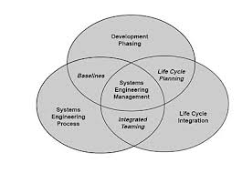

Contents
Introduction. 1
What is system engineering? 2
Applying systems of engineering thought process. 2
Customer needs 3
State the problem 3
Investigate alternatives 4
Model the system 5
Intergrate. 6
Launch the system. 9
Assess Performance. 9
Timber 10
Breeze blocks 10
Pendine Blocks straight laid 10
Pendine blocks brick bonded style 11
Findings 11
Conclusion. 11
Table of Figures. 12
References. 12

Introduction.

The purpose of systems engineering is to produce systems that satisfy the customer needs, increases the probability of system success, reduce risk and reduce total-lifecycle cost. [1]
In this report the author has been tasked with the development of a report regarding the development of a work based test trial or project with respect to the principles of systems engineering.
Following on from this there is a request by the customer to construct a blast protection wall that will be constructed around a day stay store on a trials site that will hold high explosive shaped charges during a trial. This will also have to conform to DSA 0.3OME formally known as JSP482 legislation.[3]
The purpose of the blast wall is to mitigate against significant blast damage and to lower the risk of injury to personnel, as well as mitigating against damage and loss off instrumentation equipment. By constructing a blast wall this will also reduce the travel of debris and fragments during detonation. An analysis of the customer’s requirements will be discussed during this report.
There will also be a small trial carried out to determine whether straight laying the pendine blocks weakens the structure in-comparison to brick bonding.
Further into this report will highlight why pendine blocks is the best solution for this task rather than other materials.

What is system engineering?
Systems engineering is a transdisciplinary approach and means to enable the realization of successful systems. To be able to achieve a successful system all needs must be satisfied whether it’s the customers, the user or the stakeholders. [1]
Systems engineering requires many system tools that will allow a team to understand the customer requirements, explore alternative design options, optimize designs validate design and realize system designs. System tools are primarily conferenced with generating and managing information.
A few Systems Tools are:
- Context diagram,
- Holistic requirements model,
- Pugh matrix,
- Functional modelling,
- Needs means analysis,
- N2 Analysis,
- Quality function deployment,
- Stakeholder Map.

Applying systems of engineering thought process.

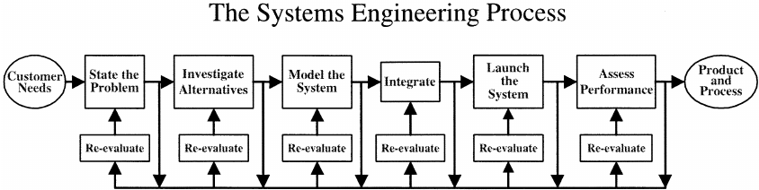
Figure 1-The SIMILAR process. [2]

To be able to understand the customer’s needs and explore alternative materials the SIMILAR process will be applied. This will help in the understanding and planning for the customer’s needs and requirements.

Customer needs
To be able understand the customer needs a meeting will commence to plan out the objectives that are required and how they will be met during this trial.
The customer is looking to carry out an explosive trial and requires a 3 meter long by 3 meter high blast protection wall to be constructed with a day store on the other side of it. This is to mitigate and raise protection towards personnel, and to reduce damage and loss to instrumentation equipment. The blast wall is also there to mitigate and reduce the risk of fragments travelling further than intended.
Once the shaped charges are on the trial site they will be placed into a day store facing downwards, this is another form of mitigation for safety.
The blast wall will need to conform to current DSA 0.3OME formally known as JSP482 regulations. To be able to conform to these regulations the wall will have to be 150mm-250mm thick.

State the problem
The problems have been discussed with the customer and these have been highlighted in the list below and a holistic requirements model has been carried out.
- Cost
- Time
- Personnel
- Reliability
- Machinery
- Materials
- Legislation

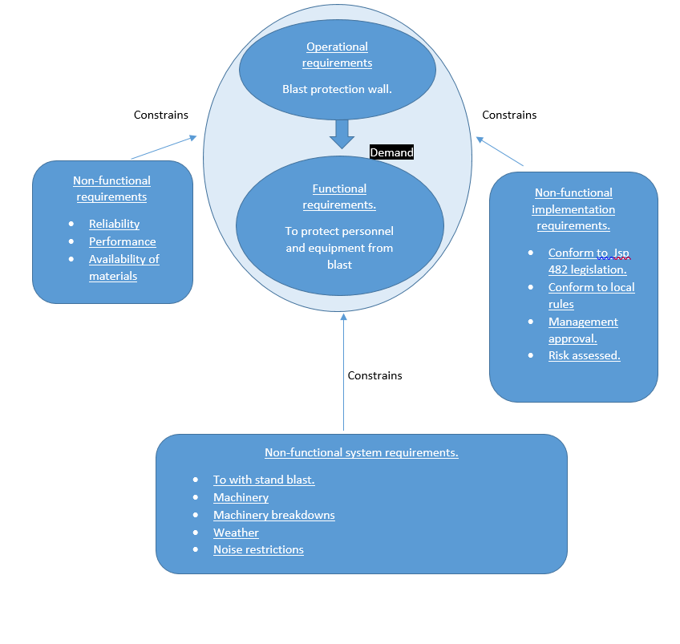
Figure 2- Holistic requirements model. [5]

Investigate alternatives
Following on from the ‘stating the problem’ exercise with the customer, the author and the customer have discussed suitable alternative materials that could be used these will be listed below:
- Timber frame with a plywood face,
- Breeze blocks,
- Pendine blocks straight laid,
- Pendine blocks brick bond style.

The timber frame will be constructed to required size and then the required thickness off plywood attached to the front of the frame.
Breeze blocks will be stacked to the required thickness and then to the required size.
Due to Pendine blocks being manufactured of site these are already constructed to the size of 1.2m by 0.60m by 0.60m and are reinforced with steel bars weighing 1 tonne.

There are other alternatives that could be used such as:
- Hesco
- Soil/Earth
Due to a variety of mitigating factors such a procurement, cost and man power that would be required to carry out trials using the above materials the customer would not be willing to trial these.

Model the system
As mentioned earlier in the report there are many different types of tools and techniques that can be used in systems engineering. However due to the requirement of comparing multiple designs for different materials for this trial a Pugh matrix would be more suited to this.
The Pugh Matrix is a Matrix Diagram that allows for the comparison of a number of design candidates leading ultimately to which best meets a set of criteria. It also permits a degree of qualitative optimization of the alternative concepts through the generation of hybrid candidates. [3]
To be able to successfully investigate alternatives the author will carry out a Pugh matrix system, this will include the customers’ requirements as well the materials that could be used.
Figure 3-Pugh matrix [6]

Intergrate.
Having carried out discussions with the customer over the requirements for the blast protection wall and carried out a Pugh diagram, it is now time to move this from the design stage to the small scale trial. There will be a site Recce carried now this is moving from the planning stage to trial stage.

To be able carry out the trial the relevant paperwork will need to be written up and approved and this will be:
- Trials plan
- Risk assessment
Once this paperwork has been formulated there will be a review meeting to go through the details of the trial and to make sure or relevant safety information has been noted. Upon completion of this meeting any points that have been raised will then be addressed by the trials manager. This will then be reviewed and signed by following the sign of process that is illustrated below.
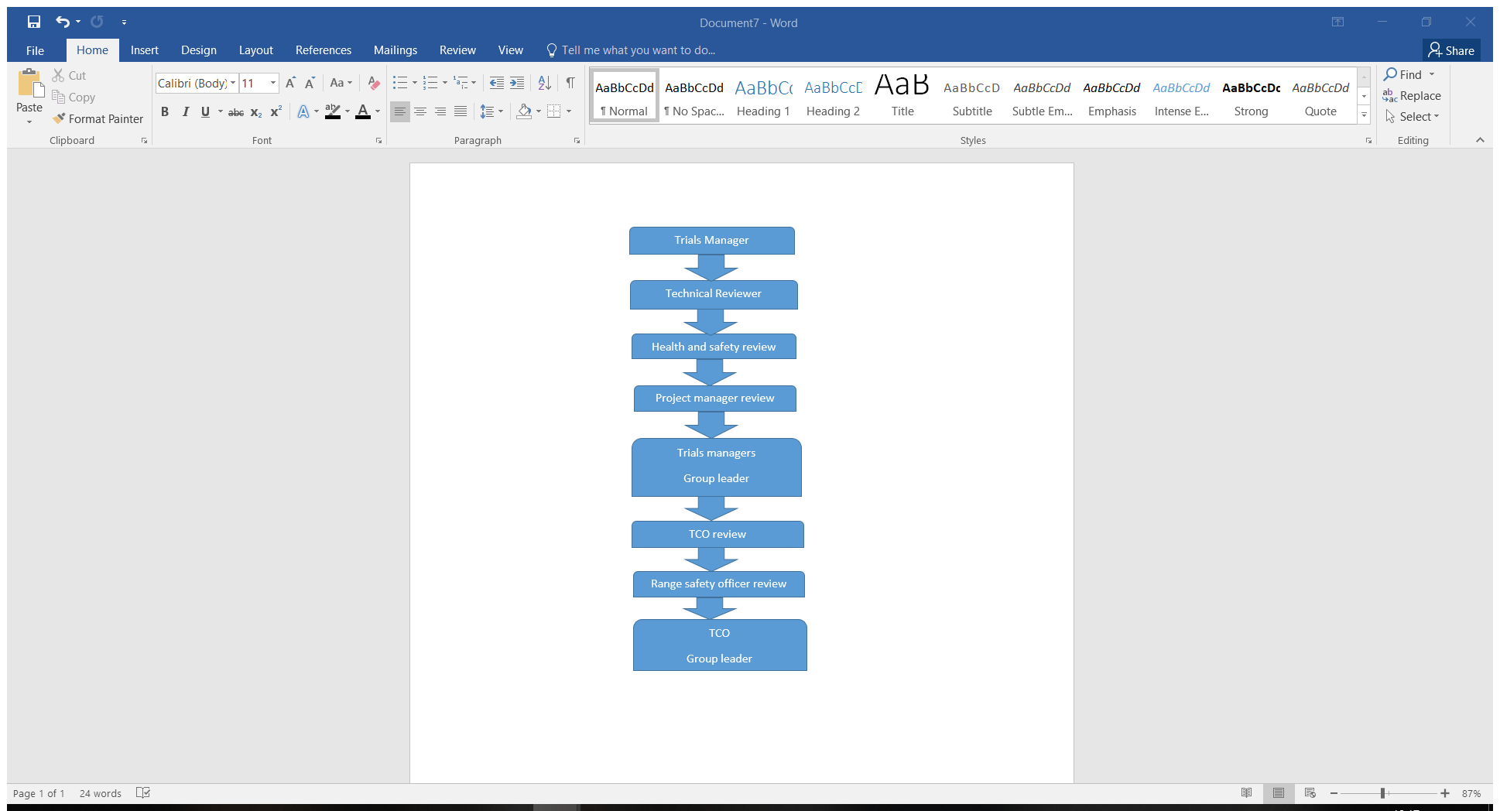Figure 4- Paperwork sign off process.
Although it was noted from the Pugh diagram that breeze blocks ranked last, the customer would still like to run a test to gain data for future requests.
There will now be a request put into the workshop to manufacture the timber wall to the requested size, and the breeze blocks will be procured for the trial. There is no additional procurement for pendine blocks as these are already located at the trial site. There will be a written request submitted for the plant machinery that will be needed to move the blocks into position during the pendine stage of the trial.
A range booking form will be submitted to book the customers trial area, the trials conducting officer will then submit a set-up permit. This is the final piece of paper work in the process that is needed for the range team to be able to start setting up the trial.
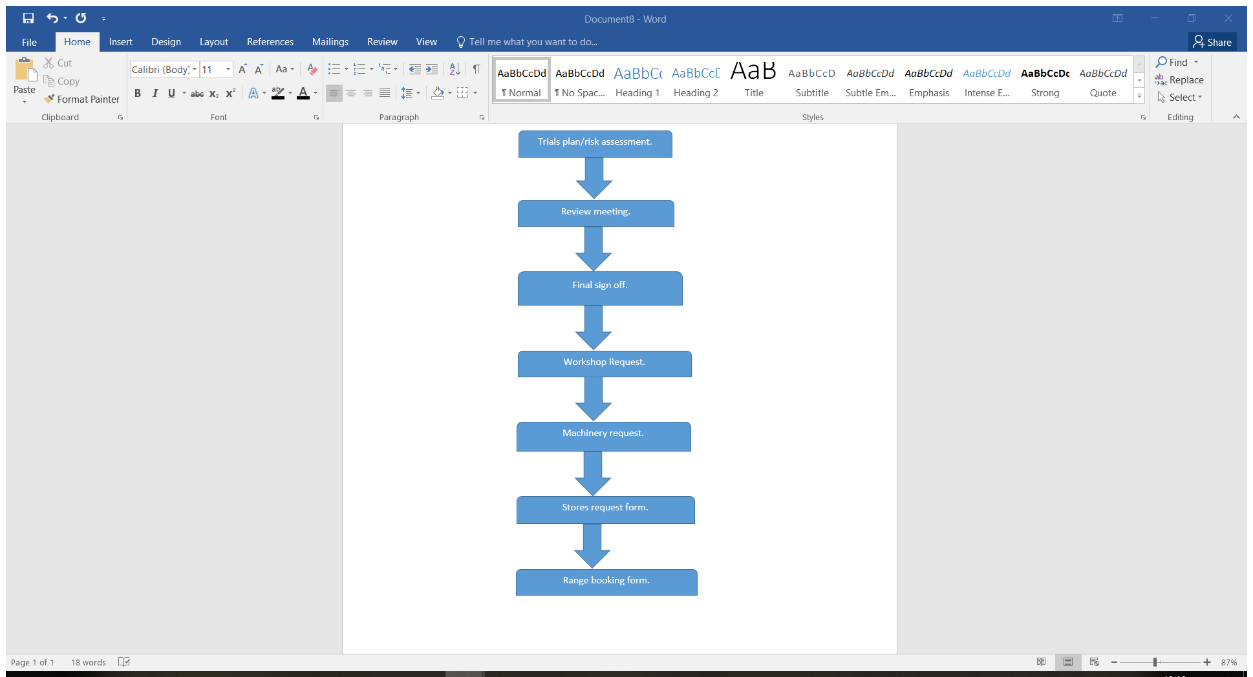
Figure 5- paperwork process.

Launch the system.
On the morning of each test days the stores will be collected as per the request in noted in Figure 5.
Setting up for the three tests will require similar steps. Each test will then have its own independent steps, the similar will be listed below:
- Pad cover established due to stores being at the trial site,
- Brief from the TCO and customer to trials team and Range staff,
- Tasks given to the trials team,
- Machinery checks
- Firing cables to be run out and protected,
- Line tests,
- Machinery checks.

To setup for the timber wall test, the range staff will need to move this into position whilst the instrumentation set-up the HSV and strawboard witness packs. Once these tasks are completed the TCO will then Request for his pre-agreed cover area as per the trials plan. Post firing the TCO will then confirm the area to be safe to allow the trials team to make their way to the arena to gather any pictures and make notes of any results.
To setup for the breeze block test (this is more time and labour consuming) due to the amount of blocks required for the size of the wall. Instrumentation will carry out the same processes as in test one setting up the HSV and strawboard witness packs. The TCO will also carry out the same processes. Post firing will have the same processes as test one also.
To setup for the Pendine straight lay test plant machinery is now required due to the size and weight of the pendine blocks. This will be carried out by competently trained range staff. The blocks will be lifted into place to the required size with the joints straight laid. Instrumentation will follow the same processes as in test 1 and 2.The TCO will also follow the same processes as in test 1 and 2. Post firing will have the same processes as test 1 and test 2.

To setup for the Pendine Brick bonded test plant machinery is now required due to the size and weight of the pendine blocks. This will be carried out by competently trained range staff. The blocks will be lifted into place to the required size with the joints being staggered. Instrumentation will follow the same processes as in test 1, 2, 3.The TCO will also follow the same processes as in test 1, 2, 3. Post firing will have the same processes as test 1, 2, 3.

Assess Performance.
To be able to assess which material is most suitable to be used as a blast protection wall a small scale trial will be conducted where a shaped charge will be placed in front of the chosen materials.
The shaped charge will be facing downwards due to the way the jet forms upon detonation, being storing the charge in this way it will also conform to the customers need to limit fragments.
Behind the materials at a 10m standoff strawboard witness pack will be placed for instrumentation purposes to assess the debris train that is left during detonation.
Strawboard can be used to measure the depth of velocity, this will give the customer informative data which can be used to determine how far away from the trials arena the day store will need to be located and the structure to be constructed.
In addition to strawboard being used, (HSV) High speed video will be setup as a secondary form off evidence to support the strawboard results.
By adding HSV into the trial this will support the results from the strawboard, as well as more supporting evidence to take back to the customer. This would also lower the costs in future development as the digital results can be kept on a hard drive which would lower the need to re-test the materials mentioned in the report in the future.
Timber
Results from the Plywood timber wall shows that this would not be suitable and does not meet the customer’s requirements due to the fact that the plywood splintered and there was traces of the shaped charge and the plywood found in the strawboard witness pack.
As the customer requirement is to mitigate and reduce the risk of fragmentation this has been found not only is it not cost effective it also doesn’t fit with the customer requirement.
Breeze blocks
Results from the breeze block wall shows that this would not be suitable due to the fact that the shaped charge penetrated the breeze block wall causing the large fragments that caused considerable damage to the strawboard as well as fragments from the shaped charge found in the strawboard witness pack.
As the customer requirement is to mitigate and reduce the risk of fragmentation this has been found not only is this not cost effective material it also doesn’t fit within the parameters of the customer’s requirement.
Pendine Blocks straight laid
Results from the Pendine block straight laid wall test shows that this would be suitable due to the fact that the shaped charge did not penetrate the pendine block and there was no trace of the pendine block found in the strawboard witness pack.
Although the wall stopped the fragments from the shaped charge it was noted that the wall was left unstable, due to the fact the blocks joins where all aligned and the shockwave from the detonation had moved the blocks from their original position thus weakening the overall structure. As the customer requirement is to mitigate and reduce the risk of fragmentation this has been found to be the most cost effective material and also it meets the customer’s requirement.
However further to this a brick bond style wall will need to be constructed and tested and re-evaluated. This is due to the straight laid Pendine blocks has met the customers requirement for the mitigation of fragments, however it has highlighted that there could be a safety issue that could cause the blocks to topple.

Pendine blocks brick bonded style
Results from the Pendine block brick bonded wall test shows that this would be suitable due to the fact that the shaped charge did not penetrate the pendine blocks and there was no trace of the pendine block found in the strawboard witness pack. Building the wall brick bond style strengthened the joints and by doing this the blocks never moved like they did in the straight lay test.
The same Pendine blocks where used in the second test that were used in the first round of testing, and although there was some form a surface scarring the blocks still withstood the secondary detonation. By re-using the same blocks from the first test in the second test this has given the customer the reassurance that this would be the most cost effective material to use. There is now quantitative data to support earlier findings within the Pugh diagram to support this.

Findings
Even though the tests in this report had positive results, there is always the possibility that there could be failures during a process these could be caused by:
- Human error
- Mechanical failure
- System failures
- weather

Conclusion.
Having carried out all three tests using the materials that customer requested two of the three tests could be noted as failures, however due to the customer needing the results for these materials they can in-fact be classed as successful tests.
It can be seen that the most suitable and cost effective material to use would be pendine blocks. The first test on the pendine blocks was successful however due to a safety concern it was requested that a second test was required with the wall being built with staggered joints. Once this test was executed it gave the results that by building the wall in this orientation meant it was structurally safer and still fulfilled the requirements that were requested by the customer.

Table of Figures.
Figure 1-The SIMILAR process. [2] 2
Figure 2- Holistic requirements model. [5] 4
Figure 3-Pugh matrix [6] 5
Figure 4- Paperwork sign off process. 6
Figure 5- paperwork process. 7

References.
[1]https://en.wikipedia.org/wiki/Systems_engineering
[2]https://www.burgehugheswalsh.co.uk/systems-engineering/tools.aspx
[3]https://www.sebokwiki.org/wiki/Systems_Engineering_Overview
[4]http://assets.publishing.service.gov.uk/goverment/uploads/system/uploads/attachment data/file/892640/DSA03 OME PART2 JSP 482 CH 06 Nov 19 – mod gov uk.pdf
[5]http://sysengr.engr.arizona.edu/whatis/whatis.html
[6] (https://www.researchgate.net/figure/The-Similar-Process-from-Bahill-and-Gissing-1998_fig1_229711045, 2020)
[7]https://www.burgehugheswalsh.co.uk/uploaded/1/documents/hrm-tool-box-v1.0.pdf
[8]https://www.burgehugheswalsh.co.uk/uploaded/1/documents/pugh-matrix-v1.1.pdf
[9]https://citoolkit.com/templates/pugh-matrix-template/

