

UWTSD MOTORCYCLE ENGINEERING

Ultrasonic Attenuation Coefficient Determination and Probability of Sizing Analysis

ACEA7013: Structural Integrity & Materials Evaluation
M.Sc. Motorcycle Engineering

Student ID: 2206956 9 January 2023
Name: Pranav AnilKumar

Table of Contents
1. Abstract 3
2. Apparatus 4
3. Introduction 5
4. Brief Review on Non-Destructive Testing 5
4.1 Statistics and Non-Destructive Testing (NDT) 6
4.2 Probability of Detection (POD) 7
4.3 Computational Probability of Detection 7
5. Measurements and Calculations 7
6. Experimentation and Estimation 11
6.1 Operator 1: Linear Regression & Error Normal distribution Curve 12
6.2 Operator 2: Linear Regression & Error Normal distribution Curve 13
6.3 Operator 3: Linear Regression & Error Normal distribution Curve 14
6.4 Operator 4: Linear Regression & Error Normal distribution Curve 15
6.5 Operator 5: Linear Regression & Error Normal distribution Curve 16
6.6 Operator 6: Linear Regression & Error Normal distribution Curve 17
6.7 Operator 7: Linear Regression & Error Normal distribution Curve 18
6.8 Operator 8: Linear Regression & Error Normal distribution Curve 19
6.9 Operator 9: Linear Regression & Error Normal distribution Curve 20
6.10 Operator 10: Linear Regression & Error normal distribution Curve 21
6.11 Overall Linear Regression & Error Normal distribution Curves 22
Conclusion 23
References 23

1. Abstract
Non-destructive testing (NDT) is a vital tool in ensuring the integrity and reliability of materials and components in various industries. One important aspect of NDT is the probability of detection (POD), which refers to the likelihood that a flaw or defect will be detected by a particular NDT method. The POD of an NDT method is influenced by several factors, including the size, shape, and orientation of the defect, the type of material being tested, and the sensitivity of the NDT method. For example, a small defect in a dense material may be more difficult to detect than a larger defect in a less dense material, even if the same NDT method is used. This study addresses mainly two sections of real-world testing data. The one in which 2 specimens are evaluated with defect measuring equipment to find the ultrasonic attenuation coefficient and the other part which includes a total of 21 defect measurements taken by 10 technicians using the same equipment and process. At last, using the collected statistics, talk about how the various technicians, the tools, and the process might improve the sizing accuracy.

2. Apparatus

For conducting the experiment, we require 3 equipment.
- Ultrasonic Flaw Detector.
- Ultrasonic zero-degree 5MHz probe.
- Vernier Calliper.
- Ultrasound Gel.
We are provided with two specimens: a Mild Steel rectangular block and a Brake disc rotor.
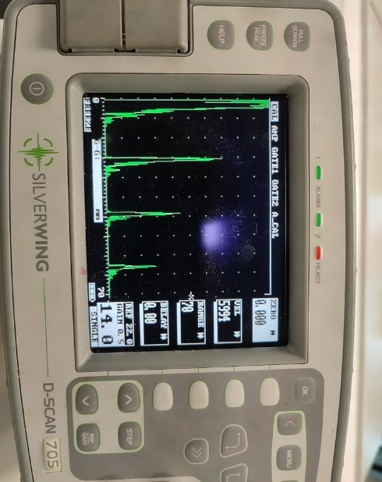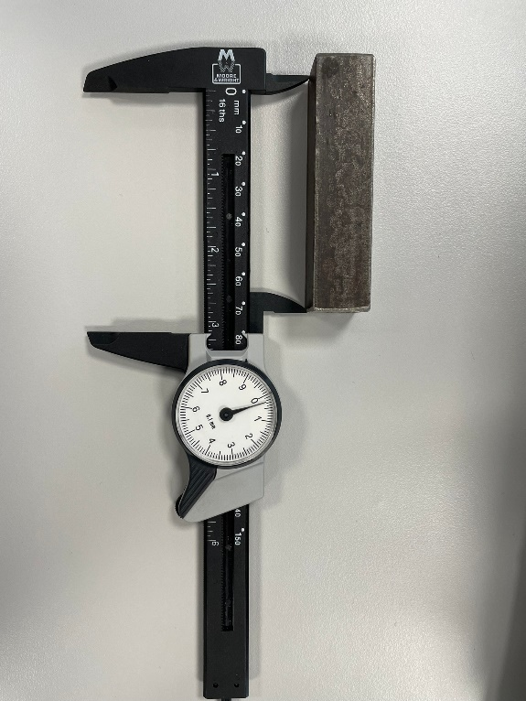
Figure 1: Ultrasonic Flaw Detector Figure 2: MS Block & Vernier Calliper

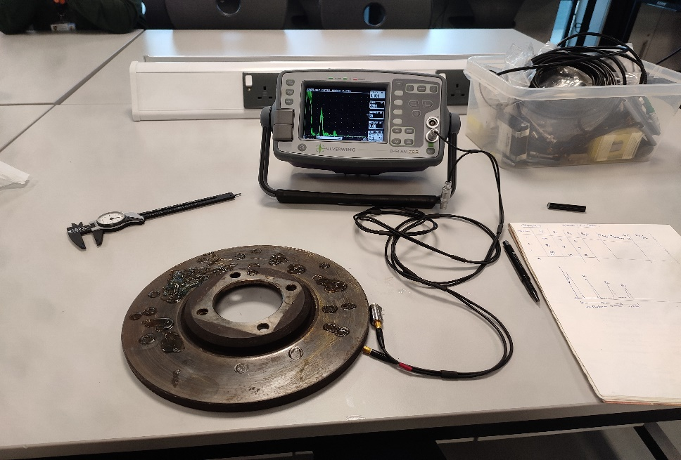
Figure 3: Experiment setup for Brake Disc & Ultrasonic 5MHz probe

3. Introduction
The term "non-destructive testing," abbreviated as "NDT," refers to a technique that analyses the characteristics of materials, components, and systems without compromising their integrity. It is important to consider the POD of an NDT method when selecting which method to use for a particular (Georgiou,2007) application. The POD can be determined through the use of standard reference materials, which are materials with known defects that are used to evaluate the performance of an NDT method. By analysing the results of NDT testing on these reference materials, the POD of a particular method can be calculated. In addition to the POD, other factors that should be considered when selecting (Trampus,2013) an NDT method include the cost of the method, the speed of testing, and the safety of the method. For instance, some NDT methods may be faster or more cost-effective, but they may also pose greater risks to the operator or the test specimen.
Linear regression is a statistical method that is often used to analyse the relationship between two variables. In the context of NDT, (Schneider,2004) linear regression can be used to determine the relationship between the size of a defect and the probability of its detection by a particular NDT method. This can be useful in predicting the likelihood of detecting defects of a certain size and in optimizing the use of NDT methods.
However, it is important to note that the POD is not a fixed value and can vary depending on the specific characteristics of the material being tested and the NDT method being used. Factors such as the type and thickness of the material, the orientation and shape of the defect, and the sensitivity of the NDT method can all affect the POD.

4. Brief Review on Non-destructive testing (NDT)

Non-destructive testing (NDT) is a technique used to evaluate the properties of materials, components, and systems without causing damage to the material specimen. NDT is commonly used in industries such as manufacturing, construction, and aerospace to ensure the integrity and reliability of materials and components.
There are several methods of NDT, each with its own advantages and disadvantages.
• One commonly used method is visual (Dwivedi,2018) testing (VT), which involves using the human eye to inspect for defects. VT is relatively simple and inexpensive, and it can be used to detect surface defects such as cracks, scratches, and corrosion. However, VT is limited in its ability to detect internal defects or defects that are not visible to the naked eye.
• Another NDT method is liquid penetrant testing (PT), which involves applying a liquid penetrant to the surface of a material (Dwivedi,2018) and then removing excess penetrant, leaving any defects on the surface highlighted. PT is effective at detecting surface-breaking defects, but it is not suitable for detecting defects below the surface or in non-porous materials.
• Magnetic particle testing (MT) is another NDT method that uses a magnetic field to detect surface and slightly subsurface defects in ferromagnetic materials. MT is relatively fast and can be used to inspect large areas, but it is not suitable for non-ferromagnetic materials.
• Radiographic testing (RT) involves using radiation to create an image of the internal structure of an object. RT is effective at detecting internal defects, but it requires the use of potentially hazardous radiation and can be time-consuming.
• Ultrasonic testing (UT) uses high frequency (Dwivedi,2018) sound waves to detect internal flaws or measure the thickness of materials. UT is effective at detecting both surface and internal defects, but it is limited in its ability to detect defects in materials with low ultrasonic wave velocity or high attenuation.
4.1 Statistics and Non-destructive testing (NDT)
Non-destructive testing (NDT) refers to a variety (Sbartaï,2012) of techniques used to inspect and evaluate the properties of materials, components, or systems without causing damage or destruction. NDT is widely used in a variety of industries, including manufacturing, construction, aviation, and healthcare, to ensure the safety and reliability of products and structures.
One important aspect of NDT is the use of statistical (Alexa,2021) analysis to evaluate the results of testing. This can help to identify patterns, trends, and anomalies in the data, and can be used to make decisions about the acceptability or reliability of a material or component.
There are several statistical techniques that are commonly used in NDT. These include:
1. Hypothesis testing: This involves testing a specific hypothesis about the properties of a material or component and determining the likelihood that the hypothesis is true based on the data collected.
2. Correlation analysis: This involves examining the relationship between two or more variables and determining how strongly they are correlated.
3. Regression analysis: This involves creating a mathematical model to predict the value of a dependent variable based on one or more independent variables.

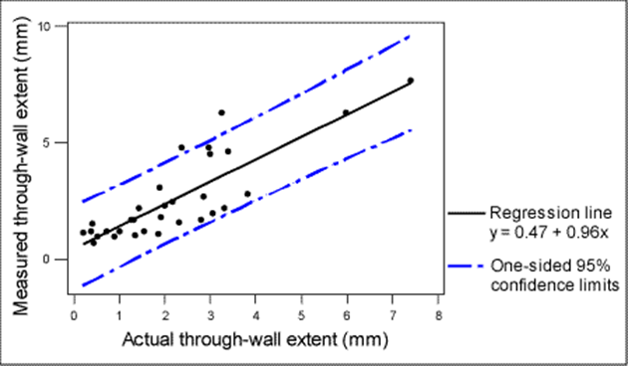
Figure 1 : Actual Value v/s Measured value (Schneider,2004)

4. ANOVA (analysis of variance): This involves comparing the means of multiple groups to determine if there are significant differences between them.
5. Control charts: These are graphing that plot data over time and are used to identify trends or patterns that may indicate a problem with the material or component being tested.
By using statistical techniques, NDT professionals can more accurately and effectively evaluate the properties of materials and components and make informed decisions about their acceptability and reliability.
4.2 Probability of detection (POD)
The probability of detection (POD) is a measure (Wehling,2011) of the likelihood that a defect or flaw will be detected by a particular non-destructive testing (NDT) method. POD is an important consideration in NDT because it affects the reliability and accuracy of the testing process.
• There are several factors that can influence the POD of an NDT method, including the size, shape, and orientation of the defect, the type and thickness of the material being tested, and the sensitivity of the NDT method.
• The POD of an NDT method can be determined through the use of standard reference materials, which are materials with known defects that are used to evaluate the performance of an NDT method. By analysing the results of NDT testing on these reference materials, the POD of a particular method can be calculated for defects of different sizes or types.
4.3 Computational probability of detection
Computational probability of detection (POD) refers to the use (Wehling,2011) of computer models or simulations to predict the likelihood that a defect or flaw will be detected by a particular non-destructive testing (NDT) method. POD is an important consideration in NDT
Finite element analysis (FEA) is a computational (Wehling,2011) method for predicting the behaviour of materials under different conditions. It is commonly used in engineering and manufacturing to design and optimize the performance of products and systems. In the context of probability of detection (POD), FEA can be used to predict the likelihood that a defect or flaw will be detected by a particular non-destructive testing (NDT) method. involves solving complex mathematical equations that describe the behaviour of materials under different conditions. It is typically used to simulate the response of an NDT method to a particular defect, considering factors such as the size, shape, and orientation of the defect, the type and thickness of the material being tested, and the sensitivity of the NDT method.

5. Measurements and Calculations

Part 1: Ultrasonic Attenuation Coefficient Determination
Determination of material attenuation coefficient values for the given samples using time of flight method.
The given material samples are: Mild steel rectangular block and Brake disc rotor.
Using the Ultrasonic flaw detector and proper settings, we obtained the defect values of the material across 4 different positions. The defects are measured by moving the probe across the test materials. Before testing, the surface should be applied with Ultrasound gel to prevent the probe from damaging and reduce the errors.
dB = 20 log (Ratio) = AH
α(dB/mm) = 20*log (AH) / distance(mm)

Considering the material sample: Mild Steel rectangular block.
Measuring values with the use of Ultrasonic Flaw Detector
Thickness measured = 18.9 mm
Position | B1 | B2 | B3 | B2/B1 | B3/B1 | B3/B2
1 | 68 | 39 | 25 | 0.573 | 0.367 | 0.641
2 | 44 | 29 | 19 | 0.659 | 0.431 | 0.655
3 | 41 | 28 | 20 | 0.683 | 0.487 | 0.714
4 | 70 | 44 | 29 | 0.628 | 0.414 | 0.659

For finding Attenuation Coefficient,
Distance = 2 × thickness (cases – B2/B1 & B3/B2)
and for case (B3/B1), Distance = 4 × thickness

AH₁₁ = 20 log (B2/B1) = 20*log (0.573) = -4.836
α(dB/mm) = (-4.836) / (2*18.9) = -0.127 dB/mm
AH₁₂ = 20 log (B3/B1) =20*log (0.367) = -8.706
α(dB/mm) = (-8.706) / (4*18.9) = -0.115 dB/mm
AH₁₃ = 20 log (B3/B2) = 20*log (0.641) = -3.862
α(dB/mm) = (-3.862) / (2*18.9) = -0.102 dB/mm

AH₂₁ = 20 log (B2/B1) = 20*log (0.659) = -3.622
α(dB/mm) = (-3.622) / (2*18.9) = -0.095 dB/mm
AH₂₂ = 20 log (B3/B1) =20*log (0.431) = -7.310
α(dB/mm) = (-7.310) / (4*18.9) = -0.096 dB/mm
AH₂₃ = 20 log (B3/B2) = 20*log (0.655) = -3.675
α(dB/mm) = (-3.675) / (2*18.9) = -0.097 dB/mm

AH₃₁ = 20 log (B2/B1) = 20*log (0.682) = -3.324
α(dB/mm) = (-3.324) / (2*18.9) = -0.087 dB/mm
AH₃₂ = 20 log (B3/B1) =20*log (0.487) = -6.249
α(dB/mm) = (-6.249) / (4*18.9) = -0.082 dB/mm
AH₃₃ = 20 log (B3/B2) = 20*log (0.714) = -2.926
α(dB/mm) = (-2.926) / (2*18.9) = -0.077 dB/mm

AH₄₁ = 20 log (B2/B1) = 20*log (0.628) = -4.040
α(dB/mm) = (-4.040) / (2*18.9) = -0.106 dB/mm
AH₄₂ = 20 log (B3/B1) =20*log (0.414) = -7.659
α(dB/mm) = (-7.659) / (4*18.9) = -0.101 dB/mm
AH₄₃ = 20 log (B3/B2) = 20*log (0.659) = -3.661
α(dB/mm) = (-3.661) / (2*18.9) = -0.096 dB/mm

Then considering the material sample: Brake Disc Rotor.
Measuring values with the use of Ultrasonic Flaw Detector
Thickness measured = 12.6 mm
Position | B1 | B2 | B3 | B2/B1 | B3/B1 | B3/B2
1 | 59 | 19 | 6 | 0.372 | 0.108 | 0.315
2 | 70 | 18 | 4 | 0.257 | 0.057 | 0.222
3 | 61 | 10 | 3 | 0.164 | 0.049 | 0.3
4 | 63 | 12 | 2 | 0.190 | 0.031 | 0.167

Finding Attenuation Coefficient,
AH11 = 20 log (B2/B1) = 20*log (0.372) = -8.589
α(dB/mm) = (-8.589) / (2*12.6) = -0.340 dB/mm
AH12 = 20 log (B3/B1) =20*log (0.108) = -19.331
α(dB/mm) = (-19.331) / (4*12.6) = -0.383 dB/mm
AH13 = 20 log (B3/B2) = 20*log (0.315) = -10.033
α(dB/mm) = (-10.033) / (2*12.6) = -0.398 dB/mm

AH21 = 20 log (B2/B1) = 20*log (0.257) = -11.801
α(dB/mm) = (-11.801) / (2*12.6) = -0.468 dB/mm
AH22 = 20 log (B3/B1) =20*log (0.057) = -24.882
α(dB/mm) = (-24.882) / (4*12.6) = -0.493 dB/mm
AH23 = 20 log (B3/B2) = 20*log (0.222) = -13.072
α(dB/mm) = (-13.072) / (2*12.6) = -0.518 dB/mm

AH31 = 20 log (B2/B1) = 20*log (0.164) = -15.703
α(dB/mm) = (-15.703) / (2*12.6) = -0.623 dB/mm
AH32 = 20 log (B3/B1) =20*log (0.049) = -26.196
α(dB/mm) = (-26.196) / (4*12.6) = -0.519 dB/mm
AH33 = 20 log (B3/B2) = 20*log (0.3) = -10.457
α(dB/mm) = (-10.457) / (2*12.6) = -0.414 dB/mm

AH41 = 20 log (B2/B1) = 20*log (0.190) = -14.424
α(dB/mm) = (-14.424) / (2*12.6) = -0.572 dB/mm
AH42 = 20 log (B3/B1) =20*log (0.031) = -30.172
α(dB/mm) = (-30.172) / (4*12.6) = -0.598 dB/mm
AH43 = 20 log (B3/B2) = 20*log (0.167) = -15.545
α(dB/mm) = (-15.545) / (2*12.6) = -0.616 dB/mm

The material Attenuation Coefficient values for both material which is inspected at different positions across the material are mentioned above. The values obtained are similar and close to each other but there are few deviations of values which is caused due to the wear and tear of the material specimen. The thickness value obtained for different Verniercaliper trials is also a factor in change of values.

6. Experimentation and Estimation

Part 2: Through Wall Sizing Accuracy Analysis
During the Non-Destructive test that was carried out, it was found that there were 21 faults. Ten technicians used the ultrasonic wall thickness technique to quantify the defects, and the results of their work are shown below. The image illustrates both the real magnitude of the problem as well as the magnitude that was measured by each technician.
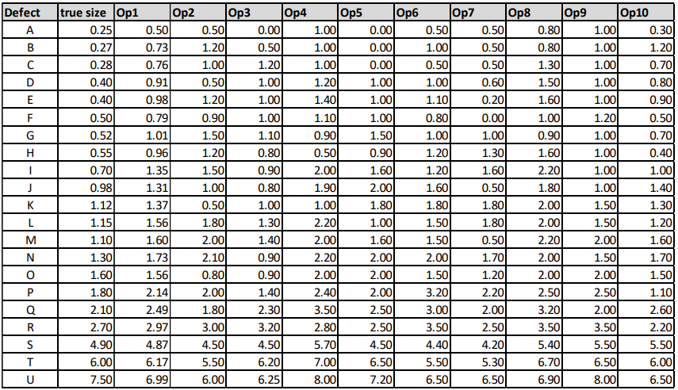

First, using the data provided, we identify ERROR for each and every flaw caused by each unique operator.

The next step is to calculate the mean and standard deviation of all errors (s).
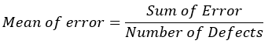

$$s_{i}^{2}= {Error}_{i}^{2}-{Mean}^{2}$$
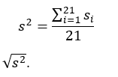

Standard Deviation (s) =

6.1 Operator 1: Linear Regression & Error Normal distribution Curve

6.2 Operator 2: Linear Regression & Error Normal distribution Curve

6.3 Operator 3: Linear Regression & Error Normal distribution Curve

6.4 Operator 4: Linear Regression & Error Normal distribution Curve

6.5 Operator 5: Linear Regression & Error Normal distribution Curve

6.6 Operator 6: Linear Regression & Error Normal distribution Curve

6.7 Operator 7: Linear Regression & Error Normal distribution Curve

6.8 Operator 8: Linear Regression & Error Normal distribution Curve

6.9 Operator 9: Linear Regression & Error Normal distribution Curve

6.10 Operator 10: Linear Regression & Error Normal distribution Curve

6.11: Overall Linear Regression & Error Normal distribution Curve

Conclusion
In conclusion, the probability of detection is a crucial aspect of non-destructive testing that must be carefully considered in order to ensure the reliability and accuracy of the testing process. Linear regression can be a useful tool in predicting the POD and optimizing the use of NDT methods, but it is important to take into account the specific characteristics of the material and the NDT method being used. Overall, NDT is a valuable tool for ensuring the integrity and reliability of materials and components, but it is important to carefully consider the specific requirements and limitations of each NDT method when selecting the most appropriate method for a particular application.

References
- Alexa, M., Misák, P., & Kocáb, D. (2021). Creating a specific regression model to determine the compressive strength of concrete through NDT. SPECIAL CONCRETE AND COMPOSITES 2020: 17th International Conference.
- Dwivedi, S. K., Vishwakarma, M., & Soni, P. A. (2018). Advances and researches on non-destructive testing: A review. Materials Today: Proceedings, 5(2), 3690–3698. https://doi.org/10.1016/j.matpr.2017.11.620
- Georgiou, G. A. (2007). PoD curves, their derivation, applications and limitations. Insight - Non-Destructive Testing and Condition Monitoring, 49(7), 409–414. https://doi.org/10.1784/insi.2007.49.7.409
- Ginzel, E. (2010). Introduction to the Statistics of NDT. Ndt.net. https://www.ndt.net/article/v11n05/ginzel2/ginzel2.htm
- Lindenmayer, D. B., Likens, G. E., Krebs, C. J., & Hobbs, R. J. (2010). Improved probability of detection of ecological “surprises.” Proceedings of the National Academy of Sciences of the United States of America, 107(51), 21957–21962. https://doi.org/10.1073/pnas.1015696107
- Niccolai, A., Caputo, D., Chieco, L., Grimaccia, F., & Mussetta, M. (2021). Machine learning-based detection technique for NDT in industrial manufacturing. Mathematics, 9(11), 1251. https://doi.org/10.3390/math9111251
- Pavlović, M., Takahashi, K., & Müller, C. (2012). Probability of detection as a function of multiple influencing parameters. Insight - Non-Destructive Testing and Condition Monitoring, 54(11), 606–611. https://doi.org/10.1784/insi.2012.54.11.606
- Raj, B., Jayakumar, T., & Thavasimuthu, M. (2001). Practical Non-destructive Testing (2nd ed.). Woodhead Publishing.
- Sbartaï, Z.-M., Breysse, D., Larget, M., & Balayssac, J.-P. (2012). Combining NDT techniques for improved evaluation of concrete properties. Cement & Concrete Composites, 34(6), 725–733. https://doi.org/10.1016/j.cemconcomp.2012.03.005
- Schneider, C. R. A., & Rudlin, J. R. (2004). Review of statistical methods used in quantifying NDT reliability. Insight - Non-Destructive Testing and Condition Monitoring, 46(2), 77–79. https://doi.org/10.1784/insi.46.2.77.55549
- Subair, S. M., Balasubramaniam, K., Rajagopal, P., Kumar, A., Rao, B. P., & Jayakumar, T. (2014). Finite element simulations to predict probability of detection (PoD) curves for ultrasonic inspection of nuclear components. Procedia Engineering, 86, 461–468. https://doi.org/10.1016/j.proeng.2014.11.059
- Thompson, R. B., Brasche, L. J., Lindgren, E., Swindell, P., & Winfree, W. P. (2009). Recent advances in Model-Assisted Probability of detection.
- Trampus, P. (2013). NDT CHALLENGES AND RESPONSES ‒ AN OVERVIEW. Ndt.net.
- Wehling, P., LaBudde, R. A., Brunelle, S. L., & Nelson, M. T. (2011). Probability of Detection (POD) as a statistical model for the validation of qualitative methods. Journal of AOAC International, 94(1), 335–347. https://doi.org/10.1093/jaoac/94.1.335

