November 2019
Nia David (P151615)
Ortho Clinical Diagnostics
Advanced Computational Methods
Assessment of a Helicopter Tail Rotor Blade
Module Code: M6X00408

Executive Summary
Stress analysis using Finite Element Method (FEM) will be used to determine the effects of both static and dynamic forces on the Apache’s rotor blade when using a Titanium Alloy material. Included within the analysis will be static stress, strain, displacement and stresses subjected by frequencies too. The FEA analysis within this report has been accomplished by the computer aided design package named SolidWorks. The FEA results will be compared to the hand calculations and evaluate the differences in the values, if any. Recommendations will be made with the objective of improving the accuracy and reliability of the analysis results.

Table of Tables
Table 1 - Extending Rotor Blade Shaft to Correct Centre of Mass (SolidWorks, 2019). 7
Table 2 - Static Loads Applied in FEA Analysis (SolidWorks, 2019). 10
Table 3 - FEA Frequency Analysis 14
Table 4 - Modes 1-6, Translation 15
Table 5 - Modes 7-10, Construction 16
Table 6 - Table Displaying the Impact of Mesh Size on Run Time (Information populated from (SolidWorks, 2019)). 17
Table 7 - Analysis Appraisal 19

Table of Figures
Figure 1 - Apache Helicopter Front Image (BBC, 2019). 5
Figure 2 - The Apache Helicopter (UWTSD Moodle, 2019) 6
Figure 3 - Apache Tail Rotor (UWTSD Moodle, 2019) 6
Figure 4 - (FAA Gov, 2016) 6
Figure 5 - (Helicopter World, 2018) 6
Figure 6 - Specific Strength of Various Materials (Science ABC, 2017) 7
Figure 7 – Yield Strength/Density (MatLab, 2019). 7
Figure 8 – Titanium Material Specification (SolidWorks, 2019). 7
Figure 9 – FEA Static Stress 12
Figure 10 – FEA Static Stress Close Up 12
Figure 11 - FEA Strain Analysis 13
Figure 12 - FEA Strain Analysis Close Up 13
Figure 13 - FEA Displacement Analysis 14
Figure 14 - FEA Displacement Analysis Side Angle 14
Figure 15 - FEA Graph Displaying Frequency to Mode Number 15
Figure 16 – 2mm Mesh (SolidWorks, 2019). 18
Figure 17 - 6mm Mesh (SolidWorks, 2019). 18
Figure 18 - H-Adaptive Mesh 19
Figure 19 - Static Stress Simulation with H-Adaptive Mesh 19
Figure 20 - Static Stress Simulation with Standard Mesh 19

Table of Contents
1. Executive Summary 2
1. Introduction – Apache Helicopter 4
1.1. Apache’s History 4
1.2. Apache Technical Summary 4
1.3. Apache Computer Aided Design (CAD) Model 5
2. Methodology 6
2.1. Rotor Blade Material 6
3. Static Analysis 7
3.1. Centre of Mass 7
3.2. Calculation for Angular Velocity (w) 8
3.3. Calculation for Rotor Blade Tip Velocity (v) 8
3.4. Calculation for Lift ($FL)$ 8
3.5. Calculation for Drag Force ($FD$) 8
3.6. Calculation for Centrifugal Force ($FC$) 9
3.7. Calculation for Force Acting Along Y Plane 9
3.8. Calculation for Force Acting Along Z Plane 9
3.9. Calculation for Youngs Modulus 9
3.10. Static FEA Analysis 10
3.10.1. Static Stress 11
3.10.2. Static Strain 12
3.10.3. Static Displacement 13
4. Frequency Analysis 14
4.1. Calculation for the Spin of Tail Rotor Frequency 14
4.2. FEA Frequency Simulation 14
4.3. Frequency Calculations vs FEA Simulation Comparison 16
4.4. Mesh Analysis 17
4.4.1. Determining Mesh Size 17
4.4.2. Mesh Improvements 18
5. Analysis Inaccuracies 19
6. Conclusion 20
7. Reference Table 21

Introduction – Apache Helicopter

Apache’s History
Established in 1916, Boeing is the world’s largest aerospace company according to a renowned engineering technological reporting website named NewEngineer (McClements, 2019), and is the leading producer of commercial airliners, defence aircraft and communication systems who employee over 140,000 people globally.
Boeing (Boeing, 2019) stated that AH-64 Apache as shown in Figure 1 is the world’s most advanced multi-role combat helicopter and is used by the U.S. Army and a growing number of international defence forces. Boeing has delivered more than 2,200 Apaches to customers around the world since the aircraft entered production. The Apache’s main function is to take out or remove any heavily armoured targets such as tanks and heavy artillery (Willmin, 2017). The book titled ‘Instruments of War’ (Tucker, 2015) praises the benefits of the AH-64A Apache within monumental world events such as the Invasion of Panama in 1989 and the Persian Gulf war in 1991.
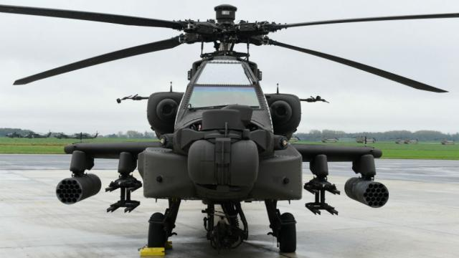
Figure 1 - Apache Helicopter Front Image (BBC, 2019).

Apache Technical Summary
The crew sits in tandem, with the pilot sitting behind and above the co-pilot (Air Recognition, 2019). Both crew members can fly the aircraft and performing methods of weapon engagements independently. The AH-64 Apache has a four-blade main rotor and a four-blade tail rotor. The crew compartment has shielding between the cockpits, such that at least one crew member can survive hits. The compartment and the rotor blades are designed to sustain a hit from 23-millimeter rounds. The airframe includes some 1,100 kg of protection and has a self-sealing fuel system to protect against ballistic projectiles. The Apache is equipped with two turbo-shaft engines, each providing 1,265kW (Willmin, 2017).

Apache Computer Aided Design (CAD) Model
The report will analysis the Apache helicopter tail rotor blades coloured blue within Figure 2 and shown enlarged within Figure 3.
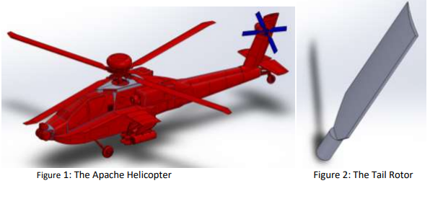  Figure 2 - The Apache Helicopter  (UWTSD Moodle, 2019) | Figure 3 - Apache Tail Rotor (UWTSD Moodle, 2019)

Newton's third law of motion tells us that when an Action force makes something move, an equal Reaction force works in the opposite direction (Lee, 2012). As a helicopter rotor spins around creating the action force, the entire body of the craft experiences a turning reaction torque. The reaction force would make a helicopters body spin completely uncontrollable, therefore there must be a counter-torque in the form of a tail rotor (Woodford, 2018). See Figure 4 & 5 for diagrams summarising forces.
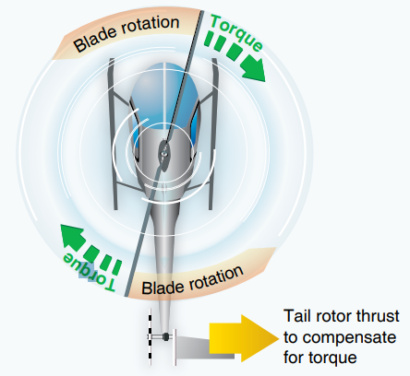  Figure 4 - (FAA Gov, 2016) | 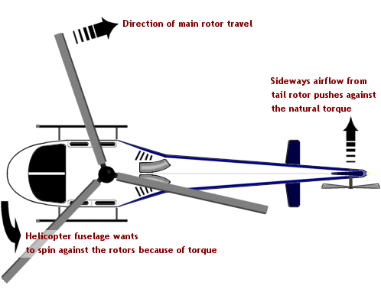  Figure 5 - (Helicopter World, 2018)

Methodology

Rotor Blade Material
Titanium is a low-density element, which is approximately 60% of the density of steel and nickel-based alloys, resulting in Titanium yielding an excellent strength-to-weight ratio. Titanium can be strengthened greatly by alloying, subsequently achieving fatigue strengths up to $600×{10}^{7}MPa$ as shown in Figure 7. Even over a wide range of temperatures, the specific 0.2% yield strength to density figure is much higher for the titanium alloys than other alternative metals as shown in Figure 6. The combination of low density, high strength, stiffness, good toughness and good corrosion resistance provided by various titanium alloys at very low to elevated temperatures allows weight savings in aerospace structures and other high-performance applications ( ASM International. , 2002).
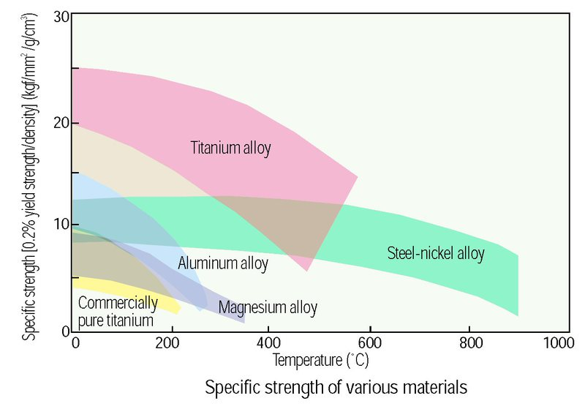  Figure 6 - Specific Strength of Various Materials  (Science ABC, 2017) | 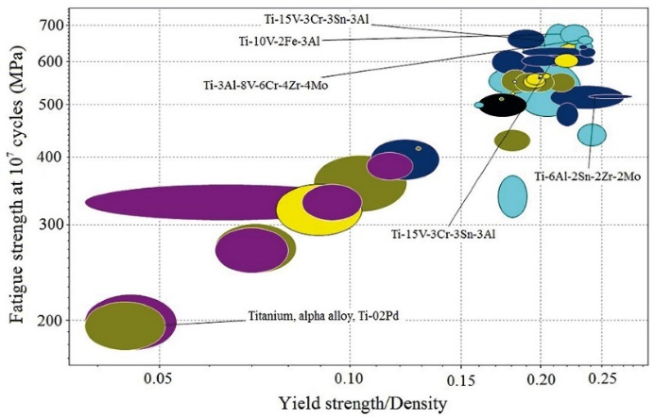  Figure 7 – Yield Strength/Density  (MatLab, 2019).
Ti-6Al-4V, Ti-6Al-2Sn-4Zr-2Mo, Ti-10V-2Fe-3Al, and Ti-6V-2Sn-2Zr-2Cr-2Mo+Si are commonly used for aerospace applications ( ASM International. , 2002) however, this report will assume the Apache’s rotor blades are made from Ti-6Al-2Sn-2Zr-2Mo (SS) as it is the most common titanium alloy grade used for aerospace is according to Nippon (INAGAKI, 2014). The Material properties used within SolidWorks are shown in Figure 8.
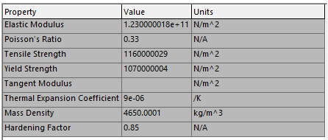
Figure 8 – Titanium Material Specification (SolidWorks, 2019).

Static Analysis

Centre of Mass
To allow stress analysis to be conducted on the part, it is critical that the centre of mass is determined accurately. On review of the rotor blade isolated CAD part, it was found the length was 40mm shorter than the actual model therefore required extending as shown in Table 1. If the shaft was not extended, then the centre of mass would have been incorrectly further down the rotor blade, resulting in all further calculations being wrong.
Using the measurement tool within SolidWorks, the length from central axis to rotor blade tip equals 366mm. | 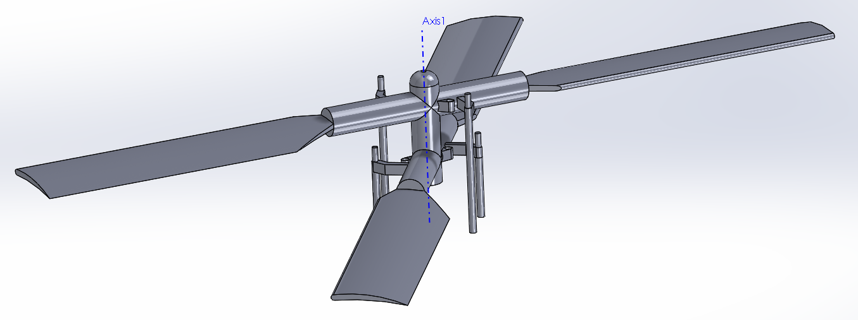
However, the trimmed rotor blade part from Moodle only had a length from model cut to blade tip of 326mm, therefore 40mm shorter than required. | 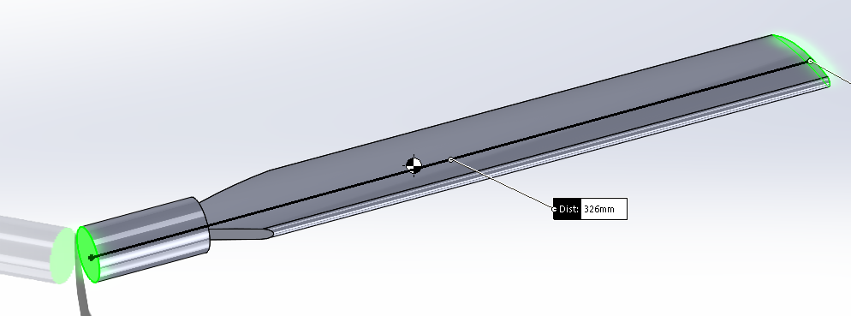
The rotor blade was extended by 40mm to achieve a representative centre of mass value. | 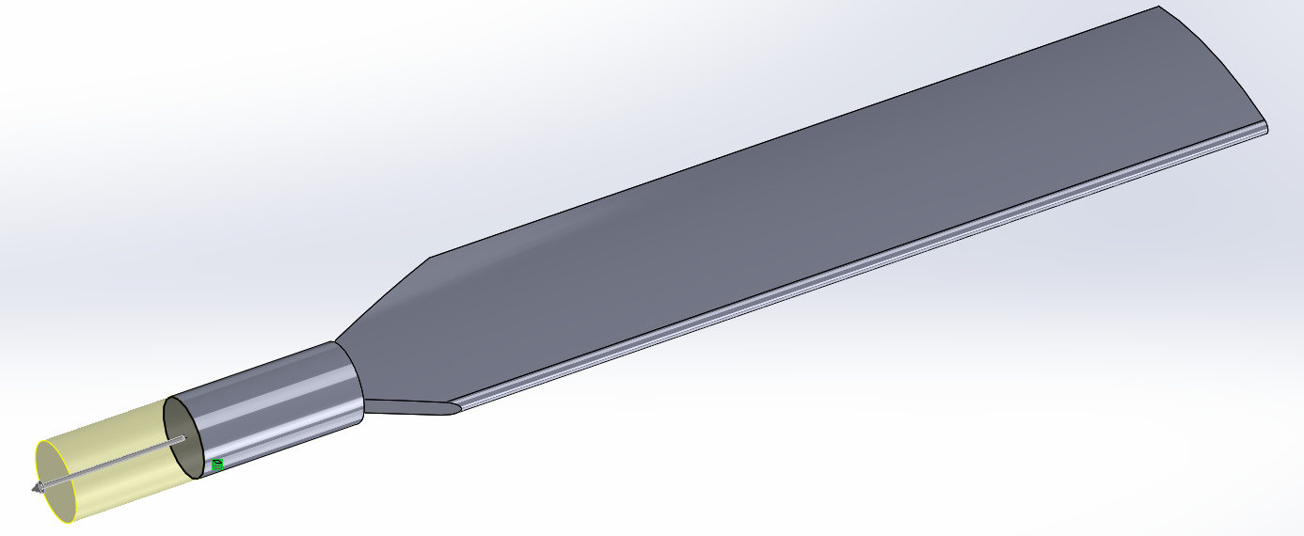
The centre of the mass has moved up the rotor blade towards the shaft end, due to the increased length. | 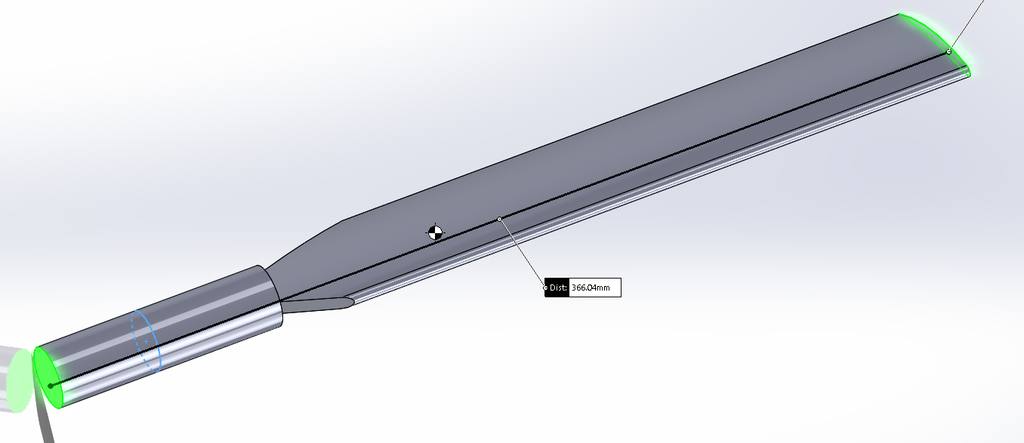
Mass properties calculated within SolidWorks. | 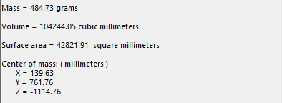
Table 1 - Extending Rotor Blade Shaft to Correct Centre of Mass (SolidWorks, 2019).

Calculation for Angular Velocity (w)
$Linear Angular Velocity \left(w\right) is 1411 RPM from$$CITATION Avi19 \backslash l 2057 (Aviation History, 2019)$$,$
$$w=1411 x \frac{2π}{60} to convert from RPM to the Standard SI Unit rad/s$$
$$w=147.75 rad/s$$

Calculation for Rotor Blade Tip Velocity (v)
$$v=w x r$$
$$v=147.75 x 0.366$$
$$v=54.0765 m/s$$

Calculation for Lift ($F_{L})$
$F_{L}=\frac{1}{2} \left(C_{L} × p × A × v^{2}\right) where,$
$$The coefficient of lift \left(CL\right) is 1.45, value from NACA 63415 from$$
$$airflow rotor blades database$$$$CITATION NAC19 \backslash l 2057 (NACA Airfoil Database, 2019)$$$$.$$
$The air density \left(d\right) is 1.225 {kg/m}^{3}, value from$$CITATION Ric15 \backslash l 2057 (Richard P. Walker, 2015)$.
$$The surface area \left(A\right) of under the blade is 0.016245{ mm}^{2},$$
$value from$$CITATION Sol191 \backslash l 2057 (SolidWorks, 2019)$$model$.
$$F_{L}=\frac{1}{2} (1.45 × 1.225 × 0.016245 × {54.0765}^{2})$$
$$F_{L}=42.195 N$$

Calculation for Drag Force ($F_{D}$)
$F_{D}=\frac{1}{2} \left(C_{D} × p × A × v^{2}\right) where,$
$$The coefficient of drag \left(C_{D}\right) is 0.04 due to streamline part,$$$value from$(Brown, 2010)
$$F_{D}=\frac{1}{2} (0.04 × 1.225 × 0.016245 × {54.0765}^{2})$$
$$F_{D}=0.14426 N$$

Calculation for Centrifugal Force ($F_{C}$)
$$F_{C}=Mw^{2}r$$
$Mass of rotor blade \left(M\right) is 484.73 grams from$$CITATION Sol191 \backslash l 2057 (SolidWorks, 2019)$
$$F_{C}=\left(484.73x{10}^{-3}\right) × {147.75}^{2} × (187.86x{10}^{-3})$$
$$F_{C}=1987.88 N$$

Calculation for Force Acting Along Y Plane
$$Sin Ѳ=\frac{Opposite}{Hypotenus}$$
$$Sin Ѳ= \frac{{ F}_{z}}{F}$$
$${ F}_{z}=F × Sin Ѳ$$
$${ F}_{z}=1987.88 × Sin 25.48$$
$${ F}_{z}=855.18 N$$

Calculation for Force Acting Along Z Plane
$$Cos Ѳ=\frac{Adjacent}{Hypotenus}$$
$$Cos Ѳ= \frac{{ F}_{y}}{F}$$
$${ F}_{y}=F × Cos Ѳ$$
$${ F}_{y}=1987.88 × Cos 25.48$$
$${ F}_{y}=1794.53 N$$

Calculation for Youngs Modulus
$$E=\frac{σ}{ε}$$
$$E=\frac{2.362×{10}^{8}}{1.496 ×{10}^{-3}}$$
$$E=157.89 N/M^{2}$$

Static FEA Analysis
Static analysis is used for determine stresses, strains and displacement caused by forces that do not create notable inertia or damping effects. Static stress analysis often assumes the relationship between the applied load and its structural response is linear and the material follows elastic behaviour (Lee, 2012). To determine the forces that the rotor blade experiences, static simulation analysis was completed.
The blade was modelled as a cantilever beam, this assumption was made because the helicopter blades remain fixed to the main rotor at the blade shaft and free at the blade tip. A fixed force was applied to the shaft, with a remote centrifugal load, and additionally external drag and lift forces as illustrated in Table 2.
Load Type | Load Position | Force Value
Fixed Load –  Shaft | 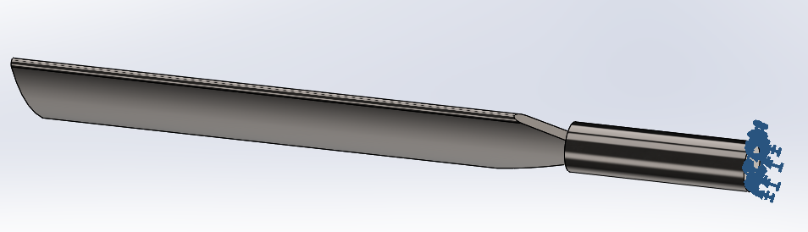 | N/A
External Load –  Drag | 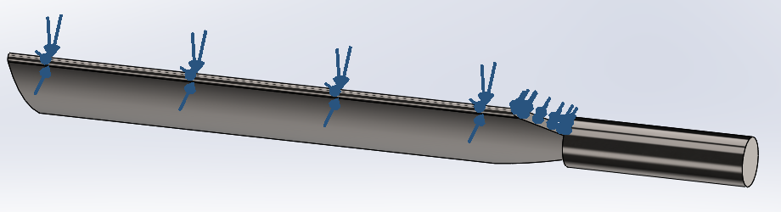 | 0.14426 N
External Load –  Lift | 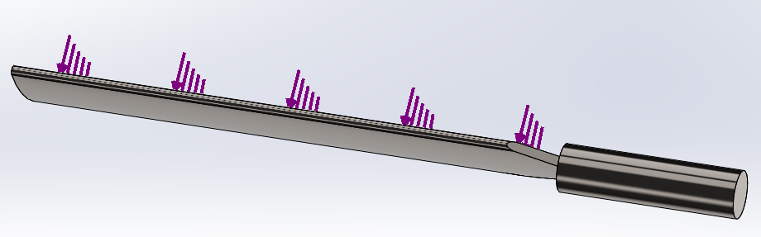 | 42.195 N
Remote Load – Centrifugal | 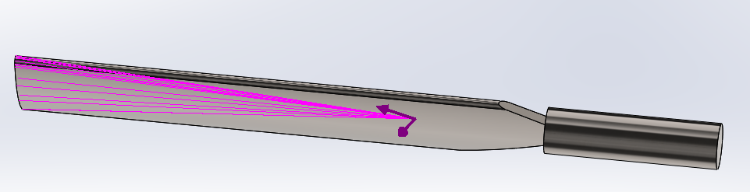 | 1987.88 N  Y = 1794.53 N  Z = 855.18 N
Table 2 - Static Loads Applied in FEA Analysis (SolidWorks, 2019).

Static Stress
The majority of the part is coloured blue as a result of low stress because the shaft is fixed and the blade tip is away from the affected stress zone, see Figure 9. The simulation identified that there are affected areas which are experiencing high stress, see within Figure 10. The stress areas are coloured green, yellow and red. The area which is experiencing the highest stress is concentrated around the joint, which is logical as is a perpendicular sharp-edged feature. If the rotor blade were to be redesigned to replace the sharp edging with instead a chamfer or fillet join then the part would instantly be more resilient to stress or even a material change could be considered. The FEA static stress analysis provided a Von Mises value of $1.328{×10}^{8}N/m^{2}$ which is when the given material will yield or fracture.
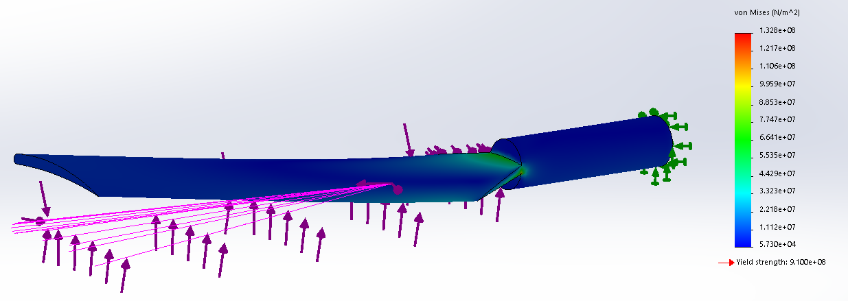
Figure 9 – FEA Static Stress

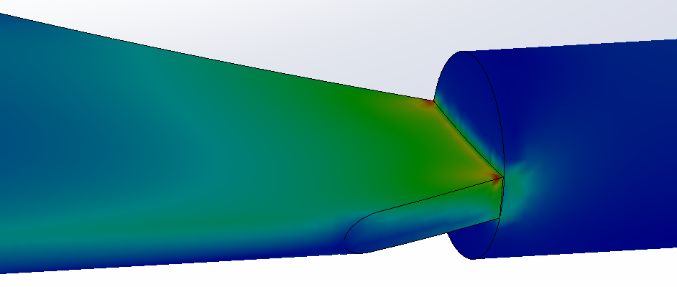
Figure 10 – FEA Static Stress Close Up

Static Strain
Again, the majority of the part is coloured blue as a result of low strain, see Figure 11. The area of high strain is similar to the area of stress, but on the opposite face working in the opposite direction, see within Figure 12. Again, the strain is concentrated around a joint, to reduce the quantity of strain then the rotor blade could be redesigned to replace the sharp edging with instead a chamfer or fillet join. Strain analysis produced an ESTRN value of $8.472×{10}^{-4}$.
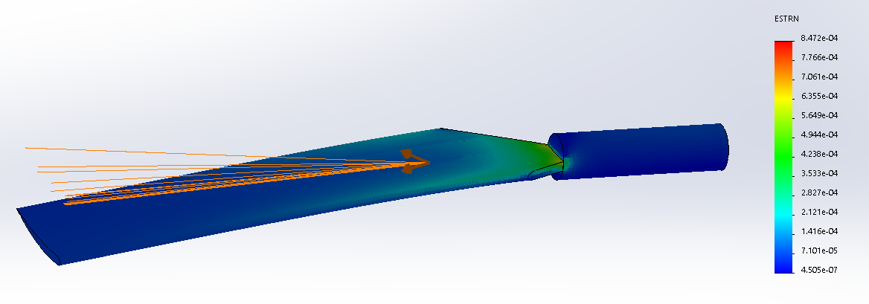
Figure 11 - FEA Strain Analysis
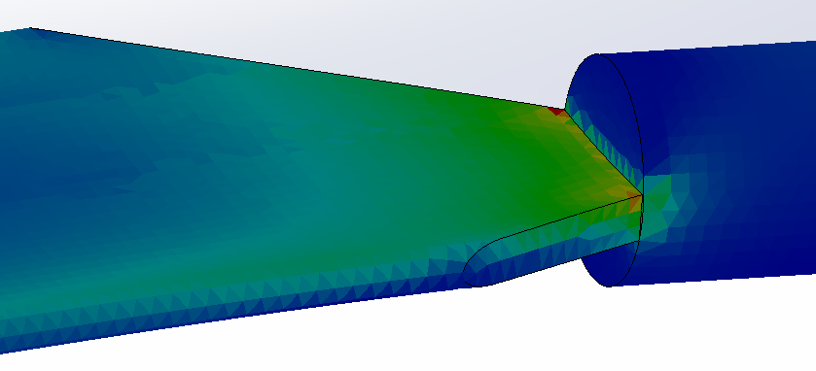
Figure 12 - FEA Strain Analysis Close Up

Static Displacement
Lastly, the static simulation analysed the displacement. As shown in Figure 13 and 14, the changes in displacement all occur from the centre of the blade, with displacement increasing rapidly when moving towards the blade tip.
Assuming that the real part was loaded exactly as simulated and the appropriate mesh was applied, then the maximum deflection would be approximately 27.71mm because the resultant displacement (URES) value is $2.771 ×{10}^{0}mm$. The model is not representative of reality as it is loaded and constrained differently as the fixed-point load would not only act of the shaft end face however, it is a great displacement benchmark for design engineers accessing behaviours of parts.
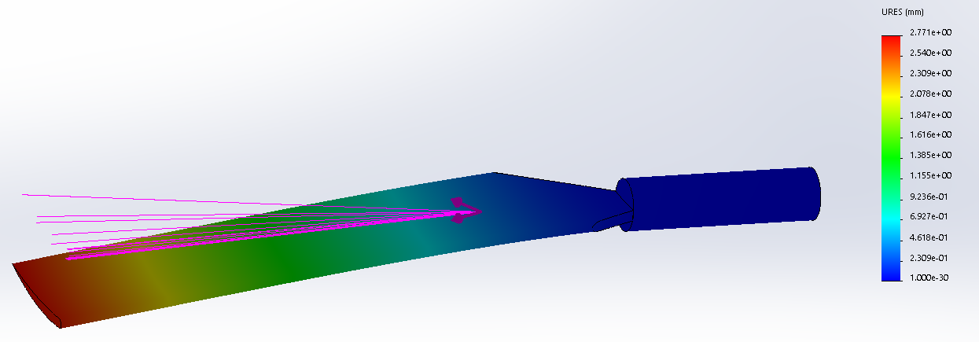
Figure 13 - FEA Displacement Analysis

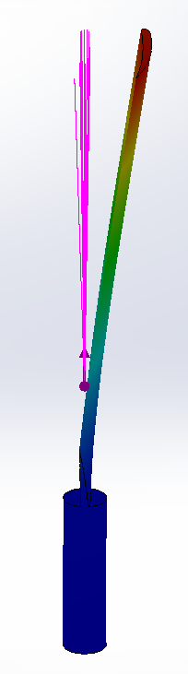
Figure 14 - FEA Displacement Analysis Side Angle

Frequency Analysis
When an object is excited by a dynamic load with a frequency that coincides with one of its natural frequencies, the structure undergoes large displacement and stresses; this phenomenon is known as resonance (King, 2018). For example, the Apache’s rotor blade will shake violently at certain speeds due to resonance, however the shaking decreases or disappears at other speeds.
Each natural frequency is associated with a certain mode shape (Raoufi, 2017). FEA models have a finite number of natural frequencies that is equal to the number of degrees of freedom considered in a model. The natural frequencies and corresponding mode shapes depend on the geometry, material properties and support conditions (King, 2018).

Calculation for the Spin of Tail Rotor Frequency
$$Frequency=\frac{rpm}{60}$$
$$Frequency=\frac{1411}{60}$$
$$Frequency=23.516 Hz$$

FEA Frequency Simulation
Dynamic simulation was used to determinate the characteristics of the natural frequencies and the mode shapes of the rotor blade. Frequency analysis was created with 10 modes as shown in Table 3 to ensure that the analysis included translation, rotation and construction conditions. As the mode number increased, so did the frequency, see Figure 15, this is because each mode increase represents an additional stress or vibration.
Table 3 - FEA Frequency Analysis | 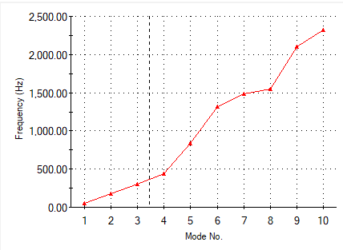Figure 15 - FEA Graph Displaying Frequency to Mode Number
  Mode Number | Frequency (Hertz)
  1 | 48.06
  2 | 181.67
  3 | 308.29
  4 | 441.00
  5 | 835.53
  6 | 1,320.10
  7 | 1,487.20
  8 | 1,547.80
  9 | 2,099.50
  10 | 2,318.50

Modes 1 – 6 as shown in Table 4 are rigid body modes, three translational (TX, TY, TZ) and three rotational (RX, RY, RZ). This means the body will not undergo any internal deformation but will be able to move or rotate freely (Stresse Book, 2015). These first 6 modes will have a low modal frequency. The first six frequencies are below 1350 Hz and vary from 48 to 1320Hz.
First Mode  of Deformation | 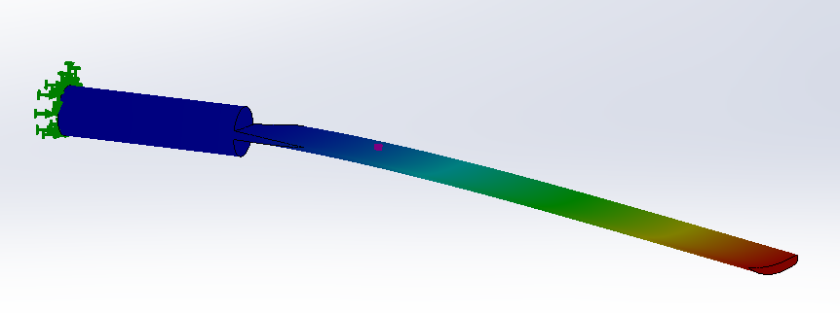
Second Mode  of Deformation | 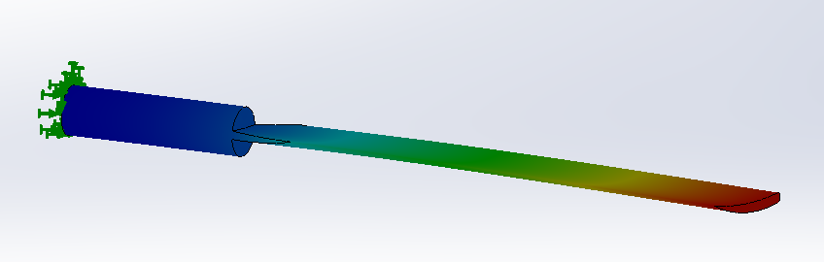
Third Mode  of Deformation | 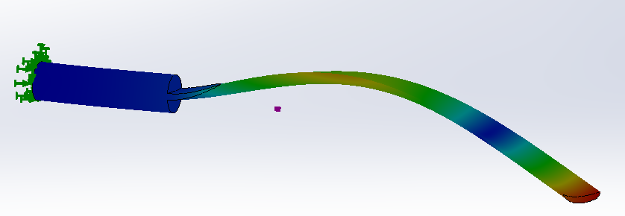
Fourth Mode  of Deformation | 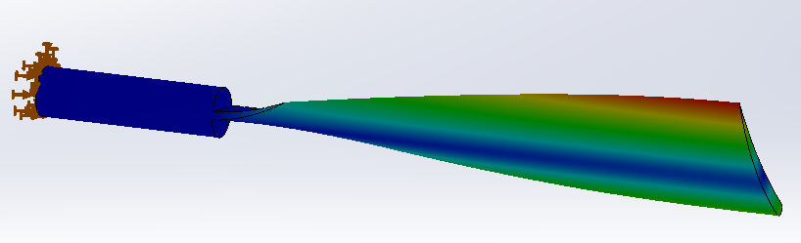
Fifth Mode  of Deformation | 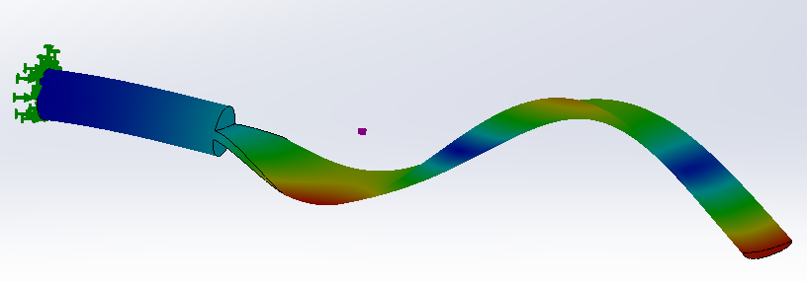
Sixth Mode  of Deformation | 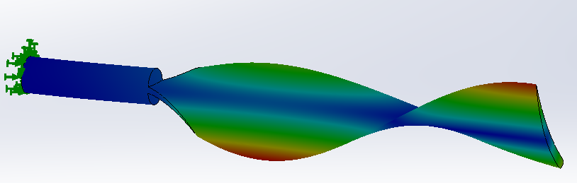
Table 4 - Modes 1-6, Translation

Furthermore, modes 7-10 are categorised as construction modes which includes 1st order, 2nd order, bending and torsional loads. Table 5 shows what the part would look like if it exceeded its natural frequency. The modal frequency for the construction modes peak at 2318Hz which is substantially higher than the translation modes due to the increased vibrations.
Seventh Mode  of Deformation | 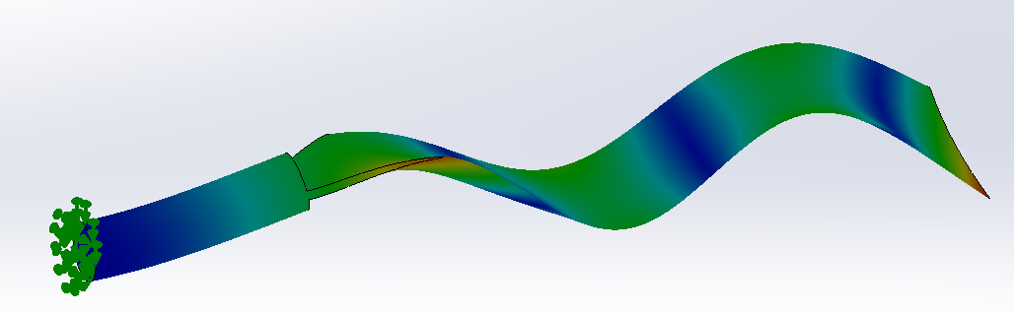
Eighth Mode  of Deformation | 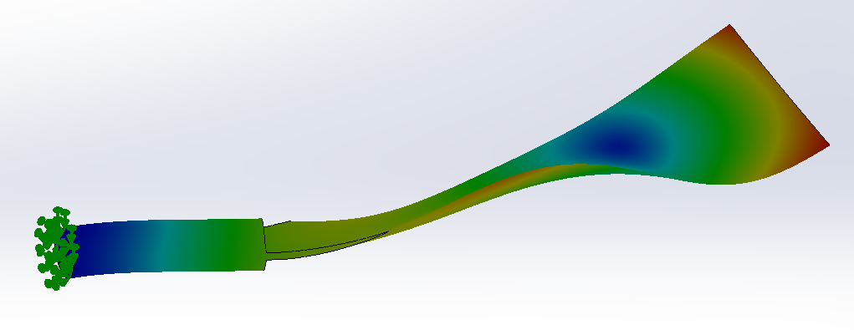
Ninth Mode  of Deformation | 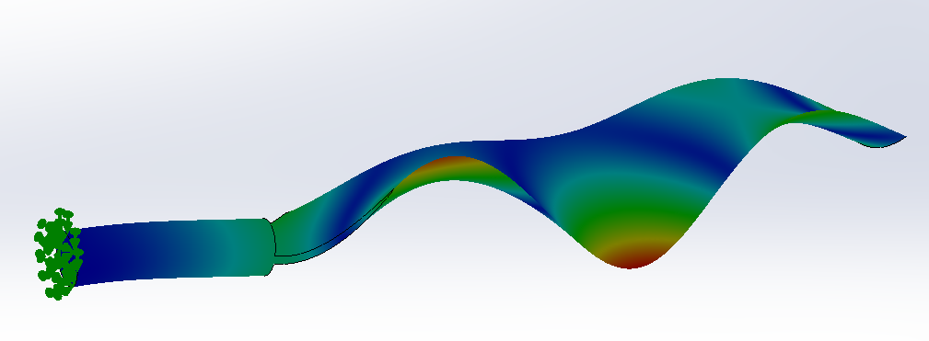
Tenth Mode  of Deformation | 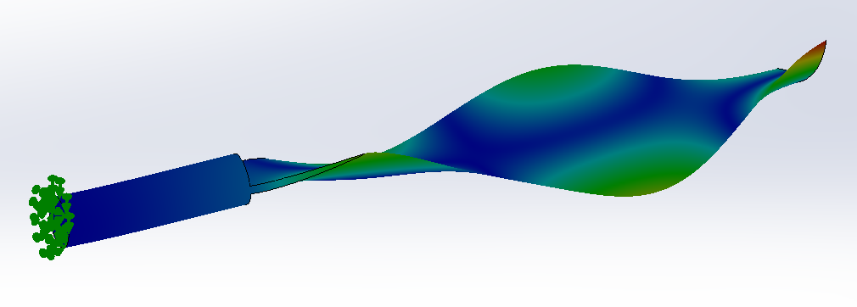
Table 5 - Modes 7-10, Construction

Frequency Calculations vs FEA Simulation Comparison
The hand calculation concluded that the rotor blade would operate at a frequency of 23.52Hz due to the helicopters spin speed however, the FEA first mode frequency value was calculated at 48Hz. There are differences between the calculated and FEA values due to inaccuracies in the model such a scale, material tolerances, geometric tolerances, rounding and more. A limitation of the FEA simulation is that SolidWorks only considers a finite number of degrees of freedom that is equal to the number of degrees of freedom generated in the FEA model structure however, the real rotor blade would have an infinite number of degrees of freedom.
The hand calculated value implies the part is fit for purpose, however FEA implies differently. The rotor blade experiences deformation at all 10 identified mode frequencies however, if surrounding helicopter parts send vibrations at the same frequency as those identified in Table 4 & 5, the deformation will be amplified due to the combined vibrations resulting in greater stress subjected to the rotor blade. All additional stresses to the part will have a negative impact, such as the increased vibrations could cause the part to come loose, wear faster or even create a fracture resulting in breakdown within the part which could result in catastrophic failure and put the lives of the aircraft passengers at risk. With the frequency limitations defined, it is critical that a factor of safety is added to ensure helicopters are not operating close to stress limits. In order for an aerospace vehicle to gain fight approval, the vehicle must have a factor of safety of at least 1.5, according to airworthiness requirements of the Federal Aviation Administration (Federal Aviation Administration, 2005).

Mesh Analysis

Determining Mesh Size
A mesh must be applied before running FEA simulations. Meshing a part creates a pyramid shape along the surface which are called an “element” and the more elements used, the finer the mesh and therefore the better the model is represented. See the visual differences in Figure 16 for a 2mm and Figure 17 for a 6mm mesh size. Table 6 shows the run outputs from the rotor blade FEA analysis. Unfortunately, the finer the mesh also the larger the run time, therefore it is important to determine an appropriately sized mesh, see Table 6.
Mesh Size  (mm) | Number of Nodes | Number of Elements | Number of DOF | Solve Time (Seconds)
1.0 | 868088 | 586903 | 2598429 | 136
2.0 | 139817 | 88364 | 417903 | 20
2.4 | 80524 | 48934 | 240462 | 16
2.8 | 67777 | 41162 | 202380 | 12
3.2 | 55052 | 32878 | 164376 | 11
4.0 | 21888 | 12251 | 65214 | 05
6.0 | 8145 | 4139 | 24231 | 03
Table 6 - Table Displaying the Impact of Mesh Size on Run Time (Information populated from (SolidWorks, 2019)).

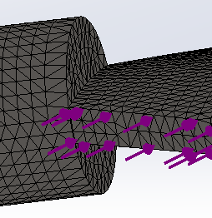  Figure 16 – 2mm Mesh (SolidWorks, 2019). | 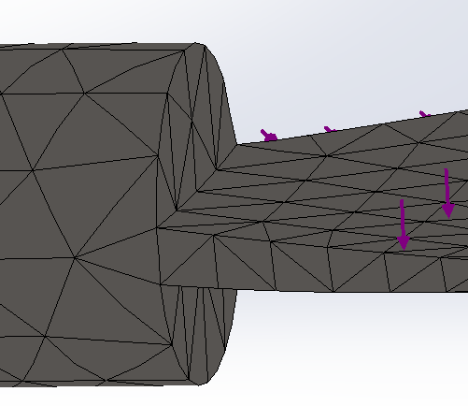  Figure 17 - 6mm Mesh (SolidWorks, 2019).
All FEA simulation results were produced using a 2mm sized standard mesh which is the recommended mesh size based on SolidWorks Help Forum (SolidWorks Help, 2019). The 2mm mesh size was calculated from 30% of the 6mm value representing the thinnest dimension of the part (SolidWorks Help, 2019).

Mesh Improvements
To improve the stress analysis results, the static stress simulation was repeated with an adaptive mesh. The H-adaptive method was chosen as shown in Figure 18 as it adjusts the size of the mesh in areas of the model where a smaller mesh is needed, such as high stress points. (Hawk Ridgesys, 2019) explains that the software achieves the target accuracy by measuring the change in strain energy and stops iterations when two consecutive values differ by less than the given value. Adaptive meshing is more time consuming than a normal mesh, but it is best for situations where the accuracy of the result needs to fall within a narrow margin (Kurowski, 2015). Figure 19 and 20 shows less stress on the corner parts due to more accurate mesh, further work can be completed to analysis the improvements in the stress analysis results using the H-Adaptive mesh.
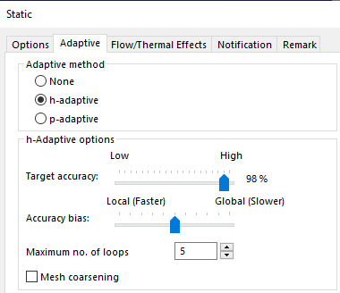
Figure 18 - H-Adaptive Mesh

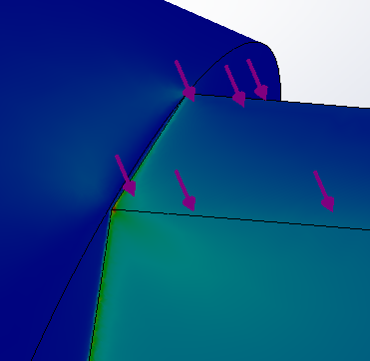  Figure 19 - Static Stress Simulation with H-Adaptive Mesh | 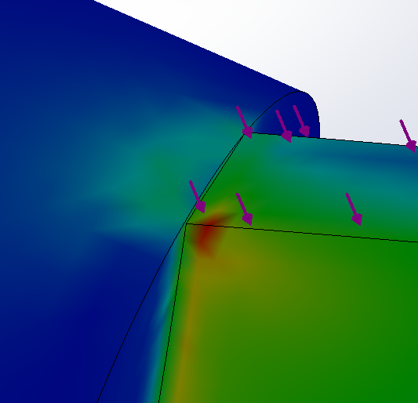  Figure 20 - Static Stress Simulation with Standard Mesh

Analysis Inaccuracies
This report has successfully analysed the Apache’s rotor blade overall strengths and weakness, see Table 7.
 | Critique | Recommendation for Approval
Inaccuracies in Analysis | The Apache SolidWorks model is not to the correct scale to represent real helicopter. | Create Apache helicopter to scale on SolidWorks
Inaccuracies in Analysis | Dimension inaccuracies within the model in comparison to real Apache helicopter, i.e shaft diameter is wrong even scaled up. | Create Apache helicopter to scale on SolidWorks
Inaccuracies in Analysis | Geometric tolerances from manufacturing or machining not included. | Determine geometric tolerances and include tolerance stack up for upper and lower conditions.
Inaccuracies in Analysis | SolidWorks uses a pure material for analysis, where in reality the material will have impurities. | Contact material provider to collect more realistic material specification information
Inaccuracies in Analysis | The use of titanium rather than composite material. Analysis would benefit from comparing data results using different materials. | Repeat analysis with a composite material rather than titanium to be more representative of current aerospace components.
Inaccuracies in Analysis | Lack of boundary condition. | Further improve analysis by implementing a boundary condition to attach rotor blade too for FEA studies.
Inaccuracies in Analysis | Both hand calculations and FEA calculations make assumptions such as no other forces acting on the rotor blade other than the forces mentioned. | Further research other forces acting upon the rotor blades, determine quantitative load values to allow calculations to be updated.
Inaccuracies in Analysis | Analysis was not completed at a range of environmental conditions such as high heat and low heat which would be representative of the user requirements. | Repeat analysis to include variety of environmental conditions to evaluate the affects experienced.
Inaccuracies in Analysis | Locked rotor blade design means the analysis is fixed, consider redesign in attempt to make efficiency improvements. | Consider modifying rotor blade design to reduce stress point, improve angle of attack to change the coefficient of lift etc.
Inaccuracies in Analysis | Availability to improve meshing of model. | Continue to look into advanced meshing techniques such as H-Adaptive to further analysis results.
Inaccuracies in Analysis | No fatigue results included within analysis. | Complete fatigue study to understand the number of cycles the part can withstand.
Table 7 - Analysis Appraisal

Conclusion
To conclude, the report used one of the most commonly used titanium materials named Ti-6AL-2Sn-2Zr-2Mo to complete the analysis. The titanium grade has a high yield/density to fatigue properties, highly resistant to environmental changes and is appropriately priced. It would be beneficial to repeat the analysis with alternative materials to ensure the right material has been selected.
Completing the analysis both by hand calculations and FEA simulated studies was useful to be able to make a comparison between the analysis methods. Both methods achieved similar results, as well as both relying heavily on geometric, material and environmental assumptions. FEA software is extremely useful to many industries, including aerospace due to its ease of use and ability to save time and money. Companies can test and verify various designs on a computer rather than having to build them, which is extremely beneficial when evaluating part as large and as complex for an Apache helicopter.
The report concluded mixed outcomes. The FEA simulation implies that the part is fit for service as it is capable of withstanding the known loads and frequencies, however hand calculations have determined that the rotor blade is not fit for purpose. More analysis is needed to improve the results and give a more accurate, definitive result.
Moreover, the report would benefit hugely from completing a fatigue study to gain an understanding of how many cycles the rotor blades can withstand. It is critical to understand when the parts need replacing because if the tail rotor system isn’t responding as expected, a considerable amount of time can be spent troubleshooting the problem. Every hour or day spent troubleshooting the tail rotor, is one less hour or day the Apache is not able to support the soldiers on the front line.
To improve the analysis, it is recommended to consider the improvement comments listed in Table 7. To summarise, there is a large availability to improve the accuracy of the analysis completed by modelling a full-scale Apache helicopter and rotor blades, then the FEA simulation would be more representative. Additionally, the result of the analysis could be improved by reducing the stress subjected to the rotor blade design by considering redesign of the blade, mounting mechanism or even a material change.

Reference Table
ASM International. , 2002. Introduction to Selection of Titanium Alloys. Titanium: A Technical Guide, 2nd Edition.
Air Recognition, 2019. AH-64 Apache Attack Helicopter. [Online]
Available at: https://www.airrecognition.com/index.php/world-air-force-military-equipment-aircraft-/north-america/united-states-air-force/united-states-american-us-air-force-usaf-helicopter-technical-data-sheet-specifications-intelligence-description-information-identi
Aviation History, 2019. AH-64 Apache. [Online]
Available at: https://www.thisdayinaviation.com/tag/ah-64-apache/
[Accessed November 2019].
BBC, 2019. Apache flight path over Essex 'hotspot' raises concerns. [Online]
Available at: https://www.bbc.com/news/uk-england-suffolk-48625846
[Accessed November 2019].
Boeing, 2019. Boeing. [Online]
Available at: https://www.boeing.com/defense/ah-64-apache/
Brown, T. M. F. a. R. E., 2010. Helicopter Tail Rotor Thrust and Main Rotor Wake Coupling. JOURNAL OF AIRCRAFT, 47(6).
FAA Gov, 2016. Helicopter Flying Handbook, s.l.: Regulatory Policies FAA Gov.
Federal Aviation Administration, 2005. Airworthiness Requirements for Airships. Washington: U.S. Department of Transportation.
Hawk Ridgesys, 2019. Adaptive Meshing. [Online]
Available at: https://hawkridgesys.com/blog/simulation-adaptive-meshing
[Accessed October 2019].
Helicopter World, 2018. Coaxial Helicopters. [Online]
Available at: https://www.rc-airplane-world.com/coaxial-rc-helicopters.html
[Accessed October 2019].
INAGAKI, I., 2014. Application and Features of Titanium for the Aerospace Industry. NIPPON STEEL & SUMITOMO METAL TECHNICAL REPORT.
King, R. H., 2018. Finite Element Analysis with SOLIDWORKS Simulation. Australia: Technology & Engineering.
Kurowski, P., 2015. Engineering Analysis with SOLIDWORKS Simulation. s.l.:SDC Publications.
Lee, Y.-L., 2012. Metal Fatigue Analysis Handbook. Michigan: Elsevier Inc..
MatLab, 2019. Titanium Analysis. [Online].
McClements, D., 2019. Top 9 Aerospace Companies. [Online]
Available at: https://newengineer.com/insight/top-9-aerospace-companies-1113357
NACA Airfoil Database, 2019. AirFoil NACA 63415. [Online]
Available at: http://airfoiltools.com/airfoil/details?airfoil=n63415-il
[Accessed November 2019].
Raoufi, C., 2017. Applied Finite Element Analysis with SolidWorks Simulation. Canada: CYRA Engineering Services Inc.
Richard P. Walker, A. S., 2015. Wind Energy Essentials. New Jersey: John Wiley & Sons.
Science ABC, 2017. Helicopter Flight Paths. [Online]
Available at: https://www.scienceabc.com/eyeopeners/cant-helicopters-fly-high-altitudes-engine-everest-rescue.html
[Accessed November 2019].
SolidWorks Help, 2019. SolidWorks. [Online]
Available at: https://help.solidworks.com/2018/English/SolidWorks/cworks/IDC_HELP_MESHSOLID.htm
[Accessed November 2019].
SolidWorks, 2019. SolidWorks FEA Analysis, United Kingdom: s.n.
Stresse Book, 2015. Rigid Body Mode. [Online]
Available at: http://www.stressebook.com/rigid-body-mode/
[Accessed November 2019].
Tucker, S. C., 2015. Instruments of War: Weapons and Technologies That Have Changed History: Weapons and Technologies That Have Changed History. Colorado: ABC Clio.
UWTSD Moodle, 2019. Moodle. [Online]
Available at: https://moodle.uwtsd.ac.uk/
[Accessed October 2019].
Willmin, D., 2017. The Apache in European Service. United Kingdom : Fonthill Media Limited.
Woodford, C., 2018. Explain That Stuff. [Online]
Available at: https://www.explainthatstuff.com/helicopter.html
[Accessed October 2019].

