
Applied Leadership and Management in the Workplace
Module Assignment Submission
Student Name: | Whitney Davies
Student Number: | 2329046
Module No: | BMSK4014
Module Title: | Problem Solving and Decision Making
Statement of Confirmation of Authenticity
By the act of making this submission, the student declares that this is the work of the student named above. The work has not, in whole or in part, been knowingly presented elsewhere for assessment, or where assessment has been built on a previous assessment, this has been identified. Where materials have been used from other sources it has been properly acknowledged. If this statement is untrue, the student acknowledges that an assessment offence has been committed.
Attention is drawn to the plagiarism and unfair practice policies of both the University and of ILM.

Table of Contents
Brainstorm 3
Mind Map 3
Flowchart 5
5 Whys in action 6
Fishbone 6
Evaluation 7
Grid Analysis 7
Financial evaluation of Grid Analysis result 7
Cost/Benefit & analysis (is it worth the money or price) 7
Benefit to cost ratio 8
Develop a detailed plan for implementing the solution 8
Gantt Chart 9
Stakeholder Analysis 10
Communicate the plan to relevant stakeholders 11
Project Communication Plan 11
Assess appropriate monitoring and review techniques to ensure successful implementation of solution 13
References 14
Appendix A – Feedback Questionnaire 15

Nature, Scope and Impact
The nature of my problem is administrative, it’s project delays. The scope of this problem is stakeholders (clients, all employees, families) and the shareholders. The impact for each of these is different. *(Stakeholders are someone that have an interest in whether the company wins or fails).
- For clients is poor quality work, late results
- For the company its bad reputation, loss of work and client, loss of money
- For shareholders it’s also a loss of money (Shareholders own a part/they have invested money)
- For myself it’s a possibility of job loss, money loss and loss of my house.
Impact
- Why is this a problem? This is a problem because they result in unhappy clients or loss of money – due to timings being out of scope and not agreed.
- What is causing the problem? Unorganised work, no availability, we come across some interruptions/disruptions.
- Who is causing the problem? Both sides, client and auditor side
- Who is this affecting? The company and the client, shareholders the employees
- How long has the problem been happening? Since the service has been offered
- How long is the solution going to take? A month or so. We should factor in how long each task should take.

Brainstorm
Before we jumped into any decision to solve our problem, we decided to brainstorm. I asked people from different departments/backgrounds to join the brainstorm to get their ideas for a solution as they will have their own opinions and experiences. A brainstorm is a good way to collaborate thinking.
Collaborate thinking is good because people can voice their thoughts and ideas, and all ideas (whether good or bad, they can spark other good ideas).
Once we came up with a few ideas, we had a coffee break and then we came back and revisited the ideas and we were able to identify some with potential. Then together a few ideas for a solution can be made.

Mind Map
During our brainstorming session, we wrote down our ideas and we created a mind map of our discussions about it. This is a good system to use because you can visually follow the stages and what was discussed on each topic.
A mind map can also be used as a way of problem solving.
Tony Buzan in 1974 launched his own version of the Mind Map. According to Edraw Content Team (n.d.) mind map techniques have been used since 300 A.D. Tony Buzan was influenced by Charles Darwin’s tree-like technique explaining his theory of evolution.
I recreated the mind map that was created during our brainstorm session.
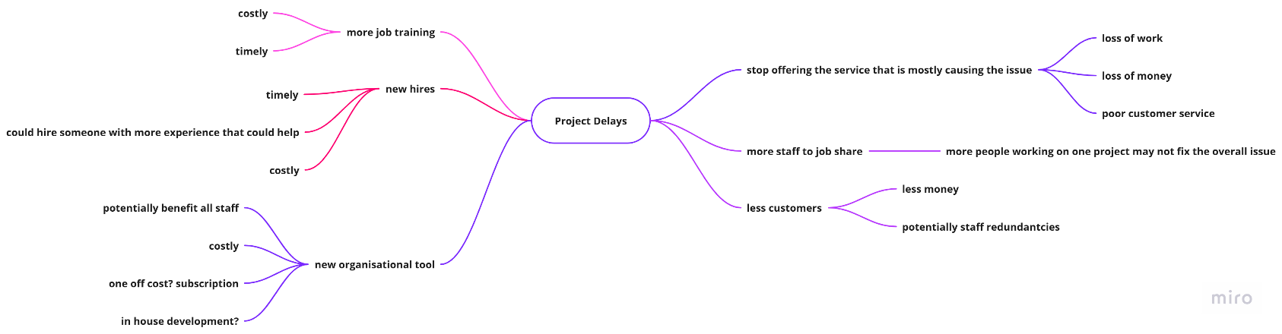
It’s also a way of problem solving.
- Good way to record all ideas
- Provides visibility
- Shows links and relationships between ideas
- It’s adaptable
- It shows the factors that need addressing
- You could show your mind map to anyone and it should be easy enough for them to understand

Flowchart
According to Miro (2024), the website I used to create my diagrams including the flowchart explains that the flowchart is a diagram which is used to visually explain a process or workflow.
Research by (UCL, 2021), explain that flowcharts were first introduced in 1921 as process chart by industrial engineers Frank and Lillian Gilbreth to the American Society of Mechanical Engineers (ASME). The emphasise that the most important part of a flowchart is it’s readability, flowcharts can easily become too complicated to follow which then defeats the purpose of creating one.
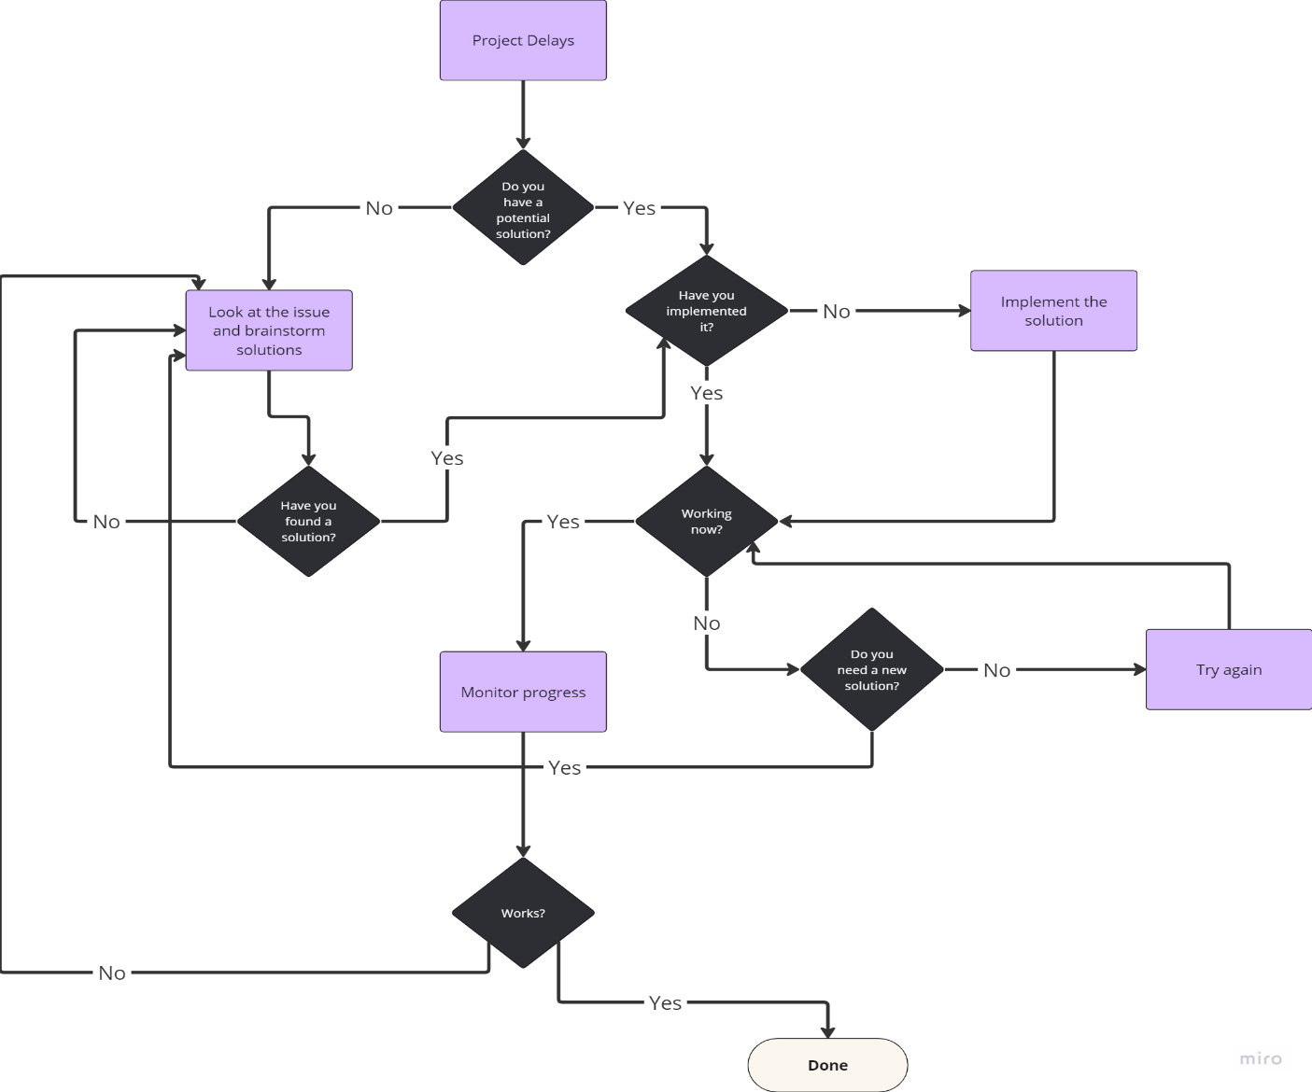
The benefits of using flowcharts they should be easy to follow and offer visual clarity to the reader and it can be a good way to improve communication especially around explaining processes and how things work, it can simplify complex operations.

5 Whys in action
The 5 whys are a problem solving technique, according to Mind Tools Content Team (2022) it was created by Sakichi Toyoda, the founder of Toyota Industries in 1930s. It still used by Toyota to solve problems within the company to this day.
- Why are the clients becoming unhappy?
Because of the project delays
- Why is there project delays?
Because people aren’t organising their work correctly and there isn’t any process to follow
- Why aren’t they organising their work correctly?
Because there isn’t a set process
- Why isn’t there process?
Because there isn’t a program or plan for them
- Why isn’t there a program or plan?
Because one has never been implemented

Fishbone
The Fishbone diagram also known as Ishikawa is a helpful diagram to use to show the flow of the processes/issues that impact and cause our problem. Paredes (2024) explains that, Japanese engineer Kaoru Ishikawa developed the method in the 1960s, which is why it’s called the Ishikawa diagram. Cotton (2024/2016), the Ishikawa Fishbone Diagram was originally invented as a product improvement tool, it now used on a much bigger scale as a problem solving tool.
The term Fishbone came from how the diagram looks visually. The fishbone diagram shows us the multiple factors that can impact the problem. It helps us think about what area to focus on for our solution.
Material
People
Method
Technology
Low quality work
Too much work
Lack of organisation
Lack of communication
Poor scheduling
Project Delays
Old/broken/unreliable equipment

The area I have decided to focus on is the Method, as I believe that this is the MAIN cause, due to poor scheduling and lack of organisation.

Evaluation

Grid Analysis
Grid Analysis is a useful technique to use for making a decision.
It is most effective where you have a number of good alternatives and many factors to into account.
The way this works is if you score each potential solution against the factors first (using 0 (poor) – 3 (very good)) then add weights to your factors based on how important they are, you then multiply your original score with your weighted score for each factor and then you add them up in the totals. The highest scorer is the one.
Factors: | Cost | Time | User friendly | Efficiency | Total:
Weights: | 2 | 1 | 2 | 4
New App/Program | 0 / 0 | 1 / 1 | 3 / 6 | 3 / 12 | 7 / 19
Excel | 3 / 6 | 2 / 2 | 1 / 2 | 2 / 8 | 8 / 18
Paper diary | 1 / 2 | 3 / 3 | 3 / 6 | 1 / 4 | 8 / 15
Whiteboard | 2 / 4 | 2 / 2 | 2 / 4 | 0 / 0 | 6 / 10
The Grid Analysis chart above shows that the best option is a new app or a new program. Further analysis will be conducted to ensure the solution is financially viable.

Financial evaluation of Grid Analysis result

Cost/Benefit & analysis (is it worth the money or price)
The Cost/Benefit analysis when done correctly will show us whether the solution we’ve come up will be financially viable for the company.
Being financially viable means that the company can generate the money they’ve spent, if not make more.
If the option is not financially viable, the tables below would show a minus figure, indicating rather than a positive figure which means a gain.
The table below shows the costs to the company over the next 5 years.
 | Year |  |  |  |  | Cost (£) Total
 | 1 | 2 | 3 | 4 | 5
Purchase of App/Program | 200,000 | - | - | - | - | 200,000
Net cost of purchase | 200,000 |  |  |  |  | 200,000
Subscription Fee |  | 10,000 | 10,000 | 10,000 | 10,000 | 40,000
Total Costs | 200,000 | 10,000 | 10,000 | 10,000 | 10,000 | 240,000
The table below contains the benefits/savings for the next 5 years.
Benefits | Year |  |  |  |  | Total
 | 1 | 2 | 3 | 4 | 5
Less out of scope work | 30,000 | 35,000 | 42,000 | 42,000 | 42,000 | 191,000
More clients | 500,000 | 1,000,000 | 2,000,000 | 1,000,000 | 3,000,000 | 9,000,000
Total Benefits | 530,000 | 1,035,000 | 2,042,000 | 1,042,000 | 3,042,000 | 7,691,000

Benefit to cost ratio
Benefit to cost ratio shows the return on investments. This is worked out by taking the net benefits and dividing that by the net costs. In this instance it’s the (benefit) £7,691,000 divided by (cost) £240,000. Resulting in a benefit to cost ratio is 32.04:1 which means £32.04 for every £1 that we spend.
The net annual benefit shows the net benefit for each of year of the project. For the solution this works out at a net annual benefit of;
- The net annual benefit 1st Year (annual benefit) £530,000 – (annual cost) £200,000 = £330,000
- The 2nd Year net annual benefit (annual benefit) £1,035,000 – (annual cost) £10,000 = £1,025,000
- The 3rd Year net annual benefit (annual benefit) £2,042,000 – (annual cost) £10,000 = £2,035,000
- The 4th Year net annual benefit (annual benefit) £1,042,000 – (annual cost) £10,000 = £1,032,000
- The 5th Year net annual benefit (annual benefit) £3,042,000 – £10,000 = £1,022,000.
My annual benefit = total benefits – total costs
7,691,000 – 240,00 / 5 = £ 1,490,200
Based on the numbers above, this plan would be financially viable as the results show how much money the company could earn/save over the next 5 years.

Develop a detailed plan for implementing the solution
The solution to solve project delays is to purchase a company membership/subscription to a project management website/application (“the program”).
The program would have a user account for each employee, they’d have their own calendars and once they’ve entered the project they’re working on, they’d need to enter tasks they have and the deadlines and this will be available for everyone to view when they view that person’s profile. This will show those who are hoping to work with them, the workload that they have and whether they can invite them to work on another project or any potential timing conflicts.
It will also include a kanban view for their tasks. The kanban view is a task tracker, you can name the columns what you want for example “Backlog”, “Doing”, “Done” and “Cancelled”.
If they are able to see the tasks they have experience in this could help to run projects more smoothly it may help them assign tasks to those who have more skills in the area.
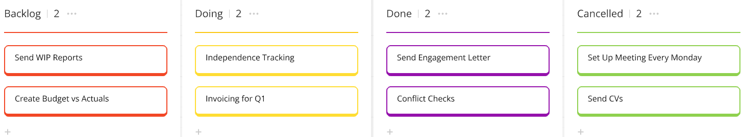
I have created an example of a Kanban Board below.

The estimate for the plan is that it’ll take roughly two months to find the right program for us. Then we’ll give a month for the purchasing of the program, purchase orders may need to be raised and purchases may have to be authorised by a few managers/directors.
Then the best practice is to allow someone or two people to practice on the program and get familiar. We will call these “superusers” or the “SME” (Subject matter experts). The superusers will then give the training to the rest of the company, broken down by depts over a few months.
The official implementation day will be after that and then we can monitor the progress by getting feedback from employees on a regular basis. This is ensure that any confusion/issues can be resolved in the early stages. The way that I will monitor the progress of this solution is to get SMART objectives for the team and then have regular progress meetings.
I will set up a Gantt Chart to reflect the plan.

Gantt Chart
In the article written by (Lyons, 2018), Henry L. Gantt introduced the first concept of a Gantt Chart during the 19th Century. It is stated that the first ‘Gantt Chart’ was designed more similar to a table than a chart, but it was still one of the first instances of a deliverable vs time model.
The Gantt chart is a useful process to use because it shows which task needs to be done and by when. In the example I created below, I also colour coded it based on the stages and I’ve also added the initials of the employees that are responsible for that task.
Task | Jan | Feb | Mar | Apr | May | Jun | Jul | Aug | Sep | Oct | Nov | Dec
Research the best application | JG | JG
Buy the subscription |  |  | WN
Train a super user |  |  | GG | GG | GG
Train employees |  |  |  |  | DF | SH | DF | SH | DF
Implement the program |  |  |  |  |  |  |  |  | HR
Feedback |  |  |  |  |  |  |  |  | EMP | EMP | EMP | EMP
Planning Stage
Purchasing Stage
Training Stage
Implementation Stage
Feedback Stage

Stakeholder Analysis
When you are conducting a stakeholder analysis, it’s important to be honest about the needs of your company. You will need to look at each stakeholder and think about their position on the influence/interest matrix.
In 1997 (Mitchell, Agle et al. 1997) created a classification of stakeholders, this was based on their power and their influence on the company. The results of the analysis would help answer the question "which groups are stakeholders deserving or requiring manager’s attention, and which are not?"
In the publication by (Mendelow, 1981), it is referred to as the dynamism of the environment and the power of the stakeholders regarding the organisation. The process of developing the environmental scanning system is then discussed.
Environmental scanning is described by (Thomas Edison State University (2019)) as the process of gathering information about scenarios in the company's internal and external areas. This would enable the management to decide the future of the company.
Stakeholders mapping is a 4 step process:
- Identifying groups, organisations, and people who are stakeholders
- Analysing stakeholders' perspectives and interest
- Mapping the relationship between stakeholders and company objectives
- Prioritising and ranking stakeholders
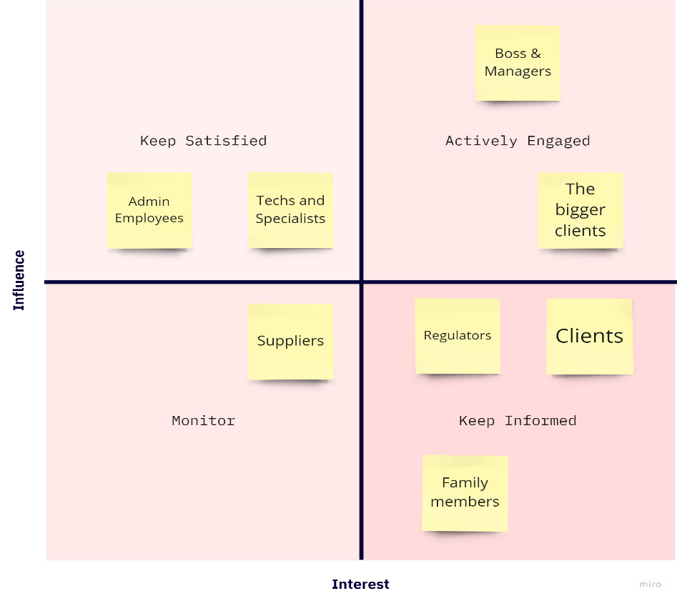
Below is a stakeholder analysis of my company’s stakeholders.

Communicate the plan to relevant stakeholders

Project Communication Plan
According to APM (2017), While sharing information with stakeholders is crucial to a project's success, it's just as important to first gather insights about them. Understanding the factors that influence how stakeholders receive, interpret, and respond to information enables you to change your communication strategies effectively. This approach ensures that your messages are clearly understood and that you achieve the desired outcomes.
Ineffective or inadequate communication often leads to project issues like unclear objectives, misunderstandings, poorly coordinated teamwork, and weak risk management. Achieving effective outcomes and realising benefits depends on strong communication, which requires an understanding of your stakeholders and ongoing evaluations of your engagement approach.
APM (2017) states that success in any project is largely determined by the satisfaction of stakeholders. Without proper consultation, project plans are based on assumptions, leading to potential misalignment with actual needs. Additionally, stakeholders may change their minds or forget initial agreements over the course of the project. Therefore, maintaining regular contact with most, if not all, stakeholders is essential to ensure alignment and successful delivery.
Applying this principle offers several benefits, including:
- Increased likelihood of project success due to clear agreement on deliverables.
- Reduced misunderstandings, conflicts, and delays through established working relationships.
- Faster problem-solving and opportunity realization.
- Greater reliability in plans and documentation.
- Smooth handover of outputs at designated project milestones.
Below is a communication plan for the potential solution to my problem. It explains the what, who, when and how items will be communicated and who is responsible for relaying the information.

Assess appropriate monitoring and review techniques to ensure successful implementation of solution
Once we have the software/app implemented, we can start using the Kanban regulary for all project tasks and objectives. Until it’s implemented, to monitor the progress of this project, we will refer back to the Gantt Chart regularly and have bi-weekly status calls/meetings to discuss whether everything is still on track and who currently responsible the stages as we progress. Along side the Gantt Chart we will use SMART Objectives in an action plan.
The Action Plan is below.
Area | Action | Measurement
Research & Planning | - Create a list of 5 project management website/app | Project team to review the list and choose 1. (2 months)
Purchasing | - Gain approval and raise the purchase order to buy the program or subscription | Purchase the program or buy the subscription (1 month)
Training | - 2 employees will practice and become familiar with the app/program | The 2 employees will become “super users” or SME and give a demo to the Project Team (3 months)
Training | - The 2 super users to provide training to the company | Broken down by dept the super users will give training to the employees.(5 months)
Implementation | - HR to announce the official start date of the new program | HR will send emails companywide to ensure everyone is aware of the start date (1 month)
Feedback | - Send surveys or feedback questionnaires | Receive AT LEAST 60% of the company feedback responses over the 4 months to make sure that any confusion/issues can be resolved in the early stages
Using the action plan above, the Gantt chart and the bi-weekly status calls, this project can be monitored and delivered successfully.
The actions in the action plan are specific, measurable, achievable, realistic and time-bound. Everyone will clearly know the stage they’re responsible for and when they need to complete it. Once the project is mostly completed and the company is using the new website/program, the final stage is to monitor the progress with feedback questionnaires and surveys (Appendix 1) this will check the success of the solution.

References
APM. (2017, June 28). Communicate. Www.apm.org.uk. [online] Available at: https://www.apm.org.uk/resources/find-a-resource/stakeholder-engagement/key-principles/communicate/ (accessed on 24/08/2024)
APM. (2017a). Consult early and often. Www.apm.org.uk. [online] Available at: https://www.apm.org.uk/resources/find-a-resource/stakeholder-engagement/key-principles/consult-early-and-often/ (accessed on 24/08/2024)
Cotton, D. (2016). The smart solution book : 68 tools for brainstorming, problem solving and decision making. Pearson. (Original work published 2024)
Edraw Content Team. (n.d.). Mind Mapping and 7 Key Steps by Tony Buzan for Developing Mindmaps. EdrawMind. [online] Available at: https://www.edrawmind.com/article/tony-buzan-biography.html (accessed on August 8, 2024)
Mendelow, A. L. (1981). Environmental Scanning--The Impact of the Stakeholder Concept. ICIS 1981 Proceedings, 20(1). [online] Available at: https://aisel.aisnet.org/icis1981/20 (accessed on 20/08/2024)
Mind Tools Content Team. (2022). 5 Whys. [online] Available at: https://www.mindtools.com/a3mi00v/5-whys (accessed on 23/08/2024)
Mitchell, R. K., Agle, B. R., & Wood, D. J. (1997). Toward a Theory of Stakeholder Identification and Salience: Defining the Principle of Who and What Really Counts. The Academy of Management Review, 22(4), 853–886. [online] Available at: https://doi.org/10.2307/259247 (accessed on 25/08/2024)
Paredes, R. (2024, April 8). Ishikawa Diagram: Guide on How to Use It. SafetyCulture. [online] Available at: https://safetyculture.com/topics/ishikawa-diagram/ (accessed on 13/08/2024)
Thomas Edison State University. (2019). Environmental scanning. Tesu.edu. [online] Available at: https://www.tesu.edu/about/ir/environmental-scanning (accessed on 27/08/2024)
UCL. (2021, June 2). What is the significance of a flowchart? Culture Online. [online] Available at: https://www.ucl.ac.uk/culture-online/case-studies/2021/jun/what-significance-flowchart (accessed on 18/08/2024)
What is a Flowchart? Types, symbols, and examples | Miro. (n.d.). Https://Miro.com/. [online] Available at: https://miro.com/flowchart/what-is-a-flowchart/ (Accessed on 17/08/2024)

Appendix A – Feedback Questionnaire


