

Coaching & Mentoring Skills for the Workplace
Case Study - Healthcare International

Amma-harar Russell Young
1808757

Contents
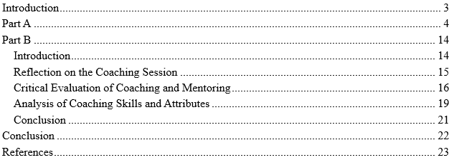

Introduction
Concerning part, A, a coaching session will be done on John Griffiths about his workload and career path choices using the GROW model. Specifically, Part B requires the author to think about this session considering how the latter improves performance and morale within Healthcare International; and, additionally, considering what fundamental skills and personal characteristics characterise coaching in this organisation (Ainsworth, 2020).

Part A
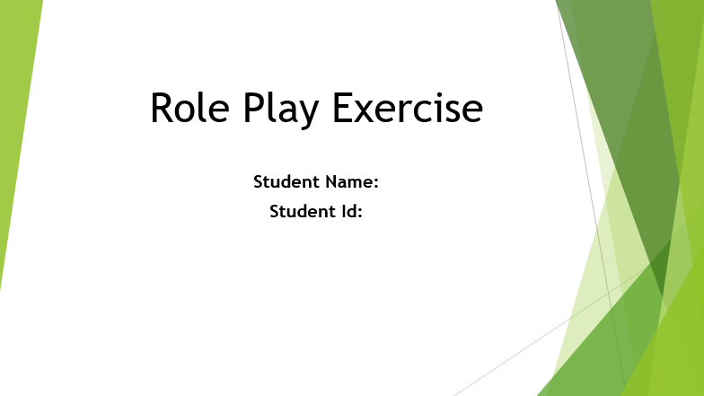

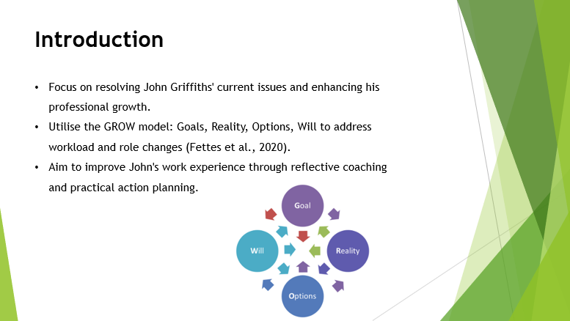
I, Philippa, Welcome to this coaching session, which will focus on the resolution of John Griffiths's present problems and further professional advancement. At the given organisation, John is a senior employed as a microbiologist, he has recently experienced changes in his responsibilities and workload (Bachkirova et al., 2020). The purpose of this specific coaching session is to address these issues and facilitate the client’s professional growth and contentment at work. Coaching is applicable at this juncture of John’s career more so because it offers a specific process of reflecting on his present circumstance, defining objectives and formulating practical ways of dealing with his challenges. In line with the GROW model, the next step would involve formulating John’s Goals, establishing the Reality of the situation, identifying the Options available to him and developing a Will or action plan. Thus, this approach will assist John in handling his load, and the role adaptation process, and increase the quality of his work experience.
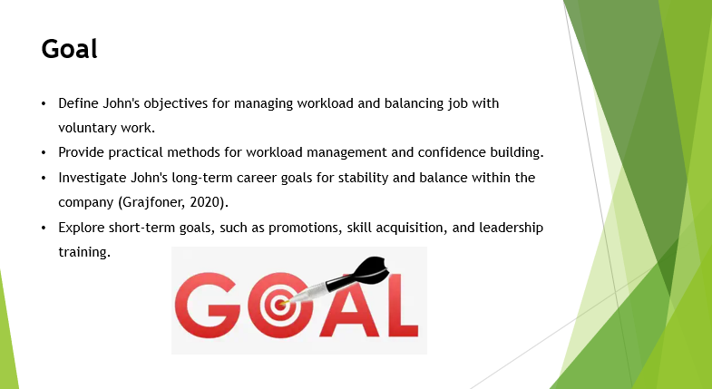
In this coaching session, the first step is to determine the objectives of John Griffiths very precisely. At this point, John is finding it difficult to deal with his new assignments and effectively juggle between his job and voluntary work. The first type of treatment that is relevant and timely at the moment is to provide him with practical methods of how to manage his workload, as well as ways of building his confidence in his job responsibilities (Binti Kamarudin et al., 2020).
Moreover, John’s future occupation objective should be investigated deeper. He wants to achieve stability and balance in this company; therefore, it is imperative to consider his targets and aspirations. Next, it will learn about his short-term career goals of what he wants to accomplish within the next year, two years and three years which may be a promotion, acquisition of new knowledge and skills, or training for other leadership positions. Thus, concrete goals may help to give proper direction to change his performance to increase satisfaction and foster his career in the organisation.
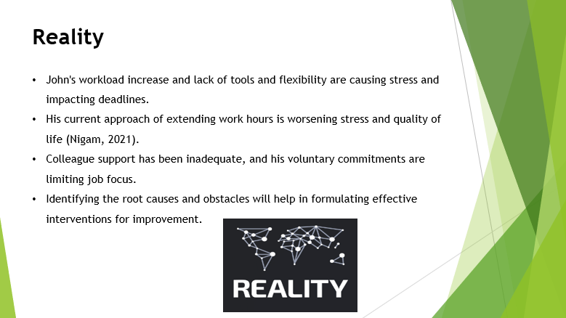
In his current position, John Griffiths is faced with numerous problems. He recently suffered some changes in the organisation through which he lost his initial relaxed nature as his workload has been enhanced much to his stress. The changes in John’s role involve handling a lot of work with fewer tools, time off, and flexibility which once again affects the deadlines (Browne, 2021). It also gives him stress by the realisation that in some cases he may be expected to grasp new facets of his work fast.
Thus far, John has tried to solve the aforementioned problems by focusing on tasks and extending the duration of work, which, however, contribute to stress and the deterioration of the quality of life. He has also asked some of his colleagues for suggestions outside the official meetings but the help he has received has been patchy and quite useless. On the same note, the voluntary youth club that John is associated with implies that he has other demands for his time and thus will not be able to devote sufficient time to his job.
These are realities that I need to pinpoint as I prepare for today’s coaching session because they will guide my prescription of how to assist him. It is necessary to determine the causes of John’s problems and the obstacles he encounters with organisational and time demands and his new assignments (Deng & Turner, 2024). Hence, this will give adequate grounds on which it shall be in a position to formulate correct intervention procedures that would make a positive impact on his status as well as overall efficiency in his duties.
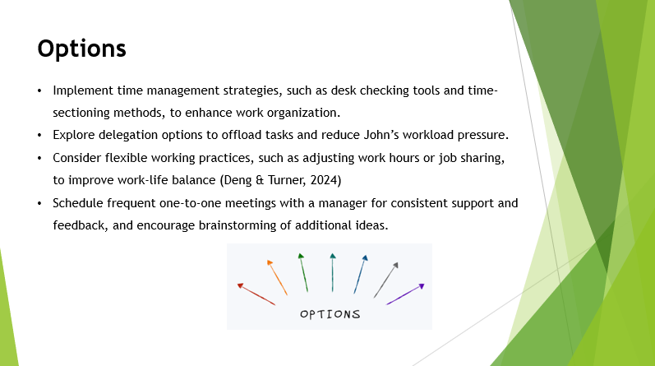
To combat the issues John is experiencing, several approaches and possible solutions must be considered. First, it would be possible to focus on time management strategies that will enable John to develop proper approaches to the schedule and enhance his capacity to organise his work. For instance, employing such interventions as utilisation of desk checking means such as tools in time management or time-sectioning methods could assist him in arranging responsibilities and being efficient (Fettes et al., 2020).
For another idea, there is always the possibility to find possible delegations. Possibly, John may find out tasks that can be offloaded to other group members or support staff which would reduce the pressure that he is experiencing. Also, offering John training or materials to improve his capabilities in certain tasks associated with the newly assigned responsibilities can improve his morale.
Another suggestion that would apply to John is to consider the aspect of flexible working practices where John could arrange to work at different times to allow for more time with his family, or if this is feasible, he could consider sharing the position with someone else and working in shifts. The opportunity of having frequent one-to-one meetings with a manager or a superior might help him get consistent encouragement and management as he familiarises himself with the position (Fong et al., 2021).
To ensure that John comes up with out-of-the-box ideas on these suggestions, more so, any other ideas he may consider appropriate should also be probed. Through a selection of the presented ideas and critical evaluation, it would be possible to identify the most appropriate interventions to assist him in dealing with the existing difficulties and improve his quality of work alongside his personal and family life.
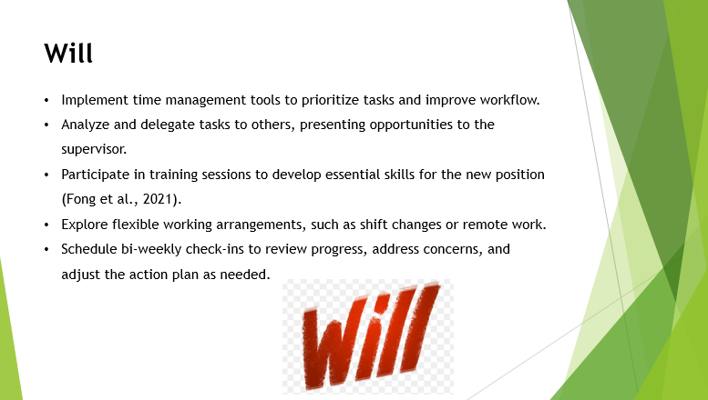
For the case of John Griffiths to start overcoming his challenges, it is required to design a clear action plan. Here are the specific actions we will focus on:
Time Management: In the case of John, he will begin to use a tool to help in planning and ordering tasks. He will agree to undertake the following behavioural change: Time management for an efficient workflow that will entail sectioning of the day to act on important tasks first.
Delegation: Activities that John will perform or accomplish will involve analysing jobs which can be delegated to other members and presenting such opportunities to the supervisor. This will aid in relieving his workload as well as boosting the capacity of his peers (Garvey et al., 2021).
Skill Development: John will participate in relevant training sessions or workshops that would help him develop in those areas deemed essential in his new position. Though he will set out some time to develop and document a learning plan, he will allocate some time each week to learning.
Flexible Working Arrangements: John will talk with HR regarding what kind of flexible working he could propose, including a shift change, or switching to part-time remote work to help him be more effective at managing himself and work at the same time.
Regular Check-ins: John’s progress, concerns and frequencies of meetings will be checked on a bi-weekly basis and depending on the results of his performance, the action plan will be altered. These sessions will be for follow-up and getting feedback on how we are going to implement those recommendations (Giacomo et al., 2020).
By these actions and assertions, John will have a plan of how to handle his workload and how to relate with his subordinates’ translating changes needed for his new position. Supervision of the plan implementation shall also entail the tracking of general progress and constant reinforcement of positive outcome indicators as a way of improving the plan.
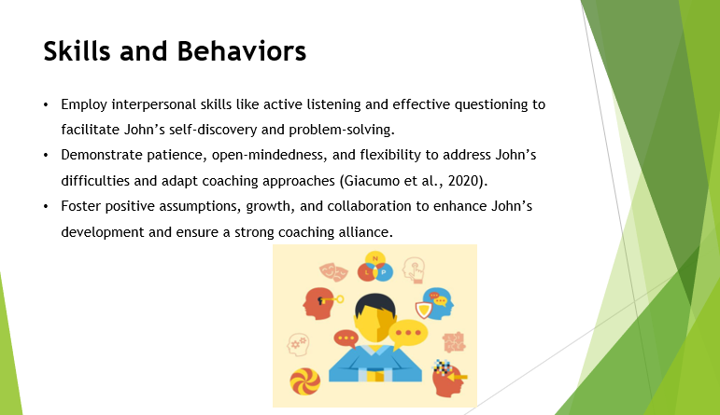
Coaching must contain features of essential skills and attributes to be effective. Some of the interpersonal skills are listening skills, understanding of emotions and the ability to ask good questions. Assertiveness makes sure that John has mattered to the solution-finding process while making him believe that there is someone who understands him. Good questions will lead John to self-discovery and solve his problems by himself (Grajfoner, 2020).
An effective coach should also possess some cardinal virtues such as; patience, open-mindedness and flexibility. Understanding is important about John’s difficulties and acceptance ensures that these difficulties can be discussed freely. Flexibility means that the particular style of coaching that may be required of John will be flexible enough to reflect the client’s progress.
Positive assumptions at the level of growth and collaboration constitute the dynamics of effective coaching. Thus, I will promote John’s development, ensure a healthy coaching alliance, and help him achieve such goals in line with the stated values (Hakro & Mathew, 2020).
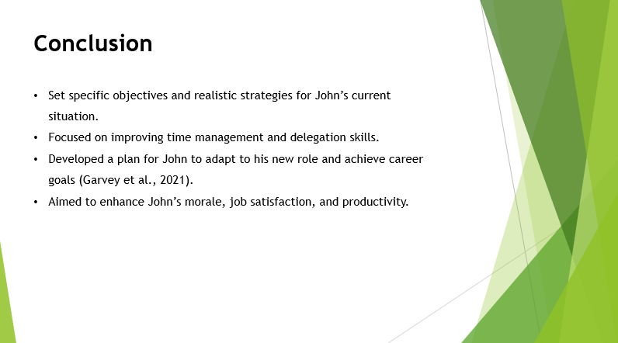
To sum up, today’s coaching session involved the following aspects: setting specific objectives for John, identifying realistic strategies concerning the client’s present situation, and establishing the means to assist John in his professional growth. Thus, established a direction on the areas that need to be improved, for instance, time management and delegation and developed a plan on how John can improve on those skills to fit the new role successfully. The coaching process is significant for John’s development and productivity (Hamburg, 2021). By applying the discussed strategies at work, John will be in a good position to cope with his workload, balance his jobs, and attain his career goals. This will improve his morale and job satisfaction thus improving his productivity in the company and improved working environment.
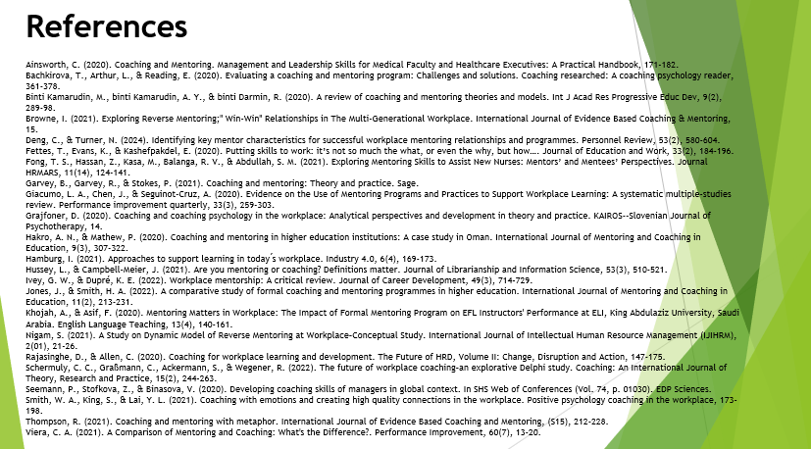

Part B

Introduction
The following reflective statement aims to provide an analysis of the actual coaching practice that occurred with John Griffiths in the Healthcare International company and identify the strengths and weaknesses of this practice. The topic of the coaching session was based on John’s problems with new roles and pressure at the workplace after the promotion, and I employed the GROW model to discuss the issues and design a viable intervention plan (Hussey & Campbell-Meier, 2021). It is therefore important to pay a lot of attention to such a coaching process as part of the growth plan for the individual and the profession. It enables me to conclude the session with John, evaluate the effectiveness of the undertaken actions on his productivity and motivation, and examine the current training practices revealing effective and ineffective methods for future sessions. This reflection also helps to understand how the concept of coaching and mentoring can be useful in improving the performance of the organisation and satisfaction of the employees which will in turn make the organisation a better place to work in.

Reflection on the Coaching Session
What Went Well
In general, the topic of the coaching session with John Griffiths proved productive in some ways. Firstly, it seemed beneficial and minimised confusion and loopholes because, from the onset, the GROW model was followed. For instance, in the Goal-setting plan, John identified working well-done objectives for example, John wanted to improve his time management and balance his working time with volunteer work (Ivey & Dupré, 2022). This proved helpful in defining concrete measures outlining his concerns, which were much different from general priorities.
The reality phase was more effective as it helped to describe some of the issues John faces at the moment such as difficulties in coping with the new amount of work and the voluntary activities. When these matters were pointed out to us, we were able to discern cause and find ways to deal with them like organising work and seeking help, which John said was useful.
As a result of the Options phase, options regarding what John could do began to be brainstormed, such as the strategies that have been previously mentioned for sorting his workload and changing his working timetable. John liked this since he was being trusted and therefore had the leverage to come up with solutions to his problems.
John, after listening to the song, gave his immediate response which was a positive reception. He said that from that session he was able to learn a lot and also got an understanding of the direction to take to conduct his new assignments properly (Jones & Smith, 2022). This component was highly valued because it allowed him to receive a professional opinion as well as express his concerns, which positively influenced his morale concerning the action plan. Such feedback signified that the participant managed to attain the set goals and objectives of the session.
What Could Be Improved
Several advantages can be highlighted when watching the coaching session with John Griffiths Despite that, there are areas where the coaching process can be more efficient. Another difficulty that could be named was the problem of the proper time distribution to deal with each step of the GROW model. Thus, the Reality and Options phases were experienced as rushed since John’s case was complicated. There are still a lot of details that could have been analysed regarding his difficulties and even more options could have been discussed if there was more time for the seminar (Khojah & Asif, 2020). This would have availed the chance to understand more of his problems and come up with better-compounded solutions.
On the same note, the process of providing feedback during the session should have garnered more attention. While John stated that he enjoyed the session he pointed out that he felt some of his issues were not discussed to the extent he would have liked. This implies the requirement for better approaches to asking questions and eliciting clients’ responses. For instance, asking questions that have possible multiple responses, or paraphrasing the responses could have made John expand on his problems so that none of the issues were left unaddressed (Nigam, 2021).
Subsequent sessions of coaching could also involve rehabilitation meetings focusing on the overall plan implemented so far and the changes that may be needed afterwards. This would help to sustain the solutions preferred as well as check whether the strategies put in place are apt and continuous. Also, using more inserts, for example, role-playing assignments or case studies, would enhance John’s ability to visualise and utilise the shared tactics. This would also make the session to be more practical and hence produce better results for the people involved.
Altogether, the outlined strategies of precise time management, efficient feedback approach, and follow-up support should be optimised for achieving higher effectiveness while working on the following coaching sessions (Rajasinghe & Allen, 2020).

Critical Evaluation of Coaching and Mentoring
Impact on Performance and Morale
The coaching and mentoring strategy can improve John Griffiths’ performance and motivation substantially. By focusing on John’s issues, for instance, how to cope with the new workload and the volunteer activities, coaching has the potential to enhance quantifiable elements such as job satisfaction and organisational performance.
Improved Job Satisfaction: It is from the Goal and Reality phases of the GROW model that John laid down his desires and concerns on the ground. This leads to the establishment of specific management plans such as the assignment of duties and setting of his organisational timetable. Strategies to lessen John’s stress and overwhelm include enacting these solutions, and this leads to a positive link with job satisfaction (Schermuly et al., 2022). That is, when employees perceive organisational support and voice, there is an increase in employees’ overall role satisfaction. In this respect, achieving the client’s key issues helps John to decrease his level of frustration and the resulting feelings of accomplishment and engagement at work increase.
Increased Productivity: Coping with the identified difficulties means that through coaching, John’s situation is improved to enable him to handle his responsibilities. For instance, John will be able to enhance his work productivity by organising tasks and looking for assistance. This means John becomes more efficient in his place of work, but it also lowers the instances that may cause burnout (Seemann et al., 2020). This expands the working capabilities of the department as John becomes more manageable in his work and productivity increases.
Long-Term Benefits: In this way, an enhanced performance and encouraging attitude of John, noticeably observed due to the application of the coaching strategies, may have a spill-over impact on other members of the team as well. The improvement in motivation and working capacity of John means a shift towards a better working environment and mutual support among employees. Moreover, due to John’s demonstration of how the problematic issues can be solved and how he would learn from the work experience to be a better professional, his co-workers would be motivated to look for coaching and mentoring support to develop a culture of learning within the team.
In the long term, the gains are not merely in performances, but in organisational experiences too. Higher morale and self-generated work output can be beneficial because it results in low turnover and high spirit de corps; the group is also more emblematic of a creative force that can adapt to change (Smith et al., 2021). It can be said that the proper and well-developed technique of coaching concerns not only daily challenges resolution but also focuses on the more constant and powerful enhancement of employees’ productivity and positive atonement of the team, making it more unified and vigorous.

Effectiveness in the Context of Healthcare International
The two major forms of personnel development, coaching and mentoring, can be applied to Healthcare International where particular kinds of organisational needs must be solved while contributing to more general objectives of the department and the organisation as a whole.
Tailoring Coaching to Organisational Challenges: At the current moment, Healthcare International seems to have severe issues as it currently opts for automation, has fewer employees, and is experiencing the necessity to cut costs. Consequently, these changes have put pressure on and transformed the duty profiles of the employees, resulting in stress and job dissatisfaction. Coaching can be tailored to address these issues by focusing on the following areas:
Adaptation to Change: By requiring the employee to go through a coaching program, it will assist him such as John Griffiths to transform to new technologies and responsibilities (Thompson, 2021). As transitions are well known to meet a certain amount of resistance, coaching enables people to manage such changes better in that it eases the process of transition.
Workload Management: In specific to working staff, then coaching can help provide solutions to time management, delegating work, or even finding priorities. The support from this structure ensures that employees work with less stress and that they are more productive even in situations where the organisation has hired fewer employees.
Mental Health and Well-being: It means that the discontent with the current level of organisational mental health can be mitigated by the implementation of the coaching process as far as it provides the subject with a possibility to address the difficulties. Coaching can also enhance the rate of work and personal satisfaction and help in dealing with stress thus enhancing morale (Viera, 2021).
Contributing to a Positive Work Environment: Coaching established a communication line whereby employees are free to express themselves and that in the process, they are appreciated. Coaching leads to improvement of the organisational climate since it entails listening to the employees’ concerns as well as offering advice on how to improve performance. Such an environment is effective in raising the level of appreciation of employees and increasing their performance.
Supporting Organisational Goals: Organisational development and employee specifications are the two aspects connected with performance coaching. Thus, coaching allows the employee to focus on his or her professional development to enhance his or her performance in contributing to the objectives of the company, such a requirement as increased effectiveness, or adaptation to the requirements of new markets (Ainsworth, 2020). The improvement in the level of human resources means better engagement of the employees and can cause the success of the department and help to achieve the company’s strategic objectives.

Analysis of Coaching Skills and Attributes
Skills and Behaviours
Coaching skills and behaviours incorporate several critical competencies that play critical roles in determining the effectiveness of the coaching partnership as well as the flow of results. For the coaching session with John Griffiths, several core competencies were crucial:
1. Active Listening: This looks at ensuring that the coachee gets undivided attention and meaningfully interacts with him or her as they speak. John’s session was focused on active listening as a technique that helps to reveal the man’s issues and problems. Consequently, Philippa appeased the situation by permitting John to express his feelings and thoughts to the service, proving to him that his opinions matter (Bachkirova et al., 2020). The above approach helped enhance permission for John to speak out about his difficulties because the two were at a point of trust.
2. Empathy: They are the psychological processes that imply an understanding of one’s situation and quite possibly being able to empathize with the situation that the other person is in. Coaching John involved the use of empathy, which involves acknowledging a situation John found intolerable; that is the new workload and extra responsibilities. Hence, Philippa formed a friendly relationship with Rami when she offered believability in his stories and concern over his affairs. Given this, John got the feeling that he was understood and he was not alone when battling the wars.
3. Questioning Techniques: Non-threatening questioning is the type of questioning that is geared towards making the respondent think past the normal answers, and come up with a new, more introspective answer. Philippa applied questioning skills that would assist John in delving deeper into goals and barriers. The strategy of the examination was to ask questions like “What aspects of the new role are most problematic?” and “How do you plan to overcome these challenges?” to help John focus on finding exact solutions and realistic objectives (Binti Kamarudin et al., 2020).
Impact on Engagement and Progress: Skills used enhanced John’s involvement and advancement as per the application of the skills. This made John listen and be empathised and as a result, he was willing to be an active participant in the session. The questioning techniques made him analyse his situation on his own and come up with a solution thereby making the coaching process more purposeful and proactive. In summary, all these skills supported a fruitful coaching session, in which John accepted the real opportunity to work on problems and find workable solutions.
Attitudes, Beliefs, and Values
Coaching is behaviour that is grounded on certain approaches to attitudes, beliefs and values that produce a positive frame for coaching. Such thinking enables one to gain insight into the effect of the elements on coaching and the process of development of a coach (Browne, 2021).
Attitudes: Of all the potential attitudes for the coaching process, it is most important for the coachee to be open. It also entails openness to variation, that is, being willing to listen and understand other standpoints and opinions. Thus, an openness of attitude as a coach will encourage the client to establish a non-defensive relationship with them when expressing suggestions. In the John Griffiths session, my less biased approach to the client’s issues enabled me to go deeper into understanding his concerns. Such an outlook led John to share the particular difficulties that were at the core of effective strategy creation, thus allowing for the elaboration of a significant action plan.
Beliefs: A coaching mindset is also defined as the belief that everyone with acceptable characteristics has the potential and can develop with proper training (Deng & Turner, 2024). This belief in John’s capabilities, as well as the ability to improve, stemmed from this idea as well. Instead of just relying on the elimination of weaknesses, I ensured that John learned how he could strengthen himself. This positive belief, therefore, facilitates the formulation of a motivating environment in which John felt he could achieve his goals.
Values: Some important aspects of coaching are- courtesy and working towards the betterment of the colleague. Evaluating John’s issues and experiences made the entire process one that was understanding and sensitive to the client. Showing that I care for his development entailed actively caring for him and making sure that ‘we follow through,’ with the actions that we have proposed. These values were applied in the way I related with John, respecting the efforts that he was making and his desire to stop the behaviour.
Alignment and Influence: The above-stated effective coaching attributes match my attitude and values (Fettes et al., 2020). For example, my principles include the ability of people to develop as well as the recognition of people’s points of view influenced my attitude towards John’s session. These attributes helped to create a positive environment in which John would feel appreciated, and, therefore, motivated.
Development and Strengthening: To build on these attributes even more, the authors insisted that self-coaching and feedback from other persons such as peers and coachees should be continuous. Practising can also improve these qualities by attending workshops on coaching techniques and by seeking mentorship. These attitudes, beliefs, and values can be fine-tuned and subsequently used to assist the next coachee in the attainment of their objective and optimisation of their performance.

Conclusion
In conclusion, the coaching session with John Griffiths has shown good aspects and bad ones still it speaks volumes about the potency and capacity of coaching in improving performance and employee morale among employees (Fong et al., 2021). By looking at the key skills, attitudes, and values, I am in a better position to improve my coaching characteristics. In the future, these findings will help to better support and enhance the methods of coaching.

Conclusion
Finally, based on Part A’s live coaching session with John Griffiths, the strengths and issues have been illustrated and helpful approaches have also been demonstrated. In the Part B reflection, the session’s effectiveness on performance and staff motivation will be determined, as well as the skills and character traits important to coaching (Garvey et al., 2021). These ideas will improve the subsequent coaching interventions and organisational performance.

References
Ainsworth, C. (2020). Coaching and Mentoring. Management and Leadership Skills for Medical Faculty and Healthcare Executives: A Practical Handbook, 171-182.
Bachkirova, T., Arthur, L., & Reading, E. (2020). Evaluating a coaching and mentoring program: Challenges and solutions. Coaching researched: A coaching psychology reader, 361-378.
Binti Kamarudin, M., binti Kamarudin, A. Y., & binti Darmi, R. (2020). A review of coaching and mentoring theories and models. Int J Acad Res Progressive Educ Dev, 9(2), 289-98.
Browne, I. (2021). Exploring Reverse Mentoring;" Win-Win" Relationships in The Multi-Generational Workplace. International Journal of Evidence-Based Coaching & Mentoring, 15.
Deng, C., & Turner, N. (2024). Identifying key mentor characteristics for successful workplace mentoring relationships and programmes. Personnel Review, 53(2), 580-604.
Fettes, T., Evans, K., & Kashefpakdel, E. (2020). Putting skills to work: it’s not so much the what, or even the why, but how…. Journal of Education and Work, 33(2), 184-196.
Fong, T. S., Hassan, Z., Kasa, M., Balang, R. V., & Abdullah, S. M. (2021). Exploring Mentoring Skills to Assist New Nurses: Mentors’ and Mentees’ Perspectives. Journal HRMARS, 11(14), 124-141.
Garvey, B., Garvey, R., & Stokes, P. (2021). Coaching and mentoring: Theory and practice. Sage.
Giacumo, L. A., Chen, J., & Seguinot‐Cruz, A. (2020). Evidence on the Use of Mentoring Programs and Practices to Support Workplace Learning: A systematic multiple‐studies review. Performance improvement quarterly, 33(3), 259-303.
Grajfoner, D. (2020). Coaching and coaching psychology in the workplace: Analytical perspectives and development in theory and practice. KAIROS--Slovenian Journal of Psychotherapy, 14.
Hakro, A. N., & Mathew, P. (2020). Coaching and mentoring in higher education institutions: A case study in Oman. International Journal of Mentoring and Coaching in Education, 9(3), 307-322.
Hamburg, I. (2021). Approaches to support learning in today ́s workplace. Industry 4.0, 6(4), 169-173.
Hussey, L., & Campbell-Meier, J. (2021). Are you mentoring or coaching? Definitions matter. Journal of Librarianship and Information Science, 53(3), 510-521.
Ivey, G. W., & Dupré, K. E. (2022). Workplace mentorship: A critical review. Journal of Career Development, 49(3), 714-729.
Jones, J., & Smith, H. A. (2022). A comparative study of formal coaching and mentoring programmes in higher education. International Journal of Mentoring and Coaching in Education, 11(2), 213-231.
Khojah, A., & Asif, F. (2020). Mentoring Matters in Workplace: The Impact of Formal Mentoring Program on EFL Instructors' Performance at ELI, King Abdulaziz University, Saudi Arabia. English Language Teaching, 13(4), 140-161.
Nigam, S. (2021). A Study on Dynamic Model of Reverse Mentoring at Workplace–Conceptual Study. International Journal of Intellectual Human Resource Management (IJIHRM), 2(01), 21-26.
Rajasinghe, D., & Allen, C. (2020). Coaching for workplace learning and development. The Future of HRD, Volume II: Change, Disruption and Action, 147-175.
Schermuly, C. C., Graßmann, C., Ackermann, S., & Wegener, R. (2022). The future of workplace coaching–an explorative Delphi study. Coaching: An International Journal of Theory, Research and Practice, 15(2), 244-263.
Seemann, P., Stofkova, Z., & Binasova, V. (2020). Developing coaching skills of managers in a global context. In SHS Web of Conferences (Vol. 74, p. 01030). EDP Sciences.
Smith, W. A., King, S., & Lai, Y. L. (2021). Coaching with emotions and creating high-quality connections in the workplace. Positive psychology coaching in the workplace, 173-198.
Thompson, R. (2021). Coaching and mentoring with metaphor. International Journal of Evidence-Based Coaching and Mentoring, (S15), 212-228.
Viera, C. A. (2021). A Comparison of Mentoring and Coaching: What's the Difference? Performance Improvement, 60(7), 13-20.

