
Master of Business Administration
International Business pathway

Module name: Strategic Management
Module code: LCMB7003
Lecturer name: Amare Desta
Zulf Khan

Student name: Akul Shailesh Panchal
Student ID: 2428878

Submission date:30/04/2026

AI use acknowledgement
Note: One acknowledgement is needed for each used AI tool.

I confirm that I have not presented any AI generated text as my own work. I confirm I have copies of my drafts, notes, and other resources I used before, and after the use of AI tools which I may be asked to provide in evidence.\

Table of Contents
Section 1 4
1. Organisational Context and Overview 4
1.1 Introduction to Spotify 4
1.2 Historical Development 4
1.3 Mission, Vision, and Core Values 5
1.4 Business Model 5
1.5 Industry Overview 6
1.6 Competitive Landscape and Market Position 6
2. External and Internal Environment Analysis 7
2.1 External Environment Analysis (PESTEL Framework) 7
2.2 Critical Success Factors and Strategic Challenges 10
2.2.1 Critical Success Factors 10
2.2.2 Strategic Challenges 11
2.3 Internal Environment Analysis 12
2.3.1 Key Resources 12
2.3.2 Capabilities 12
2.3.3 Core Competencies 13
2.4 VRIO Framework Analysis 13
2.5 Internal Strengths and Competitive Advantage 15
3. CSR and Sustainability Objectives 17
3.1 Overview of CSR Strategy 17
3.2 Sustainability Initiatives 18
3.3 Alignment with Business Objectives 18
4. Comprehensive and Holistic View: Balanced Scorecard 19
4.1 Overview of the framework 19
4.2 Financial Perspective 19
4.3 Customer Perspective 20
4.4 Internal Business Processes Perspective 20
4.5 Learning and Growth Perspective 21
5. Strategic Choices and Implementation 22
5.1 Business-Level Strategy 22
5.2 Corporate-Level Strategy 23
5.3 Recommended Strategic Choices 23
5.4 Change Management and Strategic Implementation 24
6. Strategic Evaluation and Recommendations 26
6.1 SWOT Analysis 26
6.2 Evaluation Using Strategic Frameworks 27
6.3 Recommendations 28
6.4 Justification of Recommendations 30
Section 2: Reflection 31
Model Overview 31
Model Analysis 31
Reference List 34

Section 1

1. Organisational Context and Overview

1.1 Introduction to Spotify
Spotify, an audio streaming platform founded by Daniel Ek and Martin Lorentzon in 2006 in Sweden has grown to the leading audio streaming platform globally. The company reported having more than 675 million monthly active users (MAUs), about 263 million premium subscribers, as of the beginning of 2026, having increased at a growth rate of about 12-15% per year. Spotify has very high global penetration and scalability through working in over 180 markets (AmpVortex admin, 2026).

1.2 Historical Development
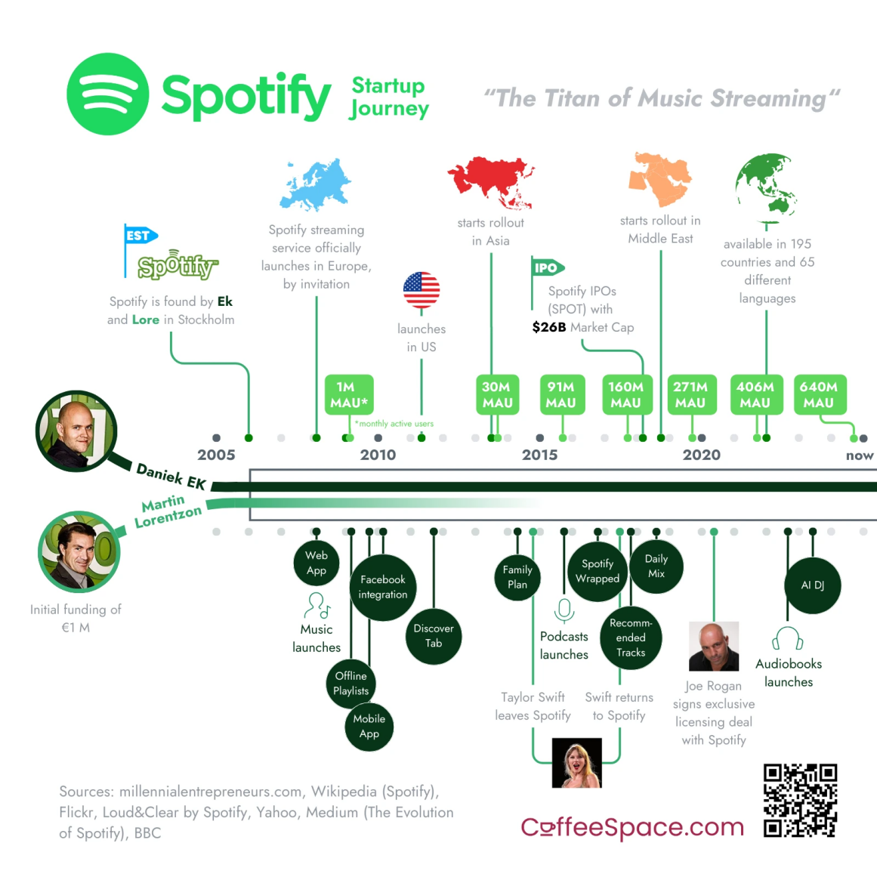
Figure 1: Spotify Growth Timeline
(Source: Counselab, 2025)
Spotify became public in 2008 and was the first streaming music to utilize the freemium model. Its IPO in the New York Stock Exchange in 2018 was a great milestone. Spotify has purchased over a billion podcasts and content, planning into podcasts and audiobooks by 202025. By 2025-26, podcast listening will make up a big share of user activity, and it will have confirmed its transition to a more general audio platform (Counselab, 2025).

1.3 Mission, Vision, and Core Values
Spotify’s mission, “to unlock the potential of human creativity,” underpins its strategic focus on creators and listeners. The vision of its focus is to be the best audio platform in the world. The culture of innovation that the firm has deployed is using data analytics and AI to improve user experience and competitiveness (MatrixBCG Team, 2026).

1.4 Business Model
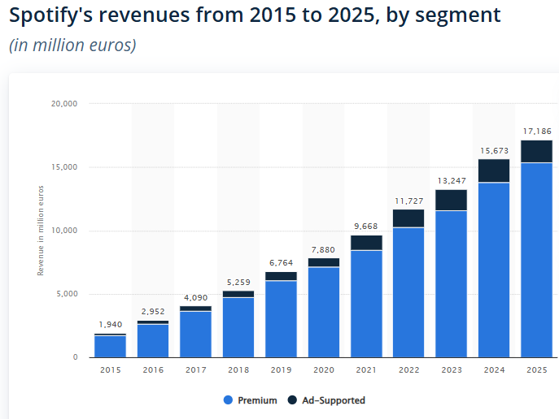
Figure 2: Spotify’s Annual Revenue Segmentwise
(Source: Statista, 2025)
Spotify offers both free services with ads, as well as a premium subscription level. It generates more than 85% of its yearly revenue of subscriptions (totaling it to over 17 billion euros) and the rest is advertising revenue in 2025. Its ecosystem includes music, podcasts, and audiobooks, earning it different types of income (Statista, 2025).

1.5 Industry Overview
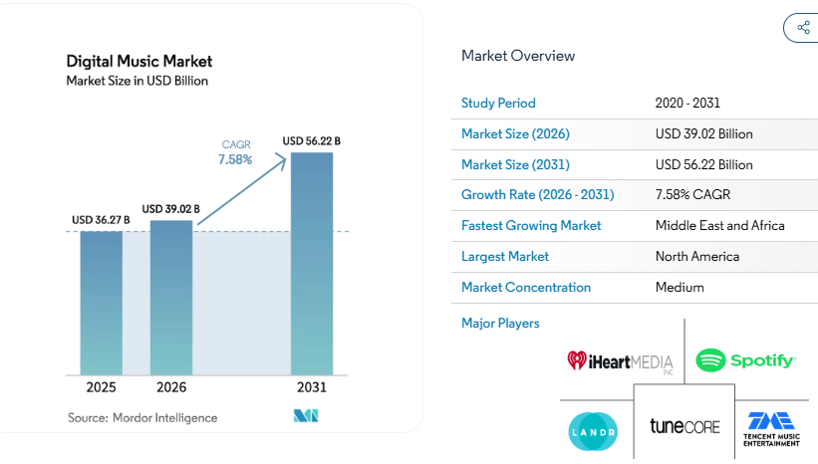
Figure 3: Digital Music market
(Source: Mordor Intelligence, 2025)
Digital transformation and the use of smartphones led to the music streaming industry to become a multi-billion industry in the world, reaching over $36.27 billion in 2025. The music industry in the whole world has surpassed over 65% of the music industry recorded revenue in streaming; and this embodies structural changes in the music industry (Mordor Intelligence, 2025).

1.6 Competitive Landscape and Market Position
Platform | Subscribers (approx.) | Key Strength | Market Position
Spotify | 263 million | Personalization, global reach | Market leader (~30-32%) (Chu, 2026)
Apple Music | 90-100 million | Ecosystem integration | Premium-focused
Amazon Music | 80-85 million (Business of Apps, 2026) | Bundling with Prime | Value-driven
YouTube Music | 100+ million | Video + music integration | Rapid growth
Table 1: Competitor Analysis
(Source: Self Created)

2. External and Internal Environment Analysis

2.1 External Environment Analysis (PESTEL Framework)
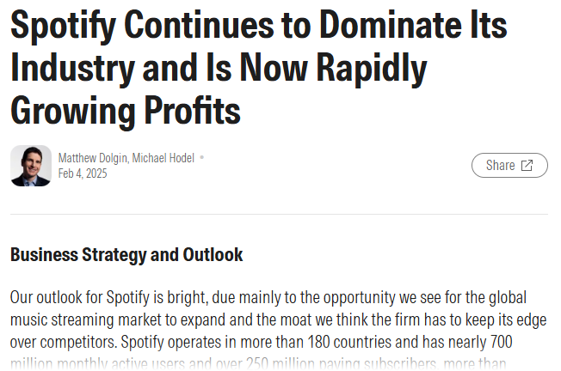
Figure 4: Operating Market of Spotify
(Source: Dolgin, 2025)
Political Factors: In the case of Spotify, copyright regulations and licensing are extremely influenced by political practices. With more than 180 markets operated, the company allocates almost three-quarters of its revenues to the right owners, which indicates that the firm significantly relies on intellectual property frameworks in terms of regulations (Dolgin, 2025).
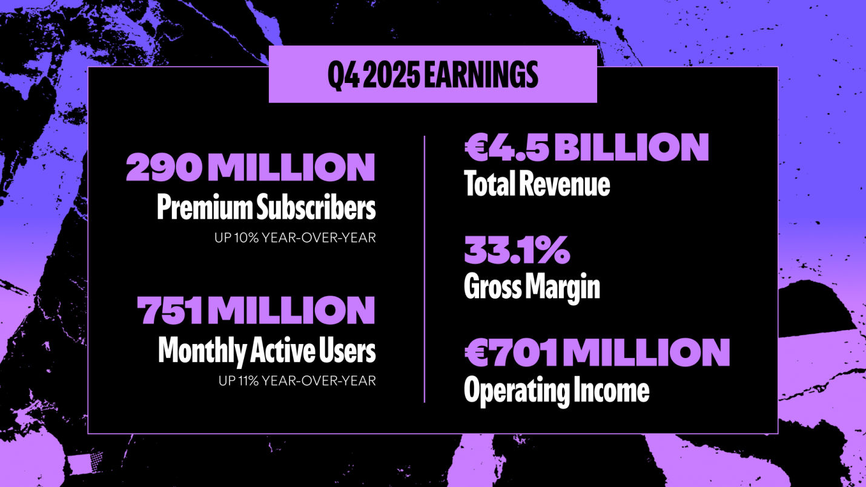
Figure 5: Spotify Quarterly highlights
(Source: Spotify.com, 2026)
Economic Factors: The growth in subscriptions is directly dependent on the economic conditions, and by 2025, Spotify will have achieved a total of €17.1 billion in revenue and around 4.5 billion quarterly revenue by Q4 2025. Yet it must be affordable and considering that in the new markets, over 60 percent of consumers utilize the ad-supported services, it must be affordable. It also has the problem of profitability as currency movements follow as Spotify expands internationally and inflation pressures in other markets have led to an increment in prices of subscriptions (Spotify.com, 2026).
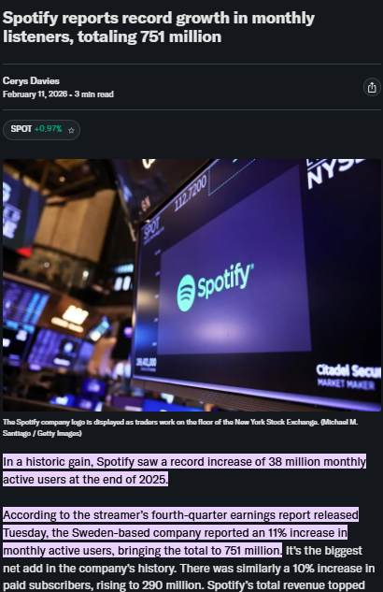
Figure 6: Spotify MAU
(Source: Davies, 2026)
Social Factors: The behaviour of the consumers is changing rapidly, as Spotify boasts 751 million MAUs and almost a third of the consumers will be listening to podcasts on a regular basis in 2025 . The shift to a more individualized and on command consumption of content is emphasized by gen Z users, 44% of whom listen to music using algorithmic playlists (Davies, 2026).
Technological Factors: The competitive edge of Spotify is its recommendation and big data analytics that is delivered on the platform powered with AI and supporting over 100 million tracks and 7 million podcasts globally. The constant expansion of the platform enables handling hundreds of millions of users and retaining them (Spotify, 2025).
Environmental Factors: Streaming carbon footprint is now the issue of concern and Spotify has taken sustainability measures in line to the global ESG requirements but there are still figures given to consider when it comes to emissions.
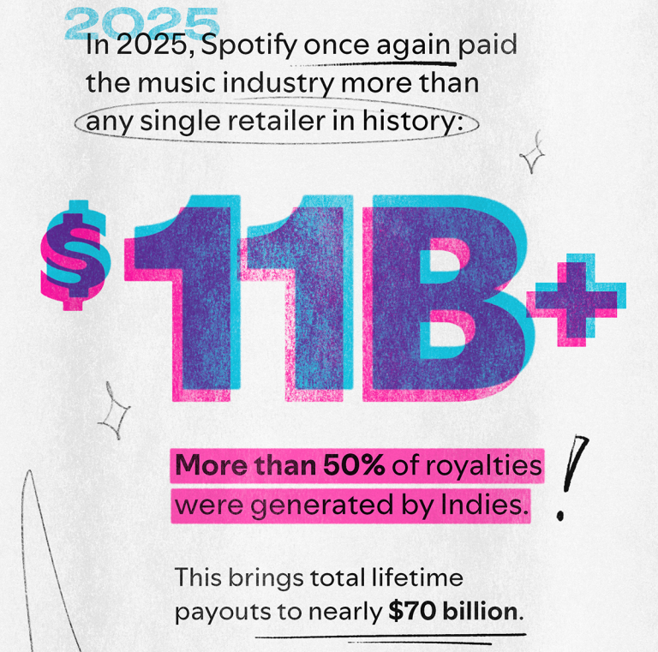
Figure 7: Spotify 11B+ Royalities
(Source: Peterson, 2026)
Legal Factors: There are legal problems on continuing claims of artists' remuneration yet Spotify has given over 11 billion to the music industry in 2025 on its own. It has been and still is the core of the operations and strategic risk of the company, the royalty structures and intellectual property laws (Peterson, 2026).

2.2 Critical Success Factors and Strategic Challenges

2.2.1 Critical Success Factors
In the case of Spotify, critical success is based on its alignment to the outside PESTEL forces. Licensing agreements and compliance with international copyright laws should be robust politically and legally because much of the revenues go the way of owners of rights. On the economic front, it uses a freemium model to assist it in the acquisition of users and transformation of premiums in different markets. On the social front, adapting to the changes in listening behaviors, in particular the increase in podcasts and personalized information enhances user engagement (Khanom, 2023). With AI algorithms and data analytics, which are at the state of the technology and, therefore, enable the personalisation of the option on a massive scale, the competitive advantage is constructed. Environmental responsiveness is also an addition to brand legitimacy (Climent, Haftor and Staniewski, 2024).

2.2.2 Strategic Challenges
Nonetheless, considerable obstacles still exist. The royalty payments are high, making the profitability to reduce; the shift in regulations increases the difficulty in operations. Economic forces such as inflation and exchange rates affect pricing strategies due to their impact on growth. Competition among various social media has aggravated the problems of user retention (Spotify, 2025b). The continuous investment on technologies adds to costs and continuing fumbling records on legal matters on paying artists also constrain long term strategic choices of Spotify.

2.3 Internal Environment Analysis

2.3.1 Key Resources
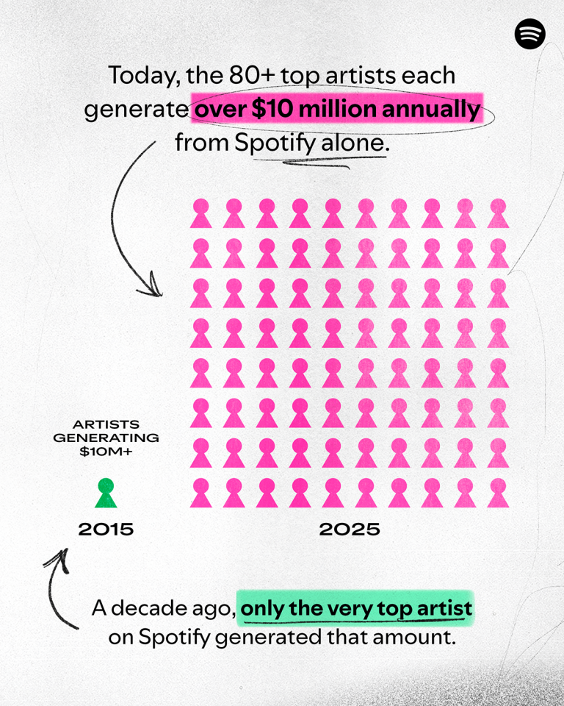
Figure 8: Spotify Revenue Generation
(Source: Peterson, 2026)
Spotify boasts a strong technological base, which can support over 675 million monthly active users and the potential of over 263 million premium users by the year 2026. The platform also has a great amount of content with more than 100 million tracks and 7 million podcast titles (Peterson, 2026). The good name of the brand is one of the most important intangible assets, and in terms of the best audio streaming services in the world, which has about 30-32% market share, Spotify always occupies the first place. The fact that its large data ecosystem is developed based on billions of streams every day provides high-level behavioural insights. One more advantage of Spotify is its human resources that include one thousand engineers and data scientists producing ceaseless innovativeness and improvement of the system (Dallos et al., 2025).

2.3.2 Capabilities
The firm can best be explained as centering core competencies on its advanced algorithms that execute the respective suggestions such as personalized playlists, and that explains significant user listening, once again. Its curation platform of content is a mix of human and AI, which makes it versatile and diversified. It is also strong in innovating its platform, as evidenced in launching podcasts and audiobooks, where the company intends to make podcasts the core product, with the consumption of 30% of its users consuming podcasts in 2025-26 (Elad, 2025).

2.3.3 Core Competencies
The most important core competency at Spotify is personalisation, and these capabilities such as Discover Weekly and artificial intelligence playlists are useful in keeping and entertaining the customers. Together with the use of data-driven user engagement strategies, these capabilities are what facilitate long session times and in low churn rates, applications to the sustainable competitive advantage of Spotify in the global streaming market (Mokoena and Obagbuwa, 2025).

2.4 VRIO Framework Analysis
Resource / Capability | Value | Rarity | Imitability | Organisation | Competitive Implication
AI-driven recommendation algorithms | Yes - enhances user experience and retention across 675M+ users (Majumder, 2025) | Yes - highly advanced and refined through years of data | Difficult - requires large-scale data and continuous learning | Yes - fully integrated into platform strategy | Sustained competitive advantage
Extensive user data and analytics | Yes - supports personalisation and targeted advertising | Yes - derived from billions of streams daily | Difficult - competitors lack equivalent data depth | Yes - leveraged effectively through AI systems | Sustained competitive advantage
Brand reputation and market leadership (~30-32% share) | Yes - attracts users and partners globally | Moderately - strong but competitors have brand power (IESE Insight, 2025) | Moderate - brand equity takes time to build | Yes - supported by marketing and product quality | Temporary competitive advantage
Freemium business model | Yes - drives user acquisition and conversion | No - widely adopted across industry | Easy - competitors can replicate | Yes - well-structured and scalable (Suganthi, 2025) | Competitive parity
Content library (100M+ tracks, 7M+ podcasts) | Yes - essential for user satisfaction (Patov, 2026) | No - similar across competitors due to licensing | Easy - licensing agreements accessible to rivals | Yes - efficiently managed globally | Competitive parity
Table 2: VRIO Analysis
(Source: Self Created)
Based on data-driven competitive advantage and AI-driven personalisation, the VRIO analysis of Spotify shows that the company was able to maintain its competitive edge, as these factors are highly valuable and difficult to imitate, considering their scale and learning curves. One of the core resources, though, such as content libraries and the freemium model, merely provide their competitors with a fair share, and Apple Music can follow it. Though short-term benefits are seen in brand strength and diversification in minute podcasts, it is vulnerable to any form of competition and the high investment cost (MOI Global, 2025). Importantly, the heavy reliance on licensed content restricts control and impacts the capacity of Spotify to maximize its benefits of internal strength into prolonged profitability and strategic autonomy.

2.5 Internal Strengths and Competitive Advantage
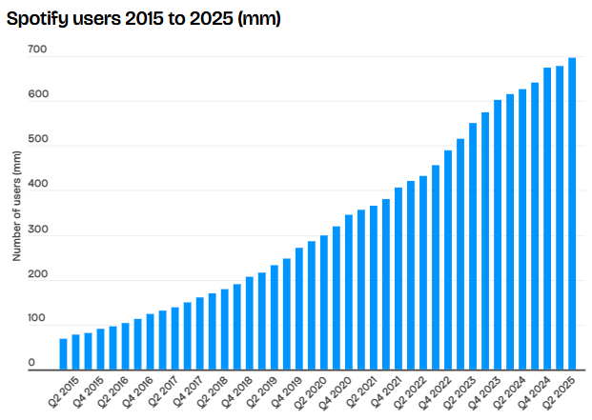
Figure 9: Spotify Active Users
(Source: Tafradzhiyski, 2025)
Strengths: The company develops a competitive advantage in the market which is acquired by Spotify by using the strengths of data, scale and early entries. With over 675 million monthly active users by 2026, the platform will lead to very large volumes of behavioural data, which can be used to produce highly accurate recommendations due to AI and targeted advertising. This data ecosystem boosts the effectiveness of user-engagement and monetisation (Yang and Kwon, 2024). Network effects further enhance this advantage since the more users there are the more artists and content in the shape of a catalogue of more than 100 million songs and 7 million podcasts (Tafradzhiyski, 2025). Also, the first-mover advantage of Spotify since 2008 has enabled the company to attain about 30-32% market share around the world by 2025-26 keeping the competition at bay like Apple Music. Personalisation, as exemplified by Discover Weekly, which is at the core of more than 30% of streams, significantly increases retention and creates a competitive advantage in the long run (PESTEL Analysis Team, 2025).
Weaknesses: These are limited to structural constraints. Extensive use of licensed content lowers strategic control and high royalty payments that are more than 65% of revenue inhibit profitability. This dependence impairs the ability of the firm to fully convert its own resources into the long run economic gain (Doran, Thomson and Webster, 2024).

3. CSR and Sustainability Objectives

3.1 Overview of CSR Strategy
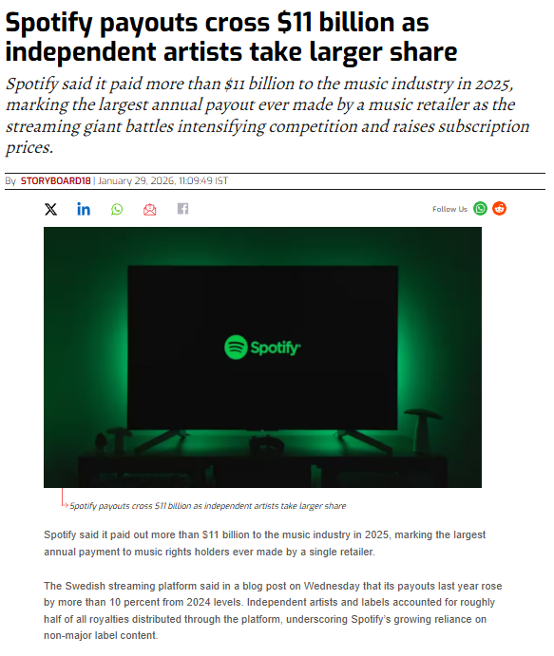
Figure 10: Spotify Artist Payment
(Source: Storyboard18, 2026)
Spotify follows a Creator-centric and responsible content distribution CSR strategy. The site has put a policy in place that they will act on the harmful or misleading information, but not interfere with the freedom of expression. On the part of assisting artists, Spotify had invested over $11 billion on rights holders in 2025, which was reflective of their input as a significant contributor to the music ecosystem in terms of revenue. Other services such as analytics of creators and promoted features also enable creators to reach people worldwide and succeed in monetising their efforts (Storyboard18, 2026).

3.2 Sustainability Initiatives
Spotify has increased its environmental sustainability framework, such as the Spotify Sustainability Program and the company has been identified to be net-zero by 2030. An additional one purported by the company was a reduction of at least 20% of the intensity of its operational emissions in the years of 2021 and 2025 which was largely due to cloud optimisation (Greenly, 2025). By partnering with technology providers like Google Cloud, Spotify services more than 675 million users worldwide by making its streaming infrastructure more efficient in energy consumption, and decreasing the carbon intensity per stream.

3.3 Alignment with Business Objectives
CSR efforts to aid the company in improving brand differentiation and building trust in the stakeholders assist in strengthening the strategic positioning of Spotify. Corporate reputation increases the ethical practices and sustainability promises, and platform loyalty is improved through artist-oriented methods (Li et al., 2023). In total, all these activities evaluate into long-term value creation in the form of balanced economic performance and social and environmental responsibility.

4. Comprehensive and Holistic View: Balanced Scorecard

4.1 Overview of the framework
The Balanced Scorecard of Spotify shows that the company has four supporting priorities to gain better financial sustainability over high royalty rates, enhance user experience through personalisation, stay resilient and scalable infrastructure and encourage a culture of innovation. These views combined can be seen as embodying the business strategy of Spotify capitalizing on technology and data to pursue growth in premiums, decrease the churn, and provide the company with a long-term competitive edge in the worldwide streaming industry (Kaplan and Norton,1992).

4.2 Financial Perspective
Objectives
The financial objective of the Spotify Company is to continue the growth in the revenues and improve the profitability of an expensive streaming market. Although the company might be earning about 15-17 billion in revenue in 2025 with royalty payments amounting to more than 65% of the revenue; the balance between scale versus cost-effectiveness and long-term financial sustainability is a must (ET BrandEquity, 2026).
KPIs
Significant ones include the growth of subscriber numbers, percentage of premium subscribers, and the average Revenue Per User (ARPU). By 2026, Spotify had enhanced its monthly active users (already over 675 million) and premium subscribers (already over 260 million), and subscriptions had become a majority of income (more than 85%).
Targets & Initiatives
Targets are aimed at obtaining higher premium penetration and enhancements of ARPU by price optimization. Some of these include tiered and geographic pricing with the investment in exclusive content as a way of diversifying revenue other than music.

4.3 Customer Perspective
Objectives
Spotify aims at maximising customer satisfaction, customer retention and engagement through delivering a personalised and listening experience that is continuous to all categories of users.
KPIs
Listening time, frequency of sessions, and churn rate are some of the fundamentals in the indicators. Algorithms recommendations are important as they attract over 30% of all streams which means that a high number of customers are interested in the site (Chowdhury, 2025).
Targets & Initiatives
Some of the targets are the reduction of churn and additional engagement particularly in the emerging markets where growth potential exists. Resolutions are AI constructions, such as Discover Weekly and Daily Mix, content that companies make exclusively, or continual interface improvements to improve the overall user experience (Alexios Kaponis, Manolis Maragoudakis and Konstantinos Chrysanthos Sofianos, 2025).

4.4 Internal Business Processes Perspective
Objectives
The Business Processes objectives of the firm revolve around operational efficiency, scalability of infrastructure and continuous innovation that will contribute to maintaining the large scale global business operation which encompasses more than 180 markets (IFSA LSR, 2025).
KPIs
The major metrics include uptime on the platform that is constantly above 99.9%, content delivery speed and platform system reliability in its collection of over 100 million songs and 7 million podcasts.
Targets & Initiatives
Targets are targets that aim to obtain high quality and streaming large scale. They have implemented cloud infrastructure optimisation programs, improvement of recommendation algorithms, and more content moderation to ensure services delivery and operations are of quality and resilience.

4.5 Learning and Growth Perspective
Objectives
Two of the pillars of sustainable competitive advantage on which Spotify concentrates in its long-term streaming strategy, to remain a competitive player in the industry will be the development of employees and an innovation-driven culture (Spotify, 2022).
KPIs
The indicators that are relevant are the size of the investment in R&D, the scores of employee engagement, and innovation output - specifically the development of new capabilities in artificial intelligence and machine learning.
Targets & Initiatives
The goals are to strengthen the technical capabilities and remain at the forefront of personalisation technology. These are on-the job training programmes, cross-functional working, and heavy and continuous investments in AI and data analytics to aid future strategic expansion.

5. Strategic Choices and Implementation
The differentiation strategies as included are diversification and internationalization strategies which have been applied to enable Spotify sustain growth. The multi-format content ecosystem and personalisation feature create enduring competitive advantages and the internationalisation aspect leads to user scale. Success of the strategy will be realised because it will have overcome the current tension that prevails between high investment requirements and the immediate need to realise greater profitability.

5.1 Business-Level Strategy
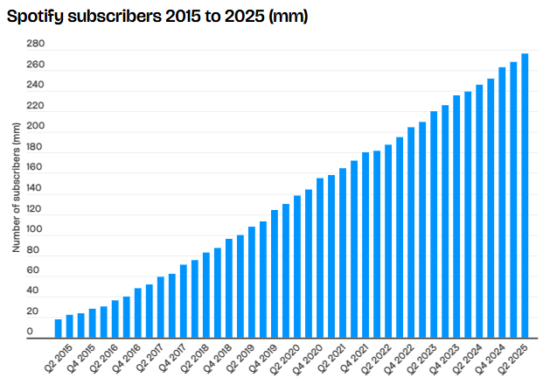
Figure 11: Spotify Premium Subscribers
(Source: Tafradzhiyski, 2025)
Spotify has an effective differentiation policy that is pegged on personalisation, content mix and excellent user experience. This strategy worked best because the platform boasted of more than 675 million monthly active users and 260 million premium subscribers in 2026. Its AI-powered recommendation engine conveys more than 30% of all the listening activity while offering high switching costs and a cohort of long-term users.
Cost leadership is structurally unsustainable with royalty payments more than 65% of revenue. Spotify, in comparison to the Apple Music, which is based on ecosystem lock-in, distinguished by cross-diversity and data-rich experiences, with a market share of about 30-32%, purposely global (Tafradzhiyski, 2025).

5.2 Corporate-Level Strategy
Spotify has been undertaking strategic diversification and internationalization in the business front as a means of failing to rely on the music streaming revenues. Investments in the podcasting industry exceeding $1 billion have spawned over 7 million episodes so far as of 2025-26 with podcast listening or listening, a rising percentage of all activity on the platform. Access to audiobook marketplace enhances the larger audio ecosystem of Spotify (Stupples, 2025). Its presence in the global market is more than 180 countries and it has experienced tremendous growth in user numbers in Asia, Latin America and Africa. Though the monetisation levels in these areas are still low as compared to those of the developed markets, this two pronged approach of diversification of content and globalization geographically makes Spotify a truly holistic global sounding platform (Boonen, 2025).

5.3 Recommended Strategic Choices
Utilising Porters Generic Strategies, Spotify ought to remain focusing on differentiation in conjunction with ecosystem growth. Its personalisation capability of data and such a massive user base is a competitive edge which competitors will not be able to compete with. It will continue to engage by investing in podcasts and audiobooks to diversify the financial sources that will sustain the engagement in case of financial shock in the long term (PortersFiveForce Team, 2026). The notion of cost leadership would be paradoxical, bearing in mind that Spotify has a radically high fixed and variable cost structure.

5.4 Change Management and Strategic Implementation
Effectiveness of Change Management
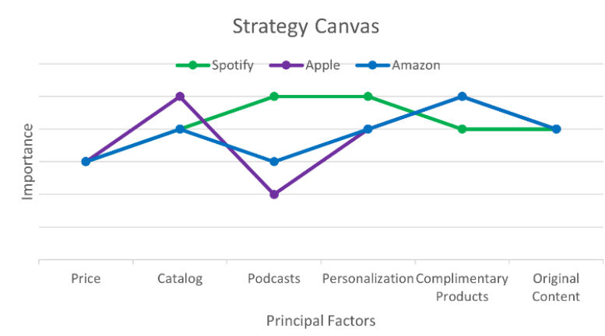
Figure 12: Spotify Strategy Canvas
(Source: Sletten, 2025)
Spotify has been effective in managing change since it has been able to shift into a diversified audio platform as opposed to it being one that solely streams music. It has spent more than $1 billion on podcasting between 2020 and 2026, and created a catalogue of more than 7 million podcasts, and has driven engagement by over 675 million monthly active users (Spotify.com, 2026). The agile organisational structure and data-driven culture allowed the quick integration of novelties in different formats, and AI capabilities enhanced content discovery. This flexibility shows good strategic alignment and transformation through innovation (Maziati and Handoko Oktavianus, 2024).
Impact on Strategic Implementation
But, the effect is ambivalent. Although diversification has enhanced user engagement and differentiation, the profitability is limited as the costs of content acquisition and royalty payments are greater than 65 percent of revenues. Also, the performance of podcast investments has been worse than anticipated, which indicates difficulties with executions. Therefore, change has both improved competitive positioning, but has not completely translated into financial efficiency (Motley Fool Transcribing, 2025).

6. Strategic Evaluation and Recommendations

6.1 SWOT Analysis
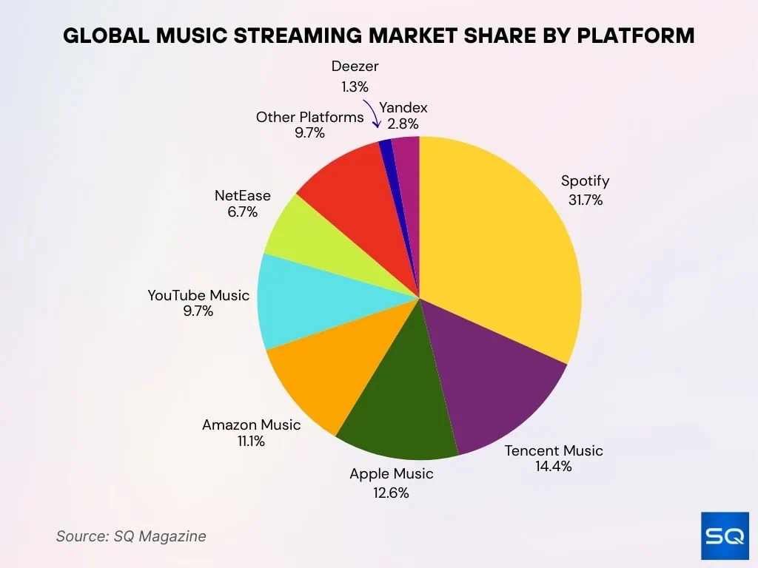
Figure 13: Spotify market Share
(Source: Elad, 2025a)
Strengths: Spotify enjoys a strong brand recognition and scopes where the of over 675 million monthly active users and over 260 million premium subscribers in 2026, would expose them to approximately 30-32% market share in the entire world. Its wide content base and personalisation facilities that are highly developed, enhance user loyalty and engagement (Elad, 2025a).
Weaknesses: Despite the fact that in 2025, this firm will enjoy considerable revenues of about 15-17 billion, its profitability will be low since royalty fees will comprise over 65% of the entire revenues. This constrains margin growth and puts an emphasis on reliance on third-party content makers (Richter, 2026).
Opportunities: Spotify has a high growth potential in the emerging markets and the tendency to increase digital use provided growth in the number of users. Besides, the podcasts (at least 7 million titles) are a novel source of monetisation through the advertising and exclusive content (Guo, Zhao and Zeng, 2025).
Threats: Spotify competes with websites such as Apple Music relatively intensely, and the control pressure in the form of copyright and data privacy and taxing authorities are increasing, which may contribute to the cost of conducting and reducing the strategic opportunities.

6.2 Evaluation Using Strategic Frameworks
Ansoff Matrix
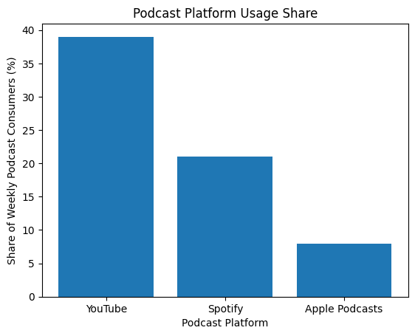
Figure 14: Spotify’s Share of Podcasts
(Source: Self Created using data from TFA Admin, 2025)

Strategy | Explanation
Market Penetration | Spotify takes advantage of its positions in existing markets by turning more premiums of its 675 million MAUs. As early as 2026, the company has projections of more than 260 million premium subscribers (Singh, 2025).
Product Development | The company is growing content with podcasts and audiobooks, with more than 7 million titles of podcasts by 2025-2026. Other aspects and inventions comprise improved times of discovery and AI mixed-playlists, which are changing user experience and retention (TFA Admin, 2025).
Market Development | Spotify already has more than 180 markets and is expanding into emerging markets such as Asia and Africa where the user base is growing and a new emerging way of monetising is being implemented.
Diversification | Spotify is neither a music platform, nor an audio platform, but an ecosystem of audio, which includes such pieces as podcasts, audiobooks and advertising. Investments of 1 billion in podcasting reflect its dedication to minimising the dependence on music streaming revenue (PredictStreet, 2025).
Table 3: Ansoff Matrix
(Source: Self Created)

6.3 Recommendations
Spotify needs to prioritize some improved pricing strategies, including tiering subscriptions, and differentiation of prices to create greater profitability within the country to generate higher ARPU even though the company still has relatively low ARPU despite increasing past 260 million premium users in 2026 (Carman, 2026). The exclusive production, particularly the podcasts and audiobooks should be continued to grow on the foundation of its existing library of over 7 million podcasts, to create inventiveness and extra involvement. It must expand to new markets in Asia and Africa as both of them are key contributors to the growth in its 675 million MAUs. In addition to that, Spotify has to improve the artist relations by promoting them through increasing revenue-sharing models and promoting ways and this will reduce the use of middle men and increase the loyalty of the platform (Spotify, 2025b).

6.4 Justification of Recommendations
The suggestions are compatible with the Resource-Based View (RBV), as the data analytics, size of the platform, and personalisation of the Spotify are extremely valuable and uncopyable resources. Porters Competitive Advantage shows that the differentiation can be made by unique content and the enhanced user experience, which can enhance the positioning. Real-life examples such as the investments of over $1 billion by Spotify in the podcast can affirm that strategic resource investments can be used to further boost the diversification and long-term benefit of revenues.

Section 2: Reflection

Model Overview
This reflection narrative is organized with the use of Gibbs Reflective Cycle, a theoretical framework of six steps, which includes description, feelings, evaluation, analysis, conclusion and action plan. The model advocates the formation of descriptive and analytical arguments, a reason why it would be ideal to dissect the process of researching and writing a strategic management report (Galli and New, 2022). It can enable us to critically examine the use of theoretical knowledge, the obstacles and what we can do next in the history of academic practice in a manner that is meaningful.

Model Analysis
1. Description
The whole process of researching and writing entailed obtaining data on academic literature, industry, and business reports, and books to carry out an overall strategic analysis. The assignment entailed the usage of multiple strategic theories of management including the PESTEL, VRIO, SWOT, the Balanced Scorecard, as well as Porters models, to appraise the performance of the organisations on the general level (O’Reilly, 2025). In order to make the report organized in a manner that not only fell within the academic norms and guidelines, but also incorporated the projections of the real world in 2025-2036, a major consideration had to be placed on logical organization, relevance and incorporation of the real world projections. A lot of research was done on the uniting of theoretical ideas and practical examples in the sense that each sector of the analysis played some significant role as opposed to standing alone (Whyte, 2021).
2. Feelings
The work was initially also complex and demanding as the range of frameworks needed and the level of critique demanded were quite extended. Some skepticism was evident in terms of picking the most pertinent data and being statistically sound, especially with the inclusion of recent data (Lin, Liu and Pham, 2023). With the advancement of research, however, there was an increasing confidence, particularly after the interrelationships between various theoretical models became evident. The analysis got more active with the emergence of particular insights and shaping of arguments. However, time limit and pressurizing requirements to correspond to the word count requirements at different stages were constant throughout the entire process (Ahmed et al., 2025).
3. Evaluation
There are a number of things in the process that were effective. The structured frameworks offered analytical guiding warrant and total coverage of the strategic posture of the organisation. The authenticity of the report and the topicality were enhanced by the availability of new and up-to-date industry information (Huynh, Nippa and Aichner, 2023). The separation of the work into certain fragments also helped to maintain a logical flow, and not to lose the focus during the analysis process.
However, there were certain challenges that were apparent. Representing statistics to ensure that it is consistent and reliable was quite a time consuming exercise more so when there were inconsistent statistics in some sources. Striking the right balance between description issue and critiques were also sometimes errors and one such common occurrence was to describe structures rather than to exercise them critically (Dibekulu, 2020). Also, to include over one non-redundant model, care was required in terms of planning and editing when drafting it.
4. Analysis
This experience was the basis on which the real essence of importance of theory-practice bridging was established. The interaction of the external environment and internal organisational capabilities in determining strategy decisions were also demonstrated with the use of frameworks such as the PESTEL and VRIO. It was also brought to light that theoretical models can never exist independently but are complementary lenses, which when combined together gives a more in-depth and holistic perspective of an organisational strategy (Larbi, Asare-Danquah and Akua, 2024).
The critical thinking came along with the assessment process of not only what strategies are followed by an organisation but the reasons why it works or why the strategies are constrained. Such an example is the fact that in analysing the competitive advantage of Spotify, it would have been important to not only take into account the fact that the company is leading in its niche as well as deal with the current restrictions of its profitability at the same time which would not have been described with ease as well (Shonubi, 2025). The activity also led to the realisation that there is a need to use evidence-based arguments where the assertions made during the analysis can be supported with the help of credible information rather than assumptions and generalisation.
5. Conclusion
This overall experience offered sufficient strategic analysis training together with academic writing. It highlighted the value of structure, conciseness and critical examination as important ingredients of quality report. The procedure improved the capacity of processing complex information, deliberate usage of theoretical formulations and logical and compelling planning of arguments. It also reaffirmed the fact that such compromises as quality and relevance are not entertained as far as data sampling aids in the creation of a valid academic product. Among the things I learnt was that to become a good strategic analyst requires breadth in addition to depth in analysis and that you need a set of perspectives besides ensuring that you stick to the strategic problems of the organisation.
6. Action Plan
Certain physical improvements will be done in later assignments. It will allow starting the research process earlier in order to spend more time on the process of checking the data, processing it deeper and conducting extensive editing. The developed detailed outline that will be prepared initially will help to prevent redundancy and even more help to unify the frameworks in sections (Xu, Wang and Qian, 2025).
On the one hand, critical evaluation rather than description will be brought into light prominently and all the points of analysis will be outlined in a way that they contain an idea of who research is intended to be. The broader the range of academic sources, which have been looked at and the references have been perfected will contribute to rigour and credibility in future work (Naeem et al., 2023).

Reference List
Ahmed, S.K., Mohammed, R.A., Nashwan, A.J., Ibrahim, R.H., Abdalla, A.Q., Ameen, B.M.M. and Khidhir, R.M. (2025). Using Thematic Analysis in Qualitative Research. Journal of Medicine, Surgery, and Public Health, [online] 6(6), p.100198. doi:https://doi.org/10.1016/j.glmedi.2025.100198.
Alexios Kaponis, Manolis Maragoudakis and Konstantinos Chrysanthos Sofianos (2025). Enhancing User Experiences in Digital Marketing Through Machine Learning: Cases, Trends, and Challenges. Computers, 14(6), pp.211-211. doi:https://doi.org/10.3390/computers14060211.
AmpVortex admin (2026). Spotify: From a Swedish Anti-Piracy Startup to a Global Audio Empire. [online] AmpVortex. Available at: https://www.ampvortex.com/spotify-from-a-swedish-anti-piracy-startup-to-a-global-audio-empire/.
Boonen, I. (2025). Spotify’s Localization and International Expansion. [online] Nimdzi. Available at: https://www.nimdzi.com/lessons-in-localization-spotify-expanded/.
Business of Apps (2026). Amazon Prime Music Revenue and Usage Statistics (2026). [online] Business of Apps. Available at: https://www.businessofapps.com/data/amazon-prime-music-statistics/.
Carman, A. (2026). Spotify Sets User Growth Record Thanks to ‘Wrapped’ Promotion. [online] Bloomberg.com. Available at: https://www.bloomberg.com/news/articles/2026-02-10/spotify-sets-user-growth-record-thanks-to-wrapped-promotion.
Chowdhury, R.H. (2025). Digital Engagement and Customer Experience Leadership: Strategies for the Modern Enterprise. doi:https://doi.org/10.70593/978-93-7185-445-0.
Chu, B. (2026). Spotify now represents one-third of the music industry’s total recorded revenue in 2025. [online] Fox Business. Available at: https://www.foxbusiness.com/technology/spotify-now-represents-one-third-music-industrys-total-recorded-revenue-2025.
Climent, R.C., Haftor, D.M. and Staniewski, M.W. (2024). AI-enabled business models for competitive advantage. Journal of Innovation & Knowledge, [online] 9(3), pp.100532-100532. doi:https://doi.org/10.1016/j.jik.2024.100532.
Counselab (2025). CoffeeSpace Blogs | Spotify Founders’ Journey - The Titan of Music Streaming. [online] Coffeespace.com. Available at: https://www.coffeespace.com/blog-post/spotify-founders-journey.
Dallos, C., Konieczka, G., Michael Holtz, H. and Sacchi, C. (2025). Data, Privacy, and Personalization: How Spotify Maintains a Competitive Advantage under the GDPR. [online] Available at: https://www.diva-portal.org/smash/get/diva2:1981304/FULLTEXT01.pdf.
Davies, C. (2026). Spotify reports record growth in monthly listeners, totaling 751 million. [online] Yahoo Finance. Available at: https://finance.yahoo.com/news/spotify-reports-record-growth-monthly-212029145.html
Dibekulu, D. (2020). An Overview of Data Analysis and Interpretations in Research. [online] ResearchGate. doi:https://doi.org/10.14662/IJARER2020.015.
Dolgin, M. (2025). Spotify Continues to Dominate Its Industry and Is Now Rapidly Growing Profits. [online] Morningstar, Inc. Available at: https://www.morningstar.com/company-reports/1262254-spotify-continues-to-dominate-its-industry-and-is-now-rapidly-growing-profits.
Doran, P., Thomson, R. and Webster, E. (2024). When royalties impede technology transfer. The Journal of technology transfer/The journal of technology transfer. doi:https://doi.org/10.1007/s10961-024-10095-5.
Elad, B. (2025a). Spotify Statistics 2025: User Growth, Streaming Trends, and Revenue Milestones. [online] SQ Magazine. Available at: https://sqmagazine.co.uk/spotify-statistics/.
Elad, B. (2025b). Spotify User Statistics 2025: Insights into Global Streaming Trends. [online] SQ Magazine. Available at: https://sqmagazine.co.uk/spotify-user-statistics/.
ET BrandEquity (2026). Spotify says it made record payout of more than $11 billion to music industry in 2025. [online] ETBrandEquity.com. Available at: https://brandequity.economictimes.indiatimes.com/news/digital/spotify-says-it-made-record-payout-of-more-than-11-billion-to-music-industry-in-2025/127755337
Galli, F. and New, C. (2022). Gibbs’ Cycle review. Emotions as a Part of the Cycle. e-Motion: Revista de Educación, Motricidad e Investigación, 19(19), pp.92-101. doi:https://doi.org/10.33776/remo.vi19.7224.
Greenly (2025). Spotify’s rising carbon footprint from turning audio into video. [online] Podnews. Available at: https://podnews.net/press-release/spotify-video-environment.
Guo, Q., Zhao, J. and Zeng, H. (2025). Influence of Spotifys Services on Its Revenue. Advances in Economics Management and Political Sciences, [online] 213(1), pp.274-281. doi:https://doi.org/10.54254/2754-1169/2024.26905.
Huynh, M.-T., Nippa, M. and Aichner, T. (2023). Big data analytics capabilities: Patchwork or progress? A systematic review of the status quo and implications for future research. Technological Forecasting and Social Change, [online] 197. doi:https://doi.org/10.1016/j.techfore.2023.122884.
IESE Insight. (2025). Spotify: A global success story in search of profitability. [online] Available at: https://www.iese.edu/insight/articles/spotify-strategy-streaming/.
IFSA LSR (2025). Spotify and Its Financial Journey - IFSA Network. [online] IFSA Network. Available at: https://ifsa-network.com/publications/spotify-and-its-financial-journey/.
Kaplan, R. and Norton, D. (1992) The Balanced Scorecard—Measures That Drive Performance. Harvard Business Review, 79.
Khanom, M.T. (2023). Using Social Media Marketing in the Digital Era: A Necessity or a Choice. [online] ResearchGate. Available at: https://www.researchgate.net/publication/370578753_Using_Social_Media_Marketing_in_the_Digital_Era_A_Necessity_or_a_Choice.
Larbi, A.O., Asare-Danquah, G.A. and Akua, A. (2024). Utilization of Internal Analysis with the VRIO Framework and Development of Scale for Resource and Capabilities of Fashion and Design Organization. International journal of research and scientific innovation, XI(VI), pp.63-70. doi:https://doi.org/10.51244/ijrsi.2024.1106006.
Li, Z., Sial, M.S., Wu, H., Căpușneanu, S. and Barbu, C.-M. (2023). The Role of CSR Information on Social Media to Promote the Communicative Behavior of Customers: An Emotional Framework Enriching Behavioral Sciences Literature. Behavioral Sciences, 13(2), p.126. doi:https://doi.org/10.3390/bs13020126.
Lin, M., Liu, L.Y.J. and Pham, T.N. (2023). Towards developing a critical learning skills framework for master’s students: Evidence from a UK university. Thinking Skills and Creativity, 48, p.101267. doi:https://doi.org/10.1016/j.tsc.2023.101267.
Majumder, A.S. (2025). The Influence of UX Design on User Retention and Conversion Rates in Mobile Apps. [online] ResearchGate. doi:https://doi.org/10.48550/arXiv.2501.13407.
MatrixBCG Team (2026). What are Mission Vision & Core Values of Spotify Technology Company? [online] matrixbcg.com. Available at: https://matrixbcg.com/blogs/mission/spotify
Maziati, D. and Handoko Oktavianus, L. (2024). A SUCCESS STORY OF SPOTIFY: STRATEGICALLY ACHIEVING BUSINESS EXPANSION AND GROWTH. [online] ResearchGate. Available at: https://www.researchgate.net/publication/388802318_A_SUCCESS_STORY_OF_SPOTIFY_STRATEGICALLY_ACHIEVING_BUSINESS_EXPANSION_AND_GROWTH.
MOI Global. (2025). Spotify: High-ROI Grower With Scale, Brand, and Network Effects. [online] Available at: https://moiglobal.com/mallik-fite-202207/.
Mokoena, N. and Obagbuwa, I.C. (2025). An Analysis of Artificial Intelligence Automation in Digital Music Streaming Platforms for Improving Consumer Subscription responses: a Review. Frontiers in Artificial Intelligence, 7(1). doi:https://doi.org/10.3389/frai.2024.1515716.
Mordor Intelligence (2025). Digital Music Market Size & Share Analysis - Industry Research Report - Growth Trends. [online] Mordorintelligence.com. Available at: https://www.mordorintelligence.com/industry-reports/digital-music-market.
Motley Fool Transcribing (2025). Spotify (SPOT) Q3 2025 Earnings Call Transcript | The Motley Fool. [online] The Motley Fool. Available at: https://www.fool.com/earnings/call-transcripts/2025/12/23/spotify-spot-q3-2025-earnings-call-transcript/.
Naeem, M., Ozuem, W., Howell, K. and Ranfagni, S. (2023). A step-by-step Process of Thematic Analysis to Develop a Conceptual Model in Qualitative Research. International Journal of Qualitative Methods, 22(1), pp.1-18. doi:https://doi.org/10.1177/16094069231205789.
O’Reilly, S. (2025). Strategic Analysis: Overview, Tools, Methods & Steps. [online] Strategic Analysis: Overview, Tools, Methods & Steps. Available at: https://www.spiderstrategies.com/blog/strategic-analysis/.
Patov, A. (2026). How Spotify Delivers a Unique Customer Experience (CX) with Personalized Music Recommendations. [online] Renascence.io. Available at: https://www.renascence.io/journal/how-spotify-delivers-a-unique-customer-experience-cx-with-personalized-music-recommendations.
PESTEL Analysis Team (2025). What is Competitive Landscape of Spotify Technology Company? [online] PESTEL ANALYSIS. Available at: https://pestel-analysis.com/blogs/competitors/spotify.
Peterson, L. (2026). As Spotify Turns 20, the Most Global and Diverse Music Industry in History Has Taken Shape — Spotify. [online] Spotify. Available at: https://newsroom.spotify.com/2026-03-11/loud-and-clear-music-economics-highlights/.
PortersFiveForce Team (2026). What is Competitive Landscape of Spotify Technology Company? [online] Porter’s Five Forces. Available at: https://portersfiveforce.com/blogs/competitors/spotify.
PredictStreet (2025). Spotify: Harmonizing Growth and Profitability in the Global Audio Arena (9/30/2025). [online] Financialcontent.com. Available at: https://markets.financialcontent.com/wral/article/predictstreet-2025-9-30-spotify-harmonizing-growth-and-profitability-in-the-global-audio-arena-9302025.
Richter, F. (2026). Spotify’s uphill battle against royalty costs. [online] Paperjam.lu. Available at: https://en.paperjam.lu/article/delano_spotifys-uphill-battle-against-royalty-costs?utm_source=syndication&pubDate=20260107
Shonubi, O. (2025). Innovation Challenges of Digital Transformation: Transitioning Legacy to the Future. Sustainable Futures, [online] p.100971. doi:https://doi.org/10.1016/j.sftr.2025.100971.
Singh, S. (2025). Spotify Statistics (2025) - User Growth, Top Artists & More. [online] DemandSage. Available at: https://www.demandsage.com/spotify-stats/.
Sletten, R. (2025). Spotify: Strategic Plan and Analysis. [online] University of Montana. Available at: https://scholarworks.umt.edu/cgi/viewcontent.cgi?article=1346&context=utpp.
Spotify (2022). Spotify Shares Our Vision To Become the World’s Creator Platform. [online] Spotify. Available at: https://newsroom.spotify.com/2022-06-08/spotify-shares-our-vision-to-become-the-worlds-creator-platform/.
Spotify (2025a). About Spotify. [online] Spotify. Available at: https://newsroom.spotify.com/company-info/.
Spotify (2025b). How the Music Industry’s Cultural and Financial Impact Define Its Success in 2025 — Spotify. [online] Spotify. Available at: https://newsroom.spotify.com/2025-03-12/beyond-profits-how-the-music-industrys-cultural-and-financial-impact-define-its-success-in-2025/.
Spotify. (2025c). Understanding Spotify royalties - Spotify. [online] Available at: https://support.spotify.com/us/artists/article/understanding-spotify-royalties/.
Spotify.com. (2026). Spotify Reports Fourth Quarter 2025 Earnings. [online] Available at: https://newsroom.spotify.com/2026-02-10/spotify-q4-2025-earnings/.
Statista. (2025). Spotify segment revenue worldwide 2025| Statista. [online] Available at: https://www.statista.com/statistics/245125/revenue-distribution-of-spotify-by-segment/?srsltid=AfmBOoraAijLNM7noAi84VB8tZrEhnimTuU09eWZMu8T1oCsoyohcfkd
Storyboard18 (2026). Spotify payouts cross $11 billion as independent artists take larger share. [online] Storyboard18.com. Available at: https://www.storyboard18.com/brand-marketing/spotify-payouts-cross-11-billion-as-independent-artists-take-larger-share-88427.htm#google_vignette
Stupples, B. (2025). Spotify Founders Pocket $1 Billion Selling Booming Tech Stock. [online] Yahoo Finance. Available at: https://finance.yahoo.com/news/spotify-founders-pocket-1-billion-092707683.html
Suganthi, M.P. (2025). Agility at Scale: Spotify’s Unique Approach to Organizational Structure and Technological Innovation. Digital Agility- A Peep into the Future”. [online] Available at: https://www.researchgate.net/publication/397936144_Agility_at_Scale_Spotify%27s_Unique_Approach_to_Organizational_Structure_and_Technological_Innovation.
Tafradzhiyski, N. (2025). Spotify Usage and Revenue Statistics (2025). [online] Business of Apps. Available at: https://www.businessofapps.com/data/spotify-statistics/.
TFA Admin (2025). Podcast Statistics 2025: Key Insights for Modern Marketing Strategies. [online] The frank Agency. Available at: https://thefrankagency.com/blog/podcast-statistics/.
Whyte, S.T. (2021). Reliable Data Collection: A Tool for Data Integrity in Nigeria. [online] doi:https://doi.org/10.13140/RG.2.2.23774.20803.
Xu, Z., Wang, Y. and Qian, Y. (2025). The design and application of in-depth interviews in primary care research. Chinese General Practice Journal, [online] 2(2), p.100062. doi:https://doi.org/10.1016/j.cgpj.2025.100062.
Yang, J. and Kwon, Y. (2024). Are digital content subscription services still thriving? Analyzing the conflict between innovation adoption and resistance. Journal of Innovation & Knowledge, 9(4), p.100581. doi:https://doi.org/10.1016/j.jik.2024.100581.

