the theory and applications of Fuel-air explosions
Samuel Page (1910580)

University of Wales Trinity Saint David
Scientific Principles of OME

Abstract
This report is all about Fuel-Air explosives and their applications in military settings. This report starts off by looking at the phenomenon called deflagration and detonation distinguishing that deflagration is the sub-sonic release of energy and detonation is supersonic. This then translates into the air surrounding the detonating explosive creating a sharp peak overpressure and an impulse capable of doing work. This impulse can be enhanced by the addition of secondary reacting metals. Fuel-Air explosions further enhance this impulse but have a lower detonation velocity and have to be within the fuels lower and upper explosive limits for a detonation to be sustained. The most likely applications for this technology is mine field clearance, soldier incapacitation and light structure defeat due to the great workability produced by the long duration blast wave that creates a long lasting impulse.

Contents
Abstract 1
1. Detonation and Deflagration 3
1.1. Introduction 3
1.2. Deflagration 3
1.3. Detonation 4
2. Free Air Explosions 5
2.1. Blast 5
2.2. Scaling laws 7
3. Target Types 7
4. Fuel-Air Explosions (FAE) 8
4.1. History 8
4.2. Differences with Conventional Explosives 9
4.3. Most Appropriate Targets 10
5. FAE Characteristics and Warhead Design 11
5.1. TNT Equivalence 11
5.2. Two stage initiation 11
5.2.1. Self-initiation 11
5.2.2. Direct Initiation 11
5.3. Factors Affecting Performance 11
References 13

Detonation and Deflagration

Introduction
When an energetic compound or mixture is initiated, a mixture of gaseous products are formed as the molecules receive sufficient energy to break down. This combustion wave travels away from the ignition source and releases the potential energy stored in the energetic compound or mixture [1]. This process is always exothermic [2]. This stored potential energy is then converted in to both Thermal and Kinetic Energy. This creates extremely high temperatures and pressures within the compound or mixture which sustain burning within the energetic [3]. This is due to the gradients in both temperature and pressure across the wave [1]. The burning front propagation is shown in Figure 1 along with the corresponding temperature profiles for each zone. The speed at which this burning occurs defines how quickly the energy is released and therefore, how the burning is defined. There are two types of rapid burning which are discussed below.
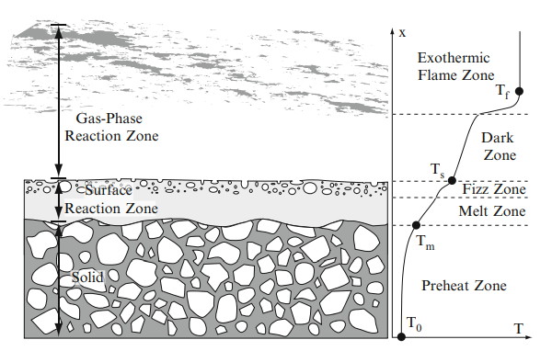
Figure 1 - Propagation of the Burning Front with corresponding Temperature Profiles for Each Zone

Deflagration
A deflagration occurs when the surface reaction zone shown in Figure 1 travels through the material at relatively low sub-sonic velocities in relation to the unreacted reactants ahead of it [1]. In all energetic reactions, it is necessary to translate energy through to the unreacted material. This can be achieved in one of two ways, either compressive shock, adiabatic heating, or thermal diffusion through the material [2]. As deflagrations are sub-sonic, in relation to the reactants ahead of the burning front, there is no shockwave established in the material so the reaction front must be sustained by diffusion through the material. Due to the steep temperature gradient across that burning front, the transfer of energy in the form of heat is performed quickly but still sub-sonic and will allow the material ahead of it to initiate [2]. This is because the thermal energy that is being transferred allows the molecules to obtain their activation energy. This the minimum energy required to activate atoms or molecules to undergo chemical transformation and if the energy transferred through the material is greater than this energy, then a reaction will be sustained [4]. In the case of deflagrations, this energy is greatly exceeded so the reaction progresses at a relatively quick rate when compared to combustion.

Detonation
A detonation occurs in a similar way to that explained above in Section 1.2, however, the combustion front proceeds at velocities an order of magnitude greater than that in deflagration. These velocities can be anywhere from 1500m/s to 9000m/s [5]. This is known as the velocity of detonation. Velocity of detonation for some common primary and secondary explosives are shown in Table 1.
Table 1 - Velocity of Detonation for common Primary and Secondary Explosives [5]
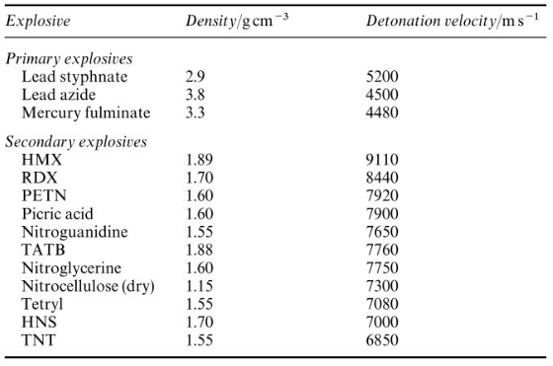
As the combustion front proceeds at supersonic speeds, the method of energy transfer must be a high pressure and temperature shock wave. Due to this very high-pressure shock wave, the reactants ahead of the shock front are undisturbed until the shock front reaches it [1]. These reactants are affected by a phenomenon known as adiabatic heating which exceeds the activation energy of the material. Adiabatic heating occurs when high-pressure is exerted on a substance in a sufficiently quick time so the material can’t exchange energy with its surroundings [6]. The implication of this means that sufficient energy is imparted into the energetic substance to sustain a very fast shock front, rapidly converting the energetic to high pressure, high temperature gas. Behind this area of very high pressure is a rapidly expanding pocket of gas so the pressure will decrease to match the rear boundary condition [1]. This leaves an area of rarefaction in the air behind this shock wave [7]. A Diagram to illustrate this is shown in Figure 2. It is also important to note that for every medium, the speed of sound changes, due to the difference in both density and elasticity of the two mediums. Whereas in air, the speed of sound is 330m/s, the speed of sound in an explosive is generally around 1800m/s [8].
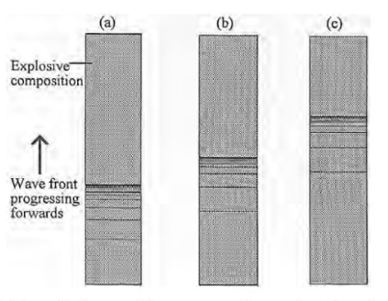
Figure 2 - Progression of a Shock Wave Front in a Detonating Explosive [5]

Free Air Explosions

Blast
In this section we will move from looking at the detonation mechanics within the energetic substance to the effect it has on its surroundings. When an explosive or explosive mixture detonates in free air, very high compressive strain rates are produced [9]. This is because a very high pressure and temperature pocket of gas is produced and rushes to reach equilibrium with the surrounding air [10]. This causes the surrounding air to shock up, creating a shock wave and a very large peak overpressure [11]. This wave consists of highly compressed air that travels radially out from the source [10]. This overpressure, however, starts to decelerate very quickly [12]. This very large overpressure is overtaken within a few charge diameters by the expanding gas wave [12]. This compresses the atmosphere ahead of it creating a powerful blast wave that contains most of the energy from the explosion [12]. This is the most damaging part of an explosion as it can do the most work on whatever it washes over instead of the initial peak over pressure [12]. The peak over-pressure isn’t the most damaging element because it only lasts for microseconds instead of the milliseconds for the impulse that is generated. Shown in Figure 3 is a typical bast profile.
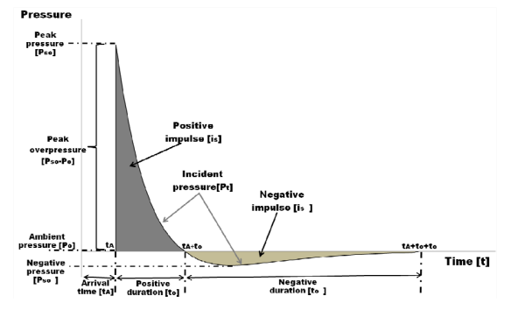
Figure 3 - The Ideal Blast Wave [3]
There is a negative impulse after the positive phase. This is due to a rarefaction wave that is created from the rapidly expanding gases [13]. This creates an area of low pressure which leads to this negative pressure area. This could also be damaging as it is imparting the opposite stress on targets, so if, for example, a structure had been cracked by the compressive wave, then this tensile wave could physically rip it apart as illustrated in Figure 4. Effectively, this leads to a suction action on any target [3].
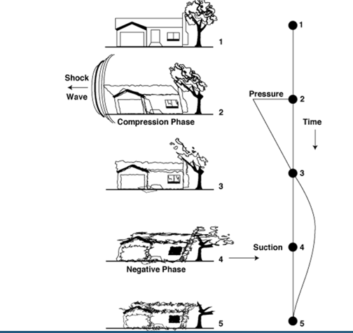
Figure 4 - Illustration of the Destructive Elements of a Blast Wave [7]

Scaling laws
Using blast scaling laws, and the Kingery-Bulmash curves, the peak overpressure can be predicted for many explosives. This also allows us to determine the damage that could be caused from an explosion.

Target Types
There are various targets for any military application of explosives, all requiring their own unique designs and effects. For example:
Man-made structures such as buildings
Man-made structures are most attacked with free air explosions [3]. This is because the compressive waves damage the buildings to a state where they are no longer safe and eventually could end up collapsing. This is usually the cause of casualties in this scenario [3]. When selecting an explosive to use for this application, it is therefore, best to use a long duration impulse as this can do the most work as explained in Section 2.1.
There are various other types of targets that militaries are interested in defeating such as tank armour, blast-proof bunkers and aircraft. However, blast isn’t ordinarily utilised for these as it doesn’t have the destructive power to defeat them. Therefore, long-rod penetrators, shaped charges and explosively formed projectiles were developed. However, this report doesn’t analyse these techniques.

Fuel-Air Explosions (FAE)

History
For a long time, High Explosive warheads were limited in their blast capability. They generally had large overpressures but short durations diminishing the work that can be performed by the blast wave [14]. Following this, metallised explosives were developed, such as Torpex and Tritonal. This works to improve the workability of the explosive as it increases the overall impulse from the explosive [15]. This is because in the case of aluminium being added, after the initial detonation energy release, there is a further energy release as the Aluminium is converted into Aluminium Oxide [15]. This is the case for most metals that are added to explosive mixes. This conversion does remove some of the gaseous products from the detonation though, which in turn creates a lower peak overpressure [15]. However, with the added energy release, the impulse can last much longer, therefore, inflicting more damage. Even after this development, an even longer impulse was sought. This is where Fuel-Air Explosions were developed. The fundamental principle is that certain fuels, when dispersed in Oxygen can produce detonable vapours over wide explosive limits [16]. Fuel-Air explosions use any fuel, these can be solid dusts, such as metal powders, liquid fuels, such as boron hydrides or hydrocarbons, or combustible gases [11]. The most common way of achieving an FAE is to use hydrocarbon fuels. If allowed to reach a true stoichiometric mix, they can yield very high impulses due to their high heats of explosion and their slightly prolonged combustion time over conventional explosives [14]. FAE tend to have a prolonged combustion period because they tend to deflagrate and transition to detonation as the droplets combust individually creating smaller waves that coalesce forming a supersonic shock front and subsequent blast wave. A good representation of this is shown in Figure 5.
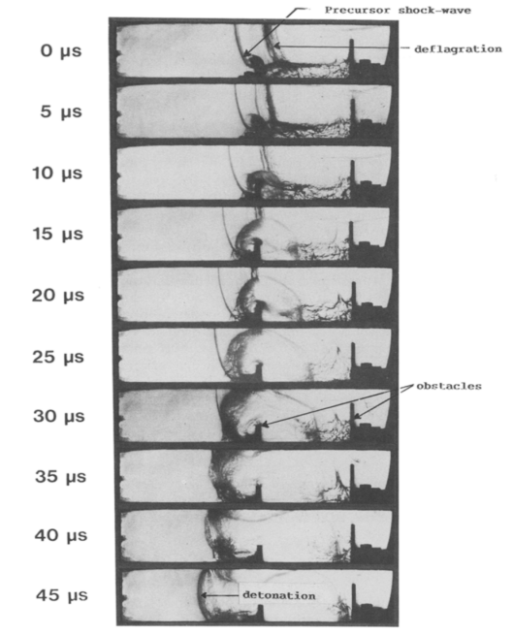
Figure 5 - Schlieren Photographs Representing a DDT due to Turbulent Shockwaves [17]
Fuel-Air explosions have been extensively researched by the United States of America who have developed many FAE based munitions such as the 500lb CBU-55 Cluster Bomb and the SLUFAE rocket system used for mine clearance [14]. They were developed at the end of World War II and were first used in Vietnam [18].

Differences with Conventional Explosives
There are lots of differences between conventional explosives and fuel-air explosives. Explosive molecules always contain their own oxygen which provides the oxygen to the combustion process whereas fuels need an external source of oxygen [19]. Therefore, they are known as the vacuum bomb [20]. This requirement for an external source of oxygen means we need a method of dispersing the fuel into the air which creates this inhomogeneous mix of fuel and air [21]. This also creates a low-density energetic mix as well, normally, around 1kg per m³ instead of 1kg per 0.001m³ [21]. This will lead to a lower detonation velocity within the energetic mix. Provided below in Table 2 is a list of detonation velocities for various stoichiometric mixes of common fuels along with the minimum initiation charge.
Table 2 - Minimum Energy and Velocity of Detonation for Some Common Fuels [14]
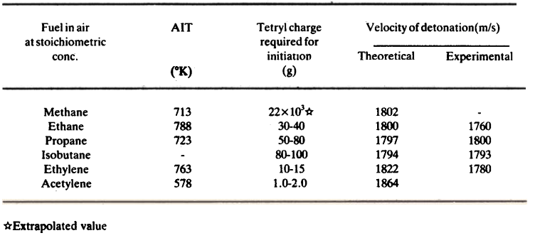
Another benefit of fuel-air explosives though, is that due to their gaseous nature, can flow around inhibitive structures and land contours creating a more tailored blast wave where appropriate. A diagrammatical representation of this is provided in Figure 5.
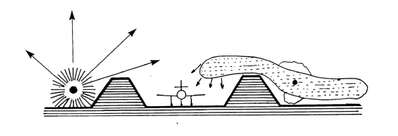
Figure 6 - Representation of the Difference Between a Point Source Conventional Explosive and a Fuel-Air Explosive [11]

Most Appropriate Targets
There are a wide range of targets for fuel air explosives. A common use for fuel air explosions is mine field clearance [22]. This is most likely due to the very powerful blast that is produced with minimal fragmentation. Another application for FAE is to injure infantry. The sustained pressures from FAE are sufficient to inflict significant internal injuries upon the soldiers [20]. Shown below in Figure 6 are the pressures needed to cause certain injuries and damage to structures.
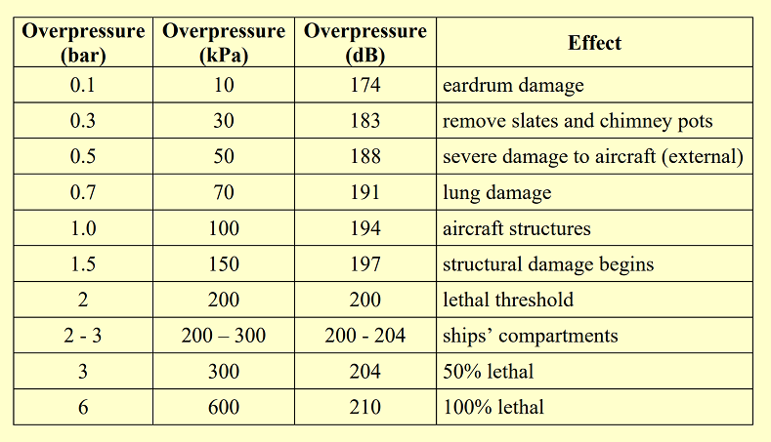
Figure 7 - Overpressures Required for Damage to Personnel and Structures
Fuel-Air applications have also been known to use long cases to disperse the fuel over a long and thin area, which is perfect for clearing landing strips and runways [23].

FAE Characteristics and Warhead Design

TNT Equivalence
Fuel-Air explosives can have very high TNT equivalences. For example, a typical stoichiometric Fuel-Air mixture of ethylene oxide and air has a TNT equivalence of 2.7 to 5.0 [14]. This is most likely due to the far superior Heat of explosion (Q) value even though, the gas volume produced isn’t as large.

Two stage initiation
In all fuel-air explosive warheads, there must be a two-stage method of initiation. Stage 1 uses a booster charge to disperse the fuel droplets in air to achieve the stoichiometric mix and a second stage initiation to ignite this explosive mixture [22]. Whilst there will always be these two stages,

Self-initiation
FAE can be self-initiating explosions in the sense that they can incorporate a glow wire to create a spark which starts the deflagration process [14]. Due to the turbulent nature of these small gaseous waves, they coalesce and eventually go through a Deflagration to Detonation Transition [14]. This will only happen when the mixture is at stoichiometry.

Direct Initiation
This is the most common method of initiation whereby, the fuel is carried in a cannister, burst to disperse the fuel and then secondary delay detonators are used to initiate the explosive cloud [16].

Factors Affecting Performance
There are many factors that will affect the performance of a fuel air explosions that you might not have to think of with conventional explosives. Some of these are listed below.
- Droplet Size
Droplet size is very important when it comes to fuel air explosives. With a larger droplet size, you need a larger secondary charge to initiate it [14]. This is probably because the energy required to release all of the energy from the droplet is higher due to the physical size of the droplet. Therefore, you want to ensure that the fuel gets sufficiently aerosolised making the burster charge one of the most important features when designing a fuel-air delivery system.
- Fuel Type
Fuel type is also extremely important. Every fuel has a different upper and lower explosive limit. Also, every fuel has a different sensitivity to shock and combustion. As is shown in Table 2, various fuels require different charge weights to initiate them due to their sensitivities and initiation temperatures.
- Additives
As was explained in Section 4.1, the addition of metals into conventional explosives will enhance the impulse. The same is true for fuel-air explosives. When a fuel-air explosion with aluminium added is initiated, both the overpressure and the reaction temperature increase greatly due to the secondary reaction process [19]. If 30% of this aluminium is replaced with Boron or Magnesium Hydride, then these effects are improved even further [19].

References

[1] | J. H. S. Lee, The Detonation Phenomenon, Cambridge: Cambridge University Press, 2008.
[2] | S. I. Jackson, Deflagration Phenomena in Energetic Materials: An Overview, vol. 5, Berlin: Springer, 2010.
[3] | V. Karlos and G. Solomos, “Calculation of Blast Loads for Application to Structural Components,” European Commission, Luxembourg, 2013.
[4] | The Editors of Encyclopaedia, “Activation Energy,” Britannica, 16 April 2021. [Online]. Available: https://www.britannica.com/science/activation-energy. [Accessed 09 December 2022].
[5] | J. Akhavan, The Chemistry of Explosives, Cambridge: The Royal Society of Chemistry, 2004.
[6] | OpenStax, University Physics II: Thermodynamics, Electricity, & Magnetism, LibreTexts, 2022.
[7] | G. Collett, Lesson 2 - Explosions in air, Swansea: University of Wales Trinity Saint David, 2022.
[8] | UK Ministry of Defence, “Chapter 7 Explosion Process,” in JSP 333: Joint Services Textbook, UK MoD, 2020, pp. 250 - 285.
[9] | P. W. Cooper, Explosives Engineering, Somerset: John Wiley & Sons, Incoporated, 1996.
[10] | FEMA, “Explosive Blast,” US Department of Homeland Security.
[11] | E.-C. Koch, “L-165 Volumetric Explosives Part I: Fuel/Air Explosives,” MSIAC, July 2010. [Online]. Available: https://www.msiac.nato.int/products-services/publications/l-165-volumetric-explosives-part-1-fuelair-explosives. [Accessed 07 12 2022].
[12] | A. Bailey and S. G. Murray, Explosives, Propellants and Pyrotechnics, London: Brassey's, 1989.
[13] | C. E. Needham, Blast Waves, London: Springer-Verlag, 2010.
[14] | A. Appa Rao, “Fuel Air Explosives,” Defence Science Journal, vol. 37, no. 1, pp. 23-28, January 1987.
[15] | E. L. Baker, W. Balas, C. Capellos, J. Pincay and L. Stiel, “Combined Effects Aluminized Explosives,” U.S. Army Armament Research, Development and Engineering Centre, Picatinny Arsenal, 2010.
[16] | M. M. Ismail, “Blast Wave Parameter Studies of Fuel-Air Explosives,” Royal Military College of Science (RMCS), Shrivenham, 1993.
[17] | I. O. Moen, “Transition to detonation in fuel-air explosive clouds,” Journal of Hazardous Materials, vol. 33, no. 1, pp. 159-192, 1993.
[18] | G. Liu, F. Hou, B. Cao, L. Xie, Z. Shen and T. Zhou, “Experimental Study of Fuel-Air Explosive,” Combustion, Explosion, and Shock Waves, vol. 44, no. 2, pp. 213 - 317, 2008.
[19] | Y.-x. Wang, Y. Liu, Q.-m. Xu, B. Li and L.-f. Xie, “Effects of metal powders on explosion of fuel-air explosives with delayed secondary igniters,” Defence Technology, vol. 17, no. 3, pp. 785-791, June 2021.
[20] | R. Meyer, J. Kohler and A. Homburg, Explosives, Weinheim: Wiley-VCH, 2007.
[21] | L. Humphreys, Fuel-Air Explosions, Shrivenham: Cranfield University, 2019.
[22] | J. Lee.United States of America Patent 553811, 1990.
[23] | I. O. Moen and J. W. Funk, “Blast Waves from Non-Spherical Fuel-Air Explosions,” 1983.

