DS 1 Template

My Screenshots/Photos

Screenshot/Photo 1
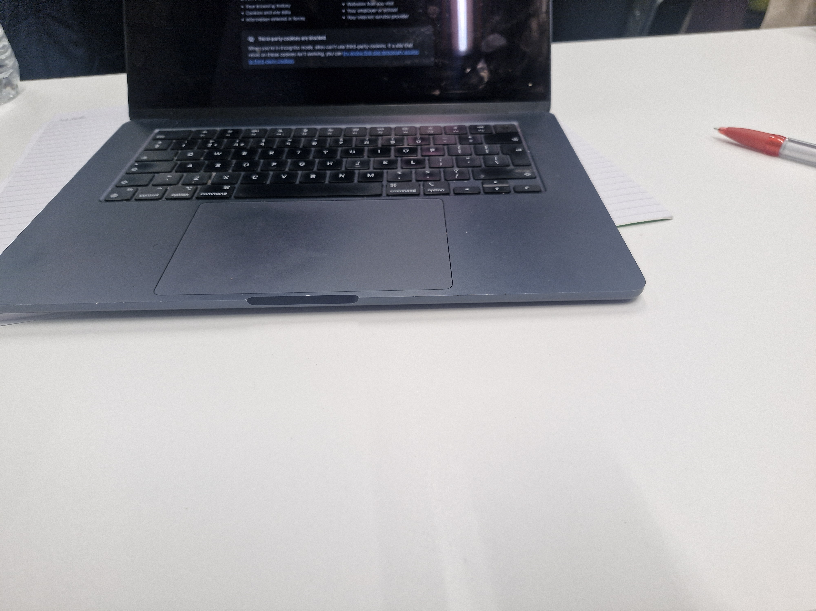
My Laptop I use for work and to store all my information

Screenshot/Photo 2
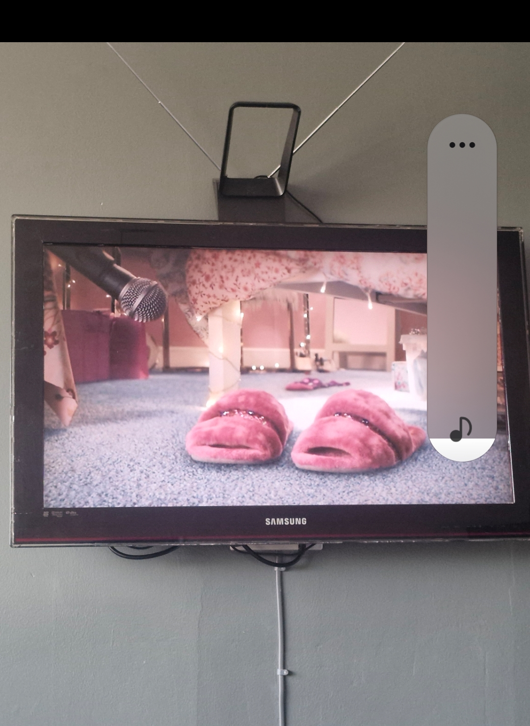
My Television I use for entertainment and learning

Screenshot/Photo 3
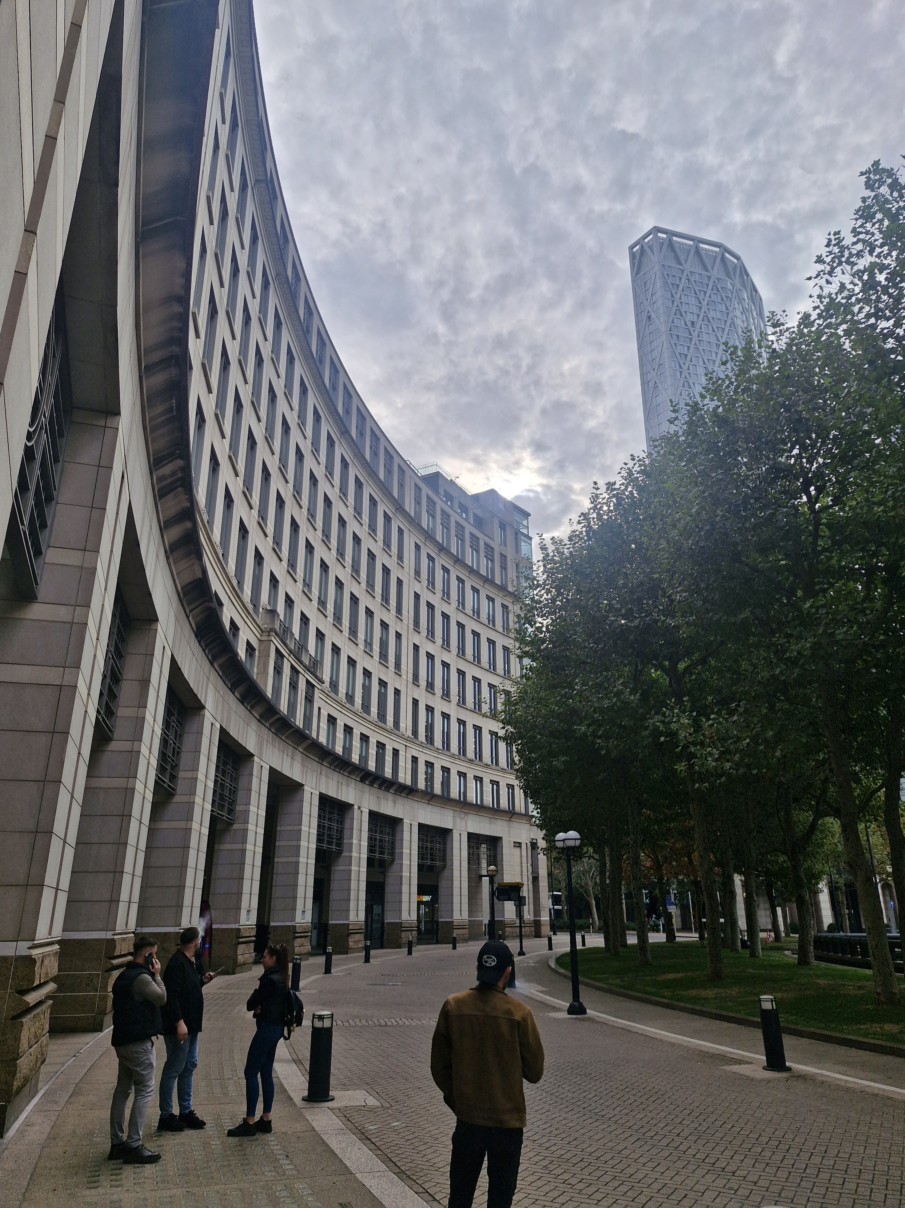
This is a building close to my university is where I go every Monday and Tuesday to increase my knowledge.

Screenshot/Photo 4
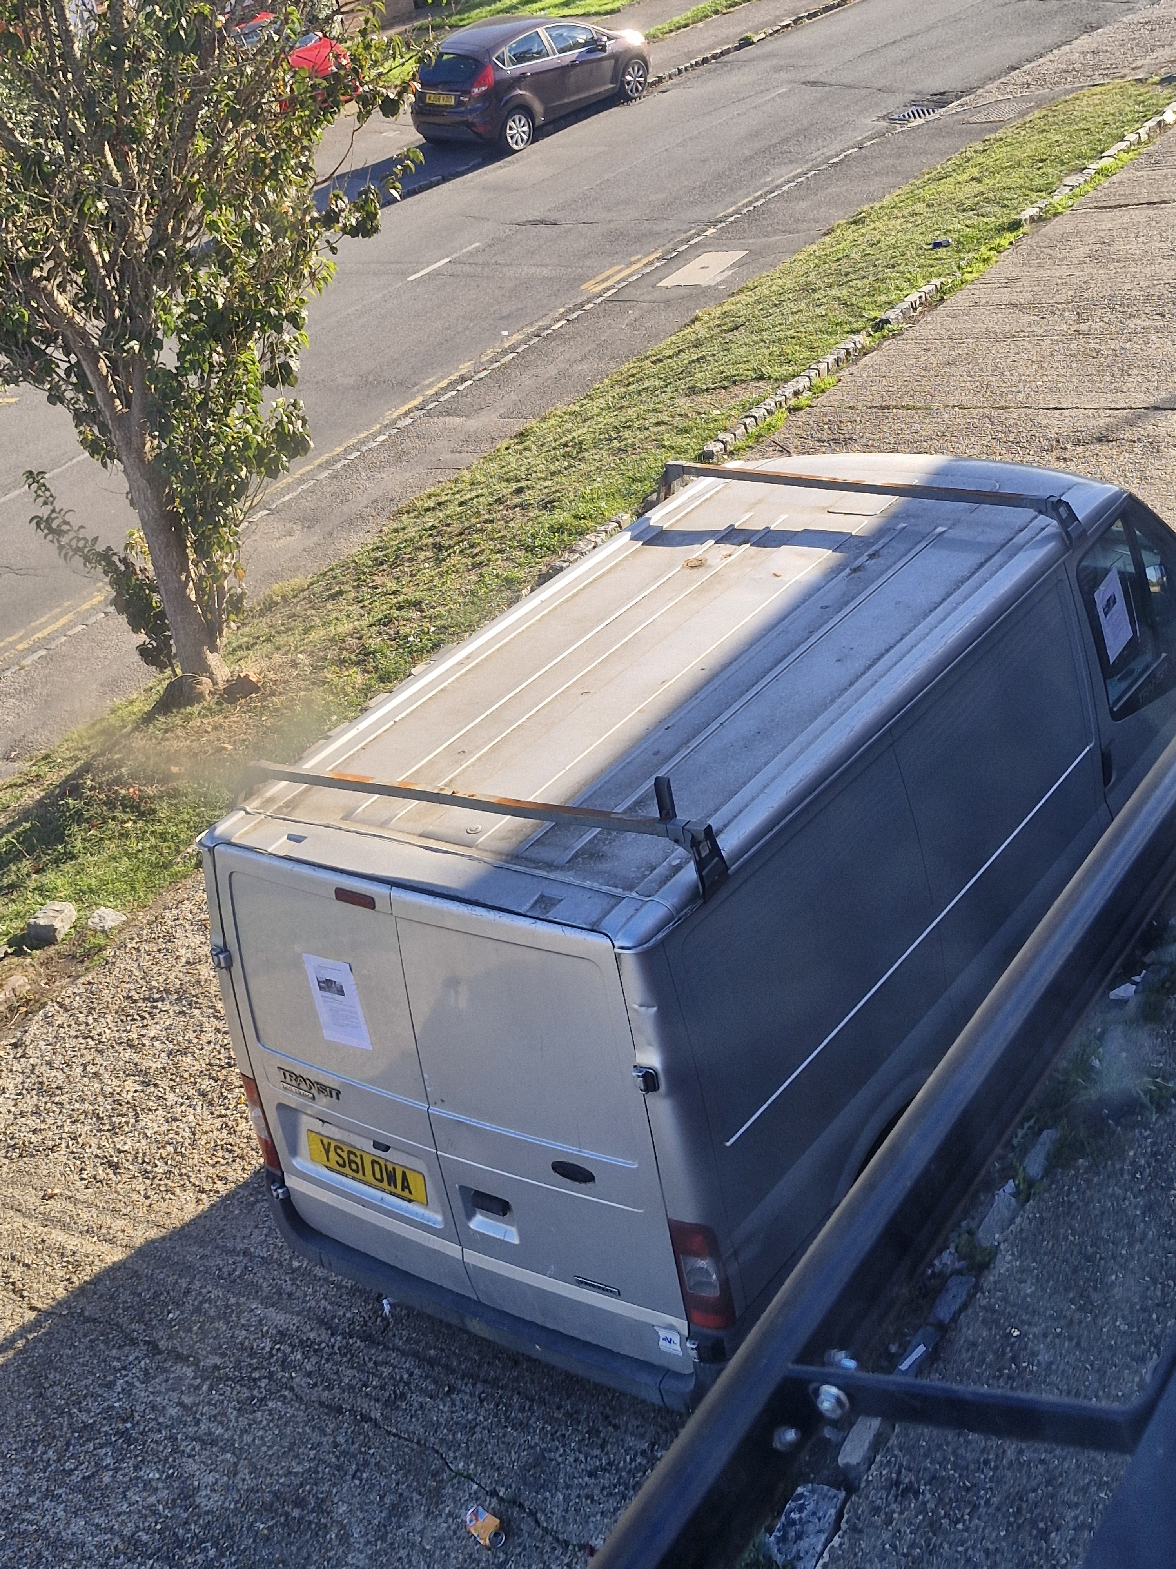
My van that I use for work to help with every day business

Screenshot/Photo 5
[Insert Photo/Screenshot below]

[Write what this shows of your digital life]

Screenshot/Photo 6
[Insert Photo/Screenshot below]
[Write what this shows of your digital life]

My Short Reflection
- Write 5–8 simple sentences about your digital life.
- You can use the sentence starters below if helpful.
I use digital tools to help me day to day like my phone for taking notes and pictures.
I feel confident using my laptop for work business and in general.
I want to improve to digital skills as I’m looking to gain more knowledge.
I often use tool like email downloads printers etc.
Sometimes I do feel nervous when doing new things with others around.
This module is already helping me to gain more understanding.
Digital skills are important in every day life learning how to use computers, printing scanning, taking photos sending emails and much more.

Sentence starters
- I use digital tools to …
- I feel confident when I …
- I want to improve …
- I often use these tools: …
- I sometimes feel nervous about …
- I hope this module will help me …
- Digital skills are important for me because …
You can write more if you want.

Submission Checklist
Before you submit, please check:
​​​ ☐ I added 4–6 screenshots
☐ I wrote short sentences for each screenshot
☐ I wrote my short reflection
☐ My work is my own
☐ My file opens correctly
​​☐ My file opens correctly

