Principles of managing organisations
Management is very important in the way an organisation, team or other can be run. Often, the success of a team can be down to whether or not they have a good leader, or manager. Mullins states that “Leaders are not necessarily managers, it could be argued that all managers should be leaders.” (2016). This is a point which often brings a debate of whether there is a difference between the two however it is true. To be a good manager, you must be a leader also. There are various different managerial roles in which are all important and different managers or leaders have different qualities it is very rare that managers have all the different types of qualities however. Mintzberg set up the ‘Mintzberg Model’ in which he believed that “from formal authority comes status, which leads to various interpersonal relations, and from these come access to information. Information, in turn, enables the manager to make decisions and strategies for the unit” Mintzberg (1990).
From this formal authority and status, he believed that a manager’s role can be seen as a set of ten managerial roles in which fall into the groups below;
- Interpersonal Roles
- Informational Roles
- Decisional Roles

The sub roles can be seen in the diagram below (Mintzberg 1990)
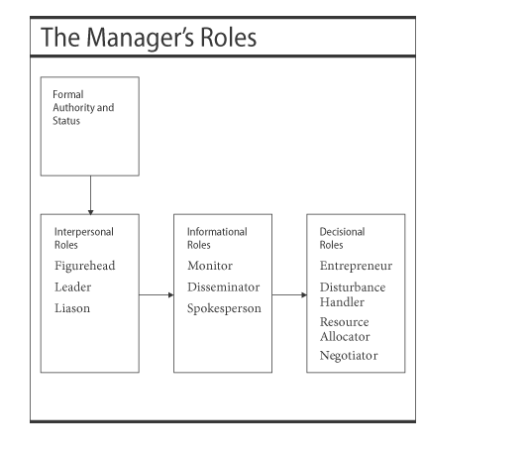

In seeing these roles, we can see how well in each roles managers can be succeeding.

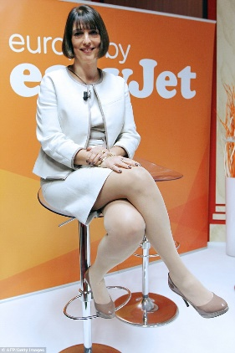

Dame Carolyn McCall pictured (Daily Mail 2016)

Dame Carolyn McCall, ex CEO of EasyJet plc is an example of a manager in which displayed some of these roles in which will be looked in to further detail and her work in the time she spent at the organisation using the Mintzberg Model.
Mullins (2016) says that “Even if there are a certain innate qualities that make for a potentially good manager, these natural talents must be encouraged and developed through proper guidance, education and training and planned experience” The development of a manager is crucial and McCall had many roles in which she learned and developed through her time at EasyJet. McCall definitely had some innate qualities however many more in which were improved. McCall showed various interpersonal roles during her time at EasyJet. Firstly, the leader role and she represented the organisation on her own as well as part of a team on various occasions. She also made various big decisions in which paid off. One instance is when she pushed ahead with plans to purchase 135 new Airbuses in 2013, despite the company’s founder Stelios Haji-Ioannou concerns. She also focused on hiring the right staff in which she believed had to have a sense of humour and be enthusiastic as well as the ability to problem solve. If something went wrong on board an aircraft, she would want the staff to be able to solve it immediately. As well as this, by pushing employees to get the best out of them meant that EasyJet was exceeding customer expectations consistently with the staff’s ability from being well trained. She also believes in allowing staff to test things and not be afraid to make mistakes which is vital and something in which many companies don’t do well. This keeps the employees happy and this means they are more likely to make big decisions and helps develop their problem solving skills also.
At a Change Board Future Talent event (2017) she stated that for success organisations “need rounded managers and directors and leaders” and that you must be “reliant on the calibre and ability of your people to speak up” and “to test on things and fail”. She went on “The pyramid is unstructured, unworkable “It puts senior leadership miles away from end user’ She also stated that “front line must be given freedom to operate”. This is important in establishing what kind of manager she is and how she sees that the usual pyramid structure doesn’t work as it puts customers and employees miles away from the top and creates a divide. Her leadership, using Lewins leadership framework (1939) which is cited in Kavanagh’s article shows she can be portrayed as a democratic style leader and this is evident through her approach allowing some freedom to staff however when needed will step in and do the work herself. This is an effective way of managing as not just getting others to do everything shows good leadership. Her role as a leader can be deemed a success with the organisation growing once she took over, and an article on Management Today states that “Faced with the task of managing cancellations and increasing the morale of a frustrated workforce, McCall championed a leadership philosophy of being more interested in people than planes, which fed into the company’s strategic objective of increasing money earned per passenger”. (Management Today 2018)
In addition to being a leader, liaison was another interpersonal role in which McCall undertook during her tenure at Easy Jet and had an email in which customers could get direct to her and an article in the Guardian (2016) states that McCall “took less than 90 minutes to reply personally”. The article also mentions that McCall has around 500 emails a day. When asked by the Guardian she stated “I’ll scan all of them, make a phone call or reply to some, and funnel them to my executive team. I’m particularly interested in when there are multiple things we haven’t got right or something has been mishandled. I want to know why, so we can improve”. As well as being someone in which customers can speak to, she also was there for staff to be able to speak with and attending staff and personal meetings was regular for her and so her people skills were incredible and it helped to build a bond with employees. “She does encourage her marketing team to, on occasion, “take a flier” and gamble on a new ideas” MMG (2017). BBC (2017) claim that she is known for “mucking in with the flight crew when flying” and helping to clear up aircraft while getting to know the staff and listen to their concerns.
As well as interpersonal roles, informational roles were attained by McCall also. (BPP 2010) defines informational roles as “A manager is likely to have a wider network of contacts within and outside the organisation than his (or her) subordinates; so he (or she) is the best person to gather and spread information” (BPP 2010)
Spokesperson is a role in which McCall succeeded in and was crucial in the rise of EasyJet under her. She held various Press Conferences, media interviews and speeches which gained interest from the outside and where she showed the world her skills as opposed to just employees and customers. McCall’s hard work was recognised also by competitors. The Financial Times state that Michael O’Leary who was the head of Ryanair, once stated that McCall was a “media luvvie”, but had changed a perception on her and said the airline industry would have been worse off without her. “I clearly underestimated her and I was proved wrong”. He also stated that “She forced us to up our game on customer service. EasyJet and the industry are better as a result of her tenure.” Being a spokesperson enabled McCall to become a better manager and these skills not only helped her during her time as CEO at Easy Jet but in landing her new job at ITV. It was crucial in these press conferences and interviews that she portrayed EasyJet in a good manner and did not slip up as it could have been costly to the brand and this role comes with a lot of pressure.
(BPP 2010) “The managers formal authority and access to information put him (or her) in a strong position to take decisions”
One decisional role in which McCall had was entrepreneur. This was shown through her constant thrive to improve EasyJet and move the business forward, for example as aforementioned the purchasing of 135 airbuses. Another example is by McCall implementing better food on board the aircrafts and allocated seating. McCall also reorganised the work force as well and by initiating changes steadied the organisation. This is a role in which is important for managers. Another decisional role in which McCall had was being disturbance handler and being someone who not only resolved conflict with fellow colleagues but also handled complaints with customers and as already mentioned had her email open to handle any disturbances that came up, and solved these problems in a timely manner which meant that customers were happier that their problems were resolved and it looks better for Easy Jet.
In addition, McCall can also be credited as filling the resource allocator role. In this role at EasyJet, she ensured targets were set and deadlines met, that plans were strategic and could be achieved and chose specific employees for different jobs not by favouring them however by who suited the task better. In 2016, “McCall was decorated with France's highest merit, the Légion d'honneur” in recognition of her and her teams hard work, (SBS 2018).
Mullins says that “effective management is clearly essential for organisational success” this can be related to McCall as what’s evident from the roles she undertook at EasyJet is that her management and leadership style was effective, and this is clearly demonstrated when her competitor had gone from knocking to praising her, and how figures such as bringing passenger numbers to highs of 80.2 million in 2017 up from 49.7 million the year she arrived (Management Today, 2018) also show how the structure of the organisation had improved drastically. In particular, through the hard financial times it is very impressive how she managed to stabilise EasyJet who were in a sector of which had been struggling for years and although towards the end of her stay the results weren’t as good, being hit by Brexit meant that the organisation was always going to struggle in 2017. Mintzbergs theory as well as Mullins gives a good understanding and knowledge of management, and going through the different roles Dame Carolyn McCall used it is easy to align her work with Mintzberg’s 10 managerial roles and some of the roles in which she had at EasyJet interlink between the different titles.
To conclude, it is evident that McCall possesses both good leadership and management skills, as well as being approachable to both employees and customers and she was willing to do work. It is also established how her people skills and spokesperson role played a key part in the growth of EasyJet and by the time that she left they were a very stable organisation despite many obstacles in which she faced throughout her spell there which collectively they managed to overcome. By treating staff as family and trusting them meant she managed to get the best out of them which previously at EasyJet and many organisations had not been the case, especially through a time of uncertainty in the tourism industry and to have done so well with an organisation who was so far behind competitors she exceeded many expectations as CEO of EasyJet.

Bibliography

BPP (2010) Organisations & Behaviour, 2nd edition, London: BPP
Brownsell, A. (2017). EasyJet CEO Carolyn McCall: ‘Marketers must be very clear about how they are spending money’ . Available: http://mandmglobal.com/easyjet-ceo-carolyn-mccall-marketers-must-be-very-clear-about-how-they-are-spending-money/. Last accessed 13th March 2018.
Duncan, H. (2016). EasyJet boss threatens to bail out of Britain: Airline run by David Cameron adviser looks at moving to Europe. Available: http://www.dailymail.co.uk/news/article-3670884/EasyJet-boss-threatens-bail-Britain-Airline-run-David-Cameron-adviser-looks-moving-Europe.html. Last accessed 13th March 2018. March 2018.
Ferguson, D. (2016). Got a customer complaint? Take it up with the CEO. Available: https://www.theguardian.com/money/2016/sep/18/customer-complaint-ceo-better-than-customer-services. Last accessed 13th March 2018.
Hall,S. (2017). What's your leadership style?. Available: https://www.virgin.com/entrepreneur/autocratic-democratic-or-laissez-faire-whats-your-leadership-style. Last accessed 13th March 2018.
Kavanagh, E. (Unknown). Three Leadership Models. Available: http://earonkavanagh.ca/article_kavanagh-three.pdf. Last accessed 13th March 2018.
Kakar, A. (2017). Carolyn McCall's 3 biggest achievements as easyJet CEO. Available: https://www.managementtoday.co.uk/carolyn-mccalls-3-biggest-achievements-easyjet-ceo/women-in-business/article/1450836. Last accessed 13th March 2018.
Marston, R. (2017). Carolyn McCall: From airline to airwaves. Available: http://www.bbc.co.uk/news/business-40628873. Last accessed 13th March 2018.
Mintzberg, H. (1990). The Manager’s Job: Folklore and Fact. Available: https://hbr.org/1990/03/the-managers-job-folklore-and-fact. Last accessed 13th March 2018.
Mullins, L. (2016) Management and Organisational Behaviour (11th edition) Harlow: Pearson
Unknown. (2017). “Carolyn McCall wins over critics in 7 years at easyJet”. Available: “https://www.ft.com/content/985b8a82-6b05-11e7-bfeb-33fe0c5b7eaa”. Last accessed 13th March 2018.
Unknown. (2018). Dame Carolyn McCall Profile. Available: https://www.sbs.ox.ac.uk/community/people/dame-carolyn-mccall. Last accessed 13th March 2018.

