

Student: Vasile Robert Gore
ID: 1915927
Supervisor: Dr.Dudley Ofori
Workforce Management in UK after Brexit; Construction Industry
BA (Hons) Business Management

Declaration

I hereby declare that this dissertation was conducted by me and supervised in accordance with the guidelines on supervision. The research is the result of my own work and has not been submitted for any other degree either in parts or as a whole for a previous degree in this University or elsewhere.

Acknowledgement

I would like to express my gratitude to my supervisor Dudley Ofori who have provided meaningful guidance and insight into workforce management trends that helped me understand the complexities involved, broadened my perspective on the topic and encouraged me to find meaningful solutions for the issues at hand.
Secondly, I would like to thank all the HR managers and constructions workers that agreed to be a part of this research and provide their answers that contributed to a more transparent and valid data projection.
In the end, I wish to express appreciation to my colleagues who through constructive feedback, sometimes critical but beneficial, helped me identify flaws and take necessary step to increase the efficiency of research and provide solutions that can be applied in real-life.

Abstract
United Kingdom's withdrawal from the European Union has created opportunities but, at the same time, multiple issues for industries. The construction industry was among the most affected as governmental policies and regulations imposed on EU labour created difficulties, particularly in terms of recruitment. This study aims to establish whether the positive impact of Brexit overweights the negative implications on human resources. The research considers the short-term and long-term impact on Work Force Management. As Brexit is a significant contributor to the workforce dynamics, it creates uncertainty for the UK economy, which heavily relies on the construction industry.
The research objectives are to explore the opportunities faced by HR in workforce management, evaluate potential risks and barriers, assess workforce management trends, and provide directions to increase the productivity and efficiency of employees. The paper attempts to answer the following questions: What is HR's role in managing the workforce in changing environments and regulations? What are the risks and barriers in workforce management and their impact on performance and profitability? How should government support businesses by making the UK more attractive to EU skilled labour or domestic labour?
The complexity of the topic requires quantitative approach which has been used to shed light on the impact Brexit has on Workforce Management, particularly in construction. Even if a comparative study of the impact on the UK and EU would have been interesting, along with the impact of Covid-19, the research is limited to the UK Workforce Management analysis. The findings suggest that the negative implications of the UK's withdrawal from the EU outweigh the positive, at least in the short term.
Keywords: Work force management, Brexit, construction industry, European Union

Table of Contents
Declaration II
Acknowledgement III
Abstract IV
Table of Contents V
Chapter1. Introduction 1
1.1 Background 1
1.2 Topic significance 1
1.3 Purpose 2
1.4 Aim, objectives, and research questions 2
1.5 Chapter Synopsis 3
Chapter 2: Literature Review 4
2.1 Introduction 4
2.2 Defining workforce management 4
2.2 Impact of Brexit on Workforce Management 5
2.3 Brexit as a management trend, risks, and barriers 6
2.4 The role of workforce management for business productivity and profitability 7
2.5 Government responsibilities and strategies 9
2.6 Conclusion 10
Chapter 3: Research Methods and Methodology 11
3.1 Introduction 11
3.2 Research philosophy 11
3.3 Paradigm position 12
3.4 Position of the research approach and interpretation of findings 12
3.5 Methodological stance 13
3.6 Research Strategy and Design 13
3.7 Research Sample and population 13
3.8 Data Collection and data analysis tools 14
3.9 Ethical Considerations of the research 14
3.10 Summary 15
Chapter 4: Findings, Data Analysis and Discussions 16
4.1 Introduction 16
4.2 Presentation/Summary of findings 16
4.3 Data Analysis 20
4.4 Discussion 23
4.3 Summary 25
Chapter 5: Conclusion and Recommendations 26
References and Bibliography 28
Appendices 34
Appendix 1. Research Onion 34
Appendix 2. Sample Questionnaires 35
Appendix 3. Questionnaires Results/ HR Managers 38
Appendix 4. Questionnaire Results/ Construction Workers 41
Appendix 5. Participant Consent Form 43
Appendix 6. Participant Information Form 44
Appendix 7. Application for ethical approval 45

Table 1. Questionnaire (2) Construction Workers, Results 18

Figure 1. Questionnaire (1) Rate of managers based on Gender 15
Figure 2. Questionnaire (1) work efficiency in post Brexit period 15
Figure 3. Questionnaire (1) Employment Rate 16
Figure 4. Questionnaire (1) Difficulty of Hiring EU personnel 16

Chapter1. Introduction

1.1 Background

The withdrawal of Britain from the European Union has created tension between them and boosted the need for new regulations on immigration on which Brexit campaign was based in the first place, “gaining back control of borders money and laws while protecting the economy, security and Union” (HM Government, 2018). Despite it being a compelling message that gained public confidence, the implications are more complex than it seems. The outcomes are not necessarily positive, at least from workforce management in construction analysis, an aspect that this study attempts to address.
Post-Brexit labour changes have created multiple challenges for construction firms that takes time to mitigate; meanwhile, profitability and performance suffer, aspect that has been widely circulating over the news. CN Construction News (2022) reported that labour force figures show a significant reduction in self-employed workers, which can be explained by looking at the new immigration system. The findings demonstrate a 19% reduction between the first quarters of 2019 and 2022 (CN Construction News, 2022). If the numbers continue to fall, it could create unprecedented outcomes for businesses and the UK economy unless adequate strategies are put in place to attract domestic labour and fill the employment gap.

1.2 Topic significance

Workforce management after Brexit in construction industry is an actual topic that is somehow neglected, despite construction industry playing a crucial role for British economy. By identifying the impact of Brexit on workforce management using the parameters such as effective adaptability to changing environments, workforce retention, major threats, and opportunities, there will be an expansion in the understanding of current issues and future potential risks that arise. This study provides clear insights into Human Resources barriers, pointing towards potential reduced productivity and profitability.
This research particularly attempts to project real-time issues HR managers and construction workers face because of Brexit, which constitutes a solid ground for potential strategies for problem-solving. This research can not only benefit stakeholders in construction, but also provides a bigger picture of the industry's issues and how they reflect on other areas, such as the UK economy, society, and the environment.
Additionally, a detailed presentation of the impact of Brexit on workforce management in construction involved in this research may serve as an essential pillar in building solutions directed towards influencing governmental policies or boosting further studies on the issue.

1.3 Purpose

The purpose of this paper is to examine workforce management in the United Kingdom (UK) after Brexit, in the construction industry. Specifically, the strategic implications for Human resources. It seeks to determine the potential impact of Brexit on EU skilled labour, employment dynamics and the effects; it generally investigates the impact Brexit has on the industry and identifies patterns in behaviours, and implications for construction productivity and national wealth with particular focus on workforce management.

1.4 Aim, objectives, and research questions

Research aim is to evaluate the impact Brexit has on the WFM construction industry by pointing out potential risks and opportunities faced by HR, assessing legal implications for workforce management, and providing directions for improvement as necessary, including further research needs.
The first objective of the research is to determine the role of HR in managing the workforce, especially in times of crisis. The second objective is to evaluate the effects, positive and negative, Brexit has on WFM in construction. The third objective is to analyse the government's role in alleviating or increasing the negative impact on human resources.
The research answers the following questions: What is HR's role in managing the workforce in changing environments and regulations? How Brexit impacts WFM in construction? Are there any significant risks and barriers that obstruct performance and profitability? Is the government doing enough to support potential challenges related to the recruitment of EU labour?

1.5 Chapter Synopsis

The first chapter of the study provides a brief background of the topic, including its significance for Human Resource management and society. Also, it projects the purpose of the study, aim, objectives, research questions and chapter structures. The second chapter critically evaluates previously published works, particularly on the interpretation of workforce management, Brexit as a workforce management trend, opportunities, risks, and barriers. Also, it discusses the role of WFM in business productivity and profitability and the government's responsibility to aid the construction industry in overcoming challenges imposed by Brexit laws. The third chapter discusses the research methodology, philosophy, approach, and interpretation of findings. The following chapters project the research results and findings, including delving into the importance and relevance of the finding. Finally, the conclusions are drawn, and recommendations are provided for further research opportunities.

Chapter 2: Literature Review

2.1 Introduction

There is extensive study on business management, including drivers of profitability, performance, and quality. Human Resource Management is among the most vital strategic approaches that determine whether a business succeeds or fails; thus, considering factors and drivers of human resource management is crucial in forecasting potential risks and taking necessary steps to minimise the negative impact. The present chapter aims to verify to what extent Brexit affects workforce management by critically evaluating the literature in the field.

2.2 Defining workforce management

To better understand the issue at hand, it is helpful to define workforce management. Among the prominent concept definitions is Lombardi’s (2019) argument that workforce management is the foundation for transformation. No matter where in the business journey, there are steps in workforce management that can increase the value of the workforce management process. Similarly, (Hook & Jenkins, 2019, p. 4) defined human resource management as “a constantly changing career”; it evolves in response to social, political, economic, and demographic dynamics. Gospel (2019) approached human resource from a blending perspective which means the scholars sees it in relation to work, employment, and industry rather than separate areas. The author suggests that the efficiency of human resource strategies depend not only on the costs available but also on the capacity of the businesses to pursue them, even by increasing investment in this department, an aspect that is not sufficiently addressed. Beardwell & Thompson (2017) refer to people management as a collection of policies placed at the heart of work organisation and employment relationships. Moving forward, next section discusses literature on the impact of Brexit on Workforce management.

2.2 Impact of Brexit on Workforce Management

Brexit is still a new phenomenon the number of studies on its impact on various areas is on the rise. As there is limited analysis of its effects on the construction industry, it is essential to understand both the positive impact of Brexit and the negative by looking equally at studies that project this aspect. The most notable defender of Brexit, implying long-lasting positive outcomes on the economy, society, and environment, is the UK government.
Based on the Brexit benefits report (2022), it offers opportunities to deliver better quality, safer and greener homes, including delivering modern methods of construction and empowering communities. Additionally, the plans involve making UK borders the most effective, attracting the best global talent, which means introducing new working roots Skilled Workers, Global Talent, Graduate and Health and Care routes (HR Government, 2022). Despite providing a convincing plan, it is questionable how practical this plan is as studies and business owners report multiple challenges that arose because of stricter migration regulations, particularly in construction, where there is a high number of EU workers. Price (2021) reported a fall in total employment in construction which probably has long-lasting issues of skill shortage.
The statistics reports from The Migration Observatory show an estimated net migration of all EU citizens at 118.900, year ending 6 April 2020, meaning the number of EU who left the country is higher than those who arrived (The Migration Observatory, 2022). The evidence points towards issues regarding filling the gap in employment left by EU citizens; however, it is questionable whether these create significant problems that impact performance and profitability and whether these have a long-lasting negative impact. Similarly, RICS (2021) pointed towards administrative challenges that affects cost, therefore inhibiting the well-functioning of the UK construction industry.

2.3 Brexit as a management trend, risks, and barriers

Brexit is widely considered a management trend that, besides positive intentions it aims to bring to the UK society, it creates various barriers and risks that are not sufficiently covered. The construction industry is particularly affected in multiple ways; first, issues arise in managing change; second, in terms of retaining EU employees, being up to date with new regulations and managing risks. Still, the opinions on the Impact of Brexit on businesses vary; scholars that have researched risks and barriers have harshly criticised government strategies. Heseltine (2020) approached rather critically governmental role in adapting to changes. The scholar argued that the government had done little to understand the nature of the challenges faced by people and the need to prepare the UK to adjust. Similarly, Hassan et al. (2020) study on measuring the uncertainty shock at firm levels point out that business expects difficulties such as labour mobility and limited trade access.
Indeed, these fears proved real and require tailored solutions. Vandenbussche et al. (2022) for example highlighted the indirect effects by stating that "the indirect effects of a hard Brexit amount to ca. 70% of the total Brexit impact for the EU-27 country sectors" the production networks in the EU are closely integrated. Thus, a system that fails to consider indirect effects would seriously undervalue the effects in terms of sector-level production and employment.
The interest in the topic significantly increased post-Brexit because of the adverse effects on business profitability which were brough to light and inability of human resource effectively adapt. Hook & Jenkins (2019) particularly discussed that human resources take the lead in informing and driving the organisation's strategic direction. Thus, potential barriers will not only have a significant impact on strategic direction but also on everyday operations.
The authors argue that HR professionals are affected by the economic situation, demographics, changes in legislation, technology, and advances in artificial intelligence. The Institute for Employment Studies (2021) research shows that Brexit prompted concerns over future labour supply. Employers face uncertainty and require flexible approaches and risk assessments for better decision-making. Based on organisational change theory (Gareth, 2013), organisations pass through different forms, levels of quality and states over time; therefore, the human resource should ensure congruence between stated goals, changes, and performance. Next section discusses in detail the role of workforce management for business productivity and profit.

2.4 The role of workforce management for business productivity and profitability

Productivity and profitability are key indicators of whether businesses succeed in coping with internal and external factors that may harm the organisation. Understanding the role of Workforce management for business productivity and profitability is valuable as it helps project the degree to which Workforce Management (WFM) issues impact the overall success of an individual business or even an entire industry. The literature mostly puts HR at the centre of organisation activities; even if there is a practical framework for operations, sufficient financial support, potential issues in recruitment, and lack of skills to cope with change, following the government laws could create major disruptions and loses for the business if not addressed on time. As per Human capital theory, people are valuable assets (Becker, 1964); thus, ignoring their needs or not supporting them deal with change can be damaging for businesses and for the employee. Strikwerda (2018) widely analysed the benefits of human resources, including the role of integrated WFM tools. The scholar stated that these” … prevent productivity losses due to separate systems or manual processes” Strikwerda (2018).
Additionally, Workforce management solutions highlighted by the author include flexible business scheduling that contributes to productivity boosts and using virtual working arrangements to broaden the hiring pool for employers (Strikwerda, 2018). Bloom & Reenen’s (2011) study on the relationship between Human Resource Management and productivity evidence that certain types of HRM raise productivity, but with some exceptions, some groups or firms have been more successful in identifying a positive association of changes in HRM policies (in a particular individual and group incentive pay) and productivity, but other aspects may lack sufficient data.
Without a doubt, there is a close connection between efficient human resource management and increased productivity; however, indicating that Human Resources alone is the main contributor can be somewhat erroneous as there is more than one pillar contributing to a certain degree. Many would argue that business strategies must be closely connected to governmental requirements, follow the legislation and drive performance by adhering to them. Next section provides a glance into the responsibility’s government has towards business in helping them to cope in times of crises.

2.5 Government responsibilities and strategies

The British public vote to leave the EU has substantially impacted the government by making room for other issues to arise. Lloyd's (2019) report shows that Brexit has questioned the political status quo, and the preparation for Brexit has posed monumental challenges, including catalysing constitutional upheaval.
The transition period that hasn't entirely ended still creates uncertainties. The government announcements on setting its own laws and all retained EU laws will be excluded, enabling the UK to create tailor-made regulations for its people to stimulate growth, innovation, and job creation (GOV.UK, 2022). However, it is somewhat unclear what this growth and innovation imply and how these new strategies will be delivered as there are few reports on risk analysis; governmental promises seem convincing, but how practical these are is debatable. Thomson (2021) somewhat in defensive of Brexit suggests that the vulnerabilities are surrounded not only Britain but also the European geopolitical space, which has been a trigger in Britain's decision to leave the EU. Not only the UK but also other members are faced with persistent difficulties; however, Brittan is the only country that decided to leave.
The government is intensifying its focus on the economic implications of Brexit, including "On domestic policy measures to reinforce the competitiveness of the Irish economy" (Gnó & Nuàlaíochta, 2017). Also, it claims that it will strengthen it to deal with the potential negative impacts of Brexit and to pursue all possible opportunities that might arise. Also, it supports national competitiveness, productivity, and innovation.
The Workforce Management Impact Model can be applied to better clarify strategies that can be used to maximise the positive outcome (Lombardi, 2019). As suggested by scholars, the WFM covers a large set of issues; thus, each industry and business vary, and it requires a unique tailored approach to support them in delivering results which are relatively difficult to achieve. The British government provides guidelines and regular updates. For example, in terms of regulations related to EU, EEA, and Swiss employees, it provides accurate information covering critical areas related to workforce management, including documentation required and support available that every employer must have (Home Office and UK Visas and Immigration (2020). Despite existing tools that can be widely accessed, the competencies of making use of what is provided are questionable and require more extensive research.

2.6 Conclusion

There are contradictory views on the impact Brexit has on Britain as a whole, various industries and businesses. Some find Brexit an opportunity for growth, innovation, and progress, while others suggest Brexit is an unprecedented challenge, a huge mistake made that would have a drastic impact on the economy, EU-UK trading relationships, legislation, and other areas. Besides, arguments are pointed towards EU vulnerabilities that are on the rise and do not exclude that other countries may follow in Britain's footsteps. It is rather difficult to forecast whether Britain is better off because it influences businesses and industries in various ways; nevertheless, the negative impact on workforce management is strongly felt because of employee shortages and uncertainties related to the right to work in the UK.

Chapter 3: Research Methods and Methodology

3.1 Introduction

The purpose of this chapter is to project the study methodology for mixed-methods theory research on the impact of Brexit on workforce management in construction. Research Onion framework was applied for a better visualisation of study methodology (See Appendix 1-Research Onion). This approach provided ground for understanding whether the negative implications overweight the positive. The study provides insights into variables such as work efficiency, employment, costs involved, employee satisfaction and behavioural changes.
The main components of this chapter include a discussion of the research philosophy, paradigm position and research approach, methodological stance of the study, research strategy and design, research sample and population, data collection and data analysis tools, ethical considerations, and a summary of the chapter.

3.2 Research philosophy

The research is conducted from a pragmatism philosophical perspective, focusing on change analysis connecting theory and real-life challenges faced by human resource recruiters and employees because of Brexit. This philosophy is selected as it is a more subtle approach to assess organisational processes based on experience and action (Kelly & Cordeiro, 2020) aspects sought to build theory in answer to the following research questions:
Research Question 1: What is HR's role in managing the workforce in changing environments and regulations?
Research Question 2: How Brexit impacts WFM in construction? Are there any significant risks and barriers that obstruct performance and profitability?
Research Question 3: Is the government doing enough to support potential challenges related to the recruitment of EU labour?
Additionally, it equips it to deal with complex and dynamic processes, which constitutes an advantage; however, limitations have also been accounted particularly the difficulties of recording different groups over a long time which may be required. Also, there is no evidence to prove that the respondents answered from an objective point view instead of subjective which may undermine data validity.

3.3 Paradigm position

Research approach and ontology combines deductive and inductive reasoning; this paradigm position was chosen because of the constant changes in society that impacts human resource, the reality is constantly debated and interpreted in relation to unpredictable events; thus, this approach seems the most relevant to achieve the objectives set. The method to measure the impact is mixed of qualitative and quantitative data collection as it helps have a better understanding of the problems at hand and find out the best possible solutions, considering the potential changes that human resources may undergo because of political shifts and new legislation related to it. The study aims to provide accurate, transparent information with consideration for the privacy of respondents.

3.4 Position of the research approach and interpretation of findings

The research approach is mainly collection of quantitative data. This approach has multiple benefits including increased validity; it provides a completer and more comprehensive picture of the phenomenon (Doyle et al., 2009), which has been among the prominent influencers on the decision to apply this approach and maximise the viability of the study.
The research results are interpreted through inductive and deductive approaches. Inductive reasoning refers to moving from specific observation to broaden generalisation, whereases deductive reasoning unpacks from existing theory. Additionally, the following steps are taken for data projection; assemblies of information collected, development of findings and conclusions, and development of recommendations.

3.5 Methodological stance

Research methodology plays a crucial role in achieving the research objectives. Quantitative method methodologies are at the base of the research with elements of qualitative data where assumptions on understanding participants choices are made. It is relevant for this study as it employs pragmatic knowledge claims (Terrell, 2012). Additionally, it allows expansion of understanding and interpretation of results forma measurable reality

3.6 Research Strategy and Design

Correlation design is applied to understand the impact of Brexit on the construction industry's human resources. The correlation between Brexit and issues in recruitment is determined. According to Tan (2014), findings from correlational research allow researchers to determine the degree to which variables change together. Thus, evaluating the impact of Brexit on human resource processes will clarify how these two elements are related to each other.

3.7 Research Sample and population

The research questionnaire is focused on the construction industry with the target groups of HR managers and construction workers. HR managers were mainly targeted to understand potential issues faced by human resources and the impact of Brexit on the recruitment process. Another target group is construction workers; these were chosen to get insight into barriers employees face and overall satisfaction after Brexit. The research sample is purposive; thus, the candidates that fit the criteria are selected. It predominantly involves the identification and selection of individuals that are well-informed about the phenomenon of interest (Etikan et al., 2015).

3.8 Data Collection and data analysis tools

A perceptual questionnaire survey will be used to elicit responses from construction professionals to identify challenges faced in terms of recruitment. In addition, theoretical frameworks, books, journals, and website data are used. As Brexit is considered a new trend, secondary data collection is centred on the most recent and relevant sources, including journals, documents from government websites, press releases and news articles. The primary data collection, particularly the survey, is conducted through the Survey Monkey tool which allowed automatic data analyses that significantly helped in data visualisation and analysis. The online survey was chosen because it is easy to use, is effective for analysing responses, and helps distribute faster, saving time and costs (Varela, 2017). However, this tool has limitations in customisation; it may not be suitable for collecting large amounts of data.

3.9 Ethical Considerations of the research

The research is conducted through the voluntary participation of respondents, assessment of relevant, valid components and confidentiality. Also, privacy, race, and gender employment issues are considered, including accurate and valid data projection. According to Resnik (2020), adhering to research norms promotes the research aims. These values are essential in collaborative work and are necessary for promoting morals and social values, which this study aims to achieve.

3.10 Summary

To summarise, this chapter unpacked the study methodologies that support and thrives to provide accurate data. The research is conducted from a pragmatism philosophical perspective with the research approach and ontology combining deductive and inductive reasoning. The methods to measure the impact include qualitative data collection. The research design type is correlation as it aims to understand the impact of Brexit on construction, particularly its effects on human resources; thus, the target groups are HR managers and construction workers. The results are analysed and discussed in the next chapter.

Chapter 4: Findings, Data Analysis and Discussions

4.1 Introduction

This chapter provides a summary of findings, data analysis and discussion. The overall aim of this study was to assess the impact of Brexit on Human resource management in the construction industry. The first objective of the research was to determine the role of HR in managing the workforce, particularly in times of crisis. The second objective was to evaluate the effects, positive and negative, Brexit has on WFM in construction. The third objective was to analyse the government's role in ameliorating or increasing the impact on human resources.

4.2 Presentation/Summary of findings

The data was collected through two separate questionnaires tailored for each group managers in constructions and employees. It was sent to 25 respondents from which 20 responded. For each group, closed-ended, multiple-choice questions were selected in relation to the research objectives.
The following parameters were selected to identify patterns and boost understanding of the phenomena. These are work efficiency general perspective, overall employment of EU workers, costs, employee satisfaction, English language competencies. The questionnaire was conducted to understand challenges and produce actionable knowledge that could help improve HR management by unpacking issues created by Brexit and providing recommendations drawn from an examination of data.

The results from first questionnaire designed for managers show that 80% are male and 20% are female and there are no responses for other categories (See Figure 1. Questionnaire (1) Rate of managers based on Gender)

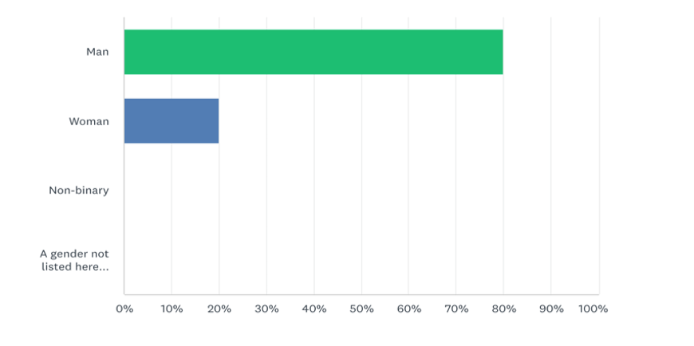
Figure 1. Questionnaire (1) Rate of managers based on Gender

The results on work efficiency in the post-Brexit period show that 40% of respondents believe the work to be somewhat effective, 30% have selected not at all effective which can be because of the rapid changes and ability to adapt to these changes and 20% have selected not so effective and 10% very effective.
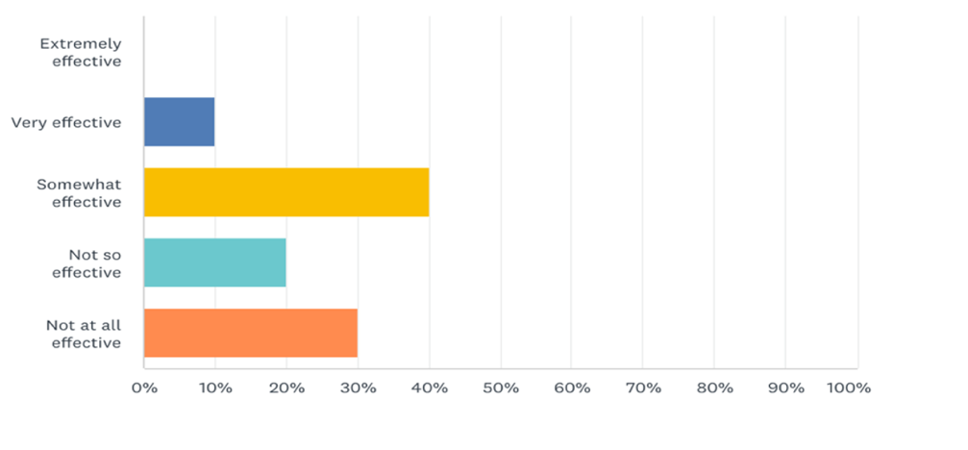
Figure 2. Questionnaire (1) work efficiency in post Brexit period

The data on increase or decrease of employment rate in their company shows that 40% of respondents selecting employment decrease in their company, 30% of respondents reported an increase, and another 30% reported no significant changes.

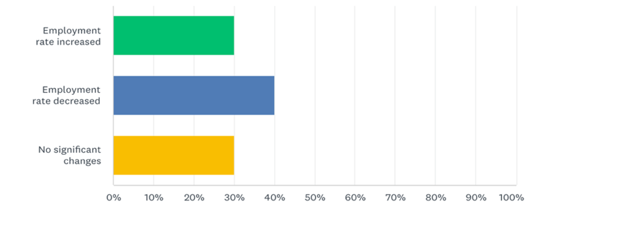
Figure 3. Questionnaire (1) Employment Rate

In term of hiring challenges 50% of participants selected challenges in adapting to fast pacing environment, 20% hiring skilled personnel, another 20% mentioned difficulties in filling the gap because many EU employees returned home (See Q4 Appendix 2. Questionnaire Results/ HR Managers). Additionally, 50% of respondents selected that is neither easy nor difficult to recruit EU workers, 30% reported that it is difficult and 20% have selected that it is very difficult.

The majority 80% have mentioned that the hiring process involves higher costs for the company and 20% suggested that it does not (See Q6 Appendix 2. Questionnaire Results/ HR Managers)
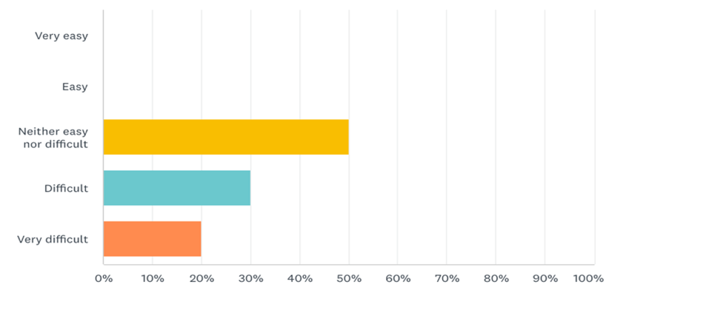
Figure 4. Questionnaire (1) Difficulty of Hiring EU personnel
In the second questionnaire the target groups were construction workers. Where they have been asked about their nationality, job satisfaction, how likely are they to remain in the UK, whether English is their first language and wellbeing. From 100% of respondents, 80% are Eu nationals and 20% are British nationals. When asked about how satisfied are they with their job, 40% are dissatisfied, 30% neither dissatisfied nor satisfied, 10% are very dissatisfied and similar percentage are for the very satisfied and satisfied values. Most of the participants 80% reported that they are unlikely to remain in the UK whereas 105 mentioned that they are very likely to remain and 10% respondents that they are likely to remain.

The majority of participates 80% selected that English is not their first language whereas only 20% mentioned that English is their first language( Table 1. Questionnaire (2) Construction Workers, Results).

Criteria | Results
Nationality | Eu 80%  British 20%
Job satisfaction | Very satisfied 10%  Satisfied 10%  Neither not  dissatisfied  nor satisfied 30%  Dissatisfied 40%  Very dissatisfied 10%
How likely to remain in the UK? | Unlikely 80%  Very  likely 10%  Likely 10%
English as first language | Yes 20%  No 80%
Table 1. Questionnaire (2) Construction Workers, Results

4.3 Data Analysis

The findings for the first study question on HR's role in managing the workforce in times of crisis such as Brexit. It that their role is critical in the efficiency of human resource strategies regarding costs and business capacity. On the other hand, highly skilled HR managers and their ability to manage change may not be enough to face significant disruptions caused by trends such as Brexit, or Covid-19. They may have the capacity to ensure a smooth transition, but they need more power and support to retain employees, particularly EU workers that dominate construction industry, when new legislation is implemented. Another important aspect is that even if the respondents operate in the same industry, they are from different companies; thus, some are more vulnerable than others in facing a crisis.
The findings for the second study question on the effects of Brexit on WFM in construction indicate a moderate impact on human resources. Workforce Management in the UK after Brexit has been challenging for organisations. Nonetheless, the employment levels continued to rise. Many organisations reported recruitment difficulties; among the cause were the employment growth rate and decrease in EU citizens coming to work in the UK. Some of the major barriers were working shortages, shifts in talent requirements and new regulations. HR specialists can benefit from multiple models for workforce management that can increase the value of the process.
According to Price's report (2021), employment in construction has declined. Similarly, the statistics report from The Migration Observatory project an estimated net migration of all EU citizens at 118.900, year ending 6 April 2020, meaning the number of EU who left the country is higher than those who arrived (The Migration Observatory, 2022). Even if the employment number shows a fall, it fully justifies the significant impact on profitability. The results from the questionnaire showed 40% of respondents selecting employment decrease in their company, 30% of respondents reported an increase, and another 30% reported no significant changes (Appendix 2. Questionnaire Results/ HR Managers).
The adverse effects on the employment of EU workers are undeniable; however, it is highly questionable whether these have a high impact on the profit to the degree that would push companies from the market or create significant disruptions. As pointed out by Hook & Jenkins (2019), human resources take the lead in informing and driving the organization's strategic direction; however, HR professionals are affected by the economic situation, demographics, changes in legislation, and technology that impacts their work. Additionally, the questionnaire results point towards issues in terms of adaptability to fast pacing environment; 50% of respondents selected adaptability as a considerable challenge (Appendix 2. Questionnaire Results/ HR Managers), followed by hiring skilled personnel and loss of EU workers, which can be because of legislative implications and other reasons. As 80% of the respondents are EU nationals and 80% reported that they are unlikely to remain in the UK (See Appendix 3. Questionnaire Results/ Construction Workers), it provides a glance at a potential increase of people leaving the UK. Also, HR managers reported difficulties in hiring EU employees as they do not automatically enjoy the right to work in the UK (Guardian, 2016).
Indeed, human resources are in a constant process of transformation and change an example can be drawn from the Covid-19 pandemic, Brexit, where human resource managers were faced with extremely difficult challenges not only in terms of management but also in dealing with mental health. The need to react promptly and adapt to rapid changes and innovations requires continuous learning, which can be achieved.
The findings for the third question on the government implications and its role in the impact level show that even if the government reports having a strong plan in place does not guarantee its efficiency, considering the instabilities and conflicts overseas that boost the uncertainties on EU-UK relationships.
Government has a double effect; on one side can be a major challenger for the companies because of the new politics and policies that cover significant aspects of employment (Price, 2011) and not necessarily positive, worsening or improving relationships between countries and on another side, the government can support industries through financing and economic growth.
Government has an important role in making a positive impact on workforce management by influencing processes including providing hiring, training, compensation and by investing in mental health recovery.

4.4 Discussion

The research outcomes provided insights into workforce management after Brexit in construction; however, the results should be interpreted with caution due to the study's limitations. This section focuses on providing a reflection of the study process, including implications for interpretations of results and recommendations for practical applications.
The results show that Brexit has a positive and negative impact on workforce management; however, the adverse effects may overweight the positive. The findings concerning the effects Brexit has on WFM in construction complement and extend the Smith et al. (2020) explanatory study on impact assessment on the UK construction industry and risk mitigation. The research projects are most affected, and these include economic, political, and legal. The factors of labour alongside materials and supply chain are among the significant concerns (Smith et al., 2020). Even if the study generally discussed the impact on the construction industry, it has been beneficial to identify common patterns.
This study focused on the human resource area, particularly effects on recruitment, performance, and employees; nevertheless, a comparison analyses with other areas of business, such as operations, financing could be helpful to obtain a better perspective on the impact Brexit has on businesses in the construction industry as these functions are interdependent. As Rahman (2022) suggested, business functions support organisations in all processes and decision-making. Thus, understanding the impact of Brexit on human resources in construction can support a better understanding of the issues faced by HR managers and employees, allowing room for a better solution for all those who manage staff.
The human resource management study field undergoes various transformational processes triggered by various external factors such as environmental; most recent examples are the implications of Covid-19, labour market conditions, and socioeconomic and governmental policies. As MacArthur (2021) highlighted, Human Resources must continuously evolve to help the future of work; thus, the human resource role in supporting organisations is open to controversies. Similarly, from a management focus, the evolution of the HR function could be among the most significant changes over the last decades that are hard to ignore. This study developed new insights into workforce management in construction; the methodology particularly was focused on emphasising the HR manager's and employee's perspective, which is useful in determining how Brexit affected them and their work.
Previous research works and collection of direct responses generated viable results that have been used to draw the recommendations. As data was gathered using mixed methods, it allowed approaching the subject from different angles and balancing potential limitations. Although using primary data collection has led to practical insights into implications for construction productivity and performance, using a large sample size is beneficial for more robust results. A higher budget may support increasing data reliability; nonetheless, the findings can constitute a ground for further research, particularly in terms of identifying the impact of Brexit on other areas of the business in the construction industry and determining the relationships between these functions.
Finally, the findings suggest that Brexit has a medium impact on workforce management; it creates multiple challenges. However, many organisations manage these crises effectively, and government financial support schemes help alleviate the risks.

4.3 Summary

To summarise, this chapter projected the results and findings, provided insights into the data gathered and discussed the study implications. The findings suggest that HR have a crucial role in managing workers, particularly in challenging times. Great Britain's exit from the EU created multiple challenges and impacted workforce management. The negative implications outweigh the positive, at least in the short run; thus, the government must provide whatever support is available to ensure the construction industry does not decline, as it is an important contributor to the UK's economy.

Chapter 5: Conclusion and Recommendations

Workforce management in the UK after Brexit is under continuous transformation and constitutes a big change for HR managers and employees who manage staff. As new migration regulations have been imposed, the construction industry is among those that suffer the most because many EU workers have left the UK or are planning to leave; they don't have the required skills or the right to live and work in the UK.
This chapter concludes the study by providing a brief review of findings and recommendations on how these can be applied to maximise workforce management efficiency. The study aimed to evaluate the impact Brexit has on the WFM in the construction industry. The objectives were to assess HR's role in managing the workforce in changing environments, evaluate the effects Brexit has on WFM in construction and identify the role of government as an actor in mitigating potential challenges and as a primary contributor factor in creating instabilities.
The research followed pragmatism philosophy, deductive and inductive study approaches, and a questionnaire as a strategy to gather data from primary sources. Mixed methods have been applied for the research, and correlation is the fundamental design strategy.
The results show that HR managers met many difficulties, particularly in retaining and recruiting EU workers, and the employment rate declined to lead to issues in operations. Also, HR managers and employees reported difficulties in adapting to a fast-paced environment and expressed concerns about work efficiency. However, there is little evidence to suggest that these issues substantially impact upon profitability. Future research may be required to understand the impact of Brexit on the construction industry's profit margins. As Brexit is quite a new trend, this study provides a solid understanding of the phenomena from a pragmatic perspective. It unfolds some of the major issues that seem rather ignored. Workforce management requires systematic analysis, forecasting of potential crises and applying necessary strategies.
It is recommended to focus on addressing some of the major concerns from a systematic perspective. Addressing systematically even minor concerns can help minimise the negative outcomes and keep employees engaged. Employee engagement is beneficial in retaining employees; therefore, keeping them informed and engaged can boost their morale. As per survey results, 40% of construction workers' respondents are dissatisfied with their job; thus, not only new regulations could have been a cause for willingness to leave the UK but also other reasons such as insufficient support, and increased living costs. HR managers and all those managing workforces must receive appropriate regular training to be able to adapt effectively when required, plan effectively and implement workforce plans in accordance with trends and developments. HR Managers face various struggles in the recruitment process, particularly in EU labour.
Therefore, for the construction industry to continue growth, changes are required from the company and government policies on immigration. Additionally, it can be crucial to drive performance by making use of technological developments to keep employees informed and ensure their well-being is also considered. Forecasting uncertainties, assessing the risks, and addressing the root causes of certain behaviours will minimise the negative impact on the organisation. Despite the lack of sufficient attention studies on strategies to mitigate these issues, workforce management in construction remains a significant topic mainly because of the construction industry's high impact on society.

References and Bibliography

- Doyle, L., Brady , A. M. & Byrne, . G., 2009. An overview of mixed methods research. Journal of Research in Nursing, 14(175).
- Beardwell, J. & Thompson, A., 2017. Human Resource Management : A Contemporary Approach. 8th ed. Harlow: Pearson Education Limited.
- Becker, G., 1964. Human Capital: A Theoretical and Empirical Analysis, with Special Reference to Education.. Chicago: s.n.
- Bloom , N. & Reenen, J. V., 2011. Chapter 19 - Human Resource Management and Productivity. In: D. C. a. O. Ashenfelter, ed. Handbook of Labor Economics.Elsevier, pp. 1573-4463.
- CIPD, 2022. Brexit impact on workforce trends. [Online]
Available at: https://www.cipd.co.uk/knowledge/brexit-hub/workforce-trends#gref
[Accessed 9 August 2022].
- Clark, D., 2022. Number of workers reporting work-related illnesses in Great Britain from 2008/09 to 2019/20*. [Online]
Available at: https://www.statista.com/statistics/292341/work-related-illnesses-among-workers-in-great-britain-gb/
[Accessed 11 November 2022].
- CN Construction News , 2022. How is the industry coping with post-Brexit labour changes?. [Online]
Available at: https://www.constructionnews.co.uk/brexit/how-is-the-industry-coping-with-post-brexit-labour-changes-10-08-2022/#:~:text=About%20191%2C000%20left%20the%20industry,drop%20from%20990%2C000%20to%20799%2C000.
[Accessed 24 October 2022].
- Dundon, T. &. W. A. (., 2020. Dundon, T, & Wilkinson, A (eds) Case Studies in Work, Employment and Human Resource Management,. Cheltenham: Edward Elgar Publishing Limited.
- Etikan, I., Sulaiman, A. M. & Rukayya, S. A., 2015. Comparison of Convenience Sampling and Purposive Sampling. American Journal of Theoretical , 5(1), pp. 1-4.
- Fulford, R., 2019. The implications of the construction industry to national wealth. Construction and Architectural Management, 26(5), pp. 779-793, https://doi.org/10.1108/ECAM-03-2018-0091.
- Gareth , R. J., 2013. Organisational theory, design, and change. 7th ed. Texas: Pearson.
- Gnó, A. R. & Nuàlaíochta, F. a., 2017. Building Stronger Business. Department of Business, Entrepresise and Innovation.
- Gospel, H., 2019. Human Resource Management: A historical perspetive . In: D. L. N. B. S. S. Adrian Wilkinson, ed. The SAGE Handbook of Human Resource Management . United Kingdom: SAGE Publications.
- GOV.UK , 2022. UK government to set its own laws for its own people as Brexit Freedoms Bill introduced. [Online]
Available at: https://www.gov.uk/government/news/uk-government-to-set-its-own-laws-for-its-own-people-as-brexit-freedoms-bill-introduced
[Accessed 3 November 2022].
- Guardian, 2016. Would Brexit make it harder to hire EU workers?. [Online]
Available at: https://www.theguardian.com/small-business-network/2016/mar/29/would-brexit-make-harder-hire-eu-workers-referendum
[Accessed 10 November 2022].
- Hassan, T. A. a. H. S. a. v. L. L. a. T. A., 2020. The Global Impact of Brexit Uncertainty. National Bureau of Economic Research.
- HM Government, 2018. EU Exit Taking back control of our borders, money and laws while protecting our economy, security and Union. [Online]
Available at: https://assets.publishing.service.gov.uk/government/uploads/system/uploads/attachment_data/file/759792/28_November_EU_Exit_-_Taking_back_control_of_our_borders__money_and_laws_while_protecting_our_economy__security_and_Union__1_.pdf
[Accessed 24 October 2022].
- Home Office and UK Visas and Immigartion , 2020. https://www.gov.uk/government/collections/eu-settlement-scheme-employer-toolkit. [Online]
Available at: EU Settlement Scheme: employer toolkit
[Accessed 9 August 2022].
- Hook, C. & Jenkins , A., 2019. Introducing Human Resource Management. 8th Edition ed. Pearson .
- Hota, J. & Ghosh, D., 2013. Workforce Analytics Approach: An Emerging Trend of Workforce Management. AIMS International , 7(3), pp. 167-179.
- HR Government, 2022. The Benefits of Brexit; How the UK is taking advantage of leaving the EU. [Online]
Available at: https://assets.publishing.service.gov.uk/government/uploads/system/uploads/attachment_data/file/1054643/benefits-of-brexit.pdf
[Accessed 31 October 2022].
- Institute for Employment Studies , 2021. Brexit impact on the workplace. [Online]
Available at: https://www.employment-studies.co.uk/brexit-observatory/brexit-impact-workplace
[Accessed 9 August 2022].
- Kelly , L. M. & Cordeiro , M., 2020. Three principles of pragmatism for research on organizational processes. Methodological Innovations, 13(2).
- Lloyd, L., 2019. The Brexit Effect, London: Institute for Government.
- Lombardi , M., 2019. Workforce Management Impct Model. [Online]
Available at: https://www.adp.com/-/media/adp/resourcehub/pdf/wfm-impact-model.pdf?rev=f53219472a3b44a38ac1c54072b7c2e0
[Accessed 9 August 2022].
- MacArthur, H. V., 2021. HR's New Role: How Human Resources Needs To Evolve To Support The Future Of Work. [Online]
Available at: https://www.forbes.com/sites/hvmacarthur/2021/03/18/hrs-new-role-how-human-resources-needs-to-evolve-to-support-the-future-of-work/?sh=39d277883bc1
[Accessed 14 November 2022].
- Price, A., 2011. Human Resource Management. 4th ed. s.l.:Cengage Learning .
- Price, D., 2021. UK construction loses a quarter of its EU-born workforce. [Online]
Available at: https://www.constructionnews.co.uk/brexit/uk-construction-loses-a-quarter-of-its-eu-born-workforce-22-01-2021/
[Accessed 31 October 2022].
- Rahman, M., 2022. Relationship between different organisational functions. [Online]
Available at: https://howandwhat.net/relationship-between-different-organisational-functions/
[Accessed 14 November 2022].
- RICS, 2021. The effect of Brexit on UK construction. [Online]
Available at: https://www.rics.org/uk/products/data-products/insights/the-effect-of-brexit-on-uk-construction/
[Accessed 16 November 2022].
- Saunders, M. L. P. &. T. A., 2016. Research Methods for Business Students. England: Pearson Research Ltd.
- Shields, J. R. J. B. M. a. K. S., 2020. Managing Employee Performance and Reward: Systems, Practices and Prospects. 3rd Edition, doi: 10.1017/9781108684675 ed. Cambridge: Cambridge University Press.
- Smith , D., Ahmed, V. & Sabor , S., 2020. BREXIT: Assessing the Impact on the UK Construction Industry & Mitigating Identified Risks. IEOM Society International , 10(12), pp. 515-523.
- Strikwerda, L., 2018. How Workforce Management Accelerates Productivity and Profitability. [Online]
Available at: https://www.workforcehub.com/blog/how-workforce-management-accelerates-productivity-and-profitability/
[Accessed 16 August 2022].
- Terrell, S. R., 2012. Mixed-Methods Research Methodologies. Where the world comes to learn qualitative research, 17(1), pp. 255-280.
- The Migration Observatory , 2022. How many EU migrants are there in the UK? How has the migration of EU citizens changed since Brexit? This briefing provides key statistics on EU migrants and migration in the UK.. [Online]
Available at: https://migrationobservatory.ox.ac.uk/resources/briefings/eu-migration-to-and-from-the-uk/
[Accessed 31 October 2022].
- Thomson, H., 2021. The European Geopolitical Space and the Long Path to Brexit (The Government and Opposition/Leonard Schapiro Lecture 2020). Cambridge University Press, 56(3), pp. 385-404.
- Torrington, D. H. L. T. S. A. C., 2020. Human Resource Management. Harlow: Pearson Education.
- Varela, C. R. J. A. A. R. R. F. A. a. S. C., 2017. Advantages and Disadvantages of using the website SurveyMonkey in a real study: Psychopathological profile in people with normal-weight, overweight and obesity in a community sample. E-methodology, pp. 77-89.

Appendices

Appendix 1. Research Onion

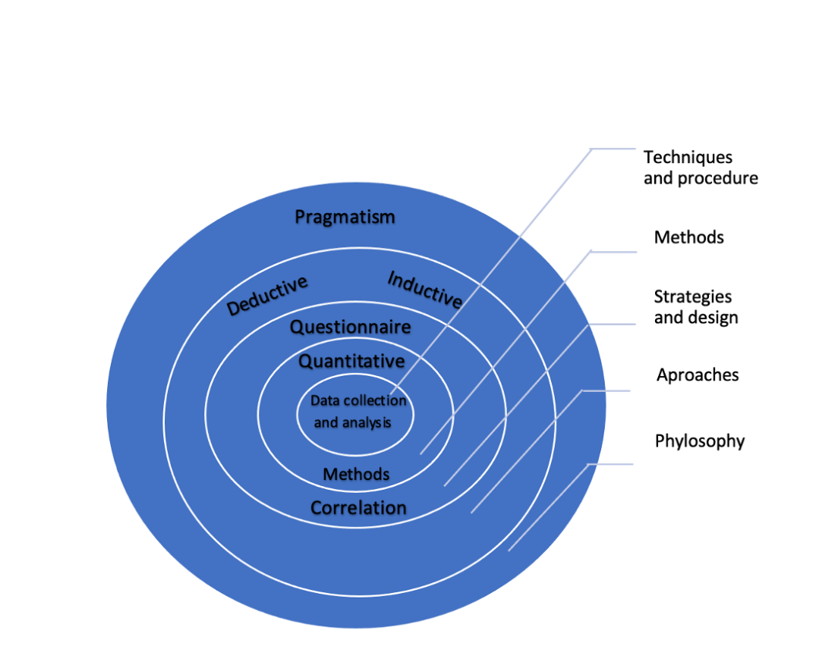

Research Methodology (Adapted from Onion Model) Saunders et al. (2016)

Appendix 2. Sample Questionnaires
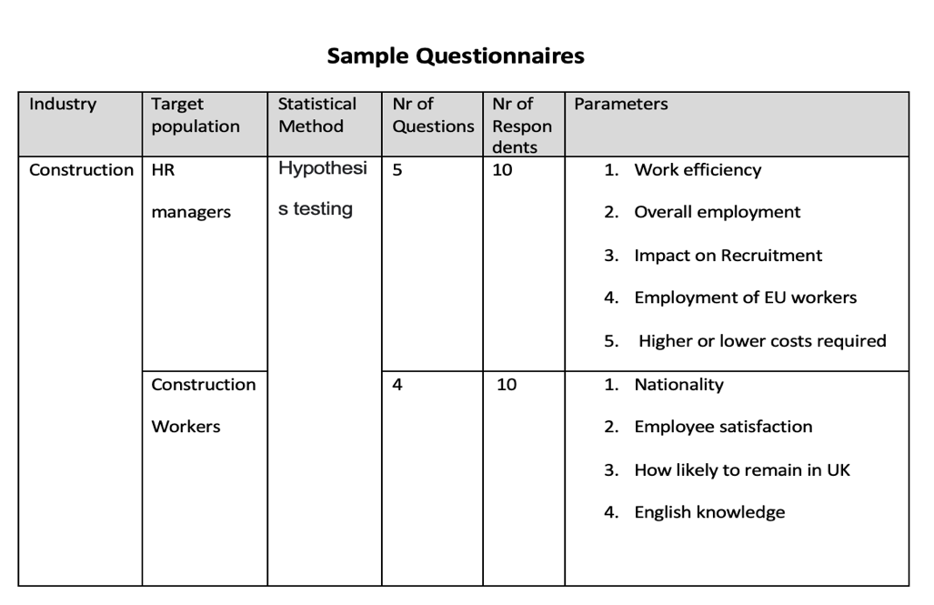

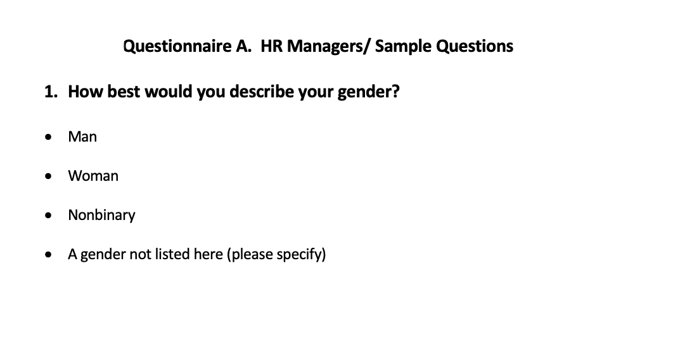
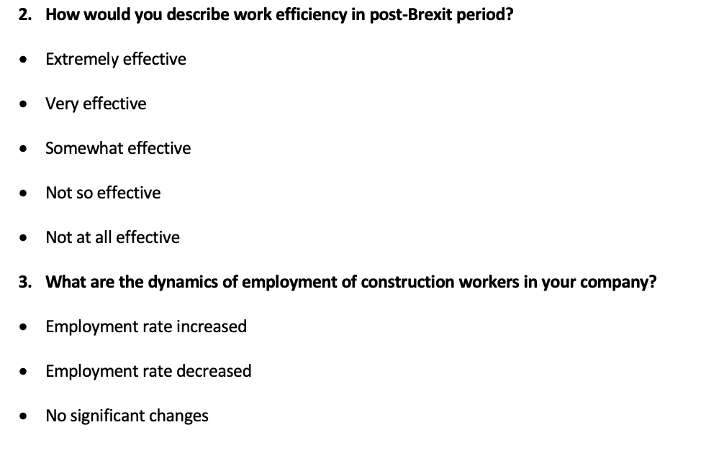
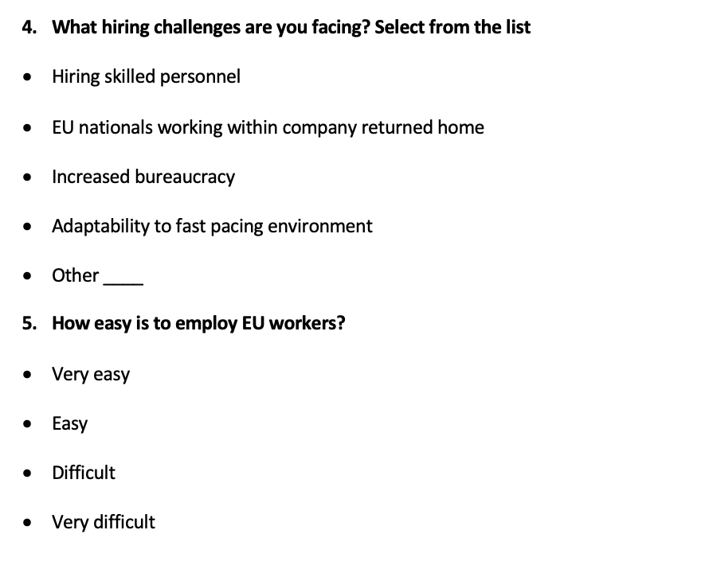



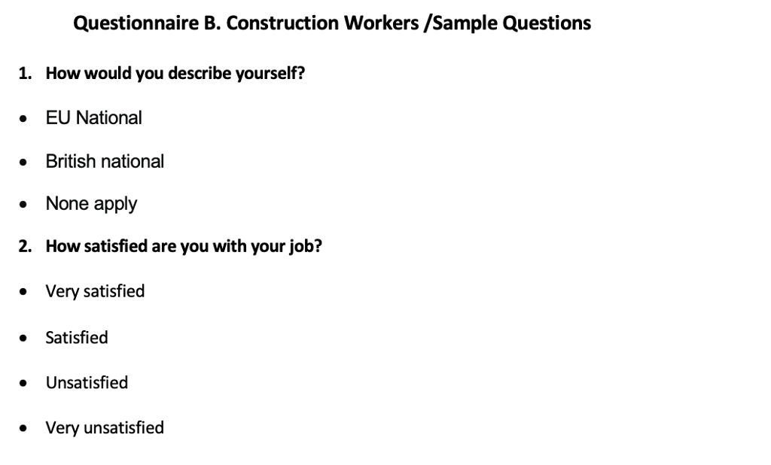
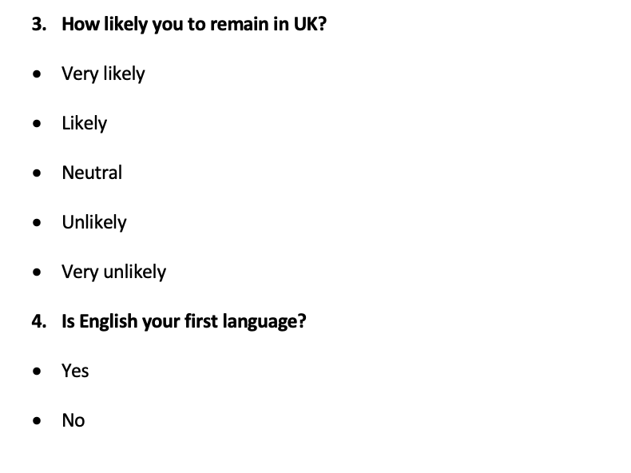

Appendix 3. Questionnaires Results/ HR Managers

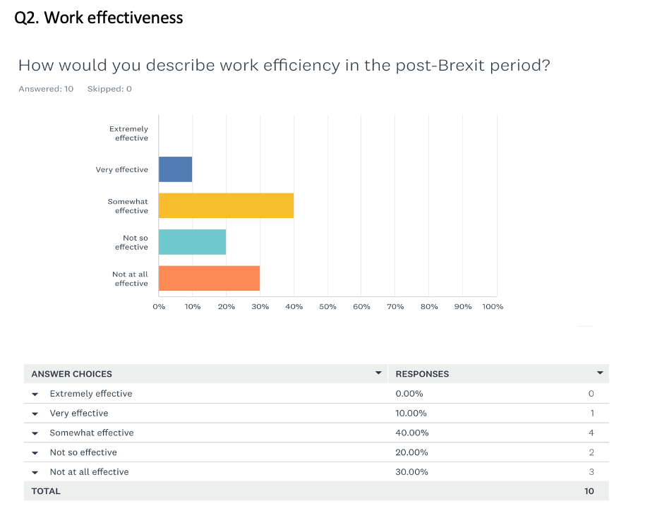
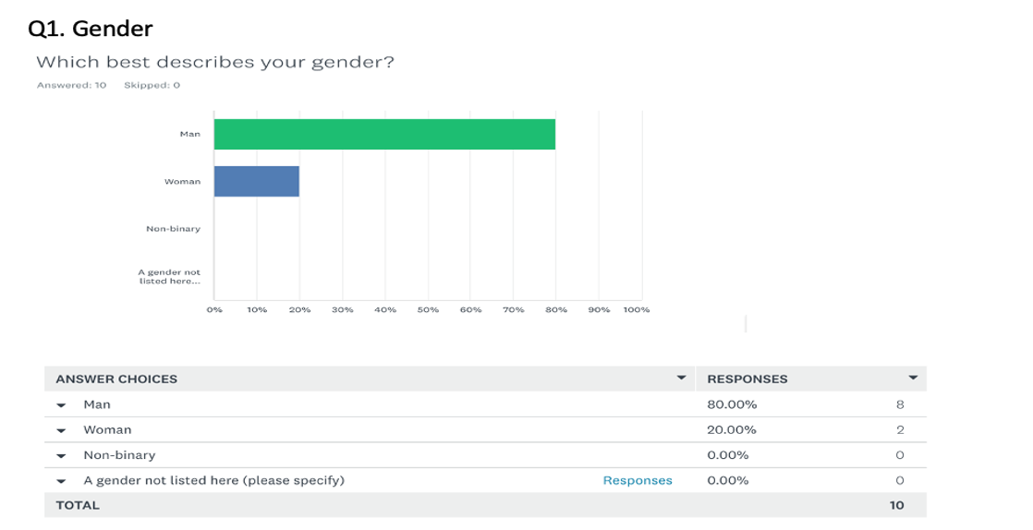
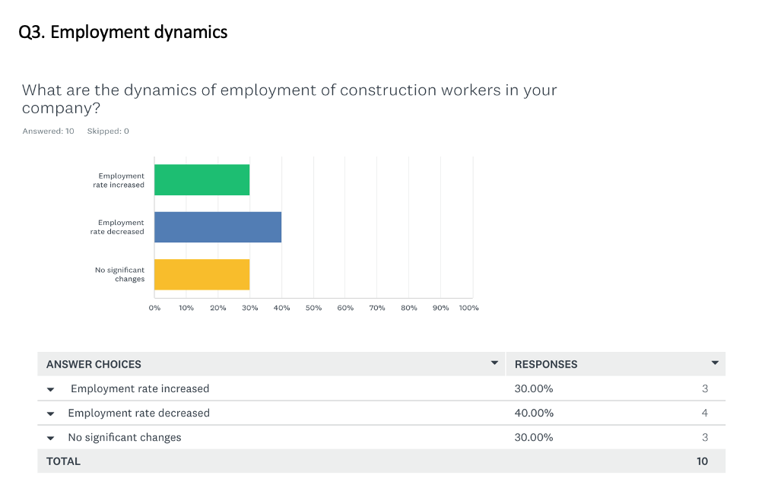
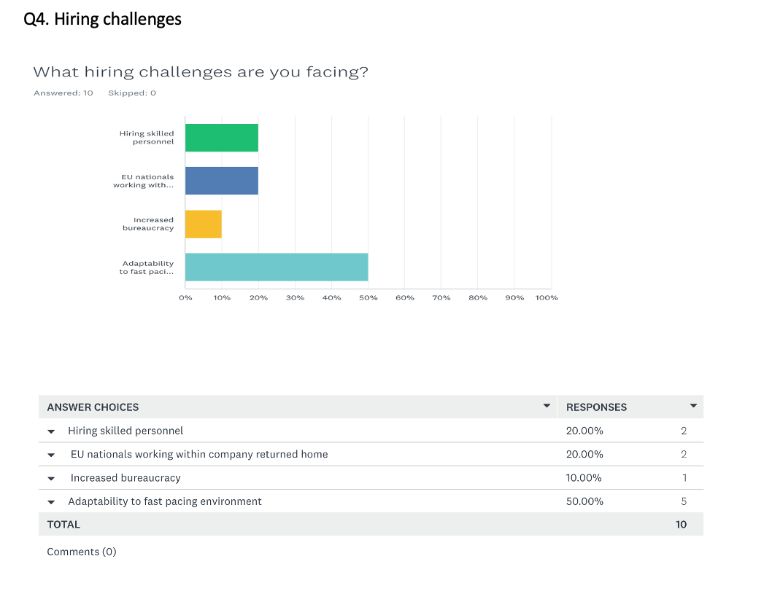

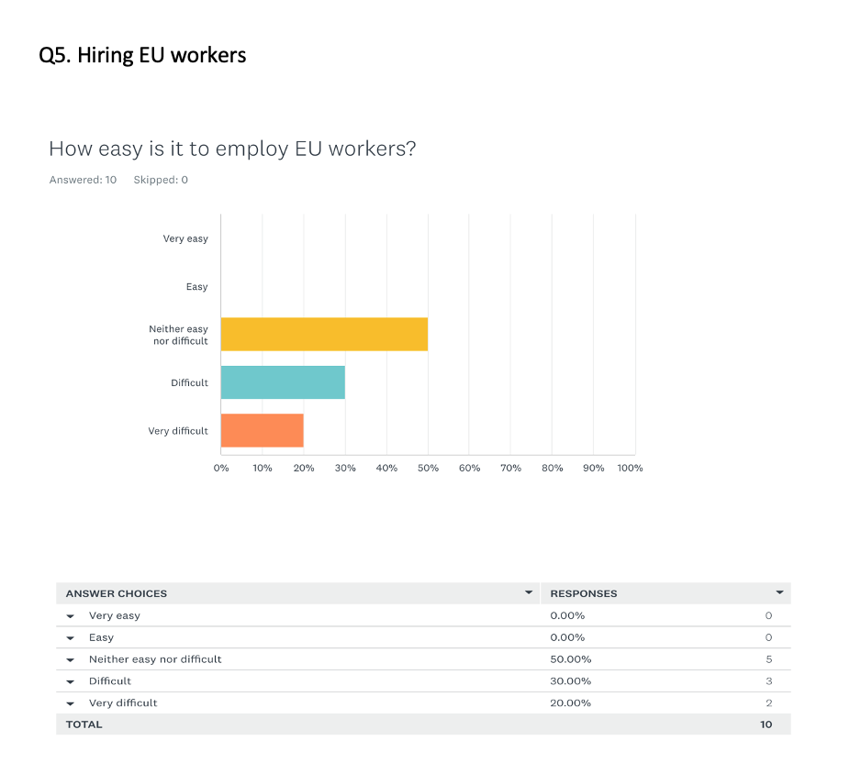

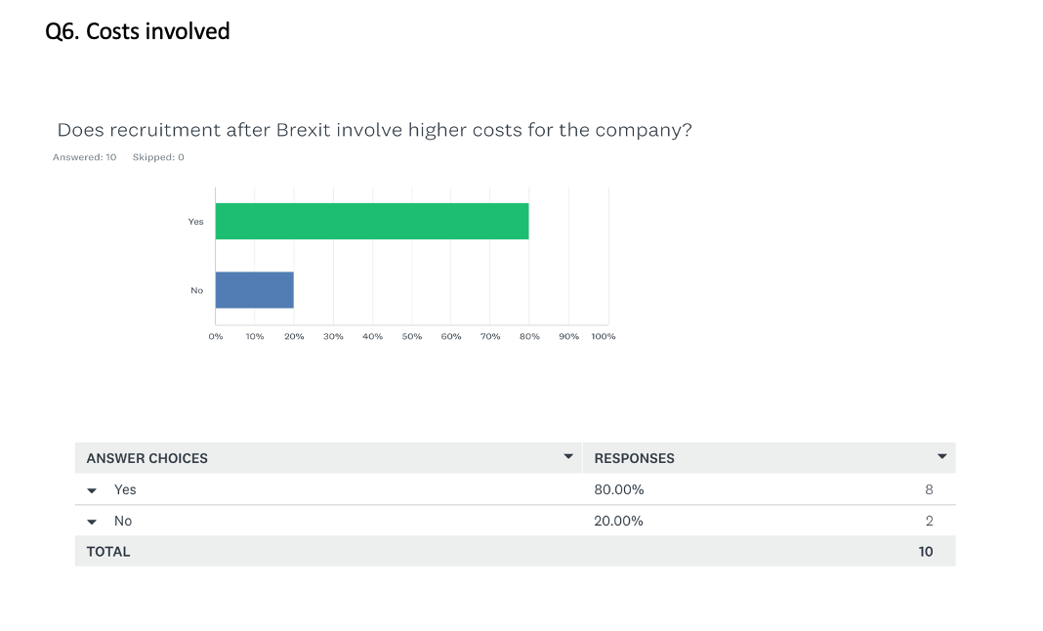

Appendix 4. Questionnaire Results/ Construction Workers

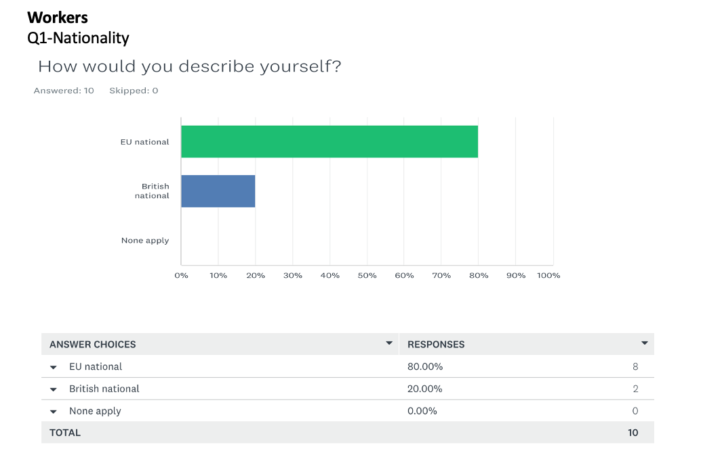
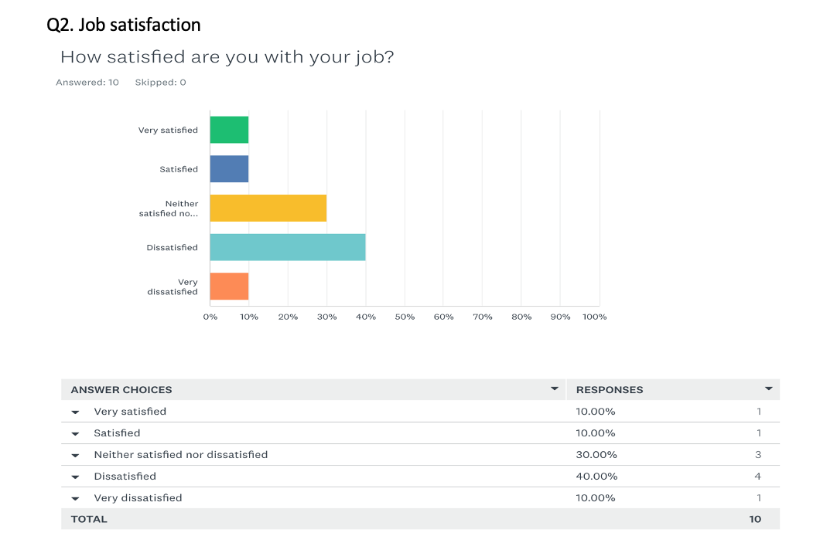

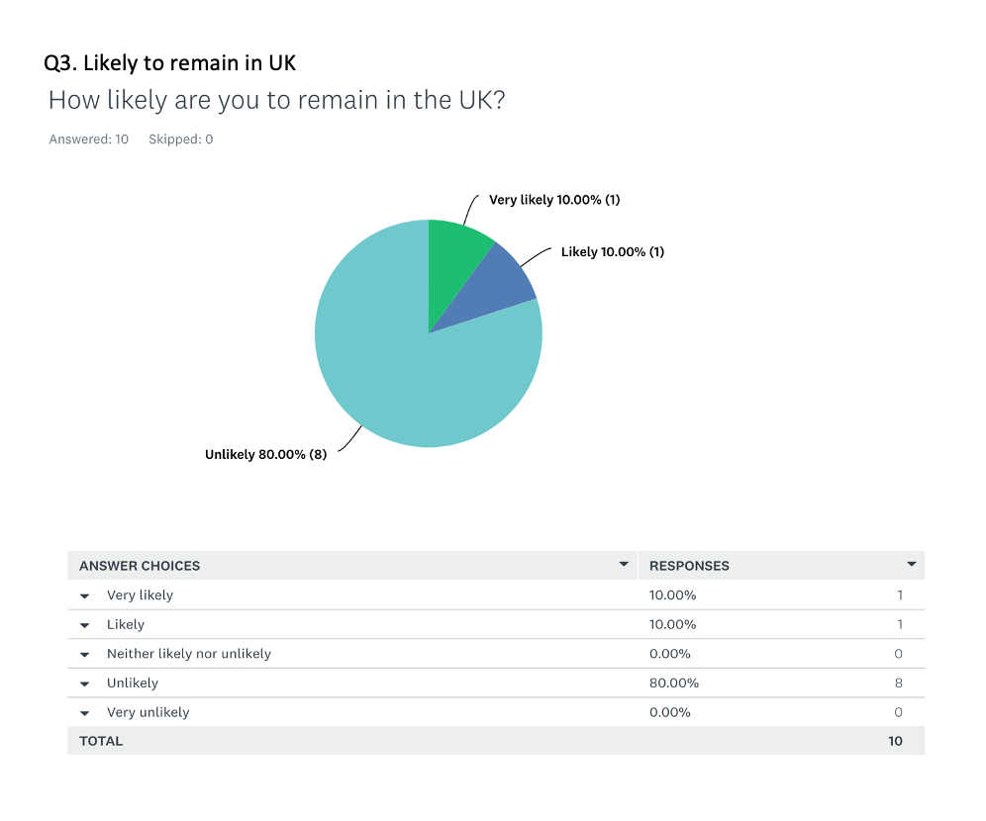

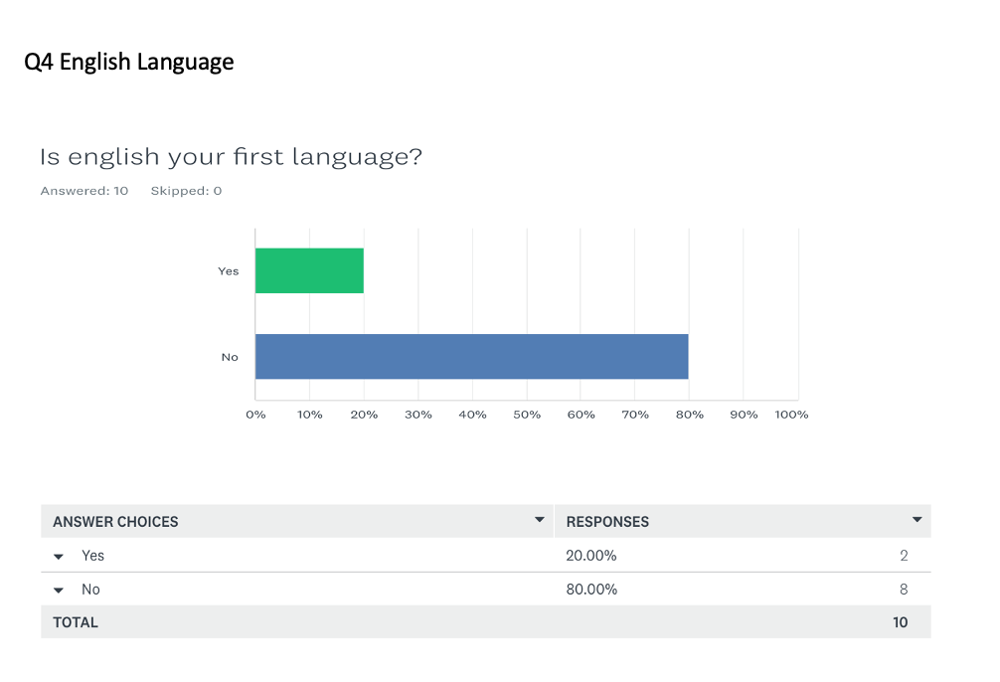

Appendix 5. Participant Consent Form

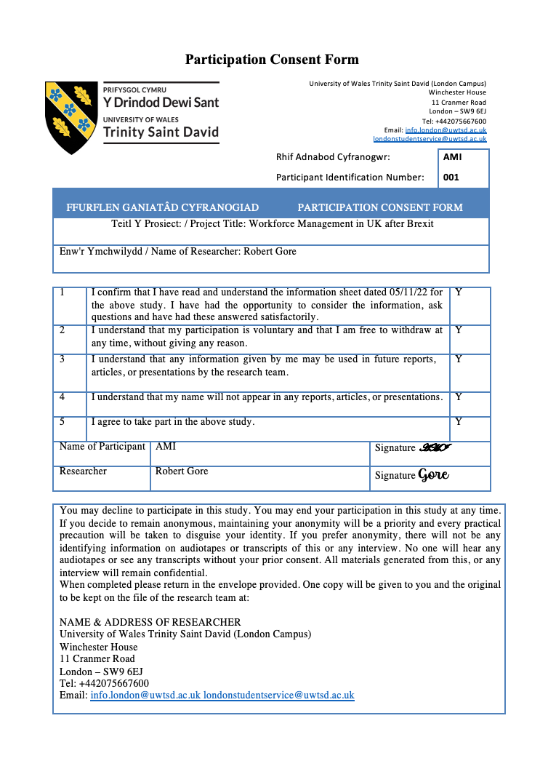

Appendix 6. Participant Information Form

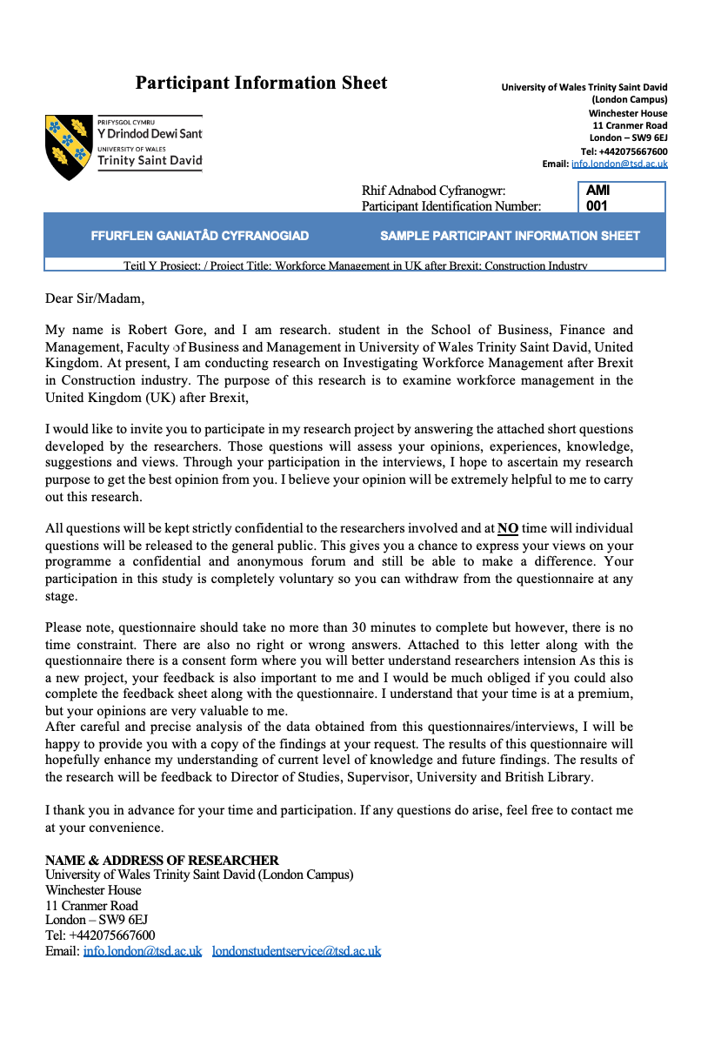

Appendix 7. Application for ethical approval



