Sophie Howells
1400370
Word count - 2147
5. Based on your visit to the National Museum Wales, consider how the museum promotes public understanding of the archaeological record.
It could be said that museums all around the world are the most important places and are at the very core of archaeology. This is because it is the very place where archaeology meets the public and the place where we engage the public with archaeology, making them interested and creating an understanding of the discipline of archaeology. (Schadla-Hall, 1999)Therefore this means that one of the essential parts of archaeology and one of the challenges we face is that we have to make sure that archaeology is shown and presented in a way that is accessible to everybody, so that everyone can engage with the archaeological record. It is also essential that we present the archaeological record correctly and efficiently as this then shapes the public understanding of archaeology and the archaeological record. On the 13th March 2018, I visited the National museum Wales, in Cardiff, to understand further how in a museum setting, especially on a national level, we engage with the public and present the archaeological record. However for 9 months in 2016 I volunteered once a week at the museum, so my observations from this time as well as my visit and my experiences growing up have also shaped this report.
When visiting the museum it is very clear that the key audience that the museum are trying to cater to is that of children, in particular families, and schools. One of the many ways they try to engage people is by trying to take their visitors on a journey and creating a story around the exhibits. An example of this could be seen as they start at the beginning of time where they explore the beginnings of the earth and then the path then guides you through along time through to the dinosaurs and further. The path is signalled by the use of signs such a no entry signs forcing you to go a certain way around the exhibit. However, at the museum you could see a couple of families and people who ignored these signs and were going against them. One particular family said they were doing this because the children wanted to go back and see the dinosaurs. By creating a path it also means that visitors then engage with ‘the boring bit’ of the geology that they might not have necessarily gone to look at, as they have to get past that section in order to get to the exciting dinosaurs. However I found that many people still walked past most of the origins exhibit as there was a lot of scientific diagrams, pictures and writing. As it was looking at the early beginnings of time understandably, the archaeological record did not seem to feature in this section, therefore it was not that interactive, especially for children. However it did contain a lot of very specific information such as specific numbers, scientific facts and diagrams. This could be seen as a good thing as it appeared to be very scientific and factual, but at the same time this also put a lot of people off. It also surprisingly took up a large section of the exhibit, considering there is little archaeological material they could display for this section.
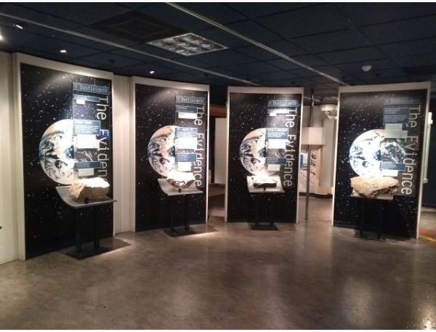
Origins exhibit (Hare, 2018)
However as you progress through the exhibit, you can see the museum really tries to completely immerse their visitors into the displays, making the exhibits and the archaeological record really come alive. One example of this is the use of planetariums in order to bring all the information to life. The museum also includes another room similar to the planetarium where visitors are transported into the centre of a volcano, including 360 degrees of lights, sounds and video footage in order to recreate the environments. Again because of the path system visitors have to walk through this section and I found that the extreme changes in environments really encouraged visitors to sit and watch all of the videos, whereas you sometimes see when it’s just a dark room, visitors usually do not often sit and watch the videos. I found that this was also an effective way of giving out information without it seeming intimidating like in the origins gallery.
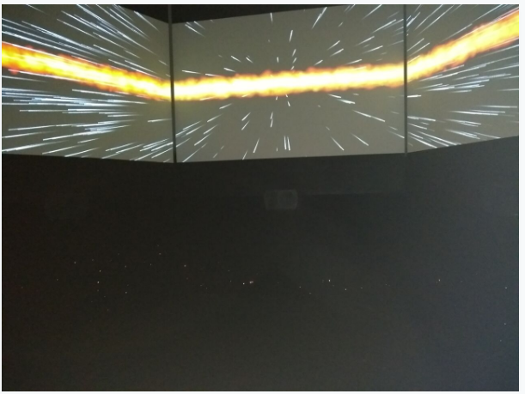
Planetarium (Hare, 2018)
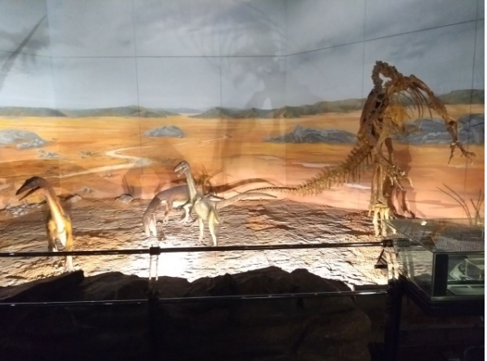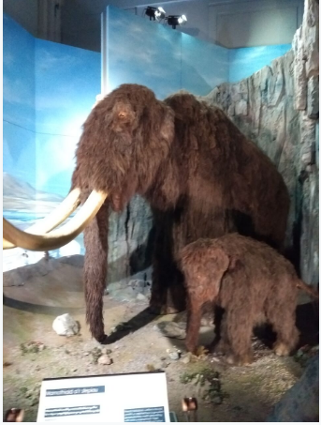
reconstructed dinosaur scene and motorised mammoths (Hare, 2018)
This also continues as the focus shifts onto the introduction of mammals. Here we see the environment change and we see various recreations of animals around the rooms. We also see the introduction of a lot more of the archaeological record, mainly that of animal remains. The exhibits tended to use these environment reconstructions and also reconstructions of both complete animals and full size skeletons, both to transport the visitor into that environment, but also to support the archaeological record and the objects in the cases. This really made the objects come alive, making the record more interactive and understandable, especially for children. They even further bring the record to life by using motorised animatronics of mammoths and hyenas that use motion sensor technology, so it moves and creates sounds as you walk past. However I found that there was so many reconstructions and they were so grand, that it made it very easy to overlook the real archaeology in the cases and to focus on the reconstructions. This could then mean that we are getting more and more disconnected from the real objects, taking away their importance as artefacts.
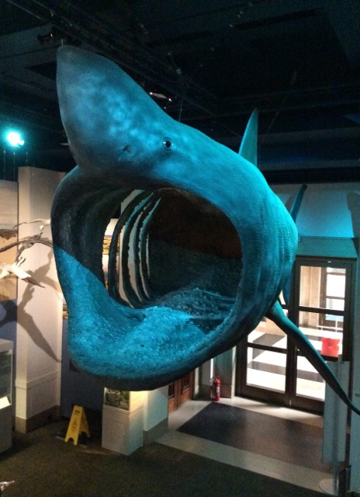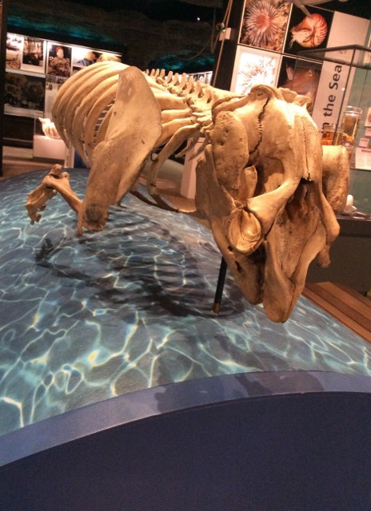
Full scale reconstructions of animals and skeletons (Howells, 2018)
This immersive way of recreating an environment, also makes your audience feel like they aren’t even in a museum at all. This included feeling like there was a lack of boundaries, unlike in other museums or even in the art galleries upstairs where there was a lot of boundaries such as ropes, cases, or a strong feeling of being watched by security. While this lack of being watched was nice, it also felt like there was real lack of information points or people to interact with and explain some of the artefacts even further. When looking at the artefacts on display the museum has also often included and used the specific, proper scientific names when explaining what the artefacts are, especially when looking at animal remains and stating their official Latin names. They also sometimes included how to pronounce these names by breaking them up phonetically. This again makes the record seem more scientific and specific. However when looking closer at the information provided about the artefacts in the cases, often little information was given about specific pieces and descriptions were often very generalised and about a collection or case of objects. Whilst this could make it more appealing as it is less off putting, it isn’t very engaging if you want to learn more information about the individual artefacts rather than just being told what they are called.
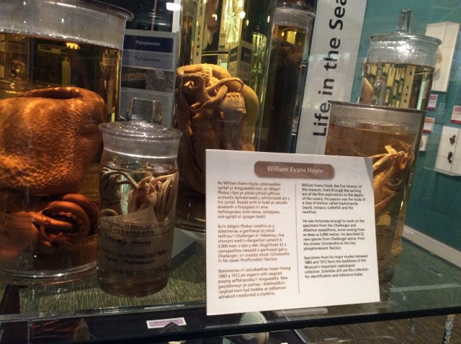
Generalised information (Howells, 2018)
The use of stories to engage the public and to draw them into the exhibit and therefore the museum, is something the museum often does, especially with visiting exhibits. An example of this is the ‘treasures - adventures in archaeology’ exhibit that they ran in 2016 (National museum Cardiff, 2016).Here they used Indiana Jones as a way to attract people as the exhibit featured Indiana Jones’s hat, whip and jacket, and one of the crystal skulls. The rest of the exhibit was made up of a variety of artefacts or treasures, from all over the world, from Mayan and Egyptian finds to more local roman and Viking hoards. From talking to visitors over the nine months I volunteered at the exhibit, it was very clear that most people came because of the Indiana Jones connections. However they left the exhibit with a wider knowledge and a better understanding about archaeology from the rest of the exhibit. It also changed a lot of people’s views about what we do in archaeology as it clarified it’s not actually how its portrayed in the movies such as Indiana Jones and Lara Croft. In that exhibit replicas also featured very strongly, especially as most of the exhibit tried to show treasures from around the world. Many visitors were unhappy with this, and felt that because the artifacts were not the ‘real thing’ they should not be on show and had little or no value.
One of the big ways that the museum tries to involve the public is by recruiting and using a lot of museum volunteers. Volunteers are often recruited in order to work with a specific exhibit for 3-4 hours a week. These therefore are often the people who interact face to face with the public in the exhibits, explaining more about the exhibits and their contents. (National museum Cardiff, 2018) However, I found that volunteers ranged from university students, to people with no experience in archaeology at all. Considering we were also the ones that dealt with the public, further information about the artifacts was not really given to us, therefore we could not provide further knowledge of the artifacts. However one invaluable thing that volunteers do provide is handling sessions of replica artifacts that are on show in the museum. This allows visitors a chance to get up close and handle artefacts, getting a different experience to just looking at them in a case. It also very much engages the visitors as the volunteers are encouraged to ask visitors questions, such as guessing what the artefacts are and what you might use them for (Pye, 2007). The museum also has an entire learning space that is dedicated to this called the clore discovery centre (National museum Cardiff, 2018) . This is where there are draws and draws of handling artefacts that people can handle and look up close at. There are also interactive spaces such as microscopes where people can look even closer. However this is very much promoted as an activity for children, so unless people came with children they didn’t tend to take part in these sessions. However handling objects could create a better understanding of the artefacts for everyone.
One big observation that was made was that considering the museum is a national museum, therefore on an international level, there was a lack of different languages other than English and Welsh, especially European languages. This is very different to other national museums such as the Scottish national museum where information in other languages is widely and openly available. I thought this was especially odd since groups of European students, particularly French students regularly visit in large groups. On the contrary there is a big emphasise at the museum on the promotion and use of the Welsh language. Absolutely everything at the museum is in both English and Welsh with even sometimes a bigger emphasis on the Welsh language. When looking at the displays I found that sometimes the colours of the English text clashed with background colours, therefore making it hard and off putting to read. All information was also available in both English and Welsh including interactive displays, videos and spoken information, making sure that the museum is fully inclusive for everyone in Wales, especially from rural towns.
As we were visitors to the museum, we were allowed to step into the archives, and take a look at some of the museums storage facilities and the archives. We also met the experts who are essential for the upkeep of the museum and the items they hold. However the majority of their work seems to go unknown as it all happens behind the scenes. This begs the question, are we really engaging the public with the archaeological record if most of it is locked away downstairs in the archives with the specialists? (Keene, 2005) It is also unclear to the public how much treasure and their heritage is hidden away out of sight from the public. Having grown up with the museum I can also say considering how much the museum holds in storage there has been hardly any change to the exhibits on show to the public. However the experts aren’t always hidden away as National Museum Wales occasionally run events such as ‘Behind the scenes at the museum’ where the curators meet the public and they learn more about their roles (National museum Cardiff, 2018) The public can also have behind the scene tour of the archives and learn more about how the museum fits into the bigger picture and the much larger role it plays in looking after Welsh archaeology. This is essential for the public to understand what the archaeological record is and its promotion within the public. Overall I believe the museum is very inclusive and it plays a massive role in making sure the public are involved in and understand what we do and the archaeological record, as ultimately it’s their history and the museum are also inspiring the next generation of archaeologists in doing so.
References
Hare. V, 2018, images taken at National museum of Wales Cardiff, 13th March 2018
Howells. S, 2018, images taken at National museum of Wales Cardiff, 13th March 2018
Keene, S. (2005). Fragments of the world : Uses of museum collections. Amsterdam ; London: Elsevier Butterworth-Heinemann.
National museum Cardiff, 2018, Behind the Scenes at the Museum - https://museum.wales/cardiff/whatson/10035/Behind-the-Scenes-at-the-Museum/ accessed 7th March 2018
National museum Cardiff, 2018, Clore discovery Centre - https://museum.wales/cardiff/clore/, accessed 7th March 2018
National museum Cardiff, 2018, meet the volunteers -https://museum.wales/takepart/volunteering/meet/accessed 9th March 2018
National museum Cardiff, 2016, Adventures in archaeology - https://museum.wales/cardiff/whatson/8641/Treasures-Adventures-in-Archaeology/ accessed 10th March 2018
Pye, E. (2007). The power of touch : Handling objects in museum and heritage contexts (Publications of the Institute of Archaeology University College London). Walnut Creek, CA: Left Coast Press.
Tim Schadla-Hall (1999) Editorial: Public archaeology, European Journal of Archaeology, 2:2, 147-158,

