Assignment Title: Reflective Portfolio
Student Name: Elena Banica
Student ID: 2126381
Lecturer Name: Masud Ibrahim
Module Code: BMSW4005_BIRM
Professional and Career development

Contents
Introduction 3
Career of Choice 3
SWOT Analysis 3
Skills and Knowledge Required 4
PDP 4
Evaluation of my skills in comparison to my chosen career 5
Assessment and Reflection 6
Reflection on cognitive learning style 6
Reflection on the topic employment legislation 7
What? 7
So What? 7
Now What? 7
Reflection on the mock interview experience 8
What? 8
So What? 8
Now What? 8
Reflection on learning about the PDP tool 8
What? 8
So What? 9
Now What? 9
Conclusion 9
References 10

Introduction
Career development is a process that every professional should strive to carry out for purposes of personal and professional improvement. Regardless of the field in which one practices their profession, it is important to understand and practice the concepts that enable one to increase their competency and expertise required to be more valuable in their career (Brown, 2013). This module has been dedicated to concept of professional and career development with the aim of providing knowledge on how one can improve their chances of professional development. Based on the choice of the role of a production supervisor, this report provides an audit of the skills I possess and those required to perform the role. Moreover, the report also provides a reflection on the concepts taught during the module with the use of the Gibbs reflective model.

Career of Choice
In the previous task in which I applied for a role and conducted mock interview for the role, I chose the role of a production supervisor. The firm where I applied for the role is a leading supplier of Body in White (BIW) components within the automotive industry. My role of choice attracted responsibilities such as managing workers, supervising, and monitoring work at the sites, and ensuring health and safety among others.

SWOT Analysis

Strengths | Weaknesses
- Fast learner: I have the ability to learn new concepts and adapt to new environments quickly, which will help me in my career.  - Competent in computer knowledge: I have experience using computers to store data and perform basic tasks required for my role as a production manager.  - Leadership skills to motivate and direct. | - Communication skills: My communication skills are currently average, which may hinder my effectiveness as a production manager.  - Impatience: I have a tendency to become impatient, which may negatively impact my ability to manage my team.
Opportunities | Threats
- Professional development: I can take advantage of various professional development opportunities such as workshops, courses, and mentorship programs to improve my communication and leadership skills.  - Networking: Building relationships with other professionals in my industry can provide me with valuable insights and opportunities for growth | - Competition: There may be other individuals who possess stronger communication, which could make it difficult for me to advance in my career.  - Rapid technological advancements: The technology used in production management is constantly evolving, and I need to keep up with these changes to remain competitive in the industry.

Skills and Knowledge Required
There are specific skills and knowledge required to be successful at production management. The first, and most important skill is that of effective communication. By definition, effective communication is the process of exchanging thoughts and ideas in a manner such that the audience receives the messages as intended by the communicator (Turaga, 2019). The skill provides a production manager with the ability to accurately convey messages to the workers they supervise and to their superiors at the management level. Another skill that is required in the role of production management is that of leadership. The skill involves the ability to provide direction and vision for a group of people who share the same goal (Mumford et al., 2007). As a production manager, one is required to lead the workers they supervise toward a common predetermined goal where they achieve their targets. In addition to the above two skills, a production manager is required to possess the knowledge of technology, especially that which is employed at the place of work. For example, according to Ham, I., Hitomi et al., (2012), a production manager should have the knowledge of using a computer to store and retrieve data on the workers they supervise and the equipment they use. Moreover, a production manager is required to have the knowledge of project management. In organizational management, project management is a process that involves setting timeframes, assigning tasks, and overseeing tasks with the aim of accomplishing a project (Henrie and Sousa-Poza, 2015). A production manager is required to have the knowledge of project management for purposes of effectively managing any project that the organization ay assign to them.

PDP
My goal | What I want to achieve | Specific actions that I will take | The resources I need | How I will measure success | Time frame
Improve my communication skills | Increase my ability to understand and manage at least 20 people. | Attending a university program to improve my communication skills.  Work on my listening skills. | Materials on team management and listening skills which I can find on Google Scholar. | When I feel prepared and confident when managing the 20 employees in my role as a production manager | 2 months
Develop my leadership skills | Understand the different leaderships styles and the different circumstances that each of them can be used to lead. | Read scholarly materials on leadership.  Take an online leadership course. | Money to pay for the online course.  The internet to access the scholarly materials. | When the employees I manage are willing to follow my direction. | 2 months
Develop my communication skills | To be able to carry communicate orally and in written form without making mistakes that can lead to misunderstandings | Read scholarly materials on the deferent concepts in communication such as models and channels of communication.  Practice effective interpersonal communication. | I will need the internet to access the communication materials. | When I can confirm that the employees I lead are making actions that match my instructions and advice. | 2 months

Evaluation of my skills in comparison to my chosen career
As established, two of the skills that my chosen career of a production manager requires include communication and leadership skills. Moreover, the career also requires the knowledge of using computers and project management. According to my personal development plan in the table above, I intend to improve my leadership and communication skills. On a scale of 1 to 5, I would rank both my leadership and communication skills at 3, which is average. An average score means that my leadership skills are not at the level that I can lead the workers with absolute confidence. Additionally, I also need to improve my communication skills from average to excellent in order to be effective at my role as a production manager. Another skill that I possess, but not with the quality required to perform my role as a production manager, is that of people management. Skills will be important in my role as I will dealing with twenty different workers on a daily basis in addition to my superiors at the management level.
I do, however, possess competent levels of computer knowledge as required in my chosen career of a production manager. I have experience with using computers to store simple data such as the type I will need to store in my role. However, my knowledge in project management is currently average due to my lack of experience. The main strength I possess that will help me become a good production manager is that I am a fast learner. When put in new environments, I am able to learn fast, which will enable me to adapt to the requirements of my role. However, I have the weakness of impatience as I have observed myself over time. This is weakness that I will have to contain as it can make me fail to manage the workers I supervise when they make mistakes.

Assessment and Reflection
An assessment and reflection of Concepts and Topics using the Driscoll model.
The Driscoll model guides a learner to analyze a learning experience by asking three questions namely, “what?” “So what?” and “Now what?” (Gladd, 2020). Based on these three questions, I can analyze my experience of the module as follows:
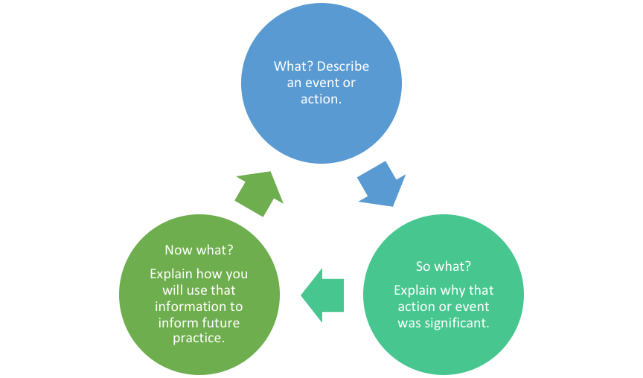
(Image source: Gladd, 2020).

Reflection on cognitive learning style

In conclusion, cognitive learning style is a theory that emphasizes the role of an individual's mental processes in learning. It proposes that learners have different ways of processing information and that the effectiveness of learning is influenced by the match between the learner's cognitive style and the learning task. Pashler, H et al (2008). In my personal experience, I have found that understanding my cognitive learning style has helped me to identify my strengths and weaknesses as a learner, and to tailor my approach to learning accordingly. This has led to greater efficiency and effectiveness in my learning, both in academic and workplace settings. Additionally, as a manager, understanding the cognitive learning styles of my team members has enabled me to better support their learning and development, by providing them with opportunities to learn in ways that align with their cognitive strengths. Overall, cognitive learning style is a valuable theory that can inform and enhance the learning experiences of individuals and teams.

Reflection on the topic employment legislation

What?
Understanding employment legislation is important for learners as the provisions they learn will govern their practice in their future life as employees (Aleksynska and Eberlein, 2016). The topic of employment legislation was where we learnt about the different laws and regulations that are put in place by the parliament of the United Kingdom to give employers and employees rights and responsibilities concerning their occupations. What I did during the topic included researching and reading on the laws and regulations that comprise the employment legislation. Other people involved in the experience include my classmates and the tutors. During the topic, I had some good experiences like interacting with my classmates, and some bad experiences like having trouble finding sources to the legislations because I was not familiar with how to search for official legislation documents on the internet.

So What?
The whole time I was learning the contents in the topic of employment legislation, my feelings kept on changing depending on the specific legislations. I felt bad during legislations that I could not easily understand, and I felt good during legislations that were straight forward in their provisions. Currently, the feeling I have is positive as I have managed to understand the legislations that caused me problems. On reflection, I can now understand that my lack of experience with UK law contributed to the bad experiences that I had during the topic. From my conversations with my classmates, I have learnt that most of them shared the feelings I have described.

Now What?
From the refection that I have done so far, I have learnt that the topic of employment legislation in the module improved my knowledge greatly. Moreover, I have learnt that I could not have prevented the negative experiences I had during the topic because they were caused by my lack of experience in UK employment legislation. In the future, I will prepare for such topics by reading on employment legislation in advance.

Reflection on the mock interview experience

What?
The exercise of conducting a mock interview required me to first produce a CV and a cover letter as part of an application process for the role of my choice. The role I chose was that of a production manager at a firm that does… having submitted my CV and my cover letter, I took part in a mock interview where I answered the questions that I would have been asked in a real-life situation. The whole experience was good as I enjoyed being quizzed on the role that I would want to do.

So What?
At the specific moment when the interview was in progress, I felt like it was a real interview with my future employer. My reaction to this feeling was that of excitement because I felt like I was being interviewed to get the job. Currently, the feeling I have about the mock interview is more of is one of accomplishment as I was able to answer all the questions with confidence. I have also noted that my past experience helped me get through the exercise with the success that I achieved. In my life, I have taken part in several interviews where I was looking for a job and had to go through the interview process.

Now What?
Even though the overall experience was good, there were some negative outcomes that I could have prevented. For example, I failed to mention some important skills that would be required in my role. I could have prevented such an outcome by reading more about the skills needed to be a production manager. In the future, if I find myself in another mock interview, or even a real interview, what I would differently is prepare more. More preparation will enable me to be better at answering question as I will have more knowledge on the role.

Reflection on learning about the PDP tool

What?
A personal development plan (PDP) is a tool that an individual uses to list the areas they would want to improve and write record the process they intend to go through to make the improvement (Clegg and Bradley, 2006). In the experience where I learnt about the tool, the main action I took was to create a PDP for myself. The good side of the experience was when I understood the components of a PDP.

So What?
When learning about the tool, I felt overwhelmed at first as I did not know the information, I needed to fill in the blanks in the PDP table. I reacted with disappointment as I thought I was not good enough to understand and apply the tool. However, currently, the feeling I have is of accomplishment as I later understood the process and became good at creating a PDP.

Now What?
From the reflection so far, I have learnt that I began the process of learning about PDP with little knowledge of the tool and ended it with good knowledge. I now know that I could have prevented the disappointment I felt in the beginning of the experience by reading more about a PDP and understanding the different sections. In the future, when I learn about a PDP and I have to create one, I will first read about the concept and understand the reasons behind its structure.

Conclusion

The main conclusion that I can make from the report is that I need to do more and increase my competency in the main skills required in my career of choice. The evaluation on my current skills and knowledge has demonstrated that I need to increase my expertise in communication and leadership. My reflection on the concepts I learnt in the module has shown that I had both good and bad experiences while learning about the concepts and topics in the module.

References

Aleksynska, M. and Eberlein, F., 2016. Coverage of employment protection legislation. IZA journal of labor policy, 5(1), pp.1-20.
Brown, D., 2013. Career information, career counseling, and career development. Allyn & Bacon.
Clegg, S. and Bradley, S., 2006. Models of personal development planning: Practice and processes. British educational research journal, 32(1), pp.57-76.
Gladd, J., 2020. John Driscoll’s “What?” Cycle of Reflection. Write What Matters.
Ham, I., Hitomi, K. and Yoshida, T., 2012. Group technology: applications to production management. Springer Science & Business Media.
Henrie, M. and Sousa-Poza, A., 2015. Project management: A cultural literary review. Project Management Journal, 36(2), pp.5-14.
Mumford, T.V., Campion, M.A. and Morgeson, F.P., 2007. The leadership skills strataplex: Leadership skill requirements across organizational levels. The leadership quarterly, 18(2), pp.154-166.
Pashler, H., McDaniel, M., Rohrer, D., & Bjork, R. 2008. Learning styles: concepts and evidence. Psychological Science in the Public Interest, 9(3), 105-119.

Turaga, R., 2019. Effective communication in organizations. IUP Journal of Soft Skills, 13(1), pp.63-69.

