

UNIVERSITY OF WALES
TRINITY SAINT DAVID
TITLE: KNOWLEGDE AND INFORMATION MANAGEMENT

NAME: Patrick Mokwe
NUMBER: 1604804
Word count:4703
August, 2018

Table of Contents
1.0 Introduction 2
2.0 Evaluation of the Concept and the Importance of Knowledge Management 2
2.1 The relationship between Data, Information, and Knowledge 2
2.2 The relationship between Individual Knowledge and Organizational Knowledge 4
2.3 Identification of Knowledge Assets 6
2.4 Evaluate Actual and Potential Knowledge Assets 8
3.0 Importance of the Knowledge Management Process 9
3.1 Requirements to Create, Store, Apply and Integrate Knowledge 9
3.2 Importance of Intellectual Property Rights 12
4.0 Framework for Establishing a Knowledge Management Culture 14
4.1 The Contribution Knowledge Assets have in an Organization 14
4.2 Evaluation of the Knowledge Requirements for the Organization 17
4.3 Evaluation of the Organization’s Framework for Enabling Knowledge Sharing 17
4.4 Recommendation of Improvements to their Current Framework 19
5.0 Conclusion 21
Bibliography 23
Appendices 25

1.0 Introduction
Knowledge management is a discipline that encompasses the creation, dissemination, and application of knowledge and information by a company. The discipline has become of immense importance to organizations that many large and medium-sized organizations have set aside resources to form business units whose primary objective is knowledge management. The focus of this paper is to evaluate the concept of knowledge management in the context of G4S UK, which is a leading provider of security and care solutions. It will also provide an explanation of the benefits that knowledge assets bring to a company as well as provide a charter for forming a knowledge management culture.

2.0 Evaluation of the Concept and the Importance of Knowledge Management

2.1 The relationship between Data, Information, and Knowledge
The word linear can be used to describe the association between knowledge, information and data. However, besides being in a linear relationship, the three concepts are differentiated from each other using hierarchy (Liew, 2013, p.49). According to Cambridge International (2017, p.4), data is defined as elements that include texts, number or symbols that when read do not provide any meaning. From these numbers, one cannot discern any meaning. Liew (2013, p. 50) states that data can be recorded in the form of signal readings, diagrams, numbers or pictures. Data can also be represented as taste, sound, and smell. For instance, data may be numbers such as 2, 4, 6, and 8.
Secondly, Liew (2013, p.50), defines information as an outcome of the data that has been processed. Once data has been transformed into information, it ceases to become worthless, and it will now have a meaning. For instance, the example of data provided was 2, 4, 6, and 8. Once the data has been processed, it will then provide information that they are even numbers. Liew (2013, p.50) states that once data has been transformed into information, it not only possesses meaning. Instead, it also maintains other elements such as implication or input that can be used in decision-making.
Lastly, Cambridge International (2017, p. 5) defines knowledge as the process of memorizing information. The process of memorizing information occurs through “rote-learning” or learning by heart. For learning to take place, one must first understand the information. Liew (2013, p.51) states that knowledge is expertise that resides within an individual’s mind. For instance, once information the even numbers 2, 4, 6, 8 has been memorized, one can obtain knowledge that they are multiples of 2.
From the description provided on the three concepts. It is discernible that knowledge is derived from information while information is obtained from data. Given that all of the ideas are subsequent of the others, a linear relationship is created. Also, in an organizational context, the significance of the three ideas are in the following order: knowledge, information, data, with knowledge being the most significant while data being the least significant. Therefore, the significance of each of the three concept forms their hierarchical order. Hence, the hierarchical and linear relationship of the ideas can be seen below.

Figure 1: Hierarchical and Linear Relationship of Data, Information, and Knowledge adapted from Liew (2013, p.51)

2.2 The relationship between Individual Knowledge and Organizational Knowledge
The affiliation among personal knowledge and organizational knowledge can be summarized as a process that converts information that has been created by individuals so that it can be useful at the corporate level. According to Ragab and Arisha (2016, p. 125), individual knowledge is part of an organization’s knowledge that is found within the physical skills and minds employees. Personal knowledge can be used to implement tasks and provide solutions to problems.
On the other hand, organizational knowledge is a product of the creation and conversion of individual knowledge through two dimensions. One of the aspects is that individuals create knowledge while the second dimension is the interaction between a tactic and explicit knowledge. The figure below shows a graphical depiction of how individual knowledge forms organizational knowledge.
Figure 2: The Relationship between Individual and Organizational Knowledge adapted from Ragab and Arisha (2016)
The diagram above links individual knowledge to organizational knowledge through a conversion process. The conversion process is a four-phase concept that involves socialization, internalization, combination, and externalization (Ceptureanu and Ceptureanu, 2010, p.151). Individual knowledge is a predecessor to organizational knowledge, and corporate knowledge is a successor to individual knowledge.
Organizational knowledge cannot exist without individual knowledge. The reason is that organizational knowledge is dependent on how the skills and capabilities that employees possess is taken through an interactive process between a tactic and explicit knowledge. Ragab and Arisha (2016, p. 125) further state that individual employees at an organization are a denominator to the quality and quantity of information that an organization amasses. They are, therefore, the most critical component in knowledge management to an organization. They are the creators of information as well as the ones who store it. They are also the ones who stimulate the transfer of knowledge from their possession to organizational departments. In summary, individual knowledge is converted to organizational knowledge by employees who undertake the knowledge conversion process, which is an interaction between a tactic and explicit knowledge. The process can be summarized using a knowledge spiral (see Appendix B).

2.3 Identification of Knowledge Assets
The identification of a knowledge asset is made by undertaking an analysis of the type of information that is most useful to the organization. A knowledge asset is an intellectual resource that a business can utilize for the purposes of investment and growth. Therefore, the identification of knowledge assets is made by determining which types of knowledge can be used to create value for the business. The figure below shows a model through which a knowledge asset can be identified.

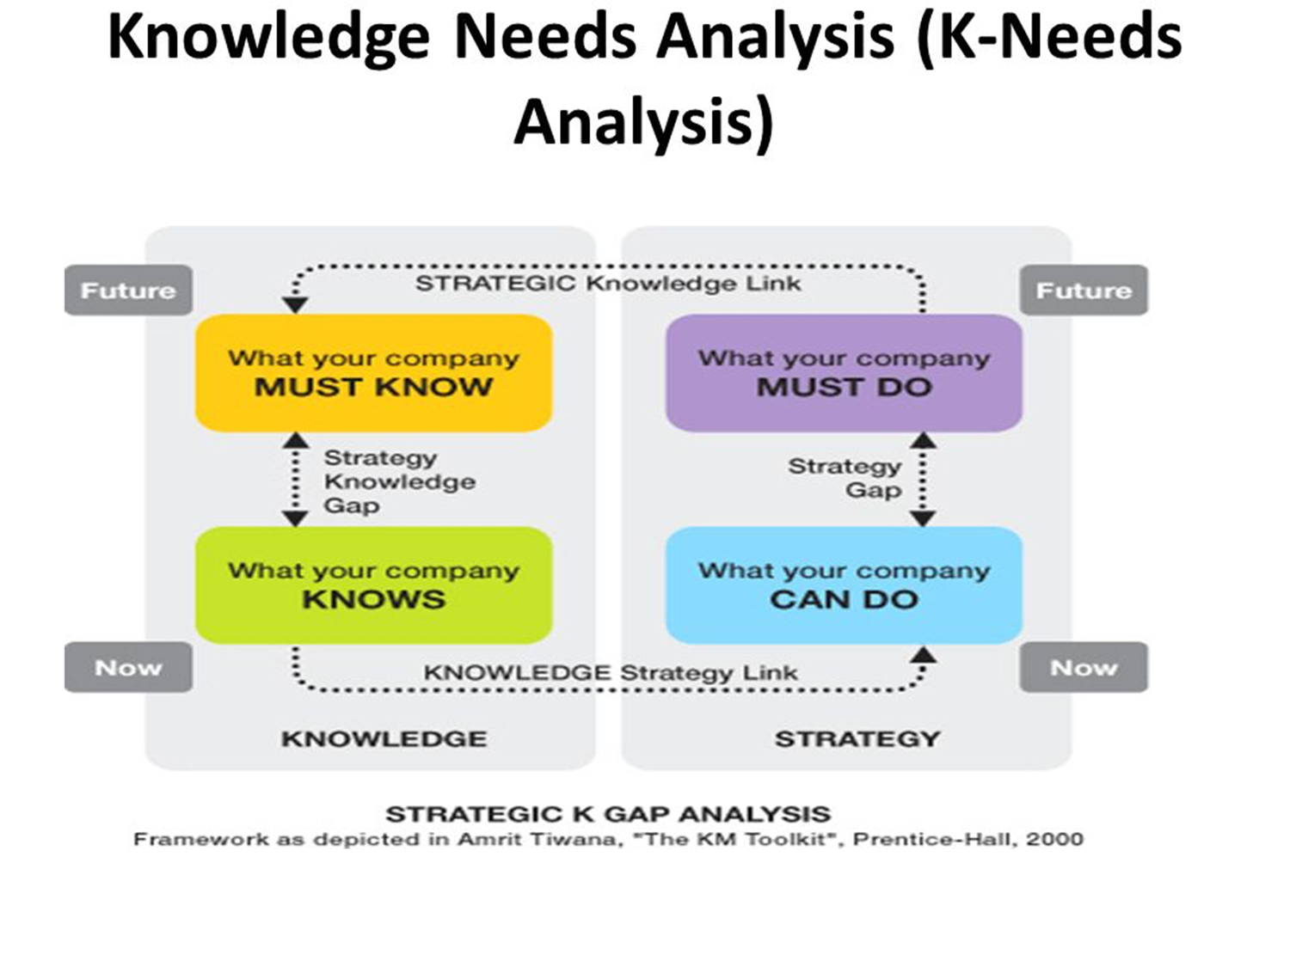
Figure 3: Knowledge Asset Analysis adapted from (Tiwana, 2000)
As stated earlier, for knowledge to be considered as an asset it must have a value creation capability for an organization. Therefore, based on insights provided by Tiwana (2000), for knowledge to be considered an asset, it must have the capacity of being aligned to the business strategy. Hence, for a company such as G4S UK, a knowledge asset is something that can be applied to its plan.
Therefore, the model that is used in identifying knowledge asset encompasses the establishment of a company position now as well as a potential position in the future which is a process known as a Knowledge Needs Analysis. In knowledge needs analysis, a company begins by identifying what it can do now and then what it must do in the future. The difference between what the company must do in the future and what it can do now is referred to as the strategy gap. For a company to execute what it can do now, it already has knowledge. On the other hand, for a company to achieve what it must do in the future, it must look for the knowledge. The difference between what a company knows now and what it must know in the future is referred as a knowledge strategy gap (Tiwana, 2000).
From the breakdown, a knowledge strategy gap has been identified as a link between what a company knows now and what it must know in the future. From the strategy knowledge gap, a knowledge asset can then be identified. Here, the knowledge asset will be information that will be used in driving the strategy. Every form of knowledge that will be used in enacting, implementing and assessing the value-driven approach for the organization, it will be considered as a knowledge asset

2.4 Evaluate Actual and Potential Knowledge Assets
The evaluation of actual and potential knowledge assets can be based on their valuation. Knowledge asset valuation is the determination of the value that they bring to a company. According to Tomblin and Maheshwari (2004, p. 35), potential knowledge assets are those that have a high level of uncertainty pertaining to their future benefits to a company. On the other hand, actual knowledge assets are those who have a high degree of certainty as to they will benefit the company in the future.
An example of a knowledge asset in the context of G4S UK is a list of emails of its current and previous clients that it provides with security services. The list of emails it possesses is an actual knowledge asset since it has a high level of certainty in benefiting the company in the future. For instance, G4S UK may email individuals and corporate bodies on the list informing them of new product offering or promotional product services they are providing at the time. Such information may have immediate returns to the company as the corporations or the individuals emailed may decide to subscribe to the company’s service and product offering.
On the other hand, an example of a potential asset knowledge is a legacy database that G4S UK may be used to store its clients' information. The company uses the asset on a regular basis to store and retrieve data for its use. The company may also choose to invest money in it for it to be developed further to create efficiency. However, there is no direct methodology through which the company cannot realize returns on investment from its use.

3.0 Importance of the Knowledge Management Process

3.1 Requirements to Create, Store, Apply and Integrate Knowledge
For an organization to be able to create, store apply and integrate knowledge, it must possess knowledge management. According to Goswami and Goswami (2013, p. 613), knowledge management is defined as a process that focuses on how knowledge is produced and how it is integrated into an organization. Goswami and Goswami (2013, p. 613) further state that it is a process where an organization’s collective expertise is captured and constructively applied to an organization. The end goal of information management is often by supporting collaboration and communication, which eventually improves performance by increasing the capacity of an organization to learn and solve problems. The definition of knowledge management provided by Goswami and Goswami (2013, p. 613) summarize the process of creating, storing, applying and integrating knowledge.
Apart from knowledge management, the four processes of knowledge conversion are also required to create, store apply and integrate knowledge. According to Ceptureanu and Ceptureanu (2010, p.151), the four-stage process is dependent on two dimensions which are explicit and tactic knowledge. Tactic knowledge encompasses knowledge that is based on perception, experience, values, beliefs, and intuition. On the other hand, explicit knowledge covers knowledge that can be documented. Explicit knowledge tends to be highly formal, systematic as well as detailed. Therefore, the process of creating, storing, applying and integrating knowledge encompassed the four process of knowledge conversion which incorporates tactic and explicit knowledge.
The first process of knowledge conversion is socialization, which is defined as a process where individuals share experiences through observation, practicing and imitating the actions of others. The process of knowledge conversion takes place through conferences, workshop, and seminars. According to Ceptureanu and Ceptureanu (2010, p.151), during socialization, tactic knowledge is converted into tactic knowledge.
Socialization is then followed by capturing which is defined as the conversion of what an individual learns during the workshops and seminars into writing. For instance, one may record what he or she learned during a G4S UK seminar and then document it in the form of a report. Ceptureanu and Ceptureanu (2010, p.151) state that during capturing, tactic knowledge is converted into explicit knowledge.
The third step in knowledge conversation is a combination, which constitutes copying of the information learned during capturing and then distributing it. For instance, once the individual who attended the G4S UK seminar captures the information into a written form, he or she spreads the report to colleagues at the company either through email or pinning it at notice boards. During this process, explicit knowledge is converted again into explicit knowledge.
Lastly, internalization concludes the knowledge conversion process where an individual combines his or her previous experiences with knowledge obtained from reading the report. During this process, explicit knowledge is converted into tactic knowledge (Ceptureanu and Ceptureanu, 2010, p.151). The whole process of knowledge management is graphically shown in the figure below.

Figure 4: Knowledge Conversion Process adapted from Ceptureanu and Ceptureanu (2010, p.151)
In summary, socialization can be equated to creating knowledge while storing can be equated to internalization. The combination may be compared to the application while externalization may be equated to integrating knowledge.

3.2 Importance of Intellectual Property Rights
Within the organizational context, there is often the need to protect intellectual property. Intellectual property is intangible assets that are a product of creativity and knowledge in a company. Intellectual property can be in different forms (see Appendix A). Protection of the type of property possesses immense benefit to its competitiveness. According to Kannan (2010, p.2), it is essential to protect property rights since it provides individuals and companies with the incentive to engage in the creation of other innovations. When an individual or an organization is conferred the sole right to the use of their intellectual property in any manner including commercial use, they will be able to optimally recover the capital expenditure used to create the intellectual asset. Therefore, the profit incentive will encourage them to create other innovations since they will be assured of being sole beneficiaries, which increases their margins of profit.
Secondly, Kannan (2010, p.2) states that intellectual property rights are essential for it provides its owners with due recognition. Intellectual property rights are instrumental in dissuading counterfeiters and infringers from taking credit on an asset they do not own. Such an occurrence, therefore, protects the legitimate owner of the property from exploitation or materially benefiting from an asset they do not own. For instance, if G4S UK develops a new cutting-edge technology that is used for surveillance, it may patent the technology to prevent other players in the surveillance field from taking the technology as their own.
Thirdly, Kannan (2010, p.2) explains that intellectual property rights are significant since they allow legitimate owners of the asset to benefit from material rewards. If a business fails to secure rights for its intellectual property, it may potentially place its self in a risky situation. When a business fails to secure its property rights, it will provide competitors the opportunity to exploit the asset for their own gain. Therefore, competitors will be able to gain financial benefits from the asset whereas if the company had secured the property right, it would have been the sole beneficiary with higher margins of financial benefits. Another example is that if G4S UK fails to secure property rights for its hypothetical surveillance invention, it may lose out on the opportunity to forge alliances with other business that may need the technology. G4S UK may also fail to secure profitable licensing deals with companies that may want to use the intellectual asset. Lastly, it may also not be able to recoup the investment in made while acquiring or developing the intellectual asset.

4.0 Framework for Establishing a Knowledge Management Culture

4.1 The Contribution Knowledge Assets have in an Organization
Knowledge assets have a positive contribution to an organization for they can help it attain its competitive advantage. According to Ibraheem (2007, p. 35), competitive advantage is a means through which an organization creates better value to its customers than rival firms over a long-term period. Knowledge assets can be used to create a competitive advantage for an organization such as G4S UK if it is valuable, rare, inimitable and non-substitutable. According to Ibraheem (2007, p. 35), when a knowledge asset is valuable, it benefits an organization in some way that it is able to generate revenue from it or increase the value of a company. Secondly, when a knowledge asset is rare, it tends to be limited in supply. Thirdly, when it is inimitable, there is no way a competing firm can reproduce it hence consumers will approach the company for it is a source of a unique resource. Lastly, when it is non-substitutable, no other resource can be used in its place.
The creation of competitive advantage in G4S UK can be manifested in the way it has used its knowledge assets. For instance, according to G4S UK (2017, p.16), one of the ways through which the company has been able to attain competitive advantage is by attracting and retaining the best employees who provide customers with the best results.

Figure 5: G4S UK's Competitive Advantage adapted from G4S UK (2017, p.16)
Knowledge management was applied so that the company could have one of the best employees in the world by having hiring and recruitment procedures, which sieve through a pool of many potential applicants and only chooses the best. It may also have been applied in training employees to equip them with knowledge of how to efficiently execute their jobs. Another way through which knowledge assets have contributed to the company’s competitive advantage is through ownership of patents. According to Warwick Economic and Development (2013, p.1), G4S UK has been able to successfully integrate human resources and knowledge that it has been able to develop six technology patents. Such an occurrence provides the company with inimitable resources, which it can use to edge out its competitors.
Another contribution that knowledge assets have to an organization can be traced to three interdependent forces. According to North and Kumta (2018), knowledge assets have an important contribution to the organization since it enabled globalization, enables structural change into a digitized knowledge society and reduces the cost of transactions while accelerating them. Below is a representation of the three interdependent forces.
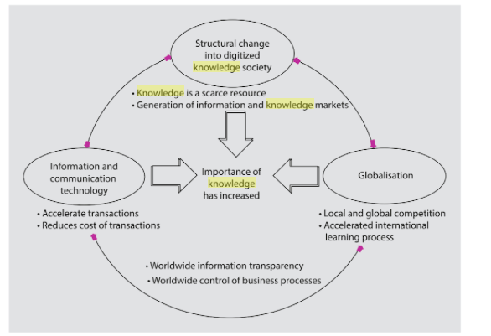
Figure 6: The Three Driving Forces adapted from North and Kumta (2018)

4.2 Evaluation of the Knowledge Requirements for the Organization
Knowledge requirements for an organization constitute the type of information that it requires it to facilitate its value and revenue generation process. G4S UK creates value and generates revenue through different approaches. These approaches include the provision of security services, cash solutions, health services, care and justice services, facility management services, and employment services (G4S, n.d). For each of the services that the company provides, they must be facilitated by the use of knowledge. Therefore, the primary form of knowledge management that the company must have concerns the six stated service areas.

4.3 Evaluation of the Organization’s Framework for Enabling Knowledge Sharing
G4S UK has a framework for enabling knowledge that is pegged in the importance of sharing intelligence. G4S UK (2018, para.1), since threat awareness is becoming progressively more important as it increases the success rate of any security initiative. G4S UK (2018, para. 15), the company’s knowledge sharing framework is based on collaboration. The company has a structure in place that ensures that knowledge in possession of individuals and project teams is disseminated throughout the organization. At the internal level, the organization has a Sales Training Program. The program is aimed at equipping employees with tools for consultations, which can be applied to the company's sales area. Secondly, the company has Knowledge Sharing Days where staff members are given invitations to take part in the knowledge of specific events. Therefore, knowledge of different areas of the organization is treated as community knowledge, which enables its sharing internally for the benefit of the company.
On the external level, the company’s specialists proactively engage with its customers. The primary objective of the engagement is to learn about their business. G4S UK hopes that by proactively engaging with its customers it builds relationships with them, which in turn helps them, understand their needs as well as identify an area that it can make improvements. Thereby, the company is able to use the knowledge is obtained from customers to create tailor-made solutions for consumers (G4S UK, 2018, para. 16).
Another framework through which the company uses to enable knowledge sharing is training and development. The company strives to invest in the training and development of its staff member with the view that it will help increase company performance. One of the ways through which knowledge is shared in the organization during training and development is through its regional leadership-training program. The company uses the program to train high potential individuals internally on different roles such as line management and business development. Therefore, the company enhances and strengthens the knowledge of high potential employees in the organization in a means similar to that of succession planning. Since the inception of the program, 90 employees have graduated, 59 other employees are undertaking the course currently (G4S, 2018, para.1).
Lastly, the company has undertaken a measure to enable knowledge sharing throughout the organization. The measure entails broadening the use of training and development materials. By broadening the use of its training materials, the company aims at expanding its capabilities in its management population for the entire organization. The framework was formalized in 2017 where the company initiated a development program that would last for 16 weeks where relevant materials to the organization such as online exercises, articles, and exercises were spread across the organization (G4S, 2018, para.3).

4.4 Recommendation of Improvements to their Current Framework
G4S UK appears to have a robust and functional knowledge sharing framework. The organization can, however, include some recommendations that can improve the framework. The recommendations that the company can use encompass other platforms through which the company can utilize to enable knowledge sharing.
An example of a platform through which G4S UK can use to increase delivery and access to shared knowledge is newsletters. According to Tsui (2006, p.29), newsletters are a collection of information concerning relevant organizational topics. G4S can use newsletters to share information to employees. The newsletters may be sent to every staff member on a weekly basis such as on every Monday. The newsletters may be sent to through email since it eliminates the needs for the use of papers and enhances its accessibility. However, since the newsletter will be meant to reach a broad audience, information is written on it will be general and of short length.
Another methodology through which the company may use to improve its information sharing framework is through the use of discussion forums. Tsui (2006, p.33), an organization may use messaging boards, internet forums which will enable knowledge sharing throughout the organization by enabling them to share information and ideas. The company must, however, ensure that the information shared does not get to the public as its competition may use it. Instead, it must ensure that the forums are only within the company extranet. The company can also put a moderator in charge to ensure to that no form of abuse takes place.
Lastly, the company may use an electronic mailing list to share knowledge with employees. Apart from sharing weekly newsletters through email, the company may share detailed information through email. Unlike the newsletter, the company can share information focused on one area of expertise through email. Therefore, the information shared here may be highly detailed. Examples of these types of knowledge shared may be accounting methods which will be shared to the finance department, intelligence briefs which will be shared to the security department and best practice in hiring which may be shared to the human resource departments. The use of these additional platforms for knowledge sharing will be instrumental since the organization will have increased access to the knowledge shared.

5.0 Conclusion
The focus of this paper is to evaluate the concept of knowledge management in the context of G4S UK, which is a leading provider of security and care solutions. After an evaluation of the association between knowledge, information and data, the paper finds that the relationship is linear and hierarchical. Also, when evaluating the relationship between personal knowledge and corporate knowledge, the paper finds that individual knowledge is a predecessor to organizational knowledge. Also, individual knowledge is converted to organizational knowledge by employees who undertake the knowledge conversion process, which is an interaction between a tactic and explicit knowledge. The paper also finds that the identification of a knowledge asset can be made through a model known as the knowledge asset analysis and that the four processes of knowledge conversion are also required to create, store apply and integrate knowledge.
In the context of G4S UK, knowledge assets can be used to help an organization attain competitive advantage. The company has a framework for enabling knowledge sharing through knowledge sharing days and a sales training program. Additionally, the company has a regional leadership-training program and has ensured that it has broadened the use of its training and development materials. The paper recommends improvements to the company’s means of knowledge sharing by using an electronic mailing list, using discussion forums and using newsletters.

Bibliography
Cambridge International. 2016. Data, information, and knowledge. [online] Available at: http://www.cambridgeinternational.org/images/285017-data-information-and-knowledge.pdf [Accessed 26 Jul. 2018].
Ceptureanu, S., & Ceptureanu, E. 2010. Knowledge creation/conversion process. Review of International Comparative Management, 1(1), 150-157.
G4S (2018). Learning and Development. [online] G4s.com. Available at: http://www.g4s.com/en/social-responsibility/securing-our-people/training-and-development [Accessed 29 Jul. 2018].
G4S UK (2018). G4S Academy: bringing intelligence into the future of security. [online] G4s.com. Available at: http://www.g4s.com/en/media-centre/news/2018/05/17/g4s-academy [Accessed 29 Jul. 2018].
G4S UK. 2017. Strategy and Performance Overview. Integrated Reports and Accounts, pp.1-18. Available at: http://www.g4s.com/-/media/g4s/global/files/annual-reports/integrated-report-extracts-2017/g4s_our_strategy.ashx [Accessed 28 Jul. 2018].
Goswami, M. and Goswami, A.K., 2013. Integrated Framework for Implementing Knowledge Management in Contemporary Organizations. Global Journal of Management and Business Studies, 3(6), pp.611-618.
Ibraheem, G.I., 2007. The Role of Knowledge Assets on Actualizing Competitive Advantage. Baghdad College of Economic Sciences University, (14), pp.395-426.
Kannan, N., 2010. Importance of intellectual property rights. Int. J. Intellect. Prop. Rights, 1, pp.1-5.
Liew, A., 2013. DIKIW: Data, information, knowledge, intelligence, wisdom and their interrelationships. Business Management Dynamics, 2(10), pp.49-62.
North, K. and Kumta, G., 2018. Knowledge management: Value creation through organizational learning. Springer.
Ragab, M.A., and Arisha, A., 2016, May. Elements of Individual Knowledge: a Practitioner's Perspective. In European Conference on Intellectual Capital (p. 215). Academic Conferences International Limited.
Tiwana, A., 2000. The knowledge management toolkit: practical techniques for building a knowledge management system. Prentice Hall PTR.
Tomblin, M.S., and Maheshwari, S.K., 2004. Value of knowledge assets: Techniques and problems. Delhi Business Review, 5(1), pp.33-37.
Tsui, L., Chapman, S. A., & Stewart, S. (2006). A handbook on knowledge sharing: Strategies and recommendations for researchers, policymakers, and service providers. Alberta: Community-University Partnership for the Study of Children, Youth, and Families.
Warwick Economics and Development. 2012. The Economic Impact of G4S in the United Kingdom. Pp.1-30. Available at: http://www.g4s.com/-/media/g4s/corporate/files/csr/g4s_uk_economic_impact_-_2012.ashx?la=en [Accessed 28 Jul. 2018].

Appendices
Appendix A: Types of Intellectual Property
Industrial Property: Industrial property encompass patents that are conferred due to inventions, company owned industrial designs and trademarks.
Copyright: Copyrights encompass items such as films, artistic works, photographs, paintings and architectural designs.
Appendix B: The Knowledge Spiral
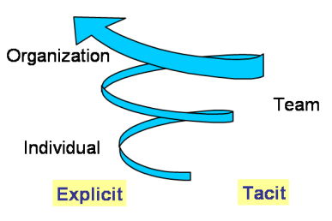
Organizational knowledge is a successor to individual knowledge. The occurrence implies that that for organizational knowledge to exists, individual knowledge must already have been attained through a process called internalization. The process then moves up the knowledge spiral through a process called socialization where individuals undertake dialogue with their organizational teams. After the dialogue, ideas are articulated in a process called externalization, which enables them to become wide spread throughout the whole organization thereby bringing about the concept of combination. As one moves higher up the knowledge spiral, knowledge ceases to be that of an individual and becomes owned by the organization.

