Community Engagement

Assessment 1
Student Name: Elitsa Yankova
Student ID:2030401

Executive summary
This report is based on Race and Ethnic Disparities by the Sewell's commission. Sewell's commission is appropriate and noble. The policies and initiatives are expertly crafted to encourage community involvement among the United Kingdom's ethnic groups. These initiatives, according to the studies, follow a three-part premise with quality criteria. Now is the time to engage the stakeholders and make use of the stakeholder connection to put the programme into action. Related outlets are also meant to encourage foreign migrant culture, and their absorption has made the UK culture a multicultural nation. It has put money into internet safety measures and a social mobility strategy for the future.

Table of Contents
Introduction 4
The body 4
Description and analysis of the project 4
Community engagement principles and standards 4
Benefits of stakeholders’ participation 6
Relationships between stakeholders 6
Strategies to engage stakeholders 7
The utilisation of social media platforms 7
Required Inter-personal skills 9
Relevant avenues 9
Forward-looking approach 10
Conclusion 12
References 13

Introduction
Community engagement refers to the business practices, which involve collaborative working with the people belonging from demographic or geographic proximity and addressing the key issues affecting the respective community. The role of the community practitioner is to provide culturally justified service regarding community engagement towards the relevant group of people. Even in modern days, academic practitioners collaborate with respective communities to influence ecological or social transformation (Arko-Achemfuor et al., 2019). This report is based on a program Commission regarding “Race and Ethnic Disparities” within the UK (“the Commission”), chaired by Dr Tony Sewell, 2022 (gov.uk, 2022). Based on this program, this report will include an analysis of the importance of stakeholder engagement, relationships, relevant avenues and future approaches for the development of these communities within the UK.

The body

Description and analysis of the project
Since 2000, the UK had seen persistent growth within the inward migrating population. It has made the population diverse but the society or treatment of this diverse UK population is still not entirely inclusive. Under the “Inclusive Britain" program Dr Sewell addressed the problems. After the defeat of Euro 2020, in Britain, many discriminatory acts have taken place, which has included assault and vituperate related criminal cases against the minority people. COVID-19 debacle also showed that people from ethnic backgrounds feel unsafe and expressed bad treatment from health practitioners in the UK. These issues influenced the government in appointing the commission under the leadership of Sewell and that has led the panel to compile reports from 9 other panels from various other fields. It becomes the base of "The commission for Race and Ethnic Disparities (2022)”.

Community engagement principles and standards
This program by the UK government is intended to deliver toward community engagement. The commission made some strategies that follow a threefold principle structure and each of them is aligned with traditional principles regarding community engagement principles. These are;
One of the key principles regarding any engagement practice is to plan the program carefully and prepare adequately, According to Hoddinott et al. (2018), planning helps in including the important aspects or stakeholders within the program, which will help make the program transparent and beneficial for the practitioner and helps in keeping the balance of diversity within the programs. Specifically, it helped in clinical trials, as then the results can be aligned with the social status and the provided treatments towards the ethnic people, which can help in addressing the issues and mitigating the dilemmas. In this context, the government would not use any excuse and design the policies which would promote fairness and build inner trust (gov.uk, 2022). This will keep the program standards transparent for the people, who experienced discrimination within the previous policies of the Government.
In the opinion of McMullen et al. (2020), the community engagements practised in the schools, have to be attentive towards designing the programs, which will help in nurturing the existing policies. It can act as a principle of enhancing the impact of the principles. In this case, the panel focused on creating equal opportunities and equality for encouraging aspiration and dismantling the practical challenges and barriers faced by some of the ethnic and minor groups within the UK. This nourishment of policies makes the panel impactful. The standard would be increased due to the intention of this chosen program, regarding developing resilience and support towards the individual and family dynamics, which will be a key to their achievement and success (gov.uk, 2022).
As stated by Luecke et al. (2022), in today's world most impactful principle is to incorporate the scientific reach with the engagement programs, as it will increase the reach of the respective programs. This panel lead commission is also required to be adjusted with the rapidly changing relevant demographics, thus incorporation with social media and utilising technologies like AI would help the commission in planning programs that will reach an extended range of the UK population.

Benefits of stakeholders’ participation
This particular commission is diligent in arranging programs for several fields. Therefore, there are several different stakeholders, associated directly or remotely with the program. This program would be improved with the participation of the stakeholders based on their impact on mitigating racial disparities within the UK. These engagement programs are often utilised for doing research or investigation for navigating further development, so the contribution from the relevant stakeholders helps make the research process explicit and informative, thus the mitigation program becomes more impactful (Adhikari et al., 2020). This commission has utilised previous policies like "Help to Buy" or targeted campaign during the COVID-19 along with successive conservative-led government reviews (10) for gaining stakeholder's participation in implying the policies and it has helped in developing strategies (gov.uk, 2022).

Relationships between stakeholders
This commission is comprised of several areas, which include education, policing, and health. It is important to include every other structural paradigm, in which discrimination can take place. A relational capital helps in increasing the potential impact of the community engagement programs. The theorised connection can influence policy implementation and mutual benefits for the relevant stakeholders (Johnston and Lane, 2018). In this context, the relationship between the government officials and the ethnic population can build a long-lasting partnership. The alliance between the health officials and the government helps in disseminating accurate information to the relevant population. Government officials accountable for the promotion of the policies and the other community influencers have created a bond to update and educate relevant stakeholders as well as respective communities about the policy implementations (fhi360.org, 2022). Transparency between the stakeholders is very important, as it helps in addressing the complex and ever-changing relationship between the stakeholders. Also with the help of community-led research, these relationships can be improved. That is why the ethics and politics regarding the stakeholder relationship must be managed accurately, as it has a direct impact on the efficacy of the community engagement policies and programs (Reynolds and Sariola, 2018).

Strategies to engage stakeholders
There are several approaches regarding stakeholder engagement. The descriptive approach requires the organisation to distinctly identify the stakeholders first and then analyse the direct linkage and remote impacts between them. Every other stakeholder pursues different intentions through their relationship with the respective organisation, thus in a descriptive approach, the intention is to develop programs that will be balanced to deliver mutual benefits to all the stakeholders (biz.libretexts.org, 2020). There are diverse approaches to identifying the channels, media or mediums, which can be considered as a way to reach the stakeholders and engage them to deliver sustainable results (Bellucci et al., 2018). In this context or modern-day social or corporate environment, social media is the best channel or medium to develop a nexus between any number of communities or people. Therefore, Commission and other UK government based programs have used social media channels or digital platforms with the intention of outreaching.

The utilisation of social media platforms
The UK population has over 84% of penetration rate within the popular social media channels. There are around 57 million people from the UK present on social media; all these prove the impact of social media along with its familiarity within the UK (statista.com, 2022). It is utilised by several corporate based business companies along with the UK government for providing relevant information to the respective population. Regarding community engagement, social media becomes a nexus point for propagating important information and conducting data-driven communication (Perreault and Mosconi, 2018). It depends on the content's metrics and strategy too, as that has a direct relationship between the community engagement and behavioural volatility.
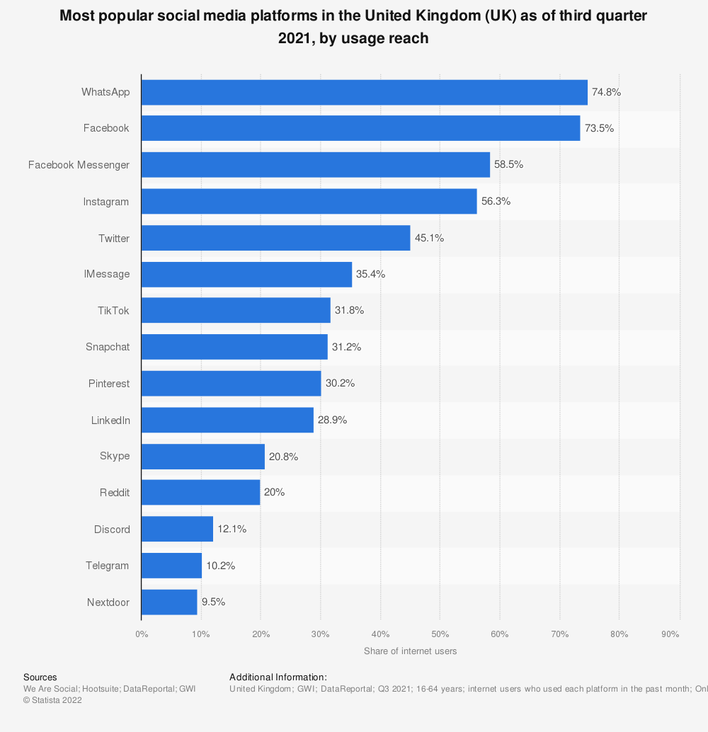
Figure 1: leading social media platform used in the UK
(Source: statista.com, 2021)
Right now Ofcom is the forerunner regarding social media utilisation. It will help in identifying the corporate businesses or individuals practising any racial activity or spreading any racial thought. Upon identification, Ofcom can inflict a bill up to 18 million GBP or can deduct around 10% of the annual turnover from the respective company or 10% of the annual income of the person (gov.uk, 2022). Social media is used to address the failure of the society and government, along with the expected improvement from the policies implied by the commission, including the involvement of the civil society and stakeholders. Also, social media would be the platform for the complaining and any stakeholder can seek action from the government regarding any cyberbullying or racial discrimination and comments.

Required Inter-personal skills
Translation of the community research and incorporation of the information within the policy reforming can help in the implementation and achieving the desired changes within the communication. Interpersonal skills like communication can help with the engagement through different channels, and effective communication can help to listen to the issues the ethnic background people are facing and address or mitigate them accurately.
Creative thinking: Interpersonal skills like emotional intelligence skills have a direct association with creative thinking. This soft skill is privy to stakeholders expressing their feelings creatively (Maisiri et al., 2019). It is required in an extreme sense for these projects, as creativity can help in content creation within social media, which has the potential to garner attention from the larger part of the population.
Professional skills: Interpersonal skills for the stakeholders accountable for implying the strategy helps in acquiring the adequate professional skill for carrying on with the policies implied by the Commission. It includes improvement in the skills like creative content creation, communication and problem solving (van Laar et al., 2020). All these skill opportunities and scope are being used for mitigating the discrimination along with tackling issues reacted transparency. It will help deliver information, which can be easily accessible and easy to interpret.

Relevant avenues
There are certain other regulations, policies, programs and legislation which act as the relevant avenues regarding this program. The Equality act 2006, 2010 helped in developing an independent regulator, "The Equality and Human Rights Commission (EHRC)". This is a vital actor within the civil society of the UK, as it has become a statutory power for the discriminated people to defend their rights and be equal (equalityhumanrights.com, 2022). Based on this legislation and the Commission’s intention the other related avenues are in the form of eliminating some significant racial practise in the UK, along with using these actions as prohibition examples. They are;
- Prevention of a year old racial practice against the Irish people in the holiday home park of the UK
- Government supports a British-Indian couple against an adoption agency, which has refused the service or given a white baby to the couple.
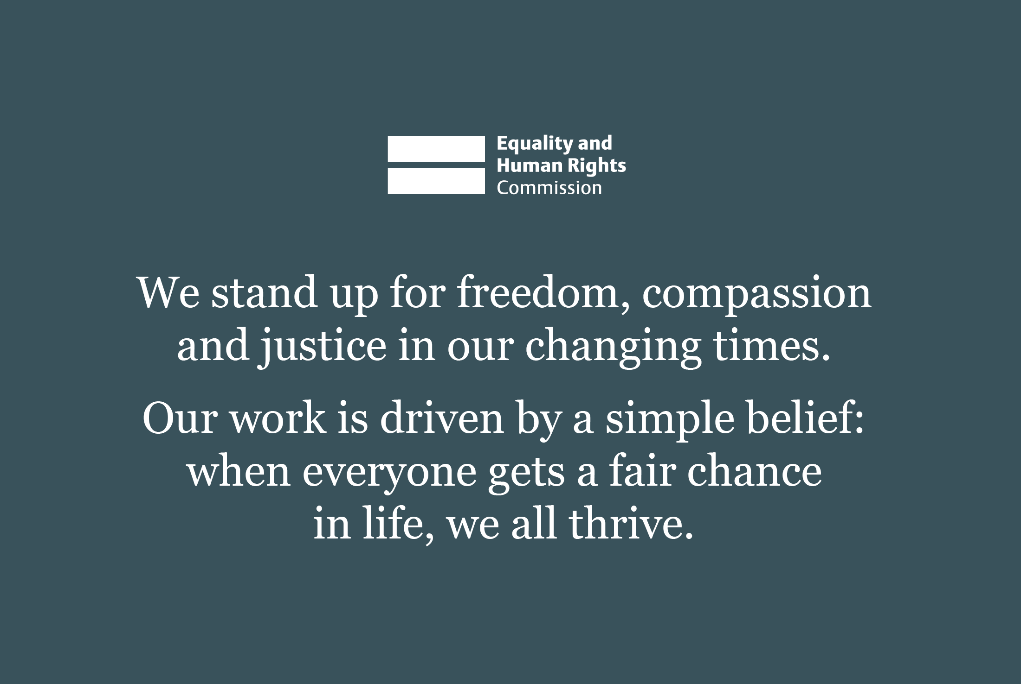
Figure 2: Commitment of the Equality and Human Rights Commission (EHRC) UK
(Source: equalityhumanrights.com, 2022)
These acts help in developing a strong bond between the discriminated population and the government. It assures these people of the government policies and efforts, therefore increasing the receptive community preferences and collaboration (bbc.co.uk, 2022). Racial equality is still a challenge since 1945. Still, the culture and societal structure within the country are integrated with the inward migrating culture. The process of the Socio-culture integration process (SCIP) from several dynamics have forged the music, food, sports, entertainment, arts and business style and practise within the nation and created multiculturalism (uni-goettingen.de, 2022).

Forward-looking approach
Within the external factors, minor communities often experience discrimination in their corporate workplace. To mitigate this, the forward-looking approach would be to educate these communities about the government's intention and the efforts put together by the government. Like Cabinet office has invested over 250,000 GBP towards EHRC for supporting the existing laws and improving the implication of the regulations. Efforts are also been made to reach the people who have a complaint against their workplaces to help them with necessary resources. An online bill for anti-racial safety within social media is also in the process, mainly based on the review provided by the Alan Turing Institute. As for Internal, the government will ban derogatory terms in internal documents like BAME. Regarding COVID-19 government will target these communities for vaccination projects. Social mobility commission would be developed to monitor and support the young ethnic population in the UK. Within education, Black Caribbean people tend to drop out, so civil society practitioners would utilise resources to stop these. At most, the government would use the social media handle to make these programs informative and make sure they reach the needed (gov.uk, 2022).

Conclusion
The commission controlled by Sewell is adequate and very magnanimous. The policies and programs are deftly designed to influence community engagement regarding the ethnic group of people in the UK. Contemporary reports show that these programs follow a threefold principle, which has a quality standard. Now it is important to engage the stakeholders and utilise the stakeholder relationship for practical implementation of the program. Related avenues also are intended to promote the foreign migrating culture and the incorporation of that culture had made the UK culture a multicultural nation. For future purposes, it has invested in online safety bills and social mobility plans.

References
Adhikari, B., Pell, C. and Cheah, P.Y., 2020. Community engagement and ethical global health research. Global Bioethics, 31(1), pp.1-12.
Arko-Achemfuor, A., Romm, N. and Serolong, L., 2019. Academic-practitioner collaboration with communities towards social and ecological transformation. International Journal for Transformative Research, 6(1), pp.1-9.
bbc.co.uk, 2022, Culture and diversity in 20th century Britain [Online] Available at: https://www.bbc.co.uk/bitesize/guides/z9h9ycw/revision/4 [Accessed 12 March 2022]
Bellucci, M., Manetti, G. and Thorne, L., 2018. Stakeholder engagement and sustainability reporting. Routledge.
biz.libretexts.org, 2020, Weighing Stakeholder Claims [Online] Available at: https://biz.libretexts.org/Bookshelves/Business/Business_Ethics/Book%3A_Business_Ethics_(OpenStax)/03%3A_Defining_and_Prioritizing_Stakeholders/3.03%3A_Weighing_Stakeholder_Claims[Accessed 12 March 2022]
equalityhumanrights.com, 2022, About us [Online] Available at: https://www.equalityhumanrights.com/en/about-us[Accessed 12 March 2022]
fhi360.org, 2022, Engage Stakeholders and Sustain Relationships [Online] Available at: https://www.fhi360.org/sites/default/files/webpages/se-toolkit/SE_Toolkit_and_Steps_PDF_files/Stakeholder_Engagement_Toolkit-Step_6.pdf [Accessed 12 March 2022]
gov.uk, 2022, Inclusive Britain: government response to the Commission on Race and Ethnic Disparities [Online] Available at: https://www.gov.uk/government/publications/inclusive-britainaction-plan-government-response-to-the-commission-on-race-and-ethnic-disparities/inclusive-britain-government-response-to-the-commission-on-race-and-ethnic-disparities[Accessed 12 March 2022]
Hoddinott, G., Staples, S., Brown, R., Simwinga, M., Mubekapi-Musadaidzwa, C., Hesseling, A.C., Hendricks, G., De Koker, P. and McKenna, L., 2018. Community engagement for paediatric MDR-TB clinical trials: principles to support ethical trial implementation. The International Journal of Tuberculosis and Lung Disease, 22(5), pp.S40-S45.
Johnston, K.A. and Lane, A.B., 2018. Building relational capital: The contribution of episodic and relational community engagement. Public Relations Review, 44(5), pp.633-644.
Luecke, S., Schiffman, A., Singh, A., Huang, H. and Wilder, C., 2022. Four guiding principles for effective trainee-led STEM community engagement through high school outreach.
Maisiri, W., Darwish, H. and Van Dyk, L., 2019. An investigation of Industry 4.0 skills requirements. South African Journal of Industrial Engineering, 30(3), pp.90-105.
McMullen, J.M., George, M., Ingman, B.C., Pulling Kuhn, A., Graham, D.J. and Carson, R.L., 2020. A systematic review of community engagement outcomes research in school‐based health interventions. Journal of School Health, 90(12), pp.985-994.
Perreault, M.C. and Mosconi, E., 2018, January. Social media engagement: Content strategy and metrics research opportunities. In Proceedings of the 51st Hawaii International Conference on System Sciences.
Reynolds, L. and Sariola, S., 2018. The ethics and politics of community engagement in global health research. Critical Public Health, 28(3), pp.257-268.
statista.com, 2021, UK: leading social networks by usage reach 2021 [Online] Available at: https://www.statista.com/graphic/1/284506/united-kingdom-social-network-penetration.jpg [Accessed 12 March 2022]
statista.com, 2022, Active social media users in the United Kingdom (UK) 2022 [Online] Available at: https://www.statista.com/statistics/507405/uk-active-social-media-and-mobile-social-media-users/#:~:text=The%20United%20Kingdom%20(UK)%20was,the%20population%20of%20the%20UK. [Accessed 12 March 2022]
statista.com, 2022, Active social media users in the United Kingdom (UK) 2022 [Online] Available at: https://www.statista.com/statistics/507405/uk-active-social-media-and-mobile-social-media-users/#:~:text=The%20United%20Kingdom%20(UK)%20was,the%20population%20of%20the%20UK. [Accessed 12 March 2022]
uni-goettingen.de, 2022, Causes and Consequences of Socio-Cultural Integration Processes among New Immigrants in Europe (Info) [Online] Available at: https://uni-goettingen.de/de/153336.html[Accessed 12 March 2022]
van Laar, E., van Deursen, A.J., van Dijk, J.A. and de Haan, J., 2020. Determinants of 21st-century skills and 21st-century digital skills for workers: A systematic literature review. Sage Open, 10(1), p.2158244019900176.

