Children and Young People in Focus
Assessment 1 – Practice Log

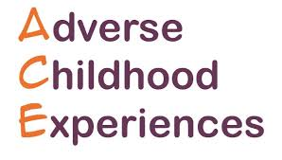
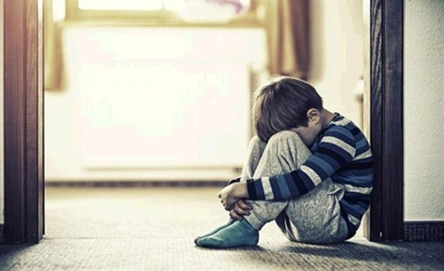
(School Improvement Liverpool, 2018)
(ACEs) impacting on the children in Wales

Introduction
You will often hear the mention of ACEs within many educational establishments, and within many Welsh areas of deprivation, as poverty is thought to be connected to ACEs (Lloyd, 2018). This is a fundamental issue for schools to tackle, often with the prospect of having to incorporate strategies such as Nurture groups to accommodate the fallout from the destructive behaviour that ACEs can cause. Nurture groups are small classroom spaces for small groups of children who struggle to maintain their behaviour within mainstream classes (Ofsted, 2011). Children with one or more ACE are often associated with low self-esteem, erratic behaviour, and dysfunctional families.

What are ACEs?
ACEs are adverse childhood experiences which are made up of a series of events that a child has been exposed to growing up (Parliament UK, 2018).These events or experiences consist of child abuse, child neglect, poor parental governance, addictions amongst family members, mental health issues, domestic violence (Ace Aware Wales, 2020). The following paragraph will give a definition of child abuse, which is an ACE.
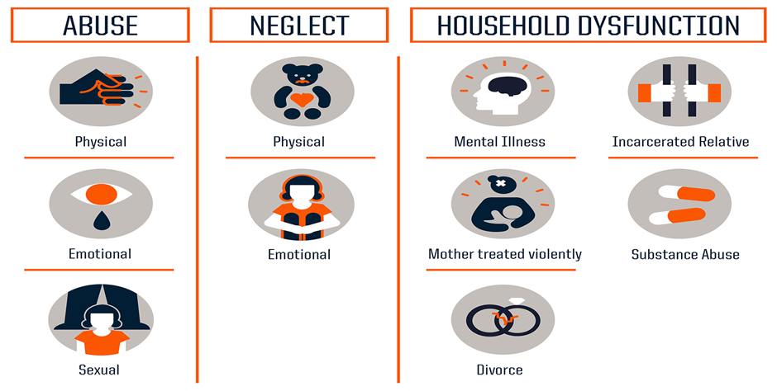
(Centres for Disease, Control, and Prevention, 2019)

Defining child abuse
Child abuse can be defined as “any recent act or failure to act on the part of a parent or caretaker which results in death, serious physical or emotional harm, sexual abuse or exploitation, or an act or failure to act which presents an imminent risk of serious harm” (National Child Abuse and Neglect Training and Publications Project 2014). In retrospect, any intentional behaviour towards a child that is damaging or harmful, physically, sexually or emotionally, as parents and caregivers are fundamentally responsible for the wellbeing and safety of the child that they are deemed responsible for by right (NSPCC, 2020). Therefore, accountable, in every aspect, until the child is deemed responsible for themselves in the eyes of the law.
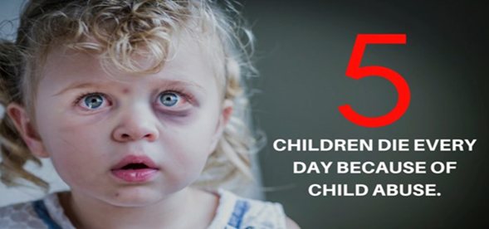

When is a child not a child according to the Law?
In England and Wales, when a child reaches the age of sixteen, they are considered to be free of parental control. However, this could be subjective due to the individual. Although children at the age of sixteen are allowed to leave school, live independently, have sex, procreate, marry a partner, become employed, be expected to pay tax, and also become a member of the forces. There are still some things such as purchase cigarettes, alcohol or take a vote that you cannot do until you are eighteen ( Full fact .Org, 2018). However, in the eyes of the UN Convention on the Rights of a Child United Nations Human Rights, (2020) and the Children Act 1989 Legislation, Gov.UK, (2020) you are considered to be a child until you reach the age of eighteen. This is quite subjective, considering children mature at different rates. Therefore, could create an issue for individuals who feel restricted and governed when they feel able to undertake actions governed by the ruling age of eighteen, although, they have not reached the age. Therefore, resulting in some individuals going against the law and participating in these actions whilst underage. This factor also links to the following paragraph, as already defining a child for some individuals becomes subjective, therefore, many children will get caught up in adopting unhealthy making decisions along with behaviours.

Linking Poverty to Child Abuse
Stats Wales, (2019) recorded 2960 children on the child protection register for different forms of abuse, by age and gender. This signifies how prolific child abuse is within today’s society of poverty, wealth, and inequalities. As child abuse is considered to be linked to poverty, there is just cause for considering Williams, (2007) theory, which is by removing child poverty within the United Kingdom, deaths of around 1400 children from fifteen years and under could be prevented every year. These statistics surely point to the Government for accountability. With the recent plights of the introduction of the new Universal Credits benefits system, highlighting how failure by the Government to implement a system that doesn’t have such consequential outcomes for claimants, surely identifies the need for a fairer system for those living in poverty (Greenwood, 2019). The Universal Credits system combines all benefits under one umbrella, which is ultimately causing some families tremendous pressure (Butler, 2020). Reason being is that the system is delayed, consequently not only failing to pay families for one particular claim but also impacting on other claims due to the combination of the Universal Credit award (Usdaw, 2019). Poverty, inequality, social deprivation is all considered to be linked to Child abuse (Joseph Rowntree Foundation, 2016). Consequently, highlighting the link to influencing factors that can be found from some perpetrators. Furthermore, with families using food banks to subsidise their income, this could also be linked to neglect, as previously highlighted as a form of neglect is failing to meet your child child’s basic needs such as adequately feeding them (Human rights watch, 2020). Article 24 of the (UNCRC) United Nations Conventions Rights Child state that it is a child’s right to be provided with nutritional food that will help them to stay healthy (UNICEF, 2020). This highlights the definitive need to address poverty issues, which also signifies the link to other factors such as Government failings, policies and legislation brought into play, to address factors that try and protect the vulnerable, and yet children are still suffering from ACEs and going hungry. Surely this is contradictory within itself? These factors also highlight how children get caught up in serious situations along with adopting unhealthy lifestyle choices when they can see no way out of their lifestyle and situation.
Please see the paragraph below defining child neglect.
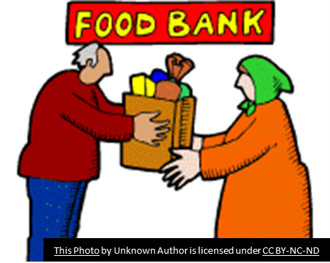

Define child neglect
Social Services and Wellbeing Wales Act (2014) state that child neglect can be defined as failure to look after a child’s welfare, wellbeing and needs. Parental or caregivers’ governance is to keep them healthy, happy, and safe. In comparison, GOV.UK, (2014) give their definition as.
“Neglect means the failure to meet a person’s basic physical, emotional, social or psychological needs, likely to result in the impairment of their health, wellbeing or development”.
These interpretations could be up for dispute with some family members who have different values, morals, and scruples in regard to their child’s wellbeing, albeit through lack of understanding and education (Helpguide.Org, 2019).



Implications of Child Neglect
The picture below significantly shows the effects of neglect on a child’s brain through neglectful treatment. Consequently, providing a visual display that surely resonates the prolific effect of sensory neglect.
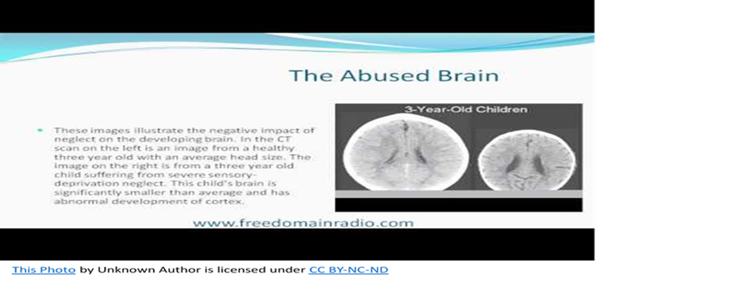
This means that a child is not developing along the same line of expected development through lack of interaction from parents or caregivers, hence when their needs are not met (Perry, 2002). When children have failed to form an attachment or bond with their mother or caregiver, from early years, which provides a harmonious comfort to both parties, the result can be detrimental to the young child, often resulting in serious mental issues within their development. This was the theory of John Bowlby the famous psychologist who developed the attachment theory in the 1950’s (Kirkbride, 2018).
Working with young children, in a school residing in an area of deprivation, there could often be children within the classroom who had delayed global abilities, often through very little interaction from parents or caregivers. Significant factors were, children were unable to interact with others, delayed speech, unable to do the basic of personal tasks for themselves, often portraying a vague look, and a lack of understanding, of the basic requests within the classroom (The Institute of Medicine and National Research Council, (2014). This also shows the link for some children who are brought up in impoverished areas, consequently resulting in one, two or more ACEs, with parents or caregivers displaying problems of their own, such as, addictions, depression, or detachment. The following paragraph will provide a definition of household dysfunction, which can also play a part in sensory neglect, as when a household is split or dysfunctional, children are often not at the forefront of priorities for some parents.

Defining household dysfunction
Household dysfunction can be defined as a family unit that is broken, in constant conflict with each other and unstable (Ubaidi, 2017). Furthermore, there can be signs of abuse and or neglect towards the younger members of the family. Hence childhood abuse and neglect. There is often signs of addictive behaviours with family members, such as, alcohol, drugs, food, along with poor mental health which is often not addressed and left untreated (Helpguide.Org, 2019). Consequently, contributing to the abuse and neglectful behaviour (King University, 2017). This also points back towards the social conditions in which the family live, as although household dysfunction points back to low socioeconomic status, there are also situations where affluent families are experiencing household dysfunction. Please see the paragraph below, which exposes the issue of ACEs in Wales.
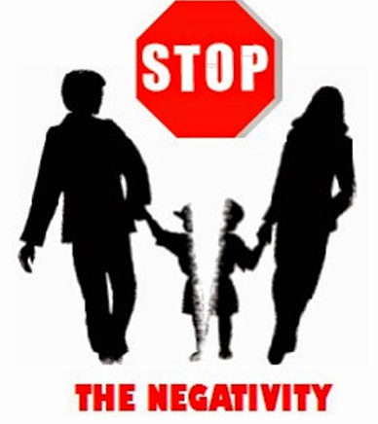

Statistics and Background Information
ACEs has impacted the Welsh population greatly. NHS, Wales (2015) state that 47 of every 100 adults in Wales have been exposed and suffered from more than one ACE growing up. Additionally, 14 have experienced 4 or more ACE’s during their early life stage. Evidence suggests, according to Children in Wales, (2014) that exposure to ACEs can greatly affect health in later life along with mental wellbeing (Hughes et al, 2017). Furthermore, individuals are more likely to adopt health harming behaviours and make ill-informed decisions (Hughes, Bellis, Hardcastle, Sethi et al, 2017). These factors can cause major implications for educational establishments throughout. With children entering education displaying many symptoms of ACEs, such as behavioural issues, poor communication and social skills, poor physical and mental health, lack of concentration and delayed development (Smith, 2018). When children are displaying more than one ACE symptom, the challenge for the educational provider becomes difficult.
There is also increasing evidence to say that children who have experienced ACEs are more likely to repeat behaviours that they have observed and learnt from parents and caregivers (Buss et al, 2017). Therefore, highlighting the major impact on the Welsh population that could be considered due to the economic climate and unfair society that we live in. The paragraph below will give an indication to the practices that are being put into place to address the ACEs issue in Wales.

What are Wales doing to tackle ACE’s?
Policy and practice had to be changed and implemented in order to address the ACEs issue and was quickly carried out through the introduction of The Wellbeing of Future Generations Wales Act (2015) (Future Generations Commissioner of Wales, 2020). This act has given responsibility to the public bodies in Wales to address issues such as climate change, diversity, cultural inclusion, poverty, inequalities in health and general responsibility required to ensure that any changes that are made are for the benefit of Welsh residents currently and in the future. The act looks to make Wales a globally responsible and fairer place to live, with a chance to live in a healthier environment, friendly place, along with providing beneficial opportunities to residents (Swansea Gov, 2019). Consequently, with the notion that everyone can grow and prosper within Wales cultured environment (GOV. Wales, 2019). In addition to this, we have made Wales an ACE Aware Wales. This is from publicly informing public bodies, such as police, schools, hospitals, fire services, social services, doctor surgeries of the possible issues that could be affecting a child that might come within their service (Public health Wales, 2020). Forewarned is forearmed, with the theory that prevention is better than cure. The Children’s Commissioner in Wales has reminded everyone of the fundamental aspects of a child’s development, which are children’s rights (Child Com Wales, 2020).These all link to ACEs and should be duly respected and incorporated by all who are responsible for children and young people. Children’s rights were incorporated by the UNCRC for a fundamental reason. The safety, wellbeing, good health and right that each child has whilst they are not deemed old enough or responsible enough to take care of themselves (Save the Children.Org, 2019).
The United Nations Conventions on the Rights of the Child state that all children should have the right to be the best that they can be. In 2019,181 countries across the world had ratified the United Nations “rights of the child” (Kids Rights Index, 2020).
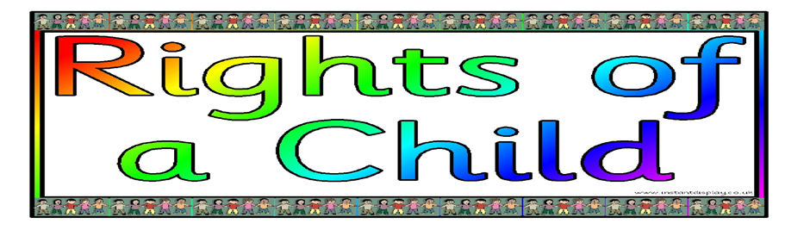
“Right to be happy, healthy and safe”
- “Article 6 - Right to life and to grow up to be healthy”.
- “Article 19 - Right not be harmed and to be looked after and kept safe”.
- “Article 26 - Right to financial support”.
- “Article 28 - Right to learn and go to school”.
(NSPCC, 2016)
The above articles are fundamental to the development of a child’s growth, health, and wellbeing, however, although the articles are straight forward and clear, many individuals, such as parents, often do not abide by the UNCCRC governance for children. This could be through lack of education or simply non-compliant attitude. All children have a right to a life that can be the best that it can be.
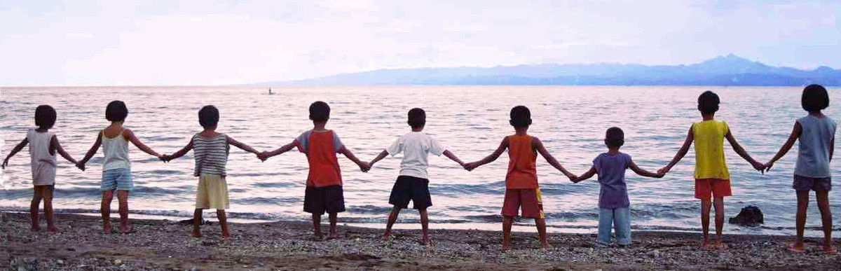
Although children’s rights have a clear mandate, culturally, children’s rights differ for many individuals, within many families and countries (Open education, 2020). This is because children are regarded differently within some countries, with religion playing a part. Furthermore, culturally, the age of consent, expectations of a child, along with family traits can all factor in to how some children might not be privy to the same rights as other children due to factors mentioned. The UK have all incorporated Children’s rights within their schools, with schools being right respecting. This informs children duly, of their rights, along with the school operating on a rights respecting directive. This is provided by what the children feel is their right, along with the UNCRC 44 articles on the rights of the child (Jerome, 2016). The children are made to feel within their educational pathway as part of the rights respecting directive. Therefore, they play a part in deciding what is important for them within their school, their development, their education, and wellbeing. This is fundamental to children feeling that they have a voice, an opinion, which is respected, allowed, and considered. Consequently, acted on and incorporated into their everyday educational experience. Schools have incorporated children’s rights into their ethos, policy, and practice, to ensure that all children feel equal, have a place within society and are informed of rights, as part of feeling fundamental to society.

Impacts on Children
ACEs can greatly influence a child or young person’s health and wellbeing, drastically affecting their education, behaviour, and persona (Virginia Commonwealth University, 2015). Although statistics point to low socio-economic status and deprivation influencing the ACEs issue, governments continue to put pressure on working families with stringent measures, penalties, and tax brackets (Butler, 2018). These issues can be the trigger factors that can influence behaviours and push individuals to make poor ill-informed choices because of the pressure they are under (Lewer et al, 2019). These choices could range from using narcotics, excessive intake of alcohol, which can in turn influence decision making and alter people’s behaviour. Other factors to consider are; when children grow up experiencing ACEs, they can then repeat the same process with their own children and family (Allen and Donkin, 2015). Learned behaviour is common practice for children to demonstrate at a later life stage, as according to Bandura, (1977), social learning is how young children learn, emotionally, through communication and modelling behaviour. Therefore, observing and witnessing aggressive, abusive violent behaviour could become the norm for some young children, with the prevalence of addictive behaviours also transferable, as the same concept applies to children living in a household where narcotics and alcohol are perceived as the norm (Bandura, 1986). They can in turn, practice the same behaviour and make the same ill-informed choice as their parents or caregivers. This leads on to the next section highlighting, The Social Determinants of Health.

Theories and Practice
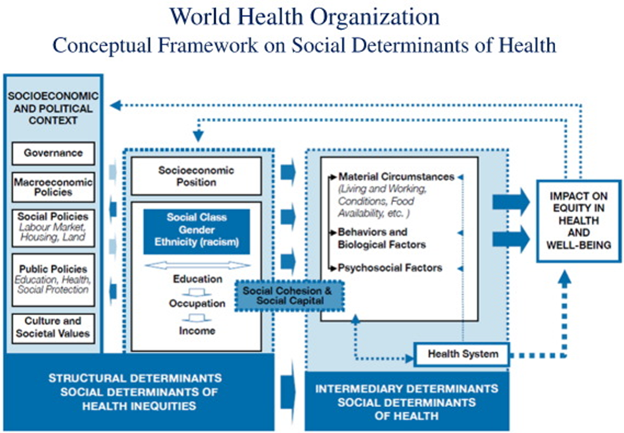

(World Health Organisation, 2019)

The Social Determinants of Health can play a big part in influencing children and young people’s health (World Health Organisation, 2008). This is because the conditions in which a child is born into and grow up in, can significantly influence a child’s health and wellbeing. Progressively affecting them as they develop. With elements such as working conditions, social class, education, and standard of living influencing health and wellbeing (Green and Tones, 2010).This identifies how ACEs can be linked to the Social Determinants of Health, as the factors highlighted have been identified as being influential to an individual experiencing ACEs. This is because low socio-economic conditions signify poor health related behaviours such as, mental health issues, addictive behaviours, abuse and neglect and many other factors (The Health Foundation, 2018). These factors point towards Government accountability to a degree, reason being is, austerity is predicted through Government leadership, policies and practices changing with each new leader put into govern, along with higher tax brackets, benefits cut and new initiatives brought in, which ultimately, can prove to be negative forces within families instead of positive enhancements. Crucially, providing increased pressure and stringent measures on individuals and families. This argument was crucially pinpointed by Marmot, (2005) who stated the urgency of levelling the playing field and the redistribution of wealth, in turn to tackle healthy inequality (Graham and Kelly, 2004). Measures taking by governments over the decades have failed to address this issue effectively enough. Through this, ACE’s have resulted amongst many Welsh children, with schools experiencing a high number of children suffering with ACEs. The Health Foundation (2019a) point out that at least half of the United Kingdom population have experienced one ace or more. Because of this, tackling ACEs has become a crucial part of recent Government agenda. Because ACEs has such a significant all-round effect on children’s wellbeing, education, health and later life experience, programmes are being introduced to inform people and introduce change. Therefore, fundamentally pointing to The Heath Foundation (2019b) who have selected five projects to focus new funding on and develop programmes. These programmes are, “Creating Ace Informed Places” which means that ACEs will be tackled throughout, with a focus on preventing ACEs and ensuring ACEs are addressed fundamentally early on, which can alter outcomes for individuals who are prime targets.

Ability to Form Relationships
When individuals have experienced ACEs, there is a general consensus along with evidence to show that building relationships or forming bonds can prove difficult. As mentioned previously, Bowlby, (1973) states that children who have been separated from their parents or caregivers, are from a family that has provided poor parenting, along with exposing children to fragmented relationships, along with failing to respond to a child’s needs, evidently, shows due cause for further difficulties with the child repeating the same actions through the development of their own self (Grady, Levenson, and Bolder, 2017). Gingerbread, (2019) point out that there are around 1,8 million single parent families within the United Kingdom. Just under 1% of these are teenagers. The majority of single parents are women, recorded at around 90%. Furthermore, the average age of a single parent has been recorded as 39 years of age. From these statistics you can already form an assumption into what complications could arise from pressures of age, both young and old, split families with only one co-dependent, which highlights the pressures of being the only caregiver with no support or respite.


The Ace Quiz
To identify if you have been exposed to ACEs or are currently experiencing ACEs there is a test that will generate your scores after answering a series of questions pointing to the ACEs issue. NPR (2015) state that when an individual has a high score of ACEs, it can indicate that they have been exposed to a turbulent background, therefore significantly influencing healthier life expectancy for future years. This test could prove to be a basic guideline and form of support for someone who is to embarrassed or frightened to access help from outside parties. Therefore, it could provide a starting point for individuals who need it.
It is crucial to note that the ACE score is just a guidance to an individual possibly being exposed to certain elements or factors that might affect their wellbeing and health. It does not hold the answers to ACEs factors.

Please find the link below to take the test.
https://www.npr.org/sections/health-shots/2015/03/02/387007941/take-the-ace-quiz-and-learn-what-it-does-and-doesnt-mean

Response as a Practitioner
With the issues of children suffering from poor concentration, behavioural issues, social skills, developmental delay, trusting issues and lack of understanding, which can be linked to adverse childhood experiences. Finding a balance that can allow a child to feel safe within the school environment can be challenging. To factor in the other class peers, the onassis is on the practitioner to provide a learning environment that will develop the child and allow them to feel safe and comfortable within their learning environment, additionally, allow them to form relationships which they might find difficult within the mainstream classroom on a daily basis.
Nurture Groups:
An initiative that is implemented by some schools are the nurture groups that help children who are suffering with ACEs to cope with school environment. These groups are made up of small sizes and can help children to focus, turn take, share, and sit for longer periods of time without displaying emotional outbursts. Nurture groups are an excellent way for children to feel safe, trust and develop within their own emotional self. Consequently, children are able to carry out small learning tasks such as creative activities that can help them to display their abilities through, drawing, singing, storytelling, cooking and make friends through developing trusting skills. Nurture groups provide learning spaces that children can feel relaxed in, safe which is paramount to their wellbeing and development along with developing social learning skills that are modelled by the teaching practitioners. In many mainstream classes, children can often feel intimidated and lost amongst the rest of the children, the confidence to participate within classroom activities or engage with others can sometimes feel too much for children who have experienced ACEs (The Nurture group Network, 2016a). The benefit of the nurture groups is the size of the groups, being with likeminded individuals, forming friendships and building relationships. Their theory philosophy is based around attachment. Therefore, mindful that the children within these groups have difficulties with, social, emotional, and behavioural difficulties. These nurture groups first originated in Hackney, South London, more than four decades ago. (The Nurture Group Network, 2016b). They have proved fundamental within some areas, proving their worth, with more than 2,000 nurture groups throughout nursery, primary and secondary education establishments in the United Kingdom.
Boxall Profile: Practice
Children are assessed carefully for the nurture groups, using the Boxall Profile. This is a resource that helps educators to pinpoint children’s emotional and behavioural difficulties. Furthermore, put into place interventions that should effectively support their learning and behavioural issues through strategies that can match the framework of the Boxall profile of each child (The Boxall Profile, 2020). Therefore, matching strategies to each goal for each child, which can then be in accordance with the Boxall Profile framework. Although, it appears that each child is being micromanaged for each goal, some of these children have experienced such adverse childhood experiences, which have impacted significantly on their behaviour. The Boxall framework allows children to develop at their own pace instead of through mainstream continuous assessment. Therefore, the child might feel less pressurised to be at the same level as their class peers, also be able to share more with likeminded individuals who have experienced the same issues as themselves. With the expectations for each child be milestones that they are meeting through a nurturing, supporting environment.

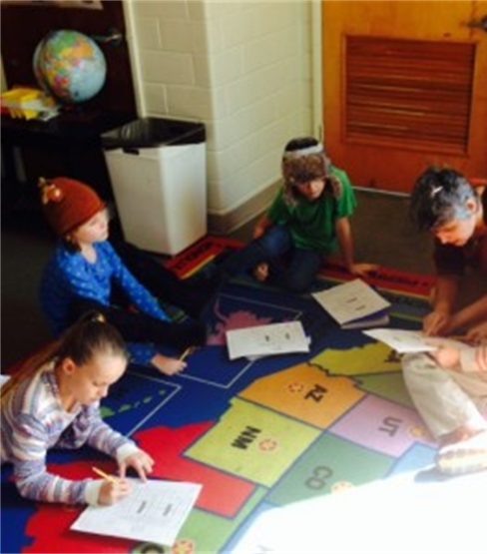
The benefits of nurture groups are:
Personal development, behaviour, and welfare.
● Pupil behaviour improved during school time (Cooper & Tiknaz, 2005) and continued when pupils were in their home environment (Binnie and Allen, 2008).
● Pupil attendance improved (Sanders, 2008), along with less children being excluded (Cooper el, 2001).
● Nurture groups have improved the relationships and bonds with teachers, children, and the school community. Consequently, helping everyone to improve on their relationship and bonding skills (Cooper and Whitebread, 2007). With the ethos that the schools should build attachments to the community (Walker, 2010).
● Improvements long term on children’s mental health and their resilience in copying with mental health issues. Over time, controlled studies have established that children who attend nurture groups are significantly more likely to have improved mental health, along with developing their social and emotional skills, which would have long-term mental health improvements and resiliency (O’Connor and Colwell, 2002) Controlled studies have concluded that students with social, emotional and behavioural difficulties are significantly more likely to improve socially and emotionally through the nurture group provision (Cole, 2015).
With nurture groups producing encouraging findings on pupil participation, improved intervention, and social, emotional, and behavioural difficulties within these groups. Surely the evidence speaks for itself in that it is positive, it is cost effective, as schools as estimated the cost to be around 10,000 to set up. It has also been highlighted that schools can set out to do this through the Pupil Deprivation Grant, which can therefore, be accountable for the nurturing provision set up. This initiative and provision suggest that all children, whether they may be from a disadvantaged background, have experienced one or more ACE or is experiencing anxiety within the mainstream classroom, gets an equal chance at education and class educational attainment. Providing this nurturing experience can enable the child to develop within an environment that they might not be used to, consequently allowing them to adapt and grow at their own pace. Which can surely only be for the benefit of the child and not the levels that they would be expected to meet whilst under such duress and stress.

How are Public Services Responding to the ACEs issue?
Public services such as the police and social housing associations are working together to share vital information. Navarra, (2018a) highlights the significance of forming hubs and drop-in centres for public bodies to work together. Fundamentally, preventing issues occurring instead of resolving issues that have already occurred. These centres provide an escape root, a first port of call and a helpline for individuals who need reactive help there and then. Thus, for some individuals this could suggest a turnaround of events happening for them. Hence having someone to talk to and someone to share their issues with. Partnership working has already been deemed as the way forward to tackling issues within communities, families, and social services (Glasby and Dickinson, 2014). When public services work together, join communities, and link the relevant authorities with the relevant issues. ACEs could significantly improve within society for children. These services reflect on their practice collectively, essentially, providing a more unified approach to tackling ACEs. The way they are working signifies the incorporation of the Wellbeing of Future Generations Act 2015. In that they are forming cohesive communities, trying to improve the Wales we want for future generations, providing a safe, happy, and resilient environment, currently and in the future (Navarra, 2018b). The UK government has recognised the significance of promoting shared partnership in communities, to enable cohesive partnerships which will provide resilient strategies to tackle ACEs within the communities, albeit through the different key partners – including the police, public health professionals, health care professionals and children’s social services (The Health Foundation, 2020c).

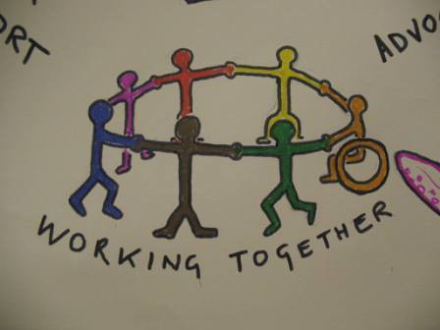
Welsh Women’s Aid, (2016) who are a national charity service have identified a number of different factors that could prevent ACE’s in children. This is through initiatives such as training public sector staff, alongside providing access and a clear pathway for referral to specialist services. One of their proposed initiatives is that the “New public sector duties within the Violence against Women, Domestic Abuse and Sexual Violence (Wales) Act 2015”, is to make mandatory that public sector professionals including health professionals directly enquire, when felt needed, using a technique called ‘Ask and Act’ (Welsh Government, 2016). This proposal clearly highlights the significance of early intervention for children and families, which can then alter outcomes for children along with their living conditions and lifestyle. If individuals feel that they can turn to someone, many situations could be altered before they are escalated, therefore causing serious harm or in some cases death.

Findings:

There is still considerable work to be done, in order to reduce the number of children who experience ACE’s. However, until fundamental factors such as inequalities, education, poverty, housing and government policy and practice is improved, ACE’s will still factor heavily amongst children. Austerity has been heavily promoted by government parties. However, none brave enough to tackle the ramifications left from the last governed party. Therefore, the outlook for ACE’s does appear to be bleak, although there is some light at the end of the tunnel, with the Wellbeing of Future Generations Wales act 2015, heavily promoted throughout Wales public bodies and their policy and practice. This beacon could go a long way to tackling ACE’s if all public bodies work together and adhere to the sustainable principle directive. The current and future generations of Wales have a right to an equal, happy, healthy life, which if full of opportunity and prosperity. Therefore, if government policy acts quickly, along with education and support improving, the forecast for our children and young people could significantly improve. These culminations could endeavour to improve ACEs considerably.

Recommendations
- Training needs to be provided within schools, for all staff to spot signs and signals of a possible pupil who is experiencing ACEs.
- Provide areas of quiet and calm for children to take time out when they are feeling overwhelmed by their issues.
- Schools should develop sound relationships with parents, so that parents can feel they can share any issues or concerns with them.
- Schools should also build sound relationships with services that are involved with families, to ensure information is shared. Therefore, families are supported holistically, and no information is lost or miscommunicated.
- All schools should set up an ACE aware hub to communicate with all staff.
- Children should be made to feel safe, along with having a trusted advisory support network within school when needed.
- All children should be made aware in school of an ACEs support network within their school.
- All schools should know their children, know their circumstances, ask questions, and encourage children and families to share their issues.
- At no point should children or families be made to feel stigmatised or embarrassed.

References
Ace Aware Wales, (2020). Ace Aware. Available at: https://www.aceawarewales.com/be-ace-aware (Accessed 31st January 2020)
Allen, M. and Donkin, A. (2015). The impact of adverse experiences in the home on the health of children and young people, and inequalities in prevalence and effects. Available at: www.instituteofhealthequity.org/resources-reports/the-impact-of... ·. (Accessed 4th March 2020)
Bandura, A. (1977). Social Learning Theory. New York: General Learning Press
Bandura, A. (1986). Social Foundations of Thought and Action. Englewood Cliffs, NJ: Prentice-Hall
Binnie, L., and K. Allen (2008) Whole school support for vulnerable children: The evaluation of a part-time nurture group. Emotional and Behavioural Difficulties. 13 (3). p 201–16
Buss C et al. (2017). “Intergenerational Transmission of maternal Childhood Maltreatment Exposure: Implications for Fetal Brain Development.” Journal of the American Academy of Child and Adolescent Psychiatry. 56 (5). p 373-382
Butler, P. (2018) Universal credit to save taxpayers only 2% in spite of benefit cuts. The Guardian, Thursday 25th January 2018. Available at: https://www.theguardian.com/society/2018/jan/25/universal-credit-taxpayers-benefits-cuts (Accessed 4th March 2020)
Butler, P. (2020) Universal credit linked to rise in psychological stress, study finds. The Guardian, Thursday 27th February 2020. Available at: https://www.theguardian.com/society/2020/feb/27/universal-credit-linked-psychological-stress-increase-study-benefits-uk (Accessed 2nd March 2020)
Centres for Disease Control and Prevention, (2019) Adverse Childhood Experiences Resources. Available at: https://www.cdc.gov/violenceprevention/childabuseandneglect/acestudy/resources.html (Accessed 31st January 2020)
Children’s Commissioner for Wales, (2020) A Children’s Rights Approach to Education in Wales. Available at: https://www.childcomwales.org.uk/resources/childrens-rights-approach/childrens-rights-approach-education-wales/ (Accessed 3rd March 2020)
Children in Wales, (2014) Adverse Childhood Experience (ACE) Available at: http://www.childreninwales.org.uk/item/adverse-childhood-experience-ace/ (Accessed 31st January 2020)
Cole, T. (2015). University of Oxford: Mental Health Difficulties and Children at Risk of Exclusion from Schools in England. A review from an educational perspective of policy, practice and research, 1997 to 2015’. Available at: http://www.education.ox.ac.uk/wordpress/wp-content/uploads/2015/02/MENTAL-HEALTH-AND-EXCLUSION-FINAL-DIGITAL-13-06-15.pdf (Accessed 1st March 2020)
Cooper et al (2001). The effectiveness of nurture groups: preliminary research findings. British journal of Special Education. 28 (4). p160-166
Cooper, P. and Tiknaz, Y. (2005). Progress and challenge in Nurture Groups: evidence from three case studies. British Journal of Special Education. 32 (4).p 211–222
Cooper, P. and Whitebread, D. (2007). The Effectiveness of Nurture Groups: Evidence from a National Research Study. Emotional and Behavioural Difficulties, 12 (3). p171-190
Full Fact. Org, (2018) How sweet is sixteen? Legal age limits in England and Wales. Available at: https://fullfact.org/law/legal-age-limits/. (Accessed 5th March 2020)
Future Generations Commissioner of Wales, (2020) Well-Being of Future Generations Wales Act (2015) available at: https://futuregenerations.wales/about-us/future-generations-act/ (Accessed 5th February 2020)
Gingerbread, (2019) Single parents: facts and figures. Available at: https://www.gingerbread.org.uk/what-we-do/media-centre/single-parents-facts-figures/ (Accessed 1st April 2020)
Glasby, J. and Dickinson, H. (2014) Partnership working in health and social care. Bristol: Policy Press
Graham, H. and Kelly, M. (2004) Health Inequalities: Concepts, Frameworks and Policy. London: Health development Agency
GOV.UK, (2014) Social Services and Wellbeing Wales Act 2014. Available at: http://www.legislation.gov.uk/anaw/2014/4/contents. (Accessed 21st February 2020)
GOV. Wales, (2019) Well-being of Future Generations (Wales) Act 2015: guidance. Available at: https://gov.wales/well-being-future-generations-wales-act-2015-guidance (Accessed 6th February 2020)
Grady, M. Levenson, J. and Bolder, T. (2017) Linking Adverse Childhood Effects and Attachment: A Theory of Etiology for Sexual Offending. Impacts on Education. 18 (4). p 433-444
Green, J and Tones, K. (2010) Health Promotion. 2nd Edition. London: Sage Publications Ltd
Greenwood, M. (2019) Universal Credit has destroyed people’s lives – it’s time to scrap it. Available at: https://labourlist.org/2019/09/universal-credit-has-destroyed-peoples-lives-its-time-to-scrap-it/ (Accessed 26th February 2020)
Helpguide.Org, (2019) Child Abuse and Neglect. Available at: https://www.helpguide.org/articles/abuse/child-abuse-and-neglect.htm (Accessed 3rd March 2020)
Helpguide.Org, (2019) Substance Abuse and Mental Health Issues. Available at: https://www.helpguide.org/articles/addictions/substance-abuse-and-mental-health.htm (Accessed 3rd March 2020)
Hughes, K, Bellis, M, Hardcastle, K, Sethi, D, et al, (2017) The effect of multiple adverse childhood experiences on health: a systematic review and meta-analysis. The Lancet. 2 (8). p 356-366
Human Rights Watch, (2020) Nothing Left in the Cupboards Austerity, Welfare Cuts, and the Right to Food in the UK. Available at: https://www.hrw.org/report/2019/05/20/nothing-left-cupboards/austerity-welfare-cuts-and-right-food-uk. (Accessed 2nd March 2020)
Hutchings M. (2015) Exam Factories? The Impact of Accountability Measures on Children and Young People. London: National Union of Teachers. 10.1177/1077801216634468
Institute of Medicine and National Research Council, (2014). New directions in child abuse and neglect research. Washington, DC: The National Academies Press.
Jerome, L. (2016) Interpreting Children’s Rights Education: Three perspectives and three roles for teachers. Citizenship, Social and Economics Education. 15 (2). p143-156
Joseph Rowntree Foundation, (2016) The relationship between poverty, child abuse and neglect: an evidence review. Available at: The relationship between poverty, child abuse and neglect: an ... www.jrf.org.uk › file › download (Accessed 2nd March 2020)
Katz E. (2016). Beyond the physical incident model: how children living with domestic violence are harmed by and resist regimes of coercive control. Child Abuse Rev. 25. p46–59
Kids Rights Index, (2020) What is the Kids Rights Index? Available at: http://www.kidsrightsindex.org/Methodology/FAQs (Accessed 4th March 2020)
King University, (2017) Defining the Traits of Dysfunctional Families. Available at: https://online.king.edu/news/dysfunctional-families/. (Accessed 29th February 2020)
Kirkbride, R. (2018) Counselling Young People. London: Sage Publications Ltd
Legislation, Gov.Uk, (2020) Children Act 1989. Available at: https://www.legislation.gov.uk/ukpga/1989/41/section/105 (Accessed 5th March 2020)
Lloyd M., Ramon S., Vakalopoulou A., Videmšek P., Meffan C., Roszczynska-Michta J., et al. (2017). Women’s experiences of domestic violence and mental health: findings from a european empowerment project. Psychol. Violence 7. p 478–487
Lloyd M., Ramon S. (2017). Smoke and mirrors: U.K. newspaper representations of intimate partner domestic violence. Violence Against Women. 23 (1). p 114-139
Lewer, D, King, E, Bramley, G, Fitzpatrick, S, Treanor, M, Maguire, N, Bullock, M, Hayward, A, Story, A. (2019) The Ace Index: Mapping childhood adversity in England. Journal of Public Health. 10 (1093). p158
Lloyd, M. (2018) Domestic Violence and Education: Examining the Impact of Domestic Violence on Young Children, Children, and Young People and the Potential Role of Schools. Frontiers in Psychology. 9 (2094). p 1 – 39
Marmot, M. (2005) ‘Social determinants of health inequalities’. Lancet. 365: p 2081-2094
National Child Abuse and Neglect Training and Publications Project. (2014). The child abuse and prevention and treatment act: 40 years of safeguarding America’s children. Washington, DC: U.S. Department of Health and Human Services, Children’s Bureau. Available at: The Child Abuse Prevention and Treatment Act www.acf.hhs.gov › sites › default › files. (Accessed 22nd February 2020)
Navarra, B. (2018 a, b) Putting ACEs front and centre with the Wellbeing and Future Generations Act. Available at: https://futuregenerations.wales/priority_areas/adverse-childhood-experiences/ (Accessed 22nd February 2020)
NHS Wales, (2015) Adverse Childhood Experiences (ACEs) in Wales. Available at: www2.nphs.wales.nhs.uk › PRIDDocs.nsf › ACE Infograph FINAL (E) Adverse Childhood Experiences (ACEs) in Wales - Public ... (Accessed 5th February 2020)
NPR.Org, (2015) Take the ACE Quiz — And Learn What It Does and Doesn't Mean. Available at: https://www.npr.org/sections/health-shots/2015/03/02/387007941/take-the-ace-quiz-and-learn-what-it-does-and-doesnt-mean (Accessed 3rd February 2020)
NSPCC, (2016) Spotlight on Child Neglect Presentations. Available at: NSPCC Cymru/Wales Spotlight on child neglect ... - BASW www.basw.co.uk › system › files › resources › basw_34626-6_2. (Accessed 22nd February 2020)
NSPCC, (2020) What is child abuse? Available at: https://www.nspcc.org.uk/what-is-child-abuse/ (Accessed 22nd February 2020)
O’Connor, T and Colwell, J. (2002). The effectiveness and rationale of the ‘nurture group’ approach to helping children with emotional and behavioural difficulties remain within mainstream education. British Journal of Special Education. 29 (2). p 96-100
Ofsted, (2011) Supporting children with challenging behaviour through a nurture group approach. Available at: Supporting children with challenging behaviour through a ... assets.publishing.service.gov.uk › uploads › attachment_data › file (Accessed 2ns March 2020)
Open education, (2020) Module 2: Module 2 - Children’s rights and the law. Available at: https://www.open.edu/openlearncreate/mod/oucontent/view.php?id=53771&printable=1 (Accessed 4th March 2020)
Parliament, UK. (2018) The evidence behind early intervention. Available at: https://publications.parliament.uk/pa/cm201719/cmselect/cmsctech/506/50605.htm (Accessed 2nd March 2020)
Perry, B. (2002) Childhood Experience and the Expression of Childhood Potential: What Childhood Neglect Tells Us About Nature and Nurture. Brain and Mind. Kluwer Academic Publishers: Netherlands
Public Health Wales, (2020) Ace Aware Wales. Available at: https://phw.nhs.wales/services-and-teams/ace-aware-wales/ (Accessed 1st March 2020)
Sanders, T. (2007). Helping Children Thrive at School: The Effectiveness of Nurture Groups. Educational Psychology in Practice. 23 (1). p 45-61
Save the Children. Org. (2019) Un Convention on the Rights of the Child (UNCRC): An International Agreement for Child Rights. Available at: https://www.savethechildren.org.uk/what-we-do/childrens-rights/united-nations-convention-of-the-rights-of-the-child (Accessed 3rd March 2020)
School Improvement Liverpool, (2018) Liverpool CAMHS Partnership Survey: Ace Agenda. Available at: https://www.schoolimprovementliverpool.co.uk/ACE-Agenda- (Accessed 31st January 2020)
Smith, L. (2018) Adverse Childhood Experiences (ACEs): educational interventions. Available at: https://www.iriss.org.uk/resources/esss-outlines/aces (Accessed 3rd March 2020)
Starecheski, L. (2015) Take the ACE Quiz — And Learn What It Does and Doesn't Mean. Available at: https://www.npr.org/sections/health-shots/2015/03/02/387007941/take-the-ace-quiz-and-learn-what-it-does-and-doesnt-mean (Accessed 31st January 2020)
Stats Wales, (2019) Children receiving care and support by local authority and gender. Cardiff, Welsh Government. Available at: https://statswales.gov.wales/Catalogue/Health-and-Social-Care/Social-Services/Childrens-Services. (Accessed 26th February 2020)
Swansea Gov.UK. (2019) Well-being of Future Generations. Available at: https://www.swansea.gov.uk/wellbeingfuturegenerations (Accessed 3rd March 2020)
The Boxall Profile, (2020) About the Boxall Profile. Available at: https://boxallprofile.org/?gclid=Cj0KCQjwmpb0BRCBARIsAG7y4zYcAUSyHTFanDEbfs9hNVIVCiTBYuAks-TH_QJjsDEckyVtdOn2cn0aAmnZEALw_wcB (accessed 2nd April 2020)
The Health Foundation, (2018) The social determinants of young people’s health. Available at: www.instituteofhealthequity.org/resources-reports/the-impact-of... ·(Accessed 4th March 2020)
The Health Foundation, (2020a, b, c) Creating ACE-informed places: promoting a whole-system approach to tackling adverse childhood experiences in local communities Available at: https://www.health.org.uk/improvement-project/creating-ace-informed-places-promoting-a-whole-system-approach-to-tackling (Accessed 3rd February 2020)
The Nurture Group Network, (2016 a, b) Nurture groups in Wales: A briefing from The Nurture Group Network. Available at: Nurture groups in Wales: A briefing from the ... - nurtureuk www.nurtureuk.org › sites › default › files › briefing_from_thenurtur.... (Accessed 28th February 2020)
Ubaidi, B. (2017) Cost of Growing up in Dysfunctional Family. Journal of Family Medicine and Disease Prevention. 3 (3). p 2469-5793
UNICEF, (2020) The Rights of Every Child. Available at: the rights of every child - Unicef UK www.unicef.org.uk › wp-content › uploads › sites › 2016/08 › CRC_s... (Accessed 1st April 2020)
United Nations Human Rights, (2020) Convention on the Rights of the Child. Available at: https://www.ohchr.org/EN/ProfessionalInterest/Pages/CRC.aspx. (Accessed 5th March 2020)
Usdaw, (2019) Problems with Universal Credit for people in work. Available at: https://www.usdaw.org.uk/Help-Advice/Money-Benefits/Benefits-Tax-Credits/Universal-Credit-for-people-in-work/Help-and-Advice-with-Universal-Credit-for-people-i. (Accessed 2nd March 2020)
Virginia Commonwealth University, 2015) Why Education Matters to Health: Exploring the Causes. Available at: https://societyhealth.vcu.edu/work/the-projects/why-education-matters-to-health-exploring-the-causes.html (Accessed 3rd March 2020)
Walker, L. (2010). The impact of nurture group interventions: parental involvement and perceptions (Unpublished PhD thesis). University of Sheffield, United Kingdom
Welsh Government, (2016) The National Training Framework on violence against women, domestic abuse and sexual violence: Statutory guidance under section 15 of the Violence against Women, Domestic Abuse and Sexual Violence (Wales) Act 2015 and section 60 of the Government of Wales Act 2006. Available at: https://www.assembly.wales/laid%20documents/sub-ld10514/sub-ld10514-e.pdf. (Accessed 4th March 2020)
Williams J. (2007) 50 facts that should change the world: 2.0. New York: Disinformation Company.
World Health Organisation, (2008) Closing the gap in a generation: health equity through action on the social determinants of health. Final report of the Commission on Social Determinants of Health. Available from: http://epi2008.tempsite.ws/apresentacoes/CONFERENCIA 3_09_11h45_pdf/Michael Marmot.pdf%5Cnhttp://periodicos.usp.br/index.php/rdisan/article/viewFile/13190/1500 (Accessed 4th March 2020)
World Health Organisation, (2019) Social Determinants of Health. Available at: https://www.who.int/social_determinants/en/ 9 (Accessed 31st January 2020)

