AN INVESTIGATION INTO THE EFFECTS OF CORPORATE SOCIAL RESPONSIBILITY ON CONSUMER BEHAVIOUR IN WALES

by
Jordan Evans
1808395

Carmarthen Business School
University of Wales Trinity Saint David
April 2021

DECLARATION

This work has not previously been accepted in substance for any degree and is not being concurrently submitted in candidature for any degree.


Signed ...................................................................... (candidate)
19/04/21
Date ........................................................................

STATEMENT 1

This work is the result of my own investigations, except where otherwise stated.

Other sources are acknowledged by footnotes giving explicit references. A bibliography is appended.

Signed ..................................................................... (candidate)
19/04/21
Date ........................................................................

STATEMENT 2

I hereby give consent for my work, if accepted, to be available for photocopying and for inter-library loan, and for the title and summary to be made available to outside organisations.

Signed ..................................................................... (candidate)
19/04/21
Date ........................................................................

Acknowledgements
Firstly, I would like to thank all of the lecturers at University of Wales Trinity Saint David Carmarthen for their continued support throughout my 3 years of study. Giving us the resources and confidence to work to the best of our ability, even during a global pandemic. You always went above and beyond for us students and I thank you all massively. Also, a special thanks to my dissertation supervisor, Anthony Burns for helping me structure and prepare for this dissertation. Without your guidance I wouldn’t have had the foundations I needed to carry out this research study.
Finally, a massive thank you to all of the interviewees and respondents of my questionnaire. Without your time and patience this research study would not have been possible. Thank you.

Abstract
Corporate Social Responsibility (CSR) is being used and recognised as an effective business strategy. Organisations all around the world have been implementing socially responsible practices within their operations in order to benefit society, CSR can no longer be neglected by an organisation if they wish to compete in todays competitive market. The true affects of CSR on consumer behaviour has caused a lot of controversy within the business world, many claim that CSR does not have an effect on consumer behaviour, whereas others claim there is a positive relationship between CSR and consumer behaviour.
This research study investigates the effects of CSR activities on consumer behaviour specifically in Wales, where there is no current literature on the topic. The study begins by introducing the theme of the study and a rationale for why the subject needs to be researched. Furthermore, all research aims and objectives are set out clearly, and are met throughout the study. An in depth analysis of current academic literature for other areas of the world is carried out before the research methodology is introduced.
Next, an analysis of the primary research is presented for both qualitative and quantitative research methods. The research findings are then discussed and compared to other literature. Finally, the research study is concluded and some recommendations for future research are set.

Table of Contents
1 Chapter One: Introduction 8
1.1 Introduction 8
1.2 Limitations 9
1.3 Rationale 9
1.4 Research Aim and Objectives 10
1.4.1 Aims 10
1.4.2 Research Objectives 10
2 Chapter Two: Literature Review 10
2.1 Introduction 10
2.2 History and Origin 10
2.3 What is CSR? 12
2.4 CSR Theories 13
2.4.1 Carroll’s Pyramid of Corporate Social Responsibility 13
2.4.2 Stakeholder Theory 15
2.4.3 The Interrelationship between CSR and Stakeholder Theory 15
2.5 Importance of CSR 16
2.6 CSR and Consumer Behaviour 17
3. Chapter Three: Research Method 18
3.1 Introduction 18
3.2 Research Onion 19
3.2.1 Research Philosophy 19
3.2.1 Research Approach 20
3.2.3 Research Strategy 20
3.2.4 Research Choice 21
3.2.5 Time Horizon 21
3.3 Techniques for Data Collection, Processes and Analysis 22
3.3.1 Data Collection 22
3.3.2 Interviews 22
3.3.3 Questionnaires 22
3.3.4 Questionnaire design 23
3.4 Logistical and Ethical Considerations 23
4. Chapter Four: Findings and Data Analysis 24
4.1 Introduction 24
4.2 Data Analysis 24
4.2.1 Qualitative Analysis 24
4.2.2 Quantitative Analysis 29
4.3 Conclusion 39
5. Chapter Five: Discussion 39
6. Chapter Six: Conclusions 40
7. Chapter Seven: Recommendations 41
References 42
Appendix 49

List of Figures
Figure 1: Carroll’s Pyramid of Corporate Social Responsibility (Carroll, A. 1991)
Figure 2: Interrelationship between stakeholder theory and CSR (Freeman and Dmytriyev, 2017).
Figure 3: The Research Onion (Saunders et al., 2009).
Figure 4.1: Gender of respondents
Figure 4.2: Examples of CSR
Figure 4.3: Are consumers willing to pay more for products that are sourced under ethical and sustainable means?
Figure 4.4: How much more individuals are willing to pay for a product that has been made ethically and sustainably.
Figure 4.5: Do consumers actively look to purchase from organisations who follow CSR?
Figure 4.6: Are consumers more likely to trust a brand that is socially responsible?
Figure 4.7: Are consumers more likely to remember a brand that is socially responsible?
Figure 4.8: Consumers’ awareness of CSR activities.
Figure 4.9: Would consumers avoid a company that does not participate in CSR activities?
Figure 4.10: Do consumer pay close attention to a company’s CSR when purchasing a product?
Figure 4.11: The importance of different CSR activities to consumers

List of Tables
Table 1: Analysis of Interviews

List of Abbreviations
CSR: Corporate Social Responsibility
CED: Committee for Economic Development
ISO: International Organization for Standardization
ACCP: Association of Corporate Citizenship Professionals
UWTSD: University of Wales Trinity Saint David

1 Chapter One: Introduction

1.1 Introduction
This chapter aims to provide a background and rationale for the study, it will also set out the aims and objectives of the research study as a whole and address some of the limitations.
The concept of Corporate Social Responsibility (CSR) has grown to be an unconscious practice not entirely under the regulations of any official laws but more as a custom that an organisation should practice and obey (Abd Rahim et al., 2011). With customers more discerning than ever about which companies they buy from and whether they operate in an ethical and sustainable way- businesses should be paying close attention to CSR and how it might affect their competitive advantage (Coleman, A. 2019).
A multitude of studies have been conducted on the relationship between CSR initiatives and consumer behaviour, with some concluding that the relationship between a company’s CSR actions and the resultant consumer behaviour is not always direct and there are numerous other factors which affect the consumer behaviour (Valor, C. 2008; Maignan, I., Ferrell, O. 2004). Furthermore, despite an increase in consumer expectations for business to do more for society than deliver economic conditions, marketplace behaviour highlights a gap between what consumers report they expect from firms and what they are prepared to reward (Kasliwal et al. 2017). Does this mean that consumers are now expecting CSR activities as a baseline for all companies to follow?
On the contrary, other scholars and studies have suggested that a positive relationship exists between a company’s CSR actions and the consumers’ reaction to that company and its products (Smith and Langford ,2009; Bhattcharya and Sen, 2004). As the importance of sustainable management has become more recognised and widespread, organisations are beginning to recognise CSR as a crucial business strategy as it can improve firm-stakeholder relationships and enhance the firm’s reputation among customers, employees, regulators, and suppliers (Berman et al., 1999). Rochlin et al. (2005) determined that by building a business strategy that aligns social, environmental, and economic performance with long-term business value, corporate responsibility becomes part of the core business and is tied to long-term value creation for both business and society. A study from Purnamasari et al. (2015) concluded that long term, CSR activities gain an organisation positive operating cash flow, reduction in corporate expenses and more efficiency and improved competitive advantage.
With several different studies having examined the effects of CSR on consumer behaviour and producing mixed results (Fatma and Rahman, 2015; Poolthong and Mandhachitara, 2009), such contradictory information will provide no real use to an organisation in deciding whether and how to engage in CSR activities, and how to integrate CSR with marketing strategies (Fatma et al. 2017).

1.2 Limitations
This research study does have some limitations which could have a slight effect on the outcomes and conclusions. One limitation to the study would be the time constraints when interviewing respondents for feedback. Interviewing can be a long process however it is arguably more effective in gathering useful and in-depth feedback from respondents rather than a questionnaire. The ability to interview each respondent in-depth would be optimal as more information can be extracted which would allow for more accurate results. Another limitation to the research carried out would be the sample size for the questionnaire. In a best-case scenario, the ability to ask every resident in Wales would allow for the most accurate results as they would account for the entire population. However, after calculating the ideal sample size, with a confidence level of 90% and margin of error of 5% the ideal sample size would have been 271 respondents.

1.3 Rationale
The topic of CSR and its effects on consumer purchasing is of great importance to organisations all over the world. CSR and its emergence over the past few decades has caused a dramatic shift in societal expectations from an organisation. Ever since society’s expectations have changed, the expectations of customers, partners and employees have altered as well…in order to retain in the market, the importance of conducting sustainable business practice has become inevitable demand from civil society (Rexhepi et al., 2013). With CSR being recognised as an essential component to business growth, continuously adapting to and understanding CSR best practices is paramount to an organisation. Research addressing CSR and consumer perceptions and expectations is relatively rare to date (Beckmann, S. 2006). This dissertation aims to provide first-hand evidence on the effects of CSR on consumer behaviour in Wales, where there has been little research done thus far on the nation.
This research study could act as an aid to organisations who are looking at expanding into Wales and would allow them to better understand their potential customers, so that they can plan their business and marketing strategy to help attract and retain more customers.
Below there are 6 questions which the primary research carried out as part of this dissertation will aim to answer:
- Are consumers willing to pay more for ethically made products?
- Are consumers more likely to trust socially responsible brands?
- Is CSR necessary for an organisation?
- Do consumers actively look to purchase from responsible businesses?
- Are certain CSR activities more effective that others?
- Can CSR be used as an effective marketing tool?

The answers to the questions above will be answered throughout this research study and once completed will be beneficial to an organisation who will be conducting research to find out which CSR strategy will best suit them. The usage of primary data being gathered which is specific to Wales will be beneficial coupled with the secondary data gathered from academics globally.

1.4 Research Aim and Objectives

1.4.1 Aims
To investigate whether there is a positive, negative, or negligible effect of CSR activities upon consumer behaviour.

1.4.2 Research Objectives
- To review current academic literature on organisations’ CSR activities and how this can affect consumer behaviour.
- To analyse the effect of an organisations’ CSR activities on consumer behaviour.
- To make recommendations which aspects of CSR are most likely to influence consumer behaviour.

2 Chapter Two: Literature Review

2.1 Introduction
This chapter will review current academic literature on CSR, from its origin to its current practises. Furthermore, there is an emphasis upon the effects of CSR activities upon consumer behaviour throughout the research which will help to meet the first objective of the research study:
“To review current academic literature on organisations’ CSR activities and how this can affect consumer behaviour.”
Many research studies have been conducted analysing the effects of CSR on consumer behaviour in the biggest countries and biggest companies in the world, however similar research for Wales as a country has not been done. The following is a review of current available literature on CSR and the effects it has on consumer behaviour:

2.2 History and Origin
In today’s competitive marketplace, where consumers have nearly unlimited choices of merchants and service providers, building a sustainable relationship with customers becomes paramount (Bolton, L., Mattila, S. 2015). The continuous search for new methods to attract and retain customers has become central to the role of marketing departments across the biggest organisations in the world. Recent research has suggested that CSR programs might be a key strategy for companies to cement their relationship with their customers (Sen et al. 2009). This literature review will give insight to current academic literature on the topic and will look to identify a gap in research that can be explored more in depth through the primary research carried out as part of this investigation.
Firstly, CSR is a broad term used to describe a company’s effort to improve society in some way (Anderson, O. 2018). As defined by the European Commission, CSR is a concept whereby companies integrate social and environmental concerns in their business operations and in their interaction with their stakeholders on a voluntary basis (European Commission, 2011). Howard Bowen, often referred to as the ‘father of CSR’, offered one of the earliest definitions of CSR as the obligations of businessmen to pursue those policies, to make those decisions, or to follow those lines of action which are desirable in terms of the objectives and values of our society (Bowen, H. 1953). Furthermore, another definition provided by (Wilson, M. 2003) states that while CSR recognises that corporate growth and profitability are important, it also requires the corporation to pursue societal goals, specifically those relating to sustainable development- environmental protection, social justice and equity, and economic development (Wilson, M. 2003). From the previous definitions above, we can gather a consensus that CSR is the activities an organisation undertakes, in order to provide a benefit to society and/ or the environment. However, there are many academics who state that CSR is sacrificing profits in the social interest (Reinhardt et al. 2008; Benabou, R., Tirole, J. 2009; Elhauge, E. 2005). Contrary to this, Nobel Prize winning economist, Milton Friedman states that the only social responsibility of a business is to increase its profits (Friedman, M. 1970), and anyone who thinks otherwise are preaching pure and unadulterated socialism.
CSR is a dynamic movement that has been evolving over decades (Visser, W. 2010). The origins of the social component in corporate behaviour can be traced back to the ancient Roman Laws and can be seen in entities such as asylums, homes for the poor and old, hospitals and orphanages (Chaffee, E. 2017). However, the modern era of the CSR construct is traced back to the 1950s, much as occurred since that time that has shaped our theory, research, and practice. Early author on the concept of CSR, Howard Bowen defines in his 1953 book the ‘Social Responsibilities of the Businessman’ and states that in view of their great power and influence, they (businessmen) may well have an obligation to pursue policies which are beneficial to society (Bowen, H. 1953). It is also claimed that CSR truly began in the 1970s when the concept of the ‘social contract’ between business and society was declared by the Committee for Economic Development (CED) in 1971 (ACCP, 2020). The CED introduce the notion of the social contract by declaring “business functions by public consent, and its basic purpose is to serve constructively the needs of society- to the satisfaction of society” (CED, 1971). The social contract was comprised of three responsibilities: provide jobs and economic growth, run the business fairly and honestly regarding employees and customers, improve conditions of the community and environment it operates in. Despite being over 40 years old, the social contract is still applicable to todays business.
The work of Bowen and the CED are considered to be the catalysts of the CSR concept with more and more organisations beginning to incorporate social interests in their business practices several years after the publication of the social contract (Thomas, 2019). Most literature refers to CSR as a voluntary activity conducted by corporations (Carroll, A. 2008). However, the evolution of corporate social responsibility, decades after the first words by Bowen and the many authors since, means that the global population now expects firms to not only produce goods and services but also play a more desirable role in society, rather than being limited to their traditional role (Cho et al. 2019). Rather than being a purely voluntary activity, the proliferation of CSR now means that society expects organisations to have effective CSR strategies in place.
As of 2020, 96% of the largest 250 companies in the world reported their CSR activities (KPMG, 2020), in 2015, 92% produced a CSR report informing shareholders and the public about the firms’ activities, this number increased from 64% of reporting in 2005 (KPMG, 2015). The increase over the years identifies that more and more companies are adopting CSR as a necessary business strategy.

2.3 What is CSR?
CSR has moved from ideology to reality, and many consider it necessary for organisations to define their roles in society and apply social and ethical standards to their businesses (Lichenstein et al. 2004). The current state of affairs may be the result of how CSR has developed; this development reflects the influence of various theories which result in various conceptualisations of CSR (Snider et al. 2003). The ubiquity of CSR dialogue and the large number of resources invested in CSR by both private and public sectors indicate the importance of a clear definition of the term (Sheehy, B. 2015). In order to gain a complete understanding of the full range of activities which CRS entails, numerous different definitions from different authors have been looked at.
Professor of Ethics and Social Responsibility, N. Craig Smith states that CSR refers to the obligations of the firm to society, or more specifically, the firm’s stakeholders- those affected by corporate policies and practices (Smith, C. 2003). Many attempts to define CSR include the obligations of an organisation to do what’s in the best interest of society. The International Organization for Standardization (ISO) define CSR as the responsibility of an organisation for the impacts of its decisions and activities on society and the environment through transparent and ethical behaviour (ISO, 2010). The ISO expand upon the definition by adding that the organisation must; contribute to sustainable development, consider the expectations of stakeholders, in compliance with the law and is integrated throughout the organisation and its relationships. Additionally, Cannon, T. (1992) defines CSR differently by stating that the primary role of business is to produce goods and services that society wants and needs, however there is an inter-dependence between business and society in the need for a stable environment with an educated workforce (Cannon, T. 1992). The strategic vision for CSR which Cannon adopts recognises the inter-dependence between business and society and the importance of forming a community of interests amongst the firm and its various stakeholders in society (IPP Media, 2016).
As a stakeholder-oriented concept, CSR holds that organizations exist within networks of stakeholders, face the potentially conflicting demands of these stakeholders, and translate the demands into CSR objectives and policies (Lindergreen, A., Swaen, V. 2010). The stakeholder is an individual or group that has an interest in any decision or activity of an organisation (ISO, 2010), therefore the stakeholder- oriented CSR approach is one which aims to meet the needs of all stakeholders through funding for the local community, local employment and education, reduction in harmful waste etc. all of which are examples of CSR activities. The scope of CSR focuses on company’s commitment to avoid harm and improve a stakeholders’ and society’s well-being (Mohr, L. et al. 2001).

2.4 CSR Theories

2.4.1 Carroll’s Pyramid of Corporate Social Responsibility
One of the most widely recognised theories of the components of CSR is Carroll’s four-part theory of the pyramid of CSR. Carroll states that for CSR to be accepted by a conscientious businessperson, it should be framed in such a way that the entire range of business responsibilities are embraced (Carroll, A. 1991). The 4 types of social responsibilities that CSR comprises of are: economic, legal, ethical, and philanthropic.
Below is an image of Carroll’s Pyramid of CSR along with a description of each of the layers.

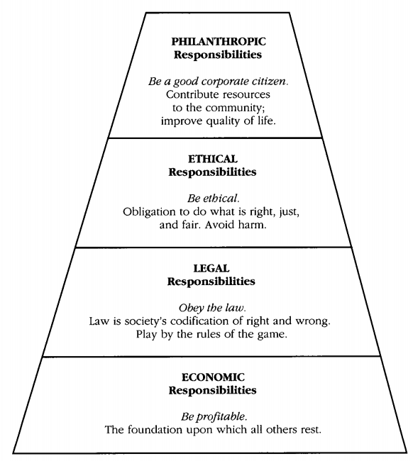
Figure 1: Carroll’s Pyramid of CSR (Carroll, A. 1991).
The fundamental layer of the pyramid is the economic responsibilities of a business. The notion that the economic expectations of an organisation are a social responsibility may seem unusual at first, however this is because society expects business organisations to be able to sustain themselves and the only way this is possible is by being profitable and able to incentivize owners or shareholders to invest and have enough resources to continue in operation (Carroll, A. 2016), if an organisation is to meet the three other social responsibilities, it must first be profitable in order to be financially able to carry out the further responsibilities.
Furthermore, the next layer of the pyramid is the legal responsibilities of an organisation where a business is expected to comply with the laws and regulations promulgated by federal, state, and local governments as the ground rules under which business must operate (Carroll, A. 1991). Organisations have a social responsibility to operate ethically and fair in the eyes of the law. Similarly, to the second layer on the legal responsibilities, the third layer of Carroll’s CSR pyramid harps on the fact that businesses should indulge in the righteous practices even when they are not compelled by the law (Bhasin, H. 2019). Ethics is concerned with what is good for individuals and society; how to live a good life, our rights and responsibilities, the language of right and wrong, moral decisions- what is good and bad? (BBC, 2020). Ethics is the set of beliefs and principles to do what is right by the many. Finally, the fourth layer of the pyramid is the philanthropic responsibility which is more than just doing what is right, but it is something that holds true to the company’s values, to give back to society (Thacker, H. 2019). Similarly, to Maslow’s Hierarchy of Needs, when a lower need is met, the next need on the hierarchy becomes the focus of attention whilst maintaining the previous responsibilities (Hopper, E. 2020). According to Carroll’s pyramid, true responsible business is one which meets the needs of the bottom three layers before fulfilling the philanthropic responsibilities as without the bottom three, a business cannot sustain.

2.4.2 Stakeholder Theory
CSR and stakeholder theory both highlight the significance of conducting business operations by taking into consideration the larger societal benefits (Naik, S, 2020). The scope of CSR has evolved to become a much more inclusive concept that involves various stakeholders and organisations have realised the importance of satisfying the stakeholders through social responsibility. Stakeholder theory is a concept that prioritises the interrelationship between business and its various stakeholders. If a firm performs trust-based entrepreneurial activities, it can maintain good relationships with various stakeholder, and ultimately expect improvement in economic performance (Aupperle et al. 1985). Aupperle suggests that the subsequent consequence of CSR activities can lead to good relationships with stakeholders and therefore an improvement in economic performance, suggesting a positive correlation between CSR activities and economic performance of and organisation.

2.4.3 The Interrelationship between CSR and Stakeholder Theory
The concepts of CSR and stakeholder theory hold many similarities, CSR emphasizes the benefit to the society at large whereas stakeholder theory works on building relationships and value between business and its various stakeholders (Freeman, R., Dmytriyev, S. 2017), the stakeholders also being a part of society who benefit from CSR activities. The various challenges in implementing CSR initiatives can be mitigated by aligning the concept with stakeholder theory as this enables leaders to have a more pragmatic approach considering the interests of all its stakeholders and planning its actions accordingly (Naik, S. 2020).
The image below shows an overlap between the two concepts and with both ideas aligned, maximum benefits in societal development can take place as well as creating a motivated workforce, better company branding, larger sales and profitability, satisfied customers (Nikolova, V., Arsic, S. 2017).
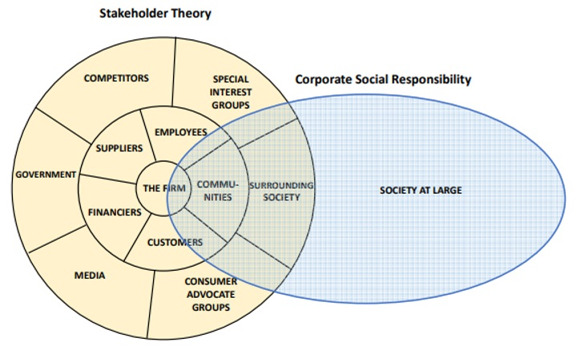
Figure 2: Interrelationship between stakeholder theory and CSR (Freeman and Dmytriyev, 2017).
The close relationship between CSR and Stakeholder Theory is visible in the image above by showing that stakeholder theory aims to satisfy the needs of the local communities and the surrounding society, similarly to CSR initiatives which aim to satisfy the entirety of society, thus including the stakeholders that are the communities and surrounding society.

2.5 Importance of CSR
Diverse perspectives have been used in academic analysis of CSR (Russel, D., Russel, C. 2010). Different functions of an organisation will review the CSR concept from different perspectives with finance typically analysing the CSR-CFP relationship, human resources on the employee well-being, motivation and satisfaction, and marketing researchers focus upon the impacts that the CSR efforts have on consumer reactions and motivations (Hildebrand et al. 2011). CSR has become an important strategy for organisations, it has been verified that companies use CSR as a channel to distinguish themselves from other firms; they have been filling the gaps to improve people’s quality of life that the government finds difficult to fill (Jamali, D., Mirshak, R. 2007).
The perception and reality of an organisations performance on social responsibility can influence; competitive advantage, reputation, ability to attract and retain workers, customers or clients, maintenance of employees’ morale, commitments and productivity, the view of investors, its relationship with companies, governments, media, suppliers, peers, customers and the community in which it operates in (ISO, 2010). CSR has become an important concept to an organisation just as much as it is to society, there is a proposed mutual benefit to all parties involved. Organisations increasingly use CSR activities to position their corporate brand in the eyes of consumers and stakeholders, such as through their annual reports (Sweeney, L., Coughlan, J. 2008), many researchers have shown a positive relationship between awareness and purchase intentions of consumers (Mishra, S. 2012). Moreover, research by Mohr and Webb (2005) also found that when consumers are made aware of an organisations level of social responsibility that information affects how they evaluate the company and their purchase intentions.
It is commonly noted that an organisation may only receive economic benefit from CSR initiatives only when consumer awareness of the initiatives is high, and understandably so however this then leads on to the notion that CSR is used as a marketing tool and not for the right reasons, which is ultimately to benefit society. Known as the ‘father of marketing’, Philip Kotler firmly believes that companies should care for people and the planet as well as make profits (Kotler, P. 2017). Kotler backs the notion that organisations should implement CSR into their practices as a form of marketing and as a result they might then benefit from improved brand image and identity.
The main idea of corporate marketing is the shift from a product and service to the corporate level concerns e.g., marketing orientation should go beyond customers’ wants and needs related to products and services (Balmer, J. 2001).

2.6 CSR and Consumer Behaviour
Within the scope of the current work, the theoretical framework of CSR is focused on analysing the strategic use of CSR practises (Gallego-Alvarez et al. 2010). Fombrun and Shanely (1990) state that investing in CSR attributes and practices may be important elements of product differentiation and reputation building (Fombrun, C., Shanely, M. 1990) and also a method for retailers to enhance brand image (Ganesan, S. 2009). A 2017 research study by Cone Communications show that 92% of consumers have a more positive image of companies that support social issues and environmental efforts (Cone, 2017). Furthermore, the same study found that 86% of Americans expect companies to do more than make a profit, therefore taking on social responsibility as an organisation. Of all the stakeholders, one important group that appears to be particularly susceptible to a company’s CSR is its consumers (Bhattacharya and Sen, 2004; Tian et al., 2011). With consumers being the main revenue stream for an organisation, their support and loyalty is imperative to their success and therefore from a stakeholder management perspective, the customers need to be managed closely as such rewards from CSR can only be achieved only if stakeholders are aware of these CSR activities (McWilliams, A., Siegel, D. 2001).
Many of the previous academic research studies have concluded that CSR has a positive influence on consumer motivations and purchase intentions of a company (Ellen et al. 2006; Sen and Bhattacharya, 2001), and now CSR is widely acknowledged as an imperative practice for organisations, resulting in greater competitive advantage and positive economic outcomes (Lii et al. 2013). Other authors agree with this by stating that CSR is known to improve both corporate image and brand image, and it ultimately helps enhance purchase intention (Balmer and Greyser, 2006; Wood and Jones, 1995). A study conducted by (Curras- Perez et al. 2017) found that the three dimensions of CSR initiatives have a different impact on each type of consumer perceived value with better social performance at corporate level, becomes better perception of value for money, the phenomenon can be explained by the existence of the halo effect (Klein and Dawar, 2004).
Additionally, cross cultural research conducted by (Singh et al. 2008) showed that Spanish consumers are significantly less interested in environmental issues compared to UK consumers, here lies the basis for this research study which will gather primary evidence to support or deny the claim that Welsh consumers (more specific than the UK) are more interested in environmental issues.
Furthermore, a study conducted by Mishra (2012) on the impact of CSR on consumer behaviour in India concluded that there is good support from consumers for good CSR practices and products and consumers are also willing on their part to pay for good CSR practices (Mishra, S. 2012). As with other research results, the consumer behaviour can differ depending upon geographic location, therefore this research study will also test this conclusion to identify if consumers in Wales are willing to pay more, and if so, how much more?

3. Chapter Three: Research Method

3.1 Introduction
The previous chapter achieved the first objective which was to review current academic literature on organisations’ CSR activities and how this can affect consumer purchasing behaviour. After carrying out secondary research on the topic, it has been identified that there is no current research based on the effects of CSR activities on consumer behaviour for the Welsh geographic. Geographic segmentation is the market segmentation strategy in which the market is divided on the basis of regions… people living in the same area often have similar needs or requirements (MBASchool, 2020). Therefore, researching Welsh consumer behaviour can be useful to an organisation which would be looking to implement CSR strategies within Wales.
This chapter aims to complete the second objective:
“To analyse the effect of an organisations’ CSR activities on consumer behaviour.”
To aid achieve this objective the Saunders’ Research Onion framework has been used to create an effective research methodology to allow for accurate and reliable research to be conducted.

3.2 Research Onion
Research is seeking through methodical processes to add to one’s own bod of knowledge and to that of others, by the discovery of nontrivial facts and insights (Sharp et al. 2013). There are multiple approaches and methods which can be used to enhance the findings of research. Different research methods have different purposes and different levels of validity, the validity being whether or not a study measures what it’s supposed to measure (Roundy, L. 2013). Therefore, to ensure the validity of this investigation, Saunders’ Research onion has been used which addresses the multiple stages that a researcher must go through when creating an effective methodology.
Each of the 6 layers must be broken down and considered, starting from the outmost layer and working in to the centre. The image below shows Saunders’ Research Onion, following the image is each stage that has been used for this research study.
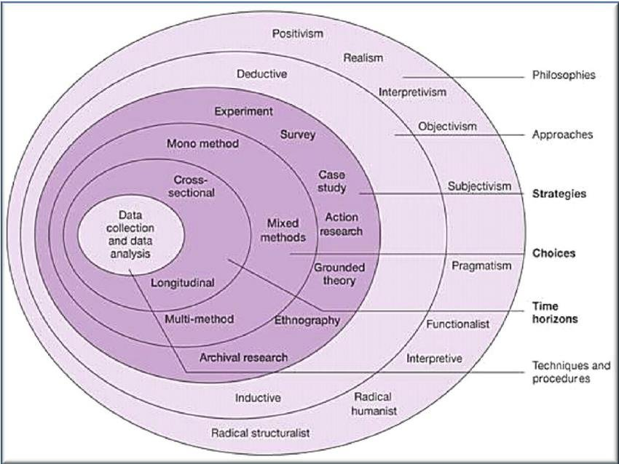
Figure 3: The Research Onion (Saunders et al., 2009).

3.2.1 Research Philosophy
A research philosophy refers to the set of beliefs concerning the nature of the reality being investigated (Bryman, A. 2012). Research philosophy is a very important part of the research methodology and is classified as ontology, epistemology, and axiology (Guhathakurta, S., Chetty, P. 2015). These philosophical approaches enable to decide which approach should be adopted by the researcher and why, which is derived from the research questions (Saunders et al. 2009). Ontology can be defined as the science of what is, the kinds and structures and objects, properties, events, processes, and relations in every area of reality… ontology seeks to provide a definitive and exhaustive classification of entities in all spheres of being (Smith, B. 2003). The three philosophical positions which come under ontology are pragmatism, constructivism, and objectivism.
Next, epistemology involves the concepts of knowledge, evidence, reasons for believing, justification and probability (Fumerton, R. 2009). Therefore, epistemology is most frequently used in scientific research as it helps to find research that is definitive through the use of evidence. Bryman (2012) notes that the philosophical positions of epistemology are positivism, realism and interpretivism. For this research study, interpretivism will be used as its based on understanding human nature and their varying role as social actors and can be used to analyse human emotions (Chetty, P. 2016). A qualitative approach is applied to interact with individuals, this research will partly use interviews as a method of gathering primary qualitative research.

3.2.1 Research Approach
The second layer of the onion focuses on the research approach, inductive of deductive. Firstly, inductive research involves the search for pattern from observation and the development of explanations- theories- for those patterns through a series of hypotheses (Bernard, H. 2011). On the other hand, a deductive approach can be described as developing a hypothesis based on existing theory, and then designing a research strategy to test the hypothesis (Wilson, J. 2010). Deduction begins with an expected pattern that is tested against observations whereas an inductive approach begins with observations and seeks to find a pattern within them (Babbie, E. 2010). As there is no current research on the effects of CSR activities on consumer behaviour in Wales, their opinions of the Welsh public are unknown, therefore an inductive approach will be used to guide the research. This approach is appropriate because there is little existing literature on this area (Saunders et al., 2009).

3.2.3 Research Strategy
The third layer of the research onion is the research strategy which describes how the researcher intends to carry out the work (Saunders et al., 2007). Choosing the most appropriate research methodology is a difficult task that must be considered carefully as they must be capable of gathering suitable information to meet the aims of the study. It is important that the technique used in collecting data is adequate enough to provide the information required to accomplish the overall goal (Opoku et al., 2016).
One research strategy that will be used is surveys. The use of survey means that a large number of respondents can be gathered for a reliable research study. Surveys tend to be used in research projects and involve sampling a representative proportion of the population (Bryman, A. 2012). The use of surveys is advantageous for this research study as they are relatively easy to administer, cost-effective, a broad range of data can be collected and numerous different questions can be asked (DeFranzo, S. 2020).
Furthermore, grounded theory will also be used as a research strategy for this study. Grounded theory is a systematic methodology emphasizing generation of theory from data in the process of conducting research. It is mainly used for qualitative research (Glaser, B., Strauss, A. 1967). The methodology is suited to this research as it involves construction of hypotheses and theories through the collecting and analysis of data (Strauss, A., Corbin, J. 1994). Grounded theory offers the researcher the benefit of approaching a study without predetermined ideas of what the outcomes of the investigation may be therefore it can offer a more neutral view of understanding (Simmons, O. 2006). This study will be the first known study of the effects of CSR on consumer behaviour in Wales and therefore there are no predetermined ideas of what the outcomes of the investigation may be.

3.2.4 Research Choice
According to Creswell, J. (2008), mixed methods is defined as the procedure for collecting, analysing, and mixing quantitative and qualitative data at some stage of the research process within a single study in order to understand a research problem more completely. Mixed methods have been chosen as combining quantitative and qualitative approaches can balance out the limitations of each method and it can provide stronger evidence and more confidence in your findings (Gov.uk, 2020). The use of qualitative as well as quantitative data research can allow for more insight than solely just using quantitative data. The qualitative data gathered from the interviews can be used to understand reasoning behind the quantitative results which would allow for a reliable set of results and also possibly finding a justification of the results (assuming there is a pattern).

3.2.5 Time Horizon
The time Horizon refers to the required time for the completion of the research study, two types of time horizons are specified within the research onion: cross sectional and longitudinal (Bryman, A. 2012). Cross sectional research is the most suitable for this study as it involves looking at data from a population at one specific point in time (Cherry, K. 2019). The study aims to find the current consumer behaviour towards CSR activities and therefore can be completed at a single point in time. Cross-sectional studies are advantageous as they are relatively quick and inexpensive to conduct (Wang, X., Cheng, Z. 2020).

3.3 Techniques for Data Collection, Processes and Analysis

3.3.1 Data Collection
Saunders, M. et al. (2016) propose that using multiple methods of data collection enables to gather a wider understanding. For example, interviews can identify key themes and issues, and questionnaires can be used to easily spot trends and create charts directly from the responses which allows for easy comparison and analysis of results. For all of the primary research, a mixture of qualitative and quantitative data research will be carried out for this study as mixed methods make it possible to conduct in-depth research and provide for a more meaningful interpretation of the data and phenomenon being examined (Teddile, C., Tashakkori, A. 2003). Mixed methods include the benefit of both, qualitative and quantitative methods which allows for a more thorough investigation and more information received which can be analysed and compared for more accurate and reliable results.
The secondary data which has been collated throughout this study and the literature review has been collected through thorough in-depth research of academic journals, books, and credible websites. Credible sources were a requirement as it would allow for more valid and accurate information, which is essential for the research study to be effective.

3.3.2 Interviews
The first method of primary research data collection was via the use of video call interviews. Unfortunately, due to the current restrictions of the Covid-19 pandemic these interviews could not be carried out face to face which would have allowed for a more personal interaction with the respondents. Despite this, the interviews were still able to be held online via online video conferencing software. Interviews were chosen as an initial method of data collection as they allow for more in-depth data collection and comprehensive understanding (Marshal, C. 2016) which would allow for more accurate feedback from interviewees. Interviews are a suitable method of data collection to gather a small group of individuals opinions and views, however when done on a large scale they can be very time consuming to carry out (Gov.uk, 2020).

3.3.3 Questionnaires
The second chosen method of primary research was qualitative research through the use of questionnaires. Questionnaires have been used as a method of gathering primary evidence as the ability of the surveys do be done via the internet means that it provides access to groups and individuals who could otherwise be difficult, if not impossible, to reach through other channels (Wellman, B. 1997). Furthermore, another advantage of using online questionnaires is that it saves a lot more time, the use of the internet means that there is access to individuals from all backgrounds in a very short amount of time, despite possible being separated by great geographic distances (Taylor, H. 2000). Additionally, according to Cohen et al. (2017) questionnaires are one of the best methods of data collection when aiming to keep individual identity confidential, therefore providing extra security to respondents and the data collected which can allow them to feel safer and give more honest answer which allow for more credible results.
A lot of time was taken in the process of creating the questionnaire as asking the right questions was pivotal to the success of the feedback that would be received. Questions needed to be clear and concise whilst always keeping the aim of the research study in mind to ensure that the feedback received would be able to answer the aims of the research study. The main aim of gathering primary data via the questionnaire was so that it can be compared to secondary data which was gathered as part of the literature review and then they could be analysed and compared together to identify any trends in consumer behaviour and to further answer any questions of the study which were specific to the Welsh population.

3.3.4 Questionnaire design
When properly constructed and responsibly administered, questionnaires become a vital instrument by which statements can be made about specific groups or entire populations… adequate questionnaire construction is critical to the success of a survey (Roopa, S., Rani, M. 2012). A lot of thought went in to the questions on the questionnaire to ensure that the feedback received would allow for the objectives to be met. The Likert scale was used for many of the answers in the questionnaire, the scale offers a continuum of five fixed-choice options and enables people to self-report the extent to which they agree or disagree with a given proposition. As opposed to a simple binary response like yes or no, the Likert scale allows for more nuance (Vinney, C. 2019).

3.4 Logistical and Ethical Considerations
The logistical considerations throughout the research stage of this study were relatively simple yet fully effective. Firstly, due to covid-19 restrictions no face-to-face interviews were allowed to take place, consequently all interviews had to be done via video conference software, Zoom. As the host, I would get into contact with each of the respondents and agree upon a time that suited them best to interview them, I would then set up the Zoom meeting and send them an invite link via email. Each interviewee participated on the basis of informed consent which involves the researchers providing sufficient information and assurances about taking part to allow individuals to understand implications of participation and to reach a fully informed, considered and freely given decision about whether or not to do so, without the exercise of any pressure or coercion (Saunders et al., 2012).
Before beginning each interview, all interviewees were made aware of the purpose of the research and how their data will be handled securely and how their anonymity will be maintained throughout the research study. Interviewees were informed that they could decline any answers they wished to and could also withdraw from the study at any time. Originally, each Zoom interview was going to be recorded to allow for them to be re-watched and notes to be made, however a decision was decided against this as it could potentially cause the interviewee to feel pressured or uncomfortable. Ensuring the comfort of each interviewee was imperative as it would allow them to feel more relaxed throughout the interview which could possibly result in more honest feedback.
None of the data obtained from an interviewee or a questionnaire respondent was personal which did negate some security risks such as breach of data or misuse of personal data. Furthermore, all of the feedback received was saved on a password encrypted device which again, added more security to data.
This research is conducted in line with the ethical standards of UWTSD, an ethics form has been completed outlining all potential threats of the study and has also been approved by the academic supervisor of the study (Appendix for Ethics Form).

4. Chapter Four: Findings and Data Analysis

4.1 Introduction

This chapter will present all of the findings from the primary research carried out. In doing so, this chapter will be laying the foundations to meet the seconds objective:
“To analyse the effects of an organisations’ CSR activities on consumer behaviour.”
This chapter will present the qualitative data findings from the six interviewees whist extracting key themes from the answers. Also, the quantitative data received from the questionnaire has been collated, interpreted, and made into graphs that allow to spot trends and compare findings.

4.2 Data Analysis
Data analysis is a method in which data is collected and organised in order to understand patterns and gather useful information from it (Whiting, B. 2016). Data analysis is a crucial part of this research study as the data gathered will be used to conclude upon the effect of CSR activities on consumer behaviour in Wales. This chapter is split into two main part, qualitative analysis, and quantitative analysis.

4.2.1 Qualitative Analysis
Qualitative researchers generally study many fewer people but delve more deeply into those individuals hoping to generate a subjective understanding of how and why people perceive, reflect, role-take, interpret, and interact (Adler, P., Adler, P. 2011). Therefore, only six interviews were carried out as part of the qualitative research, however they cultivate much deeper into reasoning and justification of responses, over the quantitative data. There were three males three females who were interviewed from a range of different ages, professions, and backgrounds. No personal questions were asked in the interviews and no further information on the interviewees will be discussed to help protect their anonymity.
Before beginning each interview, each interviewee had to read and listen to a statement by myself (See Appendix) which stated the reasons for the interview, made them aware that they could leave at any time, and it also clarified that they were over 18 years old, live in Wales and fully consented to their feedback being used as part of the research study.
Each participant has been given a code (A, B, C, D, E, F), the following tables show each of the questions with each of the answers from each participant and then an analysis of the question and how it might lead to trends. It is important to note that answers have been edited slightly so that they are more readable however the main ideas have been kept throughout.
Table 1: Analysis of Interviews
Question | Answers | Analysis
- Do you know what Corporate Social Responsibility is? If so can you describe it?  This question tests to see if the interviewees know what CSR is. | A: Yeah I think so, Corporate Social Responsibility is when a company does good for the environment and gives money to charity.  B: Is it when a company does good business and gives money to charity.  C: Corporate Social Responsibility is when a company obeys all laws and helps to look after the environment by cutting down on waste and using renewable energy.  D: When a business does good for society by making sure that employees are treated fairly and they pay farmers a fair amount for the food.  E: Yes, it is when a company gives money to charities, and invests in communities like sports and schools.  F: It’s when corporates look after the environment, look for ways to be as sustainable as possible and they also give money to charity. | Each interviewee had reasonable knowledge of what CSR is, this was a good question to ask early on in the interview as it would set the tone for the rest of the interview and it would get them thinking about CSR. The main themes which appeared were that four of the 6 respondents said ‘giving money to charity’. Other common answers were looking after the environment and sustainability, treating employees fairly and investing into the local community.  THEME: All respondents were aware of what CSR is.
- Are you more likely to purchase from a company that is socially responsible over one who isn’t? If so, why? | A: Yes, but only if the product isn’t too much more expensive because it makes me feel like I am helping a bit more to protect the environment and giving money to charity, even if it’s just a little bit.  B: Yes, because I know some of the money that they make will be going to charity and you know the company you buy from cares about more than just money by helping others.  C: Yes, it make me feel better that some of the money that I spend will be going to good causes rather than all of it going to the company.  D: Yes, if the quality of the product is the same then I’d rather my money be going to a company who supports good causes. But if the quality is worse or it is too much more expensive then I wouldn’t.  E:Yes, I would prefer some of my money to be going to communities rather than to a company who doesn’t do anything to help.  F: Yes, it shows that a company wants to give back and cares more about just profits. | Every interviewee said that they would be more likely to purchase from a company that is socially responsible over one that isn’t, providing that the price increase isn’t too dramatic. This can show that sales could possibly be improved if a company is to act responsibly as when given a choice between two products, interviewees said they would choose the one which follows CSR. Many of the reasons were that it made the participant feel better knowing that some of their money would be going to good causes such as charities and also protecting the environment.  Some of the interviewees took the potential extra cost of a product into account and said if it was much more expensive then they would have to go with the cheaper option due to financial situation.  THEME: All respondents are more likely to purchase from a company that is socially responsible over one that isn’t, providing the quality is the same or better.
- How do you view companies who have a CSR strategy? Their image, brand etc.  This question was asked to focus on the topic of brand image, are consumers more or less likely to remember a brand who follow CSR? This question can contribute to finding out if CSR can be used as an effective marketing tool. | A: I think when a company has CSR it shows that they care about things other than just profit. To me, I think that’s important and it would definitely improve their image in my eyes and I will remember the CSR that they do such as Dairy Milk and Fairtrade.  B: Yeah, I would say that the image of a company is improved if they follow CSR. I think it’s good that they care about other things in society and not just making money. I would be more likely to remember a company if I knew about their CSR activities and I would be more likely to shop with them if I needed something they sell.  C: In my opinion, I think if a company is willing to give a percentage of their profits to make more renewable packaging or to contribute to fighting against climate change then it definitely improves their image. I’d be more likely to remember them once I know what they do and I’d be more likely to shop with them because I’m familiar with them already.  D: I just think they’re better, they seem like they actually care and not just building the company for the money. It does help to remember the company and gives them a better image in my eyes.  E: As a customer it would make me more likely to want to spend with them because I know that they care more about just money. It definitely improves their brand image.  F: To me, I think brand image is improved a lot. I’m more likely to remember a company for having CSR and knowing that they do good with their profits. I’d be more likely to recommend them to someone else too. | For this question, again all interviewees said it would improve an organisations brand image if they were to follow CSR. Participant A actually recalled an example of a company who follow CSR, showing that it can improved remembrance of a brand and brand identity. The participants also stated that often it shows that a company who follows CRS cares more about just profits, but also the environment and society. Overall, from this question we can conclude that the results show that following CSR does improve brand image, identity and remembrance which suggests that CSR can be used as an effective marketing strategy as the most instinctively memorable brans’ are friendly brands (Gecko, 2018).  THEME: Brand image and identity is improved by following CSR activities.
- To you is CSR necessary for an organisation? Would you avoid a company who doesn’t follow CSR?  This question was asked to try and determine whether CSR is necessary for an organisation. It is evident that more and more companies are taking on CSR initiatives, however do they need to in order to stay competitive in the market? | A: I don’t think CSR is absolutely necessary for a company, I think that if their prices are low enough with still good quality then people will buy their products/ services. But if given a choice between two almost identical products and prices, I would go with the one that follows CSR.  B: I wouldn’t say it’s absolutely necessary because there are still companies who don’t follow it. However, I think it would help to make a company stand out if their CSR is very good.  C: CSR isn’t absolutely necessary because I think there will always be a market for cheaper goods as some people can’t afford to pay a bit more. Unless there is a noticeable difference in one company following CSR and the other not, then I wouldn’t purposely avoid a company who doesn’t follow CSR.  D: I don’t think CSR is completely necessary for an organisation as I think there will always be people who will choose the cheapest option when shopping as they simply can’t afford to spend more money. Personally, I’d be willing to spend a bit more if I knew the money was to go to a good cause.  E: It might not be necessary for a company but I definitely think it’s beneficial. I think more people would want to shop with a company who has good values and are aiming to help improve the environment and society. If given the option to between two companies I would usually go with the one with stronger CSR.  F: I think that one day it might be, so many companies will be doing it and other companies might not have a choice but to follow. I think that would be a good thing if all companies were to contribute to society. I would try and shop with company that follows CSR. I would try an avoid a company if they didn’t follow CSR but only if there were other options. | This question wanted to gain a better understanding on if the interviewees though that CSR was necessary for a company. The interviewees said they don’t think it is necessary to an extent. If given a choice between two products, interviewees said they would go with the one who follows CSR. However, not everyone has the extra finance available to be able to afford to pay extra in some cases and therefore not all companies might be encourage to follow CSR as there will likely always be a market for cheaper goods from people with lower incomes.  THEME: CSR is not necessary for a company to stay competitive although it is preferred.

After analysing the results of the interview by looking at the 4 main questions which were asked and then gathering all of the responses together and extracting key themes from the answers, it is clear to see that the participants were in agreeance upon many of the same things. Firstly, it was pleasing to find that all of the interviewees understood what CSR is, it shows that there is some awareness about an organisations’ CSR activities.
Question 2 asked if interviewees were more likely to purchase from an organisation who follows CSR over one that doesn’t. Every interviewee said they would choose the organisation that follows CSR. This could show that CSR is beneficial to a company and could increase sales as customers would take into consideration the CSR activities, if two products were compared to each other.
The feedback from question 3 also proved to consistent from all participants. Participants stated that if a company follows CSR initiatives then it makes them more likely to remember an organisation and improves the image of the organisation in the eyes of the participant as ‘it means they care about other things (society, the environment) and not just profit’.
Finally, question 4 asked if interviewees thought a company following CSR was necessary to them in purchasing from a company and would they avoid a company who doesn’t follow CSR. This answer provided the most variances in responses however the general consensus was that ‘CSR isn’t absolutely necessary’ but it can be advantageous. Justification for CSR not being necessary was down to the lower prices of products that don’t follow CSR, meaning there will be a market for these products as some individuals are not in a financial position where they can afford to pay slightly more.

4.2.2 Quantitative Analysis
The quantitative analysis takes a look at the questionnaire (See Appendix A) and has compiled graphs and charts to visually represent what the respondents of the questionnaire answered. Microsoft Excel has been used to create the graphs and charts by entering the results from Google Forms into Excel, this was used as opposed to the premade Google Forms charts as Excel allows to add labels and axis etc. which makes the charts easier to read and interpret. In total, there were 228 responses from males and females around Wales. All respondents were over the age of 18. The following is an analysis of the data.

Question 1: Are you? Male, Female, Prefer Not to Say

Figure 4.1: Gender of respondents
Out of 228 respondents, 128 were female, 100 were male.
Question 2: Which one of the following is an example of a CSR activity?

Figure 4.2: Examples of CSR
This question was asked to test the knowledge on what a CSR activity is. 215 respondents answered ‘All of the above’ which would have been the best answer to put as all possible answers were examples of CSR. Knowing that the majority of respondents were aware of some CSR activities was useful as it would allow for the integrity of the rest of the questionnaire.
Question 4: Are you willing to pay more for products which are sourced under ethical and sustainable means?

Figure 4.3: Are consumers willing to pay more for products that are sourced under ethical and sustainable means?
211 (93%) of the respondents said that they would be willing to pay more for a product which is sourced under ethical and sustainable means. This was pleasing to see as it shows that the general welsh public are willing to pay more for a product which has been sourced under ethical and sustainable means. This can encourage more and more businesses to take on CSR activities as their profits might not be affected as the public are willing to pay slightly more.
Question 5: How much more are you willing to pay?

Figure 4.4: How much more individuals are willing to pay for a product that has been made ethically and sustainably.
Question 5 was a follow on from question 4. 8 of the respondents said 0% which would be expected as 8 people from question 4 said they would not be willing to pay more. The mode for this question was 1%-9% as 192 respondents said they would be willing to pay that much more of a product if it was sourced ethically and sustainably. A further 28 respondents said they would be willing to pay 10%-19%. The final two categories, 20%-29% and 30%+, both had no entries. This information can be beneficial to an organisation as they can take this feedback into account when potentially adjusting pricing as a result of increased expenses on CSR activities.

Question 6: Do you actively look to purchase from organisations who follow CSR activities?

Figure 4.5: Do consumers actively look to purchase from organisations who follow CSR?
The results of question 6 show that 67% (152) of respondents do not actively look to purchase from organisations who follow CSR, 11% (25) said yes they do, 21% (49) said sometimes they do and 1% (2) said they are unsure. This statistic was quite alarming and it could deter and organisation from wanting to participate in CSR activities as the majority of consumers are not actively looking to purchase from companies who practice CSR. However, an organisation can also learn from this by ensuring that they report their CSR activities and therefore making consumers more aware. For example, Participant A in the qualitative study recalled Dairy Milk and their Fairtrade activities, if brands were able to make consumers aware of their activities by perhaps adding certificate badges onto their products, this could be a good idea to help distinguish brand who follow CSR and brands who don’t.
Question 7: Are you more likely to trust a brand that is socially responsible?

Figure 4.6: Are consumers more likely to trust a brand that is socially responsible?
This question was asked to determine if CSR activities improve consumer trust. Every single respondent (228) said that they would be more likely to trust a brand that is socially responsible. This would be in favour of an organisation taking on CSR initiatives as its very likely that consumers from all around Wales will have an increase in trust in the company. Having a truly successful business is based on one concept: trust (Adams, M. 2014). If introducing a CSR strategy will increase consumer trust, many authors believe that trust it the one key component to the success of an organisation, therefore implying that an organisation with a CSR strategy is likely to become more successful.

Question 8: Are you more likely to remember a brand that is socially responsible?

Figure 4.7: Are consumers more likely to remember a brand that is socially responsible?
This question was asked to determine the brand awareness. 210 of the respondents said they would be more likely to remember a brand that is socially responsible. 15 of the respondents said unsure and 3 said no. Again, this information is positive to an organisation who might be considering to introduce CSR into their company. This feedback suggests that brand awareness is improved when following CSR as 92% of respondents yes.
Question 9: You think your awareness of CSR activities is: Very Poor, Poor, Average, Good, Very Good.

Figure 4.8: Consumers’ awareness of CSR activities.
From the bar chart above it is clear to see that the majority of respondents think their awareness of CSR activities is poor. The chart shows relatively scattered results, however the majority of respondents rated themselves towards the lower end of the scale. This is something that stands out, possibly companies who perform CSR activities do not receive as much attention from the public, or they do not report their CSR activities in such a way that the public are being made aware. Previous analysis of questions show that brand trust and brand awareness are increased when following CSR, therefore it is important that CSR activities of an organisation are reported and consumers are made aware of them if an organisation wishes to increase the trust and awareness of a brand.

Question 10: How much do you agree with the following statement? “As a consumer, I would avoid a company if I was aware they did not participate in any CSR activities.”

Figure 4.9: Would consumers avoid a company that does not participate in CSR activities?
It is clear to see that most of the respondents voted agree (101) or strongly agree (92) that they would avoid a company if they were aware that they do not participate in CSR activities. This does not necessarily mean that consumers would purchase from a company if they did follow CSR however, it is useful to an organisation to consider that not acting socially responsible can cause consumers to avoid the company. This can be caused by various factors such as unfair payment to suppliers, unfair working conditions, or inequality, and discrimination in the workplace.
Question 11: How much do you agree with the following statement? “As a consumer, I pay close attention to a company’s CSR when purchasing a product.”

Figure 4.10: Do consumer pay close attention to a company’s CSR when purchasing a product?
From the bar chart, it is clear to see that the majority of the respondents disagree (86) or strongly disagree (66) that they pay close attention to a company’s CSR activity. This result was quite surprising and contradictory to some of the previous results in the research study as the majority of respondents said they do not play close attention to a company’s CSR when purchasing a product, but they agree that if they were aware an organisation did not perform CSR activities then they would avoid purchasing from the company. Although the feedback is not completely one sided towards disagree or strongly disagree, it should still be taken into account that consumers are not paying close enough attention to an organisations CSR activities. CSR not only offers a wide range of benefits to a company but also contributes to the wellbeing and betterment of society (Chandra, A. 2019). It is within the best interest of consumers as a whole to reward companies who participate in CSR so that they can continue to do so.
Question 12: How important are the following to you when purchasing from a company?

Figure 4.11: The importance of different CSR activities to consumers
The above clustered bar chart is made from a response on the importance to the consumer of different CSR activities that a company must follow. Firstly, ‘Ethically sourced products’ saw a gradual increase in respondent going up the continuum of importance but dropped off slightly from ‘Important’ to ‘Very Important’. This shows that generally, an organisation having ethically sourced products is important to a consumer.
Next, ‘Suitable employee working conditions’ shows clearly that consumers believe it is very important for an organisation. Over 50% of the respondents voted that suitable working conditions was a very important CSR activity.
A % of profits going to the local community showed quite scattered results with the majority of respondents voting around the middle of the continuum.
A % of profits going to charity gave the majority of results towards the unimportant and not very important. An explanation for this could be the stigma around charitable giving and many people believing that charity may not provide the best solutions to problems (BBC, 2014).
Biodegradable/ recycled packaging showed to be rather important with the majority of respondents voting ‘Important’ or ‘Very Important’. Given climate change and global warming awareness campaigns over recent years, recycled packaging has become a lot more widespread.
Finally, Human rights & equality campaigns were regarded as rather unimportant as the majority of respondents voted either ‘Unimportant’ or ‘Not very important’.
These results suggest that Ethically sourced product, suitable employee working conditions and biodegradable/ recycled packaging are the most important CSR activities in the eyes of the average Welsh consumer.

Conclusion
This chapter achieved the second objective:
“To analyse the effect of an organisations’ CSR activities on consumer behaviour.”
By using qualitative and quantitative analysis techniques, this chapter has presented and analysed all of the findings from the primary research carried out as part of this research study.

Chapter Five: Discussion

The aim of this study was to investigate the effects of CSR on consumer behaviour within Wales. Many studies have been done analysing the effects of CSR activities upon consumer behaviour, however there were none available on the consumer behaviour in Wales.
According to Lafferty et al. (1999) consumers are likely to purchase products from companies that project a positive image. If a company has a positive image and reputation, it tends to increase customers loyalty towards the company which, in turn, can lead to profit maximization (Min et al. 2012). This study found that from question 3 of the qualitative research and question 7 of the survey, brand image and trust in a brand is increased when a company carries out CSR activities. This information supports much of the current global academic research on the topic stating that CSR improves corporate image first, and then the corporate image improves brand image and then eventually an increase in purchase intention through the mediation of the two types of image (Lee, J., Lee, Y. 2018). Therefore supporting the notion that CSR has a positive influence on sales, perhaps because consumers are more predisposed to buy products and services from CSR companies (Afonso et al., 2012).
Furthermore, a research question for this study wanted to investigate if consumers are willing to pay more for ethically and sustainably sourced products, according to the research carried out (Figure 4.3 & 4.4) 93% of the respondents said they would be willing to pay more, 84% of those claiming they would pay 1%-9% more for CSR products and a further 12% saying they would be willing to pay between 10%-19% more. These results being in favour with current academic literature stating that consumers are willing to pay more for environmentally friendly products (Laroche et al., 2001).
Additionally, this research paper wanted to determine whether CSR is necessary for an organisation. Current literature believes that the synergy between social actions and economic efficiency is never automatically achieved; it is instead the result of efforts where managerial professionalism and business creativity are linked for the purpose of contributing to corporate growth (Gazolla, P., Mella, P. 2012). This research study can also conclude that (Question 4 of Qualitative analysis), CSR is not necessary to the success of an organisation however it can contribute massively to corporate and brand image which is likely to result in increased sales and economic performance, however, dependent upon an individuals financial situation they might not be able to afford CSR products and therefore would purchase from non CSR companies, still providing them with enough income to operate.
Next, when looking at whether any CSR activities were viewed as more important to the consumer (Figure 4.11) there were three which stood out and seemed to be of more importance. These were, ethically sourced products, fair employee working conditions and biodegradable/ recycled packaging. Fair employee working conditions stood out to be the most important factor, this could be down to personal experience from respondents and therefore activating their emotional bias causing them to view the activity as important. Improving employee working conditions can improve employees’ morale, inspire customer loyalty, and decrease employee turnover (Ksiezak, P. 2016), all of which can contribute to improved productivity and therefore economic performance of an organisation.
Finally, studies show that CSR activities, especially those linked to enhancing a company’s image, have a positive effect on shareholder value creation (Gallego- Alvarez et al., 2010). According to Mihalachem, S. (2011) companies have entered social responsibility initiatives to influence the perception of the stakeholders of the company, to create a good image of the company’s long-term picture which would bring higher profits. Therefore, it can also be conclude that CSR can indeed be used as a marketing tool as, providing the CSR activities are reported and consumers are aware, many of the activities improve company image and reputation and therefore improving consumers perception and encouraging purchasing behaviour.
This chapter has discussed the outcomes of the primary research carried out as part of this research study and compared it to other academic literature of the same nature. All of the six initial research questions have been answered.

Chapter Six: Conclusions

In conclusion, this research study has carried out a thorough investigation into CSR and its affects on consumer behaviour through a literature review and also qualitative and quantitative primary research has been carried out to gather evidence on the effects of CSR activities on consumer behaviour in Wales, as there was no previous academic literature for the geographic. Main findings of the research were that CSR activities improve brand trust and awareness and therefore improving corporate image. The resultant of the improved brand image is likely to cause in increase in sales through consumer familiarity and trust in the company, which can then improve economic performance and profits of an organisation. Furthermore, the study found that consumers are willing to pay more for products which are produced by CSR companies, therefore providing mutual benefit to all parties involved.
By thoroughly understanding the role of CSR and the current business strategies to implement the practice, management can manage an organisation more effectively by creating the right CSR strategy to stay competitive in todays market. This research study can act as an aid and provide valuable information to organisations who are looking to implement CSR into their company.

Chapter Seven: Recommendations
This research study has thoroughly investigated the effects of CSR activities on consumer behaviour in Wales. However, there are some limitations to the research which can present opportunities for future research. Firstly, conclusions from the study cannot be definitive as the research was based on a relatively small study (N=228), with the majority of respondents being from South Wales. Additionally, the research was based on consumers perception and there is no guarantee that their purchasing actions would be the same as their intentions.

References
Abd Rahim, R., Jalaludin, F., Tajuddin, K. (2011) The Importance of Corporate Social Responsibility on Consumer Behaviour in Malaysia. Asian Academy of Management Journal, 16, pp. 119-139
ACCP (2020) Corporate Social Responsibility: A Brief History. Online article retrieved from https://www.accprof.org/ACCP/ACCP/About_the_Field/Blogs/Blog_Pages/Corporate-Social-Responsibility-Brief-History.aspx accessed on 28/03/21 at 16:12
Adams, M. (2014) Three Ways to Build Customer Trust. Online article retrieved from https://www.forbes.com/sites/yec/2014/04/22/three-ways-to-build-customer-trust/?sh=2d8d5e3422b8 accessed on 19/04/21 at 12:59
Adler, P., Adler, P. (2011) How many qualitative interviews are enough? National Centre for Research Methods Review Paper, pp. 8
Afonso, S., Fernandes, P, Monte, A. (2012) CSR of top Portuguese companies: relation between social performance and economic performance. World Academy of Science, Engineering and Technology, 6(6), pp. 793-797
Anderson, O. (2018) Why corporate social responsibility is vital to a business? Online article retrieved from https://www.allassignmenthelp.com/blog/corporate-social-responsibility/. Accessed on 17/03/21 at 23:28
Arlow, P., Gannon, M. (1982) Social responsiveness, corporate structure and economic performance. Academy of Management Review. Pp.235-241
Arnold, D., Burns, K., Adhikari, N., Kho, M., Meade, M., Cook, D., (2009) The design and interpretation of pilot trials in clinical research in critical care. Critical care medicine, 37, pp. 69-74
Aupperle, L., Carroll, A., Hatfield, J. (1985) An empirical examination of the relationship between corporate social responsibility and profitability. Academy of Management Journal, 28, pp. 446-463
Babbie, E. (2010) The Practice of Social Research. Cengage Learning, pp. 52
Balmer, J. (2001) Corporate identity, corporate branding, and corporate marketing- seeing through the fog. European Journal of Marketing, 35, pp. 248-291
Balmer, J., Greyser, S. (2006) Corporate marketing: integrating corporate identity, corporate branding, corporate communications, corporate image and corporate reputation. European Journal of Marketing, 40(7), pp. 730-741
BBC (2020) Ethics: a general introduction. Online article retrieved from http://www.bbc.co.uk/ethics/introduction/intro_1.shtml accessed on 12/04/21 at 00:31
BBC (2014) Arguments against charity. Online article retrieved from http://www.bbc.co.uk/ethics/charity/against_1.shtml accessed on 19/04/21 at 18:42
Beckmann, S. (2006) Consumers’ perceptions of and responses to CSR: so little is known so far… Strategic CSR Communication, pp. 163-184
Benabou, R., Tirole, J. (2009) Individual and Corporate Social Responsibility. Research Group: Behavioural and Experimental Economics. Toulouse School of Economics.
Berman, S., Wicks, A., Kotha, S., Jones, T. (1999) Does stakeholder orientation matter? The relationship between stakeholder management models and firm financial performance. Academy of Management Journal, 42, pp. 488-506
Bernard, H. (2011) Research Methods in Anthropology. 5th Ed. AltaMira Press, pp.7
Bhasin, H. (2019) What is Carroll’s Pyramid of Corporate Social Responsibility? Online article retrieved from https://www.marketing91.com/what-is-carrolls-pyramid-of-corporate-social-responsibility/ accessed on 12/04/21 at 00:21
Bhattacharya, C., Sen, S. (2004) Doing better and doing good: when, why and how customers respond to corporate social initiatives. California Management Review, 47, pp. 9-24
Bolton, L., Mattila, S. (2015) How does corporate social responsibility affect consumer response to service failure in buyer-seller relationships? Journal of Retailing, 91(1), pp 140-153
Bowen, H. (1953) Social Responsibilities of the Businessman. University of Iowa Press: Iowa City. Pp.6
Bryman, A. (2012) Social Research Methods. 5th Ed. Oxford: Oxford University Press.
Bryman, A. (2012) Social research methods. 5th Ed. Oxford: Oxford University Press.
Cannon, T. (1992) Corporate Responsibility. 1st Edition, Pitman publishing, pp. 33
Carroll, A. (1991) The Pyramid of Corporate Social Responsibility: Toward the Moral Management of Organizational Stakeholders. Business horizons, 34, pp. 39-48
Carroll, A. (2008) A history of corporate social responsibility: concepts and practices. The Oxford handbook of corporate social responsibility, pp. 19-46
Carroll, A. (2016) Carroll’s pyramid of CSR: taking another look. International Journal of Corporate Social Responsibility, pp. 1-8
CED (1971) Social Responsibilities of Business Corporations. A statement by the research and policy committee, June 1971. https://www.ced.org/pdf/Social_Responsibilities_of_Business_Corporations.pdf
Chaffee, E. (2017) The origins of corporate social responsibility. University of Cincinnati Law Review, 85, pp. 347-373
Chandra, A. (2019) Benefits of CSR to Society and Companies in India. Online article retrieved from https://www.avinashchandra.com/benefits-of-csr#:~:text=Some%20of%20the%20major%20benefits%20of%20CSR%20to,retain%20the%20staff%207%20Effortless%20access%20to%20capital accessed on 19/04/21 at 16:19
Cherry, K. (2019) How Does the Cross-Sectional Research Method Work? Online article retrieved from https://www.verywellmind.com/what-is-a-cross-sectional-study-2794978 accessed on 16/04/21 at 00:48
Chetty, P. (2016) Choosing an appropriate research philosophy. Online article retrieved from https://www.projectguru.in/choosing-appropriate-research-philosophy/ accessed on 14/04/21 at 00:42
Cho, S., Chung, C., Young, J. (2019) Study on the Relationship between CSR and Financial Performance. Sustainability, 11(2), pp. 343 https://doi.org/10.3390/su11020343
Cochran, P., Wood, R. (1984) Corporate Social Responsibility and Financial Performance. The Academy of Management Journal. Vol. 27. Pp.42-56
Cohen, L., Manion, L., Morrison, K. (2017) Research Methods in Education. 8th Ed. Oxford: Routledge.
Coleman, A. (2019) Should businesses be paying more attention to CSR? Online article retrieved from https://www.telegraph.co.uk/business/ready-and-enabled/why-corporate-social-responsibility-is-important/ accessed on 07/04/21 at 16:18
Cone (2017) Americans Willing To Buy Or Boycott Companies Based On Corporate Values, According to New Research By Cone Communications. Online article retrieved from https://www.conecomm.com/news-blog/2017/5/15/americans-willing-to-buy-or-boycott-companies-based-on-corporate-values-according-to-new-research-by-cone-communications accessed on 06/04/21 at 15:54
Creswell, J. (2008) Educational research: Planning, conducting, and evaluating quantitative and qualitative approaches to research. 3rd Ed. Upper Saddle River, NJ: Pearson Education.
Curras-Perez, R., Dolz-Dolz, C., Miquel-Romero, M., Sanchez-Garcia, I. (2017) How social, environmental and economic CSR affects consumer-perceived value: Does perceived consumer effectiveness make a difference? Corporate Social Responsibility and Environmental Management, 25(5), pp. 733-747
DeFranzo, S. (2020) Advantages and Disadvantages of Surveys. Online article retrieved from https://www.snapsurveys.com/blog/advantages-disadvantages-surveys/ accessed on 15/04/21 at 23:26
Elhauge, E. (2005) Corporate managers’ operational discretion to sacrifice corporate profits in the public interest. Environmental Protection and the Social Responsibility of Firms, Resources for the Future.
Ellen, P., Webb, D., Mohr, L. (2006) Building corporate associations: consumer attributions for corporate socially responsible programs. Academy of Marketing Science, 34, pp. 147-157
European Commission (2011) A renewed EU strategy 2011-12 for Corporate Social Responsibility. pp.6
Fatma, M., Khan, I., Rahman, Z. (2017) CSR and consumer behavioral responses: the role of customer-company identification. Asia Pacific Journal of Marketing and Logistics, 30(2), pp. 460-477
Fatma, M., Rahman, Z. (2015) Consumer perspectives on CSR literature review and future research agenda. Management Research Review, 38(2), pp. 195-216
Fombrun, C., Shanley, M. (1990) What’s in a name? Reputation building and corporate strategy. Academy of Management Journal, 33, pp. 233-258
Freeman, R., Dmytriyev, S. (2017) Corporate Social Responsibility and Stakeholder Theory: Learning From Each Other. Emerging Issues in Management, pp. 1-14
Friedman, M. (1970) The Social Responsibility of Busines is to Increase its Profits. The New York Times Magazine. Available from http://www.umich.edu/~thecore/doc/Friedman.pdf
Fumerton, R. (2009) Epistemology. Oxford: Blackwell Publishing. pp.1
Gallego- Alvarez, I., Prado-Lorenzo, J., Rodriguez-Dominguez, L., Garcia-Sanchez, I. (2010) Are social and environmental practices a marketing tool? Management Decision, 48, pp. 1440-1455
Ganesan, S. (2009) Supply Chain Management and Retailer Performance: Emerging Trends, Issues and Implications for Research and Practice, 85, pp. 84-94
Gazolla, P., Mella, P. (2012) Corporate performance and corporate social responsibility. A necessary choice? Economia Aziendale Online, (3), pp. 1-22
Gecko (2018) Brand Image and Brand Awareness are the essential ingredients to online marketing success. Online article retrieved from https://www.geckodesign.tv/brand-image-improvements/ accessed on 18/04/21 at 13:10
Glaser, B., Strauss, A. (1967) The Discovery of Grounded Theory: Strategies for Qualitative Research. Mill Valley, CA: Sociology Press.
Gov.uk (2020) Interview study: qualitative studies. Online article retrieved from https://www.gov.uk/guidance/interview-study-qualitative-studies accessed on 16/04/21 at 01:00
Gov.uk (2020) Mixed methods study. Online article retrieved from https://www.gov.uk/guidance/mixed-methods-study#what-to-use-it-for accessed on 16/04/21 at 00:10
Guhathakurta, S., Chetty, P. (2015) Understanding research philosophy. Online article retrieved from https://www.projectguru.in/research-philosophy/#:~:text=Understanding%20research%20philosophy%201%20Ontology.%20Ontology%20is%20based,Realism.%20...%205%20Interpretivism.%20...%206%20Axiology.%20 accessed on 13/04/21 at 23:52
Hildebrand, D., Sen, S., Bhattacharya, C. (2011) Corporate social responsibility: A corporate marketing perspective, European Journal of Marketing, 45, pp. 1353-1364
Hopper, E. (2020) Maslow’s Hierarchy of Needs Explained. Online article retrieved from https://www.thoughtco.com/maslows-hierarchy-of-needs-4582571 accessed on 12/04/21 at 00:43
IPP Media (2016) Vision that recognises the interdependence between business and society. Online article retrieved from https://www.ippmedia.com/en/features/vision-recognises-interdependence-between-business-and-societ accessed on 06/04/21 at 00:19
ISO (2010) Guidance on social responsibility. ISO26000. Available at https://www.iso.org/obp/ui/#iso:std:iso:26000:ed-1:v1:en:term:2.18
Jamali, D., Mirshak, R. (2007) Corporate Social Responsibility: Theory and practise in a developing country context. Journal of Business Ethics, 72, pp. 243-262
Kasliwal, N., Khan, I., Joshi, M. (2017) Corporate Social Responsibility and Consumber Behaviour: A Review to Establish a Conceptual Model. International Journal of Emerging Research in Management and Technology, 6, pp. 142-148
Kotler, P. (2017) Philip Kotler: some of my adventures in marketing. Journal of Historical Research in Marketing, 9(2), pp. 203-208
KPMG (2015) The KPMG Survey of Corporate Social Responsibility Reporting 2015. Available from https://home.kpmg/xx/en/home/insights/2015/11/kpmg-international-survey-of-corporate-responsibility-reporting-2015.html
KPMG (2020) The KPMG Survey of Sustainability Reporting 2020. Available from https://home.kpmg/xx/en/home/insights/2020/11/the-time-has-come-survey-of-sustainability-reporting.html
Ksiezak, P. (2016) The Benefits from CSR for a Company and Society. Journal of Corporate responsibility and leadership, 3(4), pp. 53-65
Lafferty, B., Barbara, A., Ronald, E. (1999) Corporate credibility’s role in consumers’ attitudes and purchase intentions when a high versus low credibility endorser is used the ad. Journal of Business Research, 44(2), pp. 109-116
Laroche, M., Bergeron, J., Barbaro- Forleo, G. (2001) Targeting consumers who are willing to pay more for environmentally friendly products. Journal of Consumer Marketing, 18(6), pp. 503-520
Lee, J., Lee, Y. (2018) Effects of muti-brand company’s CSR activities on purchase intention through a mediating role of corporate image and brand image. Journal of Fashion Marketing and Management, pp.387-403
Lein, J., Dawar, N. (2004) Corporate social responsibility and consumers’ attributions and brand evaluations in a product-harm crisis. International Journal of Research in Marketing, 21(3), pp. 203-217
Lichtenstein, D., Drumwright, M., Braig, B. (2004) The effect of corporate social responsibility on customer donations to corporate- supported nonprofits. Journal of Marketing, 68, pp. 16-32
Lii, Y., Wu, K., Ding, M. (2013) Doing good does good? Sustainable marketing of CSR and consumer evaluations. Corporate Social Responsibility and Environmental Management, 20, pp. 15-28
Lindergreen, A., Swaen, V. (2010) Corporate Social Responsibility. International Journal of Management Reviews, pp. 1-7
Maignan, I., Ferrell, O. (2004) Corporate social responsibility and marketing: an integrative framework. Journal of the Academy of Marketing Science, 32, pp. 3-19
Marshall, C. (2016) Face-to-Face Interviews- Advantages and Disadvantages. Online article retrieved from https://www.linkedin.com/pulse/face-to-face-interviews-advantages-disadvantages-charlie-marshall/ accessed on 08/04/21 at 14:18
MBASkool (2020) Geographic Segmentation. Online article retrieved from https://www.mbaskool.com/business-concepts/marketing-and-strategy-terms/4070-geographic-segmentation.html accessed on 10/04/21 at 14:15
McWilliams, A., Siegel, D. (2001) Corporate Social Responsibility: A theory of the firm perspective, Academic Management Review, 26, pp. 117-127
Mihalache, S. (2011) CSR- A marketing tool? Annals of Spiru Haret University, 159.
Min, C., Ai, Y., Choo, A., Wah, W., Yang, Y. (2012) A Study of the Effect of Corporate Social Responsibility towards consumer buying behaviour. International Conference of Management, Economics and Finance,
Mishra, S. (2012) Exploring the impact of corporate social responsibility on consumer behaviour in India. International Journal of Business Innovation and Research, 6(4), pp. 401-417
Mohr, L., Webb, D. (2005) The effects of corporate social responsibility and price on consumer responses. Journal of Consumer Affairs, 39(1), pp. 121-147
Mohr, L., Webb, D., Harris, K. (2001) Do consumers expect companies to be socially responsible? The impact of corporate social responsibility on buyer behaviour. Journal of Consumer Affairs, 35, pp. 45-73
Naik, S. (2020) The stakeholder theory of Corporate Social Responsibility. Online article retrieved from https://www.projectguru.in/the-stakeholder-theory-of-corporate-social-responsibility accessed on 12/04/21 at 01:32
Nikolova, V., Arsic, S. (2017) THE STAKEHOLDER APPROACH IN CORPORATE SOCIAL RESPONSIBILITY. Engineering Management, pp. 24-35
Opoku, A., Ahmed, V., Aziz, Z. (2016) Research Methodology in the Built Environment: A Selection of Case Studies. Routledge. Pp. 32-49
Poolthong Y., Mandhachitara, R. (2009) Customer expectations of CSR, perceived service quality and brand effect in Thai retail banking, International Journal of Bank Marketing, 27(7), pp. 408-427
Purnamasari, V., Hastuti, T., Chrismastuti, A. (2015) CSR: The impact on Long-Term and Short- Term Company Performance. International Journal of Humanities and Management Sciences, 3(4), pp. 248-252
Reinhardt, F., Stavins, R., Vietor, R., (2008) Corporate Social Responsibility Through and Economic Lens. Resources for the Future, pp. 202-328
Rexhepi, G., Kurtishi, S., Bexheti, G. (2013) Corporate Social Responsibility and Innovation- the drivers of business growth? Procedia-Social and Behavioural Sciences, 75, pp. 532-541
Rochlin, S., Witter, K., Monaghan, P., Murray, V. (2005) Putting the corporate into corporate responsibility. Corporate Responsibility and Core Business. Greenleaf Publishing, pp. 5-13
Roopa, S., Rani, M. (2012) Questionnaire Designing for a Survey. The Journal of Indian Orthodontic Society. 46(4), pp. 37-41
Roundy, L. (2013) The Importance of Understanding Research Methodology. Online article retrieved from https://study.com/academy/lesson/the-importance-of-understanding-research-methodology.html accessed on 15/03/21 at 19:07
Russel, D., Russel, C. (2010) Here or there? Consumer reactions to corporate social responsibility initiatives. Marketing Letters, 21, pp. 65-81.
Saunders, M., Lewis, P., Thornhill, A. (2007) Research Methods for Business Students, 6th Ed, London: Pearson
Saunders, M., Lewis, P., Thornhill, A. (2016) Research Methods for Business Students. 7th Ed. Essex: Pearson Education Limited.
Sen, S., Bhattacharya, C. (2001) Does doing good always lead to doing better? Consumer reactions to corporate social responsibility. Journal of Marketing Research, 38, pp. 225-243
Sen, S., Du, S., Bhattacharya, C. (2009) Building Relationships Through Corporate Social Responsibility. Handbook of Brand Relationships, pp. 195-211
Sharp, J., Peters, J., Howard, K. (2013) The Management of a Student Research Project. 3rd Ed. Ashgate Publishing.
Sheehy, B. (2015) Defining CSR: Problems and Solutions. Journal of Business Ethics, 131, pp. 625-648
Simmons, O. (2006) Some professional and personal notes on research methods, systems theory, and grounded action. World Futures: Journal of Global Education, 62(7), pp. 481-490
Singh, J., Garcia de los Salmones Sanchez, M., Rodriguez del Bosque, I. (2008) Understanding corporate social responsibility and product perceptions in consumer markets: A cross- cultural evaluation. Journal of Business Ethics, 80(3), pp. 597-611
Smith, B. (2003) Ontology. Blackwell Guide to the Philosophy of Computing and Information. Oxford: Blackwell, pp. 155-166
Smith, C. (2003) Corporate Social Responsibility: Whether or How? California Management Review, 45, pp. 52-76
Smith, V., Langford, P. (2009) Evaluating the impact of corporate social responsibility programs on consumers. Journal of Management and Organisation, 15, pp. 97-109
Snider, J., Hill, R., Martin, D. (2003) Corporate social responsibility in the 21st Century: A view from the world’s most successful firms. Journal of Business Ethics, 48, pp. 175-187
Strauss, A., Corbin, J. (1994) Grounded Theory Methodology: An Overview. Handbook of Qualitative Research, 1st Ed. pp.273-284
Sweeney, L., Coughlan, J. (2008) Do different industries report corporate social responsibility differently? An investigation through the lens of stakeholder theory. Journal of Marketing Communications, 14, pp. 113-124
Taylor, H. (2000) Does internet research work? Comparing electronic survey results with telephone survey. International Journal of Market Research, 42, pp. 51-63
Teddile, C., Tashakkori, A. (2003) Handbook of mixed methods in social and behavioral research. CA: Sage Publications, pp. 3-50
Thacker, H. (2019) Understanding the Four Levels of CSR. Online article retrieved from https://thecsrjournal.in/understanding-the-four-levels-of-csr/ accessed on 12/04/21 at 00:39
Thomas (2019) A Brief History of Corporate Social Responsibility. Online article retrieved from https://www.thomasnet.com/insights/history-of-corporate-social-responsibility accessed on 28/03/21 at 17:12
Tian, Z., Wang, R., Yang, W. (2011) Consumer responses to corporate social responsibility in China, Journal of Business Ethics, 101, pp. 197-212
Valor, C. (2008) Can consumers buy responsibly? Analysis and solutions for market failures. Journal of Consumer Policy, 31, pp. 315-326
Vinney, C. (2019) Likert Scale: What Is It and How to Use It? Online article retrieved from https://www.thoughtco.com/likert-scale-4685788 accessed on 19/04/21 at 16:05
Visser, W. (2010) CSR 2.0: the evolution and revolution of corporate social responsibility. Responsible business: How to manage a CSR strategy successfully, pp. 311
Wang, X., Cheng, Z. (2020) Cross-Sectional Studies: Strengths, Weaknesses, and Recommendations. Chest. 158(1), pp. 65-71
Wellman, B. (1997) An electronic group is virtually a social network. In S. Kielser (Ed.) Culture of the Internet, Lawrence Erlbaum, pp. 179-205
Whiting, B. (2016) What is Data Analysis? – Definition & Overview. Online article retrieved from https://study.com/academy/lesson/what-is-data-analysis-definition-overview.html accessed on 18/04/21 at 22:13
Wilson, J. (2010) Essentials of Business Research: A Guide to Doing Your Research Project. SAGE Publications, pp. 7
Wilson, M. (2003) Corporate Sustainability: What is it and where does it come from? Ivey Business Journal. Available from https://iveybusinessjournal.com/publication/corporate-sustainability-what-is-it-and-where-does-it-come-from/
Wood, D., Jones, R. (1995) Stakeholder mismatching: a theoretical problem in empirical research on corporate social performance. International Journal of Organizational Analysis, 3(3), pp. 229-267

Appendix
Appendix A- Questionnaire
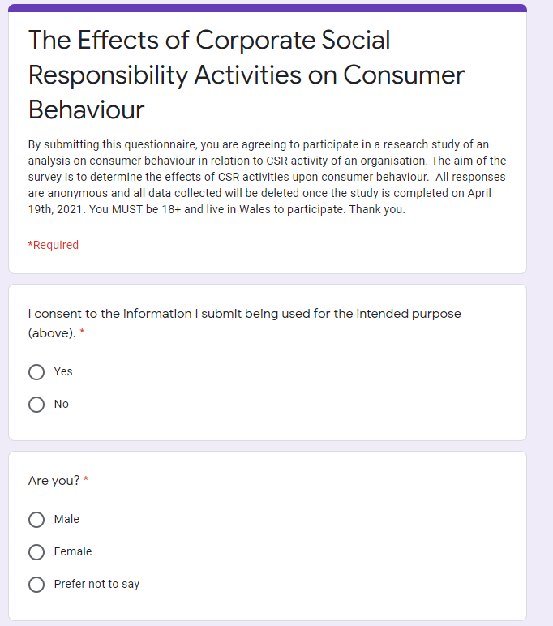

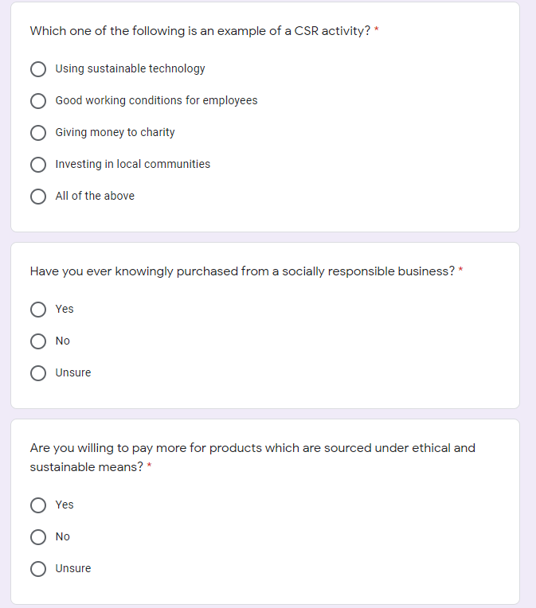

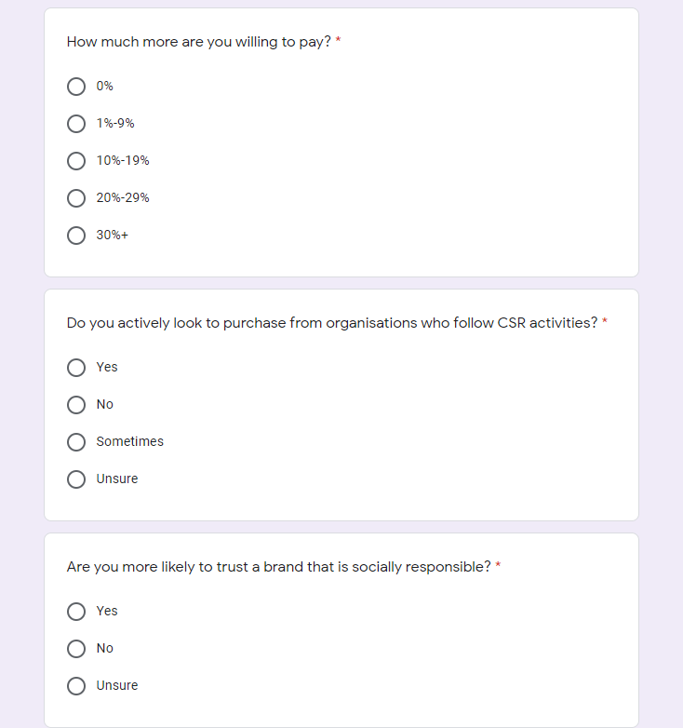

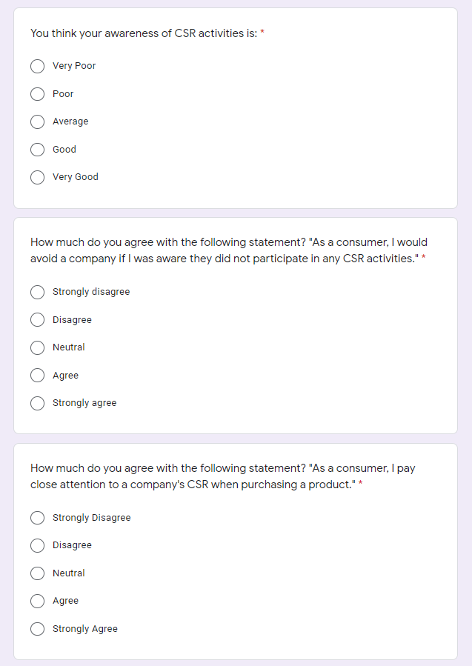

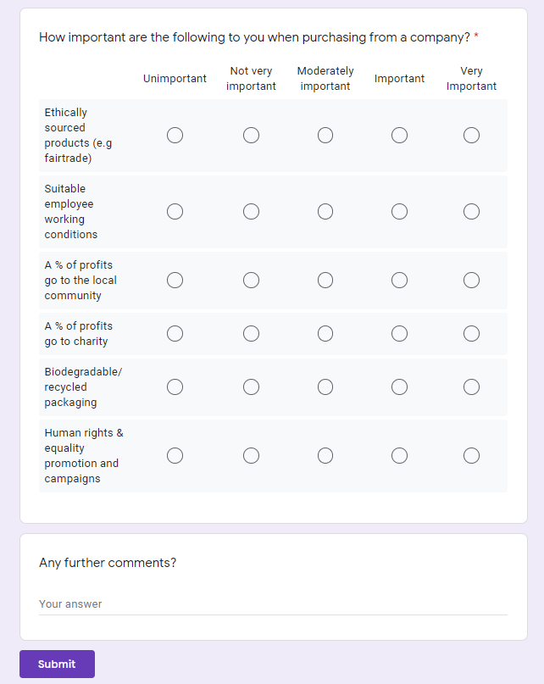
Appendix B- Ethics Form
APPLICATION FOR ETHICAL APPROVAL

In order for research to result in benefit and minimise risk of harm, it must be conducted ethically. A researcher may not be covered by the University’s insurance if ethical approval has not been obtained prior to commencement.

The University follows the OECD Frascati manual definition of research activity: “creative work undertaken on a systematic basis in order to increase the stock of knowledge, including knowledge of man, culture and society, and the use of this stock of knowledge to devise new applications”. As such this covers activities undertaken by members of staff, postgraduate research students, and both taught postgraduate and undergraduate students working on dissertations/projects.

The individual undertaking the research activity is known as the “principal researcher”.

Ethical approval is not required for routine audits, performance reviews, quality assurance studies, testing within normal educational requirements, and literary or artistic criticism.

Please read the notes for guidance before completing ALL sections of the form.

This form must be completed and approved prior to undertaking any research activity. Please see Checklist for details of process for different categories of application.

Delete the Guidance Notes at the end of the form BEFORE submitting your application

SECTION A: About You (Principal Researcher)
1 | Full Name: |  | Jordan Bryan Evans
2 | Tick all boxes which apply: |  | Member of staff: | ☐ | Honorary research fellow: | ☐
3 | Undergraduate Student | ☒ | Taught Postgraduate Student | ☐ | Postgraduate Research Student | ☐

4 | Institute/Academic Discipline/Centre: | University of Wales Trinity St David
5 | Campus: | Carmarthen
6 | E-mail address: | jordzevz@hotmail.co.uk
7 | Contact Telephone Number: | 07562171384
 | For students:
8 | Student Number: | 1808395
9 | Programme of Study: | BA Business and Management
10 | Director of Studies/Supervisor: | Anthony Burns/ Alex Bell

SECTION B: Approval for Research Activity
1 | Has the research activity received approval in principle?  (please check the Guidance Notes as to the appropriate approval process for different levels of research by different categories of individual) |  | YES | ☒ | NO | ☐
 |  |  |  |  | Date
2 | If Yes, please indicate source of approval (and date where known): Approval in principle must be obtained from the relevant source prior to seeking ethical approval | Research Degrees Committee |  | ☐
3 |  | Institute Research Committee |  | ☐
4 |  | Other (write in) |  | ☐

SECTION C: Internal and External Ethical Guidance Materials
 | Please list the core ethical guidance documents that have been referred to during the completion of this form (including any discipline-specific codes of research ethics, and also any specific ethical guidance relating to the proposed methodology). Please tick to confirm that your research proposal adheres to these codes and guidelines.
1 | UWTSD Research Ethics & Integrity Code of Practice | ☒
2 | UWTSD Research Data Management Policy | ☒
3 |  | ☐

SECTION D: External Collaborative Research Activity
1 | Does the research activity involve collaborators outside of the University? |  | YES | ☐ | NO | ☒
2 | If Yes, please provide the name of the external organisation and name and contact details for the main contact person and confirmation this person has consented to their personal data being shared.as part of this collaboration.
3 | Institution
4 | Contact person name
5 | Contact person e-mail address
6 | Has this individual consented to sharing their details on this form? |  | YES | ☐ | NO |  |  | ☐
7 | Are you in receipt of a KESS scholarship? |  | YES | ☐ | NO |  |  | ☐
8 | Is your research externally funded |  | YES | ☐ | NO |  |  | ☐
9 | Are you specifically employed to undertake this research in either a paid or voluntary capacity? | Voluntary | YES | ☐ | NO |  | ☐
10 |  | Employed | YES | ☐ | NO |  | ☐
11 | Is the research being undertaken within an existing UWTSD Athrofa Professional Learning Partnership (APLP) | If YES then the permission question below does not need to be answered. | YES | ☐ | NO |  |  | ☐
12 | Permission to undertake the research has been provided by the partner organisation | (If YES attach copy)  If NO the application cannot continue | YES | ☐ | NO |  |  | ☐

Where research activity is carried out in collaboration with an external organisation
13 | Does this organisation have its own ethics approval system? | YES | ☐ | NO | ☐
14 | If Yes, please attach a copy of any final approval (or interim approval) from the organisation

SECTION E: Details of Research Activity
1 | Indicative title: | An Investigation into the relationship between corporate social responsibility in motivating consumers to purchase.
2 | Proposed start date of your research (not your course start date): | November 2020 | Proposed end date: | April 2021
3 | Introduction to the Research (maximum 300 words)  Ensure that you write for a Non-Specialist Audience when outlining your response to the three points below:  - Purpose of Research Activity  - Proposed Research Question  - Aims of Research Activity  - Objectives of Research Activity  Demonstrate, briefly, how Existing Research has informed the proposed activity and explain  - What the research activity will add to the body of knowledge  - How it addresses an area of importance.
4 | Purpose of Research Activity  The aim of the study is to investigate whether there is a positive, negative, or negligible correlation between organisations CSR activities and the influence on consumer purchasing patterns. The answer to the question will be considered closely throughout the research.  (this box should expand as you type)
5 | Research Question  An investigation into the relationship between corporate social responsibility in motivating consumers to purchase.  The research study will also look at answering a number of questions in terms of my overall research study such as:  - Do different CSR activities have different affects on motivating consumers to purchasing?  - Which (if any) of the activities is the most effective?  - Is CSR necessary for an organisation?  - Do consumers actively look to purchase from responsible businesses?  - Are social, environmental, or economical activities most effective?  - Can CSR be used as an effective marketing tool?  (this box should expand as you type)
6 | Aims of Research Activity  The aim of the study is to investigate whether there is a correlation between an organisations CSR activity and the influence upon consumer purchasing. I want to find out whether CSR can be used as an effective marketing tool by an organisation (will it attract customers to purchase from an organisation). Also, are there certain activities which are most effective in attracting new customers, what are they?  (this box should expand as you type)
7 | Objectives of Research Activity  See above.  (this box should expand as you type)
8 | Proposed methods (maximum 600 words)  Provide a brief summary of all the methods that may be used in the research activity, making it clear what specific techniques may be used. If methods other than those listed in this section are deemed appropriate later, additional ethical approval for those methods will be needed.
9 | This research study will be conducted via qualitative data collection and analysis. The approach will be most beneficial as it will be gathering consumer opinions and motivations, which is imperative in answering the research aims. The data will be gathered through the use of interviews and questionnaires. The data collected along with secondary literature will be enough to determine whether CSR activities have an impact on consumer purchasing and therefore an impact on organisation sales.  (this box should expand as you type)

10 | Location of research activity  Identify all locations where research activity will take place.
11 | All interviews will be carried out virtually using Microsoft Teams. Questionnaires will be sent out via a survey link which can be answered online.  (this box should expand as you type)
12 | Research activity outside of the UK  If research activity will take place overseas, you are responsible for ensuring that local ethical considerations are complied with and that the relevant permissions are sought. Specify any local guidelines (e.g. from local professional associations/learned societies/universities) that exist and whether these involve any ethical stipulations beyond those usual in the UK (provide details of any licenses or permissions required). Also specify whether there are any specific ethical issues raised by the local context in which the research activity is taking place, for example, particular cultural and/or legal sensitivities or vulnerabilities of participants.
13 | N/A  (this box should expand as you type)

14 | Use of documentation not in the public domain: Are any documents NOT publicly available? | NO | ☒
14 |  | YES | ☐
15 | If Yes, please provide details here of how you will gain access to specific documentation that is not in the public domain and that this is in accordance with prevailing data protection law of the country in question and England and Wales.  (this box should expand as you type)

SECTION F: Scope of Research Activity
1 | Will the research activity include: | YES | NO
2 | Use of a questionnaire or similar research instrument? | ☒ | ☐
3 | Use of interviews? | ☒ | ☐
4 | Use of diaries? | ☐ | ☒
5 | Participant observation with their knowledge? | ☒ | ☐
6 | Participant observation without their knowledge? | ☐ | ☒
7 | Use of video or audio recording? | ☐ | ☒
8 | Access to personal or confidential information without the participants’ specific consent? | ☐ | ☒
9 | Administration of any questions, test stimuli, presentation that may be experienced as physically, mentally or emotionally harmful / offensive? | ☐ | ☒
10 | Performance of any acts which may cause embarrassment or affect self-esteem? | ☐ | ☒
11 | Investigation of participants involved in illegal activities? | ☐ | ☒
12 | Use of procedures that involve deception? | ☐ | ☒
13 | Administration of any substance, agent or placebo? | ☐ | ☒
14 | Working with live vertebrate animals? | ☐ | ☒
15 | Other primary data collection methods, please explain in this box  For example, ‘focus groups’. Please indicate the type of data collection method(s) in this box and tick the accompany box. | ☒ | ☐
16 | Details of any other primary data collection method:  Individual interviews and questionnaires.  (this box should expand as you type) | ☒ | ☐
If NO to every question, then the research activity is (ethically) low risk and may be exempt from some of the following sections (please refer to Guidance Notes).

If YES to any question, then no research activity should be undertaken until full ethical approval has been obtained.

SECTION G: Intended Participants
1 | Who are the intended participants: | YES | NO
2 | Students or staff at the University? | ☒ | ☐
3 | Adults (over the age of 18 and competent to give consent)? | ☒ | ☐
4 | Vulnerable adults? | ☐ | ☒
5 | Children and Young People under the age of 18? (Consent from Parent, Carer or Guardian will be required) | ☐ | ☒
6 | Prisoners? | ☐ | ☒
7 | Young offenders? | ☐ | ☒
8 | Those who could be considered to have a particularly dependent relationship with the investigator or a gatekeeper? | ☐ | ☒
9 | People engaged in illegal activities? | ☐ | ☒
10 | Others (please identify specifically any group who may be unable to give consent) please indicate here and tick the appropriate box. | ☐ | ☒
11 | Other – please indicate here:  (this box should expand as you type) | ☐ | ☒

12 | Participant numbers and source  Provide an estimate of the expected number of participants. How will you identify participants and how will they be recruited?
13 | How many participants are expected? | (this box should expand as you type)
14 | Who will the participants be? | Mixed demographic- male/ female over the age of 18.  (this box should expand as you type)
15 | How will you identify the participants? | Participants will be known to the researcher.  (this box should expand as you type)

16 | Information for participants: | YES | NO | N/A
17 | Will you describe the main research procedures to participants in advance, so that they are informed about what to expect? | ☒ | ☐ | ☐
18 | Will you tell participants that their participation is voluntary? | ☒ | ☐ | ☐
19 | Will you obtain written consent for participation? | ☒ | ☐ | ☐
20 | Will you explain to participants that refusal to participate in the research will not affect their treatment or education (if relevant)? | ☐ | ☐ | ☒
21 | If the research is observational, will you ask participants for their consent to being observed? | ☐ | ☐ | ☒
22 | Will you tell participants that they may withdraw from the research at any time and for any reason? | ☒ | ☐ | ☐
23 | With questionnaires, will you give participants the option of omitting questions they do not want to answer? | ☒ | ☐ | ☐
24 | Will you tell participants that their data will be treated with full confidentiality and that, if published, it will not be identifiable as theirs? | ☒ | ☐ | ☐
25 | Will you debrief participants at the end of their participation, in a way appropriate to the type of research undertaken? | ☒ | ☐ | ☐
26 | If NO to any of above questions, please give an explanation
27 | No observational research required.  (this box should expand as you type)

28 | Information for participants: | YES | NO | N/A
29 | Will participants be paid? | ☐ | ☒ | ☐
30 | Is specialist electrical or other equipment to be used with participants? | ☐ | ☒ | ☐
31 | Are there any financial or other interests to the investigator or University arising from this study? | ☐ | ☒ | ☐
32 | Will the research activity involve deliberately misleading participants in any way, or the partial or full concealment of the specific study aims? | ☐ | ☒ | ☐
33 | If YES to any question, please provide full details
34 | (this box should expand as you type)

SECTION H: Anticipated Risks
1 | Outline any anticipated risks that may adversely affect any of the participants, the researchers and/or the University, and the steps that will be taken to address them.  If you have completed a full risk assessment (for example as required by a laboratory, or external research collaborator) you may append that to this form.
2 | Full risk assessment completed and appended? |  | Yes | ☐
2 |  |  | No | ☒
3 | Risks to participants  For example: emotional distress, financial disclosure, physical harm, transfer of personal data, sensitive organisational information
4 | Risk to Participant:  No risks to the participant, interviews and questionnaires will be completed online.  (this box should expand as you type) | How will you mitigate the Risk to Participant  (this box should expand as you type)
5 | If research activity may include sensitive, embarrassing or upsetting topics (e.g. sexual activity, drug use) or issues likely to disclose information requiring further action (e.g. criminal activity), give details of the procedures to deal with these issues, including any support/advice (e.g. helpline numbers) to be offered to participants. Note that where applicable, consent procedures should make it clear that if something potentially or actually illegal is discovered in the course of a project, it may need to be disclosed to the proper authorities
N/A

(this box should expand as you type)
6 | Risks to investigator  For example: personal safety, physical harm, emotional distress, risk of accusation of harm/impropriety, conflict of interest
 | Risk to Investigator:  N/A  (this box should expand as you type) | How will you mitigate the Risk to Investigator:  (this box should expand as you type)
7 | University/institutional risks  For example: adverse publicity, financial loss, data protection
 | Risk to University:  N/A  (this box should expand as you type) | How will you mitigate the Risk to University:  (this box should expand as you type)

8 | Disclosure and Barring Service
9 | If the research activity involves children or vulnerable adults, a Disclosure and Barring Service (DBS) certificate must be obtained before any contact with such participants. | YES | NO | N/A
10 | Does your research require you to hold a current DBS Certificate? | ☐ | ☒ | ☐

SECTION I: Feedback, Consent and Confidentiality
1 | Feedback  What de-briefing and feedback will be provided to participants, how will this be done and when?
Once participants have been agreed to take part in an interview, I will provide them with a participation consent form and fact sheet providing information on the nature of the study and what I aim to gain from their feedback. I will ensure participants are fully aware of the aims of my research, and they know the information they give me will contribute to my findings which will be used in my dissertation paper.

(this box should expand as you type)
2 | Informed consent  Describe the arrangements to inform potential participants, before providing consent, of what is involved in participating. Describe the arrangements for participants to provide full consent before data collection begins. If gaining consent in this way is inappropriate, explain how consent will be obtained and recorded in accordance with prevailing data protection legislation.
Prior to undertaking interviews, participants will be given a copy of the participation form to read and sign electronically due to covid restrictions.

(this box should expand as you type)
3 | Confidentiality / Anonymity  Set out how anonymity of participants and confidentiality will be ensured in any outputs. If anonymity is not being offered, explain why this is the case.
Interviewee and questionnaire participation will be kept confidential and anonymity will be given to each participant and their information will be protected by myself. Interviews will be recorded/ transcribed and will be deleted once my dissertation has been completed.

(this box should expand as you type)

SECTION J: Data Protection and Storage
In completing this section refer to the University’s Research Data Management Policy and the extensive resources on the University’s Research Data Management web pages (http://uwtsd.ac.uk/library/research-data-management/).
1 | Does the research activity involve personal data (as defined by the General Data Protection Regulation 2016 “GDPR” and the Data Protection Act 2018 “DPA”)? | YES | NO
 | “Personal data” means any information relating to an identified or identifiable natural person (‘data subject’). An identifiable natural person is one who can be identified, directly or indirectly, in particular by reference to an identifier such as a name, an identification number, location data, an online identifier or to one or more factors specific to the physical, physiological, genetic, mental, economic, cultural or social identity of that natural person. | ☐ | x☐
2 | If YES, provide a description of the data and explain why this data needs to be collected:
 | (this box should expand as you type)
3 | Does it involve special category data (as defined by the GDPR)? | YES | NO
 | “Special category data” means sensitive personal data consisting of information as to the data subjects’ –  (a) racial or ethnic origin,  (b) political opinions,  (c ) religious beliefs or other beliefs of a similar nature,  (d) membership of a trade union (within the meaning of the Trade Union and Labour Relations (Consolidation) Act 1992),  (e) physical or mental health or condition,  (f) sexual life,  (g) genetics,  (h) biometric data (as used for ID purposes), | ☐ | x☐
4 | If YES, provide a description of the special category data and explain why this data needs to be collected:
 | (this box should expand as you type)

5 | Will the research activity involve storing personal data and/or special category data on one of the following: | YES | NO
6 | Manual files (i.e. in paper form)? | ☐ | ☒
7 | University computers? | ☐ | ☒
8 | Private company computers? | ☐ | ☒
9 | Home or other personal computers? | ☒ | ☐
10 | Laptop computers/ CDs/ Portable disk-drives/ memory sticks? | ☒ | ☐
11 | “Cloud” storage or websites? | ☒ | ☐
12 | Other – specify: | ☐ | ☐
13 | For all stored data, explain the measures in place to ensure the security of the data collected, data confidentiality, including details of password protection, encryption, anonymisation and pseudonymisation:
The security of data is ensured as all data will be stored on a password encrypted laptop, making it very difficult for someone to access the data. Regardless of this, questionnaire results will be completely anonymous, meaning the data cannot be used to harm any of the participants.

(this box should expand as you type)
14 | All Data Storage
15 | Will the research activity involve any of the following activities: | YES | NO
16 | Electronic transfer of data in any form? | ☐ | ☒
17 | Sharing of data with others at the University? | ☐ | ☒
18 | Sharing of data with other organisations? | ☐ | ☒
19 | Export of data outside the European Union or importing of data from outside the UK? | ☐ | ☒
20 | Use of personal addresses, postcodes, faxes, emails or telephone numbers? | ☐ | ☒
21 | Publication of data that might allow identification of individuals? | ☐ | ☒
22 | Use of data management system? | ☐ | ☒
23 | Data archiving? | ☐ | ☒
24 | If YES to any question, please provide full details, explaining how this will be conducted in accordance with the GDPR and DPA (and/or any international equivalent):
 | (this box should expand as you type)
25 | List all who will have access to the data generated by the research activity:
The researcher only.

(this box should expand as you type)
26 | List who will have control of, and act as custodian(s) for, data generated by the research activity:
The researcher only.

(this box should expand as you type)
27 | Give details of data storage arrangements, including security measures in place to protect the data, where data will be stored, how long for, and in what form. Will data be archived – if so how and if not why not.
No data will be archived after the dissertation is completed. Once all of the results from the questionnaire have been gathered, stored and interpreted they will no longer be needed and cn be disposed of. All information will also be password protected making sure for extra security.

(this box should expand as you type)
28 | Please indicate if your data will be stored in the UWTSD Research Data Repository (see https://researchdata.uwtsd.ac.uk/ ). If so please explain. (Most relevant to academic staff)
N/A

(this box should expand as you type)
29 | Confirm that you have read the UWTSD guidance on data management (see https://www.uwtsd.ac.uk/library/research-data-management/) | YES | ☒
29 |  | NO | ☐
30 | Confirm that you are aware that you need to keep all data until after your research has completed or the end of your funding | YES | ☒
30 |  | NO | ☐

SECTION K: Declaration
31 | The information which I have provided is correct and complete to the best of my knowledge. I have attempted to identify any risks and issues related to the research activity and acknowledge my obligations and the rights of the participants.  In submitting this application I hereby confirm that I undertake to ensure that the above named research activity will meet the University’s Research Ethics and Integrity Code of Practice which is published on the website: https://www.uwtsd.ac.uk/research/research-ethics/
 | Signature of applicant: |  | Date: 21/03/21

For STUDENT Submissions:
32 | Director of Studies/Supervisor: | Anthony Burns | Date: 23//03.2021
33 | Signature: |  | Date: 23//03.2021

For STAFF Submissions:
34 | Academic Director/ Assistant Dean: |  | Date:
35 | Signature: |  | Date:

Checklist: Please complete the checklist below to ensure that you have completed the form according to the guidelines and attached any required documentation:
☒ | I have read the guidance notes supplied before completing the form.
☒ | I have completed ALL RELEVANT sections of the form in full.
☒ | I confirm that the research activity has received approval in principle
☐ | I have attached a copy of final/interim approval from external organisation (where appropriate)
☐ | I have attached a full risk assessment (and have NOT completed Section H of this form) (where appropriate) ONLY TICK IF YOU HAVE ATTACHED A FULL RISK ASSESSMENT
☒ | I understand that it is my responsibility to ensure that the above named research activity will meet the University’s Research Ethics and Integrity Code of Practice.
☒ | I understand that before commencing data collection all documents aimed at respondents (including information sheets, consent forms, questionnaires, interview schedules etc.) must be confirmed by the DoS/Supervisor, module tutor or Academic Director.
☐ | I have deleted the guidance notes before submitting the PG2 for consideration

RESEARCH STUDENTS AND STAFF ONLY
All communications relating to this application during its processing must be in writing and emailed to pgresearch@uwtsd.ac.uk , with the title ‘Ethical Approval’ followed by your name.
You will be informed of the outcome of your claim by email; therefore it is important that you check your University and personal email accounts regularly.
STUDENTS ON UNDERGRADUATE OR TAUGHT MASTERS PROGRAMMES should submit this form (and receive the outcome) via systems explained to you by the supervisor/module leader.

