
Digital Placement Passport

Sophia Rabaiotti

Digital Placement Passport

This Digital Placement Passport serves as a portfolio demonstrating my personal, professional, and academic development throughout my university studies. It evidences my placement hours from industry events, field study visits, ship visits, and familiarisation trips undertaken as part of my training. It also includes my professional experience within a travel agency, including my role as a cruise specialist. In addition, it highlights the travel trade training courses I have completed, alongside further development undertaken for my involvement in my role working on Celebrity Cruises in the shore excursion department.

Personal Hours Log and University Engagement
Below is a summary of my professional personal hours log, outlining the wide range of opportunities I have participated in throughout the academic year. Since joining university, I have actively engaged in every opportunity available to develop my industry knowledge and employability skills. These include attending events such as Meet in Wales, ABTA Regional Meeting in Cardiff, London and Paris educational visits, Passion for Hospitality, World Skills, a TikTok marketing workshop, assisting with Terry’s book launch, supporting the Commonwealth Leadership Event, and contributing to the ITT Future You Event panel. These experiences have significantly strengthened my presentation, communication, teamwork, organisation, and problem-solving skills. They have also developed my industry-specific knowledge across travel, tourism, events, marketing, and management.

Activity: | Date: | Duration: | Hours:
Meet in Wales Event | Thursday 16th October 2025 | 1:00pm–3:00pm | 2 hours
ABTA Regional Meeting | Wednesday 22nd October 2025 | 6:00pm–9:00pm | 3 hours
London Educational Visit | Tuesday 4th November – Thursday 6th November 2025 | 2 nights | 20 hours
Passion For Hospitality | Monday 10th November 2025 | 10:00am–3:00pm | 6 hours
TikTok/Business Workshop | Tuesday 18th November 2025 | 10:00am–12:00pm | 2 hours
World Skills Event | Wednesday 26th November 2025 | 12pm–7:00pm | 7 hours
Assistance with Book Launch Event Preparation | Tuesday 9th December 2025 | 2:30pm–6:30pm | 4 hours
Book Launch Day Celebration | Wednesday 10th December 2025 | 9:30am–6:00pm | 8.5 hours
Paris Educational Visit | Friday 16th January – Friday 23rd January 2026 | 7 nights | 40 hours
ITT Future You Set Up | Tuesday 10th March 2026 | 9:00am–6:00pm | 9 hours
ITT Future You Event | Monday 9th March 2026 | 1pm-3:30pm | 3.5 hours
Commonwealth Leadership Event | Monday 2nd February 2026 | 12:00pm–7:00pm | 6 hours

ABTA Student Representative Role
I fortunate to become the ABTA Student Representative, where I attended meetings and engaged with updates and training opportunities. While further opportunities were limited, I remained actively involved and kept up to date with ABTA developments.

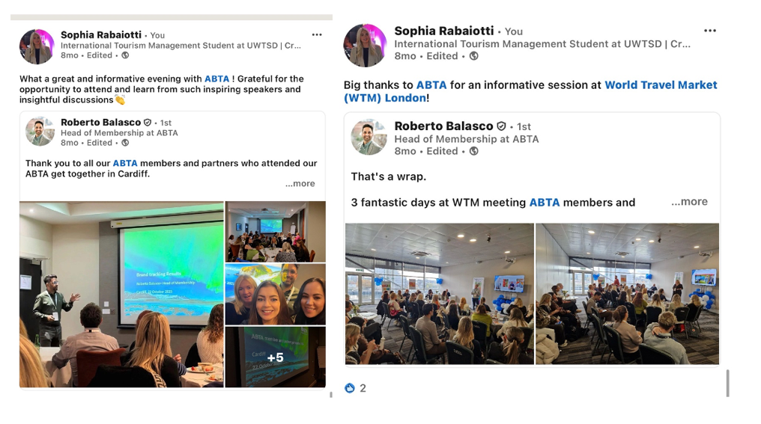

Student Representative Role
As a Class Student Representative, I have attended meetings and represented student feedback through the Student Union. This role has strengthened my communication, leadership, and advocacy skills, ensuring student perspectives are effectively communicated.
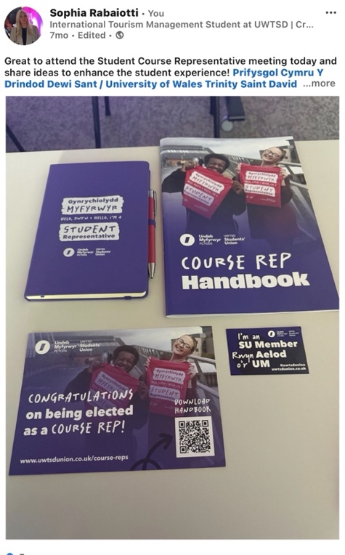

Travel Trade Training and Professional Development
Throughout the academic year, I have completed travel trade training courses covering destinations, hotel chains, cruise companies, and industry organisations including ABTA training. As part of my International Travel Operations module, I was required to complete three self-selected training courses, in addition to the Meet in Wales programme. To further enhance my industry knowledge, I have independently completed additional training courses to ensure my knowledge remains current and relevant, allowing me to better support customers in a professional setting.
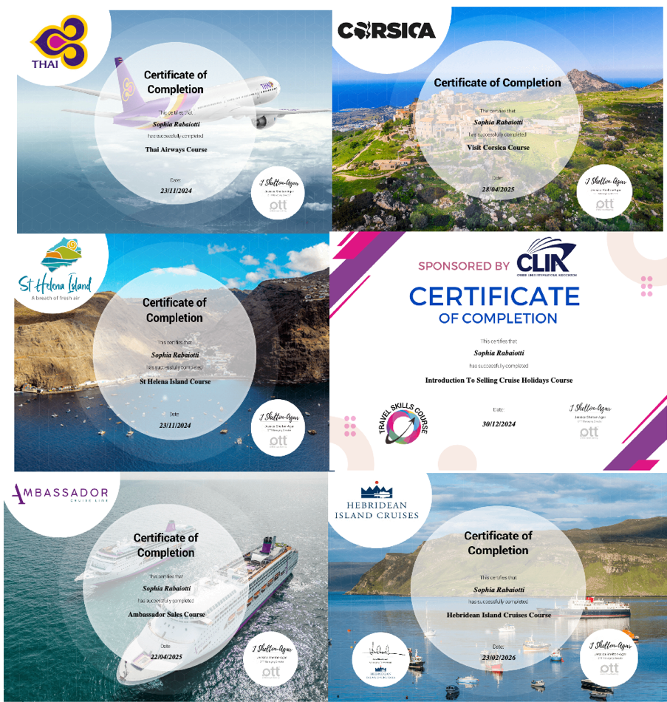

4.0- Industry Visits/ Familiarisation Trips

I have been fortunate to take part in several industry visits, including ship visits to:
- Celebrity Apex
- Azamara Pursuit
- Hebridean Princess

These experiences have provided valuable insight into cruise operations, product knowledge, and customer experience, which I have applied directly in my role as a travel agent, including marketing these experiences through social media.
I have also participated in a sustainability-focused visit to Coal Town Coffee, gaining insight into sustainable business practices within the hospitality industry. Due to my engagement in cruise training, I was selected to participate in a P&O Cruises familiarisation trip to the Mediterranean. This included flying to Malta and completing a 7-day cruise alongside travel professionals from across the UK. This experience allowed me to develop strong destination knowledge, improve customer advisory skills, and gain first-hand experience of itineraries and shore excursions. It has significantly enhanced my ability to support customer decision-making.
I also completed a Fred. Olsen Cruise Lines familiarisation trip to Iceland, where I further developed my cruise knowledge and professional network. Following this experience, I successfully sold a world cruise upon returning to work.
Additionally, I maintain industry connections and contribute travel articles and insights, including engagement with Cruise Trade News.

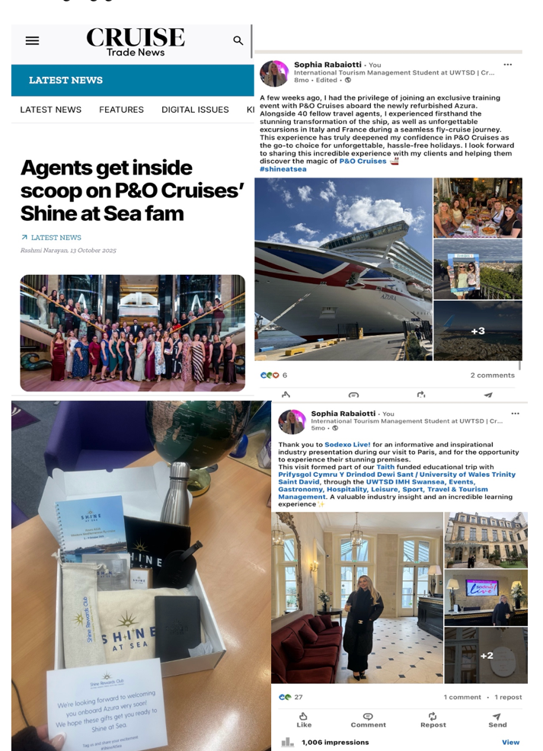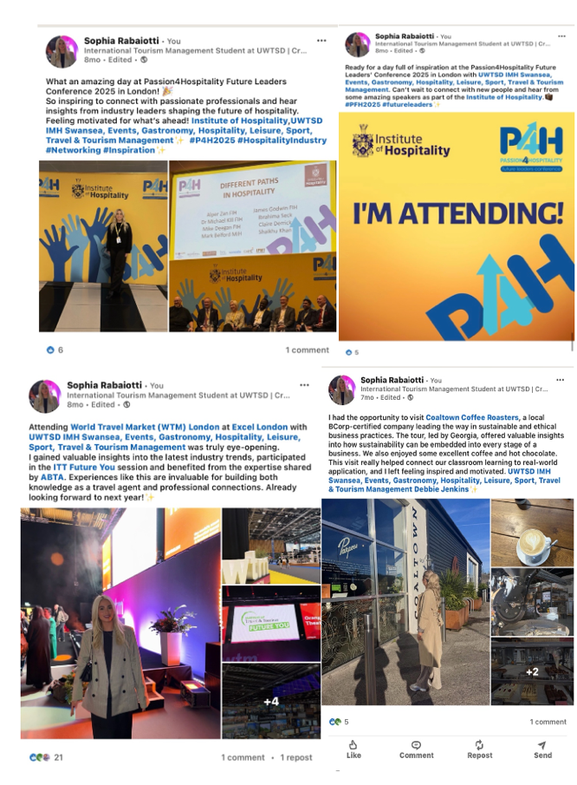

Non-Hourly Recorded Events
Activity: | Date: | Time / Duration: | Hours:
Celebrity Apex Ship Visit | Tuesday 7th September 2025 | 10:00am–3:00pm | 5 hours
Hebridean Princess Ship Visit | Friday 10th September 2025 | 9:00am–2:00pm | 5 hours
P&O Familiarisation Trip | Thursday 2nd October – Wednesday 8th October 2025 | 7 days | 50 hours
Cruise Challenge (Cruise Trade Event) | Wednesday 19th November 2025 | 6:00pm–10:00pm | 4 hours

Role as Cruise Specialist
Alongside my studies I work as a Cruise Specialist within a travel agency, where I have exceeded the required placement hours but chose not to formally register all workplace hours in order to maximise additional industry opportunities.
My responsibilities include:
- Selling and advising on cruise holidays and travel packages
- Managing day-to-day shop operations
- Handling amendments and customer enquiries
- Supporting and training team members

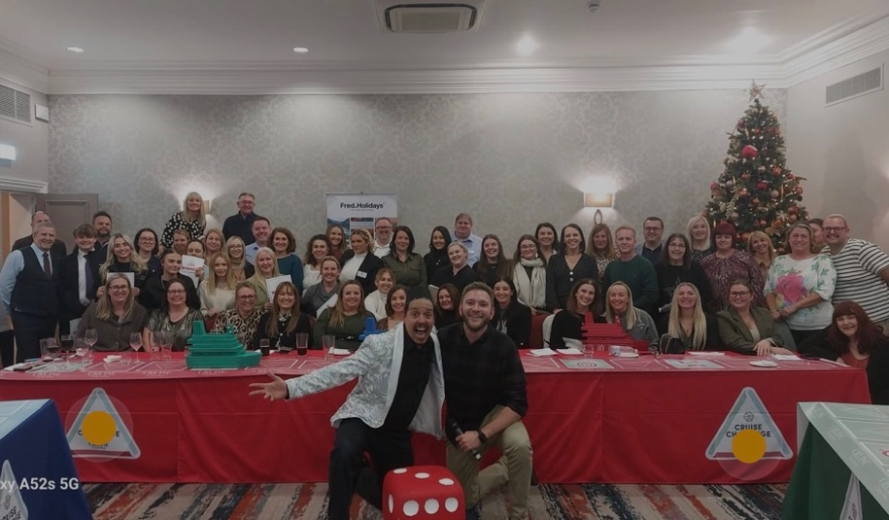

Role on Shore Excursions at Celebrity Cruises
Celebrity Cruises is a premium international cruise line operating luxury cruise holiday’s worldwide. The company provides destination experiences through accommodation, dining, entertainment and carefully planned shore excursions. The Shore Excursions Department is responsible for planning, coordinating and delivering tours safely and efficiently while ensuring high levels of guest satisfaction. I am currently working onboard Celebrity Cruises on the Shore Excursions department. Prior to starting this role, I completed extensive online training, including STCW certification, achieving 100%. Regularly attend fire safety, health and safety, and maritime survival skills. I also completed practical STCW elements such as lifeboat handling, fire drills, and swimming survival training. Since joining working onboard, I have delivered port presentations to guests and colleagues, conducted ship tours and behind-the-scenes experiences, sold shore excursion packages, managed financial spreadsheets and supplier coordination, handled dispatching and debarkation procedures and worked closely with international guests and colleagues
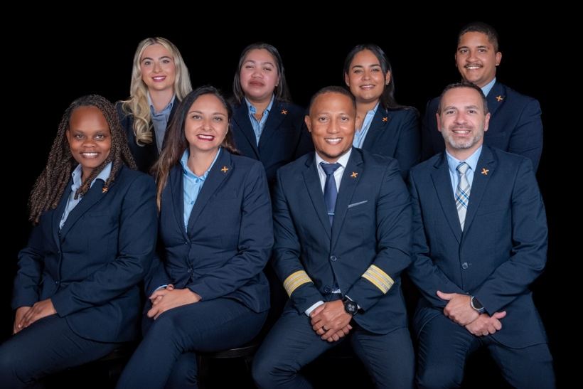
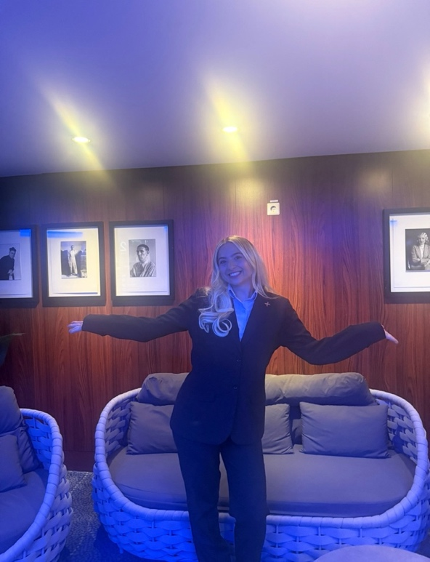
This role has significantly strengthened my communication, confidence, adaptability, and resilience, particularly within a challenging shipboard environment.

