MARKETING FUNDAMENTALS
Name: Aurora Catalina Jipa
Student ID: 1815962
Subject: CONVERSE
Course Name: Marketing Fundamentals

Table of Contents
Introduction 3
Overview of the company 4
Task 1A 6
Stages and process of marketing 6
Role of marketing environment 7
Role of marketing research 8
Role of marketing mix 9
Role and development of marketing in creating values for potential customers 10
Recognition of the relevant stakeholders and their impact on the marketing activity of the organization 11
Task 1B 12
Conclusion 14
References 15

Introduction
Fundamentals of marketing encompass the core process of promoting, selling and researching about the market for specific products and services to the targeted audience. Integrating effective marketing process enables an organization to sustain new ideas for product development, brand recognition, cost-saving and increased sales. The study discusses the different fundamentals of marketing and its impact on the operations and functioning of the company. To maintain the credibility of the study, all the relevant facts are based on the Converse brand, subsidiary of Nike.

Overview of the company
The converse is an American company that deals in shoe manufacturing and other sporting accessories. From the year 2003, the company has been a subsidiary company of Nike Inc. The company operates its stores in approx. 100 locations within the U.S. The revenue of Converse has been evaluated to be about 1.91 billion US Dollar.

Figure 1: Revenue Scale of Converse Brand
(Source: Porral and Stanton, 2017)

As opined by Porral and Stanton, (2017), due to the strong rivalry faced by Adidas, Converse has adhered to face challenges in sustaining growth in the US market, leading to sinking the revenue. Thus, this could be difficult for the company to promote and launch its new team arrival collection, Forever Chuck and Chuck Modern.
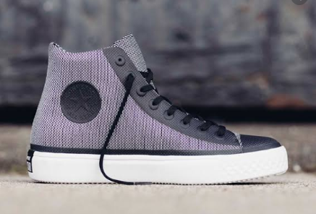
Figure 2: Chuck Modern
(Source: Porral and Stanton, 2017)

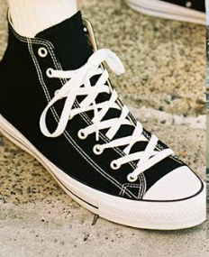
Figure 3: Forever Chuck
(Source: Porral and Stanton, 2017)

Task 1A

Stages and process of marketing
It has been evaluated that to sustain success from the new product launch of Chuck Modern and Forever Chuck, Converse would have to pass through different stages of business lifecycle while encountering with diverse challenges that required differentiate tactics and strategy. As opined by Wilson et al., (2018), development stage, start-up stage, survival stage, expansion stage along with maturity stage are the identified stages that are experienced by every company when it promotes its product into new markets or else new product in the existing market.
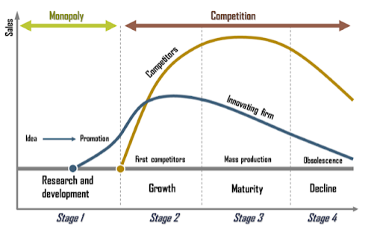
Figure 4: Different stages of marketing
(Source: Wilson et al., 2018)
As opined by Luca et al., (2016), at the introduction stage, high cost is incurred on the promotion of the product, with no profit. The desired result if rendered from the promotional activity would be considered as a profit for the company at its first stage. According to Upadhyaya et al., (2019), when the company sustain accurate response, by increasing the sales and revenue of the promoted product, the company tends to enter into the growth stage of marketing. Once the product has successfully sustained customer base in the market, it tends to gain maturity stages. It has been evaluated that at this stage of marketing, the company would achieve a competitive edge, profitability and brand recognition in the market. As depicted by Palmatier and Crecelius, (2019), the changing taste and preferences of the customers are frequent which leads the company to face declining stages. This stage arises due to a shift in customer’s interest, technological advancement and competition.
In the matter of Converse, it can be evaluated that the company would sustain growth stage for its new arrival. Despite the high brand value of Adidas, Converse name is also created popularity in the US market from its sports accessories and sneakers. Also, it can be determined that if the company implement an effective marketing strategy, the company would be able to maintain the maturity stage for the long run, before falling into the declining stage.
As depicted by Staub and Bruhn, (2017), effective collaboration of product lifecycle management is essential for every company to sustain long term success and growth of the product. For its new arrival, Converse can integrate with consolidating necessary information about the market at a central location; establish internal collaboration for improved productivity along with maintaining external communication.

Role of the marketing environment
According to Dimitriadis et al., (2018), the marketing environment is the combination of both internal and external factors of the business environment that highly influences the operation and functioning of the company. Thus, Converse needs to collaborate with both external (demographic, physical, economic, technological and political) and internal factors (public, customer, competitors, suppliers and other market intermediaries), to sustain growth and success for its new arrival. It has been evaluated the maintaining effective collaboration with all the environmental factors, Converse can overcome its marketing issues in the US market. As per the views of Antric et al., (2019), understanding internal and external environmental factors is essential for every business units to plan strategies for the future. Marketers of Converse must be aware of the current dynamism and scenario of marketing environment by the time of promoting new arrivals in the US market. This would help the company understands the needs of its potential customers, collaborate with the tapping trends and identify arising opportunity and threat. Based on the opinion of Resnick et al., (2016), with effective collaboration of marketing environment, companies successfully sustain competitive edge as they understand strategies and methods integrated by the rivalries, creating high competition ambience.
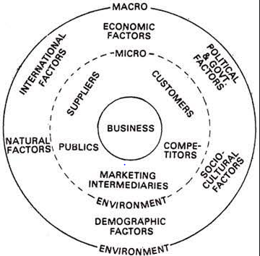
Figure 5: Marketing Environment
(Source: Resnick et al., 2016)

Role of marketing research
According to Hastings and Domegan, (2017), the major role of marketing research is to render management by providing reliable, valid and accurate information on the marketing condition. It has been evaluated that increase in the cost and competitive marketing sometimes attributes inappropriate decision-making process and hence requires support from marketing research for sound information. With the help of accurate marketing research, Converses would be able to frame its product policies and design along with executing a marketing strategy. As opined by Freberg, (2017), with the marketing research company can identify a suitable location to promote its product while sustaining success and profitability. In the matter of Converses, the company would successfully reduce and control its distribution cost along with analysing the merchandising line. Marketing research is also found to be effective in aspects to an advertisement like for, budget appropriation, placement of advertisements along with measuring the effectiveness of the advertisement process. Finally, Converses with the integration of marketing research would be able to collaborate with internal and external management.

Role of the marketing mix
The role of the marketing mix tool is determined to be ideal for both the company and the economy. As per the case of Converses, in introducing new arrivals, marketing mix strategy would help the company to promote valuable guides about resource allocation. With the help of marketing mix strategy, the company can improve its creative allocation of responsibilities to the marketing team. According to Wolter et al., (2016), integrating with the marketing mix strategy, would provide an opportunity to marketers concerning cost benefits elasticity. Thus, with effective integration of marketing strategy, Converses would be able to facilitate the communication process.
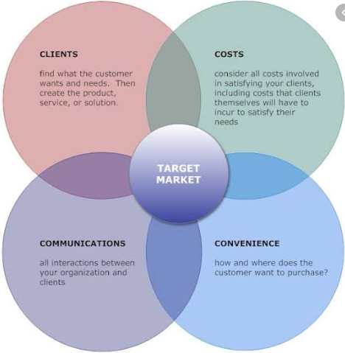
Figure 6: Marketing Mix
(Source: Wolter et al., 2016)

Role and development of marketing in creating values for potential customers
According to Pearson, (2016), marketing is a set of diverse activity which involves exchanging, communication, offering, delivering along with creating values in the market. Thus, in the case of Converses, bring values to its potential customers are identified as a major objective. As per the observation of Kumar and Reinartz, (2016), every business unit focuses on retaining its potential customers, which is found to be possible with the help of marketing. Thus, with an effective strategic marketing plan, Converses would be able to sustain its objective beyond selling products, advertisement along with collecting money. As per the views of Gashti, (2017), every business unit needs to sustain profitability along with sustainability, which would be possible if the products that are offered in the market are successfully rendering values to its customers. Thus, marketing is the sources which help the company to generate the values by building connections and between the products and public, companies and customers.
The values of the products to potential customers can be created by integrating three necessary steps which include: identifying customer’s needs, satisfy customers and retaining customers. In the matter of integrating promotional and marketing strategy for its new arrival, Chuck Modern and Forever Chuck, Converses must collaborate with all the three steps to sustain profitability and customer loyalty while creating values for its potential customers. It has been stated by Erkmen and Hancer, (2018), when the company understands the needs and demands of its customers, its can successfully compile with the necessary marketing strategies that would guide the audiences to sustain necessary information related to the usage and benefits of the products. Under the factors of satisfying customers, the company needs to make its product available at the right place and at the right time. The new arrivals of Converses are produced, targeting the youngsters in the US. Thus, to create values of the product to its targeted customers, companies can adapt the marketing tools like; digital and social media marketing as the major volume of youngsters are evolved and depend on social media and digital channels to know about the availability and usage of new products in the market. The customers need to know that the product would help them satisfy their specific needs of sports foot swears. This in return would help the company to provide a logical reason to its customers to maintain their interest in the brand.

Recognition of the relevant stakeholders and their impact on the marketing activity of the organization
It has been evaluated that Converses collaborates with Corporate social responsibility (CSR) policies to maintain the values of its major stakeholders. This is a technique with the help of which company become popular and sustains customer loyalty in the high competition market. As stated by Shobeiri et al., (2018), the sales performance and brand image of Converse's equipment and sports apparel are subjected significantly to the efforts and actions of their stakeholders. Thus, some of the major stakeholders of the company along with their impact on the company are explained below:

Stakeholders | Their impacts on marketing activities
Customers and communities | Customers are a top priority of the company for which the company integrates with promotional and marketing activities. With the marketing activity, the customers are influenced the most like the customers successfully exhibit how the product would render those values. The other impact that customers render through marketing is they get all the necessary information about the product for price, usage and other details. With the help of marketing, a company can promote its brand name to the community while sustaining customer base. This helps the company to generate sales and revenue from its products. Thus, when the company with its marketing activities successfully sustain customer loyalty, the customers then influences the potential customers so that they can gain benefits from that respective product
Employees | It has been evaluated that if the company successfully integrates marketing activity, the company then sustains strong brand recognition in the market, which in the aspect of mutual benefits employees are also recognized with the brand's names in the market. Also, if because of any employee’s performance the company renders success in its marketing activities, they are appraised for their performance which ultimately encourages and motivates them while achieving job satisfaction.
Government | With the marketing activities Government analysis the values of products that would be offered by the company to the public. Also, if due to effective marketing activity the total revenue of the company is increased, the overall rate of GDP that is economy would be increased. This would influence the government to focus more on improving the infrastructure of the company.
Table 1: stakeholders of Converse and Impacts of marketing activity to them
(Source: Developed by the Learner)

Task 1B
After analysing the significance of marketing and promotion for the Converse to launch its new arrival, Chuck Modern and Forever Chuck, in the market of US, for the youngsters who are interested in sports, certain communication tools and techniques are found to be most effective. Social intranet, internal blogs, WhatsApp, digital marketing and ez Talksmeeting are found to be most suitable for the company Converses. As per my opinion that company, with the collaboration of the above-mentioned communication techniques, can widespread necessary information about the product while creating huge customers base. After analysing the facts, it has been observed by me that the USA is a country with a high population of youngsters, besides the new arrivals of Converse, are produced targeting the youth of the country interested in sports and other physical activity. Thus, most of the information about the new establishment of products is received with the help of social and intranet. Converses can display all the information about the product on the social intranet that would help the company to communicate and connect with their potential customers most cheaply. Besides, with the help of WhatsApp also the company can directly easily connect with their customers. However, this method includes less scope to promote the product.
ezTalksMeeting is another effective tool for communication that is found to be effective for business communication. With the help of this tool, a company can influence its major stakeholders with face to face conversation. However, after analysing the brand position, blogging techniques are most preferable for the company ads this enables the company to accurately exhibit the values that are offered by the company to its potential customers. With the help of posting business blogs, Converses would be able to increase traffic to its official websites. As per my views blogging is an effective communication business tool which sustains comprehensive guide to the potential customers about the usage and values of the product due to which there arises a chance for the company to gain competitive advantages. It has been evaluated that Converses creates blogs with the launching of their new product introduced in the market. The blogs that are created by the company are found to be very beneficial as the same contents are utilized by the company to share information on the social media network. Thus, the blog contents used by the company into their social media without a repository of the contents. Besides, the blogging technique helps the company to convert traffic into the lead. The blogs that are written by Converses are found to establishing authority as from there the customers can gain answers for every question related to brand, company's profile and product. These techniques, on the other hand, are considered as a handy tool for Service and Sales professional of the company. It has been evaluated that 90% of the company depends on blogs as a business communication tool to connect with their potential customers. 70% among the 90% business is evidenced to sustain growth and success due to posting blog.

Conclusion
The company to sustain growth and success required to collaborate with marketing strategy when it comes to business development, petitioning market shares and market penetration. It can be evaluated that with the integration of effective marketing strategy, Converse can sustain customer loyalty by creating huge values from its product, reduce compliance risks concerning sales, legal action, reduce costs associated with products and improvement in productivity activity. Also, adapting adequate marketing communication tool, internal efficiency to suppliers, customers, employees and other stakeholder’s increases.

References
Antric, T., McKie, D. and Toledano, M., 2019. Soul searching: Public relations, reputation and social marketing in an age of interdisciplinarity. Public Relations Review, p.101827.
Dimitriadis, N., Ney, J. and Dimitriadis, N.J., 2018. Advanced Marketing Management: Principles, Skills and Tools. Kogan Page Publishers.
Erkmen, E. and Hancer, M., 2018. Creating value for restaurant customer: The role of other customers in dining experience. In Tourist Behavior (pp. 157-171). Springer, Cham.
Freberg, K., 2017. Social Media Campaigns: Strategies for Public Relations and Marketing. Journalism & Mass Communication Educator, 72(4), pp.480-481.
Gashti, J.Z., 2017. Study of the Impact of Relationship Marketing on the Customer Attitude with Emphasis on the Role of Advertising Effectiveness. The Journal of Internet Banking and Commerce, pp.1-16.
Hastings, G. and Domegan, C., 2017. Systems social marketing. In Social Marketing (pp. 291-309). Routledge.
Kumar, V. and Reinartz, W., 2016. Creating enduring customer value. Journal of Marketing, 80(6), pp.36-68.
Luca, N.R., Hibbert, S. and McDonald, R., 2016. Towards a service-dominant approach to social marketing. Marketing Theory, 16(2), pp.194-218.
Palmatier, R.W. and Crecelius, A.T., 2019. The “first principles” of marketing strategy. AMS Review, 9(1-2), pp.5-26.
Pearson, S., 2016. Building brands directly: creating business value from customer relationships. Springer.
Porral, C.C. and Stanton, J.L., 2017. Principles of marketing. ESIC Editorial.
Resnick, S.M., Cheng, R., Simpson, M. and Lourenço, F., 2016. Marketing in SMEs: a “4Ps” self-branding model. International Journal of Entrepreneurial Behavior & Research, 22(1), pp.155-174.
Shobeiri, S., Mazaheri, E. and Laroche, M., 2018. Creating the right customer experience online: The influence of culture. Journal of Marketing Communications, 24(3), pp.270-290.
Staub, C.M. and Bruhn, K.B., 2017. Content Marketing: Ideas for programming to meet industry demand. Teaching Journalism & Mass Communication, 7(2), pp.60-62.
Upadhyaya, S., Hughes, M.Ü. and Houston, H.R., 2019. Using Sustainability as a Framework for Marketing Curricula and Pedagogy. Journal of Sustainability Education, 20.
Wilson, E.J., McCabe, C. and Smith, R.S., 2018. Curriculum innovation for marketing analytics. Marketing Education Review, 28(1), pp.52-66.\
Wolter, J., Barth, V., Barthel, E.M., Gröbel, J., Linden, E., Wolf, Y. and Walther, E., 2016. Inside the host's mind: psychological principles of viral marketing. International Journal of Internet Marketing and Advertising, 10(1-2), pp.54-89.

