


Is there a Correlation Between Adverse Childhood Experiences and Serious Offenders?

Name: Sam Thomas
Module Number: BMPL6008

Declarations
This work has not previously been accepted in substance for any degree and is not being concurrently submitted in candidature for any degree.
This dissertation is being submitted in partial fulfilment of the requirements for the degree of BA/BSc.
This dissertation is the result of my own independent work/investigation, except where otherwise stated.
Other sources are acknowledged in the Reference Section.
I hereby give consent for my dissertation, if accepted, to be available for photocopying and for interlibrary loan, and for the title and summary to be made available to outside organisations.
I hereby give consent for my dissertation, if accepted, to be available on the university’s IT system to those who have consent to use the system.

Student’s Name: Sam Thomas

Signed: Sam Thomas

Date: 6th May 2022

Acknowledgements
I would like to express my deepest appreciation to Rhiannon Lloyd for her help in pushing myself to do better in this piece of work and her valuable advice she gave me throughout writing this work and for her relentless support. I’d like to recognize the help that I received from Jane Thomas for her helpful advice.

Contents
1. Introduction (700)
Introduction to ACEs
Why this topic
Summary of Research Objectives
Theoretical Context
2. Literature Review (2500)
Objective 1
Objective 2
Objective 3
3. Research Methodlogy (1700)
Intoroduction of Methods
Method of Primary Research
Qualitative and Quantitative Data
Data Analysis Methods
Limitations of Research Method
4. Findings (2000)
5. Conclusion (800)
6. References
7. Appendix

Introduction
The definition on what an adverse childhood experience (ACE) is hard to find as different types of literature phrase it in different ways. Public Health Wales has described it as “ACE’s are stressful experiences occurring during childhood that directly hurt a child” (Public Health Wales, 2015). However, if we look at a more detailed definition it says an ACE are events or situations that are extremely stressful and potentially traumatic and occur throughout childhood and/or adolescence. (NHS,2021). It might be a single incident or a series of threats to the young person's safety, security, trust, or bodily integrity (NHS, 2021). The problem with trying to define what an ACE means is that many people word it differently or explain it in a completely different context, for example the NHS and Public Health Wales explained it in the same context as they are from the same sort of area, but if we look at this definition which describes ACEs as complicated early stresses that may alter normal developing processes (Sheffler, Stanley and Sachs-Ericsson, 2020). ACEs disturb the development of adaptive emotion control systems by altering psychological interpretations and beliefs, as well as altering the shape and function of important brain regions (Sheffler, Stanley and Sachs-Ericsson, 2020)
This topic needs to be discussed due the amount of re offending in the UK. The overall proven reoffending rate was 29.0% for the April to June 2020 offender cohort and this represents the largest year-on-year increase in the timeseries, an increase of 2.7 percentage points from the same quarter in 2019 (Ministry of Justice, 2022). This clearly shows that reoffending is more common than ever. The reason for specifying ACE is to see if there is a link to ACEs and offenders who continue to commit crimes and to see if ACEs play a big part in their actions.
There are three different objectives that are needed to be completed from the research that is gathered.
- The first objective is to understand the public’s perception on ACEs in England and Wales. The reason for this is to see if people’s perceptions of ACEs affect the way they are treated, and to see if this could lead to their behaviour.
- The second objective is to analyse what long term effects do ACEs have on a person and how common they are. The reason for this objective is to find out how devasting ACEs can be to a person and find out how common they are, this is to see if it could be a reason why there are so many crimes being committed each year compared to how many people have an ACE or ACEs.
- The final objective is to understand the connecting variables between ACEs and serious offenders and the reason for this objective is to see whether there is a link between offending and ACEs, so that there is a better understanding of the link, for people to get better help and then to come up with measures which combat the problem.
Theories are developed to explain, predict, and comprehend occurrences, as well as to question and extend current knowledge within the confines of crucial confining assumptions in many situations. The theoretical framework is the framework that may hold or support a research study's theory (Abend, 2008). In this case, the Prison ACE Survey will be a focal point of the theoretical context as this is the only type of research in this field of topic and is like some of the main focal points that will be presented after primary research is gathered, as most other papers and surveys are about the link between diseases and ACEs. Also, there has been a lot of research conducted by Public Health Wales with Bangor University about Adverse Childhood Experiences and these will be used to find links and complete the objectives above. Lastly, other extensive research will be conducted via looking at journals, reports and books on this matter to get a broad idea on whether there is a link or not before primary research is gathered in order to guide the process.

Literature Review
The many aspects of Adverse Childhood Experiences (ACEs) have been researched widely and intensely. However, only within the past three decades have there been literature which focuses just on ACEs and the effects it has on people. Since the first ever ACE study which was conducted from 1995-97, there have been many scholarly articles, journals, research and studies on multiple aspects on this subject.
When we look at the perception of ACEs and what people think about it, it can be a major problem for several reasons. As there has not been an official study into the matter, when it comes to public opinion it is hard to judge however, there has been surveys to determine whether there is a stigma or not. A study did have findings that show interpersonal stigma and parental blame for ACEs were common, with 25% percent of respondents hesitant to have a close co-worker with “a lot of ACEs” (Purtle, Nelson and Gollust, 2021). As there hasn’t been much research in ACEs and public perception specifically, there isn’t a lot of information about it out there. However, there are common types of ACEs such as drug abuse and domestic abuse in which there has been plenty of research on. If we look at the public’s perception of drug abuse, there is a stigma around it. Two separate studies concluded that the public perception of drug abuse is mostly negative, and that seeking help is difficult because of this (Tucker, Foushee and Simpson, 2008) (Johns Hopkins Bloomberg School of Public Health, 2014). There was also a clear misconception on drug addiction and abuse with many people being ‘narrow minded’ and this shows from a study which states that “42% of respondents agreed that a lack of self-discipline and willpower was a main cause of drug dependence, and 37% agreed that if drug dependent individuals really wanted to stop using, they would be able to” (The Scottish Government, 2016). Negative representations of drug users in politics and the media enhance the public impression that drug usage is unethical and that drug users are a danger to society. This heightens the stigma and discrimination associated with drug users even more (Global Commission on Drug Policy, 2017). Even though seeing drug abuse while growing up only accumulates around 5% of all ACEs people have, it can have a devasting impact on people as it means that experiencing this makes them 16 times more likely to take crack cocaine or heroin (Public Health Wales, 2015). Furthermore, another common ACE is experiencing alcohol abuse in a household. This accounts for 14% of ACEs in Wales and means that a person who has experienced this is 4 times more likely to be a high-risk drinker (Public Health Wales, 2015). Families with one or more alcoholic members may exhibit specific behaviours and patterns, which can be passed down to children in a variety of ways, both expressed and unspoken (Mosel, 2000). Alcoholism is perceived in many ways both good and bad. An example of this is from a study that was conducted in 1989 which says outlines what people think about drinking alcohol, and it concluded that the main reported advantages of alcohol usage were relaxation and medicine; the main health and social concerns associated with alcohol misuse included brain and liver damage, as well as domestic violence and family difficulties (Hall, Flaherty and Homel, 2010). This study highlights that people know what the consequences of excessive drinking are. Research concluded that growing up in an alcoholic household may be challenging. Problematic drinking by a parent can have a long-term or cumulative effect on a child's development (Ruben, 2001). People who grow up with addicted family members or in households that are dysfunctional for other reasons are more likely to develop co-dependency (Spatz Widom and Hiller-Sturmhöfel, 2001). When a person develops harmful habits and coping strategies in reaction to the mental impacts of alcoholism and the agony of living with an alcoholic, or a person with a different type of dysfunctional behaviour, they are said to be co-dependent (Spatz Widom and Hiller-Sturmhöfel, 2001). Caretaking, enmeshment (meaning there aren't clear boundaries in your connection), a lack of a defined identity, trouble identifying what constitutes normal conduct in others, and excessive denial of the problem are all common co-dependent behaviours and qualities (American Association for Marriage and Family Therapy, 2018). This couldn’t inhibit children that face these problems to having different behaviour compared to children who has this problem, meaning that they don’t recognise some characteristics that they should do.
In terms of long term affects of ACEs, there has been a lot of research conducted on how ACEs harm people in many ways. ACEs have been predominantly linked to chronic health problems, mental illness, and substance misuse in adulthood but hasn’t been fully proven yet (CDC, 2021). Studies have found that children who grow up in sick, hazardous, or insecure situations are more likely to be economically disadvantaged as adults, but this doesn’t necessarily mean that this has affected a person health or wellbeing in any way (Monnat and Chandler, 2015). However, in saying that, early biological and psychological stress in children has been linked to long-term sensitivity to a variety of mental and physical disorders, according to multiple retrospective studies (Egle et al., 2002). These results have been supported by multiple others with one stating that children who are subjected to emotional, physical, or sexual abuse, as well as other adversities, are more likely to have poor self-rated health, chronic illnesses, functional limits, premature death, and poor mental health as adults and another finding the “history of ACE can result in complex clinical profiles with several co-occurring mental and somatic disorders” (Monnat and Chandler, 2015) (Herzog and Schmahl, 2018).
The term ‘common’ as defined by Cambridge Dictionary as “the same in a lot of places or for a lot of people” (Cambridge Dictionary, 2021). However, there are many other definitions of this term on different dictionaries and websites, but Cambridge Dictionary is a well-established and trusted source. There has been extensive research in how common ACEs are and what types of ACEs are found in people in. According to Public Health Wales, 47% of Adults in Wales had experienced at least one ACE as a child and 14% had suffered 4 or more (Public Health Wales, 2016) (Public Health Wales, 2018). Many other types of literature back this up, with Public Health Wales having done another study the year prior on ACEs and came to the same conclusion that for every 100 people in Wales, 47 of them have experienced at least one ACE and other large studies have put the likelihood of having at least one ACE above 50% of the general population (Public Health Wales, 2015) (Touloumakos and Barrable, 2020). However, there are some studies who have had slightly different results with one finding just 23.7% of participants reported at least one ACE (Cheong et al., 2017). If we look at certain ACEs and how common they are generally, the most common being parents divorcing, in 2020, there were 103,592 divorces granted in England and Wales, a decrease of 4.5% compared with 2019. This means that in most of these cases, children were affected by it but there is no way to prove how many of these cases did affect a child behaviour and growth. When it comes to witnessing alcohol abuse as a child from a parent, it is estimates that 3 million children in the UK living with parental alcohol problems (Nacoa, 2020). This makes them 6 more times likely to witness domestic violence which is another ACE (Nacoa, 2020). Before the age of 16, one in every five adults aged 18 to 74 years suffered at least one type of child abuse, whether emotional abuse, physical abuse, sexual abuse, or witnessing domestic violence or abuse, according to the Crime Survey for England and Wales (CSEW) (8.5 million people).
The first ever study into ACEs occurred in 1998 in the United States by a man Called Vicent Felitti and the study was to see if there was a link between ACEs and large-scale health outcomes. This study had over 17,000 adults who were questioned about whether they had had any negative childhood experiences (Bateson, McManus and Johnson, 2019). Then an 'ACE score' is determined by the total number of 'yes' replies (Bateson, McManus and Johnson, 2019). This ‘ACE score’ would the determine how affected a person is and how many ACEs they have. As this study was conducted in America, it means that some of the information and findings of this research will be different because it is a different part of the world which might have differences in types of ACEs compared to research in England and Wales. One thing that also must be considered is the population difference to the US and England and Wales, as that would affect the overall statistics such as the percentage of people who have an ACE. Furthermore, with these different types of research, which are all using the same method in questionnaires, the number of participants with these questionnaires might alter some of the statistics that have been discovered while conducted them. There are some major differences in the number of participants in each research too, while Felitti research having more than 17,000 participants while the Public Health Wales research had “14,893 households” (Public Health Wales, 2015) (Bateson, McManus and Johnson, 2019). However, according to Felitti himself, the amount of people that participated is stated at a different number compared to Bateson, McManus and Johnson, where there is a big difference in numbers with Felitti stating that there was a total of 13,494 adults (Felitti et al., 1998). Felitti also had different results compared to Public Health Wales stating, that more than half of the participants had reported having an ACE (Felitti et al., 1998). As Felitti research was the steppingstone in the research in this field, the methods used to get the results might be outdated making the results of their unreliable compared to other results found more recently. As Felitti was the first to ever conduct studies of a big magnitude, he did multiple and overall, he said that adverse childhood experiences are far more widespread than is recognised or acknowledged, according to the study (Felitti, 2002). Equally important was the finding that they had a strong link to adult health half a century later. It is because of this combination that they are so significant (Felitti, 2002).
When we compare these figures to the results found on a study on ACEs in a prison, the proportion of people were much higher, with 8 out of 10 people interviewed as a part of the survey had experienced one ACE (Ford et al., 2019). This survey was conducted by Public Health Wales and Bangor University, which is based in North Wales. Their method of use to obtain their results were like the other surveys that have been conducted, using questionnaires which gathers reliable information. As this piece of information comes from Public Health Wales and Bangor University, they are reliable and can be trusted. However, in saying that it has been stated that this is the first ever survey like this to have been conducted in Wales so mistakes could have been made in terms of the methods used to collect the data (Ford et al., 2019). Another piece of literature that backs the Prisoner ACE Survey conducted by Public Health Wales and Bangor University is a study in Florida in which showed that increased exposure to multiple Adverse Childhood Experiences distinguishes early-onset and chronic offending from other patterns of offending, net of several controls across demographic, individual risk, familial risk, and personal history domains, and that increased exposure to multiple Adverse Childhood Experiences distinguishes early-onset and chronic offending from other patterns of offending (Baglivio et al., 2015). Even though, both studies had the same or similar results resulting in the same conclusion, they cannot be compared to each other for several reasons, one of these being that both studies have completely different amounts of participants, with the Prison ACE survey that Bangor University and Public Health Wales did interview 468 adult prisoners compared to Baglivio study in which had an estimated 64,000 participants (Ford et al., 2019) (Baglivio et al., 2015).
There are a various number of ACEs that can inhibit a child’s growth and behaviour up until its adult years. However, does this mean that it makes them more likely to be aggressive, and more likely to commit a crime that they don’t want to for various reasons. People with four ACEs were 15 times more likely to have committed violence in the previous year and 20 times more likely to have been jailed at some point in their lives (Ford, 2017). Many convicts had been abused as children (29%) or saw violence in the home (41%), especially those who said they had a family member with an alcohol or drug problem (Williams, Papadopoulou and Booth, 2012). Those who said they had witnessed or experienced abuse as a child were more likely to be reconvicted a year later than those who did not (Williams, Papadopoulou and Booth, 2012). If we look at specific ACEs, when it comes to witnessing drug abuse as a child, or even doing drugs from a young age, according to the thinktank Reform's study of survey data from the HM Inspectorate of Prisons, the number of convicts who reported having a drug issue in jail increased 8.4 percentage points to over 15% between 2013-14 and 2018-19 (Perraudin, 2020). This shows evidence that more and more prisoners have drug problems which could be an attribute to why they have ended up in prison. The prison services know this is a problem stating, “The misuse of drugs in prison is one of the biggest challenges facing our criminal justice system today and also stating “drug misuse is prevalent and contributes to violence, crime and vulnerability within prisons” (HM Prison and Probation Service, 2019). In terms of the likelihood of reoffending when it comes to drug abuse, research results showed that offenders who reported Class A drug use after custody were more likely to re-offend than those who did not (Brunton-Smith, 2013). When we look at alcohol abuse and offending, Alcohol and crime have a closely interconnected relationship, with alcohol abuse being a contributing factor to crime and crime being a contributing factor to alcohol abuse (Juergens, 2021). At the present time there are approximately, 85,000 prisoners in England and Wales of which 63% are described as hazardous drinkers (Alcoholics Anonymous Great Britain, 2020). This could be due for several reasons such as having witnessed alcohol abuse from a young age or partaken in drinking alcohol however, not all of these would have troubles with alcohol for that reason. However, after research having witnessed this type of ACE that it could make people criminals as a study of nearly 60,000 mothers concluded that children of mothers with alcohol-related disorders were roughly twice as likely as children of mothers without alcohol-related illnesses to confront the criminal system (Sunder, 2017).
Research Methodology
Adverse childhood experiences (ACEs) are one of the most significant concerns facing the world today (Massetti et al., 2020). Preventing ACEs should be viewed as part of a larger effort to address systemic imbalances. While ACEs affect people of all ages, those who live in regions of greater need are at a higher risk of developing them (NHS Health Scotland, 2016). After research has been conducted, there are some real gaps in research about this problem. The first one being that there is little research about the public’s perception on ACEs in England and Wales. Even though there has been some globally, there is little research to find out what the public thinks about this topic in England and Wales. The second gap in which was more prevalent is to analyse what long term effects do ACEs have on a person and how common they are. There has been a lot of research about the health problems as many studies found that ACEs had a link to health problem like this study in which said, “ACEs were significantly associated with increased Odds Ratios (ORs) for various physical diseases” (Riedl et al., 2020). However, when it comes to long term effects in terms of mental state and what the likelihood of them committing crime, the research is far less. Finally, the other gap that was found was the connecting variables between ACEs and Serious offenders. There has been very little research on this topic as most research has been targeted at the health problem link between ACEs and not their behavioural traits.
In order to conduct research and find answers for the gaps that have been spotted in the research, there will be different methods used in order to get these answers. The main form of primary research will be an online questionnaire as they are easy to conduct using free platforms such as SurveyMonkey, Google Forms, and Typefor (Andrade, 2020). This will make it easier to obtain participants as the questionnaire will be posted on social networking sites. Questionnaires gather human data, which is often subjective (Falissard, 2012). In survey research, the main instrument for gathering data is the questionnaire. It is, in essence, a sequence of standardized questions, sometimes referred to as items, that follow a predetermined format in order to collect individual data on one or more specified theme (Lavrakas, 2008). A questionnaire should be relevant, understandable, unambiguous, unbiased, capable of handling all conceivable replies, well coded, piloted, and ethical (Stone, 1993). This method was picked because questionnaires are an extremely helpful survey tool for assessing big populations quickly and easily and many researchers believe that questionnaires have long demonstrated their usefulness, validity, and reliability (Jones, Baxter and Khanduja, 2013) (Einola and Alvesson, 2020).
In terms of the sampling of the questionnaire, it is not going to be aimed for a specific group of people, as some of the research gaps requires people to give their opinion which is important for this method of research. However, there are some factors to consider such as age of the participants and what sex the participants are in the sample size. The definition of a target sample is the group of individuals that can be selected from the target population given the sampling process used in the study (Martínez-Mesa et al., 2016). In terms of sample size, it has previously been recommended that qualitative studies require a minimum sample size of at least 12 to reach data saturation (Vasileiou et al., 2018) (Guest, Bunce and Johnson, 2006). The target sample for my questionnaire will just be 100 people as that is realistic for me to obtain and it will be a nice even number in order to work out results for my primary data. In terms of the other factors in terms of the target sample, it would need to be both male and female and all age groups so that views and answered can be compared between the different genders and ages to see if there is a difference of opinion. The advantage of this is that the results become more precise as more broad range will be targeted (Biau, Kernéis and Porcher, 2008). Also, all participants of the questionnaire will be anonymous as some questions will be personal and it doesn’t matter if they experts on the subject or a novice.
For this questionnaire, the questions that will be asked will be both open and closed questions. The definition of an open question is a question with an answer that can’t be wrong, as the question asks an opinion about something (Collins Dictionary, 2021). The definition of a closed question is that it has all possible answers listed, and the person answering the question must pick one of them. Closed questions include multiple-choice questions and questions that can only be answered “yes” or “no” (Cambridge Dictionary, 2021). Both these types of questions are important as the gaps that were found in the research need both types of questions in order to get results from the questionnaire questions. When it comes to data that will be gathered through the questionnaire, it will obtain both quantitative and qualitative data. Qualitative data is the descriptive and conceptual findings collected through questionnaires, interviews, or observation (National Institute for Children's Health Quality, 2021). Qualitative research assists researchers in gaining access to study participants' ideas and feelings, allowing for the creation of a better understanding of the meaning that individuals attach to their experiences (Sutton and Austin, 2015). In general, qualitative research is used to assist a researcher in developing a thorough knowledge of a topic (Lester, Cho and Lochmiller, 2020). This is crucial that the questionnaire obtains this kind of data as one of its purposes is to find out the general opinions on ACEs. Gathering qualitative data will be straight forward, as this will collected easily through research findings from various places from secondary research but also from my primary research which will most likely be an online questionnaire. In terms of quantitative data, quantitative research at their most basic level, gathers numerical data that must be examined and evaluated in order to make conclusions from the results (Albers, 2017) (Goertzen, 2017). This means that in terms of the type of data, if its statistics or anything to do with numbers, it is quantitative data. Gathering quantitative data will also likely be simple, as statistics and research finding will most be statistics which will be key for this research. Overall, when these two different types of data are put together, it means that results can be analysed properly, and themes will start to form.
When the questionnaire is released and the number of responses is sufficient, analysis will need to be conducted in order to have clear results. The first type of analysis that will be done is thematic analysis, which is a method for studying qualitative data that comprises examining a data set for repeating patterns, understanding them, and reporting them (Kiger and Varpio, 2020). Even though this method is commonly associated with quantitative data, it is crucial that this method is also used for the quantitative data as there might be themes with certain statistics that need to be looked at. This type of method has also been described as the first qualitative method that should be learned as it provides core skills that will be useful for conducting many other kinds of analysis (Maguire and Delahunt, 2017). The second type of analysis that will be conducted is the use of statistical graphics or otherwise known as using graphs. Graphs are a popular way to visually represent data connections (Slutsky, 2014). The objective of a graph is to convey data that are too many or complex to be fully expressed in text and in a limited amount of space (Slutsky, 2014). The use of graphs has been essential for analysing numerical data for approximately 200 years (Lewandowsky and Spence, 1989). Using both these methods combined, will make sure that analysis of both qualitative and quantitative data will be analysed properly and effectively, and the results will be easily displayed so that anyone can view and know the results.
However, there are some limitations with the method of research that is being used. Firstly, even though the questionnaire will be posted online which according to Office for National Statistics reporting that In January to February 2020, 96% of households in Great Britain had internet access, up from 93% in 2019 and 57% in 2006 when comparable records began, the sample population age gap will be massive (Office for National Statistics, 2020). What is meant by this is that people who are older (65 and above) won’t be equipped to use the internet on their own and some people might need help from someone else. This is backed up by a research study which found older adults have fears about making mistakes when using software, as well as concerns about its influence on society, are also key reasons preventing older persons from adopting technology (Lancaster University, 2018). Research also found “older adults consistently reject digital technology even when designed to be accessible and trustworthy” (Knowles and Hanson, 2018). Another limitation that might be faced is the sample size that the questionnaire gathers. Even though roughly 2.91 billion monthly active users as of the fourth quarter of 2021, only a very small percentage of that will view the questionnaire (Statista, 2020). Even if people see the questionnaire while on the feed, they might not choose to do it so there is uncertainty concerning the sample pool. The final limitation that was faced was the type of research method used. The research method that was originally planned was face to face interviews. In the realm of qualitative research, face-to-face interviews have long been the most common approach (Opdenakker, 2006). With improved response rates, face-to-face household surveys allow for the collection of more detailed information on a larger range of issues (Nelson et al. 2003) (Mahfoud et al. 2014). This method doesn’t face the problems with questionnaires however this method wasn’t used due to restriction because of the coronavirus which is still affecting 185,625 a week (UK Health Security Agency, 2022) (statistic showing the number of cases from 16 April 2022 - 22 April 2022).

Research Findings
To obtain the finding that I have, the approach that was taken was an online questionnaire. The reason this approach was taken is that it’s a well-established process for doing survey research with the goal of ensuring thorough research and reliable results (Ball, 2019). The reason the questionnaire was done online was because the popularity of the Internet is growing, and more people are utilising it for communication and information (Wright, 2017).
After conducting secondary researching, there was discovery of gaps in research. The questionnaire’s main goal was to tackle the gaps in the research and fill them. The gaps that were discovered were to understand the public’s perception on ACEs in England and Wales, to analyse what long term effects do ACEs have on a person and how common they are and to understanding the connecting variables between ACESs and Serious offenders. The results of the questionnaire should answer all these objectives. In total, 100 people answered the questionnaire.
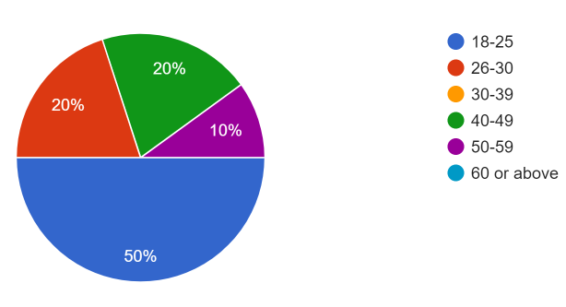
The first question that was asked was the age of the participant of the questionnaire. This was so we could see a theme on whether people who were in different age groups thought the same as others. The results show a lack of participation by older people with only 30% of participants being 40 years old and above. The results also show that there were no participants aged 60 years old and above, which supports Lancaster University research which was done in 2018 which stated that older adults have fears about making mistakes when using software, as well as concerns about its influence on society, are also key reasons preventing older persons from adopting technology meaning they didn’t want to use it at all (Lancaster University, 2018).
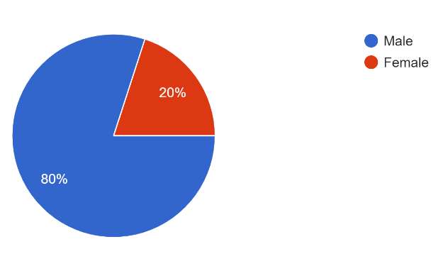
The next question that was asked in the questionnaire was to signify what gender the participant was. This was asked for the same reason as the age question, to see if there was any difference in opinions on what they think of ACEs. The graph shows that 80% of participants were male and 20% of them were female. This isn’t the best result as a 50/50 split of both genders would give a much better understanding on what their perception of an ACE is. However, knowing that this questionnaire would be posted to platforms on my personal account, the demographic I have in terms of gender is that I have more male accounts that I am friends with so the outreach would be expected to have been more males seeing the questionnaire.

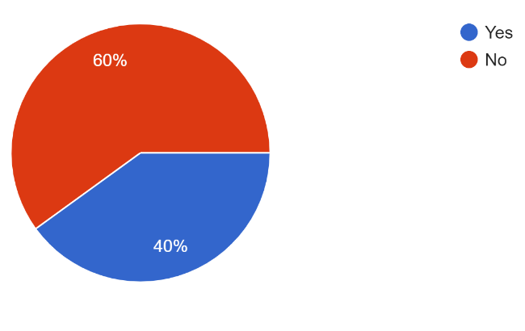
The next graph shows the participants answer to the question “Before answering this questionnaire, did you know what an ACE was?”. The reason this question was important was to see that if they have already heard of an ACE before conducting this questionnaire, if it will affect their further answers in the questionnaire when compared to people who don’t know what an ACE was before answering the questionnaire. This question was asked to gather information on people’s perception of ACEs and to see whether their perception was different compared to other who answered the opposite. The graph shows that 3 out 5 people (60%) said that they didn’t know what an ACE was before they participated in the questionnaire. This is an interesting result as when secondary research was conducted, results show that having an ACE was common and that many different research found that 50% of people had at least one ACE (Touloumakos and Barrable, 2020). This result has also helped with the objective of finding out how common ACEs really are, and this result means that people who have ACEs might not even know they have one
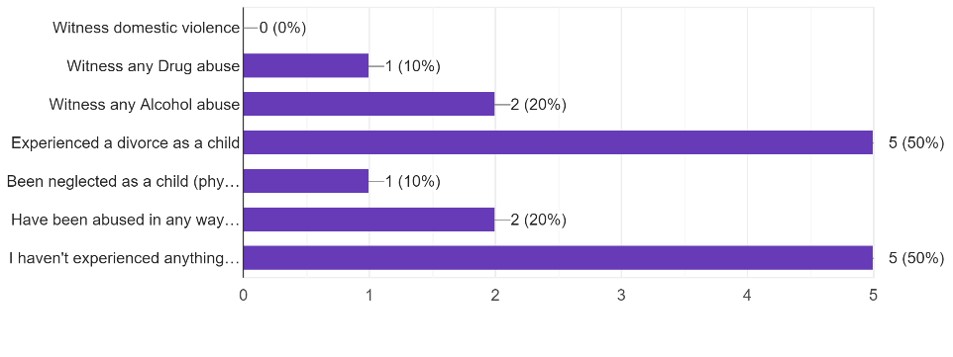
The next graph shows the answers given to the question “Please indicate whether you have experienced any of the following as a child:”. The graph is a bar chart instead of a pie chart due to the fact participants can answer by picking more than one option whereas the other graphs just had two answers. This question was important as it shows how many of the participants have been experienced an ACE in their lifetime.
This question has helped fill in gaps of research as it helps answer the question of how common ACEs really are. The results show that 50% of participants hadn’t experienced any of the ACEs listed above which are considered the most common. This lines up with secondary research which indicates the same results, and these were that 47% of Adults in Wales had experienced at least one ACE as a child (Public Health Wales, 2016). Furthermore, 50% of participants said they had experienced divorce as a child, meaning that everyone who didn’t select the option “I haven’t experienced anything of the above” had experienced a divorce. This lines up with research which discovered that divorce was the number one most found ACE in the prison survey (Public Health Wales, 2018). However, in all the other ACEs, the study found very different results than the questionnaire, with the prisoner ace survey they found that 40% of prisoners witnessed domestic violence where the results of the questionnaire found that no participants witnessed domestic abuse (Public Health Wales, 2018).
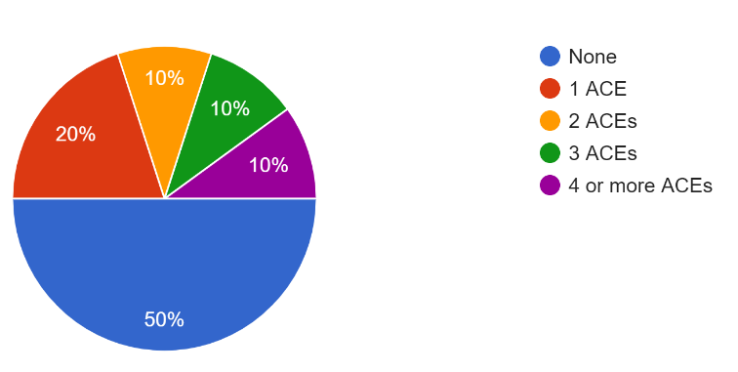
The next graph shows the number of ACEs the person has experienced in total. The exact question that was asked was “After you have answered the previous question, can you indicate how many you have witnessed in total?”. This answer was guided by the previous question to help them work out how many they have experienced as many had never heard of an ACE before. This question was asked for the number of ACEs to be worked out a lot easier instead of relaying to the previous question and trying to it out from there. This question has helped massively in finding out how common ACEs really are in the general population compared to prison. The graph shows that 10% of people experienced 4 or more ACEs. When we compare this to the prisoner ACE survey results, results show that 46% of prisoners had reported 4 or more ACEs. That is a significant increase compared to results from the questionnaire, which could signify the theory that there is connecting variables between ACESs and Serious offenders, which is one of the objectives of the research that has been conducted (Ford et al., 2019). This question also helps with finding out how common an ACE is in the general population and the result of this question also supports the secondary research that found the same result that that for every 100 people in Wales, 47 of them have experienced at least one ACE which is like the result found in the questionnaire (Public Health Wales, 2015).
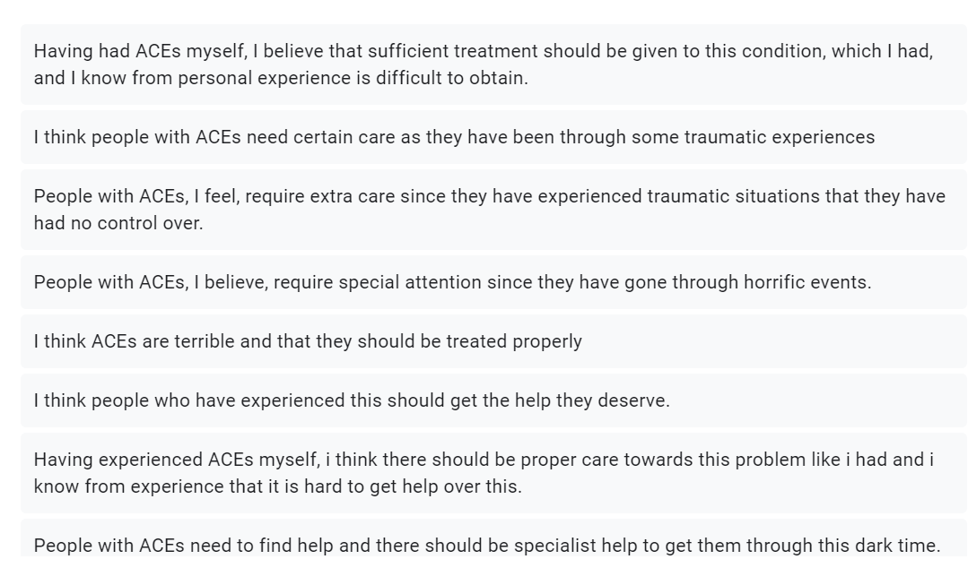
The next question that was asked was a very open question. The exact question was “Now having a basic understanding of some types of ACEs, what is your perception of them?”. As this was a very open question, the answers were long, and it meant that a graph is not applicable for this analysis. The answers varied from person to person as this question was based on opinion. This question was asked to see what people’s perception of ACEs are after a basic understanding of what they are. The main scope of the answers was along the lines of that they think people with ACEs should get specialist help.
This is shown clearly by answers from participants such as “People with ACEs, I feel, require extra care since they have experienced traumatic situations that they have had no control over” and “I think ACEs are terrible and that they should be treated properly”. The picture shows some other responses that were answered by participants who overall, said the same thing and that was that people with ACEs need care.
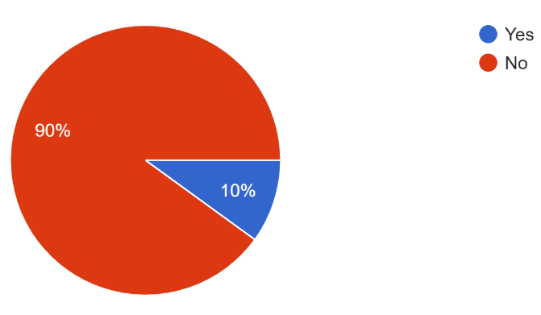
This graph shows the answer to the question “In your lifetime, have you ever been to prison for any offence?”. The reason this question is important, is because it helps solve whether having ACEs makes you more likely to go to prison for any offence. The results show clearly that only 10% of people had said that they have where the other 90% didn’t. If we compare the answers from this question to the question “After you have answered the previous question, can you indicate how many you have witnessed in total?”, we can see some distinctive themes. The first theme is that if you do have an ACE, it doesn’t necessarily mean you are more likely to go to prison as 50% of participants indicated that they did have an ACE which was backed up secondary research. However, when we investigate it at more detail, the amount of people who said that they had 4 or more ACEs is the exact same as the amount of people who said they have been to prison at any given time. This backs up the theory that people who have many ACEs are more likely to go to prison. This theory is backed up the Prison ACE Survey in which found that three times more likely to have ever been convicted of criminal damage, violence against the person and convicted of theft and two times more likely to have ever been convicted of drugs offences (Ford et al., 2019). All these results indicate that if people have 4 or more ACEs, they are very likely to go to prison at any time.
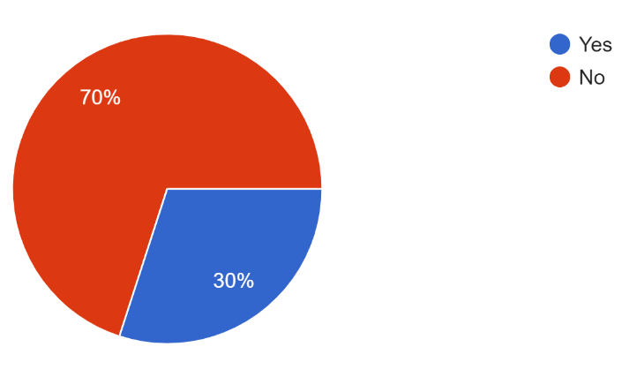
The next graph shows the answer to the question “Studies have shown that people with 4 or more ACEs are more likely to commit criminal offences such as drug offences and violence. Does this now change perception in any way?”. This question was asked to see if people’s opinions changed after finding out a fact about ACEs that was discovered by multiple studies. The graph shows that only 30% of people changed their opinions based on this one statistic which is interesting. The reason this was asked was to see if people’s perception of ACEs changed after finding more facts about how it can change a person. The reason for this question to see if there is a stigma around ACEs after people know more information. Secondary research found a study which had findings that show interpersonal stigma and parental blame for ACEs were common, with 25% percent of respondents hesitant to have a close co-worker with “a lot of ACEs” (Purtle, Nelson and Gollust, 2021). This shows that stigma around ACEs can happen but isn’t common and that both the result in the study and the result in the questionnaire found similar results.

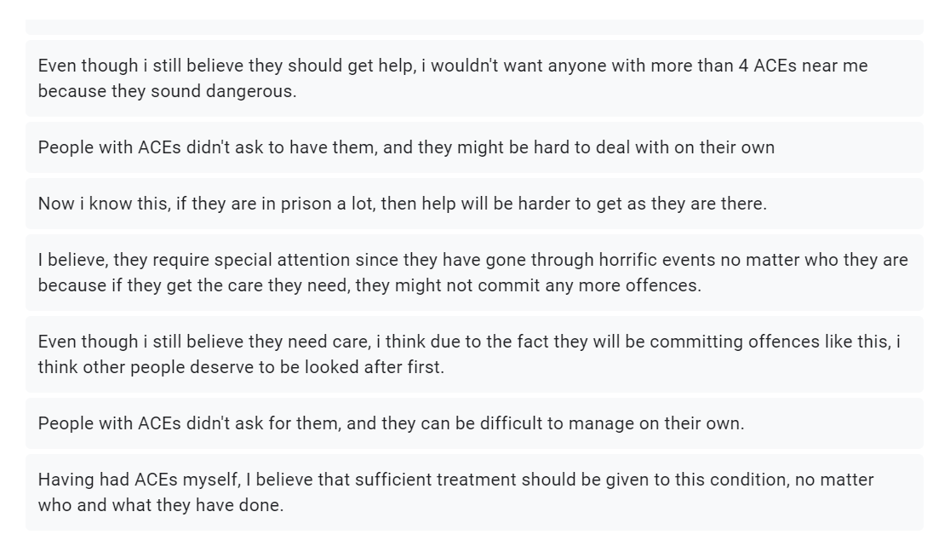
The final question that was asked was “Why did you answer yes/no to the question above?”. This again is a very open question in which participants discus their opinion on why they did/didn’t change their perception on ACEs. There is no graph to analyse for this final question due to it being an open question with some long answers.
The answers did vary, and some were very similar to other, and some were very different. As 30% of people answered the previous question by saying “Yes”, it means their opinion has changed from their original answer from the question “Now having a basic understanding of some types of ACEs, what is your perception of them?”. This shows that there is some stigma when it comes to ACEs as found by Purtle, Nelson and Gollust in 2021 whose study also discovered that 65.2% of people believed that parents were very much to blame for the consequences of ACE. The picture shows a minority of the responses that were given by participants, and it shows the clear distinction between the two opinions.

Conclusion
To conclude, ACEs research needs to broaden into the perspective that people who have them, do have more issues than thought by previous research. Most studies that have delved into ACEs have mainly been about the health risks that have been linked to them, mostly chronic health problems such as cardiovascular disease, chronic obstructive pulmonary disease, cancer, diabetes, and prediabetes (Sonu, Post and Feinglass, 2019). There is far less research of the increased risk of criminality in people with ACEs, and with little secondary research found, the questionnaire findings are key in this investigation. There was only one piece of research, in which the main dedicated goal was to find the link between ACEs and criminals and that was the Prison ACE survey which found crucial information that helped in the investigation.
The results that were found in the questionnaire had some similar themes as some secondary research, but also some differences. According to the questionnaire results, overall, it is clear to see that the results showed that people’s perception of ACEs are mostly fine however, 30% of people’s perception was negative after finding out some general statistics about the topic. This result backs up the theory that ACEs do have “interpersonal stigma” as a study found 25% percent of respondents hesitant to have a close co-worker with “a lot of ACEs” which is a very similar result to the questionnaire (Purtle, Nelson and Gollust, 2021). However, in saying that, 70% of people still had a good perception on ACEs and having known some facts behind them, expressed empathy and sympathy towards people who suffer from them. I believe from these results, we can easily dictate how people think about ACEs, as most people believe that they should get specialist help no matter the circumstances however, there will always be the stigma around people with ACEs being criminals, which isn’t necessarily true. Furthermore, when we looked at specific ACEs such as witnessing drug abuse and drug abuse itself, it was clear from secondary research that there is an indefinite stigma surrounding it with two separate studies concluding that the public perception of drug abuse is mostly negative, and that seeking help is difficult because of this (Tucker, Foushee and Simpson, 2008) (Johns Hopkins Bloomberg School of Public Health, 2014).
When we look at the how common an ACE is, the difference in both research is very minimal. According to the questionnaire, 50% of participants had at least one ACE and this is backed up with secondary research which showed that in Wales, 47 individuals out of every 100 have had at least one ACE, and another big study have found that the chance of having at least one ACE is higher than 50% of the overall population (Public Health Wales, 2015) (Touloumakos and Barrable, 2020). However, when we compare the commonality of the amount of people with 4 and more ACEs, there is a major difference. According to secondary research, the prisoner survey results show that 46% of prisoners had reported 4 or more ACEs and where we compare this statistic to the results of the questionnaire which found 10% of participants had 4 or more ACEs, the jump is very significant which means there is no concluded answer on how common people with four or more ACEs are. In order to get an answer to this question, more research will need to be done on this matter such as another questionnaire or survey, but with a much significant number of participants instead of just 100 people. In terms of long-term effects of ACEs, the effects an ACE has on someone is very significant as research found that history of having an ACE can result in complex clinical profiles with several co-occurring mental and somatic disorders” (Monnat and Chandler, 2015) (Herzog and Schmahl, 2018). Furthermore, its clear from questionnaire results that having ACEs increases a person’s chance of entering the prison system.
In terms of finding out the connecting variables between ACESs and Serious offenders, the result from the questionnaire shows a significant connection between the two. Firstly, the questionnaire found that 10% of participants have been to prison in their life, and the same amount of people responded by saying that they have 4 or more ACEs. This shows a clear link between the two that people with 4 or more ACEs are likely to be in prison in their lifetime. Also, when we look at the prison survey, results show that over 8 in 10 prisoners reported at least 1 ACE, which means a staggering 80% of people had at least one ACE (Ford et al., 2019). Results from the same research found that prisoners with 4 or more ACEs were 4 times more likely to have ever served a sentence in a young offender institution (YOI) than those with no ACEs which shows again that if a person has 4 or more ACEs, then the likelihood of them being in the prison system at any stage is very likely.
Reference list
Abend, G. (2008). The Meaning of ‘Theory’. Sociological Theory, [online] 26(2), pp.173–199. doi:10.1111/j.1467-9558.2008.00324.x.
Albers, M.J. (2017). Quantitative Data Analysis—In the Graduate Curriculum. Journal of Technical Writing and Communication, 47(2), pp.215–233. doi:10.1177/0047281617692067.
Alcoholics Anonymous Great Britain (2020). Prison - The Inside Story | Alcoholics Anonymous - Great Britain. [online] www.alcoholics-anonymous.org.uk. Available at: https://www.alcoholics-anonymous.org.uk/professionals/social-sectors/legal-&-criminal-justice/Prison-~-The-Inside-Story [Accessed 21 Apr. 2022].
American Association for Marriage and Family Therapy (2018). Children of Alcoholics. [online] Aamft.org. Available at: https://www.aamft.org/Consumer_Updates/Children_of_Alcoholics.aspx [Accessed 17 Apr. 2022].
Andrade, C. (2020). The Limitations of Online Surveys. Indian Journal of Psychological Medicine, [online] 42(6), pp.575–576. doi:10.1177/0253717620957496.
Baglivio, M.T., Wolff, K.T., Piquero, A.R. and Epps, N. (2015). The Relationship between Adverse Childhood Experiences (ACE) and Juvenile Offending Trajectories in a Juvenile Offender Sample. Journal of Criminal Justice, 43(3), pp.229–241. doi:10.1016/j.jcrimjus.2015.04.012.
Ball, H.L. (2019). Conducting Online Surveys. Journal of Human Lactation, 35(3), pp.413–417. doi:10.1177/0890334419848734.
Bateson, K., McManus, M. and Johnson, G. (2019). Understanding the use, and misuse, of Adverse Childhood Experiences (ACEs) in trauma-informed policing. The Police Journal: Theory, Practice and Principles. doi:10.1177/0032258x19841409.
Biau, D.J., Kernéis, S. and Porcher, R. (2008). Statistics in Brief: The Importance of Sample Size in the Planning and Interpretation of Medical Research. Clinical Orthopaedics and Related Research, 466(9), pp.2282–2288. doi:10.1007/s11999-008-0346-9.
Brunton-Smith, I. (2013). The factors associated with proven re-offending following release from prison: findings from Waves 1 to 3 of SPCR. [online] Available at: https://assets.publishing.service.gov.uk/government/uploads/system/uploads/attachment_data/file/491119/re-offending-release-waves-1-3-spcr-findings.pdf [Accessed 17 Apr. 2022].
Cambridge Dictionary (2021a). closed question. [online] dictionary.cambridge.org. Available at: https://dictionary.cambridge.org/dictionary/english-danish/closed-question [Accessed 23 Apr. 2022].
Cambridge Dictionary (2021b). COMMON | meaning in the Cambridge English Dictionary. [online] dictionary.cambridge.org. Available at: https://dictionary.cambridge.org/dictionary/english/common [Accessed 14 Apr. 2022].
CDC (2021). Preventing Adverse Childhood Experiences. [online] Centers for Disease Control and Prevention. Available at: https://www.cdc.gov/vitalsigns/aces/index.html#:~:text=ACEs%20are%20linked%20to%20chronic [Accessed 29 Apr. 2022].
Cheong, E.V., Sinnott, C., Dahly, D. and Kearney, P.M. (2017). Adverse childhood experiences (ACEs) and later-life depression: perceived social support as a potential protective factor. BMJ Open, [online] 7(9), p.e013228. doi:10.1136/bmjopen-2016-013228.
Collins Dictionary (2021). Open question definition and meaning | Collins English Dictionary. [online] www.collinsdictionary.com. Available at: https://www.collinsdictionary.com/dictionary/english/open-question [Accessed 23 Apr. 2022].
Egle, U.T., Hoffmann, S.O., Hardt, J., Nickel, R. and Käppis, B. (2002). Long-term effects of adverse childhood experiences - Actual evidence and needs for research/ Früher Streß und Langzeitfolgen für die Gesundheit - Wissenschaftlicher Erkenntnisstand und Forschungsdesiderate. Zeitschrift für Psychosomatische Medizin und Psychotherapie, 48(4), pp.411–434. doi:10.13109/zptm.2002.48.4.411.
Einola, K. and Alvesson, M. (2020). Behind the Numbers: Questioning Questionnaires. Journal of Management Inquiry, 30(1), p.105649262093813. doi:10.1177/1056492620938139.
Falissard, B. (2012). Analysis of questionnaire data with R. Boca Raton: Taylor & Francis.
Felitti, V.J. (2002). The Relation Between Adverse Childhood Experiences and Adult Health: Turning Gold into Lead. The Permanente Journal, [online] 6(1), pp.44–47. Available at: https://www.ncbi.nlm.nih.gov/pmc/articles/PMC6220625/ [Accessed 13 Apr. 2022].
Felitti, V.J., Anda, R.F., Nordenberg, D., Williamson, D.F., Spitz, A.M., Edwards, V., Koss, M.P. and Marks, J.S. (1998). Relationship of Childhood Abuse and Household Dysfunction to Many of the Leading Causes of Death in Adults. American Journal of Preventive Medicine, 14(4), pp.245–258. doi:10.1016/s0749-3797(98)00017-8.
Ford, K. (2017). Measuring ACEs in an offender population. [online] Health Research Authority. Available at: https://www.hra.nhs.uk/planning-and-improving-research/application-summaries/research-summaries/measuring-aces-in-an-offender-population/ [Accessed 15 Apr. 2022].
Ford, K., Barton, E., Newbury, A., Hughes, K., Bezeczky, Z., Roderick, J. and Bellis, M. (2019). The Prisoner ACE Survey The Prisoner ACE Survey. [online] Available at: https://phw.nhs.wales/files/aces/the-prisoner-ace-survey/ [Accessed 3 Nov. 2021].
Global Commission on Drug Policy (2017). THE WORLD DRUG PERCEPTION PROBLEM Countering prejudices about people who use drugs 2017 REPORT PRESS KIT. [online] Available at: https://www.sdf.org.uk/wp-content/uploads/2018/01/2017-Report-Press-Kit-ENG.pdf [Accessed 16 Apr. 2022].
Goertzen, M.J. (2017). Applying Quantitative Methods to E-book Collections. Library Technology Reports, 53(4). doi:10.5860/ltr.53n4.
Guest, G., Bunce, A. and Johnson, L. (2006). How Many Interviews Are Enough? An Experiment with Data Saturation and Variability. Field Methods, 18(1), pp.59–82. doi:10.1177/1525822x05279903.
Hall, W., Flaherty, B. and Homel, P. (2010). The public perception of the risks and benefits of alcohol consumption. Australian Journal of Public Health, 16(1), pp.38–42. doi:10.1111/j.1753-6405.1992.tb00023.x.
Herzog, J.I. and Schmahl, C. (2018). Adverse Childhood Experiences and the Consequences on Neurobiological, Psychosocial, and Somatic Conditions Across the Lifespan. Frontiers in Psychiatry, [online] 9(420). doi:10.3389/fpsyt.2018.00420.
HM Prison and Probation Service (2019). Prison Drugs Strategy. [online] Available at: https://assets.publishing.service.gov.uk/government/uploads/system/uploads/attachment_data/file/792125/prison-drugs-strategy.pdf [Accessed 16 Apr. 2022].
Johns Hopkins Bloomberg School of Public Health (2014). Study: Public Feels More Negative Toward People With Drug Addiction Than Those With Mental Illness | Johns Hopkins Bloomberg School of Public Health. [online] publichealth.jhu.edu. Available at: https://publichealth.jhu.edu/2014/study-public-feels-more-negative-toward-people-with-drug-addiction-than-those-with-mental-illness#:~:text=People%20are%20significantly%20more%20likely [Accessed 17 Apr. 2022].
Jones, T., Baxter, M. and Khanduja, V. (2013). A Quick Guide to Survey Research. The Annals of The Royal College of Surgeons of England, 95(1), pp.5–7. doi:10.1308/003588413x13511609956372.
Juergens, J. (2021). Alcohol-Related Crime. [online] Addiction Center. Available at: https://www.addictioncenter.com/alcohol/alcohol-related-crime/#:~:text=Alcohol%20and%20crime%20have%20a [Accessed 21 Apr. 2022].
Kiger, M.E. and Varpio, L. (2020). Thematic Analysis of Qualitative data: AMEE Guide no. 131. Medical Teacher, [online] 42(8), pp.1–9. doi:10.1080/0142159x.2020.1755030.
Knowles, B. and Hanson, V.L. (2018). The wisdom of older technology (non)users. Communications of the ACM, 61(3), pp.72–77. doi:10.1145/3179995.
Lacey, R.E. and Minnis, H. (2019). Practitioner Review: Twenty years of research with adverse childhood experience scores – Advantages, disadvantages and applications to practice. Journal of Child Psychology and Psychiatry, 61(2), pp.116–130. doi:10.1111/jcpp.13135.
Lancaster University (2018). Why some older people are rejecting digital technologies. [online] phys.org. Available at: https://phys.org/news/2018-03-older-people-digital-technologies.html.
Lavrakas, P. (2008). Questionnaire. Encyclopedia of Survey Research Methods. doi:10.4135/9781412963947.n424.
Lester, J.N., Cho, Y. and Lochmiller, C.R. (2020). Learning to Do Qualitative Data Analysis: A Starting Point. Human Resource Development Review, [online] 19(1), pp.94–106. doi:10.1177/1534484320903890.
LEWANDOWSKY, S. and SPENCE, I. (1989). The Perception of Statistical Graphs. Sociological Methods & Research, 18(2-3), pp.200–242. doi:10.1177/0049124189018002002.
Maguire, M. and Delahunt, B. (2017). Doing a Thematic Analysis: A Practical, Step-by-Step Guide for Learning and Teaching Scholars. *. Ireland Journal of Teaching and Learning in Higher Education, 8(3), p.3351.
Mahfoud, Z., Ghandour, L., Ghandour, B., Mokdad, A.H. and Sibai, A.M. (2014). Cell Phone and Face-to-face Interview Responses in Population-based Surveys. Field Methods, 27(1), pp.39–54. doi:10.1177/1525822x14540084.
Martínez-Mesa, J., González-Chica, D.A., Duquia, R.P., Bonamigo, R.R. and Bastos, J.L. (2016). Sampling: how to select participants in my research study? Anais Brasileiros de Dermatologia, [online] 91(3), pp.326–330. doi:10.1590/abd1806-4841.20165254.
Massetti, G.M., Hughes, K., Bellis, M.A. and Mercy, J. (2020). Global perspective on ACEs. Adverse Childhood Experiences, pp.209–231. doi:10.1016/b978-0-12-816065-7.00011-2.
Ministry of Justice (2022). Proven reoffending statistics: April to June 2020. [online] GOV.UK. Available at: https://www.gov.uk/government/statistics/proven-reoffending-statistics-april-to-june-2020/proven-reoffending-statistics-april-to-june-2020 [Accessed 7 Nov. 2021].
Monnat, S.M. and Chandler, R.F. (2015). Long-Term Physical Health Consequences of Adverse Childhood Experiences. The Sociological Quarterly, [online] 56(4), pp.723–752. doi:10.1111/tsq.12107.
Mosel, S. (2000). Children of Alcoholics. [online] American Addiction Centers. Available at: https://americanaddictioncenters.org/alcoholism-treatment/children [Accessed 17 Apr. 2022].
Nacoa (2020). Research. [online] Nacoa. Available at: https://nacoa.org.uk/research-resources/research/#:~:text=A%20research%20study%20with%204%2C000 [Accessed 21 Apr. 2022].
National Institute for Children's Health Quality (2021). Qualitative Data Analysis: 7 Things You Need to Know to Get It Right. [online] NICHQ - National Institute for Children’s Health Quality. Available at: https://www.nichq.org/insight/qualitative-data-analysis-7-things-researchers-need-know-get-it-right [Accessed 3 May 2022].
Nelson, D., Powell-Grinner, E., Town, M. and Kovar, M.G. (2003). A comparison of national estimates from the national health interview survey and the behavioral risk factor surveillance system. American Journal of Public Health.
NHS (2021). Adverse Childhood Experiences (ACEs) and Attachment. [online] Royal Manchester Children’s Hospital. Available at: https://mft.nhs.uk/rmch/services/camhs/young-people/adverse-childhood-experiences-aces-and-attachment/ [Accessed 3 Nov. 2021].
NHS Health Scotland (2016). Overview of ACEs. [online] Healthscotland.scot. Available at: http://www.healthscotland.scot/population-groups/children/adverse-childhood-experiences-aces/overview-of-aces [Accessed 3 Nov. 2021].
Office for National Statistics (2020a). Divorces in England and Wales - Office for National Statistics. [online] www.ons.gov.uk. Available at: https://www.ons.gov.uk/peoplepopulationandcommunity/birthsdeathsandmarriages/divorce/bulletins/divorcesinenglandandwales/2020 [Accessed 21 Apr. 2022].
Office for National Statistics (2020b). Internet access – households and individuals, Great Britain - Office for National Statistics. [online] www.ons.gov.uk. Available at: https://www.ons.gov.uk/peoplepopulationandcommunity/householdcharacteristics/homeinternetandsocialmediausage/bulletins/internetaccesshouseholdsandindividuals/2020 [Accessed 25 Apr. 2022].
Opdenakker, R.O. (2006). Advantages and Disadvantages of Four Interview Techniques in Qualitative Research. Forum Qualitative Sozialforschung / Forum, 7(4).
Perraudin, F. (2020). Proportion of UK prisoners with drug problem doubles in five years – study. The Guardian. [online] 20 Jan. Available at: https://www.theguardian.com/society/2020/jan/20/proportion-of-uk-prisoners-with-drug-problem-doubles-in-five-years-study [Accessed 17 Apr. 2022].
Public Health Wales (2015). Adverse Childhood Experiences and their impact on health-harming behaviours in the Welsh adult population. [online] Wales.nhs.uk. Available at: https://www2.nphs.wales.nhs.uk/PRIDDocs.nsf/7c21215d6d0c613e80256f490030c05a/d488a3852491bc1d80257f370038919e/ [Accessed 13 Apr. 2022].
Public Health Wales (2016). Adverse Childhood Experiences and their association with chronic disease and health service use in the Welsh adult population Welsh Adverse Childhood Experiences (ACE) Study. [online] Available at: https://www.wales.nhs.uk/sitesplus/documents/888/ACE%20Chronic%20Disease%20report%20(9)%20(2).pdf [Accessed 12 Apr. 2022].
Public Health Wales (2018). Over 8 in 10 prisoners reported at least 1 ACE, and nearly half had 4 or more ACEs b How many prisoners reported each ACE? Child maltreatment. [online] Available at: https://phw.nhs.wales/files/aces/the-prisoner-ace-survey-infographic/. [Accessed 14 Apr. 2022].
Purtle, J., Nelson, K.L. and Gollust, S.E. (2021). Public Opinion About Adverse Childhood Experiences: Social Stigma, Attribution of Blame, and Government Intervention. Child Maltreatment, p.107755952110047. doi:10.1177/10775595211004783.
Riedl, D., Lampe, A., Exenberger, S., Nolte, T., Trawöger, I. and Beck, T. (2020). Prevalence of adverse childhood experiences (ACEs) and associated physical and mental health problems amongst hospital patients: Results from a cross-sectional study. General Hospital Psychiatry, 64, pp.80–86. doi:10.1016/j.genhosppsych.2020.03.005.
Ruben, D.H. (2001). Treating Adult Children of Alcoholics: A behavioral approach.
Sheffler, J.L., Stanley, I. and Sachs-Ericsson, N. (2020). ACEs and mental health outcomes. Adverse Childhood Experiences, pp.47–69. doi:10.1016/b978-0-12-816065-7.00004-5.
Slutsky, D. (2014). The Effective Use of Graphs. Journal of Wrist Surgery, [online] 03(02), pp.067–068. doi:10.1055/s-0034-1375704.
Sonu, S., Post, S. and Feinglass, J. (2019). Adverse childhood experiences and the onset of chronic disease in young adulthood. Preventive Medicine, 123, pp.163–170. doi:10.1016/j.ypmed.2019.03.032.
Spatz Widom, C. and Hiller-Sturmhöfel, S. (2001). Alcohol Abuse as a Risk Factor for and Consequence of Child Abuse. [online] Available at: https://pubs.niaaa.nih.gov/publications/arh25-1/52-57.pdf [Accessed 17 Apr. 2022].
Statista (2020). Facebook users worldwide 2020. [online] Statista. Available at: https://www.statista.com/statistics/264810/number-of-monthly-active-facebook-users-worldwide/#:~:text=How%20many%20users%20does%20Facebook.
Stone, D.H. (1993). Design a questionnaire. BMJ, 307(6914), pp.1264–1266. doi:10.1136/bmj.307.6914.1264.
Sunder, K. (2017). Study: Children of Mothers Who Misuse Alcohol Are More Likely to Face Prison - Drug Rehab. [online] Addiction Treatment Services. Available at: https://addiction-treatment-services.com/blog/study-children-alcohol-misuse-likely-face-prison/ [Accessed 17 Apr. 2022].
Sutton, J. and Austin, Z. (2015). Qualitative Research: Data Collection, Analysis, and Management. The Canadian Journal of Hospital Pharmacy, 68(3), pp.226–231. doi:10.4212/cjhp.v68i3.1456.
The Scottish Government (2016). Public attitudes towards people with drug dependence and people in recovery - Research Findings. [online] Gov.scot. Available at: https://www.gov.scot/publications/public-attitudes-towards-people-drug-dependence-people-recovery-research-findings/ [Accessed 18 Apr. 2022].
Touloumakos, A.K. and Barrable, A. (2020). Adverse Childhood Experiences: The Protective and Therapeutic Potential of Nature. Frontiers in Psychology, 11. doi:10.3389/fpsyg.2020.597935.
Tucker, J.A., Foushee, H.R. and Simpson, C.A. (2008). Public Perceptions of Substance Abuse and How Problems Are Resolved: Implications for Medical and Public Health Services. Southern Medical Journal, [online] 101(8), pp.786–790. doi:10.1097/smj.0b013e31817c931c.
UK Government (2022). Coronavirus (COVID-19) cases in the UK. [online] coronavirus.data.gov.uk. Available at: https://coronavirus.data.gov.uk/. [Accessed 22 Apr. 2022].
Vasileiou, K., Barnett, J., Thorpe, S. and Young, T. (2018). Characterising and justifying sample size sufficiency in interview-based studies: systematic analysis of qualitative health research over a 15-year period. BMC Medical Research Methodology, [online] 18(1), pp.1–18. doi:10.1186/s12874-018-0594-7.
Williams, K., Papadopoulou, V. and Booth, N. (2012). Prisoners’ childhood and family backgrounds Results from the Surveying Prisoner Crime Reduction (SPCR) longitudinal cohort study of prisoners. [online] Available at: https://assets.publishing.service.gov.uk/government/uploads/system/uploads/attachment_data/file/278837/prisoners-childhood-family-backgrounds.pdf [Accessed 14 Apr. 2022].
Wright, K.B. (2017). Researching Internet-Based Populations: Advantages and Disadvantages of Online Survey Research, Online Questionnaire Authoring Software Packages, and Web Survey Services. Journal of Computer-Mediated Communication, [online] 10(3). doi:10.1111/j.1083-6101.2005.tb00259.x.

Appendix



