Resources

Mission Evidence
This is a mission that I created for my class of mixed year 2+3 students. IT was to be completed entirely in the Welsh Language, and the work would then be put into the lower foundation phase class for students to learn their colours in Welsh.
Differentiation through outcome.
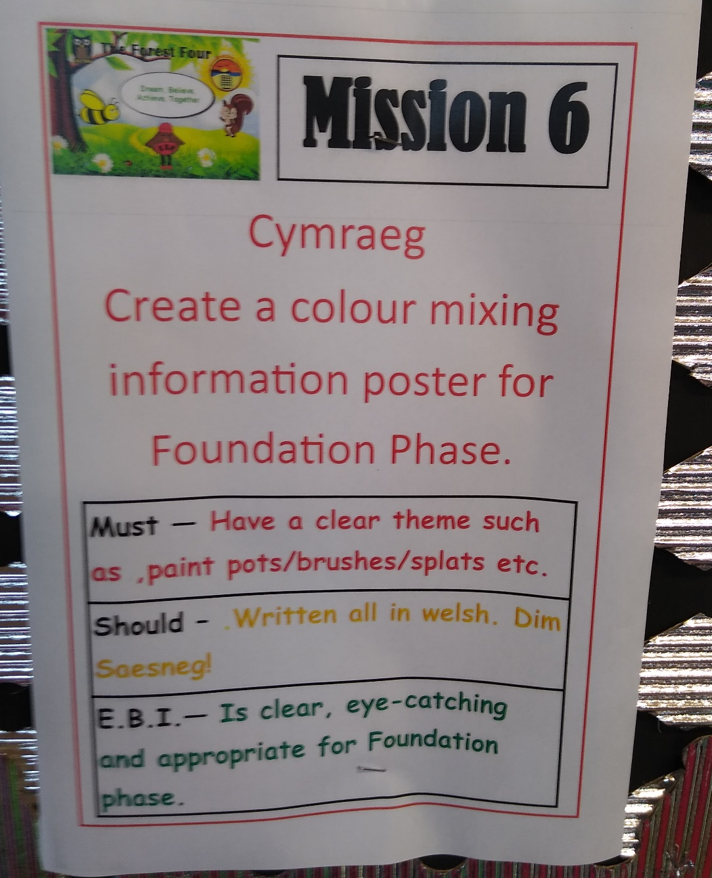

Hangman
These are the hangman cards I created for the Welsh area of the playground. The area has a whiteboard for students to practice their welsh, and these cards were to be used f=during their playtime as a form of enhanced provision. The cards will be added to after a unit of Welsh, when a new lexical group needs to be reviewed.
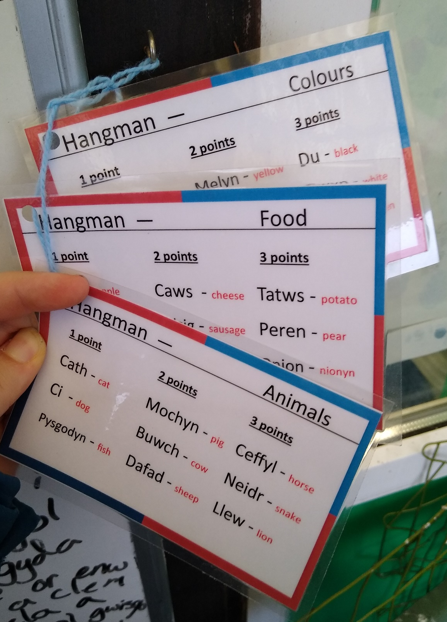
Creating this resource allowed me to recap on my own knowledge of these lexical groups.

