Application Develeopment
3D Maze Game

Name: Jonathan Davies
Student Number: 1707239
Module: Application Development
Module Code: ACCA5012
Lecturer: Kemi Ademoye

Table of Contents
Introduction 2
1. Application Design Concepts 2
1.1 Design Principles – General 2
1.2 Design Principles – Game Specific 2
1.2.1 Core Mechanics 3
1.2.2 Storytelling and Narrative 3
1.2.3 Interactivity 4
1.3 Usability and User Experience 4
1.3.1 What is Usability? 4
1.3.2 What is User Experience (UX)? 4
2. Requirements 5
2.1 Brief Description 5
2.2 Rules of the Game 5
3. Design 5
3.1 Observer Pattern 5
4. Implementation 5
4.1 PickUp Script 6
4.2 HUD Script 7
4.2 LoadNextLevelKey 8
5. Evaluation 9
5.1 Testing - Events 9
5.1.1 Sequence of Events – True 9
5.1.2 Sequence of Events – False 9
5.2 Testing – Level Timers 9
5.2.1 Level One Timer 10
5.2.2 Level Two Timer 10
5.2.3 Level Three Timer 12
5.3 Recommendations for Future Improvements 12
5.3.1 Coding Style 12
5.3.2 Game Features 12
References 13

Introduction

There are two major aims of this report with the first being to document evidence of understanding of the principles involved when conceptualising and developing a game, and the second to provide the reader with documentation that accompanies the practical element of this assignment.

Application Design Concepts

Design Principles – General

Although game design principles are the focus for this section of the report, it is worth noting some key software engineering principles as they are transferable over to any discipline of software development. The points that have been listed below provide a very high-level, generic overview of what all software products should encompass whether they are aimed towards web development, cybersecurity software or game development to name a few. These characteristics have been sourced from Ian Sommerville’s Software Engineering [1].
- Acceptability – The software, or in this case; game, must be created with the user at the forefront of the design. The game should be compatible with current hardware systems that are currently on the market and the actual gameplay itself should be simple to understand.
- Secure – Whilst the consequences surrounding an unsecure game may not be as severe as other forms of software, it may still render a game unplayable should malicious users interfere with it. This is especially true of online multiplayer games.
- Efficient – When the game is running on a user’s system, whether it is a PC or game console, it should not be an unnecessarily expensive in terms of memory usage or CPU/GPU cycles. The game should be as optimised as possible to ensure that the users experience is as fluid and stable as possible.
- Maintainable – The finished product should allow for changes and upgrades to be made after it has been released. This is so that any bugs found by users can be patched and ultimately the end user is always using the most up-to-date system.

Design Principles – Game Specific

During the development of a game, a process referred to as the Game Development Life Cycle (GDLC), there are many different design processes that ensure that the project has the best chance of success. Although the GDLC can vary from company to company, the structure remains similar. The main topic headings Core Mechanics, Story and Narrative and Interactivity have been cited from Rollings and Adams [2].

Core Mechanics

  - Feedback
One of the major functions that separate the gaming industry from other entertainment industries is feedback. When a player uses an input device such as a keyboard or controller, every action that they make must perform an operation in the game.
  - Rewards
Rewards in games principles does not refer to the playable reward items that may be found such as coins or weapons. It holds a much deeper and psychological standing and refers to what we as humans take from a game in terms of our mental health. A study was conducted by Ph.D. Scott Rigby [3] which studied the idea of people having two ‘invisible needs’, that shall be examined below, by which we may feel our personal value.
- Competence – The first need that is explored is competence, or the need to be tested. Many modern games offer the player a chance to ‘level up’ or earn experience points should their in-game actions comply with the way in which the game wants us to play. Generally, as the player progresses further and further into the game and their characters ‘level’ gets higher, the game will get harder and harder. In this way, the person that is playing the game is constantly challenged and continues to find personal satisfaction or competence [3].
- Autonomy - Humans naturally wish to feel important and in control in as many areas of life as possible. Games are engineered to place the most importance on the positive experience of the player and this usually transcends into giving the player a vast amount of control within the game. When a game starts to control the choices that players make, or force an action onto them, the level of autonomy decreases.

Storytelling and Narrative

  - Grounding the player
Grounding the player refers to the notion that the player always knows what the current objective is. At no point should the player feel as though there is no point to what they are doing or be confused as to the goal. Without the sense of placement within the game world, players will quickly become disinterested and simply stop playing.
  - Player empathy
When designing a video game, the game developers must take into account the emotional and psychological state that they wish the player to be experiencing at different points of the story. A game is so much more than a film or television programme because it allows the player to take control of the protagonists and interact with non-playable characters (NPC’s). With this kind of connection, emotional bonds can be made to various virtual entities.

Interactivity

  - Immersion
Game immersion is an amalgamation of various different elements such as the story line, visual effects, audio and game mechanics that have been integrated with each other in such a way that it creates a seamless world in which the level of realism can detach a player from actual reality [4]. Immersion can be presented in three differing levels, which has been outlined below, whereby the immersive capabilities increase as the level increases.
- Engagement [5]- The lowest form of immersion is engagement. The player needs only to physically play at this point.
- Engrossment [5]– This is the level where players may start to lose sense of time and become emotionally invested in the game.
- Total Immersion [5]– Players that have reached this level of immersion may feel disconnected from reality and feel a total and uninterrupted sense of attachment to the game.

Usability and User Experience

What is Usability?

When a user interacts with a product, a measure of how simple the interface is to understand, how easy it is to learn how to operate the product from the very first time using it and whether or not it is a viable option for real-world use is regarded to be the usability [6]. It can be broken down into five areas that further explain its qualities.
- - Ease of Understanding – Level of comprehension of control of the product on first time use.
- - Efficiency – The speed in which tasks can be completed by the user.
- - Memory Mapping – The user’s ability to use the product efficiently after a considerable break from use.
- - Common Mistakes – The number of mistakes that a user makes may provide insight to potential problems with the user interface (UI).
- - Overall Satisfaction – The level of enjoyment or satisfaction expressed by the user.

What is User Experience (UX)?

When designing the user experience, the main goal is to create as many positive feelings and emotions as possible. The combined outcome of the visual and audible media, alongside the interactive element of a game, develops a mental impression that that is imprinted onto the user and can be referred to as the user experience [7]. Many things may affect the users experience when playing a game and some examples have been provided below.
- – Storyline – If the narrative of the game is unappealing then it will negatively affect the user’s experience.
- - Poor control – Should the control system of the game be too complicated then the user will spend more time struggling to play than actually enjoying the game.
- – Difficulty – The difficulty of the game should be set to a standard that will satisfy the average player. Preferably different difficulty levels should be available.
- – Output – Whether graphically or audibly, if the player senses disruptions or bug being displayed on the screen, this will negatively impact the player’s experience.

Requirements

Brief Description

The proposed game idea is a 3D exploration/puzzle game set in a dungeon. When the player is spawned into the game, the only functionality they have is the ability to walk. They cannot run, jump or duck. Spawning in alongside the player will be various letters and power-ups. The letters contain information about what the player must do in order to escape the level and the power-ups allow the player the ability to run, jump and duck. The objective of each level is for the player to reach the portal that will take them to the next level. The portal is guarded by a key, once the player has found all loot, this key will spawn somewhere on the map along with a monster that will begin to chase the player. They must reach the portal before the monster reaches them. Once the player reaches the portal on the final level, the game is complete.

Rules of the Game

The game starts with an introduction page that will explain to the player exactly what they will need to do to complete each level. The general idea of each level is that the player is in a constant race against the clock in order to find key that is randomly spawned somewhere inside the maze. The key will unlock a gate that leads into the final room where the player can then interact with a chest that takes them to the next level.

Design

3.1 Observer Pattern

The Observer Pattern has been implemented in the design of this game to allow multiple states to be changed from a single, broadcasted event. The Observer Pattern involves at least two elements, the subject and the observer. The subject is responsible for sending out a broadcast upon a condition being met, whilst the observer’s role is to constantly listen for the sent broadcast and presumably update a variable or set of variables upon receiving it [8].

Implementation
The aim of this section is to provide information surrounding the key classes/scripts that held an integral role in the application. Each script shall be examined, and areas covered will include its name, purpose, key features and the type of objects that it is attached to.

PickUp Script

Field | Description
Name | PickUp
Purpose | The purpose of this script is to gain the ability of attaching it to any game object and immediately have the player able to collect that item.
Key Features | - It contains a Unity Event  - It waits for a mouse click  - It updates the Inventory  - It contains triggers for the player
Attached objects | Any objects that will need to be collected, in this case the script is attached to the key.
Table 1 - PickUp Script
Found below are two screenshots that depict the PickUp script in action. The first screenshot (Figure 1) is just before the key is picked up whilst the second screenshot (Figure 2) is moments after the key has been clicked on by the player.
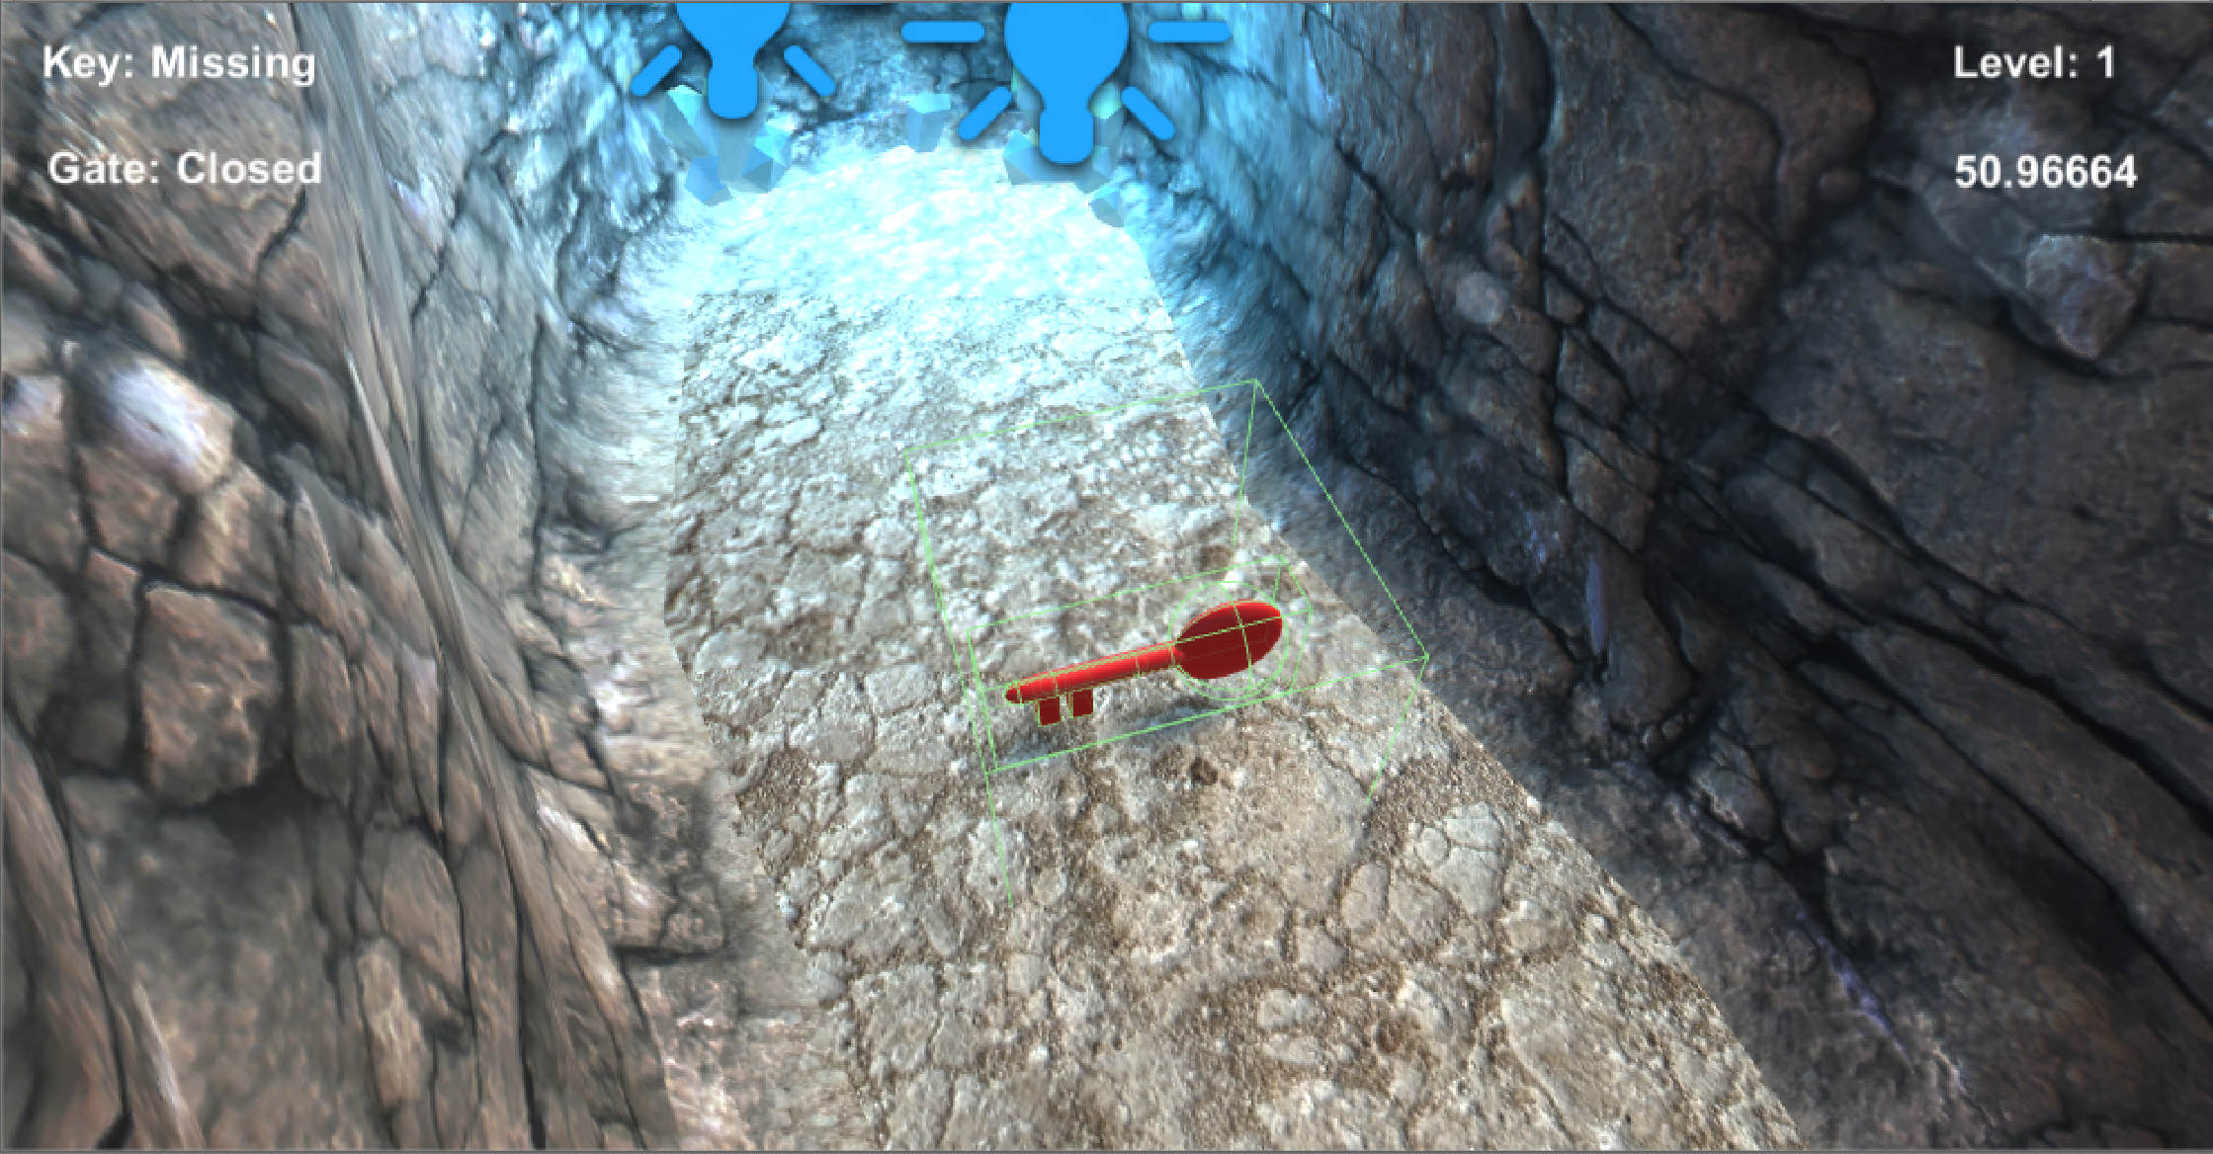
Figure 1 - The key, moments before the PickUp script is implemented
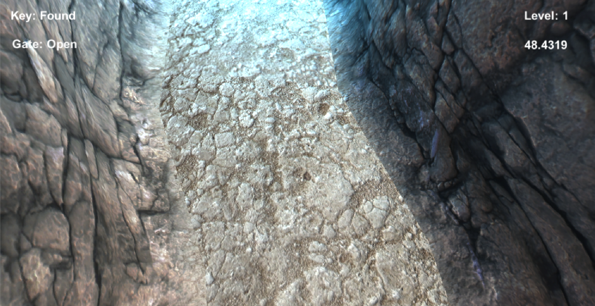
Figure 2 - The player has clicked on the item

4.2 HUD Script

Field | Description
Name | HUD
Purpose | The purpose of this script is to update the heads up display that the player can see on their screen. It is also tasked with updating and changing the amount of time that each level will take.
Key Features | - Updates UI  - Sets time limit based on each level  - Listens for broadcasts from the PickUp script
Attached objects | This script is attached to the UI Canvas and has serialized children.
Table 2 - HUD Script
Two screenshots have been attached below showing the change in the UI as it updates depending on what the player does. In Figure 3 below, the player is currently on level two (represented in the top right corner of the screen) and has not found the key and the gate is locked (shown in the top left corner of the screen).
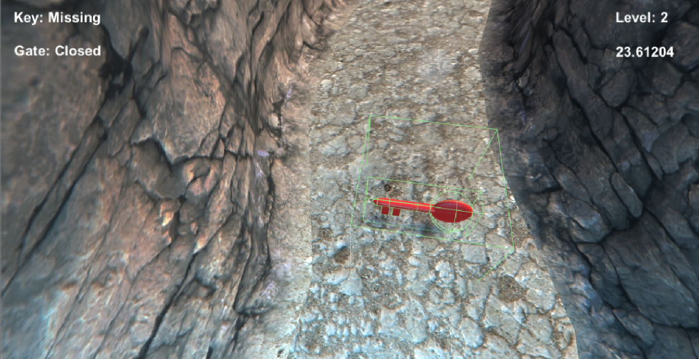
Figure 3 - Pre-Updated HUD
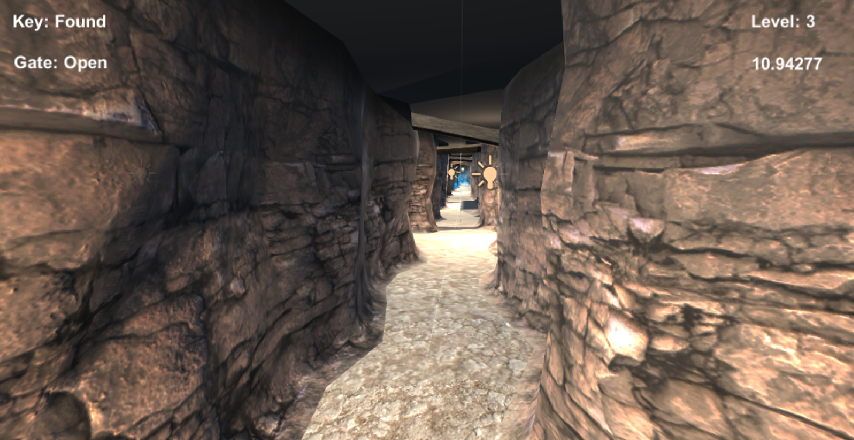
Figure 4 - Post-Updated HUD

LoadNextLevelKey

Field | Description
Name | LoadNextLevelKey
Purpose | When the chest is activated, the animation that is allowed to play to completion before the win method is shown by using the WaitForSeconds method. Once it has finished, the player is prompted to press the ‘enter’ key to progress to the next level. This script is responsible for that transition.
Key Features | - Waits for key input for keypad ‘enter’ and numpad ‘enter’.  - Loads the next level of the game from the Game Manager.  - Increments the level count in the Game Manager.
Attached objects | This script is attached to Menu Board object within the Finish Room prefab.
Table 3 - LoadNextLevelKey Script
There are two screenshots that have been included below that outline exactly what happens between the chest has been interacted with by the player.
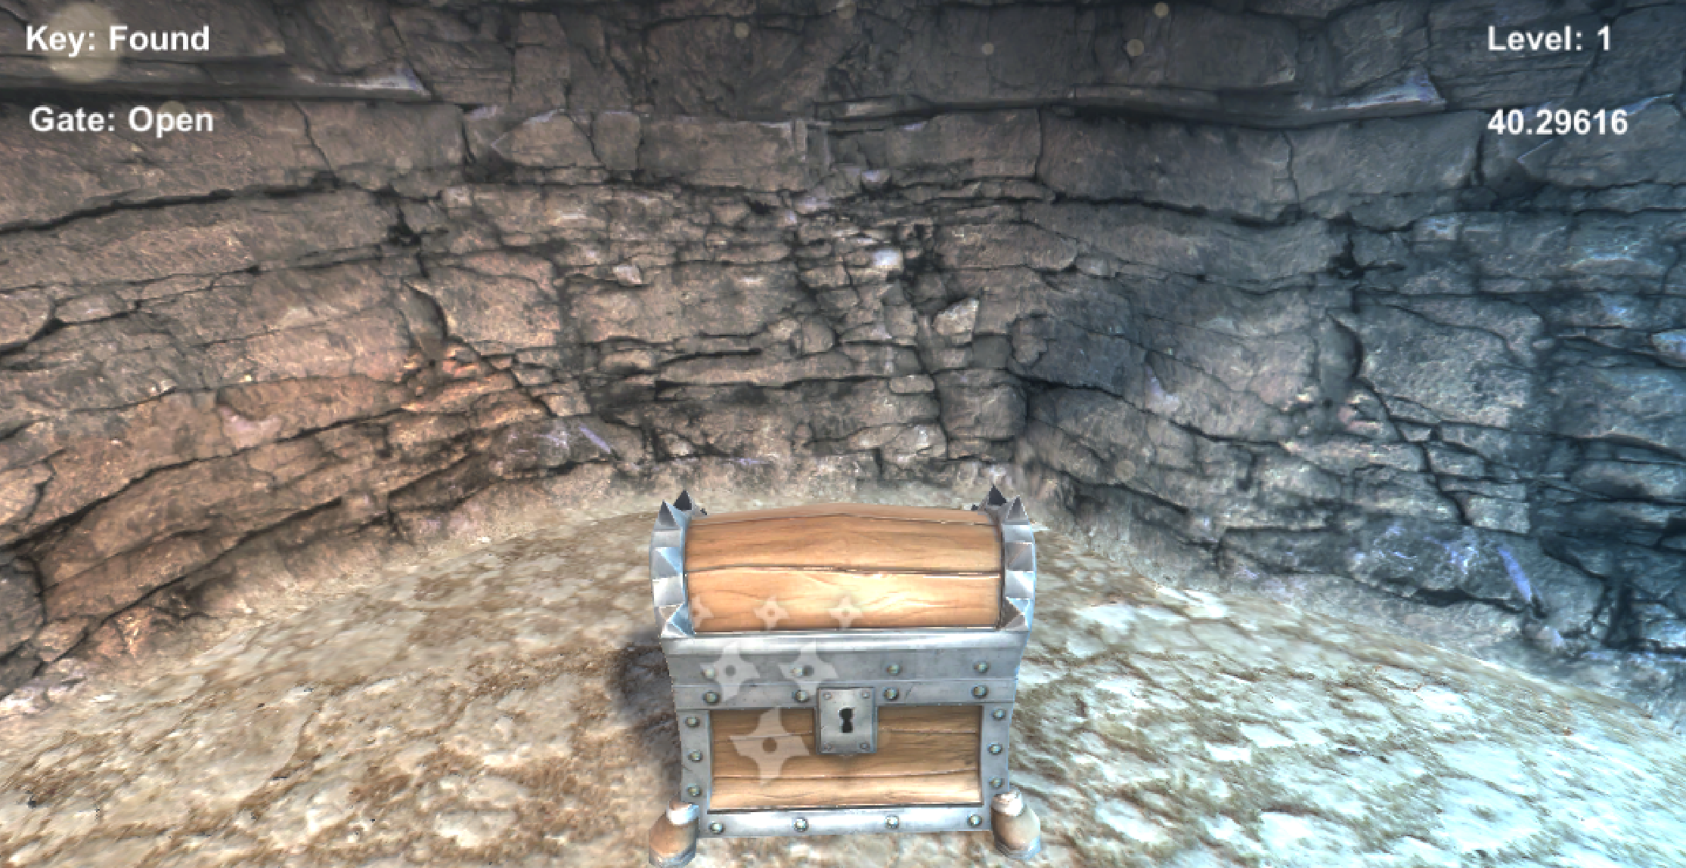
Figure 5 -Pre-Chest Interaction
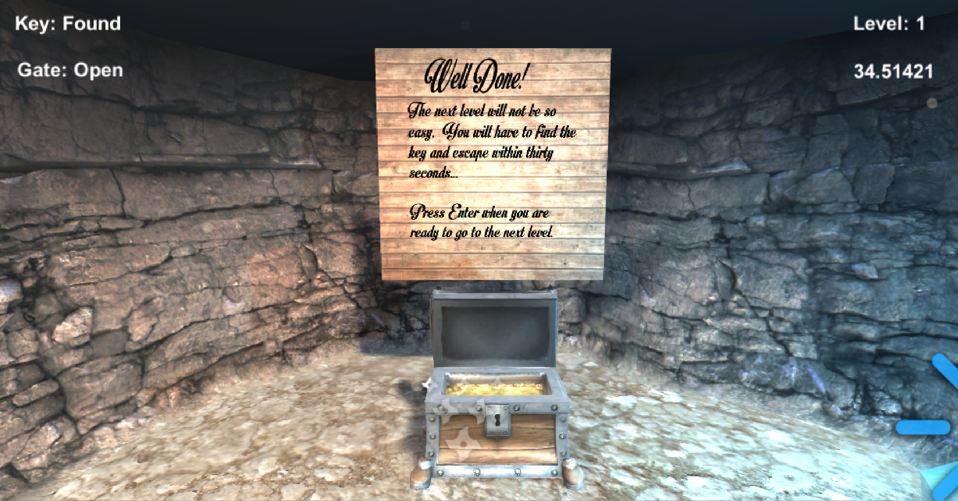
Figure 6 - Post-Chest Interaction

Evaluation

Testing - Events

As suggested, three tests have been created in order to demonstrate that various features of the program are functioning correctly. The first test covers the unity event that was implemented in the PickUp script. The test and screenshots of the code can be found below.
Test Number | Description | Expected Result | Actual Result | Test Outcome
1 | Check to see if the Invoke() method within the PickUp script is passing a value of ‘true’ through to the variable of type bool named ‘state’ in the HUD script. | state = true | state = true | Pass
2 | Check to see if the Invoke() method within the PickUp script is passing a value of ‘false’ through to the variable of type bool named ‘state’ in the HUD script. | state = false | state = false | Pass
Table 4 - Unity Event Test

Sequence of Events – True

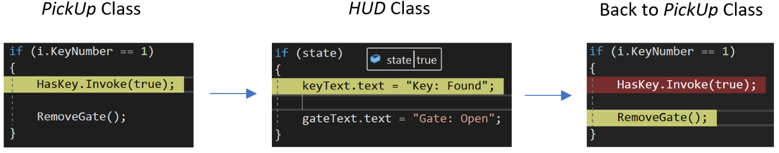
Figure 7 - Timeline - true

Sequence of Events – False

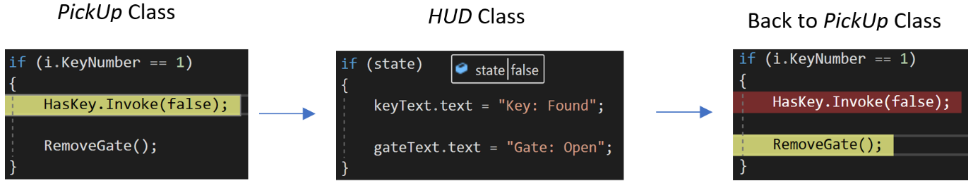
Figure 8 - Timeline - false

Testing – Level Timers

The second test that shall be performed checks that the starting time of each level is correctly set based on which level is currently being played.
Test Number | Description | Expected Result | Actual Result | Test Outcome
1 | Check if the time is set to 60 seconds when entering level one. Screenshot can be seen in Figure 9. | Level 1 = 60 seconds | Level 1 = 60 seconds | Pass
2 | Check if the time is set to 40 seconds when entering level two. Screenshot can be seen in Figure 10. | Level 2 = 40 seconds | Level 2 = 40 seconds | Pass
3 | Check if the time is set to 25 seconds when entering level three. Screenshot can be seen in Figure 11. | Level 3 = 25 seconds | Level 3 = 25 seconds | Pass

Level One Timer

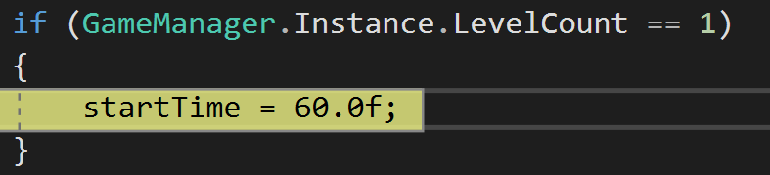
Figure 1 - Level One Timer
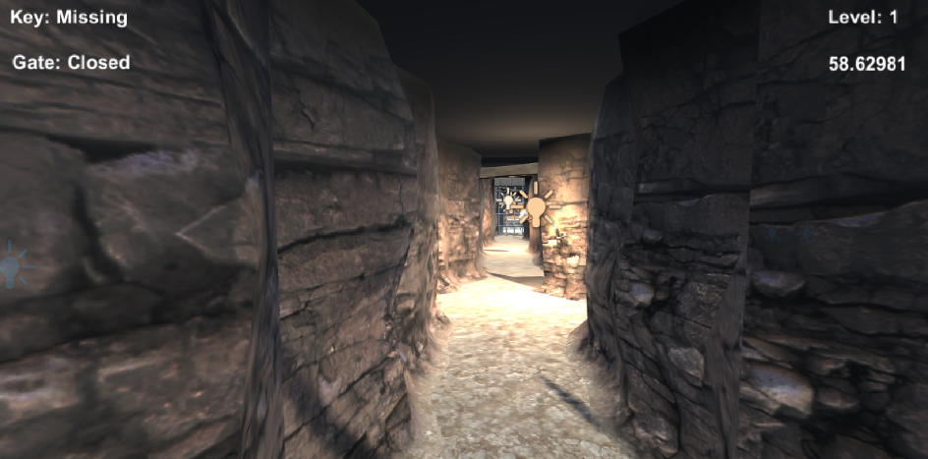
Figure 2 - Level One Timer In-Game

Level Two Timer

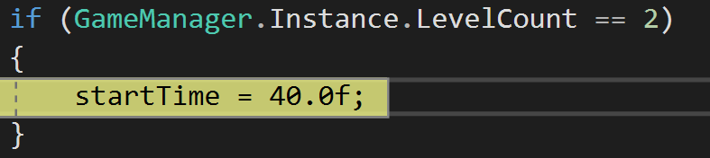
Figure 3 - Level Two Timer
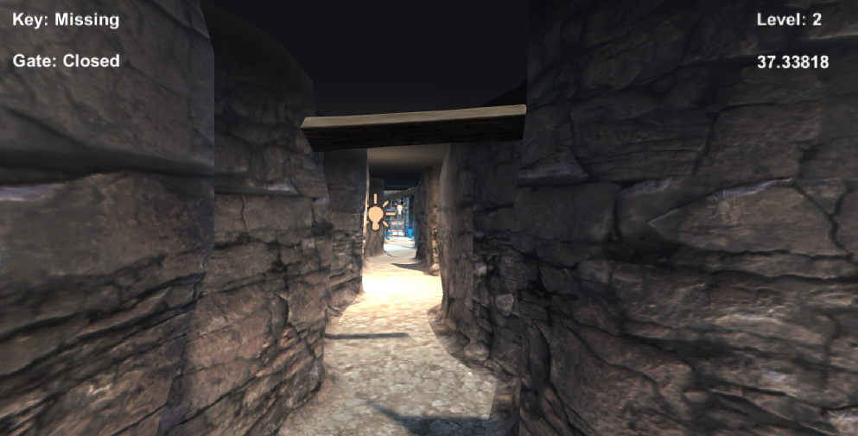
Figure 4 - Level Two Timer In-Game

Level Three Timer

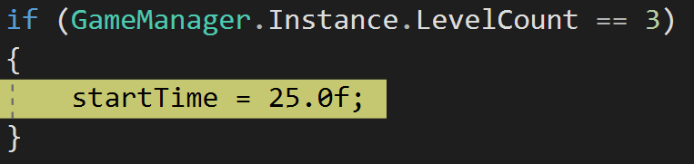
Figure 5 - Level Three Timer
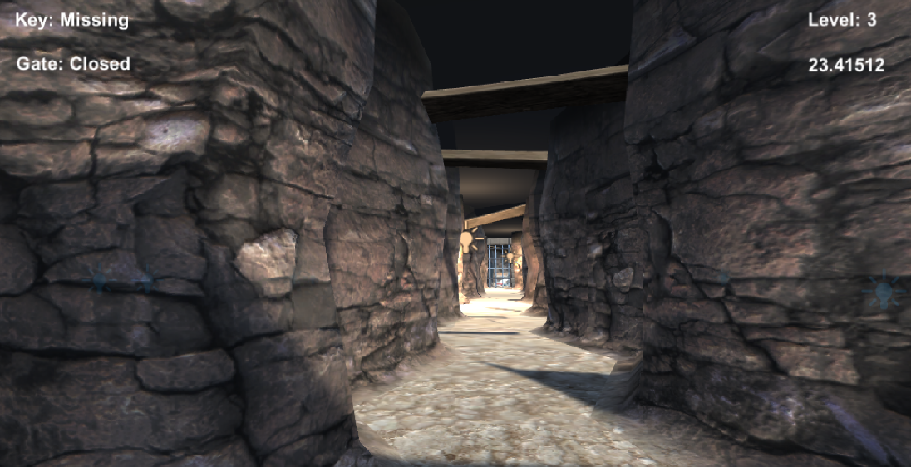
Figure 6 - Level Three Timer In-Game

Recommendations for Future Improvements

There are several concepts that would have greatly enhanced the gameplay and enjoyment should the game be expanded upon in the future. The concepts generally come in two difference types, coding style and game features.

Coding Style

The game could have been vastly improved if the code was written with more dynamic approach. The way in which it has been created means that if new features needed to be added, it would not be a straightforward task or easy to complete. If the use of interfaces had been implemented, classes would have access to data that they needed via the interface rather than creating and instantiating objects within other scripts.

Game Features

The game was planned with the increase in levels bringing in stricter time limits and enemies that would follow the player, with the attack strength of the enemies increasing with each level. Also in later levels, the lighting of the maze would slowly fade down to a near complete darkness, only leaving a small necessary amount of light for the player to navigate the maze.

References

[1] | I. Sommerville, “Professional Software Development,” in Software Engineering, 10th ed., Harlow, Pearson Education, 2016, pp. 19-26.
[2] | E. A. Andrew Rollings, “Laying Down the Ground Rules,” in Game Design, New Riders Publishing, 2003, pp. 9-13.
[3] | C. S. R. A. P. Richard M. Ryan, “The Motivational Pull of Video Games: A Self-Determination,” Motivation and Emotion, vol. 30, no. 4, pp. 344-360, 2006.
[4] | A. C. A. I. N. Paul Cairns, “Immersion in Digital Games: Review of Gaming Experience Research,” in Handbook of Digital Games, 2014, pp. 337-361.
[5] | P. C. Emily Brown, “A Grounded Investigation of Game Immersion,” University College London Interaction Centre, London.
[6] | J. K. J. M. Nigel Beven, “What is Usability?,” in International Conference on HCI, Stuttgart, 1991.
[7] | F. L. U. L. Constantin von Saucken, “Principles for User Experience,” in International Conference on Kansei Engineering & Emotion Research, Linkoping, 2014.
[8] | Object Oriented Design, “Observer Pattern,” OODesign, [Online]. Available: https://www.oodesign.com/observer-pattern.html. [Accessed 23 01 2019].

