
Coaching and mentoring within an organisational context
Coaching and Mentoring BMSW6007

December 6, 2024
allison cullen
2218746

Contents page

1.0 Introduction 1
2.0 Description 1
3.0 Feeling 2
4.0 Evaluation 3
- 4.0.1 What Went Well 3
- 4.0.2 What Did Not Go Well 4
- 4.0.3 Strengths 4
- 4.0.4 Weaknesses 4
5.0 Analysis 5
6.0 Conclusion 5
7.0 My Personal Development Plan 6
8.0 References 7

1.0 Introduction
According to CIPD (2024), Coaching, when associated with business, is a developmental tool aimed at helping an individual grow through guidance and support. Coaching is a performance-driven, non-directive method to expand or obtain new skills. It is usually short-term, time-bound, and focuses on a specific task. It is more structured and involves regular, scheduled meetings. The coach is typically an expert in a particular field, providing guidance, feedback, and support to help individuals develop solutions to enhance their performance. Santiesteban et al. (2022) discuss Mentoring in an organisation as a development-driven directive approach. The mentor is holistic in their approach, focusing on the individual's all-around development in which a more experienced colleague shares their knowledge to support the development of an inexperienced staff member. It demands the skills of questioning, listening, explaining, and reframing, which are also associated with coaching (Viera, {2021).
The importance of coaching and mentoring has grown in post-COVID workplaces due to the increased need for workforce resilience, adaptability, and mental well-being. Proquest (2021). It supports tangible benefits like improved performance and intangible ones such as increased confidence and job satisfaction, essential in post-pandemic work environments involving hybrid working arrangements and elevated stress levels. (Passmore et al., 2023). Organisations like Google use employee coaching programs to encourage innovation, development and collaboration. Their G2G (Googler-Googler) coaching program helps employees coach peers, promoting a culture of continuous learning that motivates people to improve themselves. Employees are developing new skills, which allows employers to benefit from a more engaged workforce. This ensures employees stay aligned with the organisation's mission (Vozza, 2018).

2.0 Description
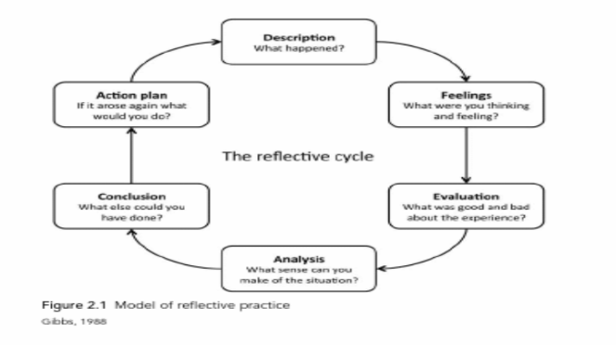
There are various reflective models, including those by Kolb, Driscoll, Boud, and Gibbs. For this written reflection, I
will be using Gibbs' Reflection Cycle. This structured framework serves as a guide, helping individuals through a continuous process of planning, executing, reviewing, and applying this learning to future situations (The Open University, (2024).
Turner, Lucas, & Whitaker (2018).
Landsberg (2015) states that the instant payoff coaching model is helpful when you're short on time or lack the knowledge to conduct a coaching session to develop the coachee’s skills. However, you can still help them complete their task or solve a particular problem.
I applied the instant Payoff Model for this coaching session. The task involved a fifteen-minute coaching session. My role as a coach was to guide Marta through her workplace challenges. I followed a structured plan, helping her identify her blocks in three categories: personal, interpersonal, situational, and brainstorming solutions. I used open-ended questions and summarised them to help the conversation Landsberg (2015). I actively listened to Marta to understand the challenges she was experiencing, but after reading many sources, I realised that I did not fully listen. According to Kimsey-House et al. (2018), there are two aspects to listening in coaching. One is awareness. The information receives from what we hear, but we also listen with all our senses and intuition. We hear, see, and experience sound, words, images, feelings, and energy, and we should be attentive to all the information we receive from our senses. The second aspect is what we do with our listening. Specifically, the impact of the coach's listening on the client. The coach needs to be aware of what they are listening to and recognise the effects of their actions based on their thoughtfulness and choices, which will impact the client. There are many other coaching models; I will only name three: GROW, ELECTRIC, and OSCAR. Compared to the Instant Payoff Model, the OSCAR Model could have been an alternative. It emphasises Outcomes, Situation, Choices, Action, and Review. OSCAR focuses more on aligning the coachee's goal to provide solutions to complex problems. Most frequently, this model is used for coachees who feel overwhelmed (Laura, 2024). The session concluded with Marta developing a SMART action plan to improve her stress and workload management. While my knowledge of tools like SMART was evident during the coaching session, I could have explained the framework to ensure clarity. Blackbym, S. (2024) describes SMART as an acronym for Specific, Measurable, Achievable, Relevant, and Time-bound. It is a coaching model used to help individuals set meaningful and attainable goals.

3.0 Feeling
Before the session, I felt prepared, but I was a little anxious about time management. I was engaged and focused during the session. I recognised the importance of empathy and ensuring Marta felt supported as she faced her challenges. I sat opposite Marta and maintained good body language and eye contact. Marta responded positively to my questions and suggestions. Her willingness to reflect on her situation and take ownership of her development was inspiring and motivating. However, I was conscious of reading my notes, which made me feel less natural in my delivery. Still, it was noted
that I was polite and respectful and communicated logically, and the conversation flowed well. Aspects of the following source were incorporated into my session. Sword, R. (2022). Coaches and mentors should communicate concerns and feelings with compassion and clarity. It is essential to convey intended meanings to avoid misunderstandings or misinterpretations. This includes foreseeing how the individual observes the words and changing the message if needed. As a coach, it's important to maintain a respectful conversation and offer suggestions while allowing the individual to disagree or redirect the conversation. For instance, consider the difference between asking, "What do you think of?" or "Is it all right if?" versus stating, "I think you should" or "Why didn't you?" I used the correct phrases in my coaching session (ibid).
Following the session, I experienced a feeling of achievement when I noticed Marta demonstrating much more confidence. Nevertheless, I can also reflect on areas where I can improve, such as more time exploring deeper blocks and using further active listening techniques, to build rapport more effectively. And to use all the allocated time. Overall, it was a valuable experience highlighting the potential for coaching to empower individuals to overcome their challenges. One of the areas I can improve is rapport. According to Kathleen (2018), An effective coaching relationship focuses on rapport. Building a strong relationship between the coach and the coachee is essential because it helps to develop trust. Sometimes, you may connect naturally with someone, but with others, you have to build rapport by finding common interests and showing empathy. I did not spend enough time building rapport with Marta.

4.0 Evaluation

4.0.1 What Went Well
The Coaching Conversation aims to help the coach and client get to know each other, discuss their interests, and express their developmental goals, whether wanting to speak more confidently in meetings or feeling frustrated about workplace challenges. The coach gains insight into the client's perspective and then attempts to address their concerns. Hunt, (2009). Some of these sources were incorporated into my coaching session. The coaching session was structured following the Instant Payoff Model. I combined the suitable elements of other models, such as the Coaching and Mentoring contract and the goal in GROW, and I used blocks from the Instant Payoff Model. During the session, my body language was positive. I maintained eye contact and used encouraging gestures, fostering a sense of trust and rapport. I used appropriate opening questions plus follow-up questions to probe Marta further. I engaged Marta by summarising her blocks. This showed her that I had actively listened to what she was saying. Helping Marta feel understood and validated was apparent in her willingness to share openly. I guided Marta in most of the talking and developing her solutions.

4.0.2 What Did Not Go Well
Although the session was productive, it was slightly rushed. My coaching session only lasted 11 minutes, which was four minutes under the allocated time. This meant that I could have spent more time explaining the Coaching and Mentoring contract at the beginning of the session, I could have also used some small talk to help build rapport at the start, and I could have spent more time clarifying the action plan at the end. Although I used the Instant Payoff Model effectively, there were moments when I relied heavily on notes, which reduced the natural flow of the conversation, causing it to lack genuine emotion. Occasionally, I used multiple questions in one go, confusing Marta. This could have meant that she would only answer the final question or whatever she could remember from the question, sometimes causing her to overlook the crucial points. I will keep this source in mind for future sessions. Starr (2021). A successful coaching journey requires time, patience, and careful planning. Trust and partnership between the coach and Coachee are essential for creating a positive first impression and a comfortable environment. This builds the coachee's confidence in the coach's abilities. By maintaining an open mind and a calm demeanour, the coach encourages communication that helps clients identify their challenges and aspirations. Ultimately, the coach provides essential support in assisting clients in achieving their goals.

4.0.3 Strengths
The coaching session showcased several strengths: I effectively listened to and summarised Marta’s concerns, demonstrated empathy, and used open-ended and probing questions to provide clarity and practical steps for her future. I maintained a warm, professional manner and positive body language, creating a comfortable environment. The session had a clear structure with smooth transitions, and I used tools like the Eisenhower Matrix and SMART measures to help Marta develop an action plan. This approach encouraged her to take ownership of her solutions and feel motivated.

4.0.4 Weaknesses
I identified several weaknesses in my coaching session. A major issue was my reliance on notes, which hindered the flow of conversation and diminished the emotional connection with Marta. Although I was polite, my delivery lacked spontaneity, affecting rapport-building. I also need to manage session time better to explore Marta’s challenges and action plan more thoroughly. Additionally, asking multiple questions at once may have led to incomplete answers from her. By expanding on these strengths and listening to my weaknesses, I can improve my coaching skills to deliver even more effective sessions in the future.

5.0 Analysis
Based on coaching literature, Kamarudin and Darmi (2020) describe effective coaches as those who demonstrate active listening, empathy, effective questioning techniques, and the ability to empower the coachee to develop solutions independently. I displayed these skills using open-ended questions to encourage Marta to explore her challenges and create actionable steps. Summarising her challenges demonstrated active listening while I used tools like the SMART Model associated with goal setting. And the Eisenhower Matrix, which helped with time management. My body language, eye contact, and encouraging manner reflect essential interpersonal skills mentioned in my coaching texts (Alisoy, 2024).
However, some gaps in my coaching session deviated from the coaching best practices. For instance, my over-reliance on notes upset the flow and natural rapport. Coaching literature emphasises that emotional authenticity and spontaneity are vital for building trust and deep engagement, which was compromised. Mcleod, A. (2014). The coaching literature also recommends asking one straightforward question at a time to avoid overloading the coachee, which I should improve upon. Lastly, time management, ensuring the whole session is used, is essential to increase the coachee's value from the meeting (Solms al et 2022
The INSTANT PAYOFF model for my session was appropriate, given the limited time and Marta’s need for immediate solutions. In contrast, other models, such as the GROW model, could have provided a more future-oriented view, allowing for a deeper exploration of long-term goals. Compared to the ELECTRIC Model, which is more powerful, it demands more time to explore and challenge underlying assumptions, which is more suitable for continuing growth. For instance, I could enrich future sessions using the INSTANT PAYOFF model for the first sessions to address pressing issues and follow up with the GROW or ELECTRIC models for more in-depth ongoing development.

6.0 Conclusion
This coaching session showed the core principles of effective coaching. My ability to listen and empathise guided Marta toward her solutions. Using tools like SMART added clarity and direction. Helping Marta with self-reflection and problem-solving is the impact of coaching. Areas for improvement and what I could have done differently include using the full allocated time, building rapport at the beginning of the session, and ending the session with a clear summary of actions. Managing my allocated time more effectively and letting go of notes will help me create a more natural flow. The session highlighted my potential as a compassionate, resourceful coach. My confidence and coaching style will only grow if I build on these strengths.

7.0 My Personal Development Plan

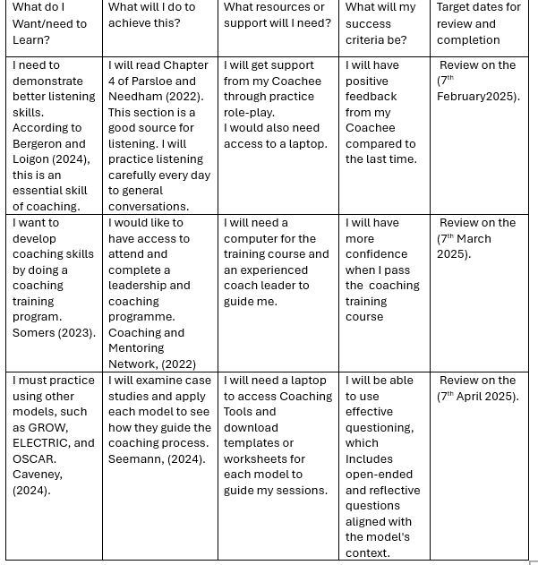

8.0 References
Alisoy, H. (2024) Navigating Impromptu Speaking Strategies for Successful Spontaneous Conversations. Web of Semantics: Journal of Interdisciplinary Science, 2(1), pp.1-8.
Bergeron, D. and Loigon, A. (2024) How to use active listening skills to coach others. Available at: https://www.ccl.org/articles/leading-effectively-articles/coaching-others-use-active-listening-skills/ (Accessed: 26th November 2024).
Binti Kamarudin, M., binti Kamarudin, A.Y. and Binti Darmi, R., (2020) A review of coaching and mentoring theories and models. Int J Acad Res Progressive Educ Dev, 9(2), pp.289-98.
Blackbym, S. (2024) Coaching Techniques: SMART. Available at: https://coachfoundation.com/blog/smart-coaching-model/ (Accessed: 25th November 2024).
CIPD (2024) Coaching and Mentoring, Available at: https://www.cipd.org/uk/knowledge/factsheets/coaching-mentoring-factsheet/ (Accessed: 24th November 2024).
Coaching and Mentoring Network, (2022) everything you want to know about coaching and mentoring. Available at: https://new.coachingnetwork.org.uk/information-portal/what-are-coaching-and-mentoring/ (Accessed: 28th November 2024).
Houlihan, K. (2018) Coaching Essentials: Building Rapport. Available at: https://leadership.global/resourceLibrary/coaching-essential-building-rapport.html/ (Accessed: 25th November 2024).
Hunt, J. (2009) Transformational Conversations: The Four Conversations of Integral Coaching. Journal of Integral Theory & Practice, 4(1).Available at: https://iccnew4now.azurewebsites.net/Documents/transformationalConversations.pdf (Accessed 26th November 2024).
Kimsey-House, H. et al. (2018) Co-active coaching : the proven framework for transformative conversations at work and in life. Fourth edition. Boston: Nicholas Brealey Publishing.
Landsberg, M., (2015) The Tao of Coaching: Boost your effectiveness at work by inspiring and developing those around you. London, Profile Books.
Laura, C. (2024) Six Coaching Models You Need to Know About. Available at: https://buildempire.co.uk/coaching-models/ (Accessed: 24th November 2024).
McLeod, A. (2014) Rapport and neuro-coaching. Training Journal, pp. 58-62.
Parsloe, E. and Leedham, M. (2022) Coaching and mentoring : practical techniques for developing learning and performance. 4 Ed. Edited by D. Newell. London ; Kogan Page Limited.
Passmore, J. et al. (2023) ‘The impact of COVID-19 on coaching practice: results from a global coach survey’, Coaching: An International Journal of Theory, Research and Practice, 16(2), pp. 173–189. doi: 10.1080/17521882.2022.2161923.
ProQuest (2021) The State of Coaching & Mentoring 2021. Leadership Excellence, 38(5), pp. 25-29. Available at: https://www.proquest.com/docview/_ra&sourcetype=Trade%20Journals/ (Accessed: 25th November 2024).
Santiesteban, L. et al. (2022) Defining Advising, Coaching, and Mentoring for Student Development in Medical Education, 14(7), DOI:10.7759/cureus.27356.
Solms, L., Koen, J., van Vianen, A.E., Theeboom, T., Beersma, B., de Pagter, A.P. and de Hoog, M. (2022) Simply effective? The differential effects of solution-focused and problem-focused coaching questions in a self-coaching writing exercise. Frontiers in Psychology, 13, p.895439.
Somers, M. (2023) How your organisational structure impacts coaching success. Available at: https://hrzone.com/how-your-organisational-structure-impacts-coaching-success/ (Accessed: 27th November 2024)
Starr, J., (2021) The coaching manual: Your Step-By-Step Guide to Discovering a Great Coach. Pearson UK. 5th Ed. Harlow, England: Pearson Education Limited.
Sword, R. (2022) How to Develop Coaching and Mentoring Skills. Available at: https://www.highspeedtraining.co.uk/hub/coaching-and-mentoring-skills/ (Accessed: 25th November 2024).
The Open University (2024) Four Models of Reflection. Available at: https://www.open.edu/openlearn/mod/oucontent/view.php?id=51386&section=4/ (Accessed 24th November 2024).
Turner, T, Lucas, M, & Whitaker, C (2018), Peer Supervision in Coaching and Mentoring: A Versatile Guide for Reflective Practice, Taylor & Francis Group, Oxford. Available from: ProQuest E-book Central (Accessed: 25th November 2024)
Viera, C.A. (2021) ‘A Comparison of Mentoring and Coaching: What’s the Difference?’, Performance improvement (International Society for Performance Improvement), 60(7), pp. 13–20. Available at: https://doi.org/10.1002/pfi.21993.
Caveney, l. (2024) Six Coaching Models You Need to Know About. https://buildempire.co.uk/coaching-models/ (29th November 2024).
Seemann, P., Štofková, Z., Poliakova, A., Biňasová, V., & Loučanová, E. (2024). Coaching Approach as a Sustainable Means of Improving the Skills of Management Students. Administrative Sciences, 14(6), 114. https://doi.org/10.3390/admsci14060114

