Written Evaluative Report
Dungeon Litch Defence

For Our Games Design and Asset Creation model, we were assigned a task where we had to design an Arcade Shooter game with a theme of our choice. Dungeon Litch Defence is a arcade wave-based shooter game. ‘A low-level Litch protects his dungeon from the forces of local adventurers. The adventurers come to seek out the treasure chest hidden away and well-guarded by the Dungeon Litch Master. The Adventurers vary is different sizes, but the Litch is equipped with a magical staff and traps to punish the trespassers’. Dungeon Litch Defence is about a Skeletal Dungeon master who has to defend and protect his dungeon and his treasure from invaders from the surface. The them of this game is similar to your typical dungeon crawler/Treasure hunting theme but with the roles reversed.

For the title, we didn’t want to be too ambitious with it. A simple title idea was settled on early on to state the key and main objective in the title. In the end we decided on the title of game to be ‘Dungeon Litch Defence’ The name clearly states the mood and themes that would be demonstrated in the game as well as specify the key objective the player will be aiming to complete in the game.

Our Target audience for Dungeon Litch Defence were the enjoyers of Arcade shooters and wave-based shooters. Because of the genre and the themes displayed in Dungeon Litch Defence, we had to have a higher age rating, but we still felt that Dungeon Litch was to be enjoyed by the older generations who are familiar with these types of games, as well as the younger generations who are being introduced to this genre of gaming. In the end, we settled on an age rating of PEGI 12 and Teen for ESRB.

Early research for Dungeon Litch was focused on studying retro dungeon crawlers and other wave-based shooters. Two similar games we researched into and played ourselves were Unreal Tournament 2004 and Left 4 dead 2. Both these games were perfect examples of the type of the game we wanted to create. Unreal Tournament had such detailed map design and how each part of their maps flow into a track-like route the player can use to lead the waves of enemies around for their advantage. This design element inspired us to implement a similar idea into our own game. Left 4 dead was very different to Unreal Tournament. Left 4 dead focuses more on the overwhelming force of the enemies more than Unreal Tournament. Left 4 dead also uses choke points rather than the detailed track-route like map in Unreal Tournament. We decided to take this into account when design the map layout, maintain the route system inspired by Unreal Tournament, as wells a few chokes points the player can use that are scattered around the map.

This Game development was a group assignment therefore the tasks were divided between the four of us. I was tasked with designing the concepts and the environment models which would be used as the made level models in game. In the early stages of development, I focused on creating the early designs and concepts for assets and ideas we would want for the game. Because I was working in mainly environmental assets, the majority of concept designs I created were for design ideas for when I constructed them in maya and blender. These were the designs for the walls, pillars, doors, and map decorations. I design one other concept design, the skull grenade concept. This was originally a concept to be used as the base design for different grenade like items. Overall, the concept designs I created were extremely effective at showcasing what each asset will need and how they should be presented as a final model. Each drawing I had to base my models on were very easy to replicate and fit in to the level and the atmosphere as a whole.

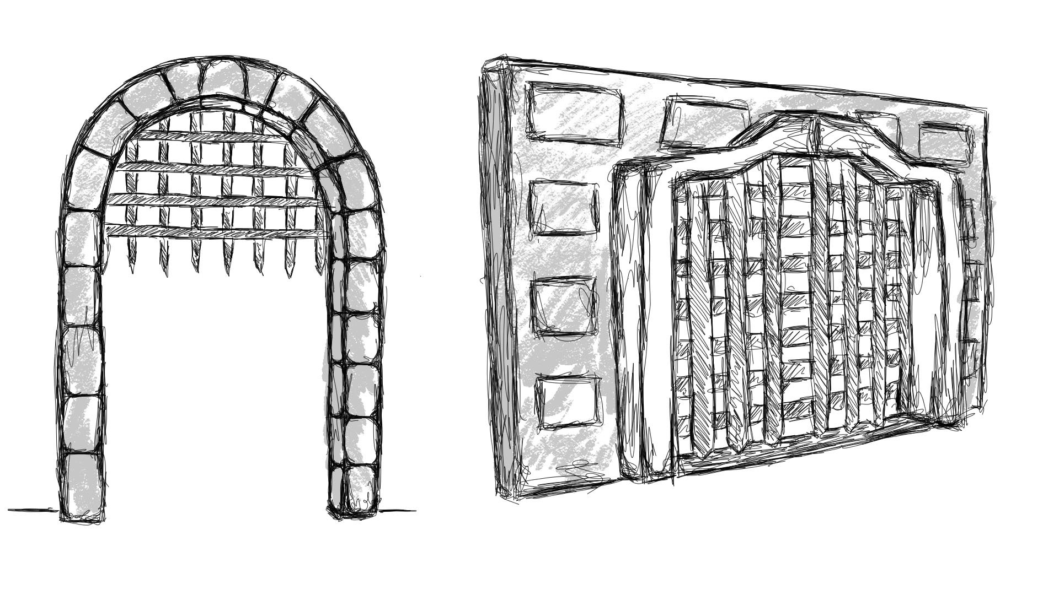Door & Wall concepts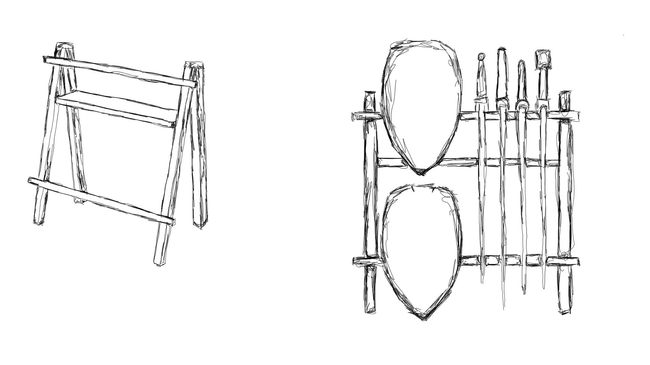Weapon Stand Concepts
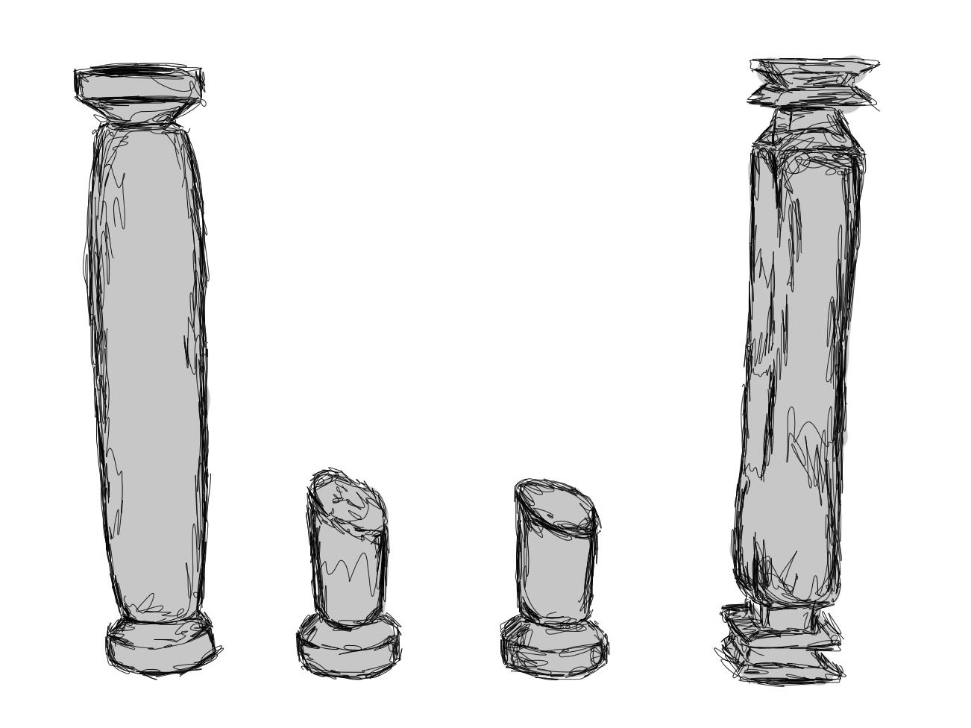Pillar Concepts

Another task I was focused on, was the creation of the physical models to be used in game. As I stated previously, the use of the concept art I created previously made the designing of the actual style and the overall presentation of the models much simpler. The models I created that were used in the final playable version were The Walls, The Doors, The Pillars/Broken Pillars, The Weapon stands, The Debris and The Skull Projectiles. Each one of these models were essential to building the map and improving the overall theme an aesthetic of the game. One of the most important assets for the game was the gate asset. The Gate were designed to be the doors to separate each of the rooms for our level. The design was very simple, the concept had a lot of resemblance to a castle gate where the wooden part of the gate would rise and lower to let things in and out. We wanted to keep this idea in our door design so when design in the asset, I kept each part separate to be organised in engine. This enabled us to construct our own version of a gate with ascension possibilities. As I mention previously, the Skull model was originally designed as a grenade asset for different types such as frag grenades and incendiary grenades. Later in development, we came to a decision to keep the skull model involved but scrap the grenade idea. This was because we would have to redesign the games foundation code as it didn’t support a grenade mechanic. Although we could have implemented it ourselves, we thought it would be much simpler to use the skull as the projectile asset that would leave the players weapon staff. As a whole, the models I produced for the final build of the game were essential for the visual appearance for the game but also for the level design too.
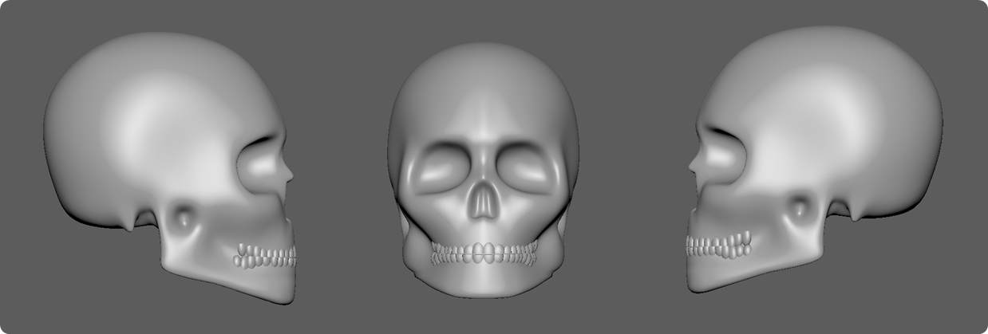
Skull Asset
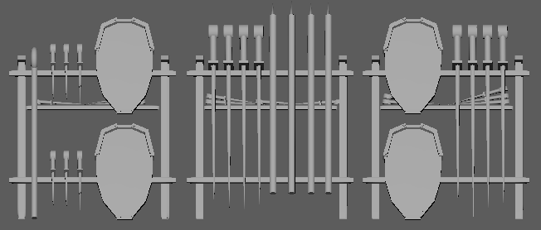
Weapon Stand Asset
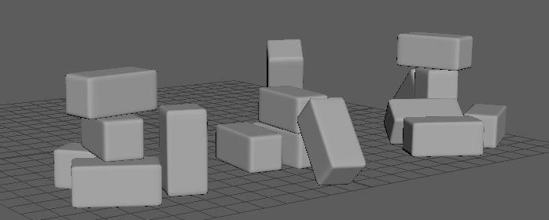
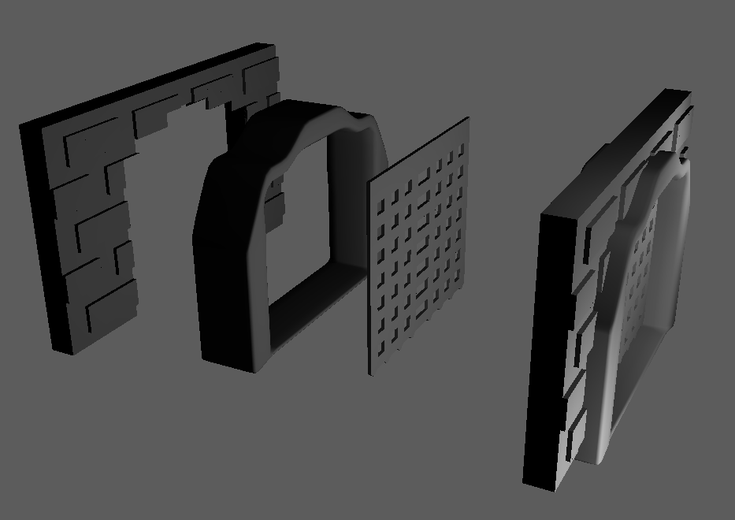
Debris Assets

A as a as a as a as A as a as a as a as A as a as a as a as A as a as a as a as A as a as a as a as A as a as a as a as A as a as a as a as A as a as a as a as A as a as a as a as A as a as a as a as A as a as a as a as A as a as a as a as A as a as a as a as A as a as a as a as A as a as a as a as A as a as a as a as A as a as a as a as A as a as a as a as A as a as a as a as A as a as a as a as A as a as a as a as A as a as a as a as A as a as a as a as A as a as a as a as A as a as a as a as A as a as a as a as A as a as a as a as A as a as a as a as

Gate Asset

As you can see, each of these models were well designed and are the modelling to the detail we were aiming to achieve. However, I do believe that we limited our creativity when it came to designs and decorations. We kept our ideas to very basic models that anyone would expect to see in a game of our theme (gates/drawbridges/stonework/weapons/etc) But to improve our games individuality, we could have improved it with unique ideas. Unique models to give the Litch’s dungeon a more unique feel with some personality scattered around the map.

The final version the game we produced was beautifully constructed by the group member Brecon. The game Each member of the group contributed equally to creating our vision of the Dungeon Litch, the communication between the team was consistent, effective, and supportive when it came to sharing work and ideas with each other. As a team, we would constantly be sharing feedback with each other to get the best work out of each other. Each of us work together to create the best version of the game we could. If we had longer, we could’ve made a full version to embody the vision we had at the beginning. However, I believe that as a team, we understood the assignment and effectively brought it to a successful conclusion for the final version.

As a whole, I think we delivered as a group on what we were being asked to complete for the module. We had effective teamwork and communication when it came to sharing work with each other and giving each other feedback to improve our final product to be the best of out ability. The work each of us completed, all came together and brought the game to a package that delivered on the task. Even though we understood the assignment and completed the work to a great standard, I believe there were parts we could have improved on. A greater variety of models would improve the maps and atmosphere. We should have also focused on texturing a lot more, the textures we had were effective and detailed but not everything fit the same art style and followed the same art style. I also believe that we could have given the game a more unique design such as giving the level more personality and focus on attention to detail. Overall, I think our project was a success and achieved what it was supposed to but could have greater potential if we had longer to improve and focus on our work.

References
Steam. (2009). Left 4 Dead 2. [online] Available at:
https://store.steampowered.com/app/550/Left_4_Dead_2/
Steam. (2004). Unreal Tournament 2004. [online] Available at:
https://store.steampowered.com/app/13230/Unreal_Tournament_2004_Editors_Choice_Edition/
Steam. (2011). Orcs Must Die. [online] Available at:
https://store.steampowered.com/app/102600/Orcs_Must_Die/

