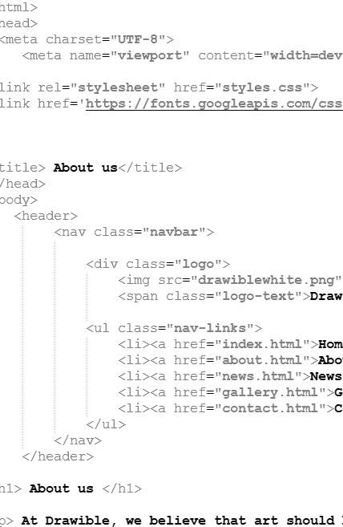

Introduction to Web Concepts
  - applied computing
Olivia Collins| 2403891 | 10.01.2025

Table of Contents
Contents
Table of Contents 1
Introduction 1
Requirements 1
Implementation 1
Evaluation 5
References 5
Appendices 5

Introduction
This report is for the module Introduction to Web and Database concepts. The primary focus for this report is to expand the various web concepts and website development skills. I will be covering the entire process of creating and developing a HTML and CSS website, from the idea to the finished product. I will also be covering the testing and improvement of the website. I will also be evaluating the end product of my website.

Requirements
The website that I have created is focused on a fake business model that I created called “Drawible”. Drawible is a business that focuses on creating horrible drawings for the purpose of humor or jokes. For example, if the customer needed a portrait of something but they wanted it to be funny and humorous, Drawible would be perfect for them. The purpose of the website is to act as an advertisement for Drawible and showcase the artwork that has previously been created. I decided to take a lighter and funnier way to create this website. The intended audience for this website is people who enjoy comedy or like to laugh. To cater to this audience, I added many jokes and quips into my website to get their attention.

Implementation
Home page:
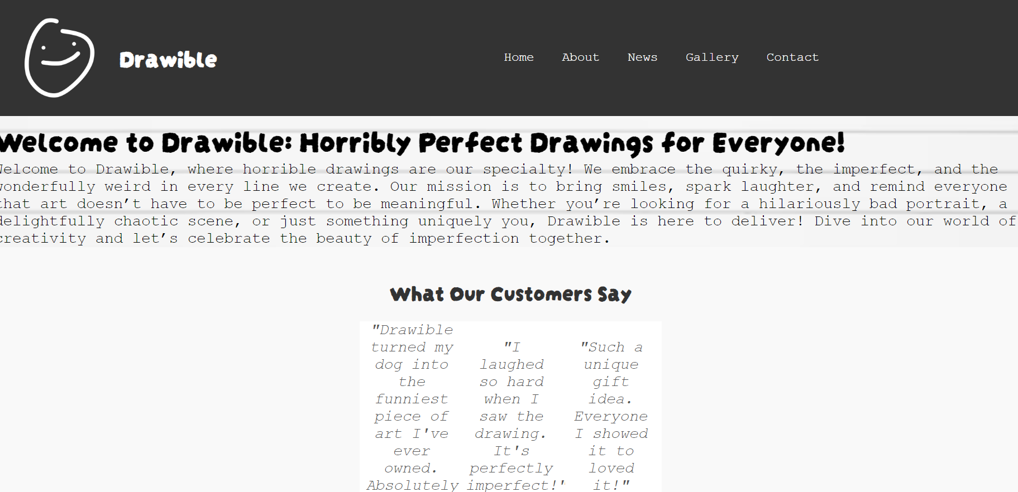
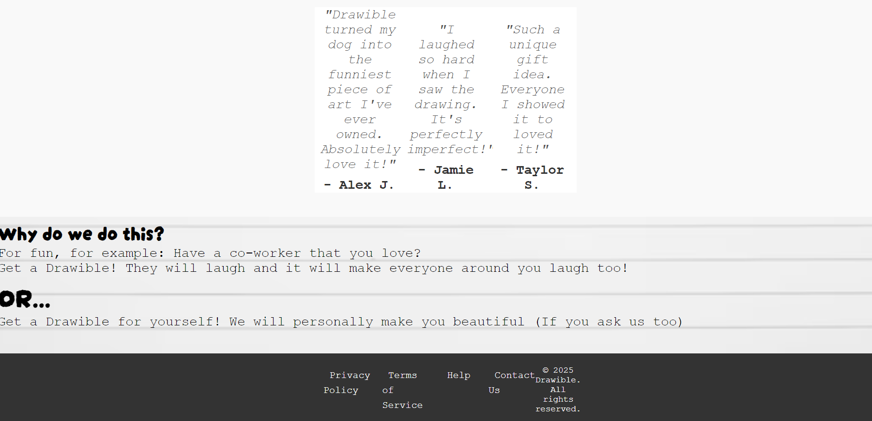
On this page, I had troubles with the testimonials and the footer. Originally, the testimonials were stuck and overlapped each other on the right side of the webpage, I fixed this by changing the display from “auto” to “flex” this allowed the div containers to spread out and sit next to each other nicely. Another error I had was with the footer. On the about page, it looks how it should be but on every other page it looks squished. I couldn’t find a solution to this; I tried changing the size of the padding and changing the display, but nothing solved this issue.
This is how the footer should look:
I also tried an online HTML validator to try and see if there’s any faults within my code.
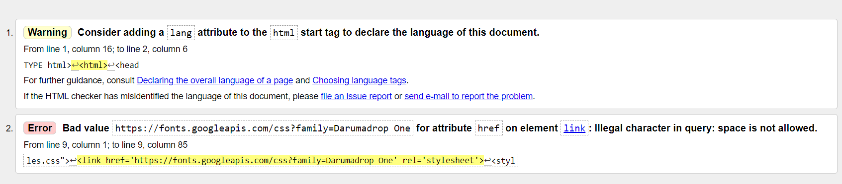
This was the result. It told me to consider adding a language attribute to my html start tag, I didn’t notice that I hadn’t added this yet so I’m glad that the validator pointed this out. The second thing it told me to change is the link within the link that I used for the font. This means that I must put a %20 between “Darumadrop” and “One” at the end. Validating my code helped me realise what I must do to improve my overall website. After doing this, I ran my HTML code back through the validator and it showed up with no errors or warnings found.
About us page:
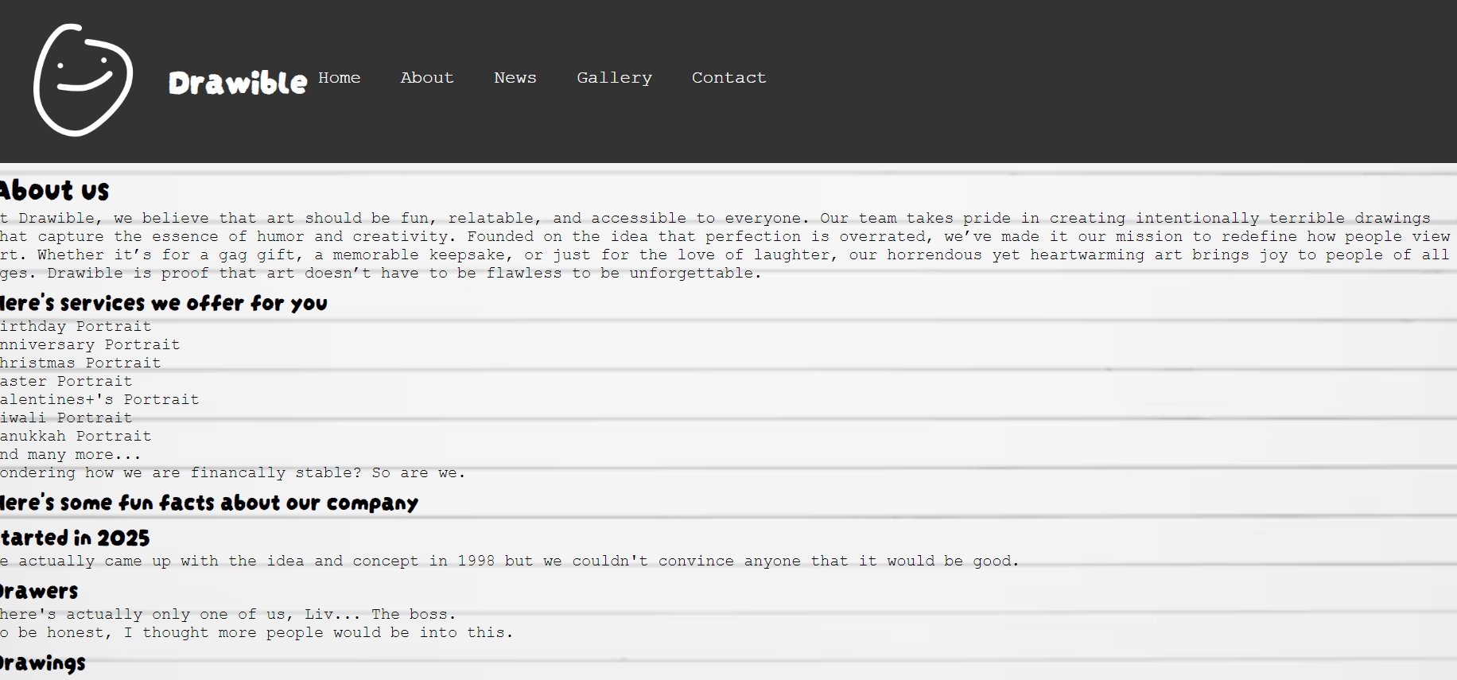
For this page I had difficulties with the navigation bar. I can’t find the reason or issue within the CSS or HTML, so this one is unsolvable for now. I think the issue may have something to do with the content or element that is on this specific page rather than the CSS itself, since every other page works as expected. I have tried looking and investigating all the code to try find the individual problem on each page but it seems to only happen on this singular page.

News page:
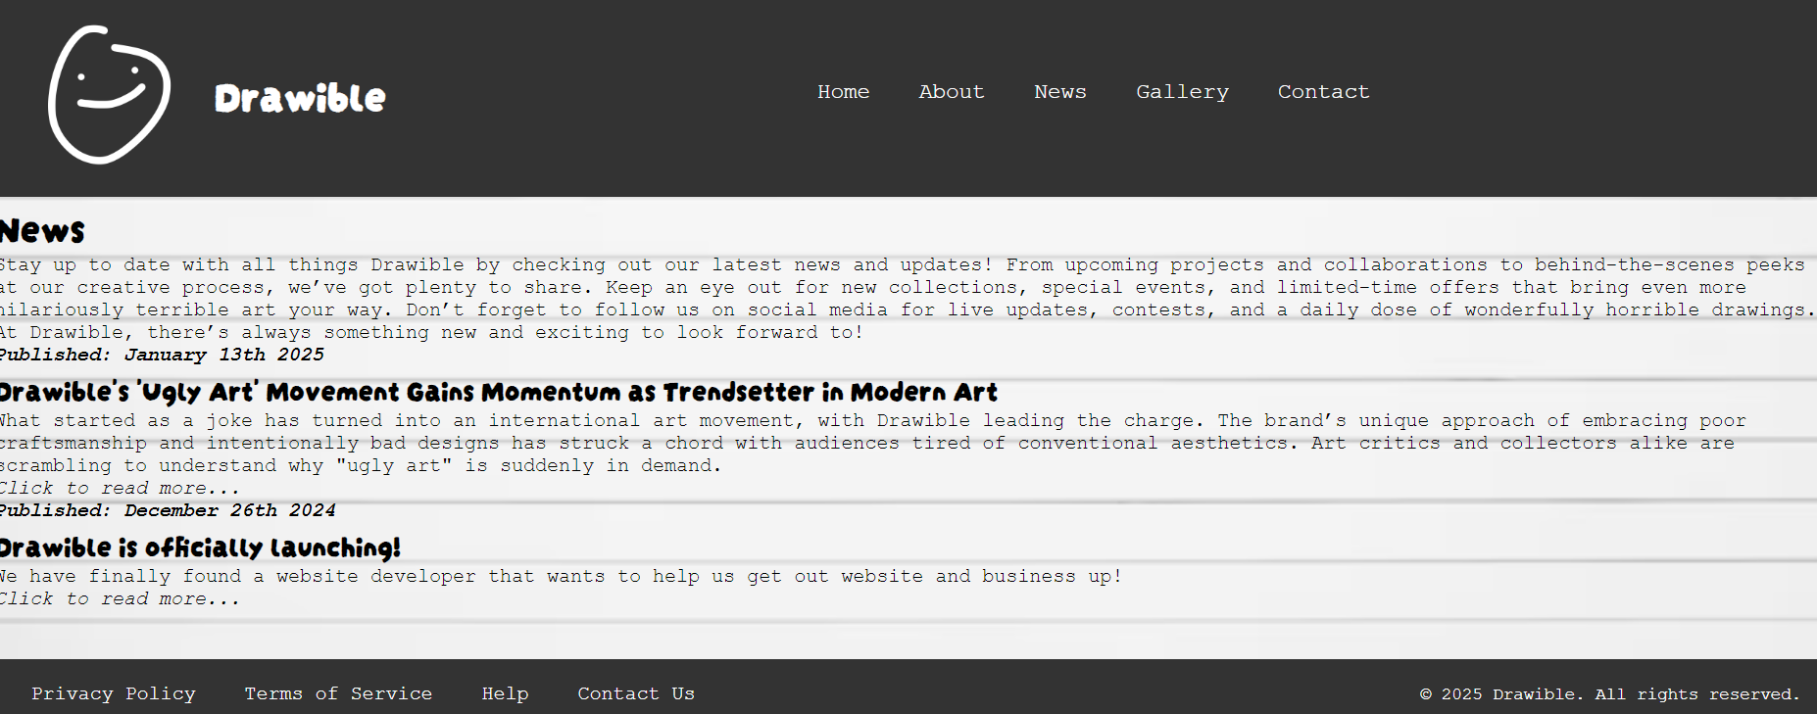
I had difficulties with the text for this page. I used <i> and <b> tags quite a lot, but I kept on forgetting to include the closing slashes to end the italic or bold formatting, which resulted in the whole website being either bold or italic. This mistake took quite a while for me to try and fix, even though it was a simple problem. I
Gallery page:
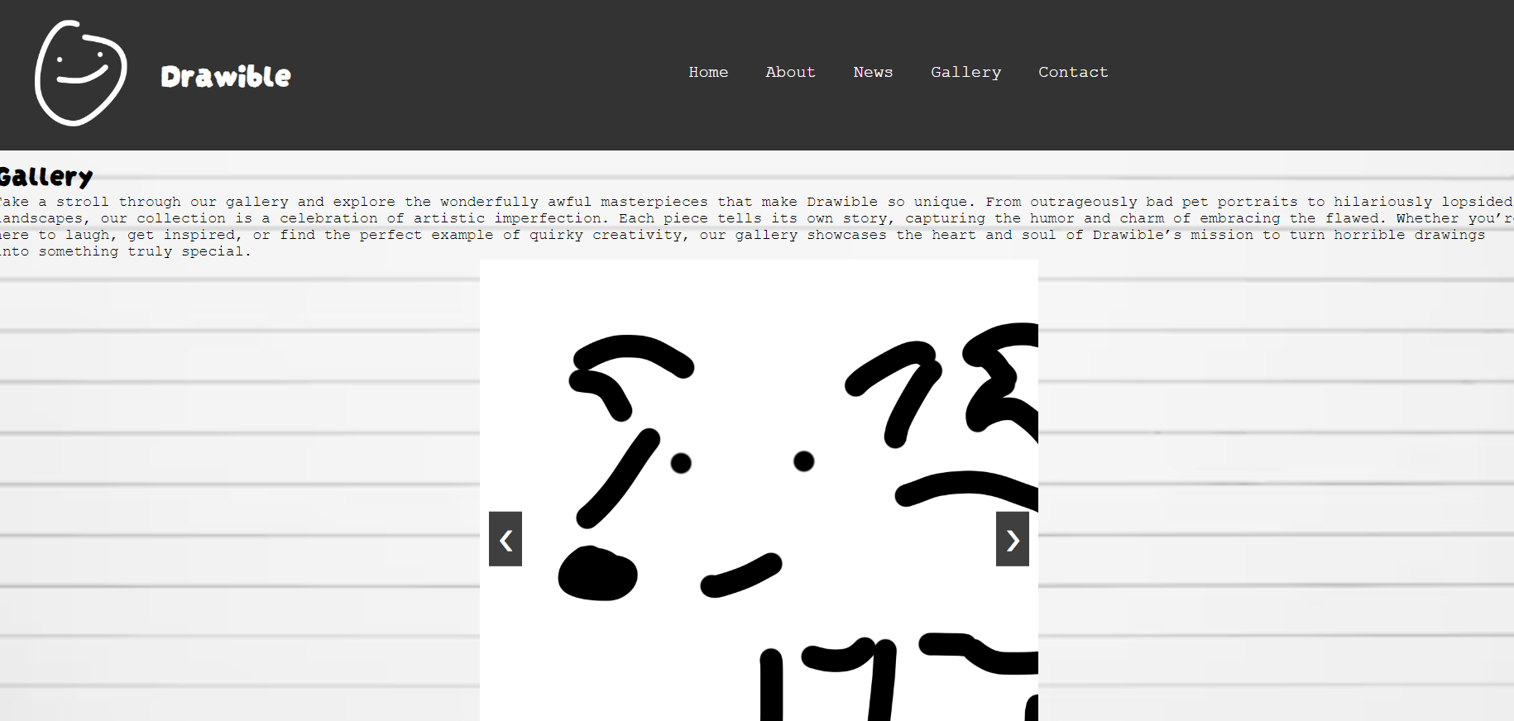
For this page the gallery part just automatically skips the second image. I have tried searching online for potential reasons behind this particular problem, I have also spent a lot of time trying to troubleshoot and fix the code, so this doesn’t happen. But nothing has worked so far. I think the radio buttons may be interfering with the labels, preventing the gallery from working correctly.

Contact page:
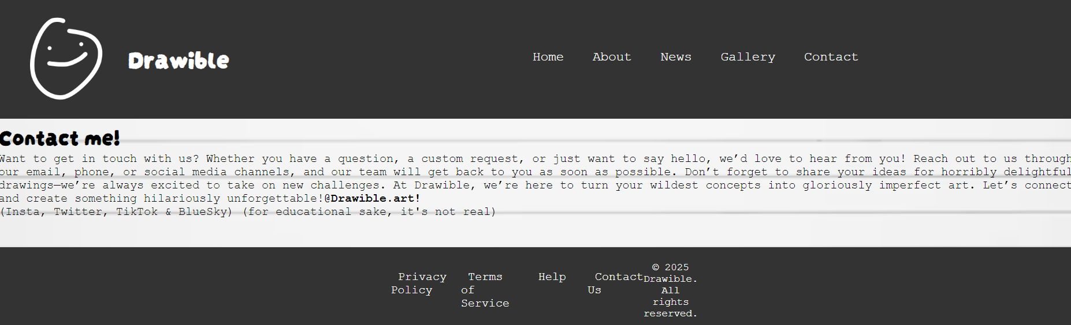

CSS Validator:
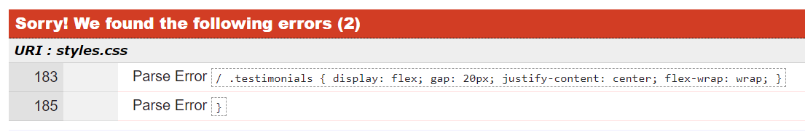
This CSS validator found two errors within my CSS. The first one is a parse error cause by an unnecessary slash that was included in the code without any actual purpose. The second error is also a parse error this time for an unused brace within the code which could’ve been left from a previous edit of the CSS that I did. I didn’t realise these errors at first since they didn’t affect my code massively but once I identified them they were very easy and simple to remove from the CSS. After removing these the validation was clear with no errors found which mean my CSS is now error-free.


In conclusion, I was able to thoroughly test all my web pages and the CSS to make sure there’s no major errors. Although there were some errors that I couldn’t resolve, I dedicated a lot of time and effort into performing trial and error on different solutions. Even though some of these errors remain unsolved for now, I am happy with all of the problems that I was able to solve. I’m looking forward to continuing to improve as I gain more skills and knowledge in web development.

Evaluation
When creating a website, there must be careful considerations into how you can make it user-friendly and effective, with multiple choices and factors that can impact both user experience and accessibility. Three of the most important aspects of web development are usability, accessibility and search engine optimization (SEO). Each of these aspects all have an important role to play to ensure that not only is a website functional but it is also easy to navigate.
Usability:
Website usability allows users to navigate and use a website with ease. It is a critical factor to consider while designing a website, depending on how you approach creating a website it can affect how people will or if they can use it. You have to consider your target audience and who will be using your website and for what purpose. For example, an e-commerce website has to be easy to use for less experienced people, like the elderly or people with disabilities. But on the other hand, if a computer parts website creates an eccentric and detailed website, the people who access that website will be able to navigate it easier. A usable website should be simple but intuitive, not so easy to navigate that there’s no content on the website but not too difficult to navigate where the user is overwhelmed with controls and functions. Taking usability into consideration also means to focus on factors like interface design, the clarity of navigation, site responsiveness and user interaction.
For a brands like Amazon or Tesco, “95.5% of users expect pricing and shipping information to be clearly presented, so usability must be an essential component of e-retail strategy.” [1] For these types of websites, whether that be groceries or just general e-commerce, website usability is essential. Users must be able to know what they are buying and all the details about the item itself and the shipping. “As a result of numerous online frauds and piracy crimes in the network, users need more and more sign to make sure that financial and personal information is under their control and that privacy and security are guaranteed.” [2] When users go onto shopping websites, they want to know that the business is legitimate and that they aren’t going to hacked or scammed. Many e-commerce websites do this by using reviews or having banners and photos on their website to tell their customers that they are a fully legal and licensed business.

Accessibility:
Website accessibility involves the designing of a website in a way that ensure that everyone using your website, including those with disabilities, can access and navigate the website. There website guidelines that can help you design your website for accessibility called Web Content Accessibility Guidelines (WCAG)[3] . WCAG recommend practices like alternative text for images, screen reader compatibility and colour contrast adjustments to help your website become more accessible for users with visual ,auditory or cognitive impairment. For example some website may offer different coloured backgrounds and text size options. Another way of making your website accessible, is offering multiple translations of your website. A common way to do this is Translate which is a web tool that is powered by Google, which offers “instant translation of words phrases and web pages between English and over 100 languages.”[4]
Search Engine Optimisation (SEO):
SEO is the practice of optimising a website to rank higher in the search engines result page. The goal of SEO is to increase organic traffic to a website by improving its overall visibility on search engines by using keyword optimisation, creating high-quality content and optimising meta tags. “Meta tags are pieces of important you tell the search engine and those viewing your site more about your page”[5] These meta tags can also lead viewers to your website depending on what they search up. For example, if the user searches up “Dog Toys”, Pet stores will automatically pop due to the meta tags that they have on their website.
SEO plays a huge role in the success of a website due to its direct impact on a website’s discoverability. Without proper SEO, a website that looks incredible and has amazing content on it can be hidden from users due to the lack of SEO, while a website with terrible design and bad content may be more successful due to the effective SEO.
Website Evaluation:
Now that, I have summarised and understood the three important terms within web development. I am going to apply what I know to my website and evaluate what I have done successfully and what I could improve on.
Usability – My websites usability is quite simple, it’s a small website so people can’t get overwhelmed and accessing the different web pages can be easily seen and used by the navigation bar. I could improve the amount of information that I include on my website about possible pricing and how the service works. I didn’t originally add this onto my website because I didn’t know what to write down but now that I know how e-commerce websites work and how they because useful to my target audience, I will be able to improve the content of my website.
Accessibility – My website could use some vast improvements on accessibility. I mainly focused on designing my website to suit the brand that I made up, rather than focusing on the people who would be possibly navigating it. One thing that I could improve on is colour contrast, since the background of my website is a pattern I could’ve made it a plain background with a different colour text. Another aspects I could improve on is the fonts that I used. Although, it may look cute and funny for the type of website I have, it may seem hard to read for people with visual impairments. One last thing that I could improve is my possible use of audio or video cues. This will help for people with possible visual impairments or people who aren’t interested in reading a lot of text.
SEO – My website could be improved with the use of meta tags, since my original website does not include any. The tags that I could use for my website could be “funny”, “art”, “gift” and “drawing”. These tags could help my website become success due to the high amount of traffic that these tags could bring.
In the end, I have learnt a lot about website development and all of the aspects and information about it. In the future, I would love to make a full fledged website with everything that it would need to be a success.

References
References
[1][2] D. Belanche, et al., "Website usability, consumer satisfaction and the intention to use a website: The moderating effect of perceived risk," 2011.
[3] "Web Content Accessibility Guidelines." https://www.w3.org/WAI/fundamentals/accessibility-intro/, 2024
[4] "Google Translate." https://translate.google.com. https://translate.google.com/about/, 2024
[5] "Is an HTML Meta Tag Important?" https://www.brightedge.com/glossary/are-meta-tags-important, 2023

Appendices
Index.html:
<!DOCTYPE html>
<html lang = "en">
<head>
<meta charset="UTF-8">
<meta name="viewport" content="width=device-width, initial-scale=1.0">

<link rel="stylesheet" href="styles.css">
<link href='https://fonts.googleapis.com/css?family=Darumadrop%20One' rel='stylesheet'>
<style>
div {
background-color: #FFFFFF;
}
div {
width:350px;
margin:auto;
}
.mycontainer {
width:150%;
overflow:auto;
}
.mycontainer div {
width:33%;
float:left;
}
div {
width: 30%;
display: inline-block;
}
body {
font-family: 'Darumadrop One';font-size: 22px;
}
body, html {
margin: 0;
padding: 0;
box-sizing: border-box; /* Ensures padding and borders are included in size */
}

</style>

<title> Drawible </title>
</head>
<body>
<header>
<nav class="navbar">

<div class="logo">
<img src="drawiblewhite.png" alt="Logo">
<span class="logo-text">Drawible</span>
</div>

<ul class="nav-links">
<li><a href="index.html">Home</a></li>
<li><a href="about.html">About</a></li>
<li><a href="news.html">News</a></li>
<li><a href="gallery.html">Gallery</a></li>
<li><a href="contact.html">Contact</a></li>
</ul>
</nav>
</header>

<h1> Welcome to Drawible: Horribly Perfect Drawings for Everyone! </h1>
<p>Welcome to Drawible, where horrible drawings are our specialty!
We embrace the quirky, the imperfect, and the wonderfully weird in every line we create.
Our mission is to bring smiles, spark laughter, and remind everyone that art doesn’t have to be perfect to be meaningful.
Whether you’re looking for a hilariously bad portrait, a delightfully chaotic scene, or just something uniquely you, Drawible is here to deliver!
Dive into our world of creativity and let’s celebrate the beauty of imperfection together. </p>

<section class="testimonial-section">
<h2>What Our Customers Say</h2>
<div class="testimonials">
<div class="testimonial">
<p class="quote">"Drawible turned my dog into the funniest piece of art I've ever owned. Absolutely love it!"</p>
<p class="author">- Alex J.</p>
</div>
<div class="testimonial">
<p class="quote">"I laughed so hard when I saw the drawing. It's perfectly imperfect!"</p>
<p class="author">- Jamie L.</p>
</div>
<div class="testimonial">
<p class="quote">"Such a unique gift idea. Everyone I showed it to loved it!"</p>
<p class="author">- Taylor S.</p>
</div>
</div>
</section>

<h2> Why do we do this?</h2>
<p>For fun, for example: Have a co-worker that you love? </p>
<p> Get a Drawible! They will laugh and it will make everyone around you laugh too!</p>

<h1> OR... </h1>

<p> Get a Drawible for yourself! We will personally make you beautiful (If you ask us too) </p>

<footer>
<div class="footer-content">

<ul class="footer-links">
<li><a href="#">Privacy Policy</a></li>
<li><a href="#">Terms of Service</a></li>
<li><a href="#">Help</a></li>
<li><a href="#">Contact Us</a></li>
</ul>

<div class="copyright">
<p style="color:White;">&copy; 2025 Drawible. All rights reserved.</p>
</div>
</div>
</footer>

</body>
</html>

about.html
<!DOCTYPE html>
<html>
<head>
<meta charset="UTF-8">
<meta name="viewport" content="width=device-width, initial-scale=1.0">

<link rel="stylesheet" href="styles.css">
<link href='https://fonts.googleapis.com/css?family=Darumadrop%20One' rel='stylesheet'>

<title> About us</title>
</head>
<body>
<header>
<nav class="navbar">

<div class="logo">
<img src="drawiblewhite.png" alt="Logo">
<span class="logo-text">Drawible</span>

<ul class="nav-links">
<li><a href="index.html">Home</a></li>
<li><a href="about.html">About</a></li>
<li><a href="news.html">News</a></li>
<li><a href="gallery.html">Gallery</a></li>
<li><a href="contact.html">Contact</a></li>
</ul>
</nav>
</header>

<h1> About us </h1>

<p> At Drawible, we believe that art should be fun, relatable, and accessible to everyone.
Our team takes pride in creating intentionally terrible drawings that capture the essence of humor and creativity.
Founded on the idea that perfection is overrated, we’ve made it our mission to redefine how people view art.
Whether it’s for a gag gift, a memorable keepsake, or just for the love of laughter, our horrendous yet heartwarming art brings joy to people of all ages.
Drawible is proof that art doesn’t have to be flawless to be unforgettable. </p>

<h2> Here's services we offer for you </h2>

<ol>
<li>Birthday Portrait</li>
<li>Anniversary Portrait</li>
<li>Christmas Portrait</li>
<li>Easter Portrait</li>
<li>Valentines+'s Portrait</li>
<li>Diwali Portrait</li>
<li>Hanukkah Portrait</li>
<li> And many more... </li>
</ol>

<p> Wondering how we are financally stable? So are we.</p>

<h2> Here's some fun facts about our company</h2>

<h2> Started in 2025</h2>
<p>We actually came up with the idea and concept in 1998 but we couldn't convince anyone that it would be good.</p>

<h2> Drawers</h2>
<p>There's actually only one of us, Liv... The boss.</p>
<p>To be honest, I thought more people would be into this.</p>

<h2> Drawings</h2>
<p> We actually know how to draw perfectly,</p>
<p> We just cannot be bothered to put our full effort into this. </p>

<footer>
<div class="footer-content">

<ul class="footer-links">
<li><a href="#">Privacy Policy</a></li>
<li><a href="#">Terms of Service</a></li>
<li><a href="#">Help</a></li>
<li><a href="#">Contact Us</a></li>
</ul>

<div class="copyright">
<p style="color:White;">&copy; 2025 Drawible. All rights reserved.</p>
</div>
</div>
</footer>

</body>
</html>

news.html
<!DOCTYPE html>
<html>
<head>
<meta charset="UTF-8">
<meta name="viewport" content="width=device-width, initial-scale=1.0">

<link rel="stylesheet" href="styles.css">
<link href='https://fonts.googleapis.com/css?family=Darumadrop One' rel='stylesheet'>

<title> News </title>
</head>
<body>
<header>
<nav class="navbar">

<div class="logo">
<img src="drawiblewhite.png" alt="Logo">
<span class="logo-text">Drawible</span>
</div>

<ul class="nav-links">
<li><a href="index.html">Home</a></li>
<li><a href="about.html">About</a></li>
<li><a href="news.html">News</a></li>
<li><a href="gallery.html">Gallery</a></li>
<li><a href="contact.html">Contact</a></li>
</ul>
</nav>
</header>

<h1> News</h1>
<p> Stay up to date with all things Drawible by checking out our latest news and updates!
From upcoming projects and collaborations to behind-the-scenes peeks at our creative process, we’ve got plenty to share.
Keep an eye out for new collections, special events, and limited-time offers that bring even more hilariously terrible art your way.
Don’t forget to follow us on social media for live updates, contests, and a daily dose of wonderfully horrible drawings.
At Drawible, there’s always something new and exciting to look forward to! </p>

<p> <i><b> Published: January 13th 2025 </b></i> </p>
<h2> <b> Drawible's 'Ugly Art' Movement Gains Momentum as Trendsetter in Modern Art </b> </h2>
<p> What started as a joke has turned into an international art movement, with Drawible leading the charge.
The brand’s unique approach of embracing poor craftsmanship and intentionally bad designs has struck a chord with audiences tired of conventional aesthetics.
Art critics and collectors alike are scrambling to understand why "ugly art" is suddenly in demand. </p>
<p> <i> Click to read more... </i> </p>

<p> <i> <b>Published: December 26th 2024</b> </i> </p>
<h2> <b> Drawible is officially launching! </b> </h2>
<p> We have finally found a website developer that wants to help us
get out website and business up! </p>
<p> <i> Click to read more... </i> </p>

<footer>
<div class="footer-content">

<ul class="footer-links">
<li><a href="#">Privacy Policy</a></li>
<li><a href="#">Terms of Service</a></li>
<li><a href="#">Help</a></li>
<li><a href="#">Contact Us</a></li>
</ul>

<div class="copyright">
<p style="color:White;">&copy; 2025 Drawible. All rights reserved.</p>
</div>
</div>
</footer>

</body>
</html>

gallery.html
<!DOCTYPE html>
<html>
<head>
<meta charset="UTF-8">
<meta name="viewport" content="width=device-width, initial-scale=1.0">

<link rel="stylesheet" href="styles.css">
<link href='https://fonts.googleapis.com/css?family=Darumadrop One' rel='stylesheet'>
<style>

</style>

<title> Gallery </title>
</head>
<body>
<header>
<nav class="navbar">

<div class="logo">
<img src="drawiblewhite.png" alt="Logo">
<span class="logo-text">Drawible</span>
</div>

<ul class="nav-links">
<li><a href="index.html">Home</a></li>
<li><a href="about.html">About</a></li>
<li><a href="news.html">News</a></li>
<li><a href="gallery.html">Gallery</a></li>
<li><a href="contact.html">Contact</a></li>
</ul>
</nav>
</header>

<h1> Gallery </h1>
<p> Take a stroll through our gallery and explore the wonderfully awful masterpieces that make Drawible so unique.
From outrageously bad pet portraits to hilariously lopsided landscapes, our collection is a celebration of artistic imperfection.
Each piece tells its own story, capturing the humor and charm of embracing the flawed.
Whether you’re here to laugh, get inspired, or find the perfect example of quirky creativity,
our gallery showcases the heart and soul of Drawible’s mission to turn horrible drawings into something truly special. </p>

<div class="carousel-container">
<!-- Radio buttons to control the slides -->
<input type="radio" id="slide1" name="carousel" checked>
<input type="radio" id="slide2" name="carousel">
<input type="radio" id="slide3" name="carousel">

<!-- Carousel Slides -->
<div class="carousel">
<div class="carousel-slide">
<img src="dog.png" alt="Image 1">
</div>
<div class="carousel-slide">
<img src="bday.png" alt="Image 2">
</div>
<div class="carousel-slide">
<img src="cat.png" alt="Image 3">
</div>
</div>

<!-- Navigation buttons (radio labels) -->
<label for="slide1" class="prev">&#10094;</label>
<label for="slide2" class="next">&#10095;</label>
<label for="slide3" class="next">&#10095;</label>
<label for="slide2" class="prev">&#10094;</label>
</div>

<h2> Please feel free to ask any questions about our art on our contact page! </h2>

<footer>
<div class="footer-content">

<ul class="footer-links">
<li><a href="#">Privacy Policy</a></li>
<li><a href="#">Terms of Service</a></li>
<li><a href="#">Help</a></li>
<li><a href="#">Contact Us</a></li>
</ul>

<div class="copyright">
<p style="color:White;">&copy; 2025 Drawible. All rights reserved.</p>
</div>
</div>
</footer>

</body>
</html>

contact.html

<!DOCTYPE html>
<html>
<head>
<meta charset="UTF-8">
<meta name="viewport" content="width=device-width, initial-scale=1.0">
<style>
div {
background-color: #FFFFFF;
}
div {
width:350px;
margin:auto;
}
.mycontainer {
width:150%;
overflow:auto;
}
.mycontainer div {
width:33%;
float:left;
}
div {
width: 30%;
display: inline-block;
}

</style>

<link rel="stylesheet" href="styles.css">
<link href='https://fonts.googleapis.com/css?family=Darumadrop One' rel='stylesheet'>

<title> </title>
</head>
<body>
<header>
<nav class="navbar">

<div class="logo">
<img src="drawiblewhite.png" alt="Logo">
<span class="logo-text">Drawible</span>
</div>

<ul class="nav-links">
<li><a href="index.html">Home</a></li>
<li><a href="about.html">About</a></li>
<li><a href="news.html">News</a></li>
<li><a href="gallery.html">Gallery</a></li>
<li><a href="contact.html">Contact</a></li>
</ul>
</nav>
</header>

<h1> Contact me! </h1>
<p> Want to get in touch with us? Whether you have a question, a custom request, or just want to say hello, we’d love to hear from you!
Reach out to us through our email, phone, or social media channels, and our team will get back to you as soon as possible.
Don’t forget to share your ideas for horribly delightful drawings—we’re always excited to take on new challenges.
At Drawible, we’re here to turn your wildest concepts into gloriously imperfect art.
Let’s connect and create something hilariously unforgettable!<b>@Drawible.art!</b> </p>
<p> (Insta, Twitter, TikTok & BlueSky) (for educational sake, it's not real) </p>

<footer>
<div class="footer-content">

<ul class="footer-links">
<li><a href="#">Privacy Policy</a></li>
<li><a href="#">Terms of Service</a></li>
<li><a href="#">Help</a></li>
<li><a href="#">Contact Us</a></li>
</ul>

<div class="copyright">
<p style="color:White;">&copy; 2025 Drawible. All rights reserved.</p>
</div>
</div>
</footer>

</body>
</html>

styles.css
body {
background-image: url('paper2.jpg');
background-size: cover;
background-repeat: no-repeat;
background-position: center;
margin: 0;
}

h1 {
color: black;
font-family: Darumadrop One;
font-size: 200%;
}
h2 {
color: black;
font-family: Darumadrop One;
font-size: 150%;
}
p {
color: black;
font-family: courier;
font-size: 100%;
}
li {
color: black;
font-family: courier;
font-size:100%;
}

* {
margin: 0;
padding: 0;
box-sizing: border-box;
}

.navbar {
display: flex;
align-items: center;
padding: 10px 20px;
background-color: #333;
justify-content: space-between;
}

.logo {
display: flex;
align-items: center;
background-color: transparent;
}

.logo img {
width: 150px;
height: auto;
display: block;
margin-right: 10px;
}

.logo-text {
color: white;
font-size: 35px;
font-weight: bold;
font-family: Darumadrop One;
}

.nav-links {
list-style-type: none;
display: flex;
gap: 20px;
justify-content: center;
flex-grow: 1;
}

.nav-links li {
display: inline;
}

.nav-links a {
text-decoration: none;
color: white;
font-size: 18px;
padding: 5px 10px;
transition: background-color 0.3s ease;
}

.nav-links a:hover {
background-color: #555;
border-radius: 4px;
}

* {
margin: 0;
padding: 0;
box-sizing: border-box;
}

footer {
background-color: #333;
color: white;
padding: 20px 0;
margin-top: 40px;
width: 100%;
clear: both;
}

.footer-content {
display: flex;
justify-content: space-between;
align-items: center;
padding: 0 20px;
max-width: 100%;
background-color: transparent;
}

.footer-links {
list-style-type: none;
display: flex;
gap: 20px;
justify-content: center;
background-color: transparent;
}

.footer-links li {
display: inline;
}

.footer-links a {
text-decoration: none;
color: white;
font-size: 16px;
padding: 5px 10px;
background-color: transparent;

}

.footer-links a:hover {
background-color: #555;
border-radius: 4px;

}

.copyright {
text-align: center;
font-size: 14px;
color: white;
background-color: transparent;
}

@media (max-width: 600px) {
.footer-content {
flex-direction: column;
text-align: center;
}

.footer-links {
margin-bottom: 10px;
}
}

.testimonial-section {
background-color: #f9f9f9;
padding: 40px 20px;
text-align: center;
font-family: courier;
}

.testimonial-section h2 {
font-size: 2rem;
margin-bottom: 20px;
color: #333;
}

.testimonials {
display: flex;
gap: 20px;
justify-content: center;
flex-wrap: wrap;
}

.testimonial {
background-color: #fff;
border: 1px solid #ddd;
border-radius: 8px;
padding: 20px;
max-width: 300px;
box-shadow: 0 4px 6px rgba(0, 0, 0, 0.1);
}

.testimonial .quote {
font-style: italic;
color: #555;
margin-bottom: 10px;
}

.testimonial .author {
font-weight: bold;
color: #333;
}

@media (max-width: 600px) {
.testimonials {
flex-direction: column;
align-items: center;
}
}
* {
margin: 0;
padding: 0;
box-sizing: border-box;
}

.carousel-container {
position: relative;
width: 80%;
max-width: 600px;
margin: auto;
overflow: hidden;
}

input[type="radio"] {
display: none;
}

.carousel {
display: flex;
transition: transform 0.5s ease;
}

.carousel-slide {
min-width: 100%;
transition: opacity 0.5s ease-in-out;
}

.carousel-slide img {
width: 100%;
display: block;
}

label {
position: absolute;
top: 50%;
transform: translateY(-50%);
background-color: rgba(0, 0, 0, 0.5);
color: white;
font-size: 30px;
padding: 10px;
cursor: pointer;
z-index: 1;
}

.prev {
left: 10px;
}

.next {
right: 10px;
}

label:hover {
background-color: rgba(0, 0, 0, 0.8);
}

#slide1:checked ~ .carousel {
transform: translateX(0%);
}

#slide2:checked ~ .carousel {
transform: translateX(-100%);
}

#slide3:checked ~ .carousel {
transform: translateX(-200%);
}

