ASSESSMENT 1

BUSINESS REPORT

Financial Management for the Hotel Industry Student name: Silvana Mihaela Lorencz
Student ID:2231303
Module Lead:Tristian Hawkins

Acknowledge Statement

I confirm that I have not used any AI tools in the research and creation of this assignment. I confirm that I have not presented any AI generated materials as my own work. I confirm I have copies of my drafts, notes, and other resources I used, which I may be asked to provide in evidence

Executive summary

The following report has highlighted the financial management techniques of Shangri-La and Travelodge Hotels. Different matrices have been used to compare their revenue generation, and market position with the help of statistical information. Capability traits of the companies or growth have also been judged alongside stating their monetary commitment to corporate social responsibility. Furthermore, some insightful suggestions have been attached at the end of the report for the beneficiation of these businesses.

Table of Contents
1.0 Introduction 5
2.0 Financial management and its effectiveness 6
3.0 Analysing the revenue generation potentiality of Shangri-La Hotel Group and Travelodge Hotels 7
3.1 Portraying the total revenue generation by the hotels 7
3.2 Describing the sources of revenue generation 8
3.3 Deriving the revenue trends 8
3.4 Presenting the key factors of the growth potentials of the hotels 9
4.0 Illustrating the market positioning of the hotels 10
4.1 Determining the market share of Shangri-La Hotel Group and Travelodge Hotels 10
4.2 Representing the customer demographics of the hotels 10
4.3 Evaluating the brand perception of the organisations 11
5.0 Evaluating the growth potential for both Shangri-La Hotels and Travelodge Hotels 12
5.1 Comparing the expansion strategies 12
5.2 Assessing the market opportunities 12
5.3 Identifying the potential barriers to growth 13
6.0 Analysing the financial commitment of each of the organisations towards CSR 15
7.0 Conclusion 16
8.0 Recommendations 17
9.0 References 18

1.0 Introduction
Managing monetary evaluations is crucial for every business association for potential profit generation. This report is going to represent the financial managerial strategies of Shangri-La Hotel Group and Travelodge Hotels. An evaluation will be conducted according to the revenue trends and market positioning of the two associations. It will drive the ways these organisations can navigate the competitive landscape in the hospitality industry considering the areas. Apart from that the report will also describe the potential of growth of the organisations stating the expansion measures and market opportunities. It will also construct an elaboration on the financial commitment of the hotels as well.

2.0 Financial management and its effectiveness
One of the major factors associated with any organisation is financial management which contains planning, organising, directing, and controlling financial activities. It is responsible for the sustainable growth of the business organisation operating significant monitory evaluation. The ways financial management signifies the fiscal operations of business associations can be understood in the following.

Figure 1: Financial management
Source: (BBC, 2024)
Budgeting: Every business association holds specific goals and objectives, and the monetary evaluation helps to forecast a sufficient budget for achieving such desired goals (BBC, 2024).
Controlling: It efficiently helps in monetary flows which maintain the liquidity of the business, ensuring the ability towards meeting the short-term obligations of the business.
Decision-making: Financial management helps for conducting inform the decision-making process by providing essential data and insights (BBC, 2024).
Financial Reporting: It is responsible for accurate and timely reporting, which benefits stakeholders' understanding towards the business performance. This enables to uplift the trust and attracting potential shareholders towards the business.

3.0 Analysing the revenue generation potentiality of Shangri-La Hotel Group and Travelodge Hotels

3.1 Portraying the total revenue generation by the hotels
Shangri-La Hotel Group:
The entity achieved potential revenue by serving its luxury accommodations, fine dining and also event management areas. Reports have stated the aggregate revenue of the association was more than £756,521,000 as of 2022 (Shangri-la, 2024). The value of the revenue has been experiencing a potential shift by growth considering the degradation due to COVID-19 in 2020.
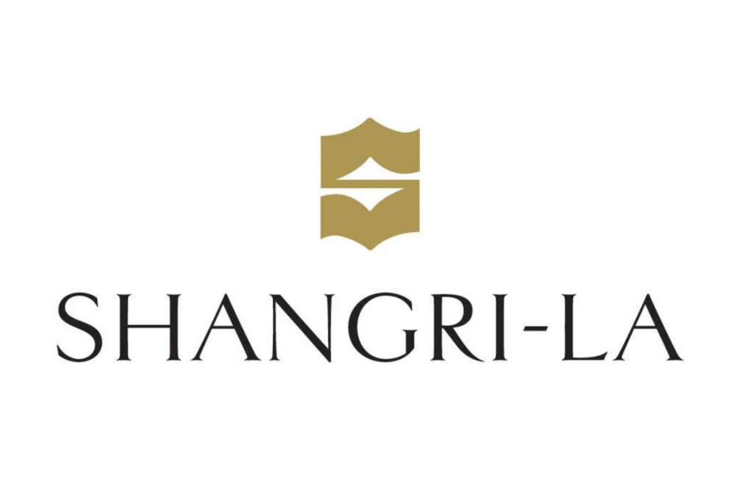
Figure 2: Presenting the brand image of Shangri-La Hotel Group
Source: (Shangri-la, 2024)
Travelodge Hotels:
This respective association operates a hotel chain focusing on offering value services to cost-conscious travellers. They have generated £453,672,600 as of 2022 offering such services in the hotel industry (Travelodge, 2024).

3.2 Describing the sources of revenue generation
Shangri-La Hotel Group:
The maximum earning of revenue of Shangri-La Hotel is from their sales of rooms. Apart from that they also generate earnings from attracting consumers towards their high-end restaurants. The services provided by the hotel for events and conferences are also the factor observing the revenue growth as well (Inkson and Minnaert, 2022).
Travelodge Hotels:
The entity also operates maximum revenue from serving the rooms to the consumers. Another factor of the profit generation is their ancillary services which contain breakfast services and vending machines (Inkson and Minnaert, 2022).

Figure 3: Presenting the brand image of Travelodge Hotels
Source: (Travelodge, 2024)

3.3 Deriving the revenue trends
Shangri-La Hotel Group:
The group has maintained a steady growth post-pandemic, increasing the demand in Asia-Pacific, especially in China. Still, there are difficulties present such as geopolitical measures, economic policies in different regions and also price level fluctuations (Elliott, 2020).
Travelodge Hotels:
The revenue trends of Travelodge Hotels have portrayed a robust recovery from the pandemic degradations serving domestic travel in the UK. However, it has faced complications due to a higher rate of operational costs and the presence of rivalries offering identical services such as Airbnb (Travelodge, 2024).

3.4 Presenting the key factors of the growth potentials of the hotels
Shangri-La Hotel Group:
The key driver that evaluates the growth potential of the respective group is the high demand towards the luxury offering, charging at a higher rate. Apart from that, the potential collaborations with airlines and conducting loyalty programs are other measures of increasing consumer acquisition (Elliott, 2020).
Travelodge Hotels:
The hotel chain has gained popularity through providing budget travel offerings which has generously increased the interest of cost-conscious consumers towards Travelogue. It has also followed a significant expansion strategy for exploring new locations engaging with high demand and potential market share (Mason, 2020).

4.0 Illustrating the market positioning of the hotels
Shangri-La Hotel Group provide services at a luxury segment in the hospitality industry focusing on high-end services attracting affluent travellers and corporate clients. On the other hand, Travelodge operates in a budget-friendly segment considering the affordability and convenience for domestic travellers, families and individuals who prefer economical options. A brief understanding of the market positioning of the hotels can be understood through the following.

4.1 Determining the market share of Shangri-La Hotel Group and Travelodge Hotels
Shangri-La Hotel Group:
The entity has established a substantial market share as a leading luxury hotel specifically in Asia. Several prestigious and significant travelling brands such as Four Season, and Ritz-Carlton have been their competitors in the tourism market (Mason, 2020).
Travelodge Hotels:
This hotel chain is one of the greatest budget-friendly associations established in the United Kingdom competing with brands such as Premier Inn and Ibis (Mason, 2020).

4.2 Representing the customer demographics of the hotels
Shangri-La Hotel Group:
This specific organisation intends to business travellers, families and tourists, especially in the major metropolitan areas and other resort locations. They provide events especially for business purposes serving their offerings with eminent efficiency.
Travelodge Hotels:
It mainly forces price-sensitive travellers which also involves families, professionals and also individuals or groups on business trips (Elliott, 2020).

4.3 Evaluating the brand perception of the organisations
Shangri-La Hotel Group:
The hotel group has been known for their exceptional service and luxury offline providing hospitality in Asian style. It has built a strong emotional connection with its consumers which has made the consumers prefer their services (Inkson and Minnaert, 2022).
Travelodge Hotels:
One of the greatest approaches by the association is the reliable standing of their offering such as the basic amenities at a competitive pricing. Although it lacks luxury measures in its services still, it is widely recognised for its value proposition in the tourism industry.

5.0 Evaluating the growth potential for both Shangri-La Hotels and Travelodge Hotels

5.1 Comparing the expansion strategies
Shangri-La Hotels:
This organisation has made its unique market position as a luxury hotel in the domain of hospitality. One of the major tactics behind this great expansion strategy of Shangri-La hotels is the geographical diversification of business locations. It is targeted countries with strong economies like China, Europe and the Middle East (Sito, 2023). Strategic acquisitions to get control over renowned property and companies are executed by this entity which enlarges the customer base. This company has recently introduced a brand-new version of its brand extension in the name of ‘Hotel Jen’, which is also a part of its expansion tactics (Sito, 2023). Apart from that, technological integration and customer centre services at least this company grow in a factor pace.
Travelodge Hotels:
Unlike the previous organisation that has been discussed in the passage above, this entity projects itself as an affordable and quality option from the context of hospitality. Travelodge Hotels is mainly focused on the UK’s economy and one can witness numerous hotels of this brand in various regions of this country (BBC, 2020). They also follow a strategic acquisition approach for quick expansion and developing new hotels in prime locations associated with high demands. Moreover, the adoption of technology and efficient cost management along with quality improvement are influencing factors of its rapid expansion (Collinson et al., 2020).

5.2 Assessing the market opportunities
Shangri-La Hotels:
This company has successfully emerged in multiple locations still it has a lot to explore from the perspective of business possibilities. Shangri-La Hotels always focuses on China as it is a great region with a growing middle-class segment with elevating disposable income. Southeast Asia covers nations like the Philippines, Indonesia and many more are attractive locations full of market opportunities (Collinson et al., 2020). This luxury brand can expand its stretch in resort destinations providing luxe services and leisure experiences for the travellers. Another potent strategy will be facilitating niche marketing by including spa and wellness-related facilities in their offerings, arranging events and many more (Shangri-la, 2024).
Travelodge Hotels:
The Rapid growth of the tourism industry globally is a matter of opportunity for this budget hotel business. The increment in business travel due to remote works and many more is great for business as the travellers in this case seek affordable yet comfortable accommodation (BBC, 2020). Furthermore, exploring various emerging markets in the world of tourism is filled with numerous possibilities for this business. It can also integrate sustainable tourism along with niche market expansion to try out different available options (Coyle and Sensier, 2020).

5.3 Identifying the potential barriers to growth
Shangri-La Hotels:
Economic adversities are the foremost reason for constraint especially for luxury hotels like Shangri-La. Currency fluctuations and uncontrolled price hikes can cause a drop in demand leading to poor revenue generation of the company. Severe competition in the market and lack of competitive advantage can also be a reason of threat to the path of growth for this hotel. (Sito, 2023) As this company operates in different nationalities, government regulations and operation challenges could be the reason for growth obstacles. Alongside, drifting travel choices of the customers and technological disruptions would also raise concerns in this way (Weaven et al., 2021).
Travelodge Hotels:
The brand perception of this organisation would be a leading factor limiting its growth in terms of price changes and brand expansion with different pricing. Operational issues like staying consistent with the quality offered and aligning with the changing trends in the market could also create difficulties (Coyle and Sensier, 2020). Apart from that, some of the key reasons like economic downturns and other eternal elements are present there to hinder the path of growth.

6.0 Analysing the financial commitment of each of the organisations towards CSR
Organisations | Financial commitment and CSR activities
Shangri-La Hotels | This hotel organisation has a strategic allotment of resources to execute its corporate social responsibilities. The actual amounts are not disclosed publicly, however, their activities could be a good instant to accept that commitment (Shangri-la, 2024). It works towards community development through different initiatives of providing education, healthcare or disaster relief. The company promotes sustainable practices in their organisation to take care of the environment. ‘Shangri-La Cares’ and ‘Sustainability Vision 2020’ are some of the key initiatives taken by this brand from the viewpoint of CSR (Shangri-la, 2024).
Travelodge Hotels | This business has demonstrated considerable financial commitment to fulfil the criteria of corporate social responsibility through various activities. This company has upgraded its internal framework by facilitating LED lighting and thermostats to diminish its carbon footprint (Travelodge, 2024). Various recycling programs are also hosted by Travelodge Hotels for waste management along with water conservation initiatives. They have encouraged community engagement through local partnerships and volunteerism of the employees alongside ethical sourcing in the business (Travelodge, 2024).

7.0 Conclusion
The report has discussed the Business proposition of two renowned Hotel companies Shangri-La and Travelodge from the context of financial management. These organisations have been compared on the basis of different indexes such as revenue generation, trends and the major areas of income. Their market positions have been examined by producing statistical data on market share, brand perception and many more to support the statement. The growth potential of both of the entities has been judged by analysing expansion techniques, market possibilities and barriers to growth. The financial commitment of the brands to facilitate CSR tasks along with some instances have been evaluated in this report.

8.0 Recommendations
Shangri-La Hotels
Exploring niche markets:
This very brand should potentially think about entering into niche markets by providing personalised facilities to appease customers. Merging the idea of travel with Wellness and mental peace should be encouraged by this company by including several experiences like meditation, Spa and other healing activities. Services for adventure-seeking visitors can also be arranged to attract more consumers.
Travelodge Hotels
Brand expansion:
Extending a new hospitality product line by this company would be a great move to overcome the potential barriers. It is genuinely required to keep the organisation away from the negative impacts of its own brand image of being a quality-affordable option. Travelodge can offer a new range of services with different pricing to diversify its target market.

9.0 References
BBC, (2020). Travelodge proposes new deal to end landlord row. [Online] Available at: https://www.bbc.com/news/business-52904443 [Accessed 15 September 2024].
BBC, (2024). Management of finance. [Online] Available at: https://www.bbc.co.uk/bitesize/topics/zqsgd2p [Accessed 15 September 2024].
Collinson, S., Narula, R., Qamar, A. and Rugman, A.M., (2020). International business. Pearson UK.
Coyle, D. and Sensier, M., (2020). The imperial treasury: appraisal methodology and regional economic performance in the UK. Regional Studies.
Elliott, J., (2020). Tourism: Politics and public sector management. Routledge.
Inkson, C. and Minnaert, L., (2022). Tourism management: an introduction. Sage.
Mason, P., (2020). Tourism impacts, planning and management. Routledge.
Shangri-la, (2024). About Shangri-La. [Online] Available at: https://www.shangri-la.com/group/media/media_post?post=Aug30_2023InterimResults [Accessed 15 September 2024].
Shangri-la, (2024). Corporate Social Responsibility. [Online] Available at: https://www.shangri-la.com/xian/shangrila/about/corporate-social-responsibility/ [Accessed 15 September 2024].
Sito, P., (2023). Exclusive | Shangri-La poised to benefit from the Middle East’s economic rebound after decades-long expansion spree. [Online] Available at: https://www.scmp.com/business/article/3239583/shangri-la-poised-benefit-middle-easts-economic-rebound-after-decades-long-expansion-spree [Accessed 15 September 2024].
Travelodge, (2024). About Travelodge. [Online] Available at: https://www.travelodge.co.uk/about/ [Accessed 15 September 2024].
Travelodge, (2024). Sustainability. [Online] Available at: https://www.travelodge.co.uk/our-business/sustainability/ [Accessed 15 September 2024].
Weaven, S., Quach, S., Thaichon, P., Frazer, L., Billot, K. and Grace, D., (2021). Surviving an economic downturn: Dynamic capabilities of SMEs. Journal of Business Research, 128, pp.109-123.

