BMSW4005
Name: Nantale Mariam
Student ID: 1905626
Assignment Title: Professional Career Development
Lecture’s Name: Molly Jack
Assignment 2

Contents
Introduction 3
Personal Reflections on my Career Development 3
Analysis on my Employability skills & knowledge 4
Self-evaluation of my Employability skills & knowledge 6
Evaluation on my readiness for Employment evaluating evidence of literature 10
Understanding of my own personal strength, areas of weakness and further development 13
Establishing my employment career goal & personal professional career development plan 15
Conclusion 17
References: 18

Introduction
According to Andrews (2012), this is the age of “Survival of the Fittest” because in today’s business, the employees need to develop their carrier skills and goals on a regular basis (Cottrell, 2010). Personal Career Development has become the buzzword, which refers to managing an individual’s career in an organizational context through a series of lifelong activities. Whereas, According to Maund (2017), professional development is the pre-requisite of personal career development since it improves all the professional aspects like skills, knowledge, experience, confidence, productivity, compatibility and efficiency of an individual. Therefore, this report is prepared by me as a portfolio to represent the personal perspectives of my professional career development. First of all, I will describe my journey of professional career development from the beginning till now. After this personal reflection, I will focus on the professional skills and knowledge that made my carrier growth through implementing related motivational theories. Again, I will evaluate my employability skills through SWOT Analysis and theories. Besides, I will evaluate my readiness for next height in employment. Finally, I will discuss my carrier goals and future carrier development plans. Indeed, this report is going to be an evidence of my on-going professional carrier related activities in the organizational scenario.

Personal Reflections on my Career Development
According to Whelan (2011), my personal reflections on my career development intends to draw the picture of my lifeline exercise to represent my achievements and experiences till a specific stage of my career. However, lifeline exercise generally reflects the high and low points of an individual’s life’s evaluating from different objective perspectives. Literally, the actual purpose of a lifeline exercise is to draw the personal skills and knowledge of an individual in a zest form so that one can easily have an idea of the employability skills of that individual. In this part of the report, I will draw the lifeline exercise to expose my personal career development through evaluating my employability skills and knowledge.
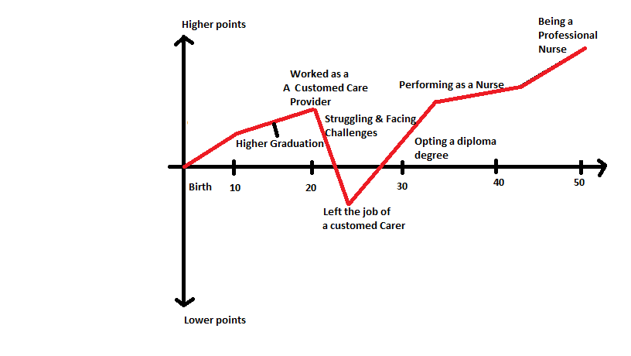
Figure: My Lifeline Exercise.
At this present stage of my career, I am performing as a nurse to provide support and save the lives of the general people attacked by COVID 19 virus and also trying to achieve a degree as nurse to provide better service in this pandemic. However, previously I worked as an accustomed care provider on a train. However, I opted for the degree of nurse after my high school and primary school graduation, since I have interest to serve the mankind to provide them a better and sound life. This is because, I have a higher ambition to bring a change in the health and medicine field through serving as a professional nurse and meeting the health demand of the human capital.

Analysis on my Employability skills & knowledge
Since employability skills and knowledge is required for me to attain my career goals, I need to develop my teamwork, communication, punctuality and problem-solving skills on a regular basis.
Employability skills
According to Morgan (2016), Employability skills are generally known as foundational skills which allow an individual to solve problems working in a professional group. On the other hand, According to Acsente (2010), employability skills and knowledge bring transformative changes, for example, artificial intelligence and globalization in the world of business. This skill indicates the readiness of an individual for employment. Whenever an individual aim to have a long-lasting professional life, he requires being competitive as well as increasing his capabilities in the dynamic labour market. Again, academic studies and post-graduation employment has a connection through employability skills. Though employees generally develop their employability to secure their jobs, but the organizations need to develop the employee’s employability for making them technically skilled for more production growth. On the other hand, lack of employability skill may hamper someone’s occupational future.
I have to focus on developing my efficiency in health sector so that I can deal with challenges as well as meet the lacking in my employability skills. This is why after finishing my diploma course I would rather take some training courses to improve my technical skills or learn how to take risks to overcome the barriers. Since I have financial issues and I don’t hold a graduation degree from a reputed institution, I have to ensure that those initiatives which I am going to take to develop my secure my professional life and attain my career goals should be sufficient and supportive to my employability skills.
Communication:
According to ARCHER (2013), the definition of Communication varies depending on the job. For instance, Communication means the capability of understanding what others want to say or through the verbal or body language. Again, Communication means speaking clearly and directly in order to collaborate with the clients and colleagues to be more productive. In my organizational context, as I am dealing with the COVID 19 patients, I have to negotiate positively and share information with patients since they need to recover immediately fighting against the virus. Beside this, as I have good conducting skills, I should use my networks and persuade effectively to contribute in this crisis moment.
Team-work:
According to NORTHOUSE (2010), Team-work refers to the ability to work along with other persons to achieve a common goal. However, I uphold good leadership skill gained from the previous work experience. Therefore, while working in a team I can lead the team to serve the community. Also, I performed several team projects during my diploma course as well as in my previous employment, so I can work with people of different age, gender, cast as well as I can face the challenges of the situation overcoming the weakness of the team.
Punctuality:
Punctuality is such kind of employable skill that is irreplaceable with any other skills for any job responsibility. Because, punctuality makes individuals passionate and dedicated towards their occupation. Therefore, I can utilize my punctuality skill in my present profession to handle the challenges of the pandemic through my dedication.
Technological Skills:
In the healthcare sector, Technical skills mean knowing how to operate technological instruments such as computer, medical equipment, internet, software, etc. As, I have a degree and also previous work experience, I can deal with technological equipment to an extent, but for further knowledge I have to figure out the required technological skills a professional nurse should have and attain a training course on this subject. Besides, I have to increase my IT knowledge as well as apply my previous skills to deal with the present situational demand in the job market.
Problem-solving:
According to Carroll (2015), Problem-solving is the capacity of finding an appropriate solution to handle an unfavourable and challenging situation. However, this a specious skill that an employee should uphold but as the COVID 19 pandemic is recent situational context which have created thousands of problems throughout the world right at this moment. So, the health workers are trying day and night to save the life of the world people which is ultimate solution of this problem. Therefore, I have to also hard work with all my dedication to save the lives as well as decrease the rate of COVID 19 patients through creating consciousness among people.

Hard work:
Hard work refers to the level of dedication, passion and enthusiasm that an individual should pose for his profession. I am very hard working since my primary school days which can be proved analysing my struggle that have gone through to fulfil my dream. Therefore, I can easily implement my hard-working capacity to serve the mankind to save their lives against this deadly disease.
Learning:
According to O’Brien (2016), Learning means acknowledging new ideas and things quickly as well as to implement them in practical life for performing several tasks. Since, I am quick learner I have enthusiasm for learning on-going things therefore I can apply learning issues in my workplace to accommodate the changing situation and to contribute in this critical crisis.
Multi-tasking:
According to Walker (2012), Multi-tasking means the ability to deal with several issues and perform more than one task at a time. In my professional sector, one must be a multi-tasking employee since he has to take care of the patients, work with colleagues, continue own professional practice all at the same time. Fortunately, I am good at multi-tasking from my student life, therefore, I can contribute properly through utilizing my skills for serving the helpless people to fight strongly in this pandemic together.
Although, I possess various employability skills that are required to deal with my professional situational demand, basically, the COVID 19 pandemic, I have to discover new skills such as imitativeness, self-management, etc. and apply them into my regular practice so that can make myself prepare for attaining my desired future position.

Self-evaluation of my Employability skills & knowledge
Employable skills are transferable since it is the sum of qualities that an individual wants to have to be employable. Therefore, mostly the graduates need employment through it to choose their career goals and to establish own career successfully through navigating the way in the global business market. However, this complex process of career establishment requires self-evaluation of an employee on their employability skills. Again, according to Boyce (2010), Self-evaluation is a process of appraising own self and own progress, judging and finding out the developed areas and the undeveloped areas.
Self- evaluation process can be done by an individual by evaluating own employability skill through applying such tools and techniques like SWOT Analysis, Self-motivation questionnaire, other analytical tool for personal and professional knowledge and skills assessment, etc.
I have applied SWOT Analysis on my employability skills to differentiate the skills I need to improve and the skills I have already improved through practices.

Self-motivational quiz
In this purpose I have made a self-motivational questionnaire as following:
Question |  | Not  at all | Rarely | Some  times | Often | Very  Often
1 | I'm unsure of my ability to achieve the goals I set for myself.
2 | When working on my goals, I put in maximum effort and work even harder if I've suffered a setback.
3 | I set goals and objectives to achieve my vision for my life.
4 | I think positively about setting goals and making sure my needs are met.
5 | I use rewards (and consequences) to keep myself focused. For example, if I finish my report on time, I allow myself to take a coffee break.
6 | I believe that if I work hard and apply my abilities and talents, I will be successful.
7 | I worry about deadlines and getting things done, which causes stress and anxiety.
8 | When an unexpected event threatens or jeopardizes my goal, I can tend to walk away, set a different goal, and move in a new direction.
9 | My biggest reward after completing something is the satisfaction of knowing I've done a good job.
10 | I tend to do the minimum amount of work necessary to keep my boss and my team satisfied.
11 | I tend to worry about why I won't reach my goals, and I often focus on why something probably won't work.
12 | I create a vivid and powerful vision of my future success before embarking on a new goal.
 | Total = | 45

Score Interpretation
Score | Comment
44-60 | Wonderful! You get things done, and you don't let anything stand in your way. You make a conscious effort to stay self-motivated, and you spend significant time and effort on setting goals and acting to achieve those goals. You attract and inspire others with your success. Treasure this - and be aware that not everyone is as self-motivated as you are!
28-43 | You're doing OK on self-motivation. You're certainly not failing - however, you could achieve much more. To achieve what you want, try to increase the motivation factors in all areas of your life. Read the relevant sections below, and work on them to strengthen your self-motivation.
12-27 | You allow your personal doubts and fears to keep you from succeeding. You've probably had a few incomplete goals in the past, so you may have convinced yourself that you aren't self-motivated - and then you've made that come true. Break this harmful pattern now, and start believing in yourself again. The tools and tips below will help you get back your motivation.

Johari Window Model:
The Johari Window, the psychological model developed by Joseph Luft and Harrington Ingham in 1955, analysis an individual’s relationship as well as mutual understanding with his group members. According to Carleton (2011), “Conquer your Blind Spots” – Johari model describes the process of giving and receiving information between team and individuals to raise self-awareness. According to this imaginary process evaluates the open communication between individuals with four panes.
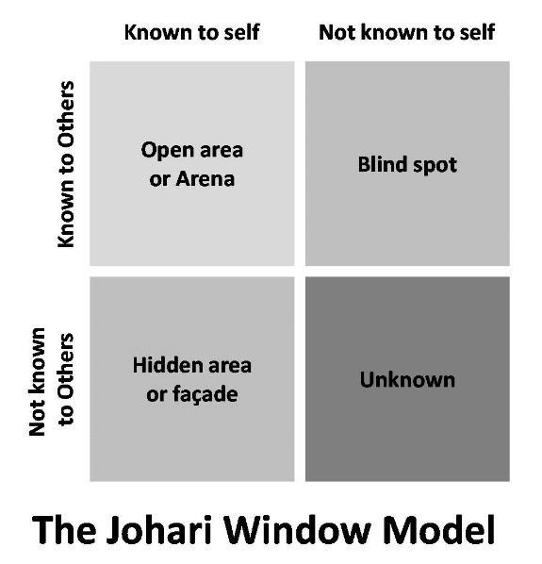
Figure: The Johari Window Model (Carleton, 2011).
According to the analysis of Johari Model implementing it on my employability skills, the self-evaluation of my professional efficiency is as following:
 | Known to Self | Not known to Self
Known to other | Open area or Arena  - I have good communication skills as well as capacity of building good connection with others.  - I am always punctual about my professional life  - I have the capacity to deal with many issues at a time.  - I have a good motivational spirit and quick learning capability which increases my knowledge and skills. | Blind Spot  - Sometimes I make chaotic situations taking too many risky steps at the same time.  - I have financial restrictions and no higher degree in nursing which can create restrictions sometime.
Not known to Others | Hidden area or Facade  - I am not a good speaker; this sometimes does not allow me to interact with people.  - I may get detached from my own goal while balancing my studies and career at the same time | Unknown  - I always tend to fulfil my tasks before the due time but though sometimes I get tired of managing too many responsibilities in a short period of time.  - Sometimes I fail to solve a situational demand since I have lacking problem solving skills, therefore I fail to show my leadership skills.

Evaluation on my readiness for Employment evaluating evidence of literature
According to York and Knight (2003), Employability is a set of activities involving skills, knowledge, behavioural attitudes, understandings contributing to the achievements of a graduate making him reading for employment as well as enable him to be successful in his chosen profession for the development of own career, organizational growth, and the national economy (Ayanian, 2012). Whereas According to Squires (2011), University of Exeter measures employability in another level of dimension, when the students wants to enhance their skills, knowledge and abilities to establish their own mechanism which would contribute to be employable through enhancing their academic learning and creating opportunities for attaining their career goal. This definition clearly specifies that being employable does not refer to have a job only, but also to develop their qualifications continuously to ensure their suitability for job in the current workplace. Again, according to Nash (2010), HEIs defined employability skills from a different perspective, Employability is not only about producing capable and non-capable graduates but also to prepare and arrange academic curriculums in the university studies with the motivation to make a graduate employable. So, basically employability is considered as a learning process rather than a product. In the report “EMPLOYABILTY & Diversity” Hervey (2001) claimed that, employability although different researcher provided different definitions of employability from their own perspectives but in a whole this definition can be categorized in two parts, one of them called employability the capability that a graduate should uphold for getting a job. Another category defines employability a process of developing the student’s skills, attributes, knowledge, in order to empower them as well as establish a life-long learner so that they can ensure their job life secure through their own capability.
According to those scholars and researchers, employability skills varies country to country but such as punctuality, communication skills, creativity, hard work, technical skills, problem solving skills, decision making skills, leadership skills, entrepreneurship, multitasking are some common skills. In UK, the core skills, key skills and common skills are known as employable skills.
According to Chatzopoulou (2015), through Kolb’s Reflective Model, an individual can develop own learning for being employable through four major stages Experience, Observation & Reflection, Development of ideas, Testing ideas in practice.
However, this reflective cycle explains, when an individual aim to develop his professional career through learning approaches, he might first take the step of reflective observation such as observe all the related aspects of his professional world. Then, in the second stage he requires abstract conceptualization which would allow him acquire knowledge and skills guiding in the right direction. After conceptualization he have to experiment what he has learned till the third stage. Finally, in the last stage he needs to concrete and sum up all the experiences he achieved through this cyclic learning process to for making own self employable and developing own the employable skills.
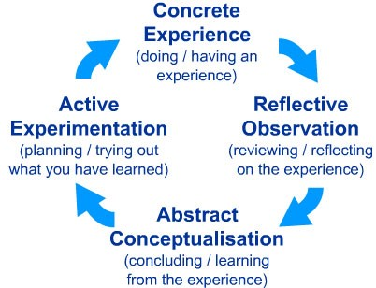

Figure: Kolb’s Learning Cycle (Chatzopoulou, 2015).
For my aspired profession to be a nurse of effective skills and knowledge with potential to manage health facilities as a practising nursing in my potential organisations to improve service quality and human capital, I need to pay attention to the followings:
Ethics & professional codes for Nurses
According to Nursing Notes website (2015), the following are the ethical and professional codes of practice for each nurse:
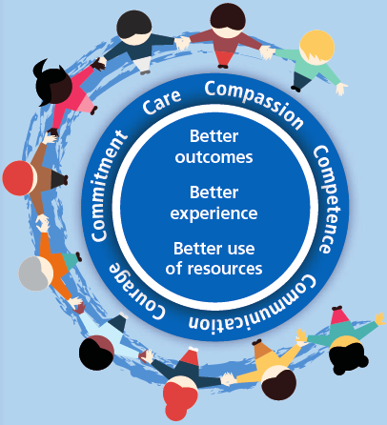
Figure: 6C’s of ethical nursing care (Nursing Notes, 2015)
To learn on the professional codes to be practices as a nurse, I will also need to learn on different national healthcare legislations such as Care Standards Act 2000 which will help me provide person-centred effective care. On the other hand, to become a nurse capable of management responsibilities in healthcare facilities, I will need to learn abreast on the Care Home Regulations 2001 and keep updating my knowledge. In any case, my job will be to safeguard individual in my workplace through the adherence to employment legislations.
Job description of a nurse
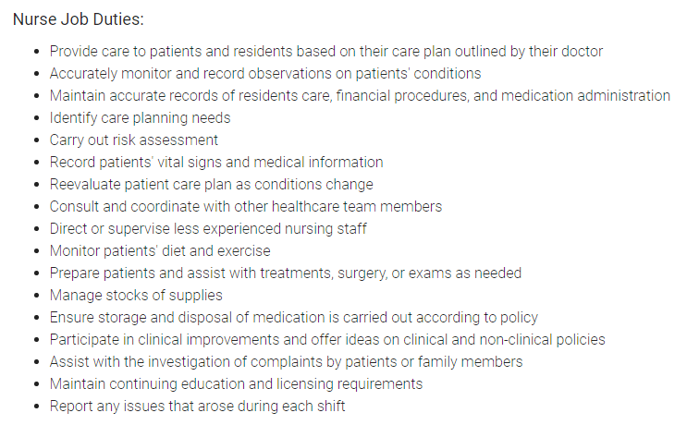
(Source: monster.co.uk, 2019)

Person specification for nursing job
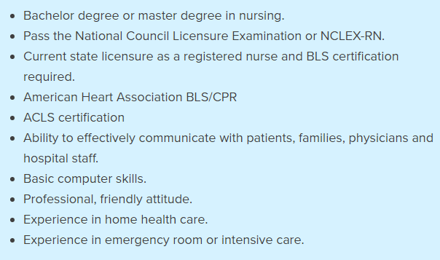
(Source: betterteam.com, 2019)

Understanding of my own personal strength, areas of weakness and further development
SWOT Analysis:
According to Peteiro (2017), SWOT Analysis is a technical tool of study which identifies different characteristics such as the internal strength and weakness as well as external opportunities and threats of an individual or an organization. SWOT Analysis is considered as an effective way of self-evaluation of the employability skill of an employee.
Applying SWOT Analysis on my employability skills to figure out my strengths, weakness, opportunities and threats to prove efficiency as a health carer serving nursing facilities in the recent Covid 19 Pandemic as well as a future professional nurse.

S | Strength | - A good communication skill helps to build good relation and to connect with people who are associated with my professional life.  - My high-level tolerance makes me enable to meet with any challenge and to solve any problem through hard work.  - My Punctuality creates scope for attending my tasks successfully in time.  - My team working quality works as my strength while working in my current professional context.
W | Weakness | - My introvert quality does not allow me to interact with so many people.  - Sometimes being too honest and humble to own profession, creates problems in my working context.  - Sometimes taking too much challenges and risks becomes a weakness when I fail to handle them.
O | Opportunities | - I am quick learner which creates scope for me to learn new ideas, technologies, strategies everyday which may contribute to my personal career growth.  - Self-motivation creates opportunities for my continuous career development since enhancing my employability skills.  - Leadership skills are such personal strength which indicates my long future professional success to serve as leader carer in the health care sector.
T | Threat | - My financial barriers are a threat to my career goals if I face financial lacking in the way to my occupational goal.  - Dealing with time is may occur problem and imbalance while dealing both personal and professional life at a time.

In this modern age, the world of employment is becoming more competitive as well as tougher for the average type of employees since the advancement in knowledge and technology is giving birth to skilled employees every day. From the perspective of my knowledge and experience, I can say that having employable skills is not enough at all, rather the employees need to develop their skills every now and then for establishing own personal career development process on life-long. However, I have learned from my job experiences that each the role of employees varies with the pattern of job and therefore each job role requires variable employable skills. Since I have gained several employable skills that would be supportive to my future dream job but still, I need to improve my weak areas to increase my efficiency.
For instance, from my previous analysis and evaluation processes applying different theories and systematic techniques on my employability skills I came to know, that I have to improve several areas along with developing my problem-solving skills as well as my speaking quality which as a whole decreasing my leadership skills. Although, I have proven myself as a punctual and multi-tasking employee in my previous responsibilities, I need to improve my blind spot areas to improve efficiency. By developing my problem-solving capability, I could solve any future problematic situation as well as can handle those situations utilizing my leadership skills as well.

Establishing my employment career goal & personal professional career development plan
Identification of SMART objectives in Professional/Personal Development Plan (PDP)
In order to continue the steps towards attaining my career goal, I not only need to work hard with strong determination but also need to improve my employability skills through practicing and learning on a regular basis.
According to Nicolson (2014), Professional/Personal Development Plan (PDP) is the technical process of creating the roadmap of an individual’s career through identifying and deciding the initiatives he should take in order to reach his career goal. Therefore, I choose PDP as technical way to establish my career plans with a strong motivation to identify the employable skills I required for achieving my dream jobs goal.
The following PDP with smart objectives will enable me to evaluate my employability skills as well as suggest me the areas which is required to be improved in order to attain my desired goal.

Personal development Plan
Skill or ability area | Specific task (What is the task or objective?) | Measure (Standards and parameter) | Agreed (Is it?) | Realistic (Is it?) | Timings (Start/finish date) | Comments/ action
Speaking & Interacting ability | The task to develop my  Speaking as well as interacting ability is to fixing appointments with the clients on a daily basis and arranging team works on weekly basis. | The parameter for measurement will be to meet at least 5 patients each day and 1 teamwork each week. | Yes, the set task is possible to be achieved. | Yes, the measurement standard is realistic to achieve. | In the next six months | I have to prepare the appointment and teamwork as well as a make schedule to make my plans fruitful and efficient.
Problem solving | To improve my Problem-solving capacity in short time of period, I have to take 1-2 projects in a week not taking much risks. | My measurement standard will be to solve at least 1 risky and challenging project to find out all possible solutions in the due time. | Yes, the task is achievable. | Yes, it is the best way to be improve problem- solving skill by experiencing the same critical and natural situation and find out the solutions timely rather than memorizing solutions. | In next six months | To improve my problem-solving skill, I will need to take part in projects, which concentration to figure out the solutions appropriately.
Leadership skills | Participation in a team work to complete a project as a leader, once in a week. | The standard of measurement will be to complete 1 project in a week. | Yes, the task is achievable | Yes, participating in team works and lead the team efficiently can improve my leadership skills. | Within 1 year | I will have to lead the team for solving problems and complete the project successfully to improve my leadership skills.

Conclusion
In this report, I have made analysis and evaluated my employable skills through several phases of implementing techniques and theories, and as a conclusion I came to draw a picture of my own employability more specifically about what skills I already have and what I need to improve. All this personal understanding as a result would be helpful directly or indirectly during my career development process resulting to attain my ultimate goal. However, from my high school graduation to my first job I struggled to establish my employability through learning and practice, and after I have opted for a diploma degree to increase my qualities as a nurse, now besides serving the COVID 19 patients to fight against this recent worldwide pandemic, I need to continue my learning and researches constantly. This is why I have made proper schedule of my plans applying different theories like Kolb’s reflective model, PDP plans with smart objectives to differentiate how I should implement my strategies practically. Indeed, this assignment is all about drawing my journey toward professional career development, from me identifying my employable skills to apply my improved skills to increase my employability potential so that I can reach to my desire goal of being a professional nurse in future.

References:
Acsente, D., (2010). Literature review: a representation of how future knowledge worker is shaping the twenty‐first century workplace. On the Horizon, 18(3), pp.279-287.
Andrews, G. and Russell, M. (2012) Employability skills development: strategy, evaluation and impact. Higher Education, Skills and Work-Based Learning, Vol. 2 No. 1, pp. 33-44.
ARCHER, D. and CAMERON, A. (2013) Collaborative Leadership; Building Relationships, Handling Conflict and Sharing Control. 2nd Ed. London: Routledge
Ayanian, J.Z. & Van der Wees, P.J. (2012). Tackling rising health care costs in Massachusetts
Betterteam.com (2019). Registered Nurse Job Description. Available at: https://www.betterteam.com/registered-nurse-job-description
Boyce, L. R., Jackson, J., & Neal, L. J. (2010). Building successful leadership coaching relationships: Examining impact of matching criteria in a leadership coaching program. Journal of Management Development, 29(10), 914-931
Carleton, K., (2011). How to Motivate and Retain Knowledge Workers in Organizations: A Review of the Literature. International Journal of Management, 28(2).
Carroll, B., Ford, J. and Taylor, S., (2015). Leadership. 1st ed. Los Angeles: Sage.
Chatzopoulou, M., Vlachvei, A. and Monovasilis, T., (2015). Employee's Motivation and Satisfaction in Light of Economic Recession: Evidence of Grevena Prefecture-Greece. Procedia Economics and Finance, 24, pp.136-145.
Cottrell, S. (2010) Skills for Success: The Personal Development Planning Handbook (2nd edition). Hampshire: Palgrave MacMillan (In the library)
Maund, A. Schriek, M. and Tinkler, P. (2017). Certificate in Higher Education: Skills for the Workplace Student Yearbook. Sage Publications

Monster.co.uk (2019). Nurse Job Description Sample. Available at: https://www.monster.co.uk/advertise-a-job/hr-resources/hr-strategies/job-descriptions/nurse-job-description/
Morgan, P. (2016) The Business Student’s Guide to Study and Employability. Sage Publications.
Nash, R. (2010). The active mentor: practical strategies for supporting new teachers Thousand Oaks, CA: Corwin Press.
Nicolson, P (2014) A Critical Approach to Human Growth and Development. Palgrave Macmillan. London
NORTHOUSE, P. G. (2010) Leadership Theory and Practice. 5th Ed. London: SAGE.
Squires, D. (2011, December). Multinational comparisons of health systems data, 2011. The Commonwealth Fund. Retrieved April 4, 2013,
Nursing Notes (2015). What are the 6Cs of Nursing? Nursing Notes. Available at: https://nursingnotes.co.uk/resources/the-6cs-of-nursing/
O’Brien, E, Z (2016) Psychology for Social Work. A comprehensive guide to Human Growth and Development. Palgrave Mcmillian. London Chapter 5 (page 156-160)
Peteiro, M, Wyatt, L, Wedlake,P, Rasheed, E (2017) CACHE Technical level 3 Extended Diploma in Health and Social care.
Walker S D (2012) Effective social work with children, young people and families. London, Sage Publications Ltd (Anglia Ruskin elibrary)
Whelan, E. and Carcary, M. (2011) Integrating talent and knowledge management: where are the benefits? Journal of Knowledge Management, 15 (4), 675-687

