Knowledge and Information Management Skills for the Workplace
Case Study- John Deere
Name: Florin Matei
Student number: 1913208
Module code: BMSW 5106
Lecturer’s name: Seyed Nasirpourosgoei

Executive Summary
The report has discussed the different information system at John Deer and different ways to collects data that generated from sensor in their machinery or equipments. The report has explained the importance of customer relationship management system at John Deer with benefits and challenges while implementing the CRM system. The report has applied a porter five forces model to discuss the competition in this sector. Furthermore, the report has highlighted about big data analytics and internet of things that help to manage knowledge and information about John Deer. The report has discussed the pros and cons of such as technologies that help to reach the desired goal of John Deer. The report has provide suggestion to John Deer strengthen the knowledge management practice and reduce the challenges of Covid-19.

Table of Contents
Introduction 4
Company Background (John Deere) 4
Information System Implemented Within John Deere Company 5
Customer Relationship Management System 8
Porter Five Forces Model 10
Big Data Analytics and Internet of Things at John Deere Company 12
Recommendation 15
Conclusion 16
Reference List 17

Introduction
Knowledge and information management skills help to manage the business operation and support employee to collect valuable information (Ahmed and Nabi, 2021). John Deer is a leading firm that produces agriculture machinery and increase the efficiency of crop production. The report has discussed information system implemented within John Deer that helps to collects information from the sensor of machinery to improve the production capacity. The report has discussed the customer relationship management system to improve the operations of John Deer with benefits and challenges to implement the CSR system. John Deer apply IS/IT each Porter five model with identify the competitive factors. The report big data analytics and internet of things that help to manage the operations at John Deer. The report has discussed the recommendation to improve knowledge management practice to deal with Covid-19 at John Deere.

Company Background (John Deere)
John Deere is a multinational firm that produces and pioneers to improve the performance of crop production (Lomonosov et al., 2020). In 1837, John Deere is largest producer of agriculture agreement. The Company mainly focuses on technology to deliver best outcome and upgrade the performance of agriculture. At John Deere, the company has maintained a unique position to deliver sustainable results. The Company produces equipment and machinery to deal with farm economy and accomplish the desired goals.
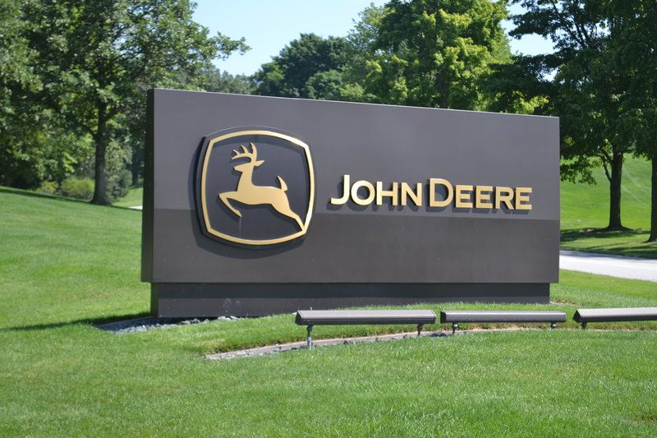
Source: (Ahmed and Nabi, 2021)

Information System Implemented Within John Deere Company
John Deere has focused on farm management information system to access the agriculture farmers to perform several tasks range for operational planning, implementation, and document to assist the performance of field work (Lomonosov et al., 2020). The Company mainly focus on improve the agriculture crop production. This information system has multiple functions that focus on delivering of high-quality services across the world. John Deere has developed a Technology centre to support farmer in effective implementation of operation system and software to improve the crop efficiency (Staff, 2020). This system not only deals with internal activities of farms but also external entities such as customer, universities and government to increase the production capacity of farmer. John Deere focuses on FMIS to take right decision for collection of data, set operational parameter, and collects market information with help of sensor (Ahmed and Nabi, 2021). Moreover, this system is completely automatic that help John Deere to collect data and monitor operational activities of agriculture production.
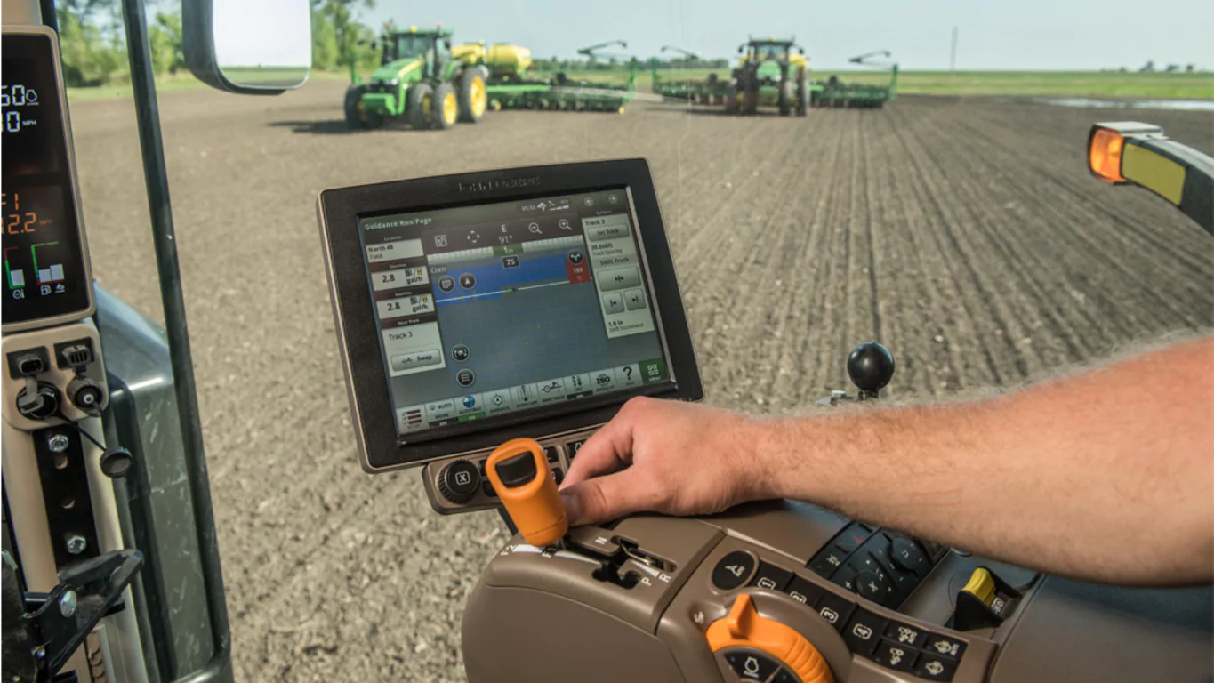
Source: (Lomonosov et al., 2020)
The Farm Manager of John Deere take initiative to filter the information collect from internal and external source to planned the operational activities effectively (Staff, 2020). John Deere mainly focuses on new agriculture technology such as variable rate technology, remote sensing, GIS and GPS to monitor the performance of crop and identify the opportunity to improve the production capacity. GPS is the best way to develop a crop map that help farmer to take decision regarding drainage, weed control, fertilizer, and seeding. This is a most effective economical to improve the productivity and efficiency of the firm (Weinert and Uslar, 2020). At tractor, John Deere has implemented a sensor or GPS to monitor the activities of farm as well as operation of crops. Through this technology, John Deere performed a data acquisition, mapping, distribution map, productivity map, and other to gain a competitive advantage. With the help of FMIS, farmer has right to take decision regarding the crop and land fertility (Lomonosov et al., 2020). The Company also developed a Myjohndeere.com is an online portal that allows farmer to collects data from sensor attached on machinery and equipments. Through the sensor, the Company provides data from sensor to farmer to take decision to improve the crop production. The farmer obtained data through remote acquisition methods plays an essential to capture device and attached to platform (Staff, 2020).
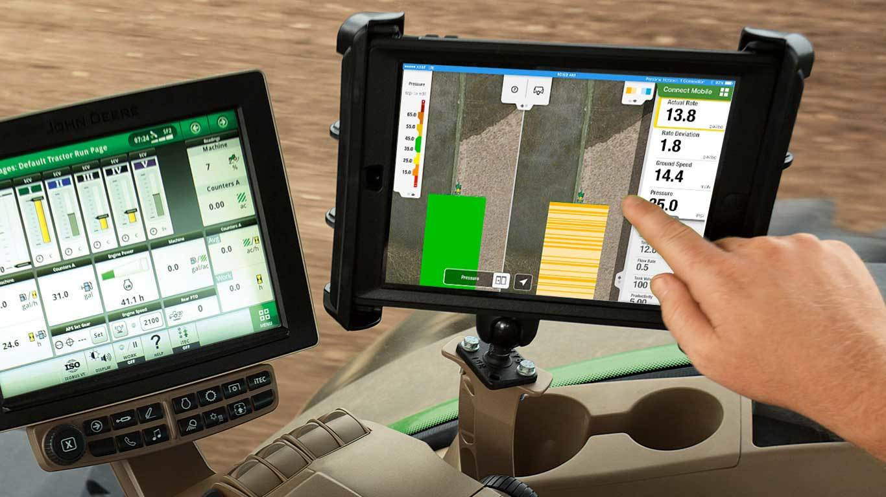
Source: (Weinert and Uslar, 2020)
The Company collects data to increase knowledge from the use of sensor in machinery used by farmer to improve the crop production (Ahmed and Nabi, 2021). The Company manufactures tractor ability to fill the field without damage the buried irrigation tape. Through sensor in machinery, John Deere has collects information about social variation, agriculture production and vegetative indicative. In this way, the data helps to find out best parameter to solve the farm management problems (Weinert and Uslar, 2020). The sensor is used by John Deere to identify the properties of soil, hydric stress and crop disease that are main reason to improve the production of crop. Through sensor, the company has measure the parameter such as electricity conductivity, potassium, sodium and pH to measure the features of crop as well as soil. The sensor system help farmer to improve the production and capability of crop, these efforts help to save natural resources (Dewnarain et al., 2019).
Using the sensor in machinery, John Deere has connected with better external database including weather and financial data. These service allows farmer to take right decision regarding using its equipments and get best result. Through sensor, John Deere analyzing the data of thousand of farmer with different crops is to improve the production and performance of the farmer (Weinert and Uslar, 2020). The FMIS helps to increase the productivity of agriculture production and decision to gain a competitive advantage.

Customer Relationship Management System
Customer relationship management system is considered as tool used to store deep information regarding current and customer to improve target communication (Dewnarain et al., 2019). At John Deere, CRM system has bring a positive change toward the operation of the firm. With the help of CRM system, John Deere has improved the customer experiences and satisfaction level. In the competitive market, John Deere has developed a machinery and heavy equipment to increase the productivity of the firm (Ahmed and Nabi, 2021). The Company also implements a sensor in their machinery and equipment that help to collects information about soil, water, and temperature. In this business, the CRM is fully based on business system and machinery.
Through CRM system, the Company can share the information about soil and crop production (Sigala, 2018). Dealer may collect customer information to maintain strong as well as long term relationship with farmer. The CRM system helps John Deere to develop connection with customer to deliver high-quality product and meet demand effectively. Through CRM system, John Deere must understand the needs of different crop production and farmer behavior. The Company produces a hi-tech machinery to improve the productivity of the farms (Anshari et al., 2019). CRM is integrated software that collects information about farm and store customer data to increase the sales margin. This helps John Deere to form a centralized platform to manage the business operations and prioritize the activities to improve customer experiences. This is a flexible platform to manage the workflow and bring continue change to gain a customer attention.
John Deere CRM system helps to keep eye on monitor open opportunities and double selling of products or service to gain a competitive advantage (Sigala, 2018). Through CRM, sales team of John Deere has develop better idea to increase the efficiency of crop to enhance the customer experiences. CRM system of John Deere has improved the operation of farmer and productivity of soil to become successful among potential customer (Anshari et al., 2019).

Advantage of CRM System
- Enhance Customer Service: CRM system of John Deere manages all data and information about the customer to develop relationship (Dewnarain et al., 2019). Through this, The Company easily accesses the customer record, last purchase, and attitude with contact in different site. In this sector, John Deere understand that customer do not repeat the purchase so include less effort to improve customer experiences.
- Automate Daily task: CRM system support John Deere to automate the performance and monitor the activities of employee at the workplace easily (Anshari et al., 2019). With CRM system, Employee mainly focuses on understand the issue of customer and take care as well as find best solution to solve the problem.
- Growth of Business Reputation: A CRM system helps to perform the business operations with perfection and quick to gain a customer attention (Raab et al., 2016). This strategy helps John Deere to improve the business value or brand image in a competitive market. The Company provide training and development program to know about system that also increase the brand image or awareness among farmers.
- Maintain transparency: CRM system of John has greater transparency through assigning task, work, and delineating to do that (Sigala, 2018). Through this system, John Deere has monitored the performance of each sales agent at the workplace. It also helps employees to gain visibility in business process, mutual understanding and collaboration among them.
Challenges of CRM System
- Poor Communication: While John Deere has implemented the CRM system, the budget and process changes that impact on business operation of employees (Anshari et al., 2019). The CRM system do not effectively implemented the lack of communication is arise at the workplace. This is main reason that increases insecurities and mental issue among employees.
- Not Select the right system: At the time implementation, John Deere has not selected the right system to manage the operation (Raab et al., 2016). Ineffective CRM system may not analyze the wide data and handle the information of business. It also impact on sale, marketing and customer service department of John Deere.
- Training: During the implementation of CRM system, John Deere offers training program to provide information about software and system effectively (Sigala, 2018). Furthermore, without training employee do not manage the data and customer at a time. At John Deere, Manager can educate the employee and their fellow team to monitor the performance through this system. Integration with Existing software: The Company has knowledge about the similar system or software. The historical information of farmer and other has been transferred to this system to integrate it (Anshari et al., 2019). At the CRM system, all employees have relevant information to manage it if not it impact on customer experiences.

Porter Five Forces Model
In 1979, Porter forces model has developed by Micheal E. Porter to assess the competitive positioning (Rai, 2012). Porter Five Forces model help John Deere to identify the position and build strategy to accomplish desired growth. Through this model, John Deere identifies the industry attractiveness and understands the competitive positioning in the marketplace (Dobbs, 2014). Factor of five force of model are discuss as under:
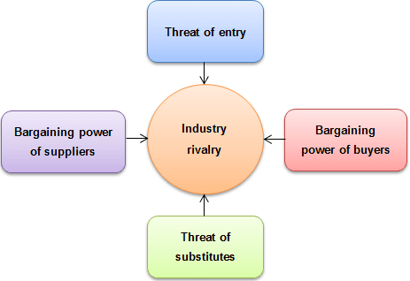
Source: (Dobbs, 2014)
Competitive Rivalry (Low): In this factor, the company has low competitive rivalry. The main competitors in the market are Kubota, Japan, AGCO, and Caterpillar (Lee et al., 2012). IT sector offers heavy machinery and equipment to gain customer attention. The Company produces heavy machinery to meet the demand of strong customer base. Market share of IS/IT sector is distributed among existing players (Almeida and Santos, 2020). Therefore, brand value of John Deere plays an essential role in capture the market in competitive market.
Threat of Substitute (Low): The Companies have low threat in the IS/IT sector in which John Deere operates its business. In this sector, the companies have no substitute to replace heavy machinery that produce by John Deere (Rai, 2012). In this sector, substitute has a manpower that is cheaper than machinery. The farmer also using hand tool to manage the production activities of crop but this incur lots of time and energy. In this factor, the customer has few chances to shift to substitute products.
Threat of New Entrants (Low): In the IT sector, the threat of new entrant is low as compare to other sector. If the production is not done in bulk it is not profitable business. In this sector, the companies’ entre with innovative product idea or differentiation is to survive in the market and gain a customer attention toward to products (Dobbs, 2014). In this sector, Government imposes heavy taxes and policies that may create difficulty to manage the operations and enter into this market. For new entrant, the company has huge capture and incurs high production cost to enter into marketplace.
Bargaining Power of Supplier (Moderate): In this force, the company manufacture heavy equipment and machinery for this they buy raw material from number of supplier. The Company easily shifts to another supplier to purchase a standardized raw material for heavy machinery (Lee et al., 2012). Supplier ensures that engage with giant IS/IT companies to increase the profitability as well as bargain power. Thus, the bargain of supplier is low at John Deere because of availability of raw material in the market.
Bargaining Power of Buyer (High): In this sector, many companies have operated similar business in IT sector, so the customer have limited alternative to select from. In this industry, the product is totally different from each other so the price is also varying from one company to another (Almeida and Santos, 2020). The customer wants to purchase high-quality machinery at reasonable rate. In this force, the bargain power is high because different product at different prices.

Big Data Analytics and Internet of Things at John Deere Company
Big Data analytics launched by John Deere that helps farmer is to monitor the data and activities of machinery (Ranjan and Foropon, 2021). This strategy help farmer to make right decision that help to manage the farms and machinery in smarter way. Through online portal, the company collects data through sensor at machinery or equipment about the field, uses and soil across the world. This analytics helps to collects wide amount of farmer information that demand cost effective, innovative form to access information and make right decision (Bag et al., 2020). Through sensor, farmer has collects information about crop production and makes informed decision. Big data analytics used to extract hidden patterns, correlation, market trends, and customer experiences. This also help farmer for better decision, prevent fraudulent activities and other. Through social media platform, the company collects million of information to reach the desired goals within estimated goals. The data analytics system helps John Deere to reduce the problem of machinery and equipments (Mikalef and Krogstie, 2020). John Deere using the data analytics, engineering is ready to supply new parts and service machinery to meet the demand of the customers. The Company has established an operation centre that help farmer to decide the crop, based on information gathered from field and other users (Dai et al., 2020).
Advantages of Big Data Analytics
- Better Decision making: Through big data, the Company has collects information about wide customer as well as their farms to accomplish the desired goals. John Deere has wide information that help farmer to take right decision for crop production (Almeida and Santos, 2020). Big data analytics decision making that helps John to compete and expand the business.
- Increased Productivity: In the competitive market, big data helps John Deere increase the performance and productivity of the firm (Bag et al., 2020). This data helps John Deere to evaluate the data, more quickly that increase the productivity of crops at farms.
- Reduce cost: In this sector, John Deere used big data analytics to reduce the operational expenses (Ranjan and Foropon, 2021). Big data tools helps to improve operational efficiency of crop production and reduce operational cost.
- Improved customer services: At John Deere, big data is important for improving the customer services (Mikalef and Krogstie, 2020). The Company mainly focuses on CRM system and social media to increase awareness among customer about latest technology and sensor.
Disadvantage of Big Data Analytics
- Rapid Changes: The Company mainly utilizes big data do not want to prepare better report (Ranjan and Foropon, 2021). In the IT sector, the technology has changed rapidly that impact on business operations of the firm. Moreover, John Deere may require updating with latest trend and fashion of big data.
- Cyber security Issues: In the competitive market, John Deere has storing big data so it has a threat of cyber attack (Mikalef and Krogstie, 2020). The biggest challenges of business to cyber security that impact on business operations.
- Difficulty to manage: At John Deere, the updated with application and system is difficulty and incurs lots of time (Bag et al., 2020). Data sources and moving data require huge expenses to manage it’s and deal with.

Internet of Things
IoT is very essential for agriculture to deal with different kind of operation to improve the customer experiences (Mikalef and Krogstie, 2020). John Deere has launched an IoT spraying machines to deal with big device and product to improve the production capability of business operations. In IT sector, IoT application help farmer to increase ability of farmer, and improve customer experiences. The Company implements a sensor in machinery and equipment to monitor the performance to increase crop productivity (Ferreira et al., 2018).
John Deere manufactures tractor and farm equipment with IoT to improve the capability of products (Dai et al., 2020). Through latest technology, John Deere explored wireless communication, cloud solution, IoT sensor and other to monitor the performance of the field and farms. Through IoT technology, John Deere helps them to improve process as well as profitability of the firm (Bag et al., 2020). The Company has designed multiple app to improve the ability of farmers; they easily monitor the performance of seeds. Through sensor, the farmers have collects relevant data about soil fertility and other amount to make a right decision regarding plantation (Nguyen et al., 2021).

Pros of Internet of Things
- Reduce human Effort: Through Iot, farmer of John Deere interact with other to complete the task within estimated time (Ranjan and Foropon, 2021). This technology also helps to reduce the effort or hardwork of human.
- Effective utilization of resources: If John Deere knows about functionality and way to each device work to increase the effective utilization of resources. It also helps to monitor the performance of field and crop (Mikalef and Krogstie, 2020).
- Improve security: The Company focus on security and safety of information to gain a competitive advantage (Nguyen et al., 2021). It also essential to secure and efficient the information of business.
- Monitor Data: IoT at John Deere monitor the performance on daily basis. It also helps to maintain record of sales and purchase from farmer (Oktian et al., 2021). For instance, John monitors the details of product to improve safety.
Cons of Internet of Things
- Data Breach: At present, Data is exposed to public and hacked by the people for illegal purpose (Oktian et al., 2021). John Deere has worry about the breach of customer data and information.
- Complexity in operation: Iot is seems as complex task and difficult to manage the business operations (Mikalef and Krogstie, 2020). Through Iot, John has find out mistakes and errors in record that impact on decision making.
- Lack of skilled employees: John Deere has unskilled workforce that may lose the operation of automatic software and system (Nguyen et al., 2021). It may lead many issues at the workplace.

Recommendation
In a global outbreak, John Deere has face challenges like monetary loss, agriculture loss, unemployment and other activities. The Company must have skills workforce that help to collects relevant feedback to identify the market opportunity (Mikalef and Krogstie, 2020). John Deere should focus on knowledge management system to improve the decision making power of farmer to improve crop production during the pandemic. In the competitive market, John Deere shares a KM program to share information across the world (Oktian et al., 2021).
During the global outbreak, John Deere mainly focuses on skilled employee to deal with latest technology and manage the business operations. The Company mainly focuses on knowledge management system to store, analyze and monitor data for future growth and development (Dai et al., 2020). In Covid-19, John Deere should encourage employee to develop a smart and latest agricultural trend. The Company motivate employee to upload latest project management to increase awareness among employees as well as farmers. In global pandemic, knowledge management system must boost employee engagement at the workplace (Santoro et al., 2018). The Company enhances organizational success and reduces the burden on time. Through effective technology, John Deere strengthens its knowledge management system. The Company should offer latest technology to improve the knowledge management system.
Furthermore, John Deere focuses on modern knowledge management system to become successful in a competitive market (Ferreira et al., 2018). In Covid-19, John Deere should focus on training session to provide guidelines and smart farming practice. During the Covid-19, John Deere should focus on knowledge manager to accomplish the desired outcome (Oliva et al., 2019). Through effective knowledge management system, John Deere must gain knowledge about rating and monitor the performance of the business. Manager of John Deere focuses on agricultural trend and farming practice to improve the production capability and performance. John Deere must set a standard to increase sales collection and gain competitive benefits (Santoro et al., 2018). The Company ensures employees to accomplish the desired goals within estimated time. Through latest knowledge management system, John Deere should focus on thinking and develop new ways to improve the customer experience.

Conclusion
In conclusion, the report has discussed the information system of John Deere to improve the operation of farm production. The report has examined the customer relationship management system with benefits and challenges at John Deere. Furthermore, the report has illustrated the big data and Iot with pros and cons at manufacture of machinery. The report has applied Porter five force model to discuss the competitors of IS/IT sector. At last, the report provides suggestion to improve knowledge management system at John Deere.

Reference List

Ahmed, L. and Nabi, F., 2021. Data-Driven Smart Farming. In Agriculture 5.0: Artificial Intelligence, IoT, and Machine Learning (pp. 157-174). CRC Press.
Almeida, F. and Santos, J.D., 2020. Annex I–Porter Five Forces.
Anshari, M., Almunawar, M.N., Lim, S.A. and Al-Mudimigh, A., 2019. Customer relationship management and big data enabled: Personalization & customization of services. Applied Computing and Informatics, 15(2), pp.94-101.
Bag, S., Wood, L.C., Xu, L., Dhamija, P. and Kayikci, Y., 2020. Big data analytics as an operational excellence approach to enhance sustainable supply chain performance. Resources, Conservation and Recycling, 153, p.104559.
Dai, H.N., Wang, H., Xu, G., Wan, J. and Imran, M., 2020. Big data analytics for manufacturing internet of things: opportunities, challenges and enabling technologies. Enterprise Information Systems, 14(9-10), pp.1279-1303.
Dewnarain, S., Ramkissoon, H. and Mavondo, F., 2019. Social customer relationship management: An integrated conceptual framework. Journal of Hospitality Marketing & Management, 28(2), pp.172-188.
Dobbs, M.E., 2014. Guidelines for applying Porter's five forces framework: a set of industry analysis templates. Competitiveness Review.
Ferreira, J., Mueller, J. and Papa, A., 2018. Strategic knowledge management: theory, practice and future challenges. Journal of Knowledge Management.
Lee, H., Kim, M.S. and Park, Y., 2012. An analytic network process approach to operationalization of five forces model. Applied Mathematical Modelling, 36(4), pp.1783-1795.
Lomonosov, D.A., Shapar, M.S., Redkokashin, A.A.E., Borodin, I.I. and Lomonosova, E.I., 2020. ECONOMIC EFFICIENCY OF AUTOTRAC UNIVERSAL JOHN DEERE AUTOMATIC DRIVING KIT AS AN ELEMENT OF PRECISION FARMING SYSTEM (AMS) IN AGRICULTURAL ENTERPRISES OF PRIMORSKY KRAI. Journal of Critical Reviews, 7(13), pp.2835-2836.
Mikalef, P. and Krogstie, J., 2020. Examining the interplay between big data analytics and contextual factors in driving process innovation capabilities. European Journal of Information Systems, 29(3), pp.260-287.
Nguyen-An, H., Silverston, T., Yamazaki, T. and Miyoshi, T., 2021. IoT Traffic: Modeling and Measurement Experiments. IoT, 2(1), pp.140-162.
Oktian, Y.E., Witanto, E.N. and Lee, S.G., 2021. A Conceptual Architecture in Decentralizing Computing, Storage, and Networking Aspect of IoT Infrastructure. IoT, 2(2), pp.205-221.
Oliva, F.L. and Kotabe, M., 2019. Barriers, practices, methods and knowledge management tools in startups. Journal of knowledge management.
Raab, G., Ajami, R.A. and Goddard, G.J., 2016. Customer relationship management: A global perspective. CRC Press.
Rai, A.K., 2012. Customer relationship management: Concepts and cases. PHI Learning Pvt. Ltd..
Ranjan, J. and Foropon, C., 2021. Big data analytics in building the competitive intelligence of organizations. International Journal of Information Management, 56, p.102231.
Santoro, G., Vrontis, D., Thrassou, A. and Dezi, L., 2018. The Internet of Things: Building a knowledge management system for open innovation and knowledge management capacity. Technological forecasting and social change, 136, pp.347-354.
Sigala, M., 2018. Implementing social customer relationship management. International Journal of Contemporary Hospitality Management.
Staff, A.S.A.B.E., 2020. The John Deere Quik-KnectTM System. Resource Magazine, 27(4), pp.8-8.
Weinert, B. and Uslar, M., 2020, June. Challenges for System of Systems in the Agriculture Application Domain. In 2020 IEEE 15th International Conference of System of Systems Engineering (SoSE) (pp. 000355-000360). IEEE.

