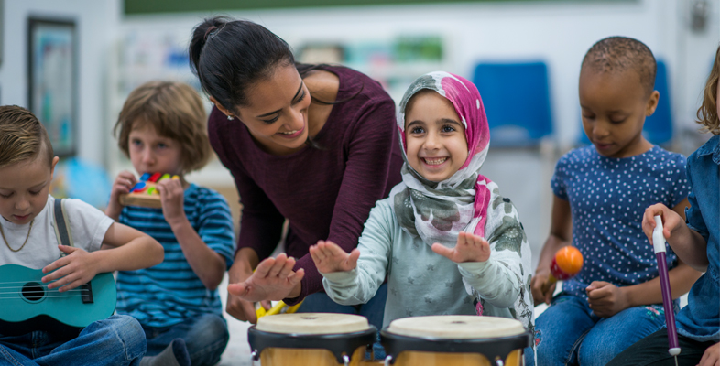
(Source: Open Learn, 2019)

Understanding the significance of communication during childhood transitions.

An Early Years Practitioner's Handbook

Contents

Introduction to transitions

Understanding the needs of a child

Role and responsibilities of the adult

Intervention

Outcomes

Introduction
It is hoped that this handbook will be a useful resource for key-workers in a wide range of settings. The book's purpose is to serve as a reference for practitioners as well as a means to help them develop an understanding of effective communication and communication patterns during times of transition and change in young children.
Brooker (2008) claims that children will go through a significant number of transitions in their early years, beginning from the moment they are born until the time they are three years old, and then continuing right through until they reach the age of five. In addition, these transitions continue well past the age of adolescence until the individual reaches the age of adulthood. As a result of these transitions, the daily routine of the child will change.
It is the intent of this handbook to highlight the importance of communication, and how it can facilitate a child's ability to make smooth transitions in the early years, regardless of their age (Welsh Government, 2008). In addition, it is also critical to acknowledge their 'culture' in a broader context. Throughout a person's lifetime, values and beliefs that are collectively accumulated by the members of a family are reflected in a family's unique home culture (Brooker, 2008).
Communication with the child's parents is beneficial in order to understand the family environment of the child. As an essential part of the ongoing transition process, it is imperative that the participants understand the needs of the individual and maintain strong communication with each other. It is possible that this process may influence a child's development in both positive and negative ways (Devarakonda, 2021).

Understanding the needs of a child
The process of transition requires constant support and communication on the part of children. As students move from educational to social settings, as well as their own morning routines, it can often be challenging for them to adjust to the change of setting. However, children do move through some other significant transitions much less frequently. Changes of schools, moving homes, joining a club, or the death of a beloved family member can cause stress (Allingham, 2012).
It can be challenging to navigate through these transitions, but this can be made easier if these transitions are undertaken within a supportive, comfortable and empowering environment. According to Allingham (2012), this can be the case. In order to foster a sense of belonging in the child, it is crucial to establish a strong connection and to communicate positively with them as this facilitates the development of a strong sense of belonging that is necessary in order for the child to reach his/her full potential. Should they have been able to adapt appropriately to the environment, expectations, and routines that exist in the workplace, they may be more inclined to take on creative challenges and to think creatively.
Earlier in the introduction, it was mentioned that early childhood practitioners are encouraged to take into account and support the unique needs of each child.
In accordance with Maslow's hierarchy of needs triangle (1943), the physical, psychological, and interpersonal characteristics of children have a substantial impact on how they learn. Maslow's hierarchy of needs is a tool for early years practitioners to apply to their work. According to Maslow (1943), in order for a student to meet their basic cognitive needs, they must be able to meet their basic physiological needs first. For example, the student who is hungry and exhausted cannot focus on studying well.
As a child progresses and achieves their full potential, it is necessary that he or she feels mentally and physically secure and comfortable while learning in the classroom. As mentioned above, transitions can be achieved more effectively in a classroom where students are shown to be treasured and appreciated by the teacher and the classroom environment is supportive. In the absence of these conditions, we can observe that students who suffer from low self-esteem and lack adequate support will be unable to progress academically and intellectually at an optimum rate until they have a greater sense of self-confidence.
When analyzing the needs of children, we should also be mindful of the evolutionary theory of attachment, which was developed by Bowlby (1969). As per this theory, children are born with a predisposition to form attachments with others because, naturally speaking, this will help them survive.
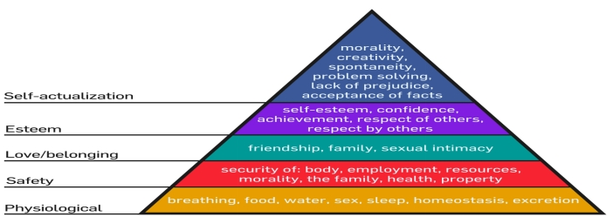
The tendency of a child who is stressed and unrelieved is to exhibit signs of proximity seeking, which are triggered by feelings of insecurity, when he or she is anxious, afraid or distressed. As practitioners, it is our duty to ensure that the child feels comfortable with their key workers and has a feeling of closeness to them at all times. Also to provide a safe and secure environment in order to support the child in reaching their full potential and effectively making the transition to an educational setting easier, as well as providing support when the child feels distressed or anxious during these conditions (Bowlby, 1969).

(Source: Wikimedia Commons, 2009)

There is a possibility that some children in an educational setting may experience separation anxiety, which is a potentially dangerous circumstance. Their attachment figure is currently away from them, which is one of the primary reasons for this. It is difficult for children, especially those in school, to cope with life transitions without this comforting figure. It would not be a wise idea to view separation anxiety as a necessary component of a child's development. This is not for the child's benefit to view it in that way (Silverman, 2011). For all professionals working with children, setting up a working relationship is essential.
In order for children to develop properly, adults must be able to interact positively with them. Such interactions are often referred to by terms such as service and return. As an example, an adult will usually intervene if a child is crying in order to comfort the child. During a child's critical developmental stages, particularly from birth to the age of seven years, it is of extreme importance that adults remain attentive to their needs (Dowling, 2014).

According to Harvard (2014), the brain has twice as many synapses during this period, which allows it to process information more quickly. Consequently, children's experiences during this phase can have a lasting impact on their development long after they have completed this phase. At this point in the child's life, the child is likely to have a variety of positive experiences that will affect the way he or she develops socially, emotionally, and cognitively in the future.
Neglecting and ignoring these children during this period would adversely affect their development (Sriram, 2020).

The Child's Development

A child's development stage as well as their individual needs must be understood in order to fully support them during difficult transitions at a young age. An observation is a valuable tool in gathering information about a child's abilities and where they are at in their development. It is essential that practitioners understand that children develop at different rates when they are facilitating a child's development (Doherty and Hughes, 2014).
At each stage of development, we should be able to identify the specific needs of the child; therefore, it is important to differentiate between developmental sequence and developmental rate. As a result, you will then plan effectively so that the child receives the appropriate support in the areas in which they require assistance (Burnham and Baker, 2010).

It is important to note that the development of a child at school depends on a number of factors. A few of these factors include medical illnesses, genetic issues, learning disabilities, or language barriers, if a child has moved to another country. Furthermore, these children are also affected by a variety of external factors that are more specific and individual to them, such as their family life, their home situation, and perhaps if they have missed a great deal of school due to moving around or not receiving any additional education support from home.

It is for this reason that communication is crucial as we assist the child during the time of transition. The importance of understanding all of these factors and adapting to them cannot be overstated. There might be very specific and unique requirements for the child that need to be met in a certain way. Adapting our practices to meet the needs of the child is part of our duty as practitioners.

Role and responsibilities of the adult
There is no question that providing support to children during transitions is an essential part of their development. Keeping children at the centre of all decisions requires a high level of communication and collaboration between key workers, parents, and agencies. This is in order to achieve the best outcomes for the children. It is also important for key workers to observe children over time. This will enable them to gain a better understanding of their needs and plan activities and interventions that will benefit the child. It has been shown that adults have a profound impact on children's survival and development. Additionally, parents, teachers, and other external agencies must communicate and collaborate to provide the best service to children.
There should be frequent communication between key workers and guardians about the child's progress, both at home and in the child's educational setting (Dowling, 2014). The environmental influence on an individual's development can be seen to be an active factor in a person's development, according to Bronfenbrenner's (1979) ecological systems theory. A Mesosystem describes the connection between the elements of a child's Microsystem and the effectiveness of that connection. It is very important to realize that children's growth and development are affected by a strong Mesosystem in which the primary caregivers of the child are in positive relationships with each other and communicate well. For children, transitions can be a particularly difficult time.

Therefore it is important to understand the needs of the child at a deeper level. Continuing the communication between the guardian and the key-worker is beneficial for both parties. When guardians become involved in their child's education, they will learn how to support their child in academics. As a result, guardians will be better able to assist their children during transitions within a classroom. In order to meet the needs of the child, various agencies will collaborate and work together with the child's best interests in mind (Dunhill, 2009).

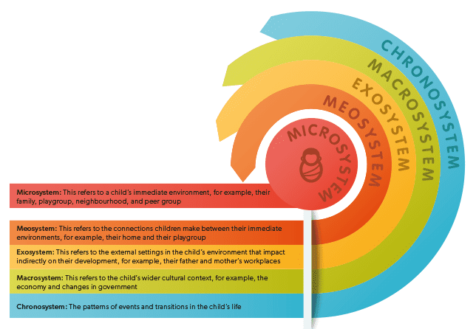
(Source: Parenta, 2018)

When a child experiences a transition, adults and practitioners must take all of these steps into consideration in order for the child to feel included, valued, and supported (Ellis, 2017).
Throughout the course of the child's school career, he or she will be treated individually, and we will make sure that all their needs are met. In order to guide the development of the child, we have to offer them constructive feedback, communicate in a positive way, and acknowledge the freedom that each child has to be creative and develop in their own way.

In order for us to provide each child with the care and communication they require in the most effective manner, we need to understand the individual needs and strengths of each child. Through engaging and creative activities, we are able to provide them with the learning and development opportunities they need (Dowling, 2014).
Further, practitioners would benefit from managing the pace at which these activities are carried out in order to ensure that they are as efficient as possible. So that they can communicate with other professionals and plan entertaining and engaging activities aimed at supporting their learning, they will be able to communicate with one another.

It is wise to gather information from parents, caregivers, and other professionals who have worked with the child in the past year in order to form a more accurate picture of the child's needs (Waller, 2009). This will allow the child to learn more easily and transition to the type of learning style that is most appropriate for him/her. To be able to determine a child's ability to interact with others and what type of learning style is most appropriate for them, it is important to observe their behaviour. It is therefore necessary to treat children as independent learners who can benefit from practice, feel confident, and take responsibility for their own learning.

Intervention

As we have discussed in this handbook, communication is very important in a time of transition. Our field is rapidly learning the importance of transitions as a critical part of a child's development, but the way we approach those transitions is equally important. We must realize that transitions are highly significant to our children's emotional well-being. Therefore, it is our responsibility to ensure that the transition takes place smoothly in order to ensure their emotional stability.

It cannot be overstated how important it is to remember that each child is unique in his or her own way. Frequently, vulnerable children find it difficult to accommodate their key-workers and to make friends in early childhood settings since they often find it difficult to establish relationships with them, which has been especially highlighted in the global pandemic (Voice of play, 2020).
There are a number of challenges that children living in these settings face, and early childhood practitioners are responsible for identifying and addressing these challenges. They can assist them in navigating through this difficult time by providing support, as well as by building bonds that will benefit them in the future. You will be able to achieve better results in your classroom if you conduct more play-based activities. In Article 31 of the United Nations Covenant on the Rights of the Child, which also calls for play to be promoted in education settings, children are also entitled to the right to play. Furthermore, the Welsh Assembly Government (2002) established the Play Policy in order to acknowledge the importance of children and play in society and to emphasize the importance of play to human development.

Effective communication can be facilitated by a playful environment

When children are free to play on their own or with other children, they are inadvertently learning the skills of communication, listening, and socialization at the same time. While playing alone, children will use their imaginations to tell the story of their play (Mooney, 2000).

They will also act as overseers while they play with toys or other items of their choice. Using a role-play scenario as an example, children often play games when they are young, such as "house", where they are given the role of the parents with other children or babies acting as their children. The role and scenario play in these games is presented in an innovative way that is worth mentioning. The purpose of this free play is to teach children to resolve disagreements, complete tasks, or settle matters to the satisfaction of all parties involved. In addition to enriching their vocabulary and learning more complex language in order to facilitate future transitions, this will be crucial for the development of communication skills (Morris, Mort and Lee, 1990). There are so many benefits to learning through this method that any child of any background can benefit from it. It is improvised and can therefore be played wherever a child chooses to, due to the fact that it is free-form (Casey, 2010).

Development of social skills can be enhanced by play
As part of the playtime activities, children will be able to work collaboratively as a team. In addition to gaining a deeper understanding of each other's requirements, team members will become more effective team players, and even develop leadership skills as they rotate roles within the group. When children play in this manner, they become more proactive, more interactive, and more cooperative by the act of playing (Bruce, 2011). It is through the skills they acquire in their peer group that they will form lasting friendships. This type of friendship is more likely to continue beyond school and continue in a more social setting at each other's homes or elsewhere wherever they may choose to meet. Additionally, this facilitates transitions in the future by allowing students to navigate these new experiences with their friends, which will make navigation more comfortable. Playtime will provide them with the opportunity to have their feelings expressed and to work through their emotions without having to be constantly supervised by their caregivers. It is important to achieve independence through activities and developing strong communication methods besides verbal communication (Casey, 2010).
Outcomes

The purpose of this handbook is to provide various strategies which can result in substantial results if implemented. It is important to keep in mind that there is no one size fits all solution, and that specific children may not adhere well to the suggestions presented above. However, utilizing the theories outlined in this handbook will enable early childhood professionals to start the journey with young children on the journey of coping with transitions.
There is no doubt that those circumstances will have an influence on how children adapt to transitions later in their lives, as Bronfenbrenner (1979) explains. In order to cope with these stressful transitions, it is imperative that children receive continuous assistance and care. By effectively accommodating children's needs, early childhood practitioners can provide children with assistance in their quest for self-actualization by using Maslow's Hierarchy of Needs. In general, this implies that children have the capacity to adapt rapidly to unfamiliar environments, they are independent and they have a solid sense of identity.
I believe that following the reading of this handbook, early childhood practitioners will better understand their role in assisting children during their transition into school. There is no doubt that key workers are instrumental in maximizing children's potential as they move from one situation to another. A child's needs will change as he or she grows, so it is imperative that you keep that in mind. In order for transitions to be successful, it is important to continuously assess and reassess them.

Reference List

Allingham, S. (2021). Early years sector transitions. Early Years Educator, 23(1), pp.10–11.

Bowlby, J. (1969). Attachment and loss. New York: Basic Books.

Bronfenbrenner, U. (1981). The ecology of human development: Experiments by nature and design. Cambridge - Mass. & London: Harvard University Press.

Brooker, L. (2008). Supporting transitions in the early years. Maidenhead: Mcgraw-Hill Open University Press.

Bruce, T. (2011) Learning through play For Babies, Toddlers and Young Children. 2nd ed. London: Hodder Education.

Burnham L, Baker B (2010) Supporting Teaching & Learning In Schools (Primary), Heinemann. London. Meggitt

Casey, T. (2010). Inclusive play : practical strategies for children from birth to eight. London ; Thousand Oaks, Calif.: Sage.

Chandrika Devarakonda (2020). PROMOTING INCLUSION AND DIVERSITY IN EARLY YEARS SETTINGS : a professional guide to ethnicity,... religion, culture and language. S.L.: Jessica Kingsley.

Chatsworth Hills Academy. (2018). Top 5 Benefits of Learning Through Play Blog | Chatsworth Hills Academy. [online] Available at: https://chaschool.org/top-5-benefits-learning-play/.

Doherty, J. and Hughes, M. (2014) Child development. Second edition. Harlow, England: Pearson.

Dowling, M (2010) Young Children’s Personal, Social & Emotional Development. 3rd Ed. London:SAGE.

Dowling, M. (2014). Young children’s personal, social and emotional development. Los Angeles: Sage.

Dunhill et al. (2009) Effective Communication and Engagement with Children and Young People, their Families and Carers. London:SAGE.
Ellis, A.L. ed., (2017). Transitioning Children with Disabilities. Rotterdam: SensePublishers.

https://voiceofplay.org/. (n.d.). 2020 Survey on the Importance of Play and the Mental Impacts of Social Injustice in the U.S. - IPEMA - Voice of Play. [online] Available at: https://voiceofplay.org/2020-survey/ [Accessed 22 Nov. 2021].

Mooney, C (2000) Theories of Childhood: An Introduction to Dewey, Montessori, Erikson, Piaget & Vygotsky. St. Paul: Redleaf Press.

Morris, J., Mort, L. and Lee, C. (1990) Bright ideas for early years. Learning through play. Leamington Spa: Scholastic.

OpenLearn. (n.d.). Listening to young children: supporting transition. [online] Available at: https://www.open.edu/openlearn/education-development/listening-young-children-supporting-transition/content-section-0?active-tab=description-tab [Accessed 24 Nov. 2021].

Playwales.org.uk. (2020). Play Wales | Welsh Government Play Policy. [online] Available at: https://www.playwales.org.uk/eng/walesplaypolicy.

Serve and Return. (2021). harvard.edu. Available at: https://developingchild.harvard.edu/science/key-concepts/serve-and-return/. (Accessed: 26/11/2021).

Silverman, W.K. and Field, A.P. (2011) Anxiety disorders in children and adolescents. Second edition. Cambridge: Cambridge University Press.

Sriram (2020). Why Ages 2-7 Matter So Much for Brain Development. [online] Edutopia. Available at: https://www.edutopia.org/article/why-ages-2-7-matter-so-much-brain-development.

Wales. Welsh Assembly Government (2006). Welsh Assembly Government Disability Equality Scheme 2006-2008. Cardiff? Welsh Assembly Government.

Waller, T (2009) An Introduction to Early Childhood. 2nd Ed. London: SAGE.

Wikimedia.org. (2009). File:Maslow’s Hierarchy of Needs.svg - Wikimedia Commons. [online] Available at: https://commons.wikimedia.org/wiki/File:Maslow%27s_Hierarchy_of_Needs.svg.

