Working with Python using Flask and SQL
Instal Visual studio code on https://code.visualstudio.com/download
- Instal Python 3.5 and above from https://www.python.org/downloads/
- Open the Visual Studio Code.
  - Create a new folder named “flask_project” or any other name of your choice.
  - Navigate into the folder within the Visual Studio
- Open Terminal
  - Run command:
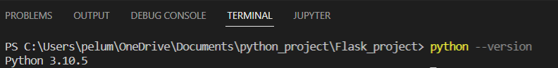
It will show the version of your Python.
  - Run another command: pip3 install virtualenv
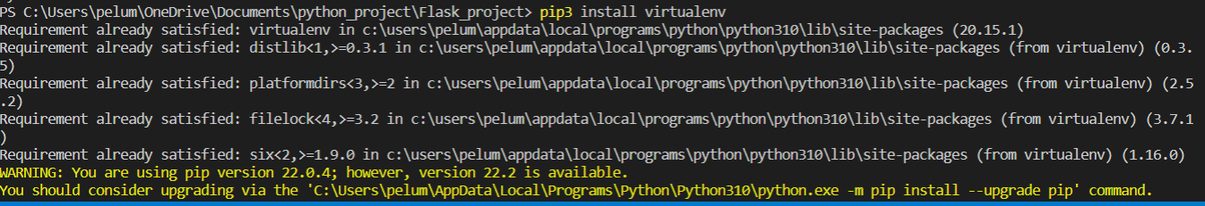
- To remove any dependency problem, Go to extensions in the Visual Studio Code and install Python.
- Run the following command: virtualenv env
This will create an environment “env” in your project folder. However, you can give it any name.
If the above command returned an error message (especially in Windows), please run the command below:
Set-ExecutionPolicy -Scope Process -ExecutionPolicy Bypass
- Run the following command: env/Scripts/activate
If the above command returned an error message (especially in Windows), please run the command below:
Set-ExecutionPolicy -Scope Process -ExecutionPolicy Bypass
- Type this command: pip install flask
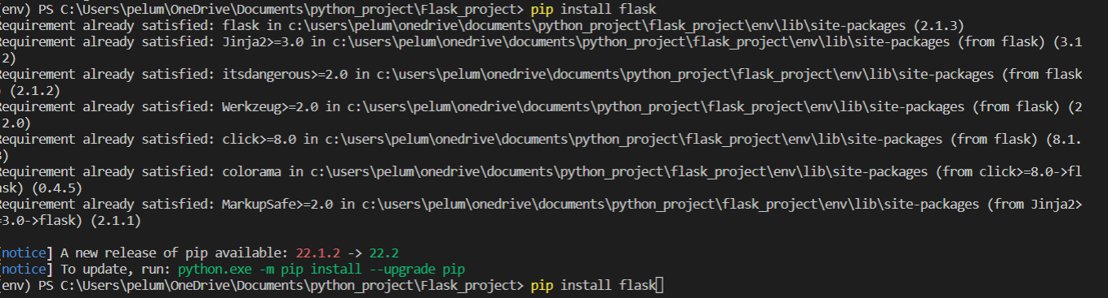
- In the “flask_project” folder, create file name “app.py”
- In the “app.py” type the following code
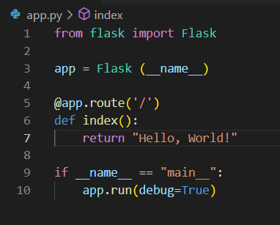
- Save the file
- Click and debug at the left hand side of the window.
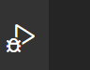
- The debug configuration will list possible values. Please, select “Flask Launch and debug a flask web application.”

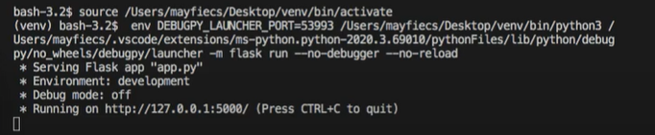
- Click on the link (i.e. http://127.0.0.1:5000/) and the next web page will be displayed.
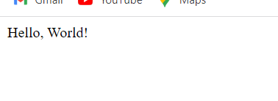
Waoh! That is your first Flask project using Python. You can play with the output to discover the changes.

