Name: Sêren Williams
Student ID: 2501567
Module Name: Environment Design
Assignment Title: 3D Diorama and Presentation
Lecturer: Rich Morgan
Date: 20/05/2026
Table of Contents
YouTube Link 1
Screenshots of Diorama 2
References 4

YouTube Link
https://youtu.be/HJmRAtFTheY

Screenshots of Diorama
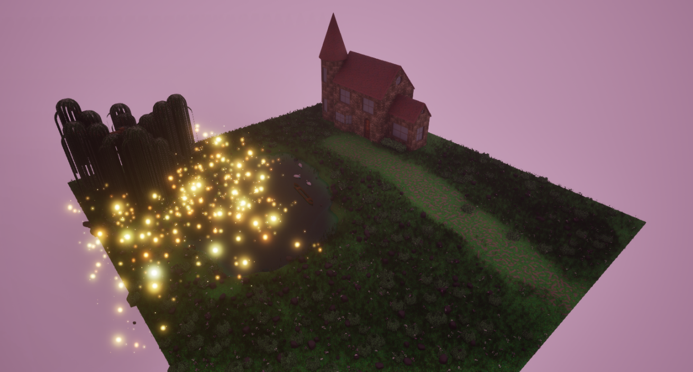
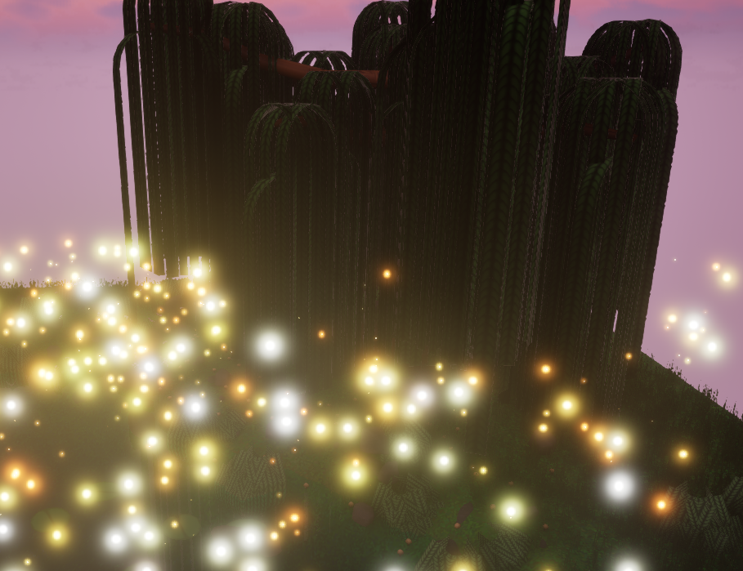
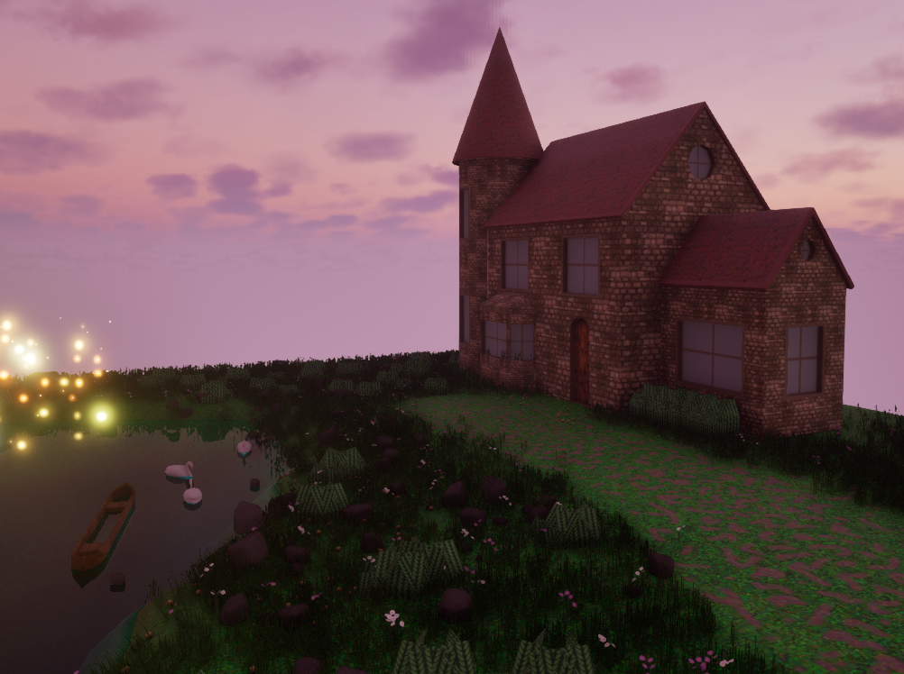
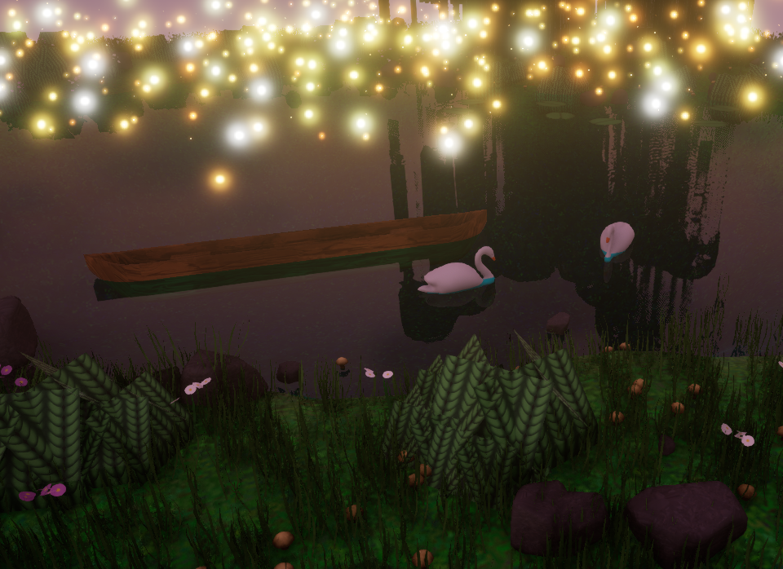

References

[1] | “Autodesk Maya,” Autodesk, 1 February 1998. [Online]. Available: https://www.autodesk.com/uk/products/maya/overview?mktvar002=3466774|SEM|23638971833|194961737998|kwd-1971040707&utm_source=GGL&utm_medium=SEM&utm_campaign=GGL_M-E_All-Products_EMEA_GB_eComm_SEM_BR_New_EX_0067_4277222&utm_id=3466774&utm_term=kwd-197104070. [Accessed 18 May 2026].
[2] | E. Games, “Unreal Engine 5,” Epic Games, 5 April 2022. [Online]. Available: https://www.unrealengine.com/unreal-engine-5. [Accessed 20 May 2026].
[3] | Adobe, “Adobe Photoshop,” Adobe, 19 February 1990. [Online]. Available: https://www.adobe.com/uk/products/photoshop/landpa.html?mv=search&mv=search&mv2=paidsearch&sdid=2XBSBWBF&ef_id=CjwKCAjwt7XQBhBkEiwAtStppw3mzeobGRvL49mo0U2nxauzYq935WwOex4IXYrqqST1BDUkgQ8o4RoCaoEQAvD_BwE:G:s&s_kwcid=AL!3085!3!763734636132!e!!g!!photoshop!2. [Accessed 20 May 2026].
[4] | “Pinterest,” 10 August 2012. [Online]. Available: https://uk.pinterest.com/. [Accessed 20 May 2026].
[5] | “Canva,” 26 August 2013. [Online]. Available: https://www.canva.com/. [Accessed 20 May 2026].
[6] | V. Z. (akbutea), “Stylized Willow Tree Tutorial,” Youtube, 31 March 2023. [Online]. Available: https://youtu.be/zfH1abKd6fk?si=Ui8LDj_CrVAvWvfV. [Accessed 20 May 2026].
[7] | V. Z. (akbutea), “Stylized Grass Tutorial,” Youtube, 26 October 2022. [Online]. Available: https://youtu.be/AEMe-kcZBLw?si=f_I8lYWibd-WNqwX. [Accessed 20 May 2026].
[8] | A. Arts, “Easy Glowing Particles with Niagara in Unreal Engine 5 Tutorial,” Youtube, 4 April 2023. [Online]. Available: https://youtu.be/xJK-QO9YH68?si=EGqKrlq9Ljj5Ph0Y. [Accessed 20 May 2026].
[9] | “Barbie of Swan Lake,” Mainframe Entertainment and Mattel Entertainment, 30 September 2003. [Online]. Available: https://www.imdb.com/title/tt0383206/. [Accessed 20 May 2026].
[10] | “Barbie: Fairytopia,” Mainframe Entertainment and Mattel Entertainment, 6 March 2005. [Online]. Available: https://www.imdb.com/title/tt0450982/. [Accessed 20 May 2026].
[11] | “StarStable Online,” Star Stable Entertainment, October 2011. [Online]. Available: https://www.starstable.com/en/register?affiliate=GA&pk_campaign=p-uk-search-brand-exact&pcid=684218572&gad_source=1&gad_campaignid=684218572&gbraid=0AAAAADwo41DuY2fGf2oLCopGRtm2JmAkG&gclid=CjwKCAjw2rrQBhBuEiwAarLWHUOMAEKgJkQRVX2_5Eqz08fvbvdQUHKLWmdj2yxRGa. [Accessed 20 May 2026].
[12] | “Adobe Substance 3D Painter,” Adobe, 14 October 2014. [Online]. Available: https://www.adobe.com/uk/products/substance3d/apps/painter.html. [Accessed 2026 May 2026].
[13] | “Procreate,” Savage Interactive, 8 March 2011. [Online]. Available: https://procreate.com/. [Accessed 20 May 2026].
[14] | G. Games, “How to Make a Simple Water Material in Unreal Engine 5,” Youtube, 23 July 2023. [Online]. Available: https://youtu.be/o6f7n4UhYq0?si=jlYH4rKI6PZslVxO. [Accessed 20 May 2026].

