KRZYSZTOF KUROWSKI ( 2009954)

GLOBAL BUSINNES ENVIROMENT ASSIGNMENT

LECTURER: ERIC OSEI

Table of Contents
Introduction 3
Major forces of the global business environment 3
Application of Pestle, Porter Five forces and Cultural Web Framework in Jaguar 4
Effect of culture on organizational efficiency 8
Impact of business ethics and corporate social responsibility on business growth 9
Theories and concepts of business growth 9
Reasons of business engagement with international trade 11
Comparison with other companies 11
Market structures 11
Long run, short-run changes 12
Features of current international economy 13
Recommendations for Jaguar 13
Conclusion 14
References 15

Introduction
The era of globalization and digitalization is supportive of enhancing business diameters and elevating the market share of organizations. Organizations have gone under certain changes in accordance with the growth of market structures. The report aims to shed light on the aspects of organizational changes in the context of Jaguar Company, a multinational car manufacturing organization. Impact of changes in both external and internal environment on the activities of an organization has been highlighted in the study for brief internalization of related ideologies.

Major forces of the global business environment
The business environment is a term that combines some factors and conditions that influence the participants of a business. It contains all activity that can enhance business management. For understanding the business environment it can be organized into six forces such as Socio-cultural, Competitive, Technological, Political, Regulatory, Natural. All of the six forces are interrelated with each other and it influences the actions of a business environment. Each force has affected any kind of business and depending on the situation for a business the forces can get the priority. A successful business always tries to balance the major forces that can lead the business to success or drawn to the failure (Ho, 2018, p. 749). In all forces, one force can have a stronger link to the particular business environment. One force can create complexities and has interconnected to the other forces.
Socio-cultural Forces include those that can bring changes in a population of demographic characteristics. This can influence the company to compete with other companies. Jaguar Company is influenced by the socio-cultural forces of the country. It has produced the products according to the cultural belief of the country.
Competitive Forces refers to the effect that can define the effectiveness of other companies. It is needed to consider the strategies of other successful companies that may be a threat to an existing company. Jaguar Company has manufactured the cars by adapting new strategies that are more powerful in the competitive market.
Technological Forces is the practice or application that can improve the effectiveness and efficiency of human actions. It contains physical tools or computing capabilities. A company should determine how technology changes time by time and need to take advanced technologies according to this (AlManei et al. 2018, p.1160). Jaguar has developed advanced technologies and also monitors all technologies of other companies.
Economic Forces refers to the economic condition that affects the supply and demand of a country, consumer expenditure levels are involved in this force (Tian et al. 2018, p. 3466). It is a vital force for the business environment. it can decide the business growth. The demand of the country and economic force of the country has affected the company positively.
Political and Regulatory factors
Natural forces can be classified into three groups, the first one mainly affects the business, social and government. Other two can impact the business environment indirectly and natural forces can refer to the availability of physical resources to the business and society. This force can impact positively that can help balance the well being of humans. Resources are more sufficient for the Jaguar Company in the aspect of this force.

Application of Pestle, Porter Five forces and Cultural Web Framework in Jaguar
PESTLE analysis
In order to highlight the influence of changed attributes of external environment, the pestle is communicated below.
Political | Stable political structure of UK is supportive of enhancing business boundaries. The complications of Brexit have affected the market diameter. However, adoption of new rules and policies have helped Jaguar company to maintain a strong cash flow in the competitive market (jaguar.co.uk, 2021).
Economic | Economy plays a vital role in the management of business operations. Changes in tax policies, inflation rate has affected the business diameter of Jaguar. The aspects of investment have decreased to a great extent post the issues of Brexit. However, application of suitable strategy has supported the company to maintain its cash flow.
Social | Global environment is beneficial for focusing on a large pool of different personalities (Witt, 2019 p.1055). Different types of customer base have improved the marker share of Jaguar company in the last few years.
Technological | Growth of technology helps the organizations to manage tasks in systematic order. Parameters of customer management, marketing have been evolved through the incorporation of modern technology.
Legal | Ethical structure helps the companies to ensure trust among the customer base. According to Zeibote et al. (2019 p.35), frequent changes in legislation however often complicate the internal as well as external dealings to a large extent.
Environmental | Different types of business environment can be registered in diverse locations. Jaguar had to abide by the laws and other requirements to attain profit from foreign market constructs (jaguar.co.uk, 2021).

Table 1: Pestle analysis
(Source: Self Created)
Cultural Web model
Stories
Jaguar management intelligently optimized the future track records in order to cater to a better environment in business. Whenever financial success crept in into the radar of Jaguar, they were quick to make full use of that flow. This has acted to facilitate the development of business in the longer term (jaguar.co.uk, 2021).
Ritual and Routine
Jaguar is not only a brand but also synonymous with work culture. Extensive designing and input analysis has worked to extract financial success for the company (Klochkova et al. 2017 p.167). In order to make it happen, they thoroughly revised the work according to the needs. There are distinctive activities that the management could consider while revising the internal inputs.
Symbols
Jaguar through its wide fame has been able to imprint the brand logo into the hearts of the consumers. The brand logo is now synonymous with financial success. The Long Term financial success is definitely a gift of the work culture but symbolism and is value cannot be undermined at all.
Organizational Structure
Business Growth in the Global Environment is not possible unless the different entities are not able to make the most out of the resources. The long term financial success is definitely the gift of Organizational Culture. Export Policies of Jaguar and other Critical Factors definitely shape Organizational Culture.
Control System
Resource Control, Quality Control and Management Control have been the sharpest tool in order to shape financial success and the External Environment and its alignment take into account different external Factors.
Power Structure
Financial Success is not possible when the Power Structure is not considered nicely. Jaguar has used its hierarchical structure in order to expedite research and implement the policies to effect (jaguar.co.uk, 2021). This forms the recipe to continual financial success.
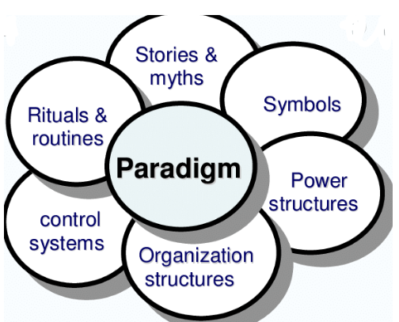
Figure 1: Framework of cultural web model
(Source: Klochkova et al. 2017 p.167)
Porter Five forces
The aspects associated with it and its implications on the Jaguar Company are depicted below-

Market competition | Strong market competition can affect the presence of an organization. Emergence of Ford, Aston Martin and other companies to an extent has suppressed the popularity of Jaguar in the last two years.
New entrants in the industry | Different car companies are there to capture the market of Jaguar. Global market has paved the path for their emergence which has affected the profit ratio of Jaguar to a great extent.
Power of suppliers | Association with different suppliers has helped the company to grow in the market. However, lack of suppliers can affect the regulation of business objectives.
Power of customers | Customers are integral part of an organization for the collection of revenue (Olexova and Chlebikova, 2021 p.02048). Attachment of diverse personalities has helped Jaguar company to grow.
Threat of substitute products | Different companies have the ability to produce goods in a cheaper price range. This parameter can object to the expansion of any organization.

Table 2: Porter five forces
(Source: Self Created)
External changes, therefore, affect the internal diameters to a large extent. Different departments of an organization have the liability to structure decisions in accordance with the market demands and trends. Changes in internal structure are also crucial for maintaining market relevance upon which business expansion is highly dependent.

Effect of culture on organizational efficiency
Organizational culture refers to the values; beliefs of an organization through a diverse range of employees are regulated for productive outcomes. Missions and goals are primarily highlighted for the increment of profit rates. According to Stindt et al. (2017 p.985), global business environment has paved the path for associating individuals with different cultural backgrounds, ethnicities, orientations and others. Maintaining a proper structure in the company in this context is mandatory to ensure attachment of creative and innovative insights. Taking example of Jaguar Company, it can be said that the organization has changed its policies and values in accordance with the changes in external environment. In the first encounter, regional individuals with skills and knowledge had been considered (jaguar.co.uk, 2021). In accordance with the growing scale of the organization, association of different personalities has been done. However, standard rules and regulations have been developed in the organization to maintain an inclusive as well as productive culture upon which organizational efficiency is highly dependent.

Impact of business ethics and corporate social responsibility on business growth
Business ethics leads the path for assuring trust of both employees and customers who play a vital role in the navigation of business objectives. Based on the opinion of Roberts et al. (2019 p.656), business development, integrity, achievement of objectives is inherently connected with business ethics. Jaguar Company in this regard has assured employment act, equality act to provide an ethical structure to the employees. Corporate social responsibilities on the other hand are supportive of enhancing market reputation. Social elevation in this respect supports the growth of business diameter to a large extent. Jaguar Company has shed light on the creation of job opportunities for 12 million individuals through the projects of technology, well being and others (jaguar.co.uk, 2021). Indirect participation in the social causes prompts the customers to be associated with the organization and the growth rate of Jaguar confirms the relationship of corporate social responsibility and organizational growth.

Theories and concepts of business growth
Systems management theory and Theory X, Y can be applied in the Jaguar Company. System management Theory is an alternative approach for planning and management of an organization. The system management theory contains multiple components that can work harmoniously that any kind of larger system operates easily (AlManei et al. 2018, p.1160). AS Employees are the most vital component of a company and it enhances the effectiveness of the performances. It evaluates the pattern of practices that can be implemented by the managers and get the best result for an organization (Ho, 2018, p. 749). This theory may be implemented by the Jaguar Company to get an effective result.
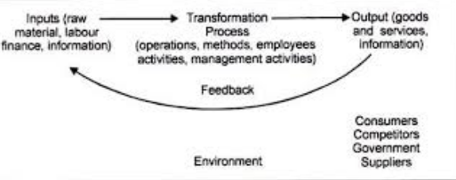
Figure 2: System Management Theory
(Source: Tian et al. 2018, p. 3466)
Theory X and Y influence the practices of a company that how an organization can run smoothly. Theory X holds the view of an employee in the sense that they cannot work in the absence of incentives (Tian et al. 2018, p. 3466). On the other hand Theory, Y can hold an optimistic opinion of an employee. This theory can be applied to achieve a collaborative and trust-based relationship (Keerthana and Babu 2018, p. 223). This theory can be applied to the Jaguar company to balance the employees and to manage the inter conflicts.
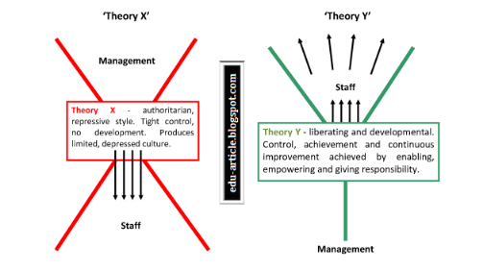
Figure 3: Theory X and Theory Y
(Source: Keerthana and Babu 2018, p. 223)

Reasons of business engagement with international trade
Different market exposure is the primary factor to be associated with international trading. It must be mentioned that diverse types of customers can be focused upon in the context of global market which is affirmative for strengthening economic aspects of an organization (Răzvan, 2019 p.176). Taking consideration of Jaguar company it can be said that establishment of the branches in different locations has helped the company to grow its brand image along with financial sector. Risks are also reduced post the engagement with international trade for a wide range of market segments can be focused on. The scope of associating innovative prospects is also highlighted during the investment in international trade. According to Mitchell and Mishra (2017 p.1073), shared liabilities and activities often pave the path for increasing market share which is the primary aim of any organization. Therefore mentioned attributes can be considered as primary reasons for the attachment with international trading diameters.

Comparison with other companies

Market structures
Market structure refers to the association of suppliers. Increased number of suppliers determines the efficiency of an organization. However, proper management of associates is mandatory for the assurance of profit from the strong market tussle. Pavlovich et al. (2020 p.12) is of opinion that monopoly in this context refers to the association with one producer while oligopoly revolves around the association with a large number of suppliers. In respect to car companies, it must be mentioned that diversity in product range assures their participation in oligopolistic environment. Jaguar Company for example has associated itself with different types of suppliers for effective management of operations. Different organizations are there to provide the company with raw materials for wheels, technical tools and others (jaguar.co.uk, 2021). In a similar vein, organizations like Aston Martin, Nissan have also focused on the association of different suppliers for navigating market requirements. However, it can be said that global diameter has helped the companies to be connected with different other organizations for enhancing profit scale.
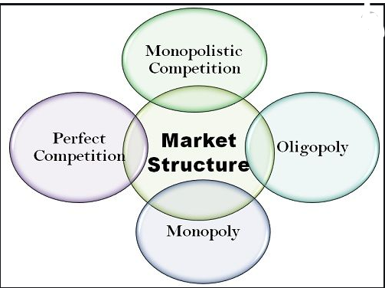
Figure 4: Different market structures
(Source: Pavlovich et al. 2020 p.12)

Long run, short-run changes
Rapid growth of modern technology has paved the path for asserting changes in organizational structure. In the initial stages, simple infrastructure is followed in Jaguar to manufacturer cars and associated tools (jaguar.co.uk, 2021). However, changed demands of customers and technical parameters have convinced the organizations like Jaguar to focus on the integration of artificial intelligence. In the short run, voice command, automatic driving and related attributes have been changed. Taking consideration of Tesla Company it can be said that the organization has focused on integration of technologies and aspects through which sustainability can be ensured. In a similar manner, for the long run, Jaguar Company has also approached relevant ideologies for sustainable outcomes. The machines now are responsible to consume less fuel than the engines used five years ago. Electric motors have been associated with the products of Jaguar to ensure customer satisfaction. Regulation of high-end technical structures requires suitable infrastructure in the organization (Moghimi and Sadri, 2021 p.015). Along with the growth of investment, certain changes in the companies can be registered.

Features of current international economy
The income of the different organizations has grown in the last few years with the increment of market transactions. 3.5% of growth has been registered in the year 2019 while 2.6 of growth can be witnessed in the year 2020. Taking consideration of the financial report of Jaguar Company, it can be said that the organization has assured $25.7 million in the year 2018 while the revenue was at 24.33 in the year 2017 (jaguar.co.uk, 2021). The strong market competition has suppressed the growth of which is reflected in its financial statements as the company has assured $24.2 million in the year 2019. Ford Company, on the contrary, has assured $155.9 billion money in the year 2019 (ford.co.uk, 2021). Therefore the market has a wide scope of growth through the application of suitable strategies.
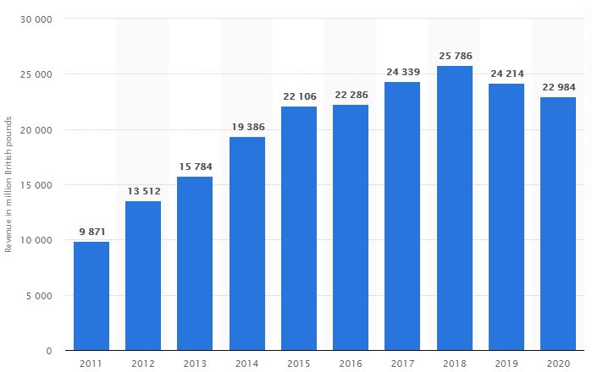
Figure 5: Economic growth of Jaguar Company
(Source: jaguar.co.uk, 2021)

Recommendations for Jaguar
The company can focus on the integration of artificial intelligence in a more critical manner to enhance its productivity. Following the opinion of Nikpour (2017 p.67), it can be said that collaborative approach can be taken in the organization to formulate market-related strategies. On the other hand, social media marketing channels should be improved by the company to inform the customers about the new products and services. Proper content should be developed by the company to attract a wide range of customers from different geographical locations.

Conclusion
It can be concluded that global business environment has changed the designs and structures of managing productivity to a large extent. The companies have shown inclinations towards the integration of modern technology which is the main driver of globalization and enhancing organizational efficiency. It has been realized that changes in global environment have modified the internal structures of the organizations. Values, rules and activities of different companies have been changed in accordance with the market requirements to capture strong positions in the competitive arena. Comparison between different companies has been done to understand the structures of global market. Based on the internalization of the prospects, some recommendations have also been provided for productive growth of Jaguar Company.

References
AlManei, M., Salonitis, K. and Tsinopoulos, C., 2018. A conceptual lean implementation framework based on change management theory. Procedia cirp, 72, pp.1160-1165.
ford.co.uk, 2021. Overview of organization. Available at: https://www.ford.co.uk/ [Accessed on 4th January, 2021]
Ho, A.T.K., 2018. From performance budgeting to performance budget management: theory and practice. Public Administration Review, 78(5), pp.748-758.
jaguar.co.uk, 2021. Overview of organization. Available at: https://www.jaguar.co.uk/index.html [Accessed on 4th January, 2021]
Keerthana, Y. and Babu, M.K., 2018. A study on theory x & theory y: implications of teachers in higher education. International Journal of Management, IT and Engineering, 8(10), pp.222-233.
Klochkova, E., Minashkin, V., Sadovnikova, N. and Prokhorov, P., 2017. Digital economy: features and trends. In 4th INTERNATIONAL MULTIDISCIPLINARY SCIENTIFIC CONFERENCE ON SOCIAL SCIENCES AND ARTS SGEM2017 (pp. 165-172).
Mitchell, A.D. and Mishra, N., 2017. Data at the docks: modernizing International Trade Law for the digital economy. Vand. J. Ent. & Tech. L., 20, p.1073.
Moghimi, T. and Sadri, R., 2021. Organizational Teamwork and the Impact of Charismatic Management on Organizational Efficiency and Health. J. Hum. Ins, 5(1), pp.015-023.
Nikpour, A., 2017. The impact of organizational culture on organizational performance: The mediating role of employee’s organizational commitment. International Journal of Organizational Leadership, 6, pp.65-72.
Olexova, V. and Chlebikova, D., 2021. Tools of product policy as part of business marketing in the conditions of globalization. In SHS Web of Conferences (Vol. 92, p. 02048). EDP Sciences.
Pavlovich, V.V., Batrazovna, V.D., Shamsudinovna, D.M., Viktorovna, A.Z. and Semenovna, N.S., 2020. Digital economy features in the field of state electronic services in the Russian Federation. International Review, (1-2), pp.11-17.
Răzvan, Ș., 2019. Several contemporary economy features, consequences of internet expansion and ict innovations in the world. Studies in Business and Economics, 14(3), pp.175-181.
Roberts, A., Choer Moraes, H. and Ferguson, V., 2019. Toward a geoeconomic order in international trade and investment. Journal of International Economic Law, 22(4), pp.655-676.
Stindt, D., Quariguasi Frota Neto, J., Nuss, C., Dirr, M., Jakowczyk, M., Gibson, A. and Tuma, A., 2017. On the attractiveness of product recovery: The forces that shape reverse markets. Journal of Industrial Ecology, 21(4), pp.980-994.
Tian, C., Zhao, J., Ou, X., Wan, J., Cai, Y., Lin, Z., Dang, Z. and Xing, B., 2018. Enhanced adsorption of p-arsanilic acid from water by amine-modified UiO-67 as examined using extended X-ray absorption fine structure, X-ray photoelectron spectroscopy, and density functional theory calculations. Environmental science & technology, 52(6), pp.3466-3475.
Witt, M.A., 2019. De-globalization: Theories, predictions, and opportunities for international business research. Journal of International Business Studies, 50(7), pp.1053-1077.
Zeibote, Z., Volkova, T. and Todorov, K., 2019. The impact of globalization on regional development and competitiveness: cases of selected regions. Insights into Regional Development, 1(1), pp.33-47.

