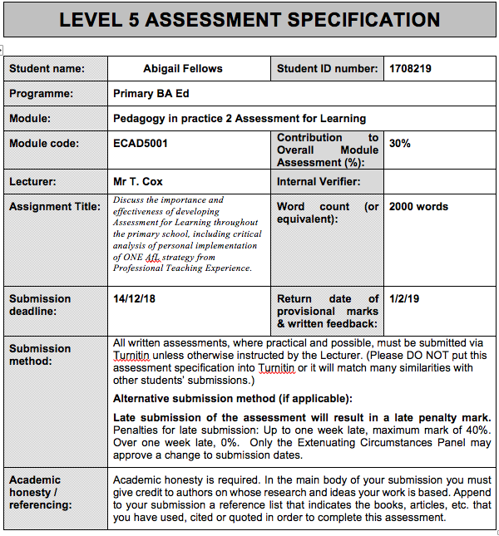

Discuss the importance and effectiveness of developing Assessment for Learning throughout the primary school, including critical analysis of personal implementation of ONE AfL strategy from Professional Teaching Experience.
Assessment for Learning (AfL) is the process of seeking and interpreting evidence for use by learners and their teachers to decide where the pupils are in their learning, where they need to go and how best to get there. (The Assessment Reform Group, 2002) It is also known as formative assessment. Sadler (1998) refers to formative assessment as a way to get meaningful feedback to accelerate learning. However, William (2013) believes he should have called it something like ‘responsive teaching’ rather than assessment as many people associate assessment with tests or exams, which is not what AfL entails. Some view it as a ‘continuous process that grows through shared understanding, adaptive practice and a clear focus on learning’ (DCELLS, 2010, p.6) rather than AfL. Assessment for learning is different to assessment of learning as AfL looks forward as well as back compared to assessment of learning which is also known as summative assessment and the main purpose is to grade and provides an overview of pupils’ achievements.
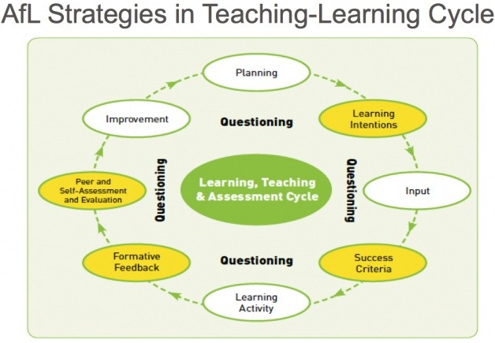
(Council for the Curriculum Examinations and Assessment, 2007)

The cycle suggests that learning, teaching and formative assessment should create a continuous cycle, where the formative assessment effects future planning and teaching which in turn improves learning. As Mansell et al (2009, quoted in Grigg, 2015, p.410) states ‘an activity is not formative unless the information it provides is used to take learning forward.’

However, some people feel AfL has not been implemented correctly as Russell et al (1995, cited in Black and William, 1998) believes AfL needs developing. Moreover, Gatbsy (2012) believes there is a lack of understanding surrounding AfL and can be viewed as exciting classroom strategies rather than a way of promoting active learning in the classroom. However, not one strategy will work with every class and strategies will need be to be personalised to suit their needs. Therefore, teachers that have a deep understanding of AfL is preferred to maximise impact and effectiveness. Harrison (2013) has highlighted the importance of the teacher role when implementing AfL as implementing the strategies requires practitioners to reconsider their practice. Another point to consider is that the ‘strategies are only as good as feedback it provides for the learners’ (Welsh Government,2010, p.13), Jones (2005) is aligned with this view as many strategies require feedback to move the learning on or close the gap.
Black and William (1998) suggested that there are four elements of assessment for learning. First, there is quality of questions/quality of talk, ‘It is through the dialogue that pupils develop a sense of what they are aiming for, how to get there, and a sense of quality’ (Pollard, 2018, p. 411). Another element is sharing criteria with learners, it is important for the teachers to break the criteria down so it is clear what they want pupils to achieve. Another element is effective feedback and it is where teachers can communicate areas of improvement and learning goals to pupils. Learners will need to be given the opportunity to reflect and act on any feedback (Welsh Government, 2013). Teachers’ feedback should act as scaffolding to support learners’ skill- building and the acquisition of knowledge. Which is encouraged by Bruner (1978, cited in Saul Mcleod, 2008) and Vygotsky (1962). Finally, there is peer and self-assessment. It is encouraged learners are showed and trained in these methods to ensure effectiveness. Self/peer assessment are not innate skills but can be developed.
The strategy implemented on Professional Teaching Experience (PTE) was what went well (WWW) and Even better if (EBI) which relates to self-assessment that will be followed with feedback. Research shows pupils should be in control of their learning, therefore considering assessment that is in agreement with the ideals of constructivist learning, which is why the writer implemented a self-assessment strategy during PTE. Research shows that self-assessment promotes metacognition in learners, in that it helps them develop a deeper awareness of how they learn, promotes better learning and research shows that learners who think about their learning have better outcomes. This was demonstrated in a study by Hattie (1996, cited in Hozien, 2017) that involved a way for students to think and reflect about what they are learning. Furthermore, by using this strategy it gives them independence, engage them in their work and promote learning. However, students can only achieve a learning goal if they understand that goal and can assess what they need to do to reach it (The Assessment Reform Group,2002). Donaldson (2015, p.69) is of the same opinion in that teaching is more effective when learners ‘take increasing responsibility for their own learning’. One would recommend utilising self/peer assessment as engaging with the work first then getting the feedback can have more value. Also, one would still ensure they are provided with meaningful feedback after pupils have self-assessed as they are centre of their learning but the teacher needs to address misconceptions or move children along.
On PTE, it was essential for the children to monitor and assess their work during the act of production. Rather than at the end of the lesson when the work has been completed. Therefore, mini-plenaries would be encouraged to discuss ‘what is going well/what went well’ (WWW) and ‘even better if’ (EBI) in relation to their learning. It is important to use mini plenaries as the misconceptions can be discussed and acted upon during the lesson. Research shows that short cycle formative assessment has the highest impact on student learning, as one can make changes, gauge the learning in the lesson and make changes if necessary. As William (2006) states if the information gathered from formative assessment is not used within a day or two its unlikely to make a difference to student achievement. The elements of the lesson e.g a certain strategy that is going well can be shared with their peers for reflection or improvements. It is essential to allow learners time to address feedback gathered during peer and self-assessment. Welsh Government (2013) supports this as work can be improved, issues can be addressed and feedforward comments can be provided. Furthermore, at the end of the lesson, one would encourage to complete a WWW and EBI in their books which can be referred to in future lessons. If relevant, during a plenary the children can discuss their reflections and this could be referred to next lesson. WWW and EBI is in line with new style assessment as it encourages learners to assess where they are and decide how they can improve as learner’s asses how their understanding has progressed during the course of the lesson. Another reason to encourage self-assessment is that it represents the development of self-appraisal, evaluative, analytical, critical and reflective skills. These are important throughout children’s school life and through the world of work (University of Exeter, 2018) Students gain a deeper understanding of topics, the process of assessment and what they are doing in their own work. This helps to make them more aware of ‘what learning is; and thus, see their own learning in this way, this is aligned with the concept of active learning.
However, for self-assessment and ‘WWW’ and ‘EBI’ to be effective the pupils should have sufficient training in self-assessment so they can understand the main points of their learning. It takes time, patience and commitment to develop a full understanding of self-assessment. Therefore, giving time to self-assessment activities has ‘implications for lesson structure and teachers will need to mark out time slots for self- assessment activities’ (McCallum, 2012 p.10) which obstructed valuable working and teaching time. Also, some children find self-assessment difficult as ‘we all know it is easy to find fault in other people’s work, but it is a far more challenging process to judge one’s own work.’ (Jones, 2005, p.20). A difficulty that was observed on PTE was that their self-assessment was vague, not focusing on the lesson or was about the enjoyment of the lesson. For example, the ‘EBI’ was about the neatness of their work was or the time it took for them to complete the work. This information did not show if they understood the task and it was irrelevant to move the learning forward. Therefore, one gave the children a clear expectation of the strategy and how to focus it on the specific lesson by showing them how to reflect according to the learning objective or success criteria to get a focused assessment. Therefore, the children will have to be showed and trained to carry out this method so it is effective. It is important for pupils to enjoy the work they do, however for this particular strategy they should self-assess against criteria rather than the likes and dislikes of the teaching. Another drawback is engagement with the strategy, perhaps some children would not feel comfortable self-assessing themselves as they may not have sufficient self-esteem therefore the promotion of learner self-esteem is critical to effective self-assessment. As DeWitt (2014) states that for learners to be fully engaged in a task they must be in a comfortable learning environment. Also, ‘The Government told schools that it was about monitoring pupils’ progress; it wasn’t about pupils becoming owners of their own learning’ (Stewart 2012, quoted by Grigg, 2015, p. 409). Therefore, they are in favour of children becoming more independent and having more control of their learning. It is important for teachers to make decisions about the next steps in learning and support children to take these steps but it’s important to consider that it is the pupils who are the ones taking the next step and more they are involved the greater their understanding of the learning process will be (Pellegrino et al, 2001).
It is important that AfL strategies are embedded throughout the whole school to ensure consistencies for learners, to compare data and to support the practitioners to work cohesively etc. Research with schools has shown that AfL practice is most successfully developed where teachers work collaboratively within and across key stages, share their practice and learn from what they and their peers do(Department for Education, 2010 ,p.6). Leaders identified the need to streamline assessment for learning practices, and to improve consistency and responsiveness to close skills gaps across the Foundation Phase and Key Stage 2 (Estyn, 2017). If the WWW and EBI strategy was a whole school approach to AfL then some adaptations would have to be made. There will have to be considerations for effective whole school self-assessment of WWW and EBI, particularly for lower Foundation Phase, as the Foundation Phase lays increased emphasis on encouraging young children to make choices and to actively participate in their learning (Welsh Government, 2011). Firstly, in the Foundation Phase the strategy could be implemented orally through using WWW and EBI. As lessons are usually carried out in focused tasks with small it is easier to assess the learning. Also by discussing the self-assessment orally it may support other learners who do not have a full understanding. Furthermore, at the end of the lessons the children could record WWW and EBI on an iPad or voice recorder to refer to next lesson if relevant rather than writing in a book. Some may align with the idea that self-assessment is too difficult in the Foundation phase, however the younger they are introduced to it, the more practice they have the more understanding they will get. However, all children should be trained and discuss the requirements and reasons behind it before implementation as previously discussed. For example, a successful case study is Pembroke Dock Community School. They encourage visual learning and for pupils to be responsible for their own learning across the whole school which leads to more independence to assess their work. (Estyn, 2016).

To conclude, it is clear to see the positives that arise from effective use of AfL strategies. There are many successful strategies that can be implemented in schools but there are many things to consider such as the effectiveness, the timing of the implementation, if it will raise standards, the feedback it provides, if it can be used in mini plenaries, if it can be changed to work throughout foundation phase and key stage two and if strategies can be changed to suit the various needs of the class. Although consistency is important it is recommended to use different AfL strategies throughout the lesson such as effective questioning, sharing criteria with learners, feedback to the teacher etc to ensure learners are challenged, understand the learning intentions and for teacher to adapt the teaching by having feedback. Also, one would recommend for self-assessment strategies such as WWW and EBI that it is a whole school approach, that is discussed with the children why it is done and how it can help them close gaps in their learning and to give them independence which in turn will make them more empowered. One would recommend pupils are exposed to it as soon as they start school so they can build up their knowledge of the strategy to ensure it is carried out effectively. One would support AfL as it is a clear tool assess learning. It can be used to identify the next steps, build on success and strengths as well as to correct weaknesses. (Black and William, 1998)

Word Count= 2198

Bibliography

Black, P. and William, D. (1998). Inside the black box: Raising standards though classroom assessment. London: GL Assessment

Council for the Curriculum Examinations and Assessment. (2007). Assessment for Learning for Key Stages 1 and 2. Belfast: CCEA.
Estyn (2017) Using assessment for learning to close gaps in pupils’ learning, Effective Practice. Cardiff :Crown Copyright
Available at: https://www.estyn.gov.wales/effective-practice/using-assessment-learning-close-gaps-pupils’-learning (Accessed 11.12.18)

DCELLS. (2008) Assessment for learning and the National Literacy and Numeracy Framework. Cardiff: Welsh Assembly Government.

DCELLS. (2010), Why develop thinking and assessment for learning in the classroom? Cardiff: Welsh Assembly Government.

Department for Education (2010) Practical strategies to support the whole-school development of AfL with APP, The National Strategies. Cardiff: Crown Copyright

DeWitt, P (2014) ‘Comfortable Learning Environment: Soften the Blow of Accountability?’ Education Week [blog] 30th October Available at: https://blogs.edweek.org/edweek/finding_common_ground/2014/10/comfortable_learning_environment_soften_the_blow_of_accountability.html (Accessed 9th December 2018)

Donaldson, G. (2015) Successful Futures; Independent Review of Curriculum and Assessment Arrangements in Wales. OGL: Crown Copyright

Estyn (2016) Encouraging Independent Learners, Effective Practice, Cardiff: Crown Copyright Available at: https://www.estyn.gov.wales/effective-practice/encouraging-independent-learners

Gadsby, C. (2012) Perfect Assessment for learning: Cardiff: Independent Thinking Press an imprint of Crown House Publishing

Grigg, R. (2015) Becoming an Outstanding Primary School Teacher, Harlow: Pearson

Harrison, C (2013) ‘Assessment for learning: are you using it effectivrly in your classroom?’ The Guardian 29th August. Available at: https://www.theguardian.com/teacher-network/teacher-blog/2013/aug/29/assessment-for-learing-effective-classroom (Accessed 8th December 2018)

Hozien, W (2017) Hattie Metacognition for the Classroom, Education News Avaliable at: http://www.educationviews.org/hatties-metacognition-classroom/ (Accessed 09.12.18)

Jones, C. (2005) Assessment for learning, London: Learning and Skills development Agency

McCallum, B (2012) Formative Assessment- Implications for Classroom Practice, London: Qualifications and Curriculum Authority Available at https://dera.ioe.ac.uk/4565/1/formative%281%29.pdf (Accessed 10.12.18)

McLeod, S. (2008). Bruner. Simply Psychology Available at: https://www.simplypsychology.org/bruner.html (Accessed:10th December 2018)

Pellegrino J et al (2001) Knowing What Students Know: The Science and Design of Educational Assessment. Washington DC: National Research Council

Pollard, A. (2018) Reflective Teaching in schools 5th Ed. London: Bloomsbury

Sadler, D. (1998) Formative Assessment: Revisiting the Territory, Assessment in Education.

Spiller, D (2012) Assessment Matters: Self-Assessment and Peer Assessment. :the University of Waikato

The Assessment Reform Group 2002, Assessment for Learning: 10 principles research-based principles to guide classroom practice: London
The National Foundation for Educational Research (2007) Self and Peer Assessment, Getting to grips with assessment: Primary. Slough: NFER

University of Exeter (2018) Peer and self-assessment in student work: principles and criteria, Learning and Teaching Support Handbook
Vygotsky, L. (1962). Thought and language. Cambridge: MIT Press.
Welsh Government. (2011) Pupil Participation -Good Practice Guide. Cardiff: Crown Copyright

Welsh Government. (2009) Qualified Teacher Status Standards. Cardiff: Crown Copyright

William, D. (2006) Assessment for Learning: why, what and how, Excellence in Assessment: Assessment for Learning, Cambridge: Cambridge Assessment Network

William, D. (2013) Example of a really big mistake: Calling formative assessment formative assessment and not something like “responsive teaching”. Twitter blog available at: https://twitter.com/dylanwiliam/status/393045049337847808 (accessed 9 December 2018)

