University of Wales Trinity Saint David
London Campus

Dissertation
LCBB6000
BA (Hons) Business Management
Modern workplace trends in the future (Bulgaria/UK)

Lector: Dr Gregory Cowan

Galina Gancheva 2022711

Date: 02/01/2024 word count: 6000

Abstract

In our current day, it is imperative to implement reforms due to the prevalence of a market economy. Every individual is seeking employment that can adapt to the rapid and dynamic cultural shifts occurring globally.
Due to the Covid19 epidemic, we were compelled to make significant alterations to our mindset and work practices. It resulted in both positive and negative alterations, some of which also occurred in the professional environment.
The modifications had the greatest impact on office work. Due to the epidemic, individuals began seeking methods to minimise interpersonal interactions and increase remote job opportunities. This tendency has transitioned from only working online to a combination of online and offline employment.
The research aims to illustrate the ongoing and intensifying shifts and patterns in growth. It will conduct a comparative analysis of the temporal evolution of two nations and examine their respective responses to emerging workplace trends. Here, you will be presented with a little nation in the process of development and a large one that is currently thriving. The countries in question are Bulgaria and England. It analyses the future growth and transformation of both nations.
The objective of our investigation is to deconstruct antiquated notions. Let us contemplate the future by adapting our actions to the current circumstances. Holman's research (2005, p. 26) outlines the necessary inquiries we must address on the New Workplace: What is the prevalence of innovative work methods, advantages and disadvantages of all aspects related to office work?
The dissertation will extensively examine the disparities between office employment in England and Bulgaria. We will examine the operational performance of the offices in both nations during the past three years. We will examine the overall approach to work, specifically how it has been affected by the Covid-19 epidemic. We will explore both the similarities and differences in the way work is conducted. Regarding office work, we conducted a poll among 50 individuals in Bulgaria and the United Kingdom, encompassing various job roles. The objective of our research is to comprehend the efficacy of office job by analysing contemporary modifications. By doing research, we may ascertain the efficacy of different approaches, identify areas that require modification, and determine whether reverting to the previous model is warranted.
The primary objective of the study project is to juxtapose the emerging workplace trends in two completely disparate countries. Thus, we shall ascertain the adequacy of the integration of all new elements. What is of high quality or beneficial? What is malfunctioning? In order to maximise the benefits of the trends and ensure their relevance in the future. The impact of emerging trends on our work practices. We require an understanding of the potential impact that future alterations will have on the economy of both Bulgaria and Great Britain.
Recommendations can be made for further study on the topic in the scope of salary expectations, government taxes and legal health and safety requirements in hybrid work contracts. Wider research could include international companies with expat employees and the effect on payroll tax, contractual hours, and work culture.

Acknowledgements

Words cannot express my gratitude to my lecturers, especially my dissertation supervisors, for their invaluable patience and feedback.
I also I could not have undertaken this journey without my lecturers, who generously provided knowledge and expertise. I am thankful for the flexible work allowed and family support while conducting the research.
Additionally, this endeavour would not have been possible without the people who participated and supported my research. They took some time to answer my questions. Thanks for their patience and full cooperation with my research.

Table of Contents

Abstract 2
Acknowledgements 3
List of Tables and Figures 5
Chapter 1: Introduction 6
Chapter 2: Literature Review 8
Chapter 3: Research Methods and Methodology 11
Chapter 4: Data analysis and Discussions 14
Chapter 5: Conclusion, Limitation and Recommendations 21
List of references 23
Terms of Glossary 27
Appendix 28
Declaration and Consent forms 66

List of Tables and Figures

Appendix 28
Table 1: Interviewed participants’ scope
Table 2: Interviewed participants’ list
Table 3: Interview questions transcripts
Table 4: Gant Chart Data and analysis from Census 2021 Source: Office for National Statistics – Opinions and Lifestyle Survey
Table 5: Research Questions Results
Table 6: Research Methods

Chapter 1: Introduction

In the context of a market economy, we now reside in an era where alterations are needed. Every individual seeks a professional environment that effectively adapts to the ever-evolving societal transformations on a worldwide level. The Covid-19 pandemic has necessitated significant shifts in our mindset and professional adaptation. It resulted in both detrimental and beneficial modifications that were also implemented in the workplace.

The impact of these changes was particularly pronounced in office environments. The epidemic prompted the exploration of potential work alternatives that minimise personal interactions and prioritise remote work. This tendency has persisted and evolved from an online format to a hybrid mode of operation.

Background and aim of the study

This subject is crucial since it prompts us to see the need to adjust to alterations. An imperative to progress, adapt, and innovate. The outcome will be enhanced and customised to specifically meet our requirements. It illustrates the ongoing changes and evolving tendencies that persist and advance in the present day. I will analyse the progress of two nations and their respective approaches to adapting to emerging workplace trends. Here I will present a comparison between England, a highly developed and populous country, and Bulgaria, a smaller and less developed one. I will do a comparative analysis of the two countries and their prospective growth trajectories.

Our research aims to contrast the traditional and contemporary methods of labour. Let us anticipate the future and contemplate the aspects that are functioning well and those that want modification. By comparing two disparate nations, we may analyse their cultural mindset, problem-solving approaches, and work methods, and then use the most effective ones in practical situations.

Importance and scope of the Research

The primary focus of the dissertation will be a comprehensive examination of the disparities between working in office environments in England and Bulgaria. We shall monitor the operational performance of the offices in both nations during the past three years. We will examine the overall approach to work, specifically how it has been impacted by the Covid-19 epidemic. We will explore both the similarities and differences in the way work is conducted.

A poll was done among 50 individuals in Bulgaria and the United Kingdom regarding office work. A total of 25 individuals from the United Kingdom and 25 individuals from Bulgaria were interviewed. Please refer to Appendix Table 1: Interviewed participants’ scope. The individuals are in distinct occupational roles, with one being male and the other female. Their ages range from 25 to 45 years. Galina Gancheva conducted this poll on 15th August 2023, at offices located in the UK and on 30th September 2023, in offices located in Bulgaria. (Table 2: Interviewed participants’ list)

The objective of our research is to comprehend the efficacy of office jobs by analysing contemporary modifications. By doing research, we may ascertain the effectiveness of certain approaches, identify areas that require modification, and determine whether reverting to the previous model is advisable. We get information by means of data collection and study. We conduct a survey to inquire individuals from various jobs and hierarchical levels. We gather the perspectives of individuals residing in Bulgaria and the UK about various matters.

Data analysis

In this analysis, we will examine the data obtained from a survey that had respondents answering a range of questions pertaining to their work experiences and the challenges they encounter in office environments. This survey will be conducted using online platforms, such as email, as well as through phone discussions and in-person interviews at the workplace. We will analyse the variations and the corresponding remedies and determine the optimal location and method. What are the benefits and drawbacks of working in two countries? We will determine the efficacy of flexible working hours and online work in both nations. The influence of the Covid-19 epidemic on business and office activities, whether beneficial or bad.

Over the past few years, several aspects related to the Covid 19 epidemic have undergone alterations. It has exerted a significant influence in several domains and has prompted individuals to demonstrate creativity and instigate numerous alterations in the commercial sector. A significant portion of these changes was instigated by the preservation of firms and the retention of a limited number of workers. It was necessary for them to ensure the provision of secure working conditions for their employees. As part of these steps, the offices shifted to online work and then adopted a hybrid work model when the restrictions were eased.

An example of a typical working day in the office in UK and Bulgaria

Working hours in the offices:

In Bulgaria are 8 hours a day 5 days per week. Most companies work between 8.00 am to 5pm and 1 hour lunch.

In UK are Usually 8 hours a day, 37 - 40 hours a week. Standard hours Monday to Friday between 8:00 or 9:00 am to 4:00 to 5:00 pm and 1-hour lunch.

A typical working day in the office in UK:
Dorothy works as an administrator in the office in UK. She explains about her working day in the office. Planning her day - The first thing to do when you get to the office is set up your workspace and start planning your day. By checking your emails, calendar, and workload, she will be able to plan out what you need to complete in the day. She needs to manage her own time and confirm with managers.
Time blocking is a great way to prioritise and make time for the most important tasks.
She removes the boring but most important things first. At the beginning of the day, she has a team meeting. It is important for the team to discuss the tasks that have been completed and what needs to be done. She has to be as focused as possible for these meetings, because they are an important part of the work in the office. She always needs to be on time for these meetings. She must inform her manager about everything she needs for the work process.
For example: If you struggle with writing and taking notes, ask if you can record meeting sessions or just listen carefully. If you find it easier to answer questions if you can prepare for them in advance, let your manager know, so that you won’t feel uncomfortable in meetings.
We have 5 – 10 Minute Breaks
The most common working schedule is a 9am – 5pm day.
Lunch Time is agreed with Colleagues. You can usually have your lunch break whenever you want it, but most people have their lunch between 12pm – 2pm. The office is open throughout the day, and we agree with colleagues that they will be on duty. She needs to check in with the priorities list made at the start of the day and the daily plan to keep track of the progress you make and adjust any timelines.
Listening to music is allowed, but with headphones. For the noise level in the office, it is good to have noise canceling headphones. For everything she needs as equipment to feel comfortable at work, such as an office chair or a glare-free screen, approved by the line manager. Usually about an hour before the end of the work day, checks emails again and finishes workday in the office.

Irina works in the office in Bulgaria. She explains about her working day in the office in Bulgaria. Her work time is from 8 am to 5 pm. Eight working hours for 5 or 6 days per week. Standard Monday to Friday. Her workday starts with a cup of coffee and a review of the day's tasks. Usually, the manager has written down the daily work plan, or at the start of the day makes a distribution of tasks.
The first thing it checks is the work e-mail. In the meantime, she answers calls on the office phone. Her work involves meetings with clients. She also helps his colleagues when they are needed for the performance of work tasks. Most documents and records are on paper. This means more processing time. The lunch break is usually one hour, then the office is closed. It's usually between 12 pm and 2pm.
She often needs to go to other departments to complete her work tasks. There is usually a lot of bureaucracy and paperwork. The systems here are not yet so automated. That is the reason it is less flexible. In most cases, it must be present in an office. Usually, the working day proceeds by following the instructions of the manager or team leader.
In Bulgaria, the use of a work calendar is not as widespread as in other countries. Online correspondence is kept to a minimum. Still relying on formal documentation. Every official document must have a physical signature and stamp. An original document is usually officially required. Even if you leave a copy, the original is also presented, and the copy must be signed - true to the original.
At the end of my working day, checks if daily tasks are completed or postponed.

Chapter 2: Literature Review

The research will comprehensively examine many facets of the chosen subject, including its definition, features, significance, models, theories, benefits, drawbacks, and obstacles. "We are heavily investing in AI to assist communities in addressing major challenges that businesses are currently encountering, such as analysing and preparing for shifts in natural disaster occurrences, biodiversity, land utilisation, and other geophysical phenomena." (Holman; 2005)

Culture has two fundamental dimensions: spatial and temporal. The spatial dimension is self-evident. Individuals affiliated with a specific geographic region typically own their own distinct culture, such as the Belgian, British, or Brazilian cultures. Naturally, within these categories, there will exist several subcultures based on regions, towns, districts within towns, and various other affiliations, including gender, socioeconomic class, religious beliefs, business associations, and generational differences. Each of these may have distinct cultural expressions, while each will undoubtedly be identifiable as a component of the broader national culture. { Western and Eastern } (Nisbett, 2003, p. 100).

Background aspects to the concept

From this standpoint, the developing stage may be defined by a variety of emotional responses, spanning from lack of awareness of cultural disparities to feelings of shame and discomfort regarding traditional power dynamics, all the way to a sincere curiosity and dedication to cultivate a robust professional connection.

The level of comfort individuals have when it comes to interacting with people from diverse cultures is contingent upon both their attitudes and knowledge. The term 'cultural intelligence', sometimes shortened as CQ, refers to the knowledge and ability to navigate cultural differences. This notion was proposed by Earley and Mosakowski (2004) and is directly connected to Goleman's theory of emotional intelligence and Gardner's theories on multiple intelligences. Earley and Mosakowski suggest that cultural intelligence is comprised of three components: cognitive, physical, emotional, and motivational.

According to Ide (1999), individuals from Western cultures are often motivated to improve their performance through praise and encouragement. In contrast, it is proposed that Japanese individuals, for instance, are motivated to perform better when they get unfavourable feedback. It is important to consider these cultural variations when planning activities in a training session.

Given the current circumstances of Work From Home orders and widespread lockdowns, it is imperative for organisational leaders to prioritise remote work as the default option and make all necessary efforts to implement it. The workplace, sometimes referred to as the "new reality," has emerged as a formidable force that poses a challenge to our existing knowledge and beliefs. Creating an optimal home office setup Effective team communication and cooperation Technological advancements, instruments, and systematic procedures. Recognising those who have made a significant contribution will also serve as an incentive for others. Nevertheless, this approach might be detrimental when dealing with individuals from a collectivist cultural background. It would be awkward to single them out as superior to other participants.(Lossen & Alic, 2021)

Gaps identified to situate own research

Ensuring the safe return of employees to the office necessitates meticulous preparation and the steadfast enforcement of hygiene and social distancing protocols. Reference 24: Expo-Real.net The arrival of the new Modern workplace will bring about significant changes. While occasional solitude and quietness might enhance productivity, they are not conducive to long-term well-being.

The current status of remote work The COVID-19 pandemic has resulted in 45% of the worldwide labour force transitioning to remote employment. In addition, a significant 46% of organisations want to use remote work on a permanent basis in the future, as a direct consequence of adopting new "modern workplace" methods. Impact of home office on real estate Prof. Dr. Günter Vornholz from EBZ Business School, University of Applied Science, has predicted a 25% rise in remote work across various situations following the COVID-19 pandemic. Source 2: EBZ Business School, Home office— 2 Scenarios. There has been a significant decline in the demand for office space. The repercussions of the Corona crisis are exerting an influence on the German real estate market, leading to a decrease in the demand for office space by enterprises. Reference 3: Handelsblatt, February 3, 2021.

Related research issues

Study Title: Workplace Cultures and Business Performance: A Comparative Analysis of British Labour Relations and Industrial Output Alan Booth and Joseph MellingLabour historians have also examined the cultural practices and reactions of working individuals to industrial capitalism, with a focus on the establishment of workplace traditions and the erosion of managerial authority by trained and semi-skilled workers. The increasing acknowledgment of the influence of cultural values in the workplace has not been readily accepted by economists and economic historians. They have encountered challenges in incorporating a cultural "residual" into their models and instead prefer to use terminology related to market systems and institutional interests. One example is Mancur Olson. The last section of the introduction examines the influence of business and labour cultures on the ability of management to intervene and innovate in various sectors of the British economy throughout this time period. Roderick (2015)

This research examines the circumstances surrounding the transition of the UK Intellectual Property Office from its previous status to an agency, and identifies various factors that influenced both the changes and continuities before and after this transition. The analysis considers factors that are directly related to the agency status, as well as those that are unrelated. It takes into account various perspectives, including general, policy, performance, strategy, and management. Additionally, the research aims to identify the reasons behind the changes and continuities observed before and after the agency status was established (Roderick, 2015).

The survey results demonstrate an enhanced perception of government activity management in independent units that have been separated. These findings support Fulton's claims made 30 years ago that creating separate agencies would lead to improvement. However, the results do not provide evidence of better "value for money" or "best value" in terms of public sector service, as claimed by Boyne, Gould-Williams, Law, and Walker in 2002.

In Bulgaria, the maximum permissible working hours per week is 40 hours, spread across a maximum of five workdays. Under Bulgarian legislation, employees are allowed to hold several paid positions. Under these circumstances, the cumulative duration of remunerated employment should not surpass 48 working hours per week, unless the employee provides written authorization. Alternative arrangements for organising working hours are permissible under the law, however employers have the authority to establish them independently through internal business regulations or through talks in a collective labour agreement.

The majority of employees, over 80%, work a standard schedule of eight hours each day, five days per week. The proportion of individuals engaged in different sorts of part-time work is quite low (less than 5%).

The practice of working on rest days is concerning in terms of both working conditions and legal obligations. Approximately 44% of the survey participants are employed on at least one Saturday each month, while 30% of the staff members are frequently or occasionally required to work on Sundays.

An examination of the impact of shift work on employees' health and safety, as well as their overall happiness with their working circumstances, reveals that shift workers are twice as likely to perceive their working hours as a potential threat to their well-being compared to non-shift workers. Furthermore, there is a larger subset of individuals among the shift workers who express dissatisfaction with their working circumstances and perceive their work schedule as problematic for their family obligations and other responsibilities. The website for the Government of Bulgaria is located at www.gli.government.bg.

An organisation requires stable frameworks and hierarchical systems to operate with optimal efficiency. If the frameworks are excessively lax, hierarchies are also established, but in a somewhat less obvious manner. When we operate remotely, there is typically a compromise in terms of both efficiency and excellence. In order to achieve unity inside Yahoo, it is imperative that we gather together in person. Chapter 17 from the book (Janson, 2023)

The protection rules for remote employees are identical to those for workers labouring in a firm plant or office. Harizanova from CMS suggests that firms should use the following measures to guarantee that remote workers adhere to safety rules. Employers want to establish communication channels with remote employees and ascertain the precise geographical location of their remote office. If there is mutual agreement between an employer and employee that the employee can perform their duties from a location outside their home country, it is imperative to explicitly state this arrangement in the employment contract. Employers have to evaluate and modify internal rules pertaining to data protection in order to support remote work. To evaluate the impact of labour mobility inside the EU on the creation of multicultural teams in Dutch private sector organisations, we can formulate the following assumptions using a deductive method. The purpose of developing a research technique is to address the challenges encountered during the research process. Bangachev and Harizanova (2021)

Chapter 3: Research Methods and Methodologies
Philosophical and Paradigm position
Research techniques and methodologies have a crucial role in determining the approach, manner, and kind of task execution. It is crucial to promptly identify them and adhere to them. This technique is a modern method that emerged from the integration of classic quantitative and qualitative methodologies. Brannen and Moss (2012) argue that the mixed methods approach was developed to enhance researchers' understanding of social relations by combining quantitative and qualitative research methods. This approach acknowledges the limitations of both methods.
Mixed methods are renowned for employing the notion of triangulation in social research. Haq (2014, p. 11) states that triangulation allows researchers to report numerous conclusions on a same phenomenon by employing both quantitative and qualitative methodologies in one study. This strategy is commonly employed for examining the relationship between sleep and academic performance. A research strategy refers to a systematic plan or approach used to conduct the process of looking for and evaluating information. A research approach often encompasses many sequential stages.
The Essence of Research Philosophy involves the examination of the fundamental concepts related to the issue. Furthermore, establishing pertinent keywords and their corresponding synonyms. An effective research plan not only offers guidance for your study, but also assists in selecting the suitable approach for data collection and analysis in your research. The descriptive technique employs three methodologies: Surveys, Observations, and Case studies, in order to comprehend a particular collection of variables and gather data that furnishes a depiction of persons, groups, communities, or circumstances.
The research employs an interpretative strategy, which has resemblance to the qualitative research strategy. It analyses the social reality by employing a process of sense-making rather than hypothesis testing. Put simply, it elucidates and comprehends life and society by means of human experience. It centres on the importance and purpose of human existence.
Initially, it is important to comprehend the distinction between a population and a sample, and then determine the target demographic for your research. It is crucial to precisely delineate your target demographic based on the objectives and logistical considerations of your project. We employed Stratified sampling, a technique that entails partitioning the population into several subpopulations that may exhibit significant variations. By assuring appropriate representation of every subgroup in the sample, it enables the drawing of more exact findings. In order to employ this sampling technique, the population is divided into subgroups, known as strata, based on the pertinent attribute, such as gender identification, age range, and work position. A methodology outlines the systematic strategy taken by a researcher to assure the production of trustworthy and legitimate results that effectively meet their specific aims and objectives. It includes the specific data to be gathered and its sources, as well as the methods used for collection and analysis. The data we are referring to and examining is derived from a survey. This study was conducted in two distinct nations, namely Bulgaria and the United Kingdom. In order to achieve this objective, a total of 50 individuals participated in the study, with 25 respondents from Bulgaria and 25 respondents from the UK. These participants were asked several questions pertaining to office-related tasks.
Data collection tools encompass several instruments utilised for the purpose of gathering data, including physical mediums like paper questionnaires as well as computer-assisted interview systems. The data collection methods employed encompassed the utilisation of case checklists, interviews, sporadic observation, surveys, and questionnaires. An effective data interpretation procedure is crucial for transforming your data into a useful format. It will assist you in ensuring that you are reaching accurate conclusions and taking appropriate actions based on your facts.
The paradigm viewpoint employed in the dissertation is Axiology, which focuses on the examination of the essence of value and valuation, as well as the identification of valuable entities. A fundamental inquiry in axiology pertains to the factors that might enhance the inherent worth of a certain circumstance.
Position of Research Approach
Quantitative research is often favoured over qualitative research due to its greater scientific rigour, objectivity, efficiency, specificity, and widespread acceptance. Qualitative research is employed in situations when the researcher lacks prior knowledge or expectations. It is utilised to delineate the problem or formulate a plan to address the problem. The research methodology employed for the dissertation is quantitative. A methodology outlines the systematic procedure that a researcher follows in order to obtain trustworthy and valid results that effectively meet their specific aims and objectives. The scope of the project includes the specific data to be collected, its sources, and the methods for both collection and analysis. An organised and methodical strategy to address a research issue.
The data we are referring to and examining is derived from a survey. This investigation was conducted in two distinct nations. Bulgaria and the United Kingdom. In order to achieve this objective, a total of 50 individuals participated in the study, with 25 respondents from Bulgaria and 25 from the UK. These participants were asked several questions pertaining to office-related tasks. The poll primarily targets office workers in two specific countries: Bulgaria and England. Here is the group of people we are studying for our research. We choose a cohort of individuals, both male and female, aged 25 to 45, from the pool of office workers. Here is our example.
Stance of the Research Strategy and Design
A research strategy is a systematic and methodical approach that guides the researcher's cognitive process. It facilitates a researcher to methodically and punctually carry out the investigation. Research design refers to a systematic and strategic approach devised to address and provide a solution to your research topic. A research technique refers to a systematic approach employed to carry out a certain purpose. Research design and methodologies are distinct yet interconnected, since a well-crafted research design guarantees that the acquired data will provide a more efficient response to the research question.
We intend to conduct a study targeting individuals employed in office settings across two different nations. Subsequently, the data is processed and analysed. Furthermore, to analyse the resemblances and disparities in the reactions of individuals employed in both nations. Ultimately, the aim is to derive findings and determine an ideal and effective approach to working in both nations.
Data Collection and Data Analysis Tools
Data collection and analysis tools refer to a set of graphical representations, such as charts, maps, and diagrams, that are specifically created to gather, analyse, and display data across various fields and sectors. The main method for gathering data involves conducting on-site surveys, questionnaires, and in-depth interviews to gather information about the target market or demographic. The researcher or organisation collects unprocessed data directly from the source to utilise it for their intended purpose, goal, or objective of study.
We possess a survey including several categories of inquiries. The topic concerns the pre and post COVID-19 work practices in office environments. What is the distinction? What is acceptable, and what specific changes do they desire? What is the number of individuals who desire to either maintain remote work or adopt a hybrid work model? What is the number of individuals who desire to resume working in the office?

Ethical Consideration of the Research
Ethical concerns in research encompass a collection of concepts that provide guidance for the design and implementation of research. The principles encompassed in this context are voluntary involvement, informed permission, anonymity, secrecy, potential for damage, and disclosure of outcomes.
We are conducting a study targeting those employed in office settings, both male and female, between the age range of 25 to 45 years. They willingly consent to respond to many forms of inquiries pertaining to their job methodology. They highlight the disparities between the before and post-COVID-19 periods, as well as their preferences and recommendations for ongoing work practices. Prior to the survey, they are provided with prior notice on the survey's circumstances and the methodology employed. They possess the knowledge that they are engaging in the activity willingly and without revealing their identity. They are also aware of the objective behind gathering the information.
Summary
Chapter 3 provides details on the survey, including its nature, the methodology employed for data collection, and the target audience. What is the objective of the survey and its function in disseminating comprehensive information to individuals? The study employs a modern methodology that integrates classic quantitative and qualitative methodologies. In order to obtain a comprehensive understanding of individuals' perspectives about the recent modifications following the Covid-19 pandemic, we conducted a poll in two nations. Here we will present statistics on their response.

Chapter 4: Data analysis and Discussions

Data analysis

The research seeks to demonstrate the continuous and escalating changes and trends in growth. The study will provide a comparative examination of the chronological progression of the two countries and investigate their reactions to rising workplace trends. Here, you will encounter a little nation during progress and a vast one that is presently flourishing. The countries in the discussion are Bulgaria and England. It examines the prospective expansion and metamorphosis of both countries.

Our inquiry aims to dismantle outdated conceptions. Let us consider the future by adjusting our behavior to the present conditions. Holman's study (2005, p. 26) delineates the essential investigations that we need to undertake about the New Workplace:
What is the frequency or occurrence of creative work methods?
What are the benefits and drawbacks of all facets associated with office work?
The evidence substantiates the relationship between working habits, job design, and human factors.
Are there any exercises or activities that need the use of resources?
What data supports the association between particular types of work and their related working practices?
What are the viewpoints and direct experiences of both managers and employees?
What is the size or scope of the new Workplace?

In contemporary times, an increasing number of individuals have challenges in keeping a harmonious equilibrium between their professional and personal lives. One often has a strong sense of obligation towards their employment and the inflexible working hours. An innovative alternative is the Home Office, sometimes referred to as Remote Work in certain regions. Some individuals even go from their workplace and embark on global journeys as digital nomads. Your workstation is connected to the internet, allowing you to operate only in an online environment without any physical location. The reference is to Chapter 12 of the book "Janson" published in 2023.(Ch 12, Janson, 2023)

Janson (Staff Writer; 2023) asserts that employee culture is crucial for the success and expansion of any organization. The term "work culture" refers to the collective set of values, attitudes, and behaviors that influence the overall environment in which work is conducted. Organizations frequently utilize employee culture surveys as a means to comprehend and enhance staff culture. These surveys facilitate the collection of useful perspectives from employees and offer a comprehensive understanding of the present condition of the organizational culture.

Employing workers at a physical office site has several advantages for both employees and companies, including the enhancement of worker cooperation and creativity. There is a substantial amount of contention over the comparative productivity of employees in office settings vs remote work environments. While research is currently being conducted, preliminary findings indicate that collaborative work environments in offices have the potential to enhance worker creativity and foster a sense of cohesion, hence promoting productivity.

The majority of poll respondents, specifically 90% or 23 individuals, expressed a preference for continuing to work remotely from their homes. Regrettably, Bulgaria offers limited flexible alternatives as a result of stringent legal paperwork requirements and a lack of cultural adaptation to alternative employment arrangements. The level of confidence and proficiency in technical software is comparatively lower in countries other than the UK. (Appendix, Table 3)

In the era of mixed work, the digital experience assumes a central role. 63% of participants have an inclination towards engaging in remote work to some extent, however just 15% favor a permanent remote work arrangement. Employees perceive both intricacy and potential within the emerging talent environment. According to a report by ServiceNow in 2021, 62% of employees believe that COVID-19 will have a lasting and major effect on their work experience. Among desk workers who are working remotely, this percentage increases to 72%.

Data Interpretation

An international corporation is implementing hybrid work possibilities in Bulgaria. Lidl Bulgaria is the pioneering chain that has implemented a system of positive electronic reporting of working hours, ensuring precise remuneration for every minute worked. The computerized reporting system guarantees complete transparency of the employees' reported working hours and assures adherence to all legal obligations, prioritizing the employees' well-being and job capacity. Our personnel are required to perform daily shifts at our stores and regional distribution facilities due to the nature of our business. We strive to guarantee our retail employees a minimum of one weekend off every month, aligning their rest period with their family's nonworking days. In 2019, we introduced two initiatives aimed at enhancing the work-life balance of our workers at the Head Office and the administrative units of the regional distribution centres. The initial project used a system of adjustable working hours. Employees have the ability to negotiate and come to a mutual understanding with their boss on their working hours in order to balance their professional responsibilities with personal obligations. The second plan is centred around telecommuting. Employees at the Head Office and the administrative units of the regional distribution centres have the freedom to select two specific days each month to work remotely. Lidl Bulgaria's annual report for the year 2019.

A notable illustration of a multinational corporation that operates in both Bulgaria and the UK, and has adjusted its methods of operation, accordingly, is Adecco - an employment agency. As a colleague within our Group, you may enjoy the advantages of being part of a worldwide organization while also having the responsibility of specializing in a specific area. It provides an opportunity to be immersed in a culture that promotes variety, well-being, independence, and flexibility. Experienced consultants possess specialized expertise in certain industries and a wealth of skills.

Conversely, Prakash proposes in a Fortune article (2023) that there is a resurgence of offices in the U.K., or perhaps it is the employees who are returning. There has been a conflict between workers and employers on the implementation of return-to-work requirements following the relaxation of COVID-19 restrictions. However, the efforts of U.K. firms to encourage their employees to return to the office are finally yielding results, as more workers are now choosing to come to the office every day of the week rather than working from home—for the first time since the start of the epidemic. In May 2022, the Census surveyed workers on their future plans in February 2022, following the lifting of government advice to work from home in England and Scotland. Over 80% of employees who were required to work remotely due to the COVID-19 epidemic expressed their intention to adopt a mixed work model. In June and July, Consultancy Advanced Workplace Associates conducted a study of 43 offices in the UK, which encompassed a population of around 50,000 individuals.

According to a survey conducted in spring 2022, it was found that workers in the UK are going to the office for an average of 1.5 days per week. Only 13% of workers are coming in on Fridays. The survey also revealed that 38% of working adults reported having worked from home at least once in the past seven days, during a time when the guidance to work from home was no longer in effect in Great Britain. Advanced Workplace Associates, a consulting firm that provides advice to organizations such as the Cabinet Office, NatWest, and Network Rail, discovered that the UK's situation was generally similar to that of other nations. (Source: Morton, Becky, BBC News, 15 Aug 2022)

Survey questionnaires provide challenges when used to evaluate a culture. This topic pertains to the challenges involved in measuring a complicated concept like culture using surveys and statistical analysis of responses. Hofstede and GLOBE employed questionnaires to evaluate the cultural dimension scores of countries. Hofstede accomplished this by employing a process of exploration, whereas the GLOBE approach entailed the initial selection of dimensions based on existing knowledge and subsequent measurement using carefully crafted questions. Both approaches prompt the inquiry of the degree of accuracy with which self-report surveys disclose cultural traits. Chapter 19 (Venaik, Brewer, and Midgley, 2023)

When questioned about factors that might enhance their productivity, 50% of British employees expressed a desire for a salary increase, 28% preferred flexible working hours, and 27% favored a four-day work week. Furthermore, 18% of respondents expressed the belief that the organizational framework of their organization is suboptimal in terms of efficiency. 25% of the respondents believed that remote work would enhance their productivity, whilst 18% indicated that a more tranquil workplace environment would be effective. Harriet Scott emphasized the need for employers to adopt innovative strategies to maximize employee output and efficiency. Implementing practices such as flexible and remote working, four-day work weeks, and designated quiet areas may significantly enhance performance and productivity within the workplace. As a common practice, we now provide our staff with a flexible working package, which aligns with the current trend observed in many UK organizations. Ballard, a business executive, wrote this on 6th February 2019.

We must consider that those who work from home tend to work longer hours. Several individuals who engage in flexible work arrangements at their home desks contribute far more to their firm than certain supervisors may realise. The issue lies in the fact that supervisors frequently fail to see this and instead prefer to keep their subordinates under (seemingly) strict supervision, thereby remaining oblivious to the situation. There are notable distinctions between office communication and digital communication (Janson, 2023 Chapter 17).

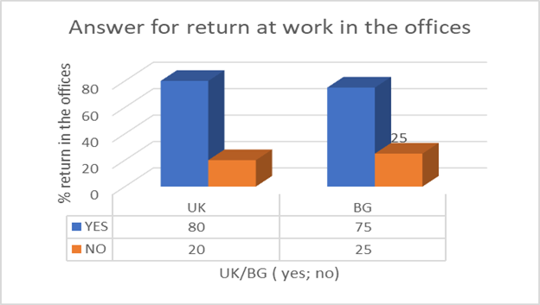

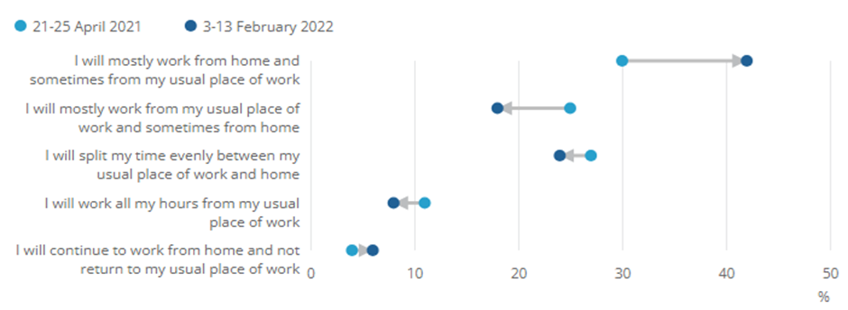
Table 1 : Gant Chart https://www.ons.gov.uk/employmentandlabourmarket/peopleinwork/employmentandemployeetypes/articles/ishybridworkingheretostay/2022-05-23 23 May 2022 Data and analysis from Census 2021 Source: Office for National Statistics – Opinions and Lifestyle Survey

Research Questions Results:
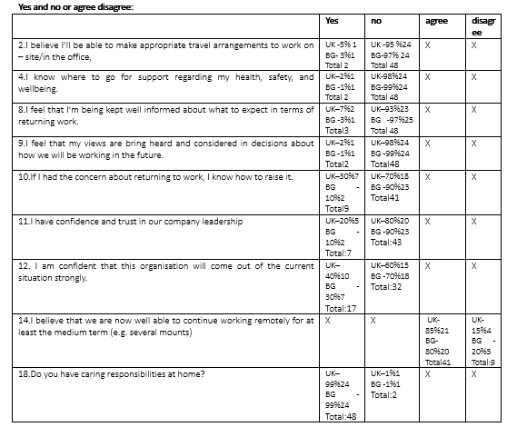
As a result of the following questions in our survey, we can draw the following conclusions. (Appendix Table 3, 4: Interview questions transcripts)
1.What are the main barriers that you see in returning to work?
UK – risk of infection with covid 19 – 85 % or 21 peoples; loose time for traveling – 5 % or 1 people; needs for time about their child (childcare, appointments, take them from school) – 10 % or 2 peoples.
Bulgaria – risk of infection with covid 19 – 95% or 24 peoples; needs for time about their child (childcare, appointments, take them from school) – 5 % or 1 people total 100 % 25 peoples.
Total UK and Bulgaria: 50 people’s risk of infection with covid 19 – 45 peoples 95 %; loose time for traveling: 15 % 3 people need for time about their child (childcare, appointments, take them from school) 15 % 3 peoples.
Risk of infection – most of the peoples 45 peoples choose this answer like basic mean to prefer work from home, then work in the offices: UK 21 peoples BG 24 people. In Bulgaria more peoples prefer online work.
2.I would prefer to continue working from home for longer, rather than return to on – site working/working in the office.
UK – I would prefer to continue working from home – 90 % or 23 people working in the office
Bulgaria - I would prefer to continue working from home – 95 % or 24 people Total UK and Bulgaria: I would prefer to continue working from home -47 peoples or 48 %
Most of the participants prefer to continue to work from home.
3. Ideally, how many days a week would you like to work in the office/ on-site?
UK: 1 - 90 % or 23 peoples
Bulgaria: 1 – 90 % 23 peoples
Total: 90 % 46 peoples
Most of the participants prefer to work only one day per week from the offices.

4. Have you been equally as productive, less productive, or more productive while working from home?
UK: Productive 75% or 19 peoples
BG: Productive 70% or 18 peoples
Total between 70 -75 % think they are productive while working at home.
5. I believe I’ll be able to make appropriate travel arrangements to work on – site/in the office,
UK -95 %24 No BG-97% 24 No
Total 48 peoples 98 % a high percentage believe that it is risky to travel in transport
6. If I had the concern about returning to work, I know how to raise it.
No: UK–70%18 BG -90%23
Total41 Most of them are worried about talking to their manager about concerns about returning to work.
7. I have confidence and trust in our company leadership
UK–80%20 BG -90%23
Total:43 Most of them don’t trust in our company leadership
8. Do you have caring responsibilities at home?
UK–99%24 BG -99%24
Total:48 High percent have caring responsibilities for work at home.
9. If you have been working from home, would you prefer to continue doing so?
Yes: UK-90%22 BG-85%20
Total: 42 High percent prefer to continue to work at home
10. Are you looking forward to returning to work
No: UK-80%20 BG-75%18
Total: 38 peoples. Most of participants don’t look forward to return to work.
11. Are you able to be flexible in your start, break, and finish times to account for social distancing and limiting the number of employees on-site at a single time?
UK-65%16 BG-35%8
Total:24 Most of the peoples from BG and UK are able to be flexible in their start, break, and finish times to account for social distancing and limiting the number of employees on-site at a single time
15. Do you have concerns about commuting to work?
Yes: UK-85%21 BG-40%10
Total:31 In UK most of participants have some concerns about commuting to work, in BG this percent is lowest.
16. How comfortable do you feel coming back into the office?
Somewhat confident, not sure if it’s the right thing to do. 85 % 21 BG 75% 18 Total: 39 peoples
Highest percent of participants are not sure it’s right things to coming back into the office.
17. What are your major concerns about returning to the office?
Catching Covid-19 while commuting UK20 % 5 BG 75% 18 Total:23 peoples
Arranging for childcare UK 75 % 18 BG 20% 3 Total: 21 peoples
Like whole most of participants answers are about Catching Covid 19 and Arranging for Childcare.
18. Do you have all the equipment and support to work from home?
Yes, I have everything I need. UK 98 % 20 BG 5% 1 Total: 21 peoples
Most of the participants have everything about equipment and support to work from home.
19. How many days a week would you like to come to the office?
High percent answer 1 day. About 98 %

Chapter 5: Conclusion, Limitation and Recommendations
In conclusion, based on the current research, it is evident that the cultural disparities between the two nations significantly influence their cognitive processes and work methodologies. Occasionally, we are compelled to optimise our circumstances or reach a compromise in order to ensure that everything aligns in our advantage. We should prioritize actively seeking and attentively considering the perspectives of our employees. They possess the ability to inform us of the correct option. Which modifications result in a favourable consequence, and which ones do not? The survey findings precisely demonstrate this. Typically, individuals in office settings are seeking greater flexibility. They are seeking a harmonious equilibrium between their professional and personal lives. Their primary objectives are to attain stability and tranquillity, increase adaptability, and reduce administrative red tape.
The focus of our research is to the emerging patterns in futuristic work environments. We examined the operational procedures in the office environments of two nations, namely the United Kingdom and Bulgaria, employing various methodologies. By tracing the trajectory from recruitment to adaptation during the COVID-19 pandemic, we have discerned disparities in the operational procedures of the two locations. Furthermore, we have examined the repercussions and modifications that have been implemented as a result. By delineating these distinctions between the two nations, we get the upper hand in extracting the finest practices in terms of productivity and designing appealing, contemporary workspaces that match the demands of modern society.
The pandemic has precipitated several alterations in the realm of office employment. It introduced greater adaptability in the manner of functioning and the equilibrium between job and personal life. In this context, an online or hybrid mode of operation necessitates a more mechanized approach and the utilization of technology. Team meetings, virtual communication, and digital document submission have become integral to the operational practices of several firms. Some individuals are still in the process of adjusting to the emerging patterns of the future. New trends are determined by events, our everyday lives, and our wants. They provide us with instructions on how to perform tasks. They enable us to contemplate strategies for adaptability and staying abreast of the latest developments. They enable us to progress and advance. The objective of our research is to comprehend the efficacy of office job through contemporary modifications. By doing research, we may ascertain the effectiveness of certain methods, identify areas that require modification, and determine whether reverting to the previous model is necessary.
Based on our comprehensive study and survey of both managers and employees, we have observed a clear shift towards the adoption of flexible working hours. This trend is primarily driven by the strong dedication and commitment exhibited by individuals. Telecommuting using a computer, with the ability to have flexible working hours. Enhanced capacity to decrease the duration of transportation. An increasing number of employees are drawn to the concept of working in serene and isolated environments that facilitate focused engagement with their daily responsibilities. Hence, I propose establishing workplaces in more isolated locations, implementing greater flexibility in working schedules, and enabling the option of working both on-site and remotely, if feasible. Increased mobility provides individuals with a greater range of options to effectively address their daily activities. The ultimate objective is to maximise the advantages of the collaborative approach between the two parties and provide a highly desirable and appealing work environment. The trajectory of our future entails more reliance on technology and mobility.
Suggestions might be provided for more research on the subject of pay projections, governmental taxation, and legal regulations pertaining to health and safety in hybrid employment agreements. A broader scope of research might encompass multinational corporations using expatriate staff and examine the impact on payroll taxation, contractual working hours, and organisational culture. Our research was constrained by the limited availability of in-house surveys from foreign organisations, employee data, and compliance with GDPR restrictions, which prevented us from obtaining a broader scope of information.

Reference list:

1. Alic. L 08.02.2021 Bulgarian industrial association: https://en.bia-bg.com/news/view/28301/ 21/08/2023 3.30 pm. Date: 08.02.2021 Source: BNR Bulgarian National Radio
(Lossen and Alic, 2021)
2. Bertolini, A. (2020) Temporary Agency Workers in Italy and the UK. [edition unavailable]. Springer International Publishing. Available at: https://www.perlego.com/book/3481160/temporary-agency-workers-in-italy-and-the-uk-the-comparative-experience-of-labour-market-disadvantage-pdf (Accessed: 17 August 2023).
(Bertolini, 2020)
3. Booth, A. (2017) Managing the Modern Workplace. 1st edn. Taylor and Francis. Available at: https://www.perlego.com/book/1487616/managing-the-modern-workplace-productivity-politics-and-workplace-culture-in-postwar-britain-pdf (Accessed: 12 August 2023).
(Booth, 2017)
4. Dinev, V. (2016) Business strategy for the launch of a British bar in Bulgaria. 1st edn. LAP LAMBERT Academic Publishing. Available at: https://www.perlego.com/book/3394976/business-strategy-for-the-launch-of-a-british-bar-in-bulgaria-pdf (Accessed: 19 August 2023).
(Dinev, 2016)
1. Dr. Nikolay Nikolov6/03/ 2023https://apolitical.co/solution-articles/en/report-summary-a-national-survey-on-the-attitudes-of-bulgarian-civil-servants?fbclid=IwAR3_6lZI2HHdo26Fdp3FKG6wy7qAMrR0zixETwwU9Y84kJQLskyjmVwE2VA
08/08/2023 10:25 am.
5. Economidou, M. (2016) Learning Skills for Work: Internships UK/Cancer Research UK. 1st edn. LAP LAMBERT Academic Publishing. Available at: https://www.perlego.com/book/3390485/learning-skills-for-work-internships-ukcancer-research-uk-pdf (Accessed: 17 August 2023).
(Economidou, 2016)
6. Seldon, A. (2021) The Impossible Office? [edition unavailable]. Cambridge University Press. Available at: https://www.perlego.com/book/2957629/the-impossible-office-the-history-of-the-british-prime-minister-pdf (Accessed: 19 August 2023).
(Seldon, 2021)
7. Holman, D; D. Wall, T; W.Clegg C; Sparrow, P; Howard, A; Holman, D (2005) The Essentials of the New Workplace, A Guide to the Human Impact of Modern Working Practices;Wiley; 1-st ed.
8. Hopkins, B. (2016) Cultural Differences and Improving Performance. 1st edn. Taylor and Francis. Available at: https://www.perlego.com/book/1569537/cultural-differences-and-improving-performance-how-values-and-beliefs-influence-organizational-performance-pdf (Accessed: 12 August 2023).
(Hopkins, 2016)
9. Lidl-CSR-2019-EN-WEB-FIN-131220.pdf (annual report Lidl Bulgaria, 2019)
10. Lossen, B. and Alic, A. R. und J. (2021) The Ultimate Guide To Supercharge The Modern Workplace. [edition unavailable]. tredition. Available at: https://www.perlego.com/book/2575623/the-ultimate-guide-to-supercharge-the-modern-workplace-from-getting-started-to-stepping-up-organization-leaders-must-steer-the-ship-to-enable-their-global-workforce-to-operate-more-efficiently-than-ever-before-pdf (Accessed: 12 August 2023).
11. Lupo (Ed.). (2011). Recent Hurricane Research: Climate, Dynamics, and Societal Impacts. InTech.
12. Roderick, R. (2015) The UK Intellectual Property Office: An exploration of change. 1st edn. Scholars’ Press. Available at: https://www.perlego.com/book/3212144/the-uk-intellectual-property-office-an-exploration-of-change-pdf (Accessed: 17 August 2023).
(Roderick, 2015)
13. Salih, I. I. (2017) Plights of Migrant Domestic Workers in the UK. 1st edn. LAP LAMBERT Academic Publishing. Available at: https://www.perlego.com/book/3414676/plights-of-migrant-domestic-workers-in-the-uk-a-legal-perspective-pdf (Accessed: 17 August 2023).
(Salih, 2017)
14. Janson, S. (2023) Working Efficiently in the Home Office. 3rd edn. Best of HR – Berufebilder.de®. Available at: https://www.perlego.com/book/2746498/working-efficiently-in-the-home-office-organize-stress-free-digital-communication-successful-together-in-a-network-agile-project-management-team-spirit-motivation-psychology-pdf (Accessed: 29 November 2023).
(Janson, 2023)
15. Venning, T. (2005) Compendium of British Office Holders. [edition unavailable]. Palgrave Macmillan UK. Available at: https://www.perlego.com/book/3499504/compendium-of-british-office-holders-pdf (Accessed: 29 November 2023).
(Venning, 2005)
16. Venaik, S., Brewer, P. and Midgley, D. (2023) Management Research, International Business, and National Culture. 1st edn. Taylor and Francis. Available at: https://www.perlego.com/book/4160995/management-research-international-business-and-national-culture-evaluating-hofstede-and-globe-pdf (Accessed: 14 December 2023).
(Venaik, Brewer and Midgley, 2023)
17. Zgheib, & Mull, J. (2015). Business ethics and diversity in the modern workplace. Business Science Reference. https://doi.org/10.4018/978-1-4666-7254-3
18. https://www.businessleader.co.uk/british-employees-work-for-just-three-hours-a-day/
Story by :Oli Ballard February 6, 2019
19. https://www.bbc.co.uk/news/business-62542537
15 August 2022 By Becky Morton Business reporter, BBC News
20. May 10, 2021 Atanas Bangachev and Maria Harizanova https://www.lexology.com/library/detail.aspx?g=72a47f76-204e-4e26-a65f-f3a32f3cc927 21/08/2023 2:10pm
21. https://www.askcody.com/blog/what-is-a-modern-workplace#:~:text=The%20modern%20workplace%20is%20designed,outside%20of%20traditional%20business%20hours. 08/08/2023 2:30 pm
22.https://www.globalexpansion.com/countrypedia/bulgaria?fbclid=IwAR116lcyGf-QPWMnanrH8iFNDa-tj5Du1Z0Ci37IO6MDdIQfjt8p8ssgSwE 08/08/ 2023 10:45 am.
23.Reed 2022 https://www.reedglobal.bg/blog/2022/04/a-four-day-work-week-the-pros-and-cons?fbclid=IwAR0V2691TBiKd7eq4ycf6Byva7OZLFm51olbTLu_G0h2LAq16GUwyHNWZws&source=l.facebook.com 08/08/2023 11:00 am
24.Reed 2022https://www.reedglobal.bg/blog/2022/04/top-questions-to-ask-candidates-on-a-telephone-interview?source=l.facebook.com 08/08/2023 11:15
25.Ricoh https://www.ricoh-europe.com/insights/modern-workplace/?fbclid=IwAR0eDtG8frvJYjhMw5hhDFM29yVuBDR64pkVDz-P40bwYDTXzRtTRoWSQHY 08/08/2023 11:30am
26.Ricoh https://www.ricoh-europe.com/insights/reports-whitepapers/workforce-united/ 12:30 pm
27.https://fortune.com/europe/2023/10/23/britain-return-to-work-hybrid-remote-jobs-covid-19/
28.Sep 26, 2012 https://www.ft.com/content/e8c6ff48-8a1d-3e13-b820-25ceb0c6c68d 21/08/2023 3:20 pm.
Time prospects of the research (Gantt chart)
https://www.template.net/business/proposal-templates/gantt-chart-research-proposal/
29.Eurofound 2012 https://www.eurofound.europa.eu/publications/article/2012/bulgaria-trend-of-improved-working-conditions 21/08/2023 11:40
30.Krassen Nikolov 30/06/2023 https://www.euractiv.com/section/economy-jobs/news/bulgaria-looks-toward-quality-jobs-to-combat-poverty/?fbclid=IwAR31mAyT-fDi9GLIj11qWyqKKn8hlK5sZG5_Q8XMwY2rwfgW5kMGDGOzkko 08/08/2023 10:30 am
31.Ministry of Defence 28/09/2016 https://www.gov.uk/government/news/uk-strengthens-bulgaria-ties-to-tackle-threats--2?fbclid=IwAR2g_HWw2dM_e0 duONoH_6F34GxedDcgxyYltYz1HgbKbIkILbQAUKiU2k 08/08/2023 12:45 pm.
32.https://www.mckinsey.com/mgi/our-research/generative-ai-and-the-future-of-work-in-america?stcr=D2B0E2A3B2674FEDB1394DB1C8BBE552&cid=other-eml-dre-mip-mck&hlkid=96ed504f0d0f4810a0396b8166069fca&hctky=12429928&hdpid=fad47d03-e473-4cd8-be64-5fef42dfb43f 08/08/2023 1:00 pm
33.https://www.mckinsey.com/capabilities/mckinsey-digital/our-insights/the-top-trends-in-tech?stcr=613FE23AE98C418CBE93BE4DBC78149A&cid=other-eml-dre-mip-mck&hlkid=7744f408ab7549f29deb039a6661ddb5&hctky=12429928&hdpid=fad47d03-e473-4cd8-be64-5fef42dfb43f#tech-talent-dynamics 08/08/2023 1:15 pm
34.https://www.mckinsey.com/industries/healthcare/our-insights/setting-the-revenue-cycle-up-for-success-in-automation-and-ai?stcr=74D4FCB90B0D431C8B74A942004E4F18&cid=other-eml-dre-mip-mck&hlkid=3b1181906b524d37967c46d492b01df5&hctky=12429928&hdpid=fad47d03-e473-4cd8-be64-5fef42dfb43f 08/08/2023 1:30 pm
35.Nathan Thomas 25.04.2023 https://www.ricoh-europe.com/insights/blog/how-hr-can-boost-collaboration-with-flexible-work/ 08/08/2023 12:00 am
36.Nathan Thomas 23.02.2023 https://www.ricoh-europe.com/insights/blog/the-future-workplace/ 08/08/2023 12:15 pm
37.https://www.nidirect.gov.uk/articles/working-time-limits-48-hour-week Gov UK
38. https://peopleinsight.co.uk/
39.https://www.parliament.bg/en/const 21/08/2023
40.Ruskov and colleagues lawyers Feb 6, 2022 https://www.bulgaria-labour-law.bg/employment-contract.html 19/08/23 5:50 pm

41.https://www.servicenow.com/lpayr/employee-experience-survey.html?campid=83743&cid=p:hr:dg:nb:prsp:exa:goog_hrsm_restructure:emea:all&s_kwcid=AL!11692!3!591485002217!p!!g!!employee%20surveys&ds_c=GOOG_EMEA_All_EN_DEMANDGEN_HRSM_PRSP_NonBrand_PHR_Topres&cmcid=71700000091582993&ds_ag=Employee+Survey_PHR&cmpid=58700007716239861&ds_kids=p70009800228&gclid=Cj0KCQiAuqKqBhDxARIsAFZELmIOgBb6e5AAANA2yPbrxEQPI24BUjlyye-eAS1v26w8klNn9HrCT9oaAheOEALw_wcB&gclsrc=aw.ds
(Analyst Report, 2021)
42. https://www.simpli.com/lifestyle/uncover-key-insights-top-employee-culture-survey-questions-ask?utm_content=params%3Aad%3DdirN%26qo%3DserpIndex%26o%3D740008%26ag%3Dfw&ueid=D7ECEB27-790B-48A2-BA6F-17DAC09DB74E
By Staff Writer Last Updated August 24, 2023
(Staff Writer; 2023)
2https://www.reference.com/business-finance/office-work-important-7cb6c3c3917f8049?utm_content=params%3Aad%3DdirN%26qo%3DserpIndex%26o%3D740005%26ag%3Dfw&ueid=D7ECEB27-790B-48A2-BA6F-17DAC09DB74E
By Staff Writer Last Updated March 25, 2020
(Staff Writer; 2020)
43. https://www.theguardian.com/business/2023/aug/12/never-again-is-britain-finally-ready-to-return-to-the-office

Terms of Glossary

groundbreaking/ˈɡraʊndbreɪkɪŋ/ - innovative
sufficient /səˈfɪʃnt/ - enough;
investigation /ɪnˌvɛstɪˈɡeɪʃn/ - the action of investigating something or someone; formal or systematic examination or research.
Frequently /ˈfriːkw(ə)ntli/ - regularly or habitually; often.
Procrastinate /prə(ʊ)ˈkrastɪneɪt/ - delay or postpone action; put off doing something.
Congested /kənˈdʒɛstɪd/- (of a road or place) so crowded with traffic or people as to hinder or prevent freedom of movement.
Conscientiously /ˌkɒnʃɪˈɛnʃəsli/ - 1) in a thorough and responsible way. 2) in a way that is motivated by one's moral sense of right and wrong.
Encouragement /ɪnˈkʌrɪdʒm(ə)nt,ɛnˈkʌrɪdʒm(ə)nt/ - the action of giving someone support, confidence, or hope.
Hence /hɛns/ - as a consequence; for this reason.
Meaningful /ˈmiːnɪŋf(ʊ)l/ - having meaning
Exorbitant /ɪɡˈzɔːbɪt(ə)nt,ɛɡˈzɔːbɪt(ə)nt/ - of a price or amount charged) unreasonably high.
Onward /ˈɒnwəd/ - in a continuing forward direction; ahead.

Appendix:

Table 1: Interviewed participants’ scope
Place | Male % | Male No | Female% | Female No | Ages: 30 - 45 | Ages: 3045 No
UK (United Kingdom) | 45 | 11 | 55 | 14 | 100% | 25
Bulgaria | 35 | 9 | 65 | 16 | 100% | 25
Total |  | 20 |  | 30 | 100% | 50

Table 2: Interviewed participants’ list
Name | Male/Female | Ages | Country | Date | Position
Mark | Male | 37 | UK | 15/08/23 | Office Manager
Angela | Female | 39 | UK | 15/08/23 | Account Manager
Wiliam | Male | 48 | UK | 15/08/23 | Sales executive
Kate | Female | 36 | UK | 15/08/23 | Payroll Manager
Rihana | Female | 37 | UK | 15/08/23 | accountant
Jorgina | Female | 32 | UK | 15/08/23 | Office assistant
Dayana | Female | 44 | UK | 15/08/23 | HR Specialist
Adrian | Male | 30 | UK | 15/08/23 | Accountant
George | Male | 41 | UK | 15/08/23 | Sales executive
Caroline | Female | 38 | UK | 15/08/23 | Office administrator
Kevin | Male | 32 | UK | 15/08/23 | IT
Daniel | Male | 47 | UK | 15/08/23 | Accountant
Damyan | Male | 43 | UK | 15/08/23 | Marketing
Jennifer | Female | 36 | UK | 15/08/23 | Sales
Mary | Female | 32 | UK | 15/08/23 | Sales
Kany | Male | 39 | UK | 15/08/23 | Marketing
Jeremy | Male | 31 | UK | 15/08/23 | Accountant
Kasia | Female | 42 | UK | 15/08/23 | HR specialist
Piper | Female | 48 | UK | 15/08/23 | Office manager
Robert | Male | 45 | UK | 15/08/23 | Office administrator
Jakson | Male | 37 | UK | 15/08/23 | IT
Bryan | Male | 34 | UK | 15/08/23 | assistant
Lisa | Female | 43 | UK | 15/08/23 | reception
Jemma | Female | 52 | UK | 15/08/23 | sales
Lyla | Female | 46 | UK | 15/08/23 | HR
Ivan | Male | 41 | BG | 30/09/23 | IT
Ivelina | Female | 45 | BG | 30/09/23 | Marketing
Kristina | Female | 36 | BG | 30/09/23 | Office Manager
Damyan | Male | 39 | BG | 30/09/23 | IT
Elena | Female | 41 | BG | 30/09/23 | Reception
Anton | Male | 43 | BG | 30/09/23 | Accountant
Maya | Female | 38 | BG | 30/09/23 | Office Administrator
Teodora | Female | 34 | BG | 30/09/23 | Sales
Kalin | Male | 56 | BG | 30/09/23 | Accountant
Desislava | Female | 47 | BG | 30/09/23 | IT
Reneta | Female | 42 | BG | 30/09/23 | Payroll manager
Raya | Female | 37 | BG | 30/09/23 | Accountant
Milena | Male | 51 | BG | 30/09/23 | Marketing
Martin | Male | 49 | BG | 30/09/23 | Sales
Elitsa | Female | 53 | BG | 30/09/23 | Sales
Kremena | Female | 37 | BG | 30/09/23 | Accountant
Simona | Female | 54 | BG | 30/09/23 | HR
Emilia | Female | 30 | BG | 30/09/23 | Sales
Stanimir | Male | 36 | BG | 30/09/23 | IT
Miroslav | Male | 45 | BG | 30/09/23 | Accountant
Lilyana | Female | 32 | BG | 30/09/23 | Customer service
Kamelia | Female | 38 | BG | 30/09/23 | Office administrator
Kalina | Female | 45 | BG | 30/09/23 | Reception
Silvia | Female | 34 | BG | 30/09/23 | Marketing
Martina | Female | 31 | BG | 30/09/23 | Accountant

https://www.ons.gov.uk/employmentandlabourmarket/peopleinwork/employmentandemployeetypes/articles/ishybridworkingheretostay/2022-05-23
23 May 2022 Data and analysis from Census 2021 Source: Office for National Statistics – Opinions and Lifestyle Survey
Table 4: Gant Chart
https://www.ons.gov.uk/employmentandlabourmarket/peopleinwork/employmentandemployeetypes/articles/ishybridworkingheretostay/2022-05-23
Table 2:
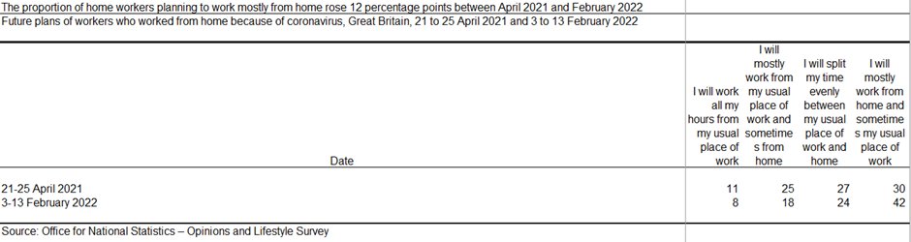
https://www.ons.gov.uk/employmentandlabourmarket/peopleinwork/employmentandemployeetypes/articles/ishybridworkingheretostay/2022-05-23
23 May 2022 Data and analysis from Census 2021 Source: Office for National Statistics – Opinions and Lifestyle Survey
Picture 1:
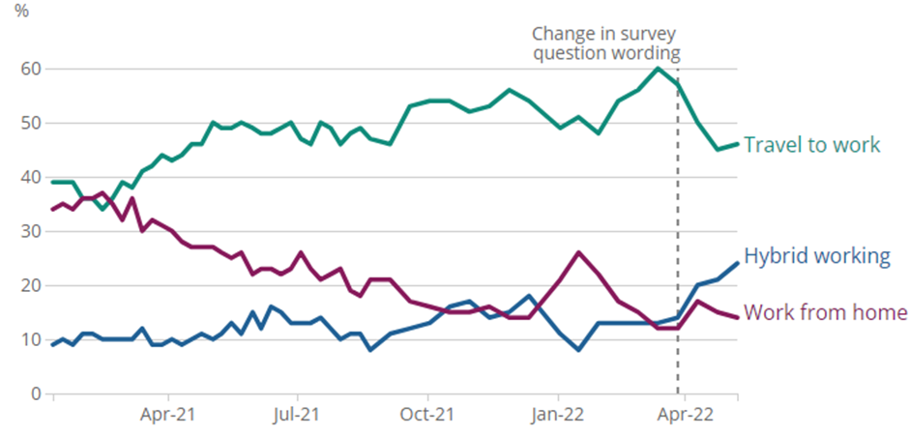
https://www.ons.gov.uk/employmentandlabourmarket/peopleinwork/employmentandemployeetypes/articles/ishybridworkingheretostay/2022-05-23
23 May 2022 Data and analysis from Census 2021 Source: Office for National Statistics – Opinions and Lifestyle Survey
Picture 2:
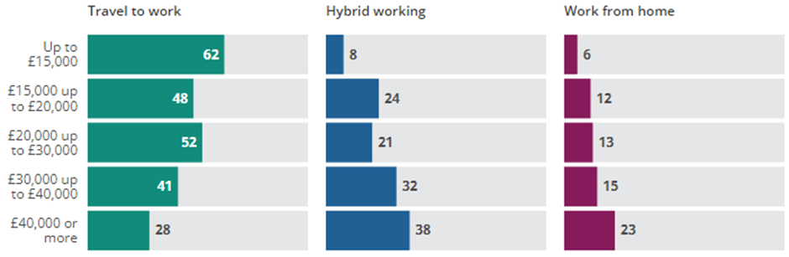
Picture 3:
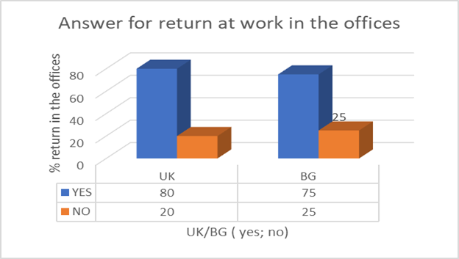
Picture 4:
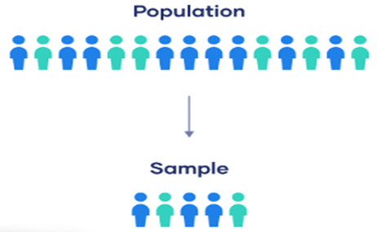

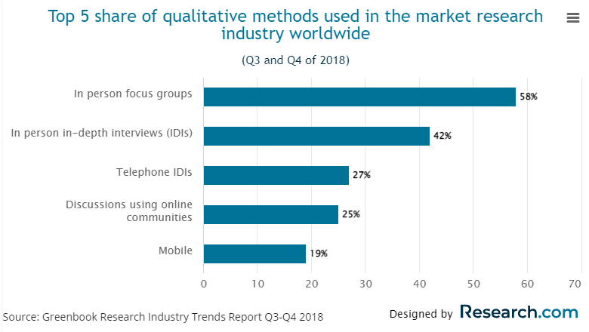
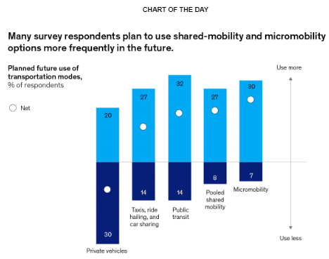
Page 18:

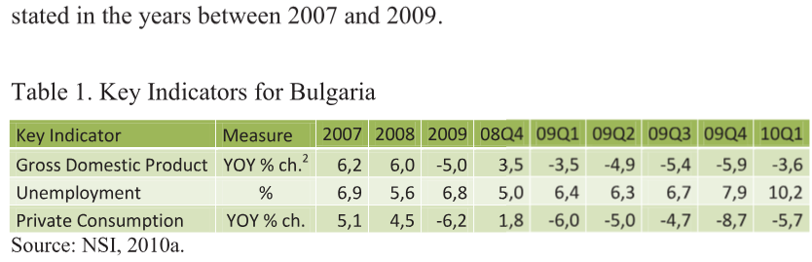
Page 15:
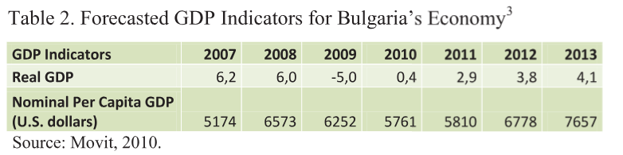
Source (google maps, 2010)
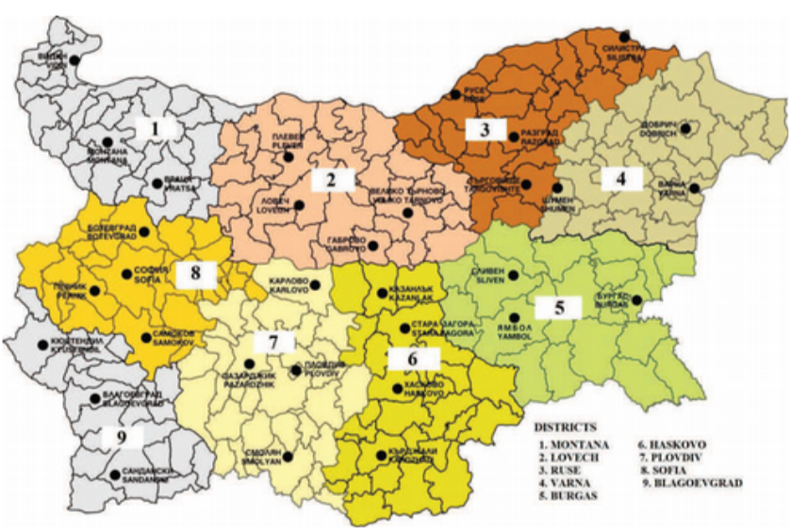

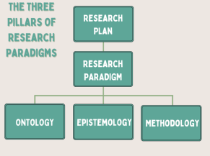

Dissertations with deductive approach follow the following path:

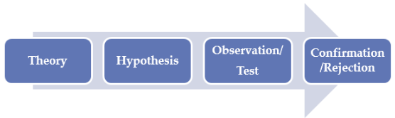
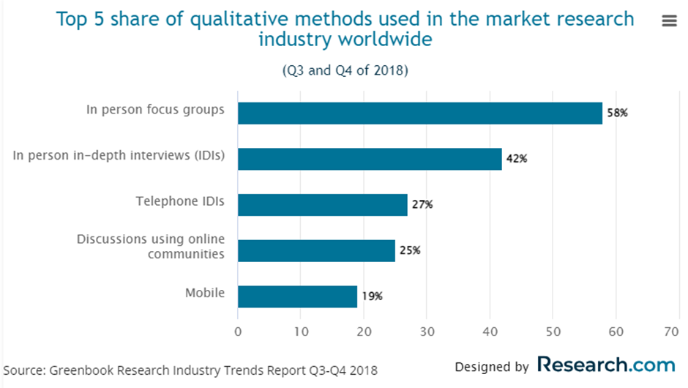
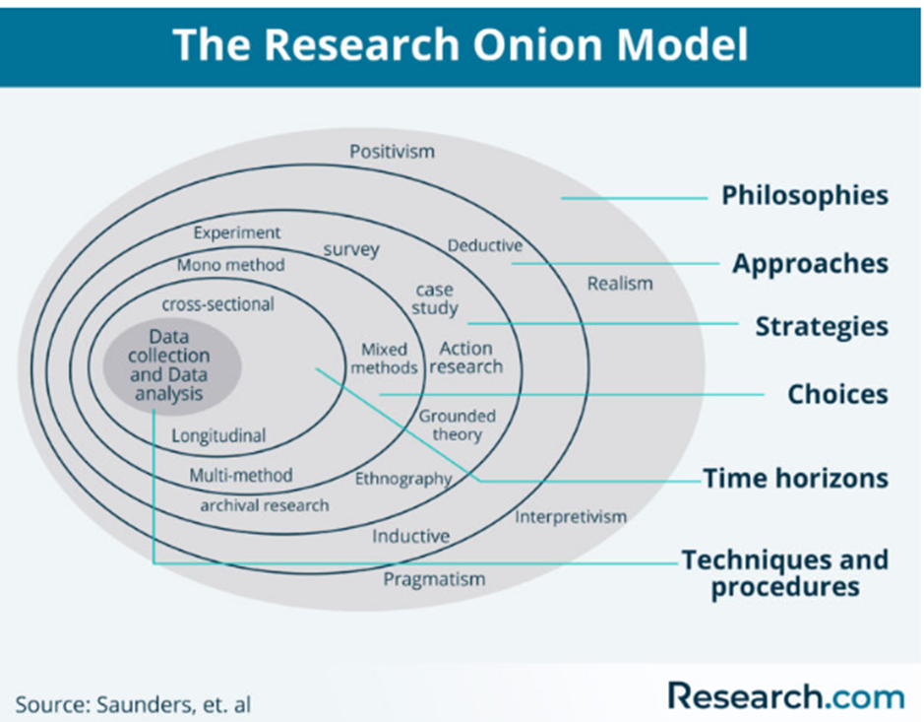
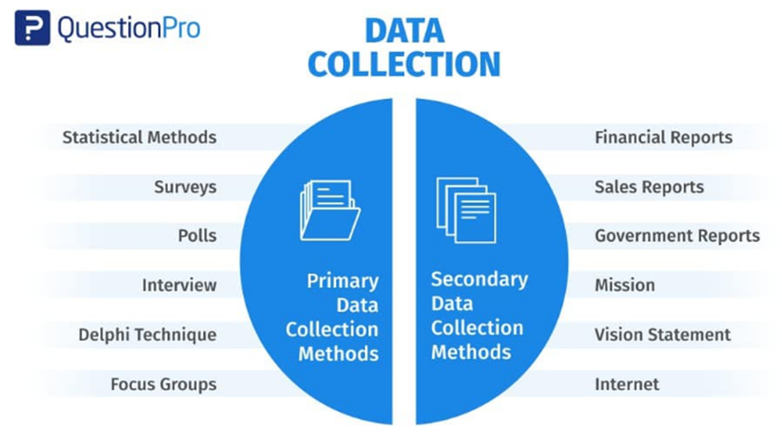
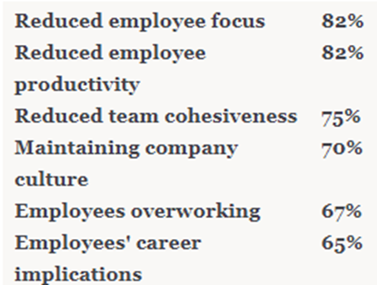

Table 3: Interview questions transcripts

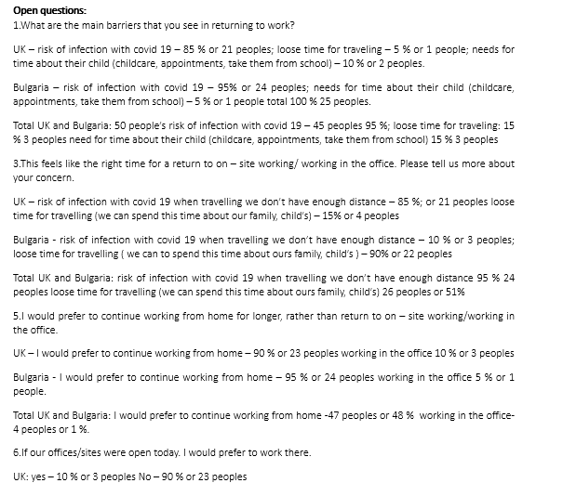
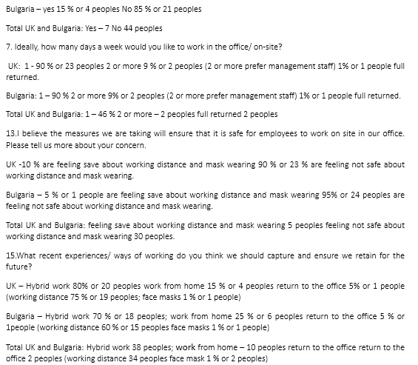
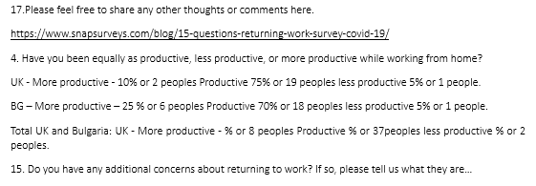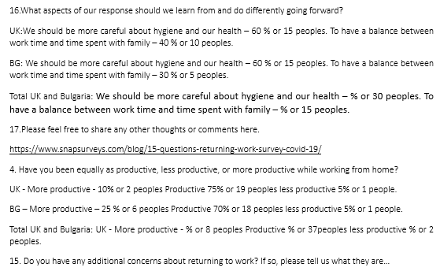
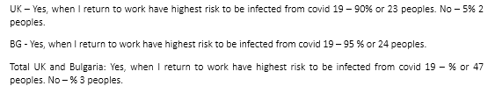
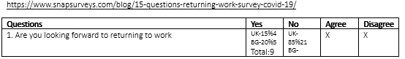
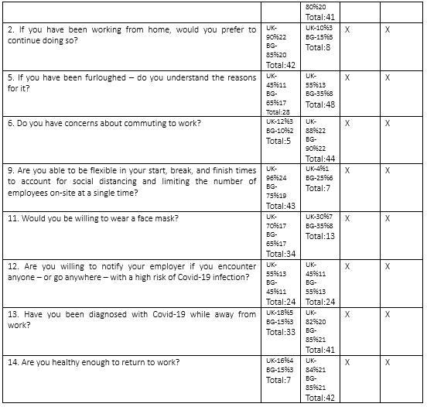
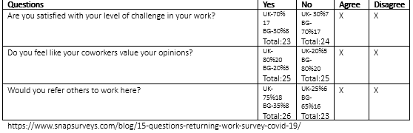
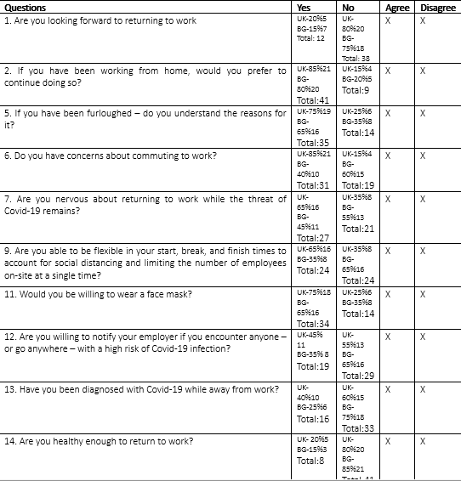
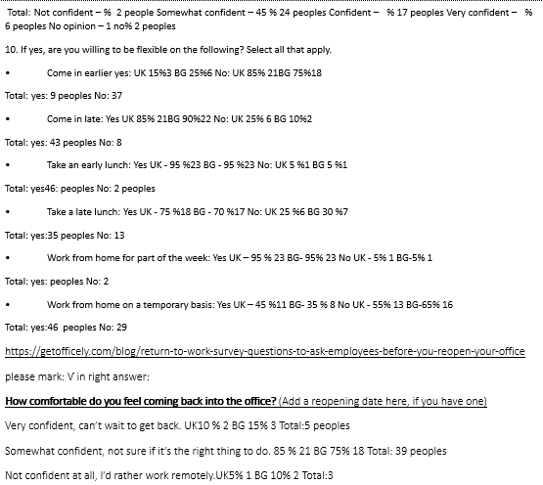
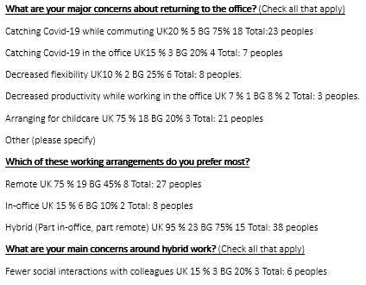
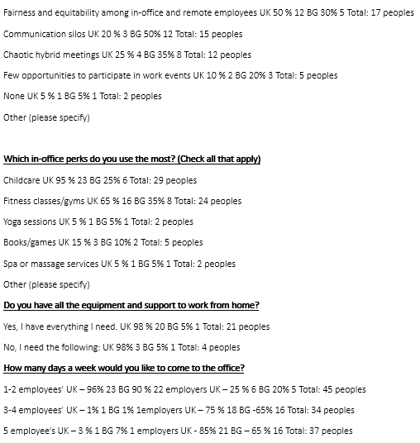
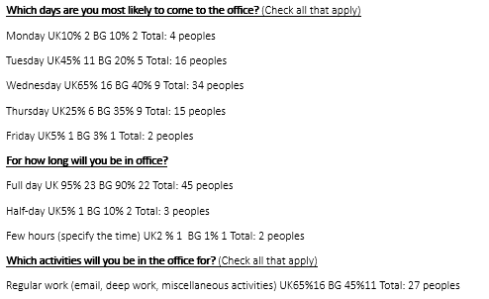
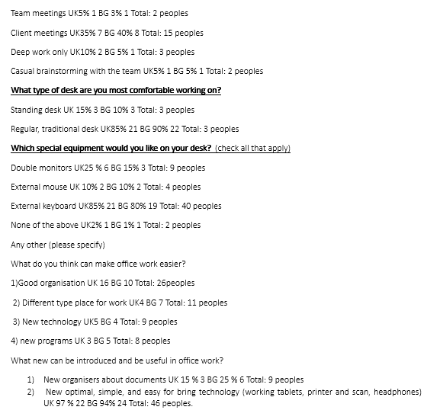
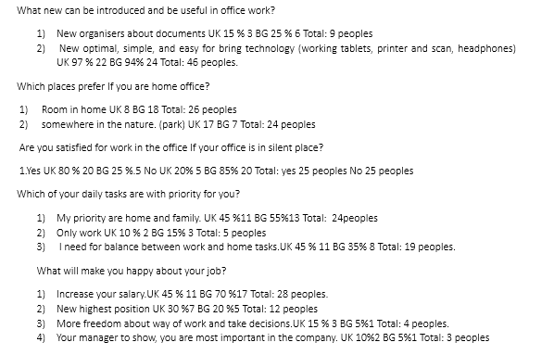

Table 4: Interview questions detailed transcripts.
1
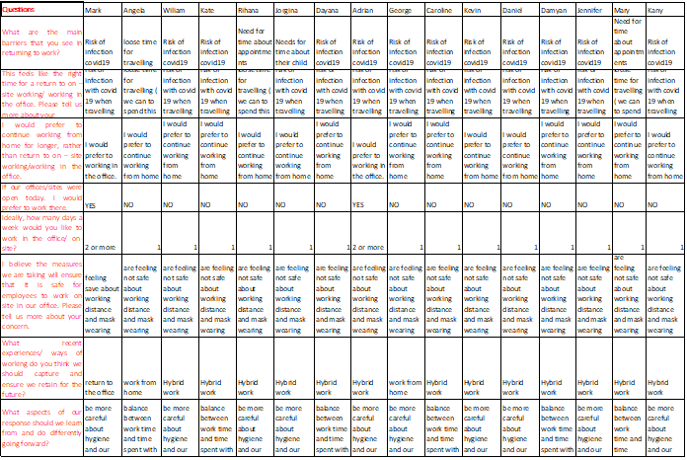
2

3
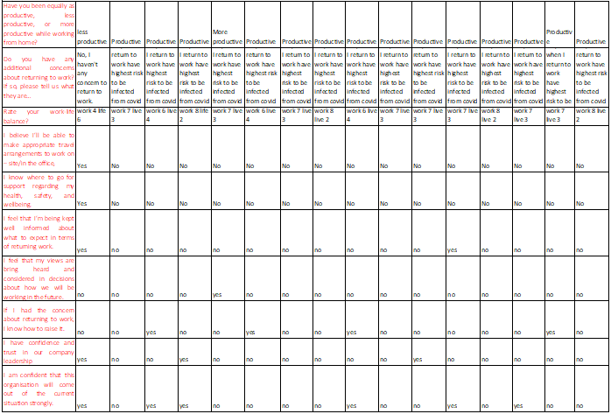
4
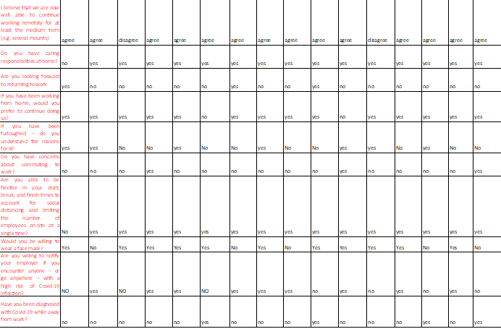

5
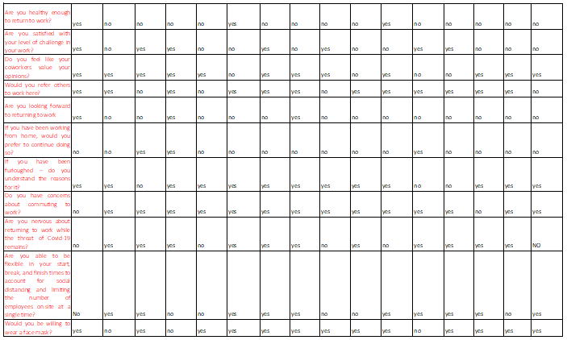
6
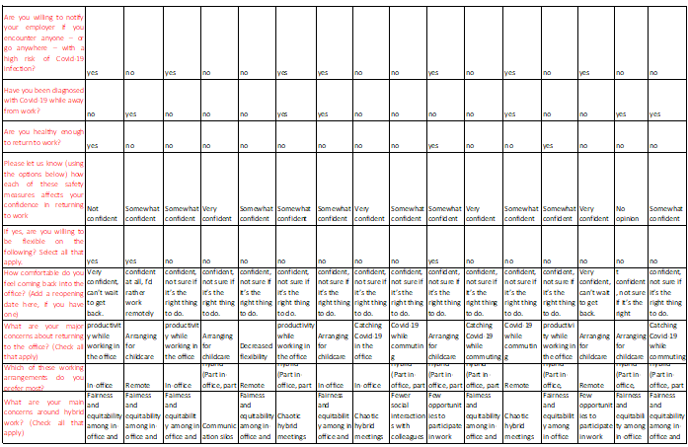

7
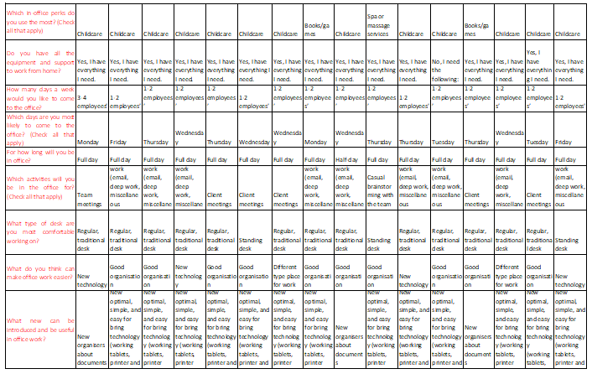
8
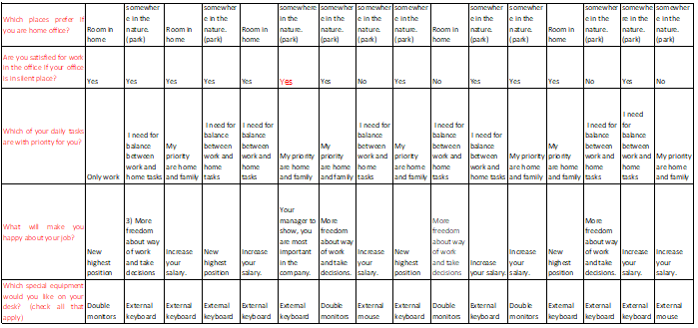

9
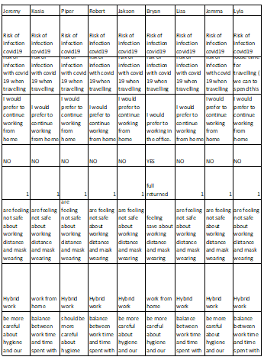

10.
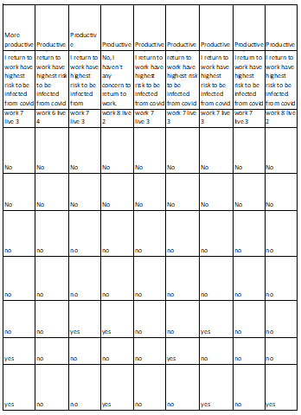
11
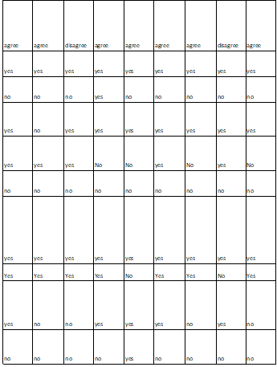
12

13
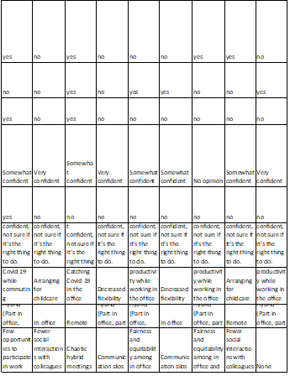
14
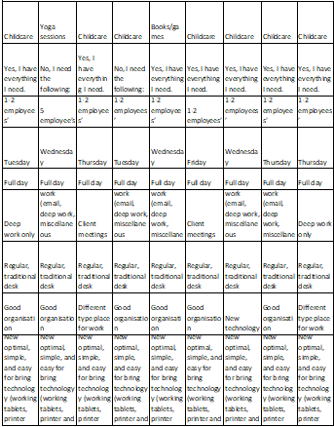
15
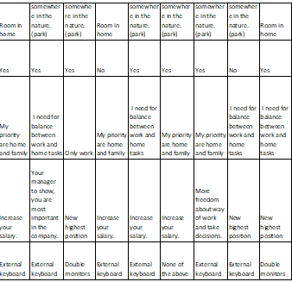

1 bg
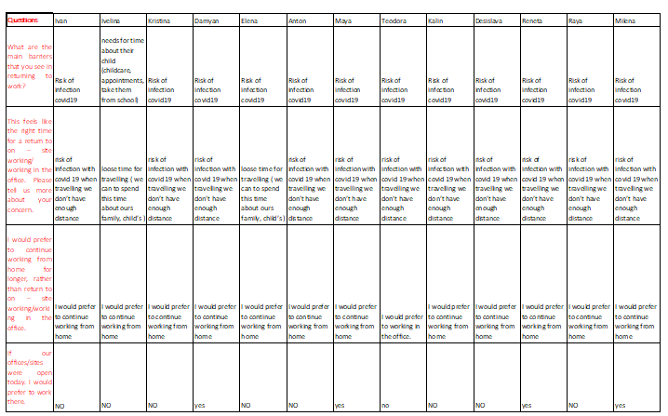
2bg
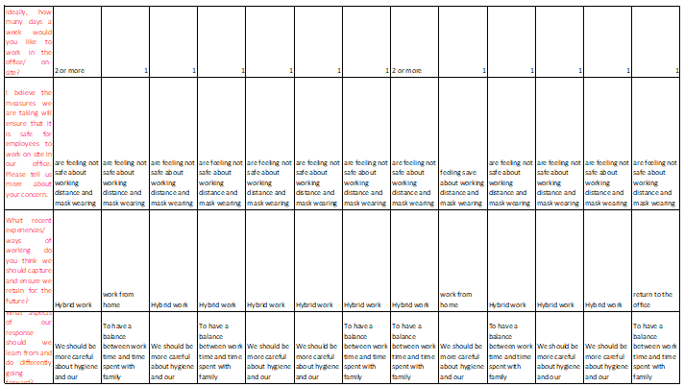
3bg
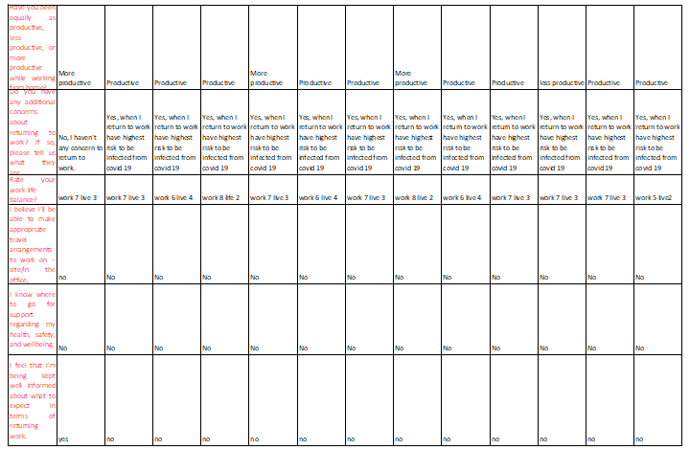
4bg
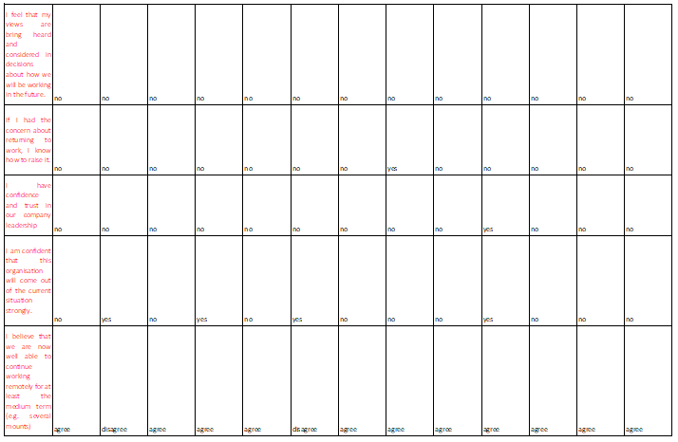
5bg
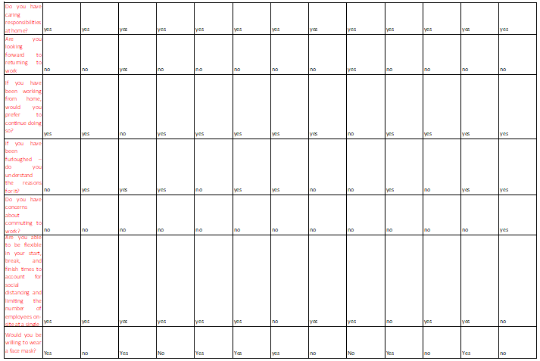
6bg
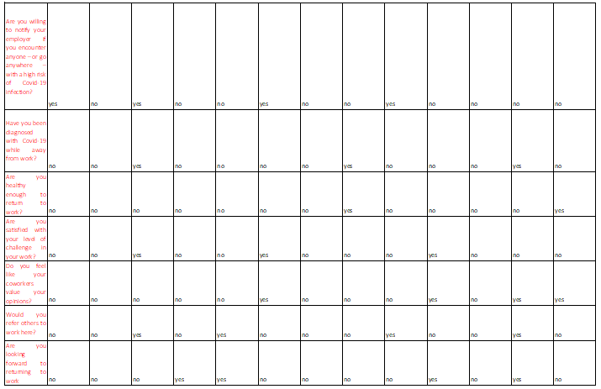
7bg
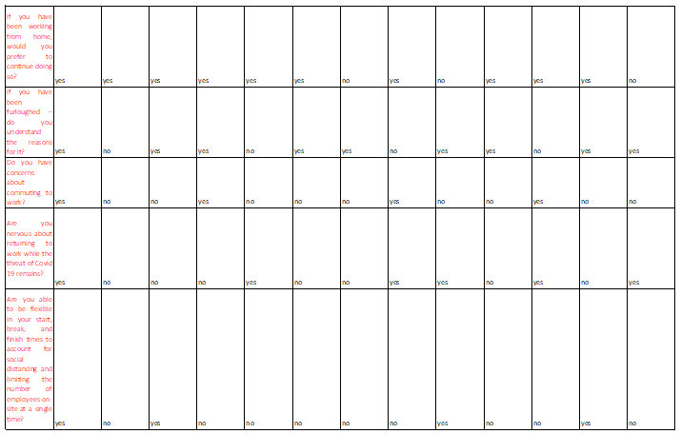
8bg
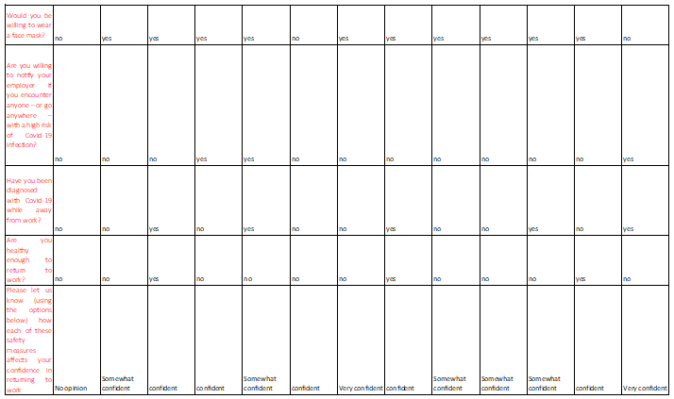
9 bg
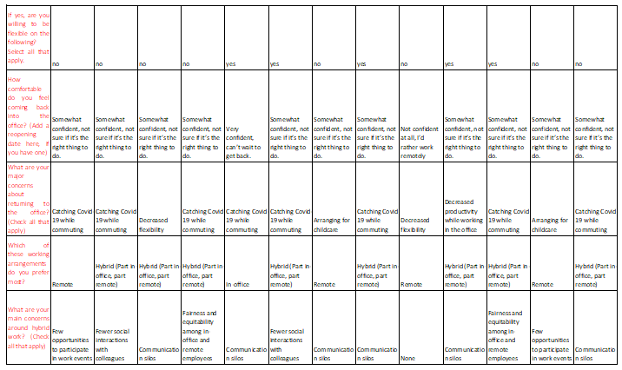
10bg
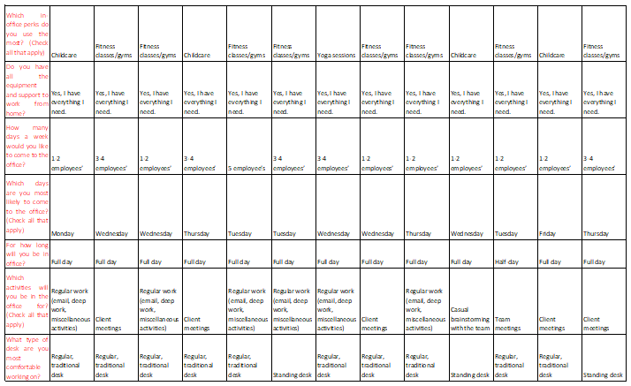
11 bg
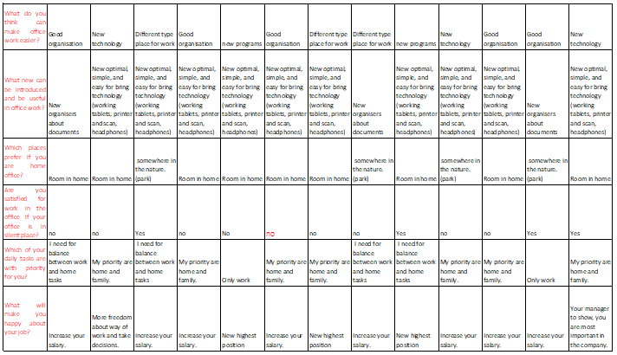
12 bg
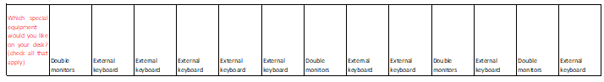
13bg
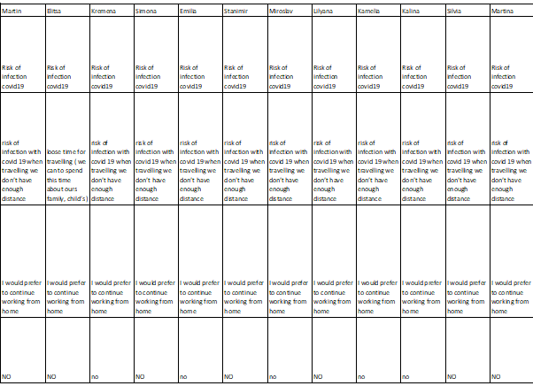
14 bg
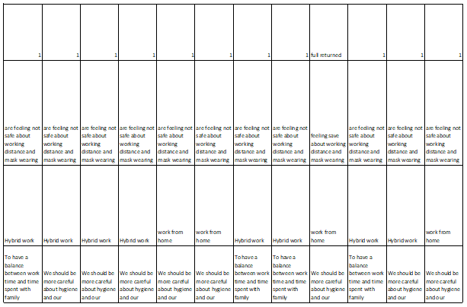
15 bg
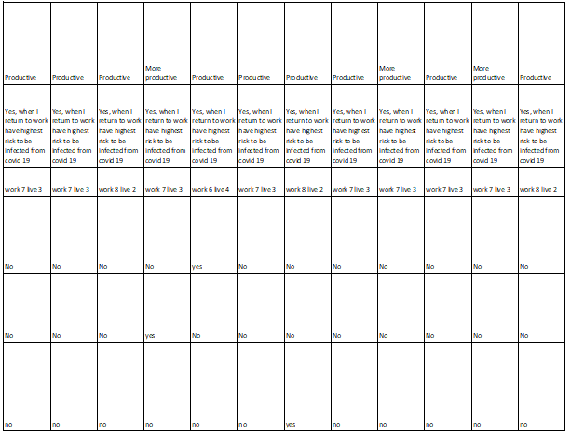
16 bg

17bg

18bg

19bg

20bg

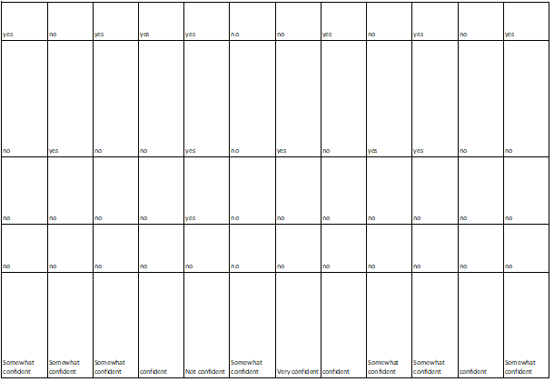
21 bg
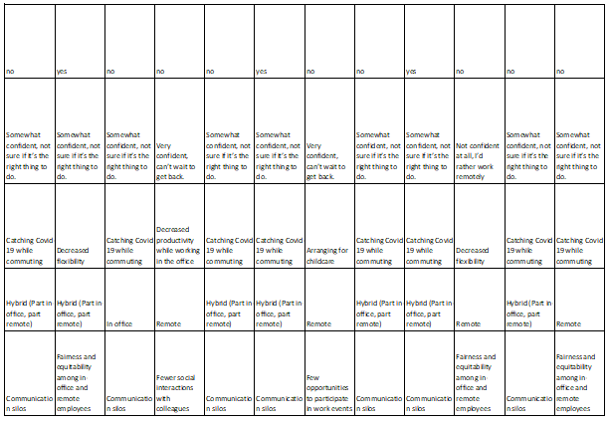
22 bg
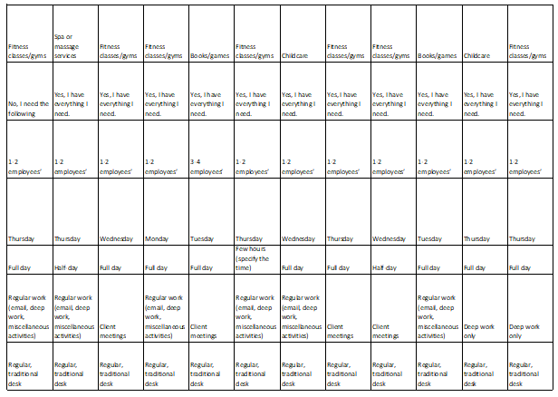
23 bg
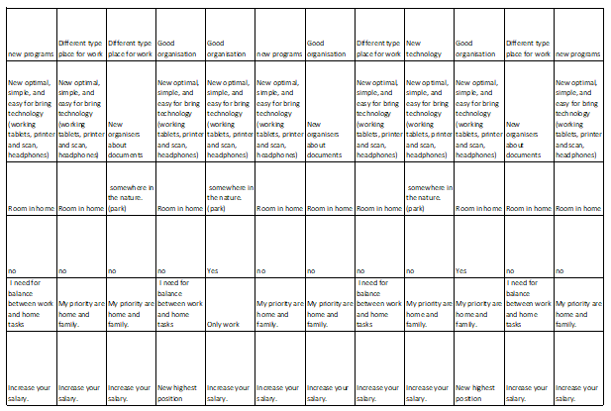
24 bg
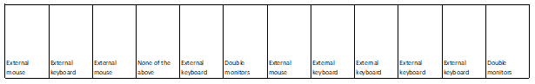


Declaration and Consent forms

Participation Consent Form
University of Wales Trinity Saint David (London Campus)
Winchester House
11 Cranmer Road
London – SW9 6EJ
Tel: +442075667600
Email: info.london@uwtsd.ac.uk
londonstudentservice@uwtsd.ac.uk



Rhif Adnabod Cyfranogwr:
Participant Identification Number:
FFURFLEN GANIATÂD CYFRANOGIAD | PARTICIPATION CONSENT FORM
Teitl Y Prosiect: / Project Title:
Enw'r Ymchwilydd / Name of Researcher: Galina Gancheva

1 | I confirm that I have read and understand the information sheet dated Moodle for the above study. I have had the opportunity to consider the information, ask questions and have had these answered satisfactorily. |  |  | Yes
2 | I understand that my participation is voluntary and that I am free to withdraw at any time, without giving any reason. |  |  | Yes
3 | I understand that any information given by me may be used in future reports, articles or presentations by the research team. |  |  | Yes
4 | I understand that my name will not appear in any reports, articles or presentations. |  |  | Yes
5 | I agree to take part in the above study. |  |  | Yes
Name of Participant |  | Galina Gancheva | Signature
Researcher |  | Galina Gancheva | Signature

You may decline to participate in this study. You may end your participation in this study at any time. If you decide to remain anonymous, maintaining your anonymity will be a priority and every practical precaution will be taken to disguise your identity. If you prefer anonymity, there will not be any identifying information on audiotapes or transcripts of this or any interview. No one will hear any audiotapes or see any transcripts without your prior consent. All materials generated from this or any interview will remain confidential.
When completed please return in the envelope provided. One copy will be given to you and the original to be kept on the file of the research team at:

NAME & ADDRESS OF RESEARCHER

University of Wales Trinity Saint David (London Campus)
Winchester House
11 Cranmer Road
London – SW9 6EJ
Tel: +442075667600
Email: info.london@uwtsd.ac.uk
: londonstudentservice@uwtsd.ac.uk



