

Assessment 1 – Reading and Notes
PART 1: Photo of Mind Map:
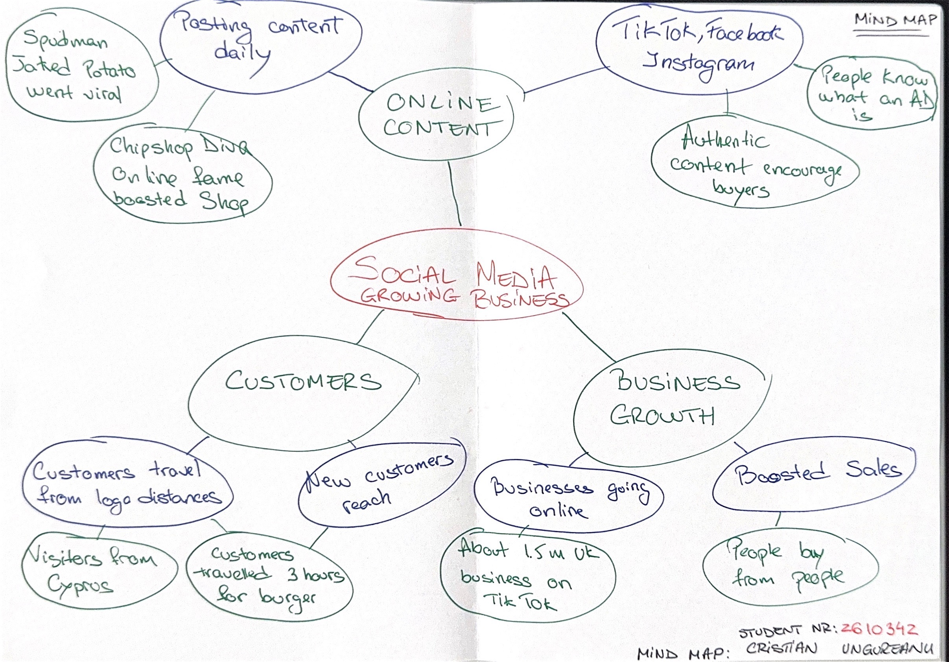

- What is the main idea of the whole text?
The main idea of the text is that social media can significantly boost a business. It also allows companies to expand into international markets.

- What is one key point that supports the main idea, and which specific example from the text shows this?
A key point supporting this idea is social media content. For example, seeing an advertisement for a unique item like a special burger, can persuade customers to drive for hours just to try it.

- What is a different key point that supports the main idea, and which specific example from the text shows this?
Another key point supporting the main idea is how business can transition from traditional physical stores to online platforms. A clear example is Linda Hunter, who moved her business online after 46 years of a traditional shop owner.

- Which part of the text do you think is most important, and why?
The most important part from the text is the phrase ‘People buy from people.’ This shows that customers prefer authentic products. For example, using AI to create a perfect advertisement can sometimes make people doubt the product’s reality.

Reflection:
- What did you find difficult in this task (including in-class components), and why was it difficult?
I found creating a mind map challenging because the source material includes multiple business case studies and a significant amount of detailed data.

- What helped you with this difficulty, and how did it help you?
However, structuring the main idea alongside key details, evidence, and examples helped me gain a clearer understanding of the text.

