3/24/2025
University of Wales Trinity Saint David
London campus
LDE Assignment 1
E-Portfolio: https://dolapothegoat17.wixsite.com/my-site-3
Module Name: Learning In the Digital Era
Module Code: ACCA 4025

Student Name: Dolapo Owolabi
Student ID: 2518096
Group: 2

Lecturer’s Name: Koushik Modak

Table of Contents
Introduction 2
Main Body 2
Task 1: Essential Academic and Employment Skills for the future career Path 2
Task 1 (a): Report on Essential Academic and Employment Skills 2
Task 1 (b): Similarity Report analysis 2
Task 2: 3
B) Poster link: 3
Task 3 : Virtual Collaboration and RefWorks: 3
Report on Virtual Collaboration 3
Task 4 3
Conclusion 3
References 3
Task 1 References: 3
Task 3 References: 3

Introduction
My name is Dolapo Farouk Owolabi, my student ID is 2518096. This assessment aims to explore the impact of computing on education in the digital learning era, focusing on key concepts such as the rise of online learning platforms, the role of artificial intelligence, and the evolving skills required for the modern workforce. By examining both the positive outcomes and the potential challenges associated with digital learning, this work will provide insight into the future of computing in education and its implications for learners, educators, and institutions.

Main Body

Task 1: Essential Academic and Employment Skills for the future career Path

Task 1 (a): Report on Essential Academic and Employment Skills
This report, I learned that to succeed it is essential to have good academic and employment skills, especially in technical fields such as computer programmer or game developer, individuals must develop a range of essential skills. One of the essential employment skills is problem solving skills because they allow future programmers to debug code efficiently and need able to develop logic solutions in the software development era [1] . Time management is essentials and important skills because helps individuals to able to work effectively with their peers which is important for technology industry [2]. Teamwork is another useful and essential skill for employment reason why because skill like Teamwork allows you to collaborate with other people effectively to able to achieve shared goals, an expectation in most modern workplaces like for example game developer or computing programmer [3]. . Finally, the most important skill that is essential for employment to have been problem solving skill reason for why is important is because it requires individuals to analyses complex situation and able to develop solution for the problem smartly and quick. An important requirement in careers such as game developers or software or development [4]. The basic academic skills are essential for employment skills are as following reading, writing, Science, Math, Communication and listening. For higher order thinking skills that very useful for academic skills are as following Learning, Reasoning, Thinking Creatively, Decisions Making and Problem solving. As result Basic thinking skills help learning and applying knowledge accurately. Higher order thinking skills help analyse, evaluate and create new ideas. [5]

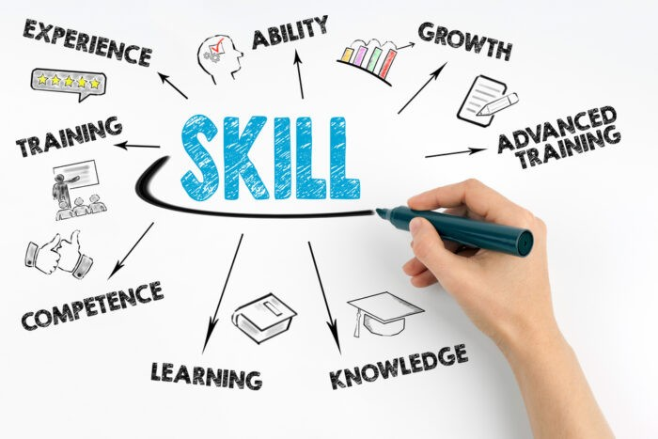 [6]

Task 1 (b): Similarity Report analysis
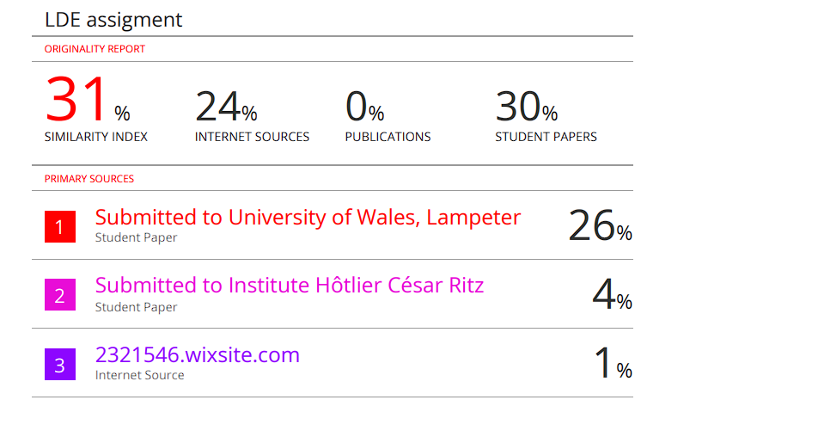
Similarity report analysis score: 31%
The reason why got score of 31% percentage is because I took many direct quotes from sources, not enough paraphrasing could also be copying structure or copying sentence from sources that mostly likely the reason I got 31 similarity index. To improve my similarity score is to be firstly careful when paraphrasing by changing structure, vocabulary and sentence order. Also use IEEE style to show where you got the information from. The similarity I got from my report analysis that although my work was original there several areas matched existing source too closely. To Improve this in my future submissions, I will focus on paraphrasing more effectively by rewriting information my own words by analysing where I get in the information to reduce direct wording from textbooks or online materials. Lastly, I plan my research and writing earlier so I have enough time to check my draft with a similarity check and revise any sections that match other sources by applying these strategies, I aim to produce more independent work with much lower similarity score.

Based on my similarity report analysis assessment criteria, I would award myself around 70%. The reason why give myself 70% is because my work shows I got clear understanding of my topic and includes relevant research to support my arguments, which aligns with the criteria for a good grade. I also showed evidence of analysis and applied key concept appropriately. However, my similarity score is 31% shows that I need to improve my paraphrasing, and I need to show more originality in my parts of my writing, to achieve a higher mark, I would need to reduce reliance on source wording, Deeping my critical evaluation, and strengthen the structure of my argument.

Task 2:

Mind map: https://mm.tt/map/3845110229?t=PGtNGMuiKT
[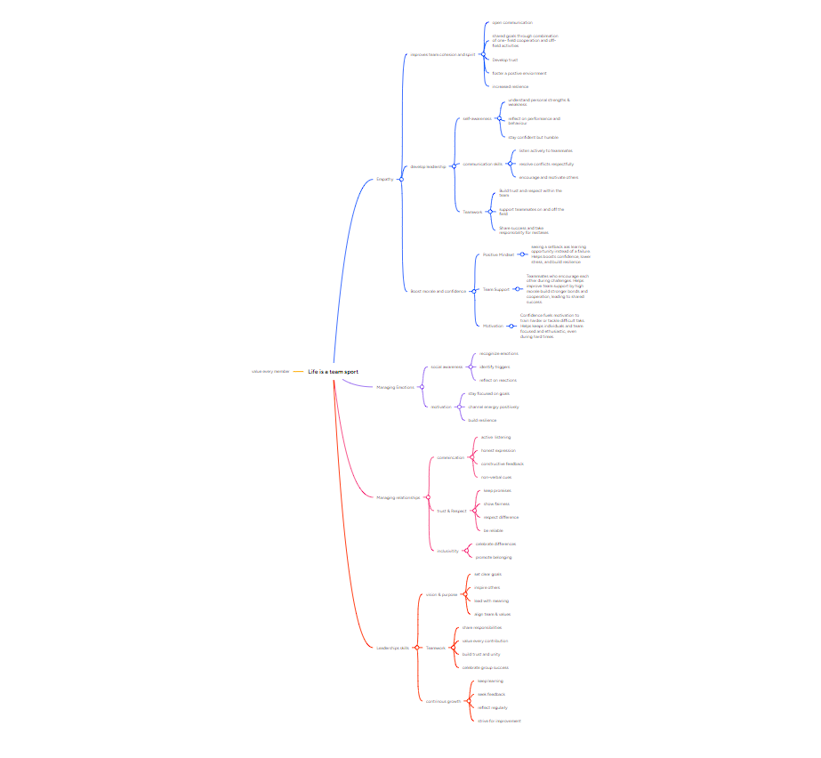

Posterlink:https://www.canva.com/design/DAG4T3iVoio/Hs7Es-E2tdYJOZWkVPoyTA/edit?utm_content=DAG4T3iVoio&utm_campaign=designshare&utm_medium=link2&utm_source=sharebutton
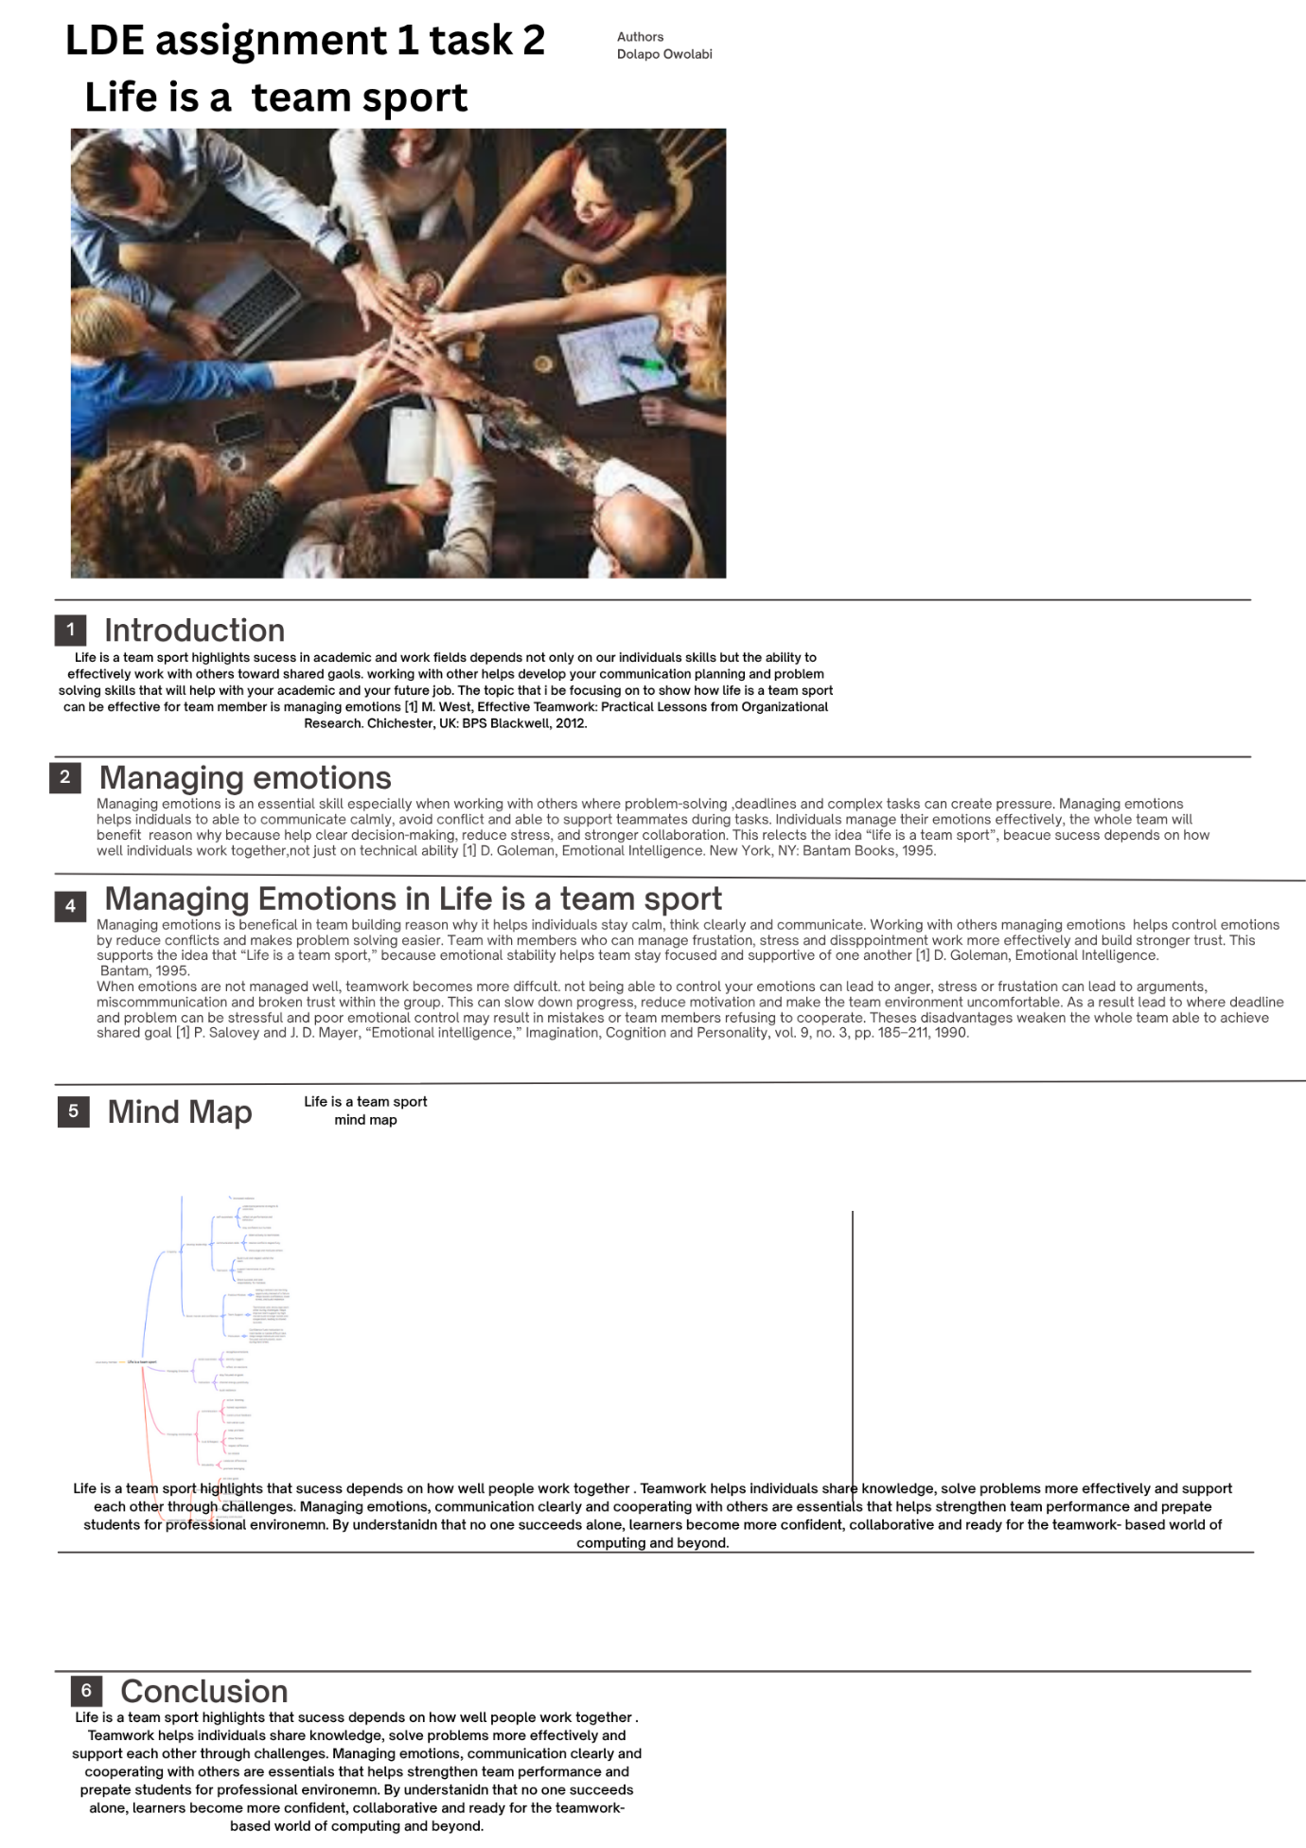

Task 3: Virtual Collaboration:
Topic 3: The new norming:
In virtual collaboration, “the new norming talks about how team able to develop their shared norms, expectations and working behaviours when they are not physical together. Teams form norms naturally through everyday interactions.
Tuckman’s 5 stages of Group Development
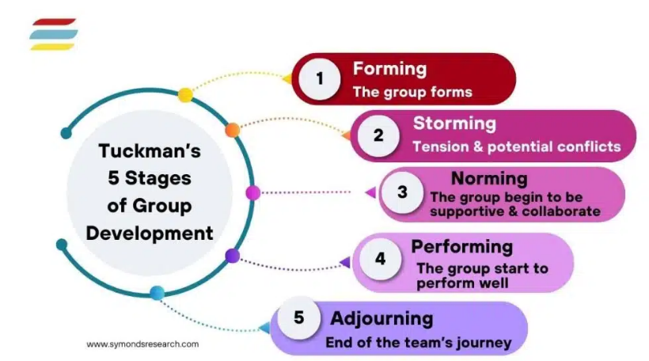
[7]

The Tuckman’s 5 stages of Group Development model of team development which talk about 5 stages of Group Development Forming, Storming, Norming, Performance and Adjourning. Forming is the first stage of Tuckman’s 5 stages of Group Development model by leaning about each other’s roles and but however individuals lack the casual interaction with each other that helps build trust in face-to-face teams. The role for leader in team must provide clear structure, tool selection and communication guidelines on. Storming is the second stage of Tuckman’s 5 stages of Group Development model. The difference about storming Is the work style or communication can cause tension between the team. In virtual collaboration between team, this stage may be less visible because conflict is often avoided online, but misunderstandings can still arise such as unclear messages or delays in communication. Able to clarify the team’s responsibilities and addressing issues openly is essential. The norming stage of the Tuckman’s 5 stages of Group development model talks about how teams should agree on communication rules such as video calls, teams meeting and tools. Collaboration process shares document and deadlines to share their own individual work to the team to discuss and collab with each other. Behavioural expectations like respect each other. Performing is the four stages of Tuckman’s 5 stages of Group Development talks about when virtual norms are in place, teams can work effectively and no issues and autonomously. Trust improves in team because expectations are predictable and transparent enabling higher productivity. Adjourning is the final stages of Tuckman’s 5 stages of Group Development model talks about team completes its work and disbands. Virtual team will benefit with this because from structured closure such as sharing final deliverables, reviewing lessons learned and acknowledging contributions to avoid an abrupt ending [8].

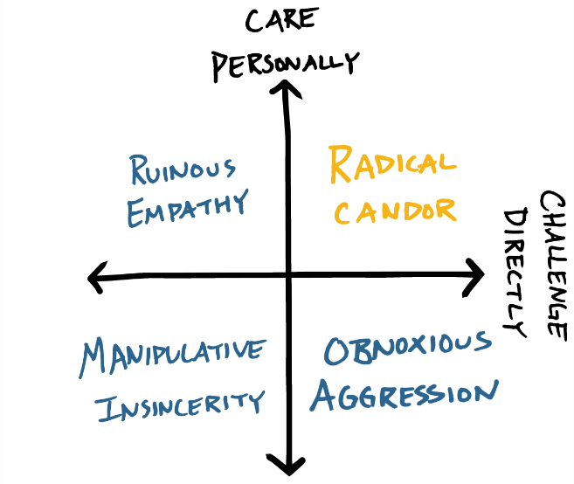

In the image of Radical Candor, shows radical Candor is a communication approach from the diagram showing that encourages people to care personally while also challenging directly. This means want people to be honest and give clear feedback but want people to do it in way that shows respect, support and genuine concern for the other person. In virtual collaboration, Radical Candor helps teams build trust, avoid misunderstandings, and improve performance by making communication open, kind, and productive. [9]

RefWorks: step 1 : create or login in to Refworks
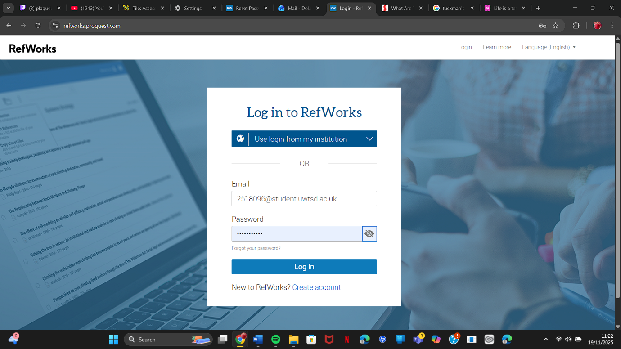
step 2 : create your reference of your choice from information got reference from into refworks by create reference manually meaning easier to add reference.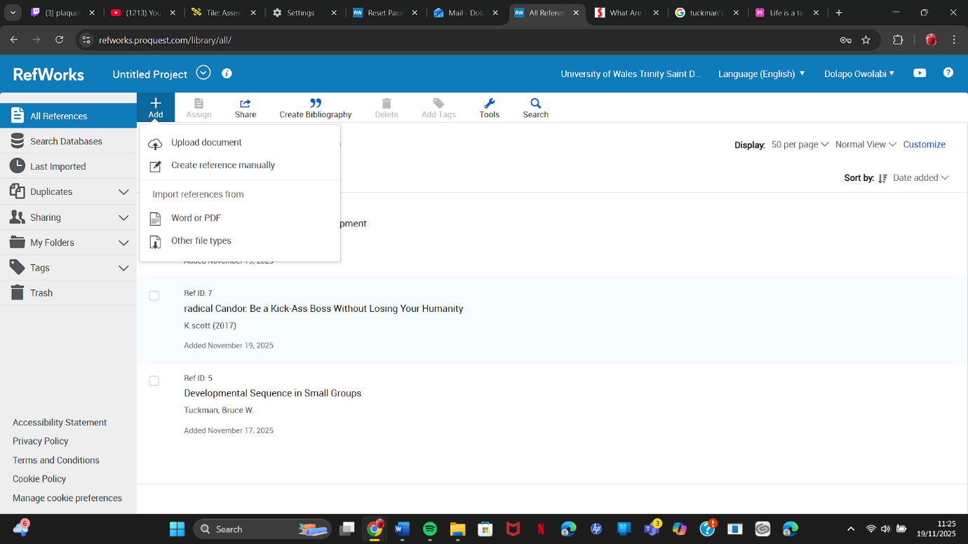

Step 3: after creater your own reference manually on refworks make sure enter all the information required for your reference such as ref type, tittle, Author , Date published , Volume , URL , Journal, Page and publisher. After entering all the information make sure the reference.
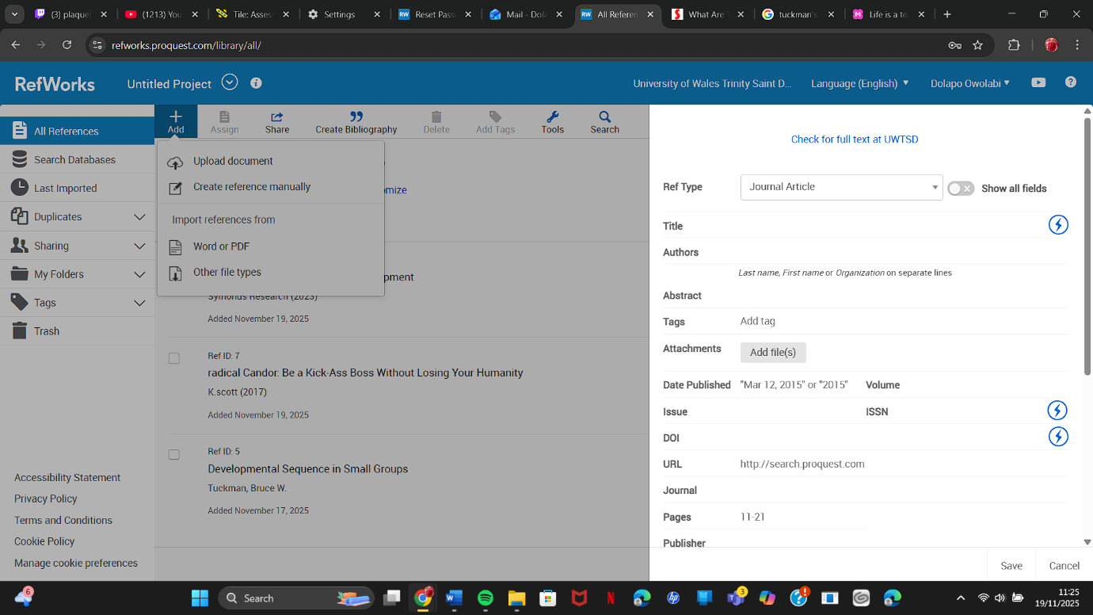Step 4: after adding information of the reference and saving into refwork you can see the reference was added and clicking the reference shows the information you put and where the reference came from.
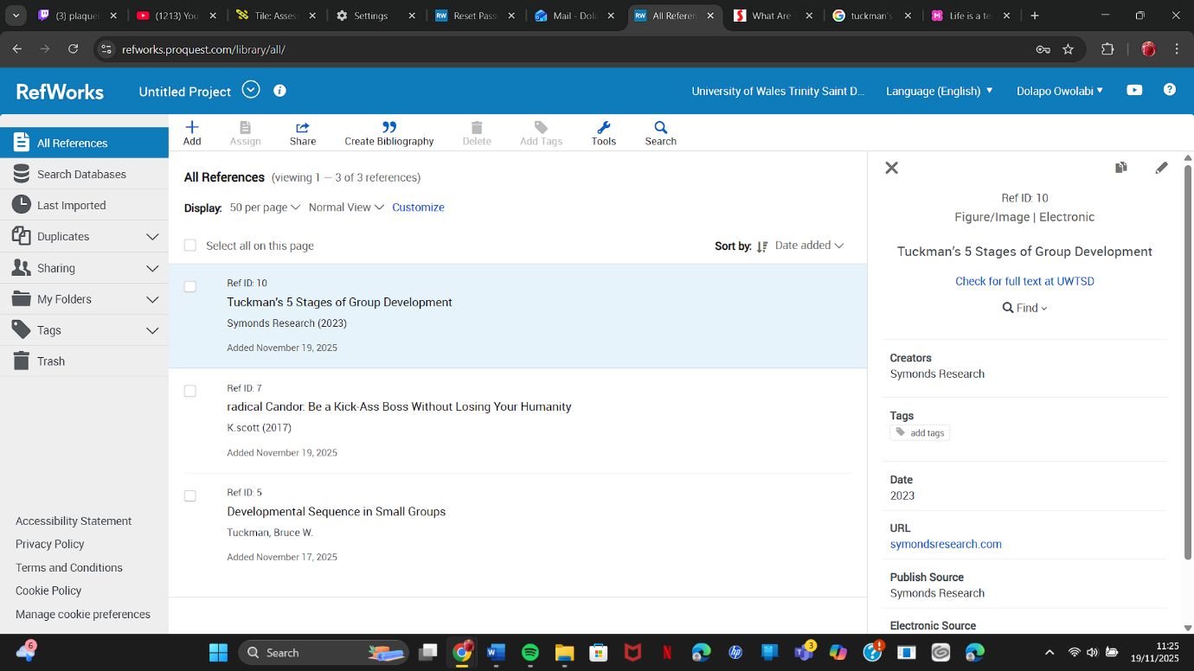
Step 5: After adding and saving the reference in Refwork you can edit the infromation saved making sure added the correct reference you need for your work to put your work from refworks. 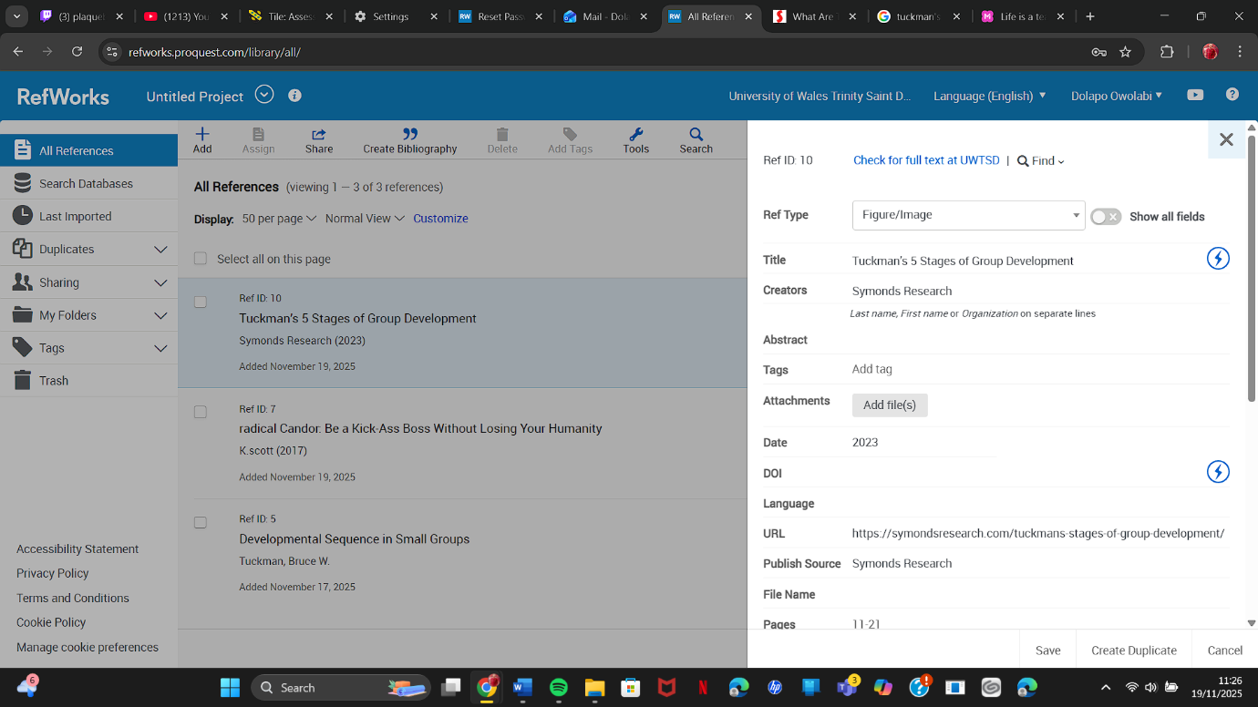Step 6: When done adding all your refernce should look like this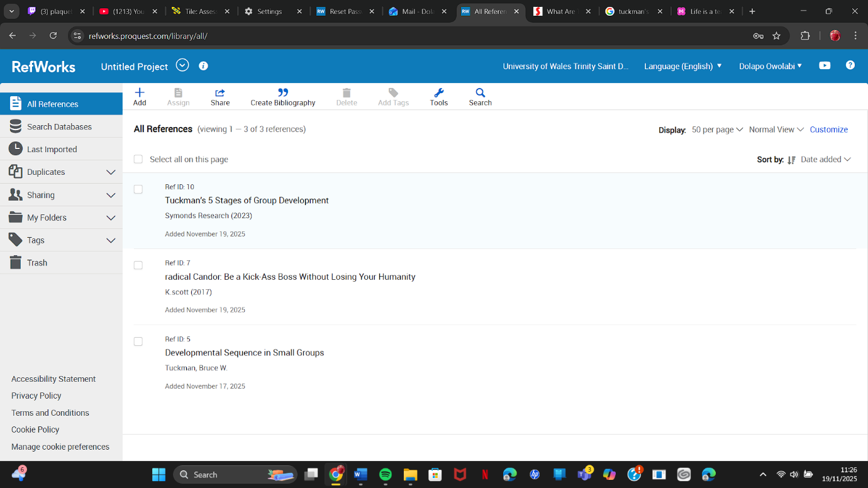
Step 7: Selete the reference needed to create bibliography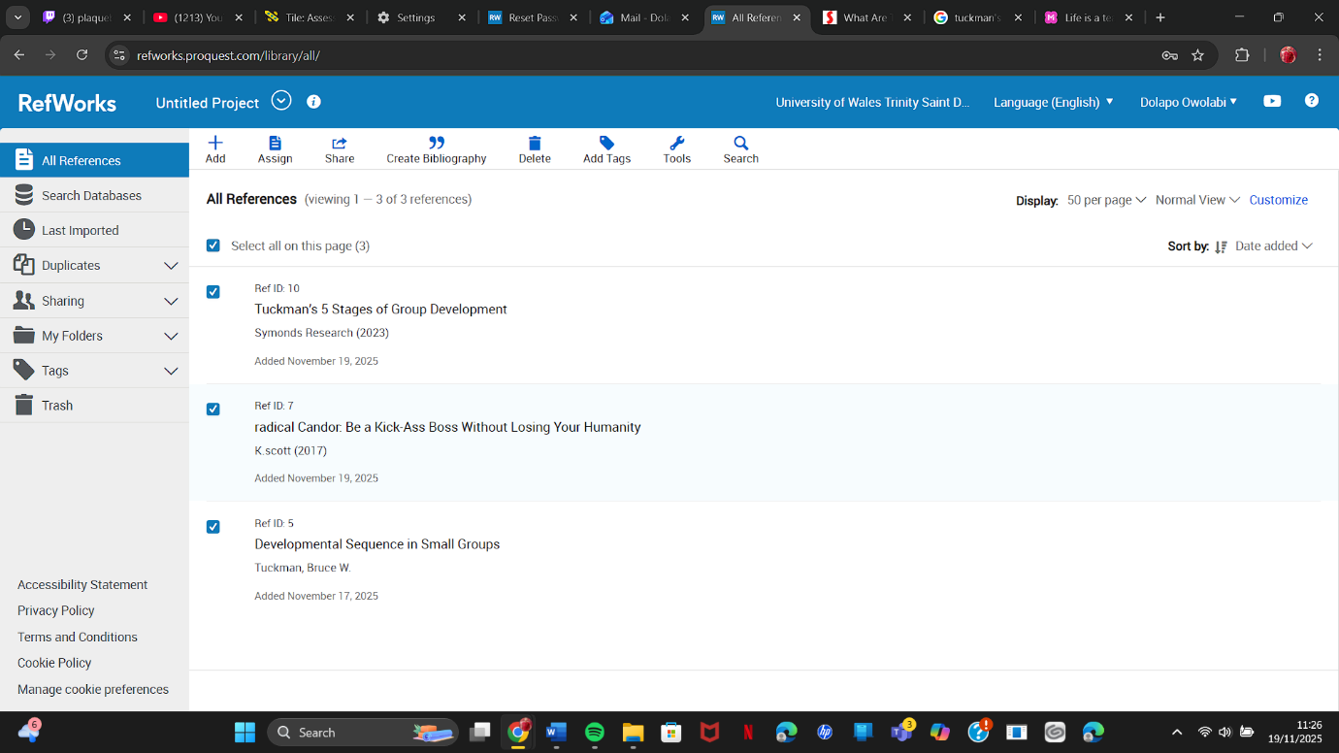Step 8: Click to create bibliography so you can see the information all your refernce from refworks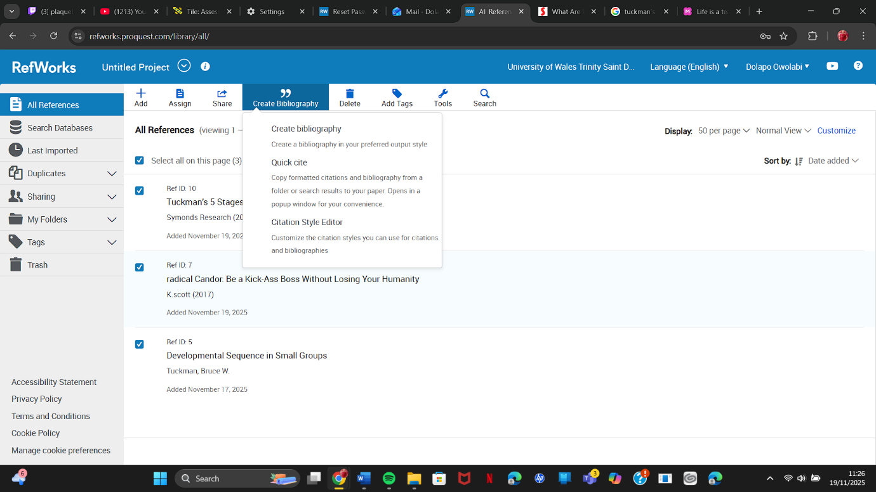
Step 9: After clicking to create bibliography you can see all the reference you added to refworks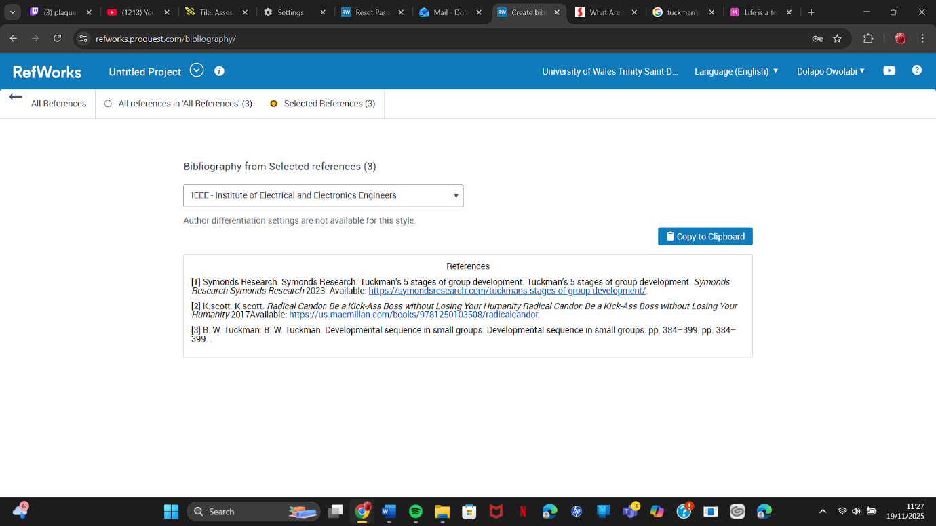
Step 10: copy the refernce from Refworks and add the reference to your word document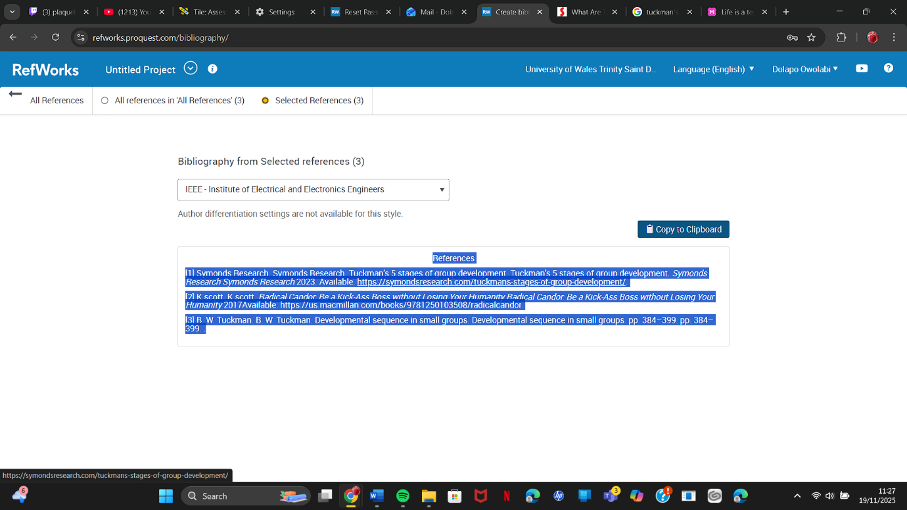Step 11: After copying refernce from refwork add it to your word document and this allow should look like.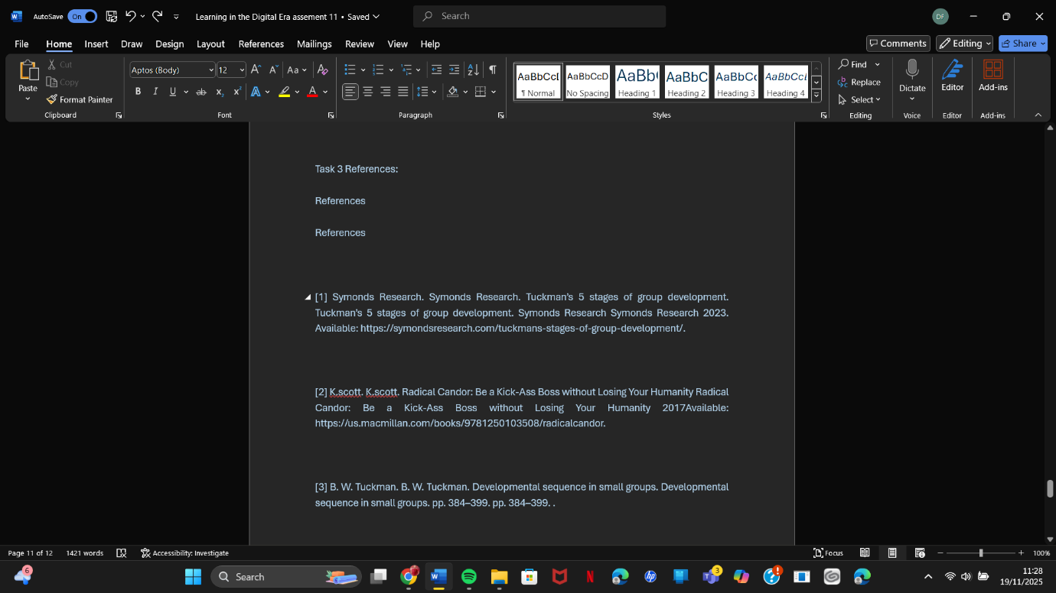

Task 4:
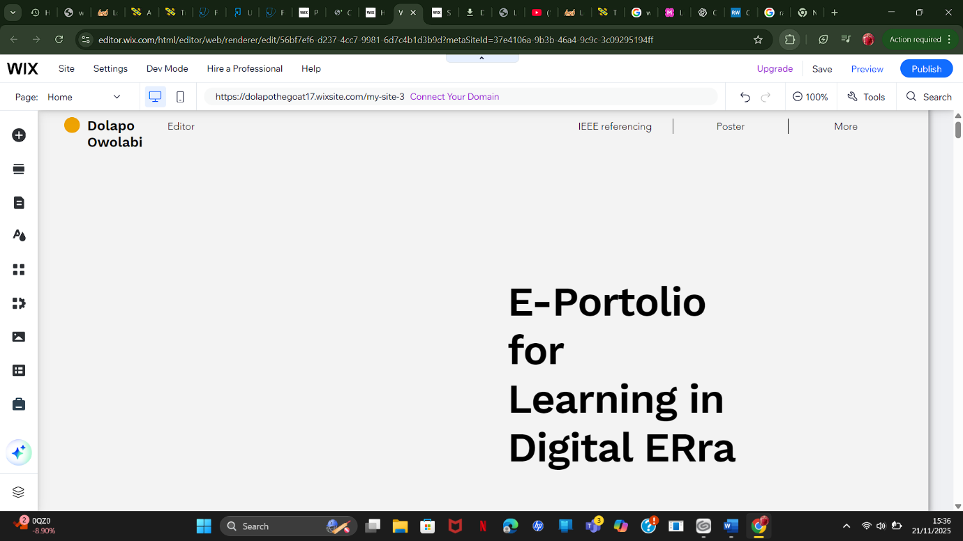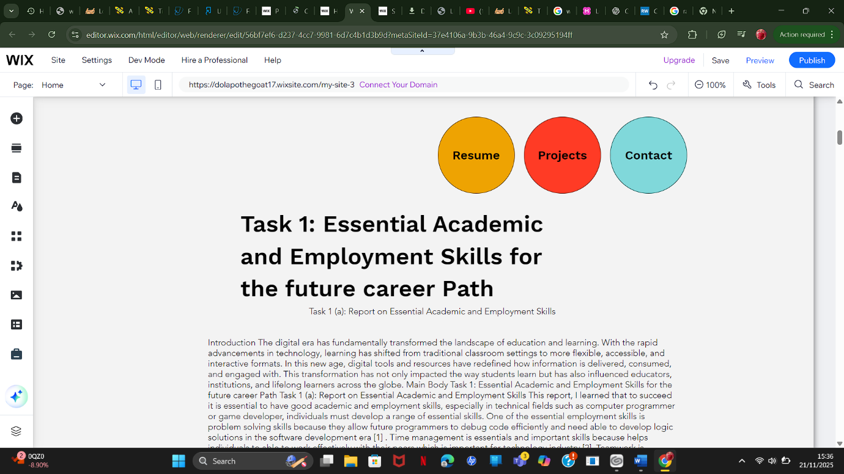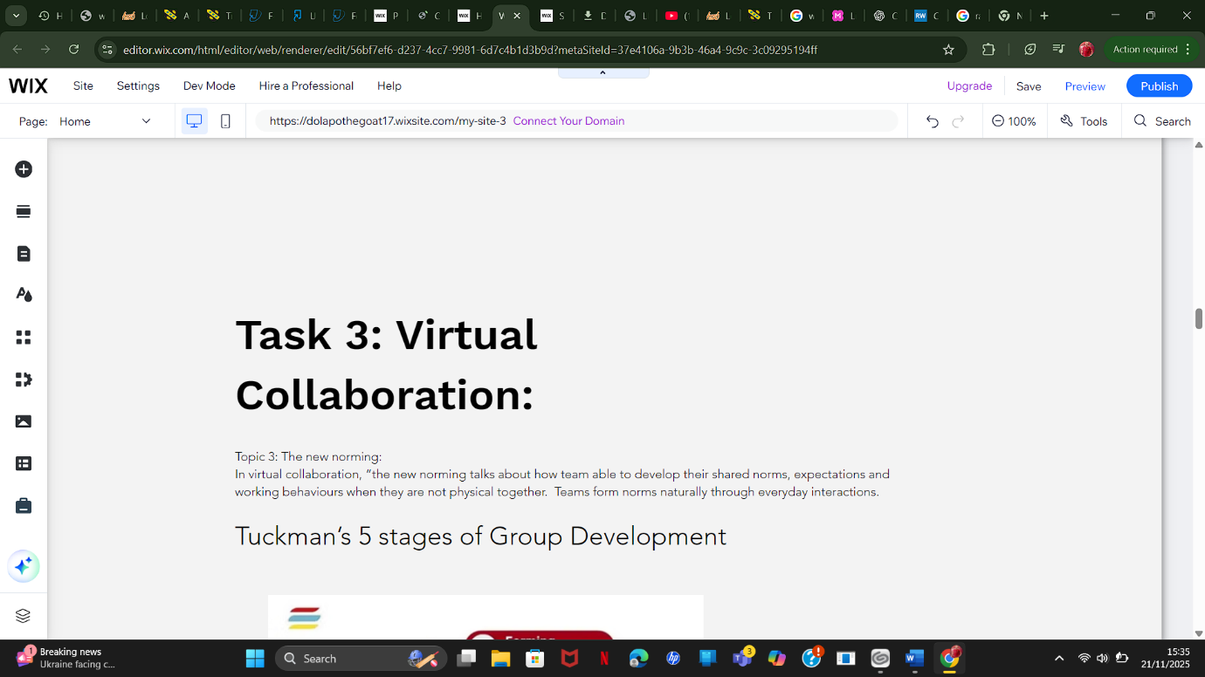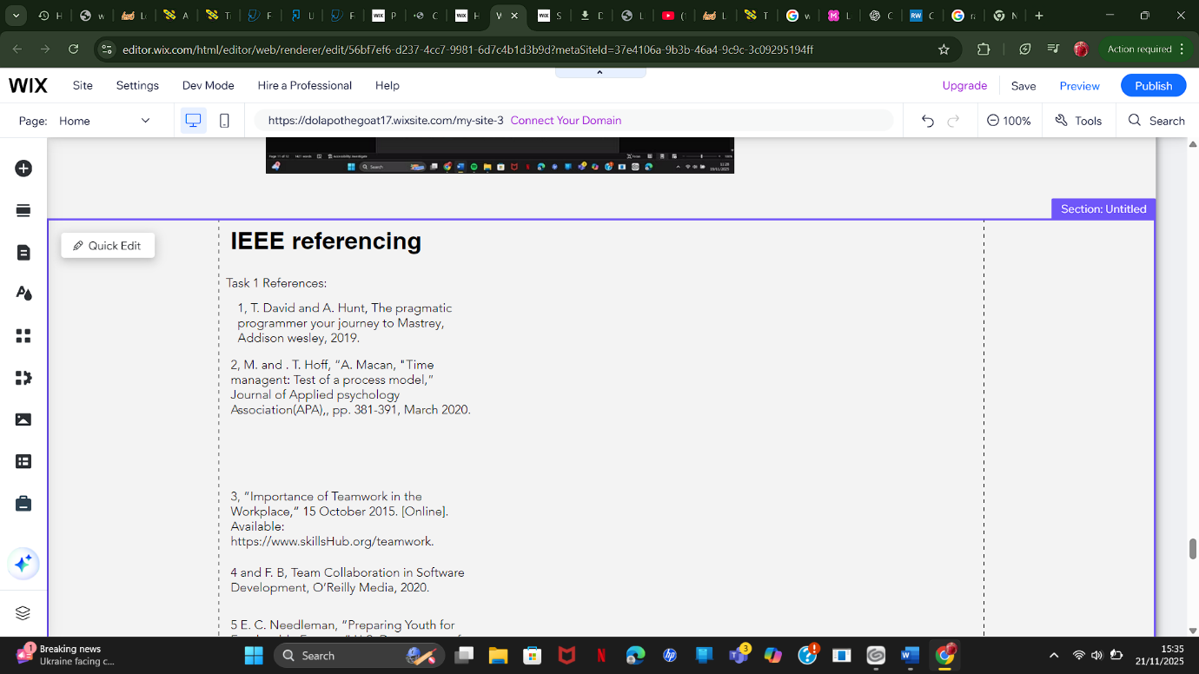

these technologies. The future of education in the digital era will depend on a balanced approach, where technology enhances, rather than replaces, the core values of education. By embracing these changes thoughtfully, we can ensure that the digital transformation of learning benefits all stakeholders and prepares learners for success in a rapidly evolving digital world.

References

Task 1 References:
1, T. David and A. Hunt, The pragmatic programmer your journey to Mastrey, Addison wesley, 2019.
2, M. and . T. Hoff, “A. Macan, "Time managent: Test of a process model,” Journal of Applied psychology Association(APA),, pp. 381-391, March 2020.
3, “Importance of Teamwork in the Workplace,” 15 October 2015. [Online]. Available: https://www.skillsHub.org/teamwork.
4 and F. B, Team Collaboration in Software Development, O’Reilly Media, 2020.
E. C. Needleman, “Preparing Youth for Employable Futures,” U.S. Department of Labor, Washington, DC, 1995.
J.smith, “skill development concept diagram,” EducationStockImages, 15 August 2021. [Online]. Available: https://www.google.com/url?sa=i&url=https%3A%2F%2Fwww.timeshighereducation.com%2Fcampus%2Ftechnopedagogic-design-blended-and-online-courses&psig=AOvVaw26rz8ZaLxQinBQFIMw0Vcx&ust=1762871704954000&source=images&cd=vfe&opi=89978449&ved=0CBIQjRxqFwoTCJDx3prn5. [Accessed 10 February 2025].

Task 3 References:

[1] Symonds Research. Symonds Research. Tuckman’s 5 stages of group development. Tuckman’s 5 stages of group development. Symonds Research Symonds Research 2023. Available: https://symondsresearch.com/tuckmans-stages-of-group-development/.

[2] K.scott. K.scott. Radical Candor: Be a Kick-Ass Boss without Losing Your Humanity Radical Candor: Be a Kick-Ass Boss without Losing Your Humanity 2017Available: https://us.macmillan.com/books/9781250103508/radicalcandor.

[3] B. W. Tuckman. B. W. Tuckman. Developmental sequence in small groups. Developmental sequence in small groups. pp. 384–399. pp. 384–399.
[10] K. Scott. K. Scott. Radical candor: Be a kick-ass boss without losing your humanity. Radical candor: Be a kick-ass boss without losing your humanity. St. Martin's Press St. Martin's Press 2017.

Task4:Portfiolo 4
=

Conclusion :
In conclusion, the digital learning era presents both immense opportunities and significant challenges for educators, learners, and society at large. As computing technologies continue to evolve, the way we approach education must adapt accordingly. The integration of online learning platforms, data analytics, and artificial intelligence offers exciting possibilities for personalized learning and global accessibility. However, it is crucial to address issues such as digital inequality, privacy concerns, and the need for continual upskilling in order to fully harness the potential of

