BMIH5007 Financial Management for the Hotel Industry

Students Name: Dragos Stefan Coanca
ID: 2026724

Table of Contents
Introduction 3
Task-A 4
Interpretation of the comparison of Marriott’s financial ratios between the years 2020 and 2021 4
Task-B 11
The significance of using ratio analysis in the administration of hotels in order to evaluate the facts contained in financial statements 11
Task-C 13
The significance of analyzing various financial ratios in the decision-making process 13
Conclusion 14
Reference 15

Introduction
Marriott is a global hotel chain brand that has been running the business successfully throughout the years. It is the largest lodging and hospitality service-providing company in the globe as well as it has been a market leader in this sector for quite a long time. Though the firm seems to be profitable, the last 2 years went very crucial for the financial situation of the company due to the global pandemic situation (Horrigan, 2019). In this report, the financial performance of Marriott International would be analysed using the financial ratios of the years 2020 and 2021. The limitations of such ratios would be also discussed along with their impacts on the decision-making processes of the firm.

Task-A

Interpretation of the comparison of Marriott’s financial ratios between the years 2020 and 2021
To evaluate a company's financial health, financial ratio evaluation employs information from financial records including the balance sheets, income statements as well as cash flow statements. The earnings, stability, scalability, liquidity, valuation, and other aspects of a company may all be evaluated with the assistance of these fiscal metrics, which are helpful to both company owners as well as typical investors (Nissim and Penman, 2021). Some of the major financial ratios of the company has been evaluated here with their trends and criticism;
Current ratio:
This has been a useful indicator that may be used to determine whether or not a company has enough working capital to meet its imminent obligations and liabilities. The usual range for a good current ratio seems to be between 1.5-2 (Wei, 2022).
The trajectory of Marriott's current ratio: It would seem that Marriott has been gradually decreasing its ability to repay its imminent liabilities, as well as it had also been far under the average for a considerable amount of time.
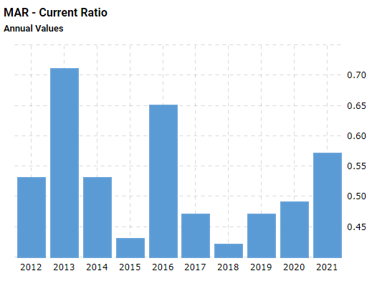
Figure: Current ratio of Marriott
Source: (Hormby, et al. 2021)
Comparing the years 2020 with 2021: Although the ratio has been under the desired range for a long time, it seems that Marriott will have made more improvements toward the optimal zone in 2021 compared to 2020.
Long-term debt/capital:
A corporation's financial stress may be determined by comparing its long-term liabilities to its overall capital. A value that is less than one is considered to be an optimal value for the ratio (Wei, 2022).
The trajectory of Marriott's current ratio: Considering the long-term debt/capital ratio in recent years, the firm is in a great position.
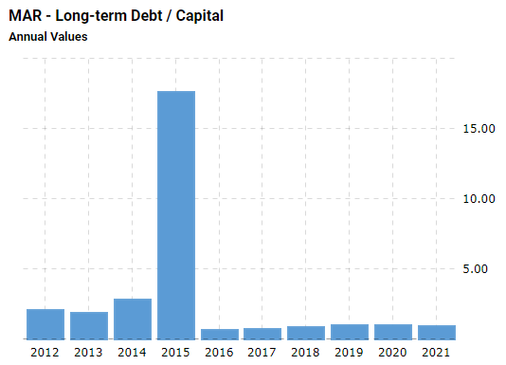
Figure: Long-term debt/capital ratio of Marriott
Source: (Hormby, et al. 2021)
Comparing the years 2020 with 2021: Not very satisfactory, it has been below the ideal spot in both of these years.
Debt/equity ratio:
This ratio illustrates the extent to that a company is able to fund its operational activities more efficiently via debt rather than using the utilisation of its own assets. In most circumstances, a debt-to-equity ratio of about 2-2.5 is considered to be favourable (Neves, 2022).
The trajectory of Marriott's current ratio: Considering the debt/equity ratio in recent years, the firm is not in a great position. The ratio is significantly low.
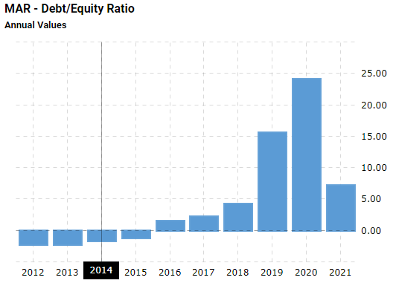
Figure: Marriot’s debt/equity ratio
Source: (Hormby, et al. 2021)
Comparing the years 2020 with 2021: In 2020, the ratio is very unsatisfactory, however in 2021, it is comparatively better but not ideal.
Net profit margin:
The percentage of a company's net profit to its total sales may be measured using this ratio, which is more usually referred to simply, as net profit margin. It refers to the proportion of a company's or commercial section's net profits to the number of revenues it generates. In business, the range of seven per cent to ten per cent is a good profit margin (Wei, 2022).
The trajectory of Marriott's current ratio: Considering the net profit margin in recent years, the firm has been below average.
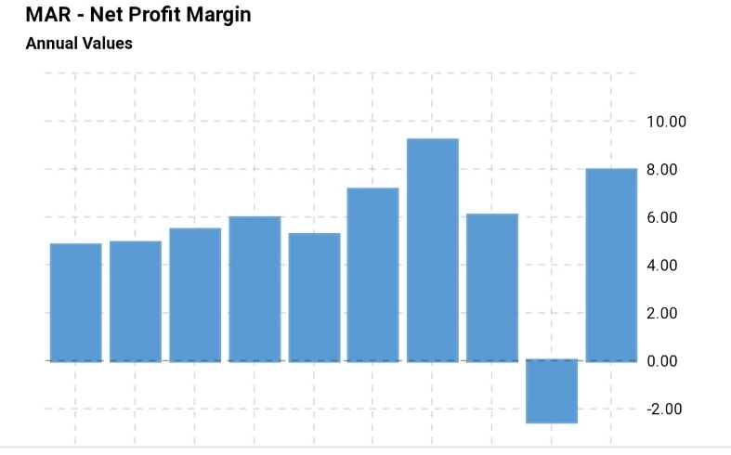
Figure: Marriott’s net profit margin
Source: (Hormby, et al. 2021)
Comparing the years 2020 with 2021: Due to the global epidemic, Marriot’s Net Profit had been very low, however in 2021, it was successful to be on the ideal spot.
Asset turnover:
The measurement of this ratio determines how successful a business is in bringing in new customers or money. It does this by contrasting the total amount of sales with the annual % of total resources. If the ratio is minimum 2.5, then it may be considered good (Neves, 2022).
The trajectory of Marriott's current ratio: Considering the asset turnove in recent years, the firm has not been very successful.
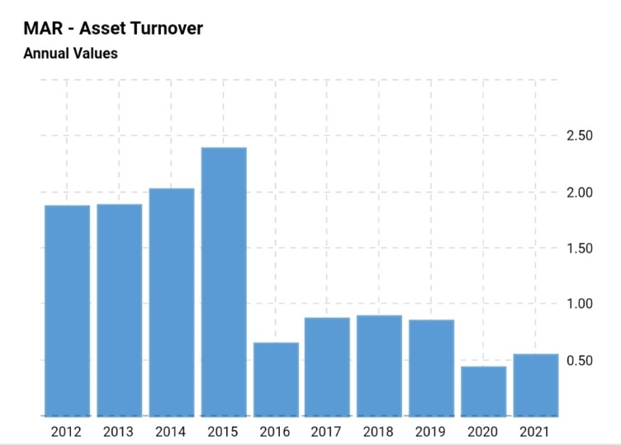
Figure: Marriott’s asset turnover
Source: (Hormby, et al. 2021)
Comparing the years 2020 with 2021: In 2020, the ratio is very unsatisfactory, however in 2021, it is comparatively better but not ideal.
Receivable turnover:
It is a key indicator of how well a business is collecting on the loan it gives to its clients. Additionally, the ratio determines the frequency with which a firm's receivables are turned into cash over a definite time period. The standard point of this ratio is 4-6 (Simões, 2021).
The trajectory of Marriott's current ratio: Considering the receivable turnover in recent years, the firm has been on the ideal spot.
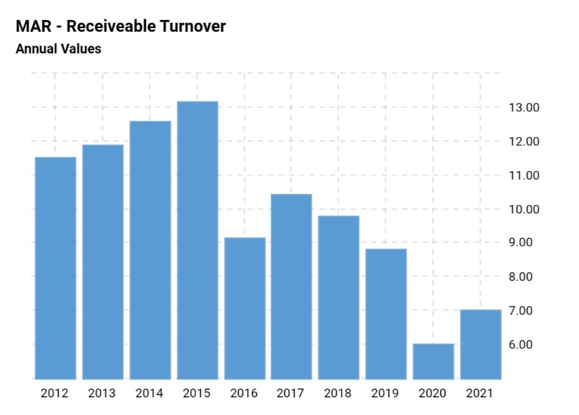
Figure: Marriott’s receivable turnover
Source: (Hormby, et al. 2021)
Comparing the years 2020 with 2021: Due to the global epidemic, Marriot’s receivable turnover had been very low, however in 2021, it was successful to be on the ideal spot.
Return on investment (ROI):
It is a profitability measure that is used to determine how much of a profit an investor would get in comparison to the amount of money they invested. The standard ROI is of generally higher than 10 per cent (Neves, 2022).
The trajectory of Marriott's current ratio: Considering the ROI in recent years, the firm’s performance is exceptionally good.
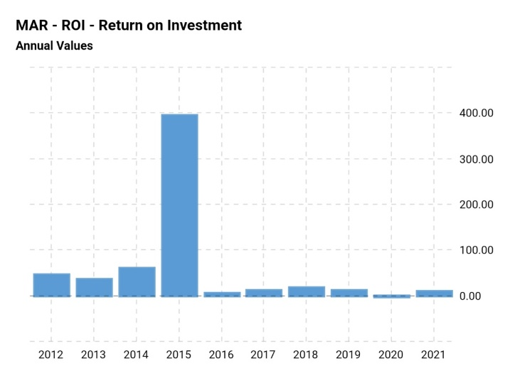
Figure: Marriott’s return on investment
Source: (Hormby, et al. 2021)
Comparing the years 2020 with 2021: Due to the global epidemic, Marriot’s went negative, however in 2021, it got back on the track.
Free cash flow per share:
A company's cash flow is measured by this analysis. Larger ratios of free cash flow per share is considered to be good (Simões, 2021).
The trajectory of Marriott's current ratio: Considering the free cash flow per share of Marriott, the firm’s performance is not good, as its share are getting undervalued.
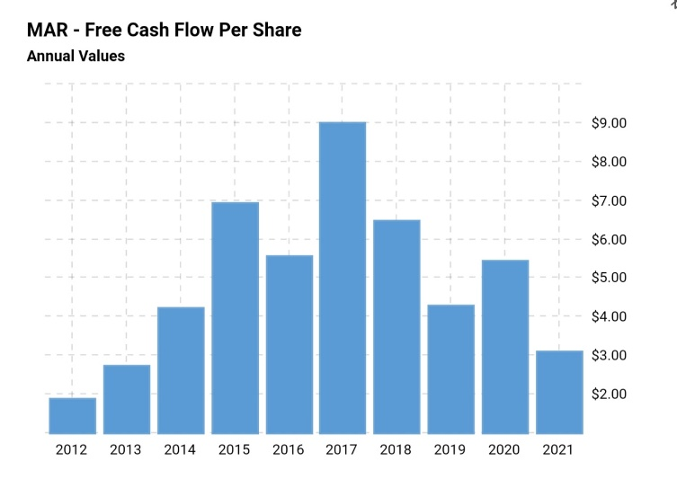
Figure: Marriott’s free cash flow per share
Source: (Hormby, et al. 2021)
Comparing the years 2020 with 2021: In 2020, Marriott was successful in obtaining satisfying ground, which it lost in 2021.

Task-B

The significance of using ratio analysis in the administration of hotels in order to evaluate the facts contained in financial statements
Such ratios are highly useful in easily communicating sophisticated facts. The financial statements have been the primary source of data used to calculate most ratios. When presenting data to its many interested parties, hotels often and extensively depend on ratios of this kind. There is a good chance that the majority of the participants are unable to devote the time required to carefully examine each and every aspect of the accounting records (Lesakova, 2017). Because of this, these ratios have a tendency to be quite useful in effectively communicating the narrative of a property to the many partners using the most practical way possible. Other applications of these accounting analyses in this context include the following:
- Using financial ratios may assist in determining what areas want improved performance as well as which issues should be prioritised for attention.
- Because they display the problematic as well as big data that may be found on the statements in a much more adaptive form, ratios might be helpful when offering equities in a marketplace that moves quickly.
The ratio analysis has some drawbacks:
The usage of ratio analysis may be highly beneficial; however, they do have certain restrictions attached to them. A few of them include;
Historical data: The information used in the research comes from the firm's publicly available records of its overall results in the past (Frecknall-Hughes, et al. 2015). Therefore, the results of ratio analyses could not always accurately forecast future company success.
Impacts of inflation: As a result of the fact that income reports are only supplied on a quarterly basis, there seem to be time lapses between every release. If there has been inflation throughout the time period being compared, real expenses will not be recorded in the accounting for that time period.
Changes to the accounting principle: It is possible that the company has altered its bookkeeping processes and policies, which would have a significant effect on the presentation of financial information.
Operational changes: This might cover anything from a company's administration of its distribution network to the good or service that it is really offering. A corporation might even make significant changes to the organisational framework of its business (Lesakova, 2017). When significant operational modifications are implemented, it is easy to arrive at erroneous conclusions regarding the development possibilities of the firm by comparing financial metrics that were in existence before and during the administrative alteration.
Fraudulent activity on financial statements: Financial ratios are built on top of the material that is available in a firm's balance sheet as its primary source of data. This information could be altered by the administration of the organisation so that they can present a higher level of efficiency than they really achieved.

Task-C

The significance of analyzing various financial ratios in the decision-making process
It is essential for the business to do financial ratios in order to assess its financial state, stability, competitiveness, risks, viability, efficiency, and operational effectiveness, as well as the appropriate utilisation of finances. In addition to this, it provides a trend analysis or comparisons of the economic outcomes, which is useful information for firm shareholders to consider when making decisions on investments. The administrative team of a firm finds it helpful to utilise ratios analysis in order to make decisions. The further discussion focuses on that;
- Ratios may provide insight into a firm's fiscal viability and provide direction to the administration regarding how the firm should be run (Goyal, et al. 2018).
- Ratios are an essential component of the fiscal strategy as well as forecasting processes, which serve as the cornerstone of the cash flow management as well as decision-making processes.
- It is possible for administrators to take remedial action based on trends revealed by financial ratios.
- Ratios are useful tools for keeping an eye on expenses and assessing overall success.
- Evaluation of ratios may provide information on the stability, profitability, efficiency, as well as capital structure of a firm that are all indicators of the firm's overall financial condition (Altman, 2019). In order for administrating to properly run the company, they need to be knowledgeable of such particulars.

Conclusion
Marriott name international is known around the world as a reputable hotel chain that has been operating its business profitably for many years. It is the organisation that offers accommodation and hospitality services to the greatest number of people everywhere in the world, and it has held the position of the market leader in this industry for a considerable amount of time. Even if it seems that the business is making a profit, the last two years have been very challenging for the company's financial status as a result of the worldwide pandemic scenario. The ratio analysis of the firm's financial statement has presented various aspects of the firm's financial conditions. Although ratio analysis got some limitations, it helps administrators during the decision-making procedures.

Reference
Altman, E.I., 2019. Financial ratios, discriminant analysis and the prediction of corporate bankruptcy. The journal of finance, 23(4), pp.589-609.
Frecknall-Hughes, J., Simpson, M., Padmore, J. and Padmore, J., 2015. Inherent limitations in using financial ratio analysis to assess small and medium sized company performance (pp. 2007-01). Working Paper.
Goyal, A., Heidelberger, P. and Shahabuddin, P., 2018, December. Measure specific dynamic importance sampling for availability simulations. In Proceedings of the 19th conference on Winter simulation (pp. 351-357).
Hormby, S., Morrison, J., Dave, P., Meyers, M. and Tenca, T., 2021. Marriott International increases revenue by implementing a group pricing optimizer. Interfaces, 40(1), pp.47-57.
Horrigan, J.O., 2019. A short history of financial ratio analysis. The Accounting Review, 43(2), pp.284-294.
Lesakova, L., 2017, June. Uses and limitations of profitability ratio analysis in managerial practice. In International Conference on Management, Enterprise and Benchmarking (pp. 1-2).
Neves, D.D., 2022. Marriott international inc. equity research-the hotel Giant´ s recovery (Doctoral dissertation).
Nissim, D. and Penman, S.H., 2021. Ratio analysis and equity valuation: From research to practice. Review of accounting studies, 6(1), pp.109-154.
Simões, A.V.C., 2021. Equity valuation of Marriott International (Doctoral dissertation).
Wei, L., 2022. Marriott International, Inc: A Financial Analysis.

