
Hywel Cleaves 2520281
University of Wales Trinity ST David
Design for manufacture and assembly : Component optimisation
Bsc Material Science
Manufacturing design and Technology
ACMA5002

Contents
1. Introduction 4
2. Literature review 5
2.1 Design for manufacture 5
2.1.1 Simplifying the Design 5
2.1.2 Standardising the components 5
2.1.3 Minimising tooling costs 5
2.1.4 Optimising Wall Thickness 5
2.1.5 The Use of Recycled materials 6
2.1.6 Manufacturing tolerances 6
2.2 Design for assembly (DFA) 6
2.2.1 DFA Considerations 6
2.2.2 Injection Moulding 8
2.2.3 Design considerations 9
2.2.4 Introduction To QFD (Quality Function Deployment), DOE (Design of Experiments), FEA (Finite Element Analysis) and Fusion 9
3 Defining customer requirements. 9
3.1 Attributes affecting performance 9
3.2 Quality function deployment (QFD 10
3.3 Failure Model and effect analysis (FMEA) – Risk analysis 12
3.4 Design of experiments (DOE) 16
3.4.1 Parameters 16
3.4.2 Experimental Design 17
3.4.3 Analysis procedure 17
3.4.4 Equipment and materials 17
3.4.5 Outcome 21
4 Design 21
4.1 CAD Design 21
4.1.1 Phone case 21
4.1.2 Mould Design 24
4.2 Performance balance, cost and sustainability 25
5 Simulation 26
5.1 Sink marks and weld lines 28
5.2 Warpage 28
6 Cost 29
6.1 Material Cost 29
6.2 Production Cost 29
6.2.1 Machine 29
6.2.2 Labour 29
6.2.3 Tooling costs 30
6.2.4 Total Manufacture cost 30
6.3 Break even calculation 30
7 Sustainability 31
7.1 Recyclability 31
7.2 Energy use 31
7.3 Waste reduction 31
8. Conclusion 32

Figure 1 Injection moulding process (Trumould (2023).
Figure 2 Customer needs rating QFD
Figure 3 House of quality
Figure 4 FMEA Severity rankings (Lean Six Sigma Definition. (n.d.).
Figure 5 FMEA Occurrence rankings (Lean Six Sigma Definition. (n.d.).
Figure 6 FMEA Detection rankings (Lean Six Sigma Definition. (n.d.).
Figure 7 FMEA RPN (risk priority number) score (Hartwell, J. (2017)
Figure 8 Phone case FMEA
Figure 9 Experimental Design
Figure 10 Phone case front in Fusion
Figure 11 Phone case back in Fusion
Figure 12 Phone case bottom in Fusion
Figure 13 Phone Case side in Fusion
Figure 14 Phone case Drawing
Figure 15 Phone case mould bottom

Introduction

The purpose of this report is to investigate the manufacture of a mobile phone case. The phone case will need to be made from a lightweight polymer that has integrated mounting points, snap fit fasteners and ventilation slots. The phone case will need to be durable, lightweight, interchangeable and visually appealing to the consumer.
In order to design and manufacture the case and ensure the highest quality, cost effectiveness whilst ensuring a safe and environmentally friendly process. There are multiple tools that will be used. This contain but are not limited to, quality function deployment (QFD), Failure Model and effect analysis (FMEA), Finite Element Analysis, FEA. Fusion 360 design software will also be used alongside cost calculations.
The conclusion of the report will show how these tools demonstrate the design and manufacture process of the mobile phone case.
The specifications are as follows.
Manufacturing
The design will need to be suitable for high volume production
Defect Mitigation
The mould/Die design should minimise any defects such as warping, stress concentrations or air pockets.
Material selection and Cost effectiveness
The design of the case should balance performance with cost effectiveness using clear cost analysis to demonstrate.
Sustainability
Recyclable materials should be used alongside energy efficient processes.
Note, for the purposes of pricing cost calculations will be in $ to reflect the economy globally.

Literature review

2.1 Design for manufacture

A DFM or design for manufacturability is a key element when designing any manufacturing process for components. When used in the manufacturing of the phone case the DFM will ensure the process flow, is cost effective and simple to produce. It is the engineering practice to proactive design products, parts or components. This will optimize the ease of manufacture and assembly. With the primary goal to make a high quality product whilst minimising production time and reducing overall cost. (Bralla, J.G. (1999)

Simplifying the Design

Simplifying the design will aid in reducing the cost and tooling requirements, minimising complexity in manufacturing. One single piece of design will avoid the need for a complex mould and in turn will reduce labour and machining demands. (Dfma.com. (2025)

Standardising the components

By using industry-standard polymers and fasteners, such as Acrylonitrile Butadiene Styrene (ABS) or Polycarbonate (PC), overall costs can be reduced and procurement simplified due to their widespread availability, established supply chains, and suitability for high-volume manufacturing applications (Ashby, 2011).

Minimising tooling costs

Tooling will be a significant cost the design should be as simple as allowable, the aim should be to avoid any unnecessary undercuts and complexity. Leaning away from and specialist dies or use of multi part moulds. A simple smooth and geometric design is desirable, this should reduce overall production costs. (Boothroyd, Dewhurst and Knight, 2010)

Optimising Wall Thickness

During the moulding process a 2-3mm wall should be used as a uniform thickness will allow a constant flow of material. This will minimise waste, reduce defects and cut down on warping. This will mean less material scrapped, efficient use of energy and more reliable components. (Malloy, 2010)

The Use of Recycled materials

By using recycled polymers, allows the process to reduce costs and increase sustainability. Aligning with the sustainable goals of today’s business and making the product more appealing to conscious customers. This allows for greater marketing appeal and supports circular economic practices. (Ellen MacArthur Foundation, 2013)

Manufacturing tolerances

Where appropriate, generous tolerances can improve manufacturability by reducing the need for precision machining. For features such as button openings, allowing slight dimensional variations simplifies production while maintaining functional performance. (Boothroyd, Dewhurst and Knight, 2010)

Design for assembly (DFA)

The DFA approach simplifies the assembly process by reducing product complexity, handling time, and the number of components required. This minimises the likelihood of assembly errors while improving overall manufacturing efficiency. (Boothroyd, Dewhurst and Knight, 2010)

DFA Considerations

Part Count
A single-piece design incorporating integrated button features and grips reduces the number of components required, minimising assembly operations and production time.

Self-Locating Features
Features such as grooves, snap-fits, and locating tabs assist with component alignment, reducing assembly errors and improving consistency.

Orientation and Handling
The mould design should minimise orientation requirements and facilitate straightforward part ejection, simplifying automated and manual handling processes.

Minimising Fasteners
The use of interlocking joints and snap-fit features in place of screws or other fasteners simplifies assembly and reduces manufacturing costs.

Moulding Ease
Uniform wall thicknesses, appropriate draft angles, and well-positioned parting lines promote efficient mould filling, cooling, and ejection while reducing the risk of defects.

Material Selection
Materials such as Polycarbonate (PC) or Thermoplastic Elastomer (TPE) offer a balance of mouldability, durability, and performance, making them suitable for the application.

Quality Control
The design should facilitate both automated and visual inspection methods, enabling efficient quality assurance throughout the manufacturing process.

(Ashby, M.F. (2011)
(Bonenberger, P.R. (2005)

Injection Moulding

The ideal manufacturing method for the phone case is injection moulding because it can produce complex geometries with high precision, excellent repeatability, and is highly scalable for mass production. (Kalpakjian, S., & Schmid, S. R. (2014). The injection moulding process involves heating a thermoplastic material, such as Acrylonitrile Butadiene Styrene (ABS), Thermoplastic Elastomer (TPE), Thermoplastic Polyurethane (TPU), or Polycarbonate (PC), until it reaches a molten state. The molten material is then injected under high pressure into a mould cavity that has the desired shape of the phone case. After the cavity is filled, the material is cooled and allowed to solidify. Once sufficiently hardened, the mould opens and the finished component is ejected, ready for any required post-processing operations (Groover, 2020; Kalpakjian and Schmid, 2014). ABS, TPE, TPU, and PC are commonly used for phone cases because they provide a combination of flexibility, ease of moulding, impact resistance, and durability, which are important characteristics for protecting electronic devices (Groover, 2020; Kalpakjian and Schmid, 2014). The mould consists of two halves composing of a core which contains the internal structure and the cavity for the outer shape. An effective and efficient mould design includes cooling channels alongside vents in order to manage and regulate temperature and quality. This is important and a stable cooling process is essentially for dimensional control as it avoids warping and shrinking. Once ejected the case may need minor finishing. Injection moulding is widely used for the manufacture of phone cases because it offers high production rates, consistent quality, and low unit costs at large production volumes, making it a highly cost-effective manufacturing process (Groover, 2020; Kalpakjian and Schmid, 2014).
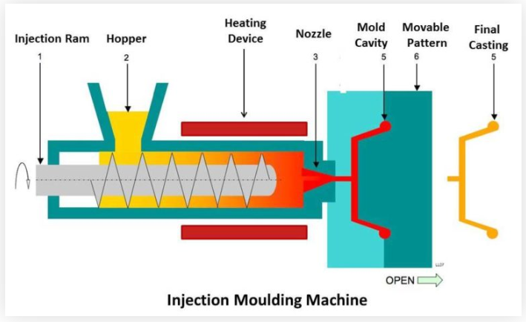
Figure 1 Injection moulding process (Trumould (2023).

Design considerations

A uniform wall thickness should be maintained to ensure consistent and controlled cooling throughout the component, reducing the likelihood of defects such as warping, sink marks, and residual stresses. Draft angles should also be incorporated into the design to facilitate easier ejection from the mould by reducing friction between the component and the mould surfaces (Groover, 2020; Kalpakjian and Schmid, 2014).Structural features must also be factored in to improve strength without adding weight and designed so that cooling is unaffected. For the more functional areas like the buttons and port a tight tolerance must be adhered to. Material flow is a critical factor in injection moulding. By optimising injection pressure, injection speed, and gate design, the molten polymer can flow uniformly throughout the mould cavity, reducing the risk of defects such as short shots, where the cavity is not completely filled, and flash, where excess material escapes between mould surfaces (Groover, 2020; Kalpakjian and Schmid, 2014).

Introduction To QFD (Quality Function Deployment), DOE (Design of Experiments), FEA (Finite Element Analysis) and Fusion

QFD a structured design tool that uses customer need and expectations to create engineering characteristics and design specs. This will ensure that the final product meets customer requirements. (Quality Function Deployment Cohen, L. (1995). This uses the house of quality matrix.
DOE is a statistical approach used to identify cause-and-effect relationships by systematically varying process variables to optimise performance and improve product quality. (Design and Analysis of Experiments Montgomery, D.C. (2019).
FEA will use simulations to show how the design will interact with any stress, force and heat, this will allow structural optimisation and safety assurances
Fusion 360 will reduce the need for prototypes and reduce production costs by simulating cooling, material flow. This will also reduce defects such as air traps and weld lines. Doing this early in design phase is key.

3 Defining customer requirements.

3.1 Attributes affecting performance

The phone case requires an accurate, snug fit to ensure effective protection while maintaining full functionality. It must also be durable and provide a high level of impact and shock resistance. Therefore, materials such as Thermoplastic Elastomers (TPE) and Polycarbonate (PC) should be considered, as they are capable of absorbing and dispersing energy generated during impacts. High moulding accuracy and precision are essential to ensure that openings for the camera, charging port, speakers, and buttons are correctly positioned. This will enhance both the protective performance of the case and the overall user experience by maintaining accessibility and usability. Polycarbonate is widely used in protective products due to its high impact strength and durability, while TPE provides flexibility and shock absorption, making the combination suitable for phone case applications (Matmatch, 2024) Injection moulding will allow for high quality and a smooth finish, without compromising the integrity of the case. The use of Thermoplastic Elastomer (TPE) improves user handling by providing a non-slip surface and increased flexibility, reducing the likelihood of accidental drops. Injection moulding also enables the incorporation of ergonomic surface textures, which further enhance grip and user comfort, making TPE an ideal material for phone case applications. In addition, Polycarbonate (PC) and Acrylonitrile Butadiene Styrene (ABS) offer excellent thermal stability and durability, allowing the phone case to withstand heat generated by the device during operation and charging. Injection moulding is a cost-effective and efficient manufacturing process that is well suited to mass production. It enables high production rates while maintaining consistent quality and dimensional accuracy, helping manufacturers achieve competitive pricing without compromising product performance (Ashby and Johnson, 2014).

3.2 Quality function deployment (QFD

To carry out a Quality Function Deployment (QFD) analysis, customer requirements must first be identified and understood. This information can be gathered through a variety of methods, including interviews, questionnaires, focus groups, and customer feedback. These techniques help designers capture the needs, expectations, and preferences of users, which can then be translated into measurable engineering specifications. By incorporating customer requirements into the design process, QFD helps ensure that the final product meets user expectations and improves overall customer satisfaction (Akao, 1990).

Once this is understood, each need should be assigned a rating

Customer requirements | Importance rating
Must be heat resistant | 2
Needs a ergonomic grip | 3
Needs to be aesthetically pleasing | 3
Case should be lightweight | 4
Made from eco friendly material | 4
Must be scratch resistant | 4
Case should be durable | 5
Must fit phone correctly | 5

Figure 2 Customer needs rating QFD
When customer needs are understood, technical requirements will need to be considered
The below matrix will show relationships, strong being scored as 9 medium 3 and weak 1
This allows designers to identify which technical characteristics have the most influence on customer needs.
Customer Requirements | Importance | Heat Resistance | Material Density | Tensile Strength | Impact Resistance | Surface Hardness | Ergonomic Design | Dimensions & Tolerances | Recyclability
Must be heat resistant | 2 | 9 | 1 | 0 | 0 | 0 | 0 | 0 | 0
Needs an ergonomic grip | 3 | 0 | 0 | 0 | 0 | 0 | 9 | 1 | 0
Needs to be aesthetically pleasing | 3 | 0 | 1 | 0 | 0 | 3 | 3 | 1 | 0
Case should be lightweight | 4 | 0 | 9 | 0 | 0 | 0 | 0 | 0 | 1
Made from eco-friendly material | 4 | 0 | 0 | 0 | 0 | 0 | 0 | 0 | 9
Must be scratch resistant | 4 | 0 | 0 | 0 | 0 | 9 | 0 | 0 | 0
Case should be durable | 5 | 1 | 0 | 9 | 9 | 3 | 0 | 0 | 0
Must fit phone correctly | 5 | 0 | 0 | 0 | 0 | 0 | 1 | 9 | 0

Calculating the technical score
Technical Score=∑(Customer Importance × Relationship Value)
Technical Requirement | Score
Heat Resistance | 23
Material Density | 41
Tensile Strength | 45
Impact Resistance | 45
Surface Hardness | 51
Ergonomic Design | 30
Dimensions & Tolerances | 51
Recyclability | 40

Once score they can be ranked
Rank | Technical Requirement | Score
1 | Dimensions & Tolerances | 51
1 | Surface Hardness | 51
3 | Tensile Strength | 45
3 | Impact Resistance | 45
5 | Material Density | 41
6 | Recyclability | 40
7 | Ergonomic Design | 30
8 | Heat Resistance | 23

Figure 3 House of quality
The relationship matrix highlights that dimensions and tolerances, material tensile strength, impact resistance, and material density are among the most important technical requirements because they strongly influence the highest-rated customer needs. Therefore, these characteristics should be prioritised during the design and manufacturing stages to ensure the phone case meets customer expectations. (Hauser, J.R. and Clausing, D. (1988)

3.3 Failure Model and effect analysis (FMEA) – Risk analysis

Failure Modes and Effects Analysis (FMEA) are a systematic risk assessment tool used to identify potential failures that may occur within a product, component, or manufacturing process. FMEAS are used to evaluate the potential causes and effects of each failure mode. This allows engineers to prioritise risks and implement corrective actions before production. By performing this activity early in the design process, FMEAs helps improve product reliability, safety, and overall quality (Stamatis, 2003).

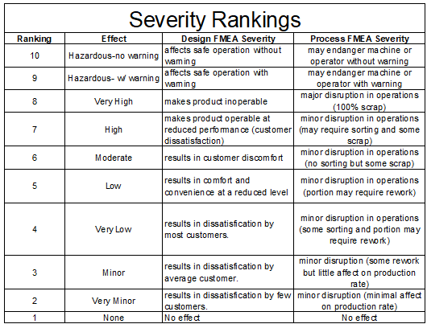
Figure 4 FMEA Severity rankings (Lean Six Sigma Definition. (n.d.).

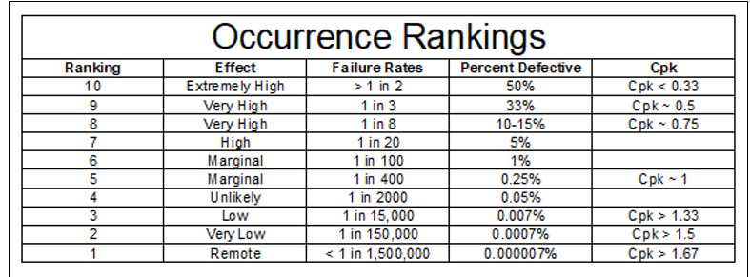
Figure 5 FMEA Occurrence rankings (Lean Six Sigma Definition. (n.d.).

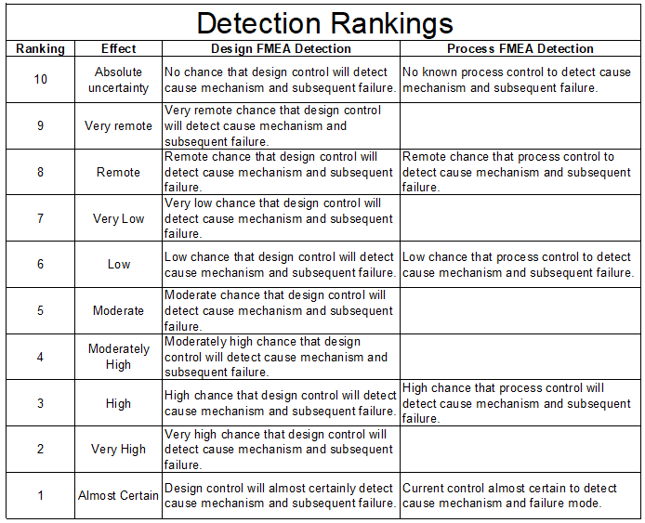
Figure 6 FMEA Detection rankings (Lean Six Sigma Definition. (n.d.).

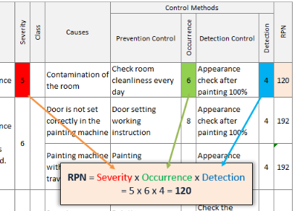
Figure 7 FMEA RPN (risk priority number) score (Hartwell, J. (2017)

Component / Function | Potential Failure Mode | Potential Effect | Severity (S) | Potential Cause | Occurrence (O) | Current Control | Detection (D) | RPN
Phone fit | Case does not fit phone correctly | Phone may fall out or buttons may not align | 5 | Incorrect dimensions or poor tolerance control | 3 | CAD modelling and prototype testing | 2 | 30
Durability | Case cracks under impact | Phone may become damaged | 5 | Weak material or poor wall thickness | 3 | Drop testing | 3 | 45
Grip | Case is slippery | User may drop phone | 4 | Smooth surface finish or poor ergonomic design | 3 | Grip texture testing | 3 | 36
Scratch resistance | Case surface scratches easily | Poor appearance and reduced customer satisfaction | 3 | Low surface hardness | 4 | Material selection and scratch testing | 3 | 36
Weight | Case is too heavy | Reduced comfort and usability | 3 | Material density too high | 3 | Weight checks during design | 2 | 18
Heat resistance | Case deforms when hot | Poor fit or damage to case | 4 | Material has low heat resistance | 2 | Heat resistance testing | 3 | 24
Eco-friendly material | Material is not recyclable or sustainable | Does not meet environmental requirement | 3 | Incorrect material choice | 3 | Material data sheet checks | 2 | 18
Aesthetics | Case looks unattractive or poor finish | Lower customer satisfaction | 3 | Poor surface finish or colour mismatch | 3 | Visual inspection | 3 | 27

Figure 8 Phone case FMEA

3.4 Design of experiments (DOE)

Design of experiments purpose in this case is to optimise the injection moulding process for a phone case. With the ultimate outcome of achieving minimal defects, high degree of dimensional accuracy, a good surface finish and suitable mechanical strength.

3.4.1 Parameters

Some key output metrics should be
Warpage in mm
Shrinkage in %
Cycle times in Seconds
Surface finish in Ra
Using industry guidance the key processing parameters should include
Melt temperature
Injection pressure
Cooling time
Melt temperatures will range from 200°C - 400°C
Injection pressure is measured in megapascals MPa
Cooling Time in Seconds
This will have a great effect on dimensional stability and part quality.
(Rosato and Rosato, 2000; Goodship, 2004; Strong, 2006).

3.4.2 Experimental Design

Taguchi’s method can be applied as it effective in optimising process on a small number of experimental runs. It will also aid in identifying major process factors and help improve overall robustness.
Run | A: Temperature (°C) | B: Pressure (MPa) | C: Cooling Time (s)
1 | 200 | 60 | 10
2 | 200 | 75 | 15
3 | 200 | 90 | 20
4 | 220 | 60 | 15
5 | 220 | 75 | 20
6 | 220 | 90 | 10
7 | 240 | 60 | 20
8 | 240 | 75 | 10
9 | 240 | 90 | 15

Figure 9 Experimental Design
The above layout follows Taguchi L9 Orthogonal array. It allows for the three factors to be investigated efficiently

3.4.3 Analysis procedure

- The next stage is to calculate the signal to noise ratio. The signal shows the desired performance and the noise is process variability.
- Use Analysis of Variance (ANOVA) to identify statistically significant factors.
- Generate response surface or main-effects plots to support visual interpretation of the results.
- Optimise through, smaller = better
(Strong, A.B. (2006) (Phadke, M.S. (1989)

3.4.4 Equipment and materials

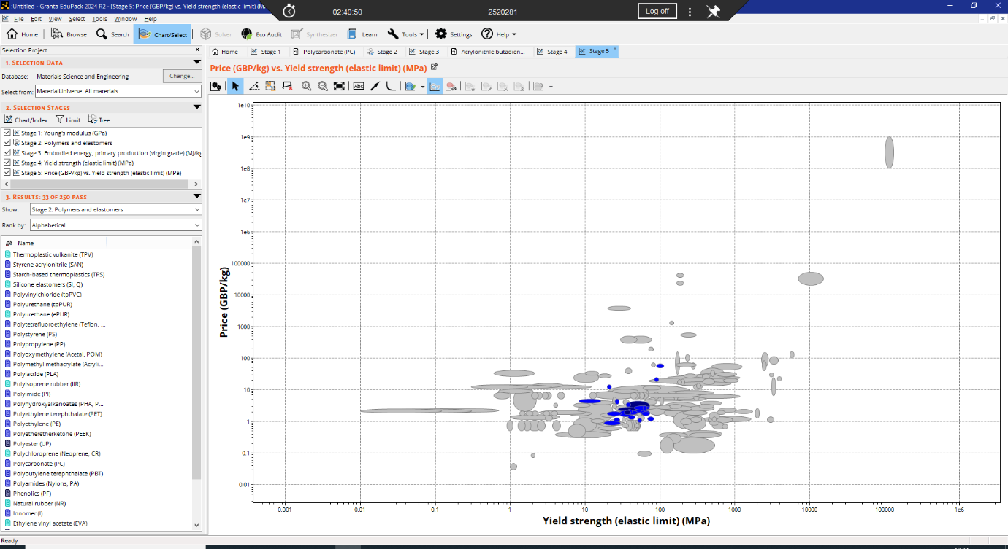

Cost vs Yield strength for thermoplastics (Granta edupack 2026)
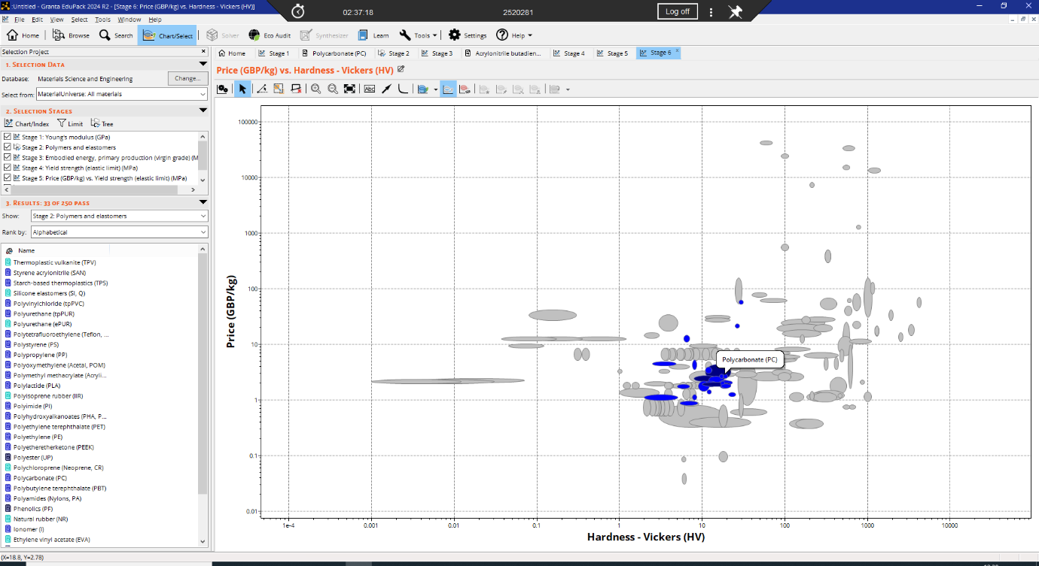
Hardness vs Cost for thermoplastics (Granta edupack 2026)
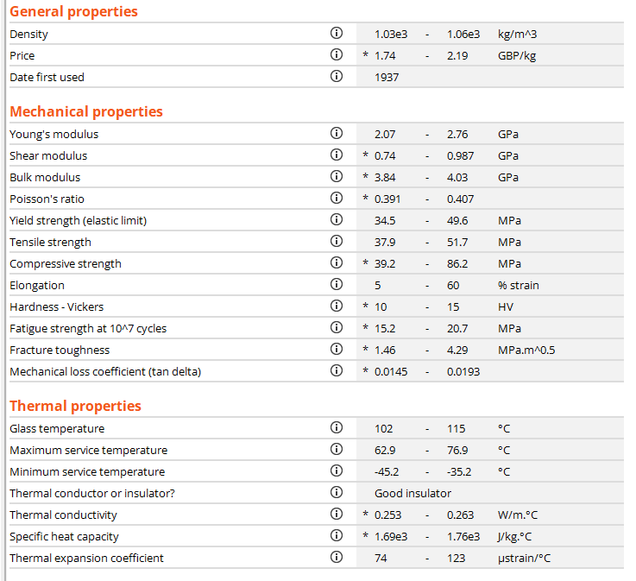
Properties of ABS (Granta edupack 2026)
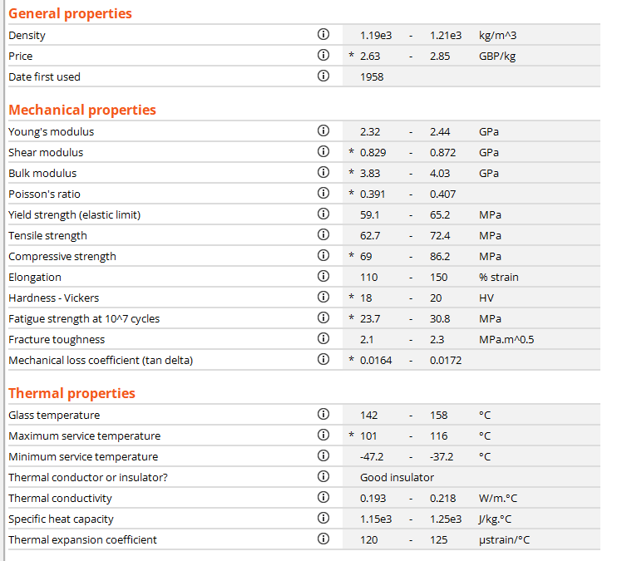
Properties of PC (Granta edupack 2026)
The material selection charts indicate that a PC/ABS blend offers a favourable balance between cost and mechanical performance for an injection moulded phone case. In the cost versus yield strength analysis, PC/ABS lies within a region that provides relatively high yield strength while maintaining a moderate material cost, making it more cost-effective than many higher-performance engineering polymers. This enables adequate structural strength without significantly increasing manufacturing costs.
The cost versus hardness analysis further supports this selection, showing that PC/ABS achieves a useful level of hardness at a comparatively low cost. This combination is advantageous for a phone case, as sufficient hardness improves resistance to scratching and wear, while the polycarbonate component contributes high impact toughness to protect the device during accidental drops.
In addition to its favourable position on both material selection charts, PC/ABS exhibits excellent injection moulding characteristics, good surface finish, and dimensional stability. Therefore, PC/ABS provides the most suitable compromise between strength, hardness, toughness, manufacturability, and cost, making it an optimal material choice for a mass-produced phone case.
MatWeb (n.d.) Granta educpack

3.4.5 Outcome

The expected outcome of this DOE is to identify a combination of processing parameters that minimises defects, improves dimensional accuracy, reduces cycle time, and produces a consistent, high-quality phone case. The Design of Experiments (DOE) methodology identified melt temperature, injection pressure, and cooling time as the primary process variables affecting part quality. Based on established injection moulding principles, cooling time is expected to have the greatest influence on dimensional stability and warpage, while injection pressure significantly affects cavity filling and the formation of defects such as short shots and sink marks. Melt temperature influences material flow behaviour and weld line formation. Therefore, optimisation should focus on achieving adequate cavity filling while maintaining uniform cooling to minimise residual stresses and dimensional variation (Rosato and Rosato, 2000; Strong, 2006; Groover, 2020).

,

4 Design

CAD Design

Using Fusion 360 the phone case was designed based on specification widely available.

4.1.1 Phone case

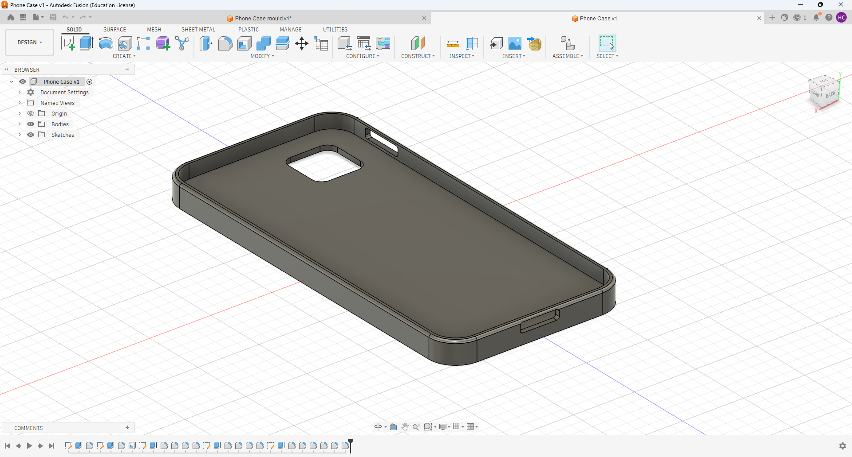
Figure 10 Phone case front in Fusion
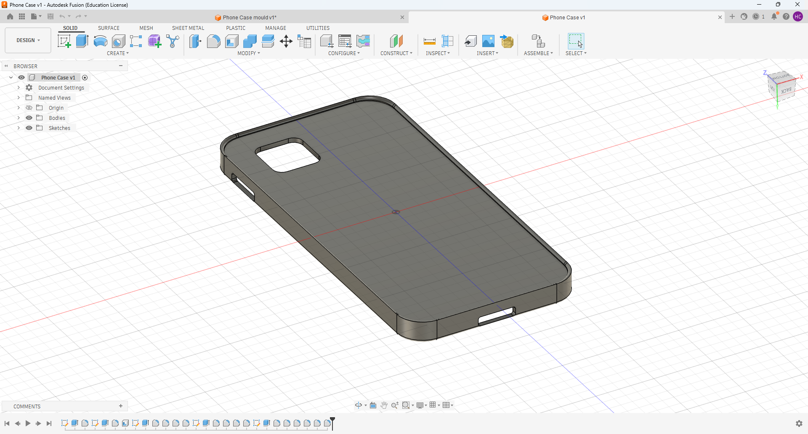
Figure 11 Phone case back in Fusion
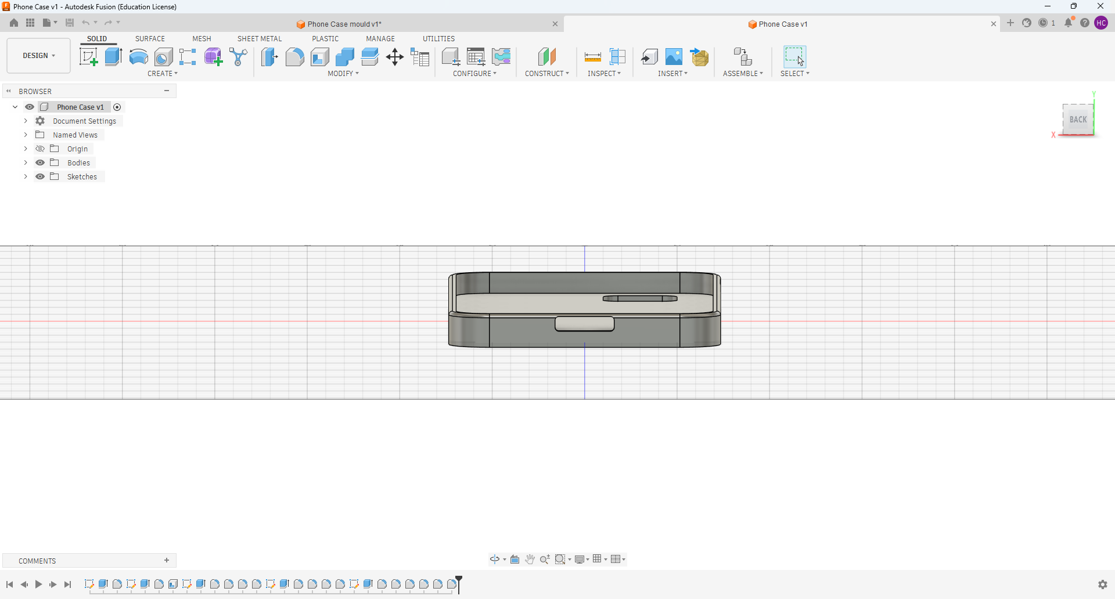
Figure 12 Phone case bottom in Fusion

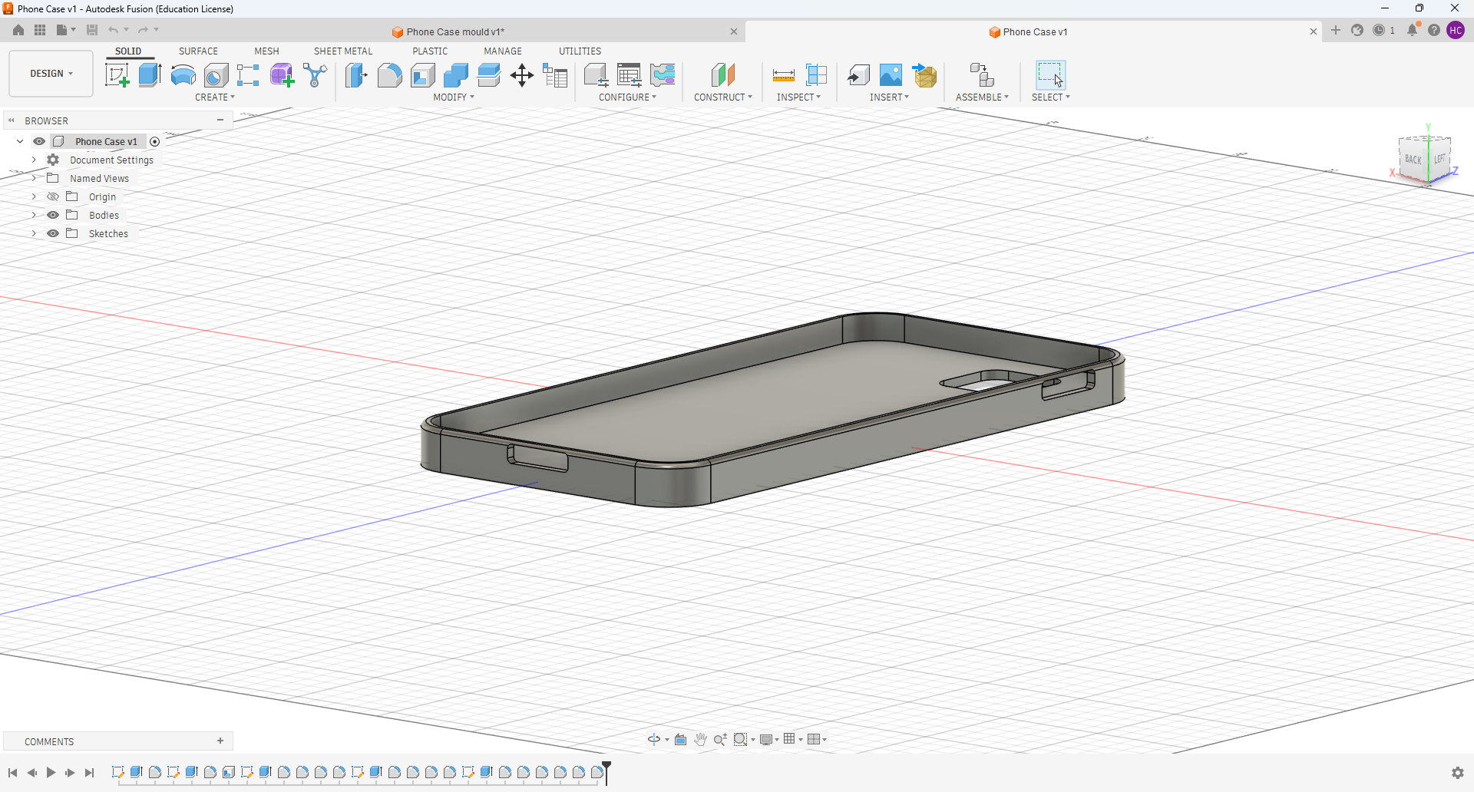
Figure 13 Phone Case side in fusion

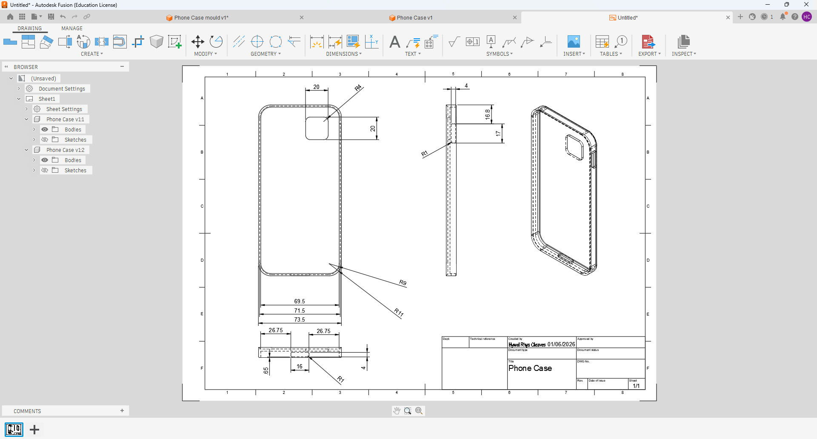

Figure 14 Phone case Drawing

4.1.2 Mould Design

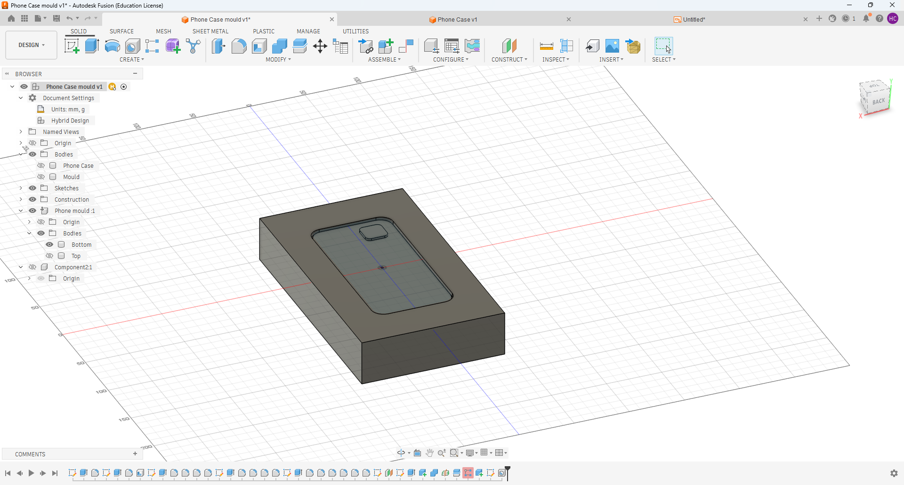
Figure 15 Phone case mould bottom
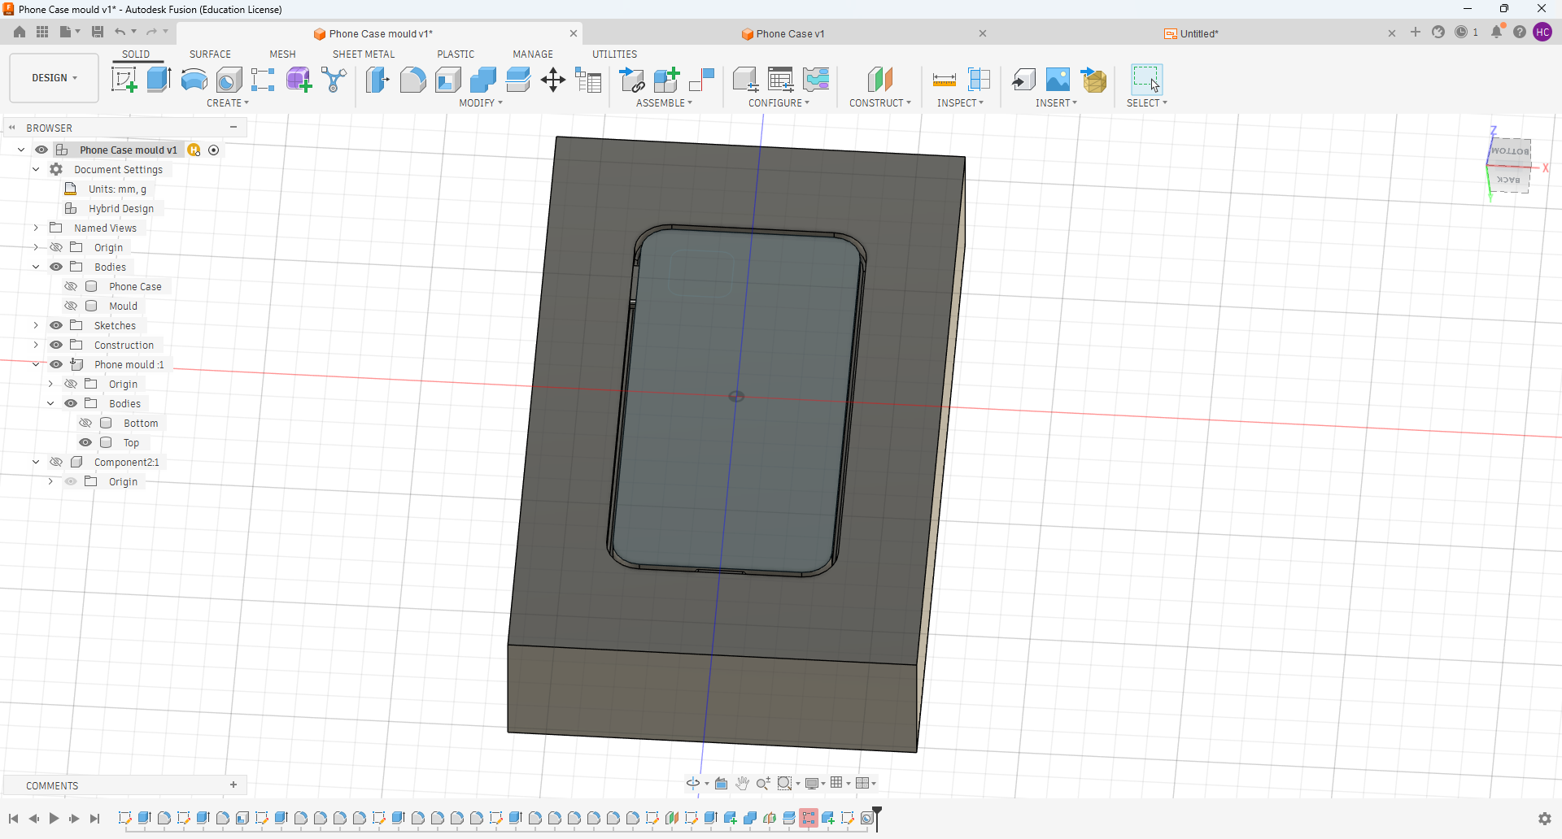
Figure 16 Phone case mould top
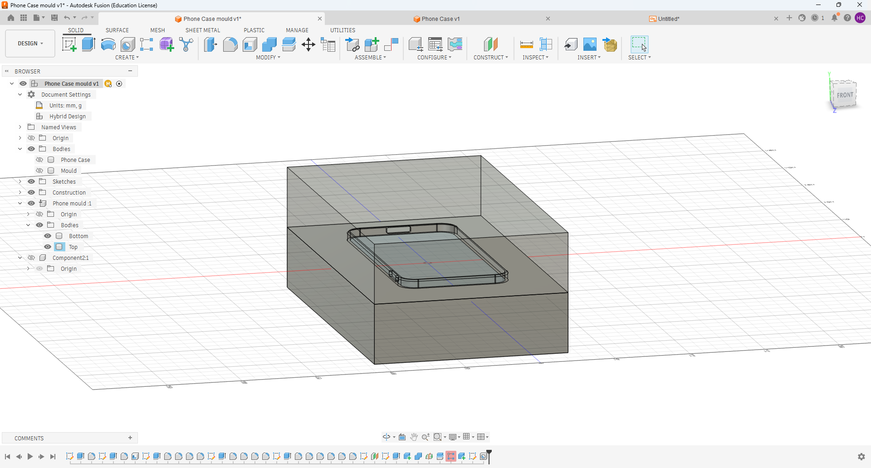

Figure 17 Phone case mould top and bottom with top opacity adjusted for visibility

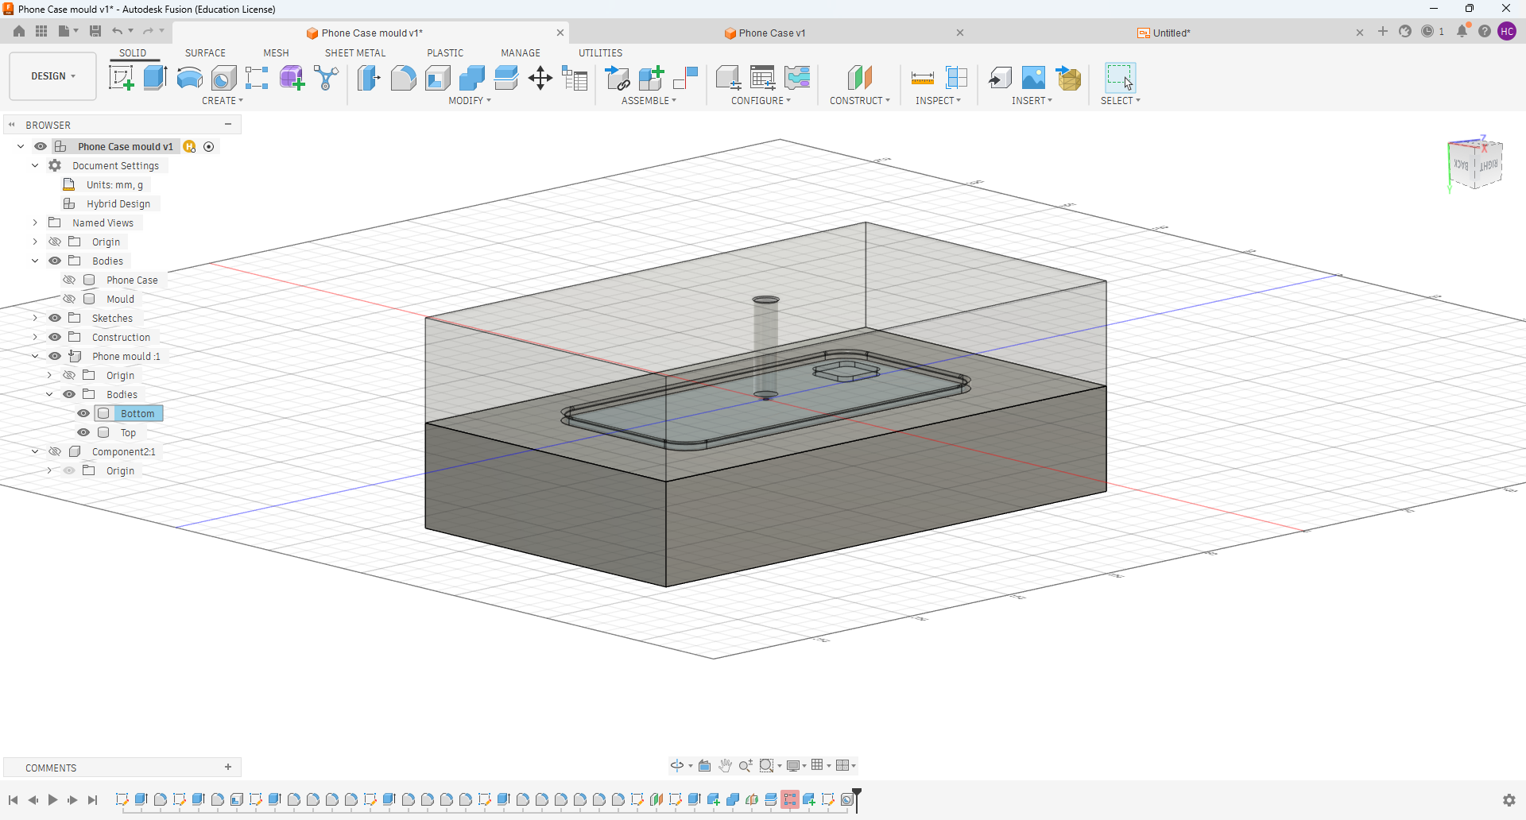

Figure 18 Phone case mould top and bottom with bottom opacity adjusted for visibility

Performance balance, cost and sustainability

The ABS–PC blend demonstrates strong performance within consumer products, in particular where durability and user comfort are critical. The elastomeric nature of the material will reduce brittleness in a cold environment, while polycarbonate (PC) provides excellent strength and impact resistance (Ashby, 2011). This combination also improves compatibility with automated robotic assembly processes, enhancing manufacturing efficiency and reducing the potential for human error. Furthermore, the blend is well suited to phone accessories that may be exposed to a range of environmental conditions. Both components exhibit excellent colour retention, giving manufacturers greater control over product appearance through visuals. (SUKE Plastics 2026)

5 Simulation
Simulations software like Fusion help engineers evaluate
- Material flow through the mold
- Fill time and injection pressure requirements
- Potential defects such as air traps, weld lines, sink marks, and short shots
- Cooling performance and part warpage
- Gate location optimization and manufacturability
By simulating the moulding process before creating tooling, designers can reduce development costs, improve part quality, and identify manufacturing issues early in the design stage.
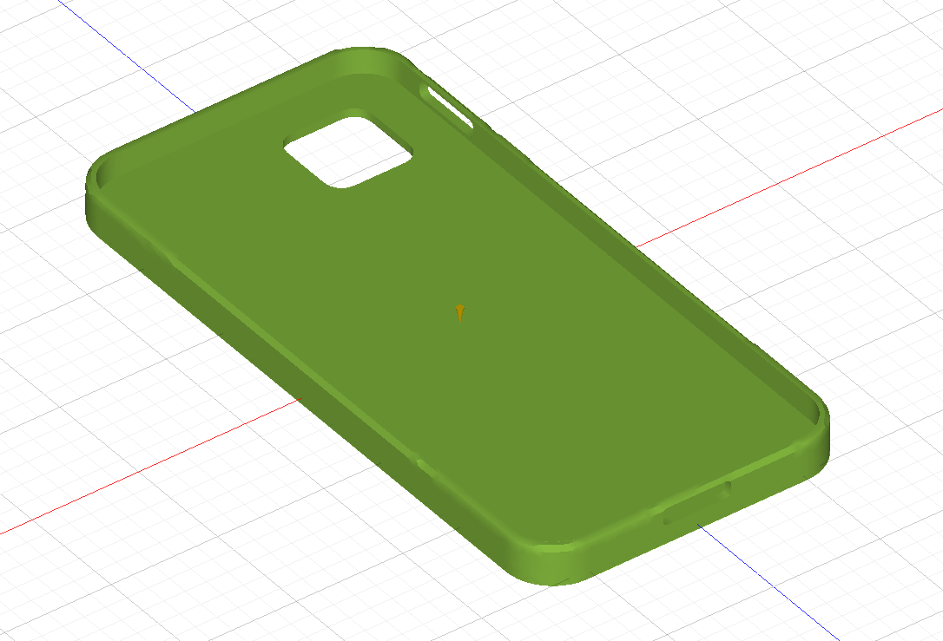

Fusion 360 screenshot showing 100% Fill confidence (Cleaves 2026)
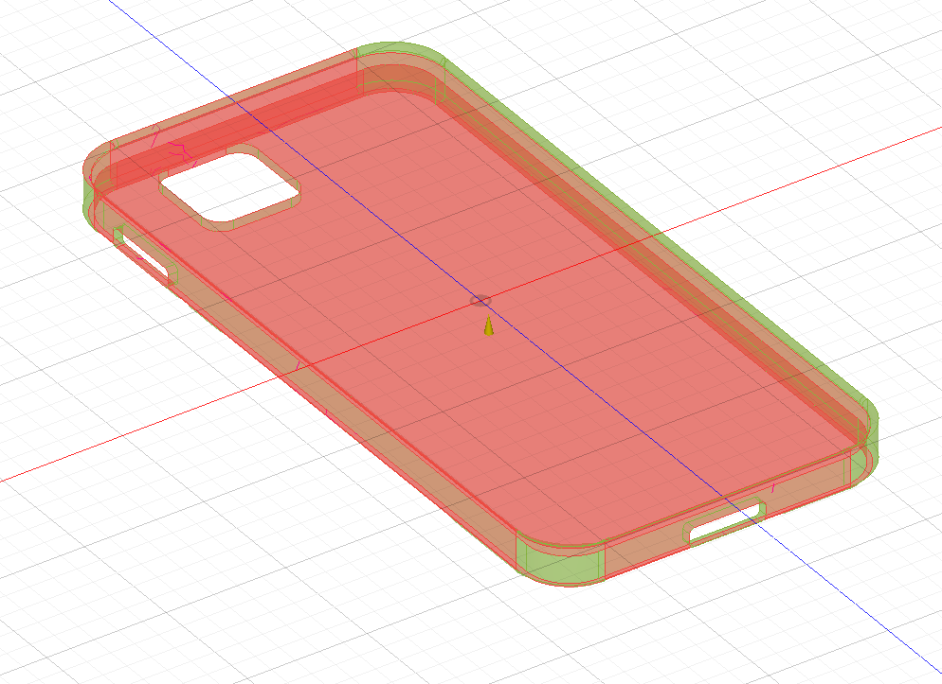
Fusion 360 screenshot showing potential sink marks (Cleaves 2026)
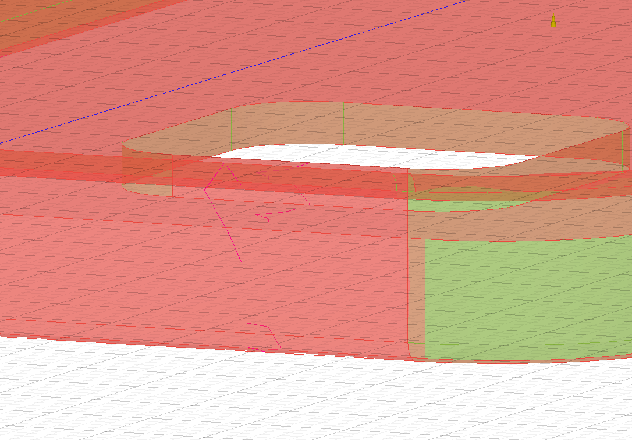
Fusion 360 screenshot showing Weld lines (Cleaves 2026)

5.1 Sink marks and weld lines
Within injection moulding sink lines are shallow depressions which appear on the surface of a component, some common causes are when thicker portions cool and shrink more than the surrounding material, when insufficient material is pushed through the mould during cooling, the face is then pulled backward creating a visible indentation. Some causes could be, excessive wall thickness, short holding time and high temps. A potential solution could be to maintain a uniform wall thickness throughout the case, reducing the thickness of ribs, increasing the packing press and holding time, optimising the gate location and improving cooling efficiency.Weld lines are created when two or more flows meet, and fail to fuse entirely, this will often occur around holes or where multiple gates are used. Potential solutions careful gate placement and by ensuring the melt temperature is within the recommended processing range for the ABS-PC blend.
(Bozzelli, J.W., 2010)

5.2 Warpage
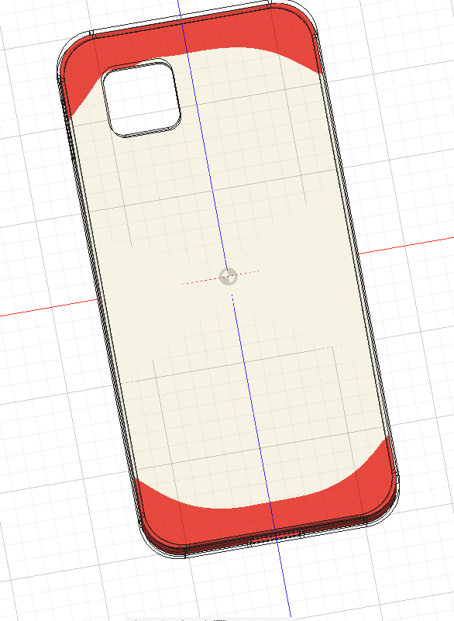

Fusion 360 screenshot showing potential warpage (Cleaves 2026)
Warpage is caused by uneven shrinkage and residual stresses that develop during cooling. This defect can be minimised through uniform wall thickness, balanced cooling, appropriate gate placement, and optimisation of processing parameters such as packing pressure and cooling time, resulting in improved dimensional accuracy and product quality (Bozzelli, 2010; Rosato and Rosato, 2012).

6 Cost

6.1 Material Cost

The material selected for the case is a 60% ABS and 40% PC blend. This provides good impact resistance, excellent dimensional stability, and good processability.
Using current June 2026 European material price estimates, ABS is approximately $2.44/kg and PC is approximately $3.58/kg.
(Mike (2020).
The blended material cost is calculated as:
(0.60 × 2.44) + (0.40 × 3.58) = $2.90/kg
With the average mass of a phone case assumed to be 0.05 kg, the material cost per unit is:
0.05 × 2.90 = $0.145
Therefore, the material cost is approximately $0.15 per unit.

6.2 Production Cost

6.2.1 Machine

Assuming an injection moulding cycle time of 30 seconds and two cases produced per cycle:
(3600 ÷ 30) × 2 = 240 units/hour
Machine operating costs are estimated at $50/hour, including energy use, depreciation, maintenance, and general operating overhead.
50 ÷ 240 = $0.208
Therefore, the machine cost is approximately $0.21 per unit.

6.2.2 Labour

Production labour is estimated at $25/hour, with one operator supervising multiple machines producing approximately 500 units/hour.
25 ÷ 500 = $0.05
Therefore, the labour cost is approximately $0.05 per unit

6.2.3 Tooling costs

A hardened steel production mould suitable for high-volume manufacture is estimated at $20,000. Assuming the mould produces 300,000 parts over its service life:
20000 ÷ 300000 = $0.067
Therefore, the tooling cost is approximately $0.07 per unit.

6.2.4 Total Manufacture cost

The total estimated manufacturing cost per unit is:
0.145 + 0.208 + 0.05 + 0.067 = $0.470
Therefore, the total estimated manufacturing cost is approximately $0.47 per unit.
Boothroyd, G., Dewhurst, P. and Knight, W.A. (2010).
Brydson, J.A. (1999).
Ford, R. and Coulston, C. (2008)

6.3 Break even calculation

To determine the production volume required to recover the tooling investment, a selling price of $0.99 per unit is assumed.
For break-even analysis, tooling is treated as a fixed cost and is therefore excluded from the variable cost per unit.
Variable cost per unit:
0.145 + 0.208 + 0.05 = $0.403
Contribution margin per unit:
0.99 - 0.403 = $0.587
Break-even quantity:
20000 ÷ 0.587 = 34,071 units
This indicates that approximately 34,000 units must be sold to recover the tooling investment.
Although high-quality moulds require significant upfront expenditure, they offer substantial economic advantages in high-volume manufacturing environments. The extended service life of the tooling, combined with low variable production costs, allows profitability to increase rapidly once the break-even threshold has been reached. Effective cost recovery, equipment utilisation, and long-term production stability are key factors contributing to the commercial viability of the product throughout its lifecycle (Ulrich & Eppinger, 2015).

7 Sustainability

7.1 Recyclability

The ABS/Pc blend is a thermoplastic, this allows it to be highly recycled and re-used at the end of its service life. Using a mechanical recycling process all of the waste material can be reprocess and used in new components. This will reduce the amount of waste going to landfill. However, repeated reuse will result in some mechanical performance, this can be countered be selective material separation and controlled processing methods. The use of PC/ABS blends supports sustainable manufacturing practices and contributes to circular economy objectives by promoting resource efficiency and material recovery.
(Plastics Materials by J. A. Brydson)

7.2 Energy use

The ABS-PC blend is well suited to injection moulding due to its good flow characteristics, thermal stability, and moderate processing temperatures. These properties enable efficient mould filling, minimise defects and material waste, and support high-volume production As both ABS and PC are thermoplastics, the blend can also be mechanically recycled, contributing to more sustainable manufacturing practices.
Modern injection moulding machines further improve efficiency through the use of optimised heating systems and servo-electric drives, which reduce energy consumption and cycle times. The compatibility of ABS-PC blends with these technologies supports energy-efficient manufacturing and aligns with sustainability objectives, including compliance with ISO 50001 energy management standards (Bozzelli, 2010; Goodship, 2004; Crawford and Martin, 2020).

7.3 Waste reduction

The simple product design and use of a single ABS-PC material blend contribute to waste reduction during manufacturing. Standardised production methods minimise material usage and reduce scrap generation, while the uncomplicated geometry eliminates the need for many secondary finishing operations, such as trimming (Boothroyd et al., 2010).
In addition, the ABS-PC blend exhibits good flow characteristics during injection moulding, allowing for consistent cavity filling and uniform wall thickness. This helps reduce defects such as warpage, air traps, and incomplete filling, thereby lowering rejection rates and material waste (Brydson, 1999). As a thermoplastic material, ABS-PC can also be mechanically recycled and reintroduced into the production cycle, further supporting sustainable manufacturing practices (Callister and Rethwisch, 2020).

8. Conclusion

This report investigated the design and manufacture of a mobile phone case using Design for Manufacture and Assembly (DFMA) principles. The objective was to develop a lightweight, durable, cost-effective, and sustainable product suitable for high-volume production while incorporating integrated mounting features, snap-fit fasteners, and ventilation slots.
A review of relevant literature demonstrated the importance of Design for Manufacture (DFM) and Design for Assembly (DFA) in reducing manufacturing complexity, minimising production costs, and improving product quality. Injection moulding was identified as the most suitable manufacturing process due to its ability to produce complex geometries with high dimensional accuracy, excellent repeatability, and low unit costs at large production volumes.
Customer requirements were translated into engineering specifications through the Quality Function Deployment (QFD) process, highlighting the importance of dimensional accuracy, durability, impact resistance, and material selection. A Failure Modes and Effects Analysis (FMEA) was conducted to identify potential risks within the design and manufacturing process, allowing key failure modes to be evaluated and mitigated before production. In addition, a Design of Experiments (DOE) approach was proposed to optimise injection moulding parameters and reduce the likelihood of defects such as warpage, shrinkage, and surface imperfections.
The phone case was designed using Fusion 360 and supported by mould design development suitable for injection moulding. Manufacturing simulations demonstrated a high fill confidence while identifying potential sink marks, weld lines, and warpage areas. These results enabled design improvements to be considered at an early stage, reducing development costs and improving manufacturability before tooling investment.
Material selection identified an ABS-PC blend as the most appropriate solution due to its combination of impact resistance, dimensional stability, thermal performance, and processability. Cost analysis demonstrated that the design is commercially viable, with an estimated manufacturing cost of approximately $0.47 per unit and a break-even point of approximately 34,071 units. Furthermore, the use of recyclable thermoplastic materials and energy-efficient injection moulding processes supports sustainable manufacturing objectives and aligns with circular economy principles.
Overall, the proposed phone case design satisfies the project requirements by balancing performance, manufacturability, cost-effectiveness, and sustainability. The application of DFMA methodologies, supported by simulation, risk analysis, and economic evaluation, demonstrates how engineering design tools can be used to optimise both product performance and manufacturing efficiency for large-scale production.

References
Bralla, J.G. (1999). Design for Manufacturability Handbook. McGraw Hill Professional.
‌ Dfma.com. (2025). What is DFMA? | Design for Manufacturing and Assembly Explained. [online] Available at: https://www.dfma.com/resources/what-is-dfma.asp.
Ashby, M.F. (2011) Materials Selection in Mechanical Design. 4th edn. Oxford: Butterworth-Heinemann
Boothroyd, G., Dewhurst, P. and Knight, W.A. (2010) Product Design for Manufacture and Assembly. 3rd edn. Boca Raton, FL: CRC Press.
Malloy, R.A. (2010) Plastic Part Design for Injection Molding: An Introduction. 2nd edn. Munich: Hanser Publishers.
Ellen MacArthur Foundation (2013) Towards the Circular Economy: Economic and Business Rationale for an Accelerated Transition. Cowes, UK: Ellen MacArthur Foundation.
Boothroyd, G., Dewhurst, P. and Knight, W.A. (2010) Product Design for Manufacture and Assembly. 3rd edn. Boca Raton, FL: CRC Press.
Ashby, M.F. (2011) Materials Selection in Mechanical Design. 4th edn. Oxford: Butterworth-Heinemann.
Bonenberger, P.R. (2005) The First Snap-Fit Handbook: Creating Attachments for Plastic Parts. Cincinnati: Hanser Gardner Publications.
Trumould (2023). How Does Injection Molding Work – An Introduction. [online] TRU MOULD. Available at: https://trumould.com/how-does-injection-molding-work-an-introduction/.

Kalpakjian, S., & Schmid, S. R. (2014). Manufacturing Processes for Engineering Materials (6th ed.). Pearson.
Fundamentals of Modern Manufacturing Groover, M.P. (2020) Fundamentals of Modern Manufacturing: Materials, Processes, and Systems. 8th ed. Wiley.
Manufacturing Processes for Engineering Materials Kalpakjian, S. and Schmid, S.R. (2014) Manufacturing Processes for Engineering Materials. 6th ed. Pearson.
Quality Function Deployment Cohen, L. (1995). Quality Function Deployment: How to Make QFD Work for You. Addison-Wesley.
‌ Design and Analysis of Experiments Montgomery, D.C. (2019). Design and Analysis of Experiments. 10th ed. Wiley.
Matmatch (2024) Polycarbonate (PC): Properties, Applications and Uses.
Ashby, M.F. and Johnson, K. (2014) Materials and Design: The Art and Science of Material Selection in Product Design. 3rd edn. Oxford: Butterworth-Heinemann.
Akao, Y. (1990) Quality Function Deployment: Integrating Customer Requirements into Product Design. Portland, OR: Productivity Press.
Hauser, J.R. and Clausing, D. (1988) 'The House of Quality',
Stamatis, D.H. (2003) Failure Mode and Effect Analysis: FMEA from Theory to Execution. 2nd edn. Milwaukee, WI: ASQ Quality Press.
SUKE Plastics (2026) PC/ABS Blends for Electronics & Consumer Goods.
Lean Six Sigma Definition. (n.d.). FMEA – Lean Manufacturing and Six Sigma Definitions.
‌ Hartwell, J. (2017). FMEA RPN - Risk Priority Number, Calculation and Evaluation. [online] IQASystem. Available at: https://www.iqasystem.com/news/risk-priority-number/.
‌Rosato, D.V. and Rosato, D.V. (2000) Injection Molding Handbook. 3rd edn. Boston: Kluwer Academic Publishers.
Strong, A.B. (2006) Plastics: Materials and Processing. 3rd edn. Upper Saddle River, NJ: Pearson Prentice Hall.
Ashby, M.F. (2011) Materials Selection in Mechanical Design. 4th edn. Oxford: Butterworth-Heinemann.
Groover, M.P. (2016). Fundamentals of Modern Manufacturing: Materials, Processes, and Systems. 6th ed. Hoboken, NJ: Wiley.

Boothroyd, G., Dewhurst, P. and Knight, W.A. (2010). Product Design for Manufacture and Assembly. 3rd ed. CRC Press.
Ford, R. and Coulston, C. (2008). Design for Manufacture: A Structured Approach. Pearson Education.
Brydson, J.A. (1999). Plastics Materials. 7th ed. Butterworth-Heinemann.
Ulrich, K.T. and Eppinger, S.D. (2015). Product Design and Development. 6th ed. New York: McGraw-Hill Education.
Bozzelli, J.W. (2010) Injection Molding Handbook. 3rd ed. Munich: Hanser Publishers.

Plastics Materials by J. A. Brydson. Oxford: Butterworth-Heinemann, 1999.
Bozzelli, J.W., 2010. Injection Molding Handbook. 3rd ed. Munich: Hanser Publishers.
Rosato, D.V. and Rosato, D.V., 2012. Injection Molding Handbook. 3rd ed. Boston: Springer.
MatWeb (n.d.) Overview of Materials for Polycarbonate/ABS Alloy. Available at: MatWeb.
Mike (2020). ABS (acrylonitrile-butadiene-styrene copolymer) price index. [online] businessanalytiq. Available at: https://businessanalytiq.com/procurementanalytics/index/abs-price-index/.

Figure 1 Injection moulding process (Trumould (2023).
Figure 2 Customer needs rating QFD
Figure 3 House of quality
Figure 4 FMEA Severity rankings (Lean Six Sigma Definition. (n.d.).
Figure 5 FMEA Occurrence rankings (Lean Six Sigma Definition. (n.d.).
Figure 6 FMEA Detection rankings (Lean Six Sigma Definition. (n.d.).
Figure 7 FMEA RPN (risk priority number) score (Hartwell, J. (2017)
Figure 8 Phone case FMEA
Figure 9 Experimental Design
Figure 10 Phone case front in Fusion
Figure 11 Phone case back in Fusion
Figure 12 Phone case bottom in Fusion
Figure 13 Phone Case side in Fusion
Figure 14 Phone case Drawing
Figure 15 Phone case mould bottom

