
CERTIFICATE OF HIGHER EDUCATION BA (HONS) LEADERSHIP AND MANAGEMENT SKILLS IN THE WORKPLACE

RESEARCH TOPIC: INVESTIGATING THE IMPACT OF OUT-OF-STOCK PRODUCTS AND LIMITED CASH TILLS ON CUSTOMER EXPERIENCE IN TESCO STORES
A DISSERTATION SUBMITTED IN PARTIAL FULFILMENT OF THE REQUIREMENTS
FOR THE AWARD OF THE CERTIFICATE OF HIGHER EDUCATION
SUBMITTED BY: GURPREET KAUR

STUDENT NUMBER: 2309090

MODULE: LCLM6005
SUPERVISOR: MR MAZEN JOUREIH
JULY 2026

DEDICATION
This dissertation is dedicated to my family who have supported and loved me throughout this journey without any doubt. To my parents who gave me the value of learning, perseverance, and hard work. To friends and colleagues, who encouraged me when I needed it the most. And to anyone who has ever found an empty shelf or a closed till because there was nobody there to help — may this work help in some small way to make the small things in life better.

ACKNOWLEDGEMENTS
I would like to express my sincere gratitude to my supervisor, Mr Mazen Joureih, for his invaluable guidance, constructive feedback and continued support throughout this research. His knowledge and experience have greatly influenced the content and direction of this dissertation. Great thanks also go to the 43 people who took the time to complete the questionnaire, the honest, thoughtful results of which made this study possible. Lastly, I would like to express my gratitude to the University of Wales Trinity Saint David for allowing me to conduct this study.

EXECUTIVE SUMMARY
This dissertation investigates the impact of out-of-stock products and limited cash tills on customer experience in Tesco stores. The study is informed by two recurring issues in operation: the lack of availability of often requested products, especially perishable goods, and insufficient provision of staffed, cash-receptive tills that disproportionately disadvantage customers who pay with cash in a more cashless retail sector.
The study is based on two theories. The Stock-Out Response Behaviour Theory is an explanation of the customers' behaviour reactions to product unavailability, which would include substitution, brand switching, postponement, and purchase abandonment. According to the Expectation-Confirmation Theory, customer satisfaction is based on the extent to which the customer's expectations are met, and any discrepancies can result in a negative outcome. These can be used as a lens to view how operational failures at Tesco create dissatisfaction and drive customers' behaviour.
The main research approach is secondary data analysis, as the focus of the study is on examining secondary data gathered from Tesco PLC Annual Reports and Preliminary Results, Financial Conduct Authority publications, Office for National Statistics retail data, Payment Systems Regulator reports, industry research and analysis by Mintel and Kantar Worldpanel. An online questionnaire, using Google Forms, was used to gather this secondary evidence, asking 43 adult Tesco customers to complete, giving supporting evidence on a customer-by-customer basis.
Key findings include: Tesco has reported it has a line availability of around 98% for products, while 81.4% of the people who filled in the questionnaire said that they had had at least one stock-out in the last 3 months. More importantly, half of shoppers (60.5%) have not been able to pay by cash at Tesco at least once because of the lack of staffed tills. The mean scores were below the neutral point (3.0) for all seven Likert scales of satisfaction, with the lowest mean score being for cash-till availability (2.28).
As a result, the dissertation suggests four evidence-based recommendations for Tesco, which are to implement real-time inventory monitoring in high-turnover perishable categories, increase stock forecasting at the store level, ensure the minimum quantity of cash accepting tills at all times, and implement dedicated lanes for cash-paying customers as express checkout lines. The recommendations are actionable and evidence-based from both the secondary as well as the primary sources.

Table of Contents
DEDICATION 2
ACKNOWLEDGEMENTS 3
EXECUTIVE SUMMARY 4
CHAPTER 1: INTRODUCTION 9
1.1 Introduction 9
1.2 Background of the Study 9
1.3 Problem Statement 10
1.4 Research Rationale and Significance 10
1.5 Research Aim and Objectives 11
1.6 Research Questions 11
1.7 Chapter Summary 12
CHAPTER 2: LITERATURE REVIEW 13
2.1 Introduction 13
2.2 Theoretical Framework 13
2.2.1 Stock-Out Response Behaviour Theory 13
2.2.2 Expectation-Confirmation Theory 14
2.3 Out-of-Stock Products, Customer Satisfaction and Buying Behaviour 15
2.4. Self-Service Checkout Systems & Customer Experience 16
2.5 Cash Payment Preferences and Financial Inclusion in UK Retail 17
2.6 Cash Payment Restrictions and Wait at Check out 18
2.7 Customer Loyalty and Retention in Retail Operations 18
2.8 Methodological Approaches in Prior Studies 18
2.9 Research Gap 19
2.10 Chapter Summary 19
CHAPTER 3: RESEARCH METHODOLOGY 21
3.1 Introduction 21
3.2 Research Philosophy 21
3.3 Research Approach 21
3.4 Research Design 22
3.5 Research Strategy: Secondary Data Analysis 22
3.6 Types of Secondary Data Sources 22
3.7 Search Strategy 23
3.8 Inclusion and Exclusion Criteria 23
3.9 Source Credibility Assessment 23
3.10 Supplementary Primary Component: Online Questionnaire 24
3.11 Data Analysis 25
3.12 Ethical Considerations 25
3.13 Limitations of the Methodology 25
3.14 Chapter Summary 26
CHAPTER 4: FINDINGS AND ANALYSIS 27
4.1 Introduction 27
4.2 Participant Profile (Questionnaire Section A) 27
4.3 Research Question 1: Impact of Out-of-Stock Products on Customer Satisfaction and Buying Behaviour 30
4.3.1 Secondary Data Evidence 30
4.3.2 Questionnaire Corroboration 31
4.4 Research Questions 2 and 3: Cash Till Availability, Waiting Time and Customer Experience 34
4.4.1 Secondary Data Evidence 34
4.4.2 Questionnaire Corroboration 35
4.5 Likert Scale Analysis 38
4.6 Research Question 4: Operational Improvements 39
4.7 Chapter Summary 42
CHAPTER 5: CONCLUSIONS AND RECOMMENDATIONS 43
5.1 Introduction 43
5.2 Conclusions in Relation to the Research Aim and Objectives 43
5.3 Theoretical Implications 44
5.4 Recommendations for Tesco 45
5.5 Limitations and future research. 45
5.6 Chapter Summary 45
6.0 REFERENCES 47

List of figures
Figure 1: Stock-Out Response Behaviour Theory applied to the Tesco retail context (adapted from Kumar, Hofer and Peinkofer, 2023). 14
Figure 2: Age Distribution of Participants (n=43) 28
Figure 3: Gender of Participants (n=43) 28
Figure 4: Shows the frequency of the items people shop from Tesco (n=43). 29
Figure 5: Tesco Clubcard Ownership (n=43) 29
Figure 6: Frequency of Out-of-Stock Experience in Last 3 Months (n=43) 31
Figure 7: Product Categories Most Frequently Out of Stock (n=43) 31
Figure 8: shows customers' reactions when they find that the product is out of stock. 32
Figure 9: Satisfaction with Product Availability at Tesco (n=43) 32
Figure 10: Extent to Which Out-of-Stock Products Affect Overall Satisfaction (n=43) 33
Figure 11: Preferred Payment Method at Tesco (n=43) 34
Figure 12: Ease of Finding an Available Cash Till (n=43) 35
Figure 13: Average Waiting Time at Checkout (n=43) 35
Figure 14: Experience of Being Unable to Pay by Cash at Tesco (n=43) 36
Figure 15: Effect of Queue Length on Overall Shopping Satisfaction (n=43) 36
Figure 16: Mean Likert Scale Scores — Overall Satisfaction Statements (n=43) 37
Figure 17: Proposed Correction to Product Availability (n=43) 38
Figure 18: Suggested Improvements to Cash Checkout Provision (n=43) 38
Figure 19: Single Most Important Operational Improvement (n=43) 39

CHAPTER 1: INTRODUCTION

1.1 Introduction
The retail supermarket industry has experienced significant transformation in the past few decades, with technology, consumer expectations, and increasing competition being among the factors driving this change ( Yang, Chen and Zheng, 2025). One of the most obvious changes has been the use of self-service checkout by big supermarket chains, which was driven mainly by operational efficiency and labour savings to help speed up checkout time for customers. Even with this investment, some ongoing issues need to be addressed that leave the whole shopping experience marred. Among the most common are product out-of-stock (OOS) events and insufficient cash payment facilities in self-service check-out (SSC) queues, which have been associated with longer waiting times and customer inconvenience with cash payment and lower satisfaction (Stanković et al., 2024). The background to the research, the problem to be investigated, the rationale and significance of the study, as well as the aim and objectives of the research and the research questions are described in this chapter. This is followed by a summary of the organization of the remaining chapters of the dissertation.

1.2 Background of the Study
Tesco was established in 1919 by Jack Cohen and is based in Welwyn Garden City, United Kingdom. It is a leading British multinational company in grocery and general merchandise and is still the UK's biggest grocery chain with 28.7% of the market as of December 2025, which is the highest since March 2015, and is accessible to millions of customers via its physical stores and online channels (Tesco PLC, 2026). Over the last ten years, the UK grocery sector, where Tesco has a presence, has been hugely competitive.
By December 2025, the share of sales of large-format stores accounted for by Aldi and Lidl had reached over 18% (Kantar Worldpanel, 2026), and the constant growth of the online grocery delivery sector has pushed large-format stores to put more effort into operational excellence to win customer loyalty instead of competing with lower prices. The consequences of any shortcoming in the core service offering are amplified because in this environment, customers have more realistic alternatives than they ever have before in the trading history of Tesco in either the product they can access on the shelf or the payment methods they have when they reach the checkout.
Like many supermarkets, achieving a continuous flow of stock and providing flexible and convenient payment procedures is key to ensuring customer satisfaction, operational efficiency and competitive edge (Al Najjar and Qandeel, 2025). A failure in either of these areas of operation can put the retailer's ability to retain customers and market share in jeopardy. The present research takes place within the operational context in which both self-service technology is an integral part of the service, and supply and payment-related friction exists.

1.3 Problem Statement
Tesco is dealing with issues in operations due to frequent stockouts and an insufficient number of cash-enabled tills in the self-service checkouts, which have a significant impact on customer experience (Court, 2026). When products are not available, shopping behavior is affected and frustrates and dissatisfies consumers. Stockout events, therefore, are not just a nuisance in the short run, but also portents of the retailer's inventory management system and its inability to deliver on its promises, as over time it can result in diminished consumer trust in the retailer's operation and capability. (Kumar, Rabbani and Khan, 2024) Meanwhile, inadequate cash tills lead to longer waiting times for paying with cash, which is a factor that disproportionately affects customers who wish or rely on cash payments (Li and Zeng, 2024). In this study, both of these operational gaps are taken together and not separately, as they both influence the customer experience, the number of customers who stay in the stores, and the overall performance of Tesco stores, as these two are related to each other.

1.4 Research Rationale and Significance
In the ever-changing business landscape, organisations are increasingly turning to operational efficiencies and customer experiences to gain a competitive advantage (Al Najjar and Qandeel, 2025; Kotler and Keller, 2016). This study is thus timely and relevant because it addresses two operational problems, availability of the product and checkout efficiency, the impact of which on customer satisfaction, customer loyalty, and purchasing behaviour has been documented separately with unclear research results, but which often have not been researched together. The theoretical lenses adopted in this study are two complementary theories developed completely in Chapter Two, namely Stock-Out Response Behaviour Theory which gives insight into the consumer's response to the absence of a product in the store (Kumar, Hofer and Peinkofer, 2023) and the Expectation-Confirmation Theory which explains customer satisfaction as a result of comparing pre-purchase expectations with actual performance of the service (Oliver, 1980; Ramasamy, Ramasamy and Ramasamy, 2024). Previous studies have considered 'Stock Out' and ‘checkout time' as discrete events, but there is limited research that considers both events in a single large UK retailer (Gruen and Corsten, 2021). This research will therefore provide new, integrated evidence based on a secondary data analysis and primary data gathered from questionnaires sent out to customers to provide both academic understanding of the retail customer experience, as well as practical evidence to aid in decision making within Tesco's store operations.

1.5 Research Aim and Objectives
This research aims to investigate the impact of out-of-stock products and limited cash tills on customer experience in Tesco stores. To attain this, the study has four objectives which are stated below:
- To examine the impact of out-of-stock products on customer satisfaction and buying behaviour in Tesco.
- To establish the perceptions of customers about the availability of cash tills in self-service checkout areas.
- To investigate the impact of the checkout system limitations on the wait time and customer experience in Tesco stores.
- To identify possible operational improvements that could increase inventory availability and checkout efficiency in Tesco.

1.6 Research Questions
To ensure that each objective is met, the study is divided into four research questions that correspond directly to the four objectives.
RQ1: What is the impact of out-of-stock products on customer satisfaction and buying behaviour in Tesco stores?
RQ2: What is Tesco's customers' perception of the availability of cash tills in their self-service checkouts?
RQ3: What are the impacts of the ‘checkout systems limits' on waiting time and customer experience in Tesco stores?
RQ4: What further changes could be made to improve the efficiency of the checkout queue and the availability of the stock in Tesco?

1.7 Chapter Summary
This chapter has provided an introduction to the research, including an outline of the operational issues Tesco encounters with product availability and the provision of checkout service; the problem statement, rationale, aim and objectives, and research questions for the research study. The rest of the dissertation in the following order. Chapter Two summarizes and critically evaluates the literature regarding out-of-stock situations, self-service checkout systems, and customer experience in the retail setting. The research methodology is presented in Chapter Three, along with its justification, covering a secondary data analysis strategy as well as a supplemental online questionnaire. The results from both are reported and discussed in Chapter Four. The dissertation is rounded up with Chapter Five, which summarizes the main findings, offers their implications for theory and practice, as well as outlining the limitations of the study and recommendations for further research.

CHAPTER 2: LITERATURE REVIEW

2.1 Introduction
This chapter critically reviews the body of literature relevant to the study's twin focus on product out-of-stock situations and limited cash-till provision in self-service checkout areas, and their combined effect on customer experience. The chapter starts by describing the theory that has guided the research, followed by an empirical analysis of out-of-stock situations, self-service checkout systems, cash payment preferences, financial inclusion, waiting time at checkout, and customer loyalty. This dissertation is concluded by stating the particular research gap addressed herein.

2.2 Theoretical Framework

2.2.1 Stock-Out Response Behaviour Theory
The Stock-Out Response Behaviour Theory describes the responses customers may have when the product they want is not found on the racks (Kumar, Hofer and Peinkofer, 2023). The theory distinguishes several key behavioral reactions available: substitution of the unavailable product with another product, changing to another brand, postponing purchases until the product is available, or giving up the purchase. These are not any arbitrary choices, but rather mirror the actual brand loyalty of the customer, the perceived availability of close substitutes, and the need of the customer that is being fulfilled (Ezhil Kumar, Sharma and Tapar, 2021).
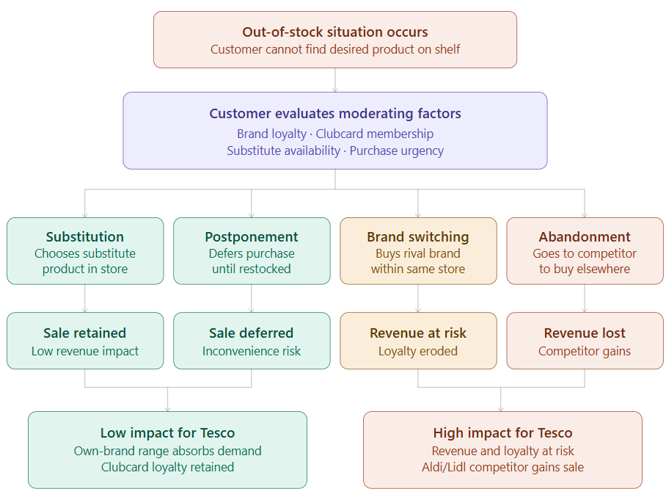
Figure 1: Stock-Out Response Behaviour Theory applied to the Tesco retail context (adapted from Kumar, Hofer and Peinkofer, 2023).
The theory fits in very well with the behaviour of customers of Tesco, but with some important qualifications. Tesco's giant size as a shopping retailer allows it to have a significantly varied own-brand range, from value to standard and premium, which makes it possible to really substitute in-store unusually. Conversely, as a consumer-based scheme, Tesco's Clubcard scheme provides strong financial incentives for maintaining customer loyalty, even if it is not possible to switch to a new brand that carries the same loyalty program, a more economic response for customers than the theory suggests. But that loyalty system could be put to the test by the ongoing rise of discount retailers and the pressure of living with rising costs at present (Kantar Worldpanel, 2026). Secondary and additional primary evidence seems to be important in this study to examine whether the unique nature of the retail context and loyalty mechanisms at Tesco 'clouded' the theoretical prediction.

2.2.2 Expectation-Confirmation Theory
According to the Expectation-Confirmation Theory of Customer Satisfaction, it is when the customer compares their expectations about the service he or she was seeking with what they actually received (Oliver, 1980; Ramasamy, Ramasamy and Ramasamy, 2024). Negative disconfirmation takes place when performance is lower than expected, leading to dissatisfaction and a reduction in the perceived quality of service, whereas positive disconfirmation takes place when performance has met or exceeded expectations, thus creating satisfaction.
The theory needs to be applied in the context of the Tesco store, with a greater focus on the formation of customer expectations in this retail setting. Tesco's own marketing, such as the Clubcard Prices campaign and its 100-year reputation of trading, can actively send a message to the customer before they enter the store and can cause a disconfirmation when checking out, and make them feel like they let the brand down, which extends their dissatisfaction beyond what is estimated by the conventional applications of the theory (Kotler and Keller, 2016). What is missing here is something for frequent “Tesco,” or “CB” shoppers: over time they may be expected to lower their standards when they repeatedly encounter a situation where there is no adequate cash-till, or limited products, and adjust accordingly. A version of the theory has been suggested to describe this process of expectation recalibration, but it is not explicitly modeled here. This poses an extremely important question to which the secondary and supplementary primary evidence is specifically geared to answering.
However, the following two theoretical approaches are not mutually exclusive. The two theoretical views are not contradictory, however.
These two theories have a different background, one behavioural marketing, the other services marketing, but they are not conflicting theories, but complementary. The first takes care of what a customer does after the problem happens; the second is about how a customer feels about it. When read together, they imply two stages: the initial failure causes a disconfirmation of the customer's belief on the cognitive and emotional level, and that subsequently influences the behavioural actions he ultimately takes.
Most importantly, boundary conditions for each theory are linked to each other in a manner specific to the retailer, who is influenced by Tesco's size and customer base. This disconfirmation can be lessened by a loyal, Clubcard-holding customer who no longer expects the store to have all the items. A loyal customer carrying a Clubcard may have different expectations that a given level of stock-out will cause a milder disconfirmation response to the extent that it is less likely to prompt the loyal customer to switch brands or abandon the store. The research design used in this research is influenced by both theories and pays attention to the possibility that the combined effect of both theories is moderated by loyalty and frequency of shopping in the context of Tesco. This study will be discussed in detail in Chapter Three.

2.3 Out-of-Stock Products, Customer Satisfaction and Buying Behaviour
When a customer orders a product that is unavailable at the time and place of the order, it is known as an out-of-stock (OOS) product and is considered a key indicator of the shortcomings in inventory control and forecast of demand (Stanković et al., 2024). According to Ezhil Kumar, Sharma and Tapar (2021), product availability is one of the most influential drivers of both customer satisfaction and purchase intention, as customers cannot complete the shopping journey unless they find the desired product; it often leads to frustration. Thomas (2025) agrees with this view and adds a further dimension to the cost of a stock-out to the retailer, in the form of a loss of value on the entire shopping experience. Similarly, Kumar, Rabbani and Khan (2024) argue that frequency of non-availability leads to a loss of consumer trust over time.
The financial impact of being out of stock on the retailer is significant and not limited to the value of the sale lost. The amount of stock-outs is estimated in every retail organisation to be between 7 and 25 per cent, with the same result: the majority of customers who experience a stock-out go somewhere else, rather than wait for re-orders (Gruen and Corsten, 2021). Even at a level of just 1%, this is equivalent to a significant and ongoing loss of revenue for a retailer that is handling millions of transactions each week, and becomes a serious and important commercial issue over time, and especially important in categories where repurchase cycles are short, such as dairy or fresh fruit and vegetables, where Tesco can count.
However, Gruen and Corsten (2021) warn that the consequences of a stock-out are not constant – they depend on the category of product, as well as brand loyalty and the ease with which customers can locate a satisfactory alternative product in stores. Anderson and Sullivan (1993) also point out that the effects of service failure go beyond a customer's single purchase and may extend to customer repurchase behaviour and customer loyalty levels, which is supported by Zeithaml, Berry and Parasuraman (1996), that ranks service quality perceptions directly related to repurchase intention and service loyalty.

2.4. Self-Service Checkout Systems & Customer Experience
The main reason for the introduction of self-service checkout systems is to cut down on labour costs and the time taken to make purchases, and the use of self-service checkout has continued to grow in both the UK and globally in retail ( Yang, Chen and Zheng, 2025). The results of the study carried out by Fernandes and Pedroso (2017) showed that the overall impression of the customers regarding the service quality that they perceive from self-checkout, based on the dimensions of the self-checkout (speed, ease of use and reliability), is directly linked to customer satisfaction and the likelihood of return visits. This result is consistent with Parasuraman, Zeithaml and Berry's (1985) SERVQUAL framework that identifies service quality dimensions based on the service's reliability, responsiveness and assurance. The correlation between self-checkout and customer satisfaction is more complex, however: When technical issues arise or when employees are not on hand, the impact on customer satisfaction is reduced considerably (Gurley, 2021). Customers who check out using staffed checkout report greater loyalty than do customers who check out using self-service checkout machines (Nusrat and Huang, 2024), in part because customers feel they are entitled to be served, and in part because they believe they have to do more to scan and bag their own shopping.
Gurley (2021) determined that besides costs, the willingness to reduce self-service technology is influenced by the customer's perceived trust and employee training. This body of evidence suggests that self-service checkout technology does not guarantee a positive experience for the customer, and this is a direct connection to Tesco's offering of staffed and cash-available checkouts alongside self-service lanes.

2.5 Cash Payment Preferences and Financial Inclusion in UK Retail
The Financial Conduct Authority (2021) found that about 1 in 10 UK adults uses cash to make most of their daily spending, which is more likely to be older customers, those on lower incomes, and those with less access to digital banking. The FCA's Access to Cash regulatory regime, which entered into effect in September 2024, imposes requirements on designated banks and firms to test and uphold access to cash services in local areas (FCA, 2024). The House of Commons Library (2025a) says that in 2024 5% of adults in the UK were heavy cash users and 24% of those who were excluded from digital services were heavy cash users. The Payment Systems Regulator (2023) has oversight of the LINK ATM network to ensure that there is appropriate provision available. However, Milne and Zachariadis (2025) point out that if retail and policy actors are not careful, this reduction in the cash system could exclude those who are financially excluded. This is not just a business decision for an organization as large as Tesco; it's a financial inclusion and social responsibility question.
Cash-based consumers' age and demographic profile has significant implications for Tesco in particular. The FCA (2021) notes that heavy cash users disproportionately exist amongst adults aged 65+, disabled people and areas of higher deprivation, which are all well catered for by Tesco's Express and Metro convenience stores (that serve local neighbourhood catchment areas, rather than out-of-town shopping destinations). Hence, if cash-paying facilities are closed or restricted in these stores risks that the most economically and socially vulnerable customers in the Tesco catchment areas are disproportionately harmed, lending weight to the argument for the minimum guaranteed provision of staffed cash tills in all store types.

2.6 Cash Payment Restrictions and Wait at Check out
In line with the issues outlined for financial inclusion, Li and Zeng (2024) highlight the lack of cash-enabled tills and staff, which results in increased wait times for cash-paying customers. In a cross-sectional study of the retail checkout lines, Pallikkara et al (2024) found that uncertainty about the line to join, perceived inefficiency in the queue management, and the lack of a quicker way to leave the line led to emotional discomfort before joining the line, while waiting inside the line, and during the checkout process itself. These two sources of aggravation are likely to reinforce the need to consider both issues together, especially for customers facing both an out-of-stock item and a lengthy wait in the queue at a cash till.

2.7 Customer Loyalty and Retention in Retail Operations
Compromised customer loyalty and customer retention are the result of operational failures. Dick and Basu (1994) define loyalty as the strength of the relationship between an individual's relative attitude and repeat patronage, and social and contextual factors which mediate this relationship are those that constitute it. Bascur and Rusu (2020) expand it to the retail environment, and describe customer experience as the cognitive and emotional assessment that a customer creates over time. Consistently negative evaluations usually lead customers to decrease their spending or go to another competitor (Kumar, Rabbani and Khan, 2024). Based on their finding that checkout format alone can influence loyalty, devoid of price, Nusrat and Huang (2024) demonstrate that there are operationally specific factors that can impact long-term loyalty. In a market where Aldi and Lidl have over 18% of the market (Kantar Worldpanel 2026), operational challenges at the checkout in relation to in-store checkout systems and concerns on the shelf as it relates to the white goods area are a strategic priority and will have an impact on continued customer loyalty.

2.8 Methodological Approaches in Prior Studies
In addition, it is helpful to examine how other work in the field has produced evidence, as this provides an insight into the methodological decisions made for the current study, which is fully discussed in Chapter Three. The above-mentioned studies, such as Pallikkara, Pinto and Hawaldar (2024), used a structured instrument based on surveys to determine patterns among a variety of customers. However, others have emphasised qualitative depth, like Gurley (2021). According to Mazhar et al. (2021), the research question is what should direct the selection of these methods, and not convenience. This study uses secondary analysis as the main research design and systematically gathers and analyzes corporate reports, government publications, and industry research, for which the individual customer response is supplemented by a supplementary online questionnaire system, to corroborate and contextualize the gathered secondary data. Bowen (2009) and Bryman (2016) reported that the use of documentary analysis is a well-established qualitative research method to generate evidence from publicly available institutional evidence, and that the use of primary data collection instruments enhances the credibility of the evidence drawn from the documentary analysis.

2.9 Research Gap
This chapter reviews literature and shows that each of the four investigated products (OSP, self-service checkout quality, cash payment access, checkout waiting time) has been studied in a relatively adequate way, with each link to customer satisfaction, behavioural response and loyalty being reasonable. Both Gruen and Corsten (2021) and Al Najjar and Qandeel (2025) highlight that this literature typically has split the worlds of product availability and checkout speed as distinct operational requirements. The impact of the joint provision of stock-out and low cash-till levels is rarely considered, specifically within one of the largest supermarket groups in the UK, and even less research has compared secondary corporate/industry data with evidence from individual customers. This is a particular gap that is going to be filled by the present study, and is the aim of the present study that both secondary data analysis and supplementary primary evidence are aimed to address.

2.10 Chapter Summary
This chapter has reviewed the theoretical and empirical literature, beginning with Stock-Out Response Behaviour Theory and Expectation-Confirmation Theory and a critical synthesis of how the two relate to the Tesco context, before examining empirical evidence on out-of-stock products, self-service checkout systems, cash payment preferences, checkout waiting time, customer loyalty, and methodological approaches in prior research. The review indicates that these issues have been examined separately, but there has been little research that has looked at the combined impact of these factors in a particular big retailer in the UK. The methodology that was adopted to fill this gap is presented in Chapter Three.

CHAPTER 3: RESEARCH METHODOLOGY

3.1 Introduction
This chapter introduces and rationalises the methodology that was adopted in this study. The chapter is organised according to the research onion model presented by Saunders et al. (2023) from the general research assumptions to the specific research procedures. Following an outline of the research philosophy, approach and design, the chapter details the secondary data strategy that forms the primary research method, including the types of sources selected, the search strategy, the inclusion and exclusion criteria, and the approach to assessing source credibility. The chapter then details the supplementary online questionnaire and discusses data analysis techniques and ethical issues. Limitations of the method are recognized in the final part.

3.2 Research Philosophy
This study adopts an interpretivist philosophical position. According to the interpretivist perspective, social reality is created through the subjective meanings and experiences of the people involved rather than as an objective reality awaiting measurement (Denny and Weckesser, 2022; Bryman, 2016). The role is suitable for a research project that aims to uncover the meaning and significance of certain operational failures as experienced by the customer, as these are personal and contextual. Interpretivism is applicable when it involves published reports, company communication, and consumer data, as the research is not to test a predetermined hypothesis; rather, the job of the researcher is to interpret information found in these sources (Creswell, 2014).

3.3 Research Approach
The study uses an inductive approach, starting from secondary and primary data that are collected all the way up to the identification of patterns and themes that can be used to make a theoretical interpretation (Saunders, Lewis and Thornhill, 2023). This is suitable for an interpretivist study, utilising a range of source types, because this theoretical framework from Chapter Two acts as an analytical lens to interpret findings rather than as a series of hypotheses which are tested, accepted or rejected. An inductive approach will enable the evidence to be critically questioned for its own qualities, both revealing insight, based on the actual working context of Tesco, and also being interpreted through the given framework of ideas developed in Chapter Two.

3.4 Research Design
A descriptive and exploratory research design is employed. The descriptive dimension enables the nature and extent of the operational problem(s) studied to be characterised as described in secondary sources and verified from primary sources. The study's exploratory dimension was appropriate to the degree that there are limited existing studies that explored both issues together within a single large UK supermarket and was appropriate for generating new understanding of an integrated nature rather than testing existing theory.

3.5 Research Strategy: Secondary Data Analysis
This study uses secondary data analysis as the main research method. Secondary data is data that was originally gathered for another purpose but is now used for a new research question (Saunders, Lewis and Thornhill, 2023). This is an appropriate approach for several reasons. Firstly, Tesco is a public firm whose operational effectiveness, measures of customer satisfaction and strategic choices are reported in great detail within annual reports and preliminary financial results and in investor presentations as part of the firm's publicly released communication documents, which provide a wealth of company-specific evidence relevant to the research questions. Secondly, companies including the government, consumer organisations and analysts gather regular, nationally representative statistics on retail trends, cash access and consumer behaviour that provide a context for Tesco's operational issues in the context of all retail outlets in the UK. Thirdly, a systematic review of published evidence can provide a more comprehensive and authoritative evidence base than can a small-sample primary study (Bowen, 2009; Gruen and Corsten, 2021).

3.6 Types of Secondary Data Sources
In this research, the secondary data is divided into 4 categories. First, corporate publications include Tesco PLC's Annual Report and Financial Statements 2025 and Preliminary Results of 2025/26, which feature information on the metrics of product availability, Clubcard penetration, customer satisfaction scores, and strategic priorities. Second, government / regulatory publications containing the ONS Retail Sales data for the year 2025, the FCA's Access to Cash regulatory policy statement (2024), the House of Commons Library Access to Cash briefing (2025a) and Retail Industry briefing (2025b), and the FCA's consumer research on UK cash infrastructure (2021). Third, Mintel UK Supermarkets Market Report (2025) and Kantar Worldpanel grocery market share data (2026) will be used as industry and market research reports. Fourth, systematic reviews of peer-reviewed academic literature from 1980 to 2025 constitute another source of secondary data.

3.7 Search Strategy
Google Scholar and ScienceDirect were systematically searched for retail academic literature, with the following keywords: ‘out of stock retail customer behaviour’, ‘Satisfaction with self-service checkout’, ‘cash access UK retail’, ‘Expectation-Confirmation Theory retail’, ‘Stock-Out Response Behaviour Theory’, and ‘customer loyalty supermarket’. Searches were conducted on a limited number of sources from 2017 onwards, followed by some foundational theoretical sources, which were published before 2017. Articles from corporate and industry sources were obtained from each publisher's website. Search terms were used systematically with the help of Boolean Operators (AND, OR), and sources that were not directly relevant to the UK retail grocery context were excluded.

3.8 Inclusion and Exclusion Criteria
Sources were selected if they were written in English, published by a credible and identifiable author or organisation, and directly addressed at least one of the four research questions for this study or the UK retail grocery sector; or acted as key foundation texts in the literature and were cited broadly. Sources were omitted if they referred only to non-UK retail markets; they appeared in unedited print sources or could not be accessed in full length and were not published in a source with clear editorial oversight; their primary focus was on parts of retail operations that did not relate directly to the customer experience of retail outlets. All source types were treated in the same way and all criteria applied.

3.9 Source Credibility Assessment
Three criteria were used to evaluate the credibility of each source that were drawn from Scott (2014) (authority, accuracy and currency). The authoritative status of the publisher was assessed based on the reputation and accountability of the publishing company: Tesco PLC's annual reports are subject to a system of regulatory checks and verification are financial documents; ONS (Office for National Statistics), FCA (Food Foundation & Consumer Agencies) and PSR (Parliamentary Scientific Research) data are generated by government organisations with statutory obligations to accuracy; Mintel and Kantar are established market research companies; academic journal articles are peer-reviewed before publication. Where possible, key statistics were gathered from several sources, and these were compared for accuracy. All of the resources used were assessed according to their priority importance, with sources from 2023 and onward being prioritised; publication dates of all sources were clearly noted from the first.

3.10 Supplementary Primary Component: Online Questionnaire
The secondary data was used in conjunction with an online questionnaire which was administered using Microsoft Forms as a supplementary primary data collection instrument to corroborate and contextualise the secondary evidence at the level of the individual Tesco customers' lived experience. The questionnaire was divided into five sections containing 21 closed questions regarding the demographics, out-of-stock experiences, cash till perceptions, the Likert scale of satisfaction, as well as operational improvement priorities. The questionnaire was given out to 43 adult customers of Tesco, who were recruited by purposive sampling through social media and personal networks. Participation was totally voluntary, anonymous, and informed through a consent statement presented at the beginning of the questionnaire.
The decision to use a closed-question approach throughout the questionnaire instead of some open-ended items was dictated by two reasons which arise from the fact that the study is based on secondary data. Closed questions, first, elicit answers that make them easier to compare between subjects and easier to analyse with the quantitative secondary data, together organizing into a coherent and integrated evidence base. Secondly, as mentioned by Mazhar et al. (2021), closed forms of questionnaires have the advantage of lessening the cognitive burden of the attendees and have a greater return rate in the online survey setting, which was relevant here because they wanted to cross the 40 participants needed to meet the aim of the study and had a limited time frame for data collection. All ethical concerns were adhered to as per the UWTSD Research Ethics and Integrity Code of Practice, GDPR 2016 and Data Protection Act 2018.

3.11 Data Analysis
Documentary analysis was used to analyse the secondary data sources; this involved systematically reviewing and interpreting existing texts to gain insight into the evidence that could be used to address the research question or questions (Bowen, 2009). The relevant statistics, findings and arguments extracted from each of the sources were recorded against the four research questions set in Chapter One, whilst reading through the entire sources. In cases where there were contradictory sources, both sides were reported and discussed. The analysis of the supplementary questionnaires data presented in Chapter Four was done descriptively in terms of frequency, percentage and mean scores for each of the questions. To add weight to the credibility of the conclusions drawn, the results from the questionnaire are also included, along with the secondary evidence, to gauge how much corroboration there is between independently produced evidence (Bryman, 2016).

3.12 Ethical Considerations
The research ethics and integrity code of practice (UWTSD Research Ethics and Integrity Code of Practice), GDPR 2016, Data Protection Act 2018 and BERA Ethical Guidelines for Educational Research have all been followed. Before any data was collected, an ethics application was submitted to UWTSD. Sources used for secondary research are all described in full, and only public documents. The participants filled out the questionnaires after being fully informed, without any personal information collected, and all responses were anonymized. All data is securely stored in password-protected files, and the researcher and supervising academic are the only ones who can access the data.

3.13 Limitations of the Methodology
The major drawback of the secondary data approach is that the company's sources are readily available in the public sphere and can be very positive about the company's performance. Available figures from the Annual Report for Tesco are headline figures which may not always represent the difference between stores. The sample used for the questionnaire (43 responses) is adequate as a supplementary corroborative instrument but doesn't provide a statistical representation, and the results cannot be generalized without taking into account the secondary evidence. Such restrictions are acknowledged clearly and discussed in Chapter Five.

3.14 Chapter Summary
This chapter has set secondary data analysis as the main research approach and supported it with an online questionnaire and justified all the methodological approaches in the context of an interpretivist, inductive, descriptive, and exploratory approach. The type of secondary sources and how they were searched, inclusion and exclusion of secondary sources, and credibility assessment of the secondary sources have been explained, and the questionnaire supplementary to this has been described. The findings are reported in Chapter Four both from these sources and in the organization of the four research questions.

CHAPTER 4: FINDINGS AND ANALYSIS

4.1 Introduction
This chapter reports the results from two complementary data sources: secondary data from company reports, government statistics, and industry publications; and supplementary primary data based on an online questionnaire which was deployed with 43 Tesco customers. The chapter is organised around the study's four research questions. Secondary data findings are presented, followed by findings from the questionnaire which supplement, support, or challenge the secondary evidence for each of the research questions. The results of the Likert-scale satisfaction questions are analysed in Section 4.5, and Section 4.6 contains the participants' operational improvement priorities. The results are analysed within the framework suggested in Chapter Two.

4.2 Participant Profile (Questionnaire Section A)
A total of 43 responses were obtained, which were valid. As shown in Figure 1, the largest age group was 18–24-year-olds (30.2%, n=13), followed by 25–34-year-olds (25.6%, n=11) and 35–44-year-olds (20.9%, n=9). The sample is thus biased toward younger consumers, in line with the social media-focused recruitment tactic, as highlighted in Chapter Five. As shown in Figures 2 and 3, 53.5% of participants were female, and the most common shopping frequency was several times a week (34.9%) or once a week (30.2%). As predicted by Expectation-Confirmation Theory, Tesco's own expectations of the Clubcard have been actively influencing the sample, as revealed in Figure 4: the sample is primarily a loyalty-engaged sample with 79.1% of its population holding a Tesco Clubcard.
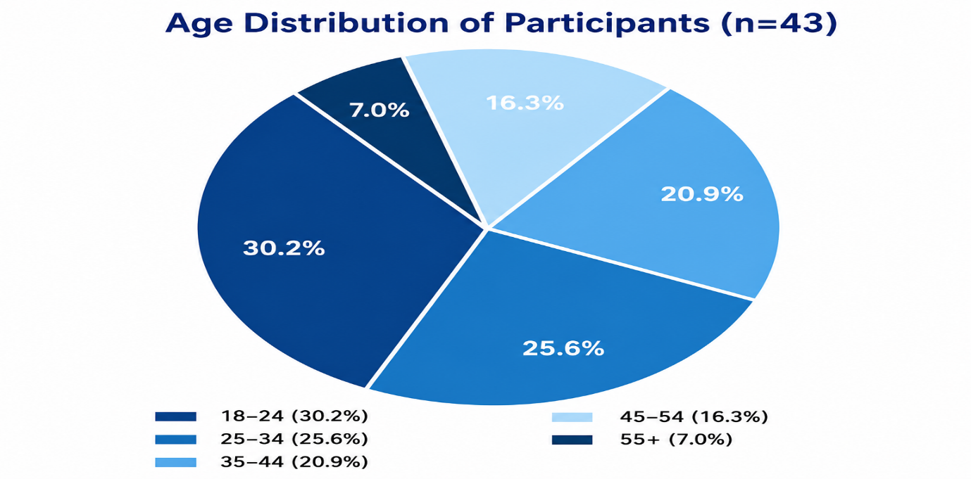

Figure 2: Age Distribution of Participants (n=43)
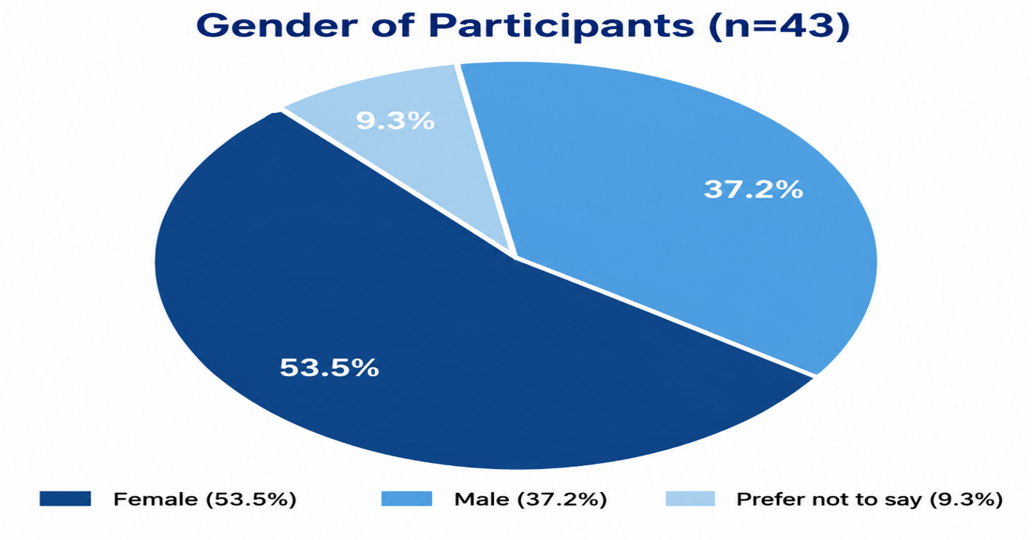

Figure 3: Gender of Participants (n=43)
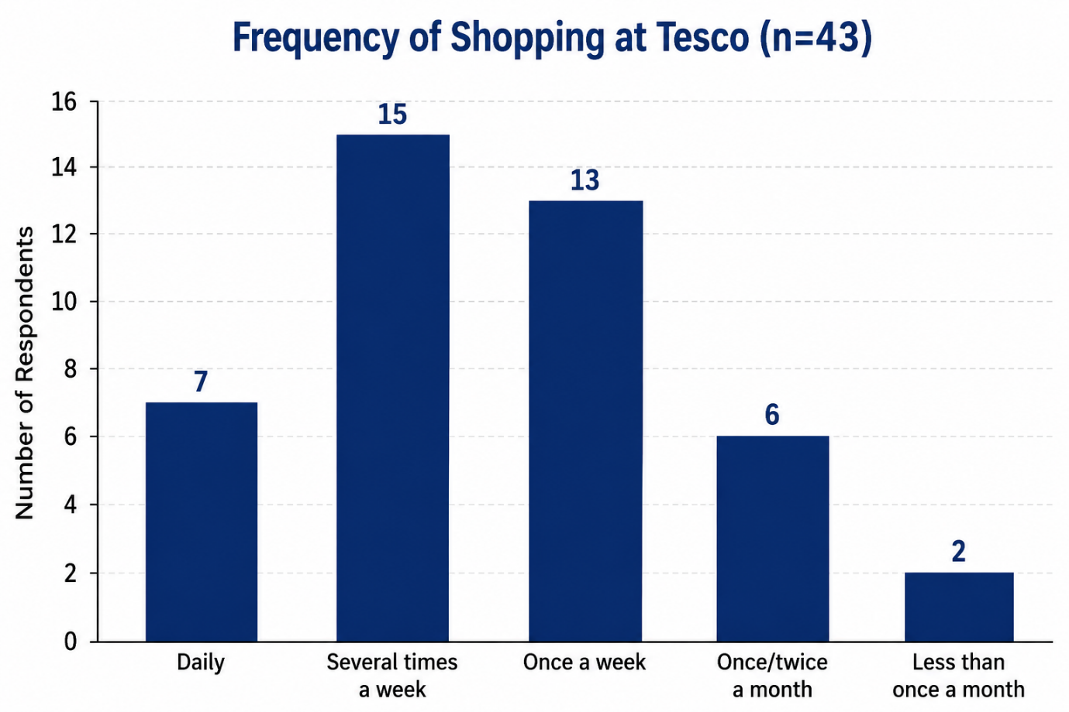
Figure 4: shows the frequency of the items people shop from Tesco (n=43).
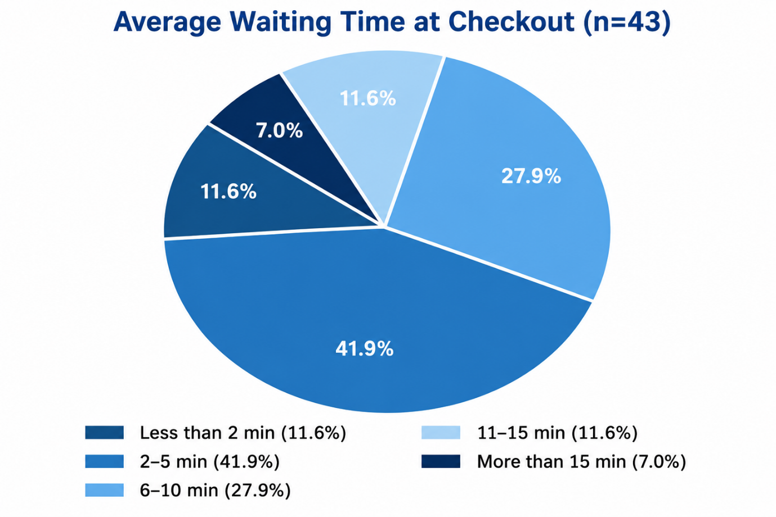

Figure 5: Tesco Clubcard Ownership (n=43)

4.3 Research Question 1: Impact of Out-of-Stock Products on Customer Satisfaction and Buying Behaviour

4.3.1 Secondary Data Evidence
The performance of Tesco is a good starting point and has been published. The Preliminary Results for 2025/26 indicate that customer satisfaction in the United Kingdom is now at an all-time high for Tesco PLC; the company's Interim Results for 2024/25 reveal that product availability is at 98% or higher (Tesco PLC, 2025a; 2026). This is due to the investments made in store hours with staff and continued efforts to focus on the basics of operations noted by the company (Tesco PLC, 2025b). But it's a more negative picture for the sector as a whole, as put out by Mintel UK Supermarkets Market Report 2025 – 47% of grocery shoppers in the UK are making an effort to reduce their purchases, and large format stores are seeing a loss of market share compared to discount stores, making their shopping journey even more sensitive when products are unavailable. The House of Commons Library (2025b) also highlights that people are shopping more often, but buying less per transaction, adding to the commercial impact of per-visit stock-outs. In an era of increased customer choice, the risks for inventory management failures are compounded, as Stanković et al. (2024) suggest.

4.3.2 Questionnaire Corroboration
The secondary evidence is supported and refined by the questionnaire results. Figure 5 shows that 81.4% of the 43 participants experienced at least one stock-out over the last three months, and of these, the categories most commonly affected were meat and fish products (both 39.5%, n=17) and dairy products (37.2%, n=16), which are the hardest to predict due to demand variability (Figure 6). This result conflicts with Tesco's own 98% availability score, and it may be because, in Tesco's approximately 40,000 product lines, it represents around 4% of the failures per visit of its individual customers.
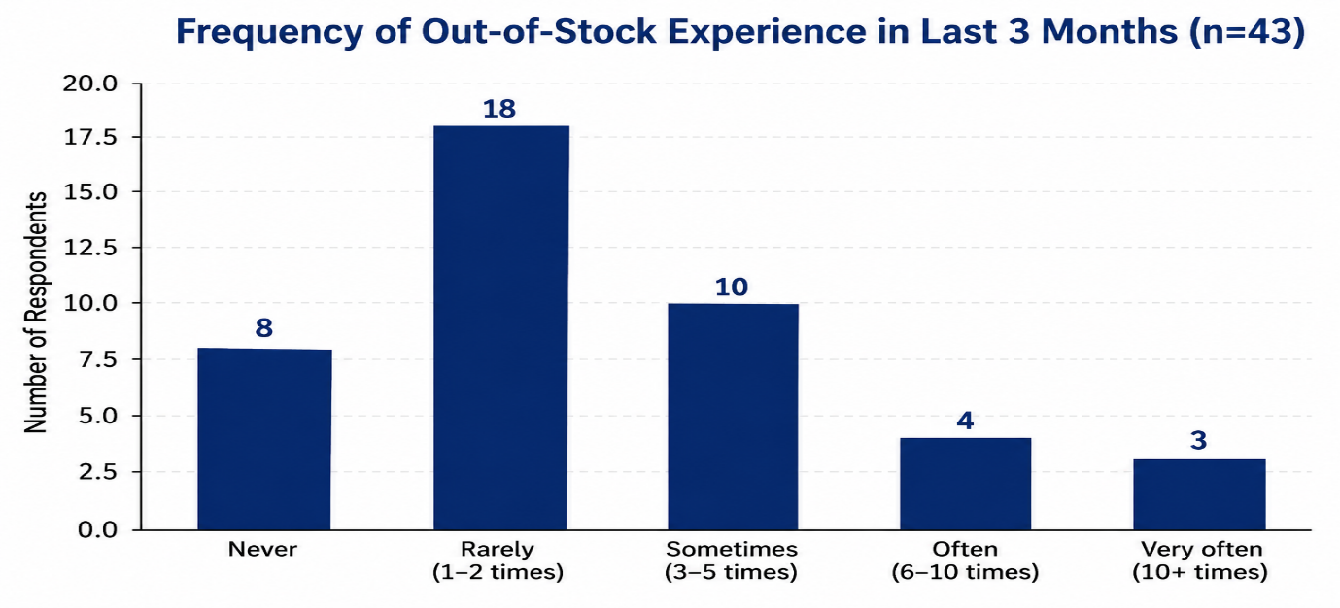
Figure 6: Frequency of Out-of-Stock Experience in Last 3 Months (n=43)
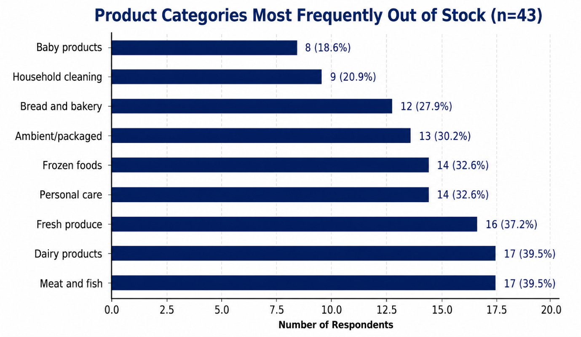
Figure 7: Product Categories Most Frequently Out of Stock (n=43)
The most frequent response to behaviour was postponement (39.5%, n=17), which was in line with the prediction of the Stock-Out Response Behaviour Theory that loyalty would induce the non-reaction of switching, in relation to the sample who used the Clubcard (79.1%, n=31). The 14.0% that did not complete the purchase but went to other stores are a significant leakage that is not reflected in Tesco's bottom line. Overall satisfaction with the availability of the products (Figure 8) was generally positive, with 55.8% satisfied or very satisfied, and 37.2% stating that the products had a moderate to significant negative impact on their overall experience (Figure 9), which aligns with Thomas' (2025) argument that the cost of stock-outs goes beyond the loss of sale.

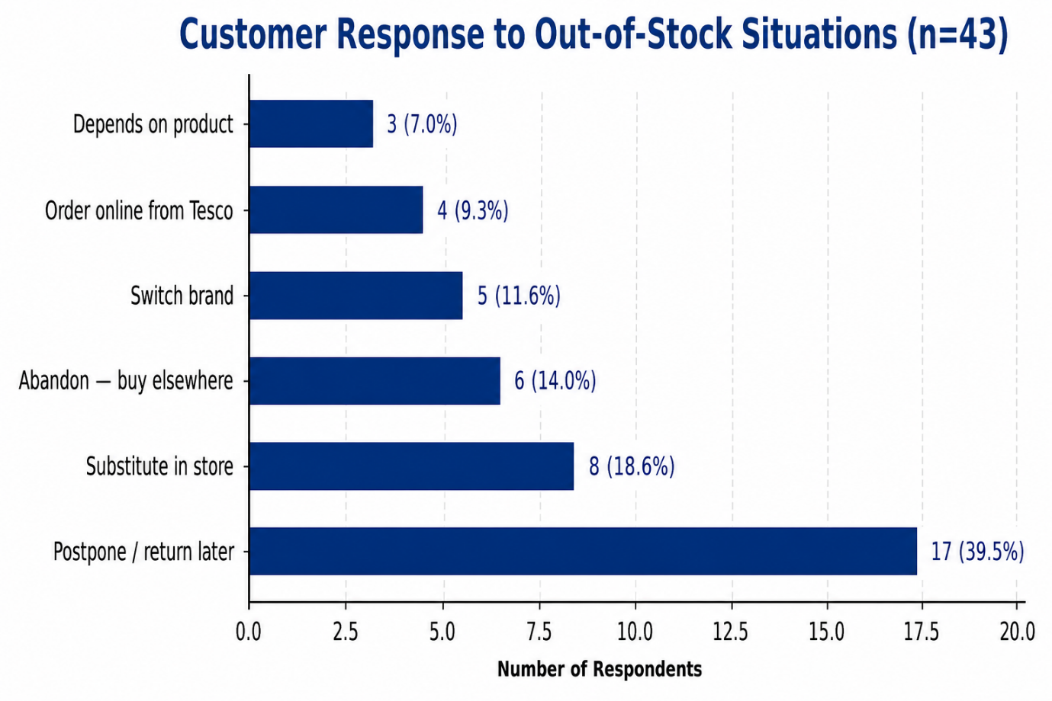
Figure 8: shows customers' reactions when they find that the product is out of stock.
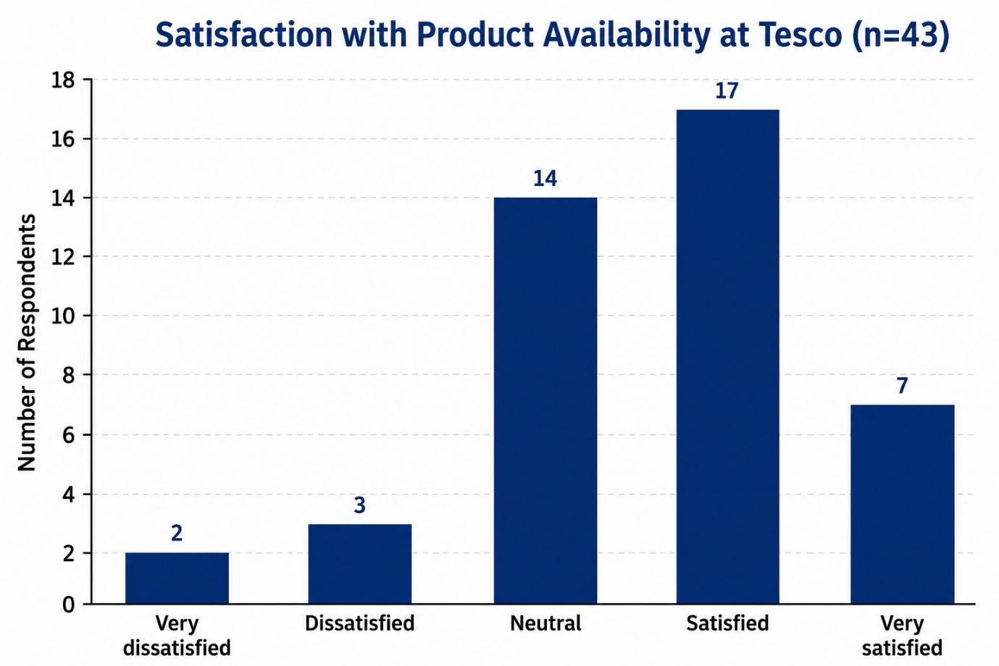

Figure 9: Satisfaction with Product Availability at Tesco (n=43)
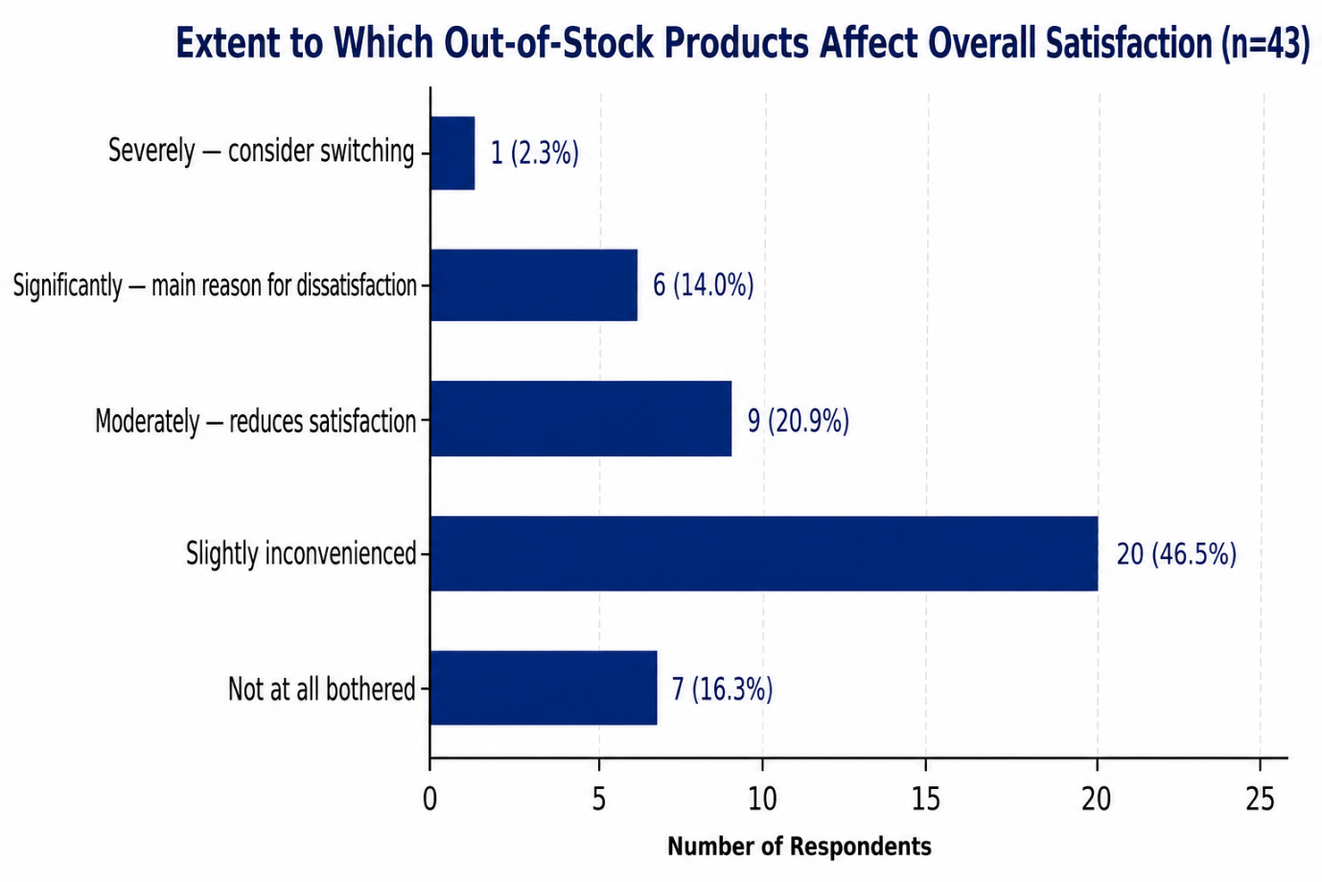
Figure 10: Extent to Which Out-of-Stock Products Affect Overall Satisfaction (n=43)

4.4 Research Questions 2 and 3: Cash Till Availability, Waiting Time and Customer Experience

4.4.1 Secondary Data Evidence
According to the FCA (2021), around 10% of UK adults use cash predominantly for their daily purchases. Access to Cash regulatory regime was introduced in September 2024 by the FCA and imposes obligations on the banks and firms identified as having cash access services in local areas for them to assess and maintain these services (FCA 2024). The House of Commons Library (2025a) shows that 5% of UK adults were heavy users of cash in 2024, and 24% of those who did not have digital access were heavy cash users. Monitoring cash access points is carried out by the Payment Systems Regulator (2023), which will ensure sufficient access to cash is maintained.
Milne and Zachariadis (2025) note that shrinking cash-taking facilities could be problematic if they leave out cash-using clientele. There is no explicit mention of cash-till provision in Tesco's own Preliminary Results 2025/26, and instead, the company has been positioning itself as an organisation based on digital and cashless transactions, based on its focus on Tesco's 24m household card user base and the growth of 51% in Whoosh (Tesco PLC, 2026). The rise in online sales has continued, as confirmed by ONS data, which saw it make up 28.3% of all UK retail sales in December 2025, continuing the secular trend from cash to online transactions.
The important thing about this trajectory with respect to the current study is how quickly it has taken place. One of the quickest behavioural change examples in the history of UK retail was the change in the use of cash - this fell from around 60% of all retail transactions in 2010 to less than 15% in 2023 (House of Commons Library, 2025b). The commercial logic behind the strategic response adopted by Tesco in the face of this transformation, namely a high investment in the so-called digital payment system, in shopping via an application, and in fast delivery, is clear. It has, however, at the same time decreased the percentage of staffed checkouts in proportion to the customer base paying cash at the very time when the rest of the customer base has become more reliant on staffed checkouts and cash payments.

4.4.2 Questionnaire Corroboration
Cash is still a large payment choice – 55.8% of this sample pay at least sometimes in cash (Figure 10). As can be seen in Figure 11, 41.9% of respondents feel some level of difficulty finding a cash till. It is noteworthy, though, that Figure 13 shows that 60.5% of participants had not been able to pay cash at Tesco at all on at least one occasion, with 37.2% saying that they had not managed to pay cash at Tesco at all more than once, a significant failure in service that shows directly the financial inclusion risk identified by both the FCA (2021) and the House of Commons Library (2025a).
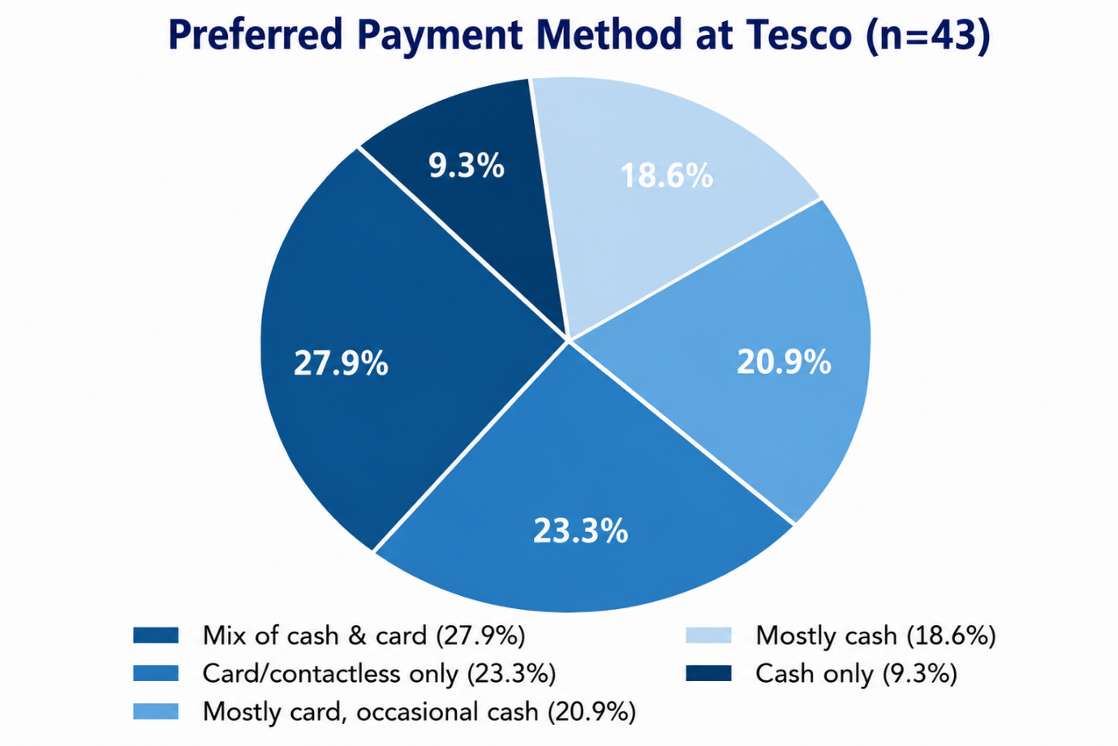
Figure 11: Preferred Payment Method at Tesco (n=43)
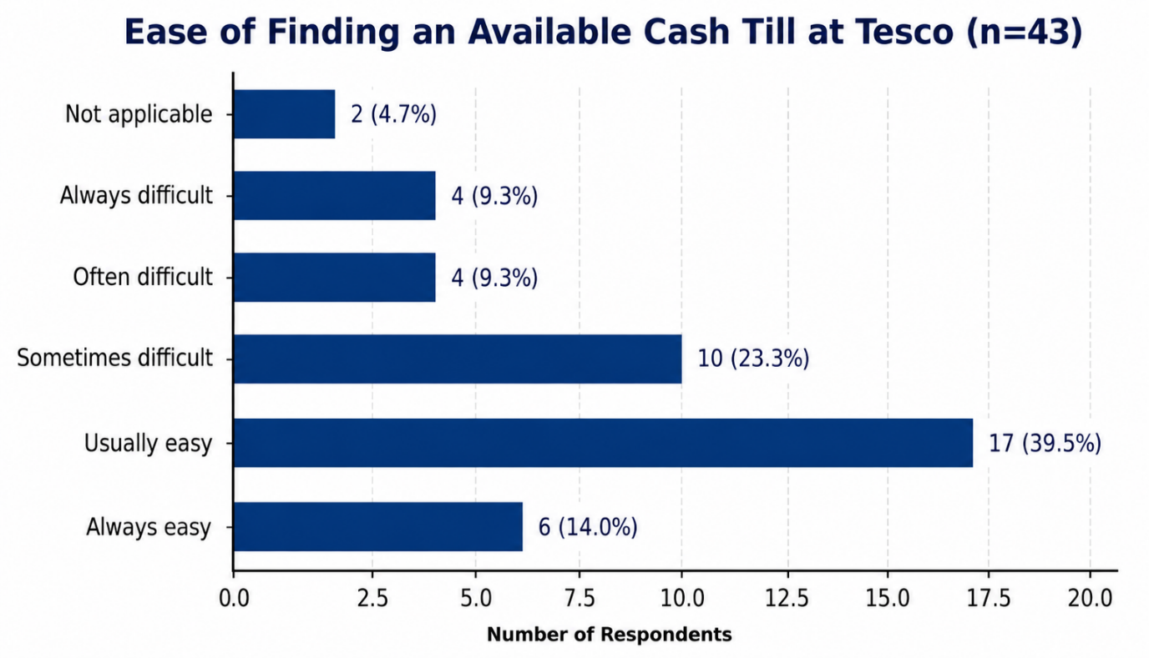
Figure 12: Ease of Finding an Available Cash Till (n=43)
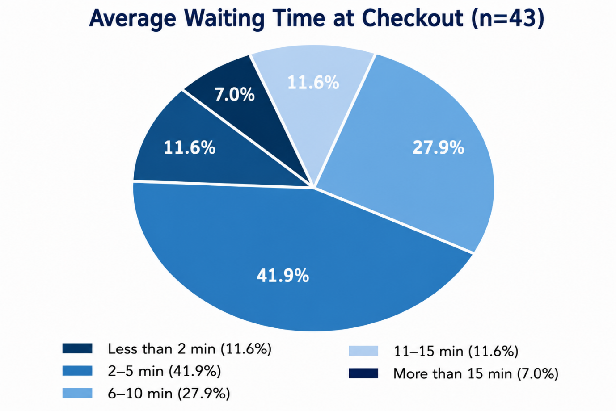

Figure 13: Average Waiting Time at Checkout (n=43)
Regarding waiting time (RQ3), Figure 12 shows that the majority wait between two and ten minutes (69.8%), with 18.6% waiting eleven minutes or more. Figure 14 shows the psychological dimension: 83.7% agreed that there was some negative impact on their total satisfaction due to the length of the checkout queue; 11.6% said that they left the store without purchasing anything because of the checkout line.
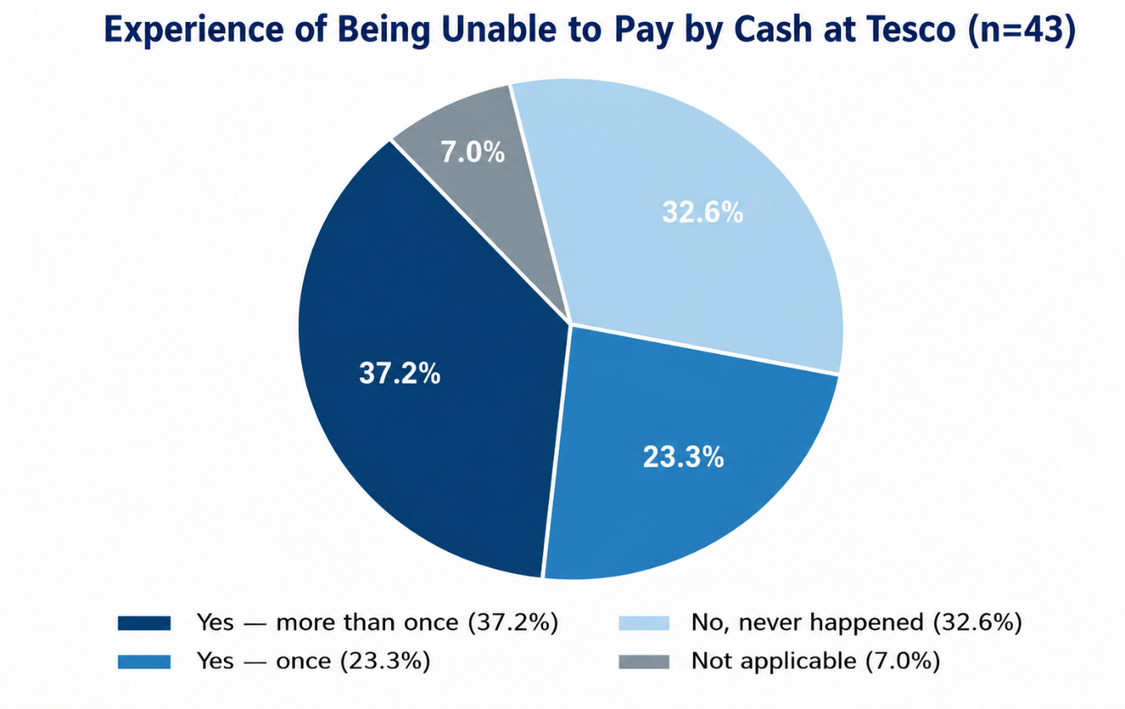
Figure 14: Experience of Being Unable to Pay by Cash at Tesco (n=43)
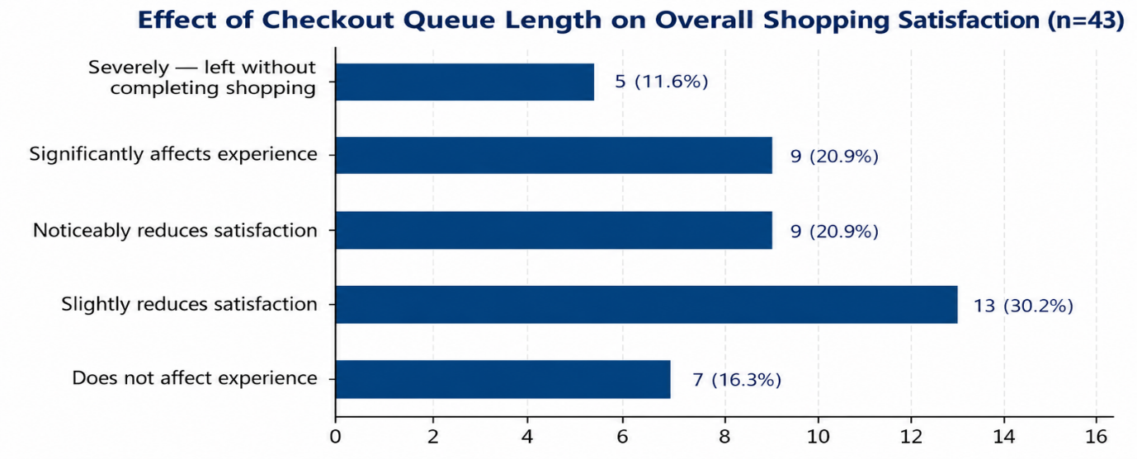

Figure 15: Effect of Queue Length on Overall Shopping Satisfaction (n=43)

4.5 Likert Scale Analysis
All seven mean scores on the Likert scale are below the neutral center score of 3.0 (Figure 15), and there is a consistent pattern of dissatisfaction on each dimension measured. The two lowest means were for 'Enough staffed cash-accepting tills available' (M=2.28) and 'Product availability meets my expectations' (M=2.33), which are in the Disagree and Strongly Disagree range, respectively. These findings have strengthened the secondary evidence: whilst Tesco's 98% aggregate availability metric is reasonable, the overall measure of customer dissatisfaction is focused in certain areas of the business. Overall satisfaction (M=2.70) and willingness to recommend (M=2.67) are near Neutral, consistent with Nusrat and Huang's 2024 results that while being frustrated at work, they were more likely to remain loyal to a brand, specifically Clubcard. The mean score of 2.60 for ‘Operational issues have made me consider switching’ indicates that a significant minority (20.9% agreed or strongly agreed) are starting to consider alternatives, in line with the increase in discount competitors reported by Kantar Worldpanel (2026).
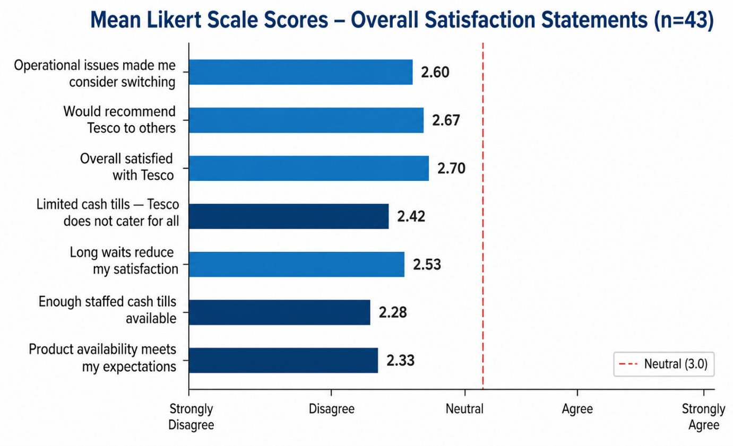
Figure 16: Mean Likert Scale Scores — Overall Satisfaction Statements (n=43)

4.6 Research Question 4: Operational Improvements
The most strongly agreed-upon product availability improvements were faster shelf restocking with 60.5% (n=26) and better demand forecasting with 46.5% (n=20) (Figure 16). The most strongly agreed-upon checkout improvements were opening additional stalls/cash tills during peak hours (65.1%, n=28) and increasing the number of staffed cash tills (60.5%, n=26) (Figure 17). Both are actionable as issues at the store-operations level. However, when asked if they could select just one overall priority, 32.6% (n=14) selected 'ensuring products are always available', with 23.3% (n=10) saying 'all equally important', suggesting that a fairly high proportion of interviewees view both operational issues as different facets of the same overall service quality issue.
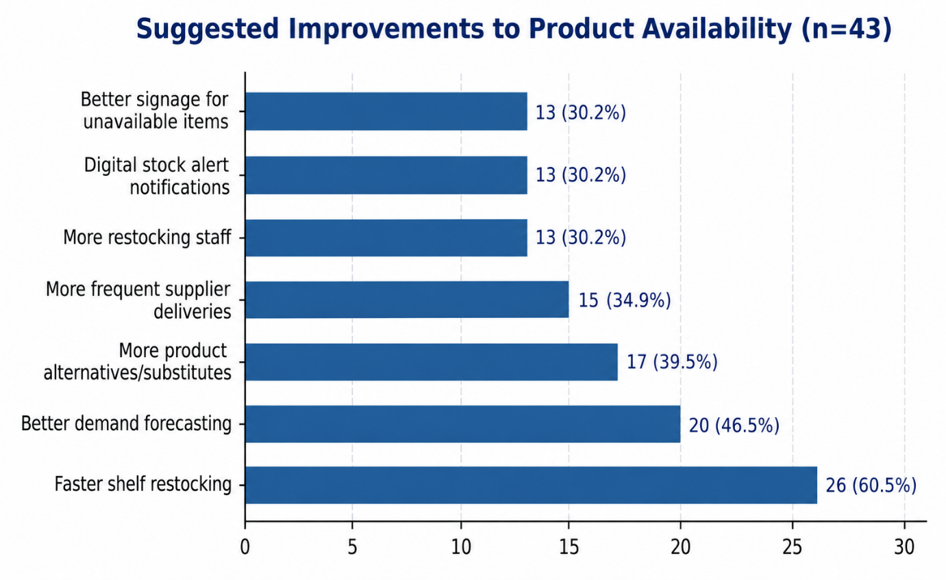
Figure 17: Proposed Correction to Product Availability (n=43)
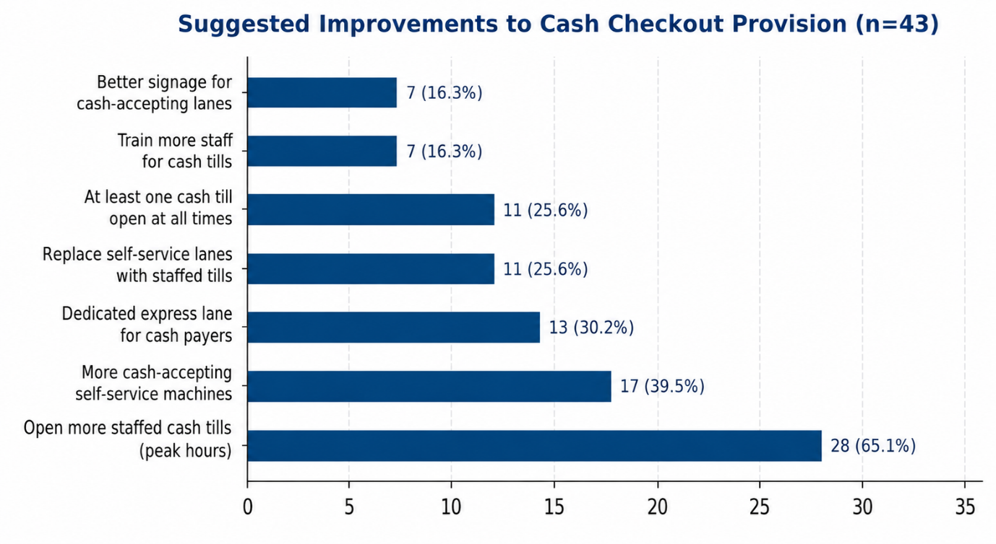

Figure 18: Suggested Improvements to Cash Checkout Provision (n=43)
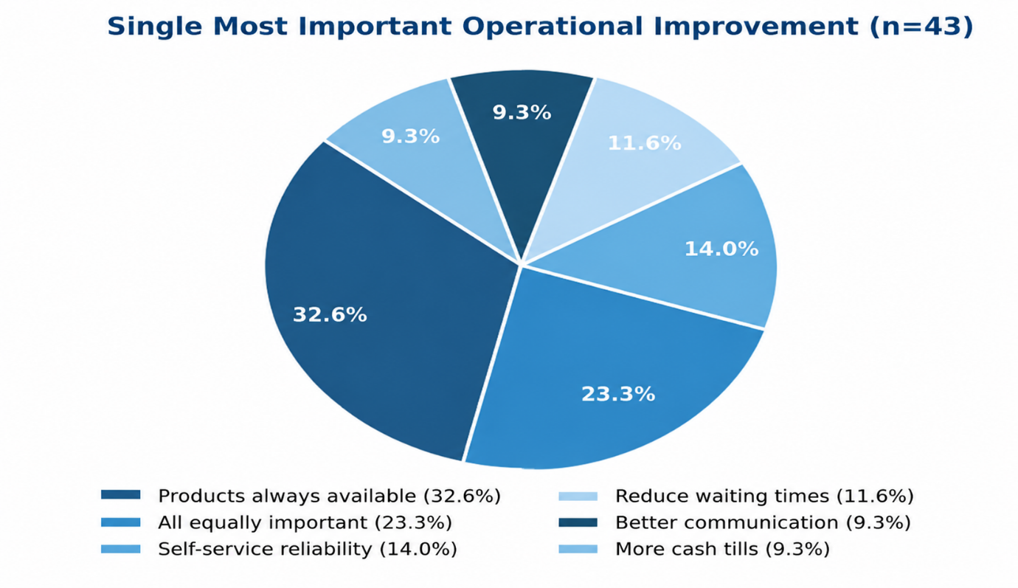

Figure 19: Single Most Important Operational Improvement (n=43)

4.7 Chapter Summary
The results of all four research questions from secondary data and the additional questionnaire have been presented and analysed for this chapter. Secondary sources from Tesco's published reports, the ONS, the FCA, the PSR and industry analysts offer operational context of both issues, and the questionnaire data offers corroboration at the customer level, with 81.4% reporting a stock out on at least one occasion, 60.5% reporting not being able to pay by cash at least once, and all seven Likert satisfaction means being below the neutral point. In summary, these findings validate both theoretical frameworks outlined in Chapter Two - the negative disconfirmation was present throughout, and behavioural reactions were found to be shaped by the nature of the loyalty and competition context faced in UK grocery retail. In Chapter Five, these results are combined to arrive at conclusions and recommendations.

CHAPTER 5: CONCLUSIONS AND RECOMMENDATIONS

5.1 Introduction
This final chapter summarises the results of secondary and primary data analysis, critically appraises its implications for theory and practice and proposes specific recommendations for the operational management of Tesco. The chapter revisits the study's aim and four objectives, discusses theoretical contributions, acknowledges limitations and proposes directions for future research.

5.2 Conclusions in Relation to the Research Aim and Objectives
This research aimed at exploring the effects that out-of-stock products and the shortage of cash till have on customer experience in Tesco's stores. The triangulation of secondary data and the data generated through the questionnaires indicates that both operational difficulties exist, are measured, and are relevant to the market.
Tesco has reported about 98% product availability in relation to Objective 1, whilst secondary evidence shows 81.4% of the questionnaire respondents had experienced at least one stockout in the past 3 months; this was focused mainly on perishable categories. Most respondents (39.5%) delayed the purchase, a result that aligns with the findings of Stock-Out Response Behaviour Theory, which states that Clubcard is likely to lead to a lessened likelihood of switching, but there were also 14.0% who abandoned the purchase to a competitor, a commercially meaningful leakage rate that is not captured in aggregate corporate data.
In relation to Objective 2, secondary evidence from the FCA (2021, 2024), House of Commons Library (2025a) and PSR (2023) confirms that cash-dependent customers make up a significant minority population and a very financially vulnerable group in the UK retail sector. This is reinforced by results from the questionnaire, which showed that 60.5% of the participants had not been able to pay by cash in Tesco at least once, and the lowest Likert mean (M=2.28) was for the availability of a cash till, which showed the greatest and most consistent disconfirmation of expectations in the study.
Secondary evidence indicated that cash infrastructure has been reduced, and primary data revealed that 83.7% of the participants reported negative impacts from checkout system limitations, reinforcing the fact that checkout system limitations are a significant cause of customer dissatisfaction. The 11.6% who stated they walked away without finishing their shopping corroborates Pallikkara, Pinto, and Hawaldar's (2024) research on the emotional toll of standing in line at the cashier.
About Objective 4, participants identified these as most urgently needed changes: faster shelf restocking (60.5%) and more staffed cash tills during peak hours (65.1%). These were the operational-based demands arising from the failure that the participants experienced themselves or found in secondary data from the literature covered in Chapter Four.

5.3 Theoretical Implications
The study also adds to the usage of Stock-Out Response Behaviour Theory and Expectation-Confirmation Theory, in the context of a large UK supermarket. The theory predicts that the stock-out response will be moderated by loyalty, and the empirical results from this sample (which is largely composed of Clubcard holders) support this prediction; additionally, the 14.0% who abandoned their purchase provides a glimpse into the extent to which loyalty protects them. The Likert is always below neutral, and as such, it means to confirm negative disconfirmation in both operational areas, most severely in the cash-till provision.
The findings of the study also give an extension of Dick and Basu's (1994) loyalty framework to the operational context investigated. Dick and Basu (1994) define true loyalty as a high positive attitude with a high repeat patronage, which is the most enduring type of customer retention but is subject to erosion if the retail environment does not sustain the positive attitude over time. The overall pattern of below neutral Likert scores in this study, including a score of 2.60 for ‘operational issues have made me consider switching' mean scores, suggests that a significant proportion of Tesco's currently loyal customers are experiencing the ‘attitudinal weakening' that Dick and Basu (1994) describe as precursory to the negative perceptions that lead to loyalty decline.
Additionally, the synthesis of secondary and primary evidence also suggests that Tesco's overall indicators of high service availability (98%) and very high customer satisfaction scores (94.7%) could be reconciled with primary evidence of sometimes poor service quality (availability of 85% for overall service, 78% for cashiers, and 80% for staff) in certain operational areas, which lent validity to the triangulated research design and suggested that customer satisfaction should be measured in specific grocery retail contexts rather than solely in the UK.

5.4 Recommendations for Tesco
Four recommendations are made based on the converging secondary and primary evidence. First, Tesco must have a real-time inventory system for their shelves where high turnover and perishable products have stock-out issues, so that restocking can be initiated before the stock level reaches zero. Second, store-level demand forecasting should be improved to better anticipate stockouts, as noted by 46.5% of the respondents, aligning with Kumar, Rabbani and Khan (2024) who advocated for a new forecasting approach for retailers. Third, there should be a minimum number of staffed, cash-accepting tills at every point in time, and they should be increased during peak times, the one most urgently endorsed improvement (65.1%) and the most directly addressing the financial inclusion risk identified by the FCA (2021, 2024) and PSR (2023). Fourth, cash-paying customers should have dedicated checkout lanes within large stores, as endorsed by 30.2% of the participants.

5.5 Limitations and future research.
There are three main constraints of this study. First, the secondary data sources only provide aggregated performance data, which may overlook the differences in performance across stores, especially Tesco's own published data. Second, a small sample of 43 customers, from a supplementary questionnaire sent out via social media, is not statistically representative of all Tesco customers, as it is skewed towards younger customers. Third, the study was limited to a single retailer, and so the results of the study might not be transferable to other stores. Future studies should focus on the same operational issues with other grocery retailers in the UK. Data from the stores would allow for more accurate measurement of the stock-out and cash-till problems highlighted here.

5.6 Chapter Summary
In this chapter, the secondary and primary sources used to answer the aim, objectives and research questions of the study have been synthesised; the application of the Stock-Out Response Behaviour Theory and Expectation-Confirmation Theory to the context of the study at Tesco has been confirmed, and four operational recommendations have been established based on the evidence obtained from the study. The study reveals that product stock-outs and limited cash-till provision are both measurable and meaningful reasons for customer dissatisfaction in Tesco stores and that stock-out and cash-till provision represent some of the most productive investments that Tesco can make towards strengthening its customer proposition within an increasingly competitive UK grocery market.

6.0 REFERENCES
Al Najjar, A.S. and Qandeel, M.S. (2025) Operational strategy, capabilities, and accomplishing business strategy. Journal of Applied Research in Technology & Engineering, 6(1), pp.1–11. https://doi.org/10.4995/jarte.2025.20708
Anderson, E.W. and Sullivan, M.W. (1993) The antecedents and consequences of customer satisfaction for firms. Marketing Science, 12(2), pp.125–143. https://pubsonline.informs.org/doi/10.1287/mksc.12.2.125
Bascur, C. and Rusu, C. (2020) Customer experience in retail: A systematic literature review. Applied Sciences, 10(21), p.7644. https://doi.org/10.3390/app10217644
Bowen, G.A. (2009) Document analysis as a qualitative research method. Qualitative Research Journal, 9(2), pp.27–40. https://doi.org/10.3316/QRJ0902027
Braun, V. and Clarke, V. (2006) Using thematic analysis in psychology. Qualitative Research in Psychology, 3(2), pp.77–101. https://doi.org/10.1191/1478088706qp063oa
Bryman, A. (2016) Social Research Methods. 5th edn. Oxford: Oxford University Press. https://global.oup.com/academic/product/social-research-methods-9780199689453
Court, M. (2026) Tesco shoppers complain self-service checkouts are too loud. https://www.theresident.co.uk/news/national/uk-today/25904154.tesco-shoppers-complain-self-service-checkouts-loud/
Creswell, J.W. (2014) Research Design: Qualitative, Quantitative and Mixed Methods Approaches. 4th edn. Thousand Oaks, CA: SAGE. https://study.sagepub.com/creswellrd4e
Denny, E. and Weckesser, A. (2022) How to do qualitative research? Qualitative research methods. Bjog, 129(7), p.1166. https://doi.org/10.1111/1471-0528.17150
Dick, A.S. and Basu, K. (1994) Customer loyalty: Toward an integrated conceptual framework. Journal of the Academy of Marketing Science, 22(2), pp.99–113. https://doi.org/10.1177/0092070394222001
Ezhil Kumar, M., Sharma, D.P. and Tapar, A.V. (2021) Out-of-stock justifications and consumers’ behavioral outcomes – exploring the role of product type and sales level information in out-of-stock situations. Journal of Retailing and Consumer Services, 60, p.102458. https://doi.org/10.1016/j.jretconser.2021.102458
Fernandes, T. and Pedroso, R. (2017) The effect of self-checkout quality on customer satisfaction and repatronage in a retail context. Service Business, 11(1), pp.69–92. https://repositorio-aberto.up.pt/bitstream/10216/82349/2/108365.pdf
Financial Conduct Authority (2021) UK’s cash infrastructure and consumer research. [Online]. https://www.fca.org.uk/publications/research/uks-cash-infrastructure-consumer-research
Financial Conduct Authority (2024) PS24/8: Access to cash. [Online]. https://www.fca.org.uk/publications/policy-statements/ps24-8-access-cash
Gruen, T. and Corsten, D. (2021) Accessibility and availability: A cross-cultural study of shopper responses to online retail stock-outs. Journal of Global Scholars of Marketing Science, 31(3), pp.415–432. https://doi.org/10.1080/21639159.2021.1924819
Gurley, R.C. (2021) Strategies for implementing self-service technologies in supermarket retail operations. DBA thesis. Walden University. https://scholarworks.waldenu.edu/dissertations/11397/
House of Commons Library (2025a) Access to cash and banking services. Research Briefing CBP-9453. [Online]. https://commonslibrary.parliament.uk/research-briefings/cbp-9453/
House of Commons Library (2025b) Retail industry statistics. Research Briefing CBP06186. [Online]. https://researchbriefings.files.parliament.uk/documents/SN06186/SN06186.pdf
Kantar Worldpanel (2026) Great Britain grocery market share: Festive period 2025. [Online]. https://www.kantar.com/uki/inspiration/fmcg/2026-wp-promo-premium-own-label-and-no-alcohol-options-inside-britains-13-8-bn-xmas-grocery-shop
Kleinheksel, A.J., Rockich-Winston, N., Tawfik, H. and Wyatt, T.R. (2020) Demystifying content analysis. American Journal of Pharmaceutical Education, 84(1), p.7113. https://doi.org/10.5688/ajpe7113
Kotler, P. and Keller, K.L. (2016) Marketing Management. 15th edn. Harlow: Pearson. https://www.pearson.com/en-us/subject-catalog/p/Kotler-Marketing-Management-15th-Edition/P200000007478/9780133856460
Kumar, N., Rabbani, Q. and Khan, N.A. (2024) Efficient customer service and operation maintenance by inventory management. Journal of Mechanics of Continua and Mathematical Sciences, 19(9), pp.66–76. https://doi.org/10.26782/jmcms.2024.09.00007
Kumar, P., Hofer, A.R. and Peinkofer, S. (2023) The role of scarcity-inducing post-stockout disclosures on consumer response to stockouts. International Journal of Physical Distribution & Logistics Management, 53(9), pp.946–966. https://doi.org/10.1108/IJPDLM-02-2023-0070
Li, L. and Zeng, J.H. (2024) Strategic analysis of Tesco’s international purchasing and supply chain management: Challenges, opportunities, and future directions. International Journal of Science and Business, 35(1), pp.132–143. https://doi.org/10.58970/IJSB.2360
Mazhar, S.A., Anjum, R., Anwar, A.I. and Khan, A.A. (2021) Methods of data collection: A fundamental tool of research. Journal of Integrated Community Health, 10(1), pp.6–10. https://doi.org/10.24321/2319.9113.202101
Milne, A. and Zachariadis, M. (2025) Making UK payments work for everyone. Loughborough University Business School. [Online]. https://www.lboro.ac.uk/media-centre/press-releases/2025/october/vulnerable-left-behind-shift-towards-cashless/
Mintel (2025) UK Supermarkets Market Report 2025. London: Mintel Group Ltd. https://store.mintel.com/report/uk-supermarkets-market-report
Nusrat, F. and Huang, Y. (2024) Feeling rewarded and entitled to be served: Understanding the influence of self- versus regular checkout on customer loyalty. Journal of Business Research, 170, Article 114352. https://doi.org/10.1016/j.jbusres.2023.114352
Office for National Statistics (2026) Retail sales, Great Britain: December 2025. [Online]. https://www.ons.gov.uk/businessindustryandtrade/retailindustry/bulletins/retailsales/december2025
Oliver, R.L. (1980) A cognitive model of the antecedents and consequences of satisfaction decisions. Journal of Marketing Research, 17(4), pp.460–469. https://journals.sagepub.com/doi/abs/10.1177/002224378001700405
Oliver, R.L. (1999) Whence consumer loyalty? Journal of Marketing, 63(Special Issue), pp.33–44. https://journals.sagepub.com/doi/10.1177/00222429990634s105
Pallikkara, V., Pinto, P. and Hawaldar, I.T. (2024) Navigating waiting situations at retail checkouts: associated emotional discomfort and its impact on shopping satisfaction. Management & Marketing, 19(2), pp.256–274. https://doi.org/10.2478/mmcks-2024-0012
Parasuraman, A., Zeithaml, V.A. and Berry, L.L. (1985) A conceptual model of service quality and its implications for future research. Journal of Marketing, 49(4), pp.41–50. https://journals.sagepub.com/doi/10.1177/002224298504900403
Payment Systems Regulator (2023) Access to cash. [Online]. https://www.psr.org.uk/our-work/access-to-cash/
Ramasamy, G., Ramasamy, G.D. and Ramasamy, P. (2024) Conceptual review of consumer satisfaction theories with expectation-confirmation and disconfirmation paradigm for business sustainable growth and decision making. F1000Research, 13, p.1399. https://doi.org/10.12688/f1000research.158612.1
Saunders, M.N.K., Lewis, P. and Thornhill, A. (2023) Research Methods for Business Students. 9th edn. Harlow: Pearson. Available at: https://www.pearson.com/en-gb/subject-catalog/p/research-methods-for-business-students/P200000007247
Scott, J. (2014) A Matter of Record: Documentary Sources in Social Research. Cambridge: Polity Press. : https://www.wiley.com/en-gb/A+Matter+of+Record%3A+Documentary+Sources+in+Social+Research-p-9780745603599
Stanković, A., Odalović, T., Lajka, N. and Jozić, Z. (2024) The management of operational risks and impact of product availability. International Review, (1–2), pp.61–68. https://doi.org/10.5937/intrev2401061S
Tesco PLC (2025a) Annual Report and Financial Statements 2025. Welwyn Garden City: Tesco PLC. https://www.tescoplc.com/investors/reports-results-and-presentations/annual-report-2025
Tesco PLC (2025b) Interim Results 2024/25. Welwyn Garden City: Tesco PLC. https://www.tescoplc.com/media/qjejufrm/tesco-plc-interim-results-2425-press-release.pdf
Tesco PLC (2026) Preliminary Results 2025/26. Welwyn Garden City: Tesco PLC. https://www.tescoplc.com/media/ch1fbgss/tesco-plc-preliminary-results-statement-fy26.pdf
Thomas, R. (2025) Towards a value-in-use view of retail stockout costs. International Journal of Physical Distribution & Logistics Management, 55(1), pp.49–67. https://doi.org/10.1108/IJPDLM-03-2024-0133
Yang, P.J., Chen, S.C. and Zheng, M.C. (2025) The impact of guidance information on checkout efficiency and user experience in supermarket self-checkout machines. Sage Open, 15(4), p.21582440251404195. https://doi.org/10.1177/21582440251404195
Zeithaml, V.A., Berry, L.L. and Parasuraman, A. (1996) The behavioral consequences of service quality. Journal of Marketing, 60(2), pp.31–46. https://journals.sagepub.com/doi/10.1177/002224299606000203

