Assessment component 2: Marketing Strategy Pitch : PurePlastic

Student Name : Dipak Modhavadiya
Student ID : 2506701
Module Name: Marketing Management
Module Code: LCMB7024
Lecturere’s Name: Jayalakshmi Gopalkrishnan
Word Count : 2,610 words (± 10%)
Term 1

Table of contents
Element 1: Segmentation, Targeting, Differentiation, and Positioning (STDP) Analysis for New Brand Concept Development ......................................................3 6
Element 2: Marketing Mix for PurePlastic ( 4Ps framework ) ..................................7
2.1 Product .........................................................................................................7
2.2 Price ............................................................................................................8
2.3 Place ............................................................................................................8
2.4 Promotion .....................................................................................................9
Element 3 : Marketing Strategy Pitch ....................................................................10
Poster .....................................................................................................................11
7.0 Reflection ..........................................................................................................15
8.0 References ........................................................................................................17

Element 1 : Segmentation, Targeting, Differentiation, and Positioning (STDP) Analysis for New Brand Concept Development
Highland Spring is the leading brand in the UK of naturally sourced water. It has 13% market share in Uk’s bottled water market with 1.8 Billion pounds in revenue (Insider.co.uk, 2025). Known for its ethical sourcing from the Ochil Hills in Perthshire, the company has already pioneered sustainability initiatives, such as launching a 100% recycled PET (rPET) eco-bottle and investment in a seven megawatt, 23-acre solar farm, that will generate nearly 20% of the electricity required at the factory (Highland Spring, 2025 & Insider.co.uk, 2025). Inorder to maintain its leadership position and expand into more diverse market segments, the company is launching a new sub-brand: PurePlastic.
PurePlastic is a product line of mineral water packaged in 100% plant-based, biodegradable bottles made from Polylactic Acid (PLA). Which is a material derived from renewable biomass like fermented plant starch from corn or sugar cane (MDPI, 2025). Traditional or recycled plastic perpetuates the plastic cycle, whereas PurePlastic is compostable and returns to the earth. The name "PurePlastic" was chosen with thought to challenge the industry and show that this material is purely natural, purely renewable, and purely transient, rather than a permanent pollutant.
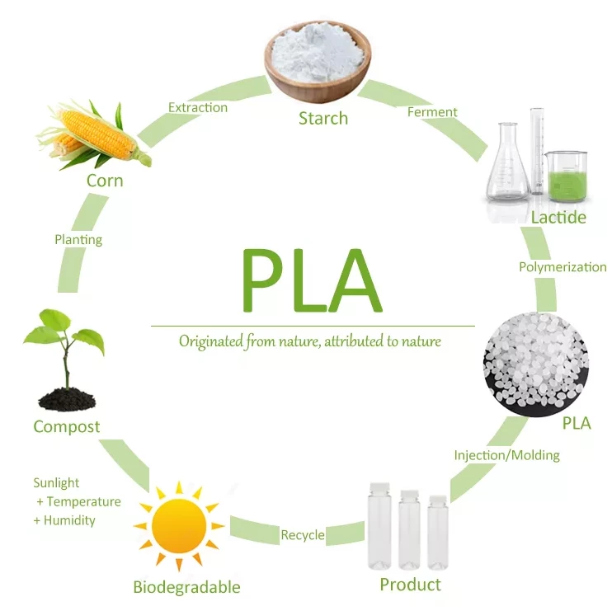
Market Appeal and Consumer Trends

The PurePlastic brand will appeal to the current market by directly addressing the "Plastic Problem" evident among UK consumers. While Highland Spring currently utilizes rPET, market analysis shows that consumers hold a generally positive attitude toward biodegradable options but often lack the knowledge to distinguish between bio-based and fossil-based plastics (European Bioplastics, 2023).

Three key trends drive this appeal:

- The Green Shift: UK consumers are increasingly prioritizing genuine environmental impact over superficial claims. Recent reports indicate that sustainable packaging awareness is driving lifestyle changes and consumers are actively seeking alternatives to standard waste streams (IMARC Group, 2025). They are moving beyond "recycling" (which is seen as a broken system) toward "regeneration" (materials that disappear).
- Willingness to Pay for Sustainability: Research indicates that 43% of consumers are willing to pay extra for sustainable packaging (Shorr Packaging, 2025), which is majorly seen among younger generations who are "eco-anxious."
- Transparency Demand: 78% of shoppers consider sustainability important but they also demand transparency to avoid greenwashing (Smurfit Kappa, 2025). PurePlastic capitalizes on this demand for transparency by being honest regarding its material origin.
- The "Health-Conscious" Shift: Beyond environmental damage, consumers are more and more alarmed about the health risks of microplastics and studies suggest that humans ingest a credit card’s worth of plastic weekly. Hence, the health conscious consumer is now seeking the alternatives to avoid microplastic ingestion because of degrading PET bottles (Harvard, 2025).

Market Segmentation

The market is segmented using demographic, psychographic, and behavioural variables. This is to identify the most relevant audience:

- Demographic Segmentation: Primary segments are Millennials and Gen Z (18-44), who are living in urban UK centers such as London, Manchester, and Edinburgh. These groups have the highest concentration of " climate conscious consumers" with enough disposable income to purchase premium water (Grand View Research, 2025).
- Psychographic Segmentation: There are 2 main markets : "Passive Recyclers" - who buy whatever is convenient and "Ethical Activists" - who actively scrutinize packaging labels. PurePlastic targets the latter consumers, because they value end-of-life certainty for their waste, specifically compostable solutions over landfill (Rheom Materials, 2024).
- Behavioural Segmentation: The primary focus is "On-the-Go" consumers. While many eco-conscious people use reusable bottles, they either forget them or need emergency hydration. They experience "purchase guilt" when buying standard plastic; PurePlastic solves this emotional pain point by offering a guilt-free alternative (Avenue Printing, 2025).

Target Audience Analysis

The primary target audience for PurePlastic is the "Ethical Urbanite."

This consumer is typically aged 25–40, working professional who is highly educated on climate issues. They are skeptical of corporate sustainability claims and view recycled plastic as a "lesser evil" rather than a complete solution (European Bioplastics, 2023). They are willing to pay a premium (e.g., £1.50 vs £0.80) for a product that aligns with their idea of responsible citizen. They are heavily influenced by social norms and share their sustainable purchases on social media, where "plastic-free" lifestyle content is a dominant trend (Shorr Packaging, 2025). They actively seek a guilt-free convenience product that does not compromise their environmental values.

Differentiation

Differentiation: Competitors (Evian, Buxton, etc) largely focus on rPET or carbon neutrality. PurePlastic differentiates itself through Material Innovation.

Competitors (rPET) | PurePlastic (PLA)
They use old plastic to make new bottles. (Circular but dependent on oil). | We use plants to make earth-friendly bottles." By using PLA technology, PurePlastic offers a tangible difference: a bottle that is technically capable of composting, offering a distinct "End-of-Life" value proposition that recycled plastic cannot match.  (Bio-circular and oil-free)
They use old plastic, which still degrades into harmful microplastics that persists in the ecosystem and human body | We use plants that does not have microplastics and breaks down into harmless organic matter. Which also eliminates the risk of permanent microplastic pollution

Positioning Strategy

PurePlastic will be positioned as the "Guilt-Free Convenience" choice.
Positioning Statement: "PurePlastic is the only bottled water that offers 100% plant-based packaging. It is for the environmentally conscious professional who refuses to compromise on ethics for convenience and believes that convenience doesn't have to cost the planet. Unlike standard recycled water bottles that extend the life of fossil fuels, PurePlastic is born from plants and designed to return to the earth."

Element 2 : Marketing Mix – 4Ps for PurePlastic

The 4Ps framework (Product, Price, Place, Promotion) is the appropriate model to structure the marketing strategy because PurePlastic is a tangible product (AdLift, 2024). This strategy will position the brand as a "Guilt-Free Convenience" product for the ethical urbanite. It will also reinforce the message of radical transparency and material innovation.

1. Product

The product strategy focuses on the 3 Levels of Product model to differentiate PurePlastic from standard market offerings.
- The Core Product: The fundamental benefit is "healthy hydration with a clear conscience." For the target audience, the core value is not just water, but the alleviation of "eco-guilt" associated with single-use purchases and the danger of microplastics because of the packaging (Shorr Packaging, 2025). Also, there is an assurance of water purity which is free from the microplastics found in standard degrading plastic bottles.
- The Actual Product: The bottle is made from 100% Polylactic Acid (PLA), which is 100% bio-degradable - this is the primary differentiator for PurePlastic. It will have a distinct cloudy or matte finish, which is a natural characteristic of PLA—which serves as a visual cue to the consumer that this is not normal plastic. In orfer to ensure the entire package is biodegradable, the label will use vegetable-based inks and a water-soluble adhesive (Green Socials, 2025). Finally, the water inside remains Highland Spring’s premium natural source water from the Ochil Hills, to maintain the brand's established reputation for quality and purity (Highland Spring, 2025).
- The Augmented Product: The product will feature a Smart Label Technology. A QR code on every bottle will unlock a Lifecycle Tracker that will show the exact sourcing of the bioplastic and a map of local industrial composting facilities. This will address consumer skepticism about greenwashing and build the transparency demanded by specific consumer segment and act as a differentiation factor (CarbonBright, 2025).
2. Price

The pricing strategy will be Premium Pricing. It will be positioned above standard mineral water but competitive with functional beverages. Research from the PwC 2024 Voice of the Consumer Survey indicates that 43% of consumers are willing to pay a premium of nearly 10% for verified sustainable goods, despite inflation (PwC, 2024). The target demographic shows the highest willingness to pay for products that align with their identity (Shorr Packaging, 2025). Price for standard Highland Spring (500ml) ranges between £0.80 - £1.00, the PurePlastic will be prices at £1.30 - £1.50 . This price point will position PurePlastic as an accessible luxury product. It is affordable enough for daily "on-the-go" purchase but high enough to signal superior quality and cover the higher production costs of PLA packaging. It also avoids the "race to the bottom" by reinforcing the authenticity of the product claims against cheaper, greenwashed competitors and maintaining a higher price. the brand signals that "real sustainability costs money," (Deloitte, 2024).

3. Place (Distribution)

The distribution begin as a selective distribution at launch and then move towards Intensive Distribution as the brand matures. This includes 2 main channels :
- Retail Partners : Launch partners will include high-end supermarkets like Waitrose and M&S, who has strong sustainability charters. This channel is important because to create the immidiate "Trust Halo" Effect for our new brand. Waitrose, for example, has a customer base that highly values provenence and ethics and It has committed to reduce single-use plastic (Waitrose & Partners, 2023).
- On-the-Go Channels: The target segment purchases water when they forget their reusable bottle, So distribution must be present in high-traffic urban hubs as well. This includes partnerships with Premium Coffee Chains and cafes that serve the professional demographic. Also, transit Hubs like WHSmith Travel and vending machines in major rail stations in major cities like London Waterlo and Manchester Piccadilly, where commuters need immediate hydration.
Highland Spring should leverage it’s new rail freight facility at Blackford, which will help in saving 3,200 tonnes of CO2 annually by removing HGV trucks from the road (Scottish Cities Alliance, 2022). This "low-carbon logistics" becomes a secondary selling point by ensuring that the process of distribution aligns with the product promise.

4. Promotion

The promotional strategy uses Integrated Marketing Communications (IMC) to educate the consumer and build a community around the "Post-Plastic" movement and it will leverage both online and offline channels for it. "Plants, Not Petroleum” campaign will aggressively highlight the material difference and frame standard recycling as "delaying the inevitable" while presenting PurePlastic as "returning to the earth”. On the digital channel, Tiktok and Instagram reels will be primary channels to reach gen z and millenials.Educational content will expose the myths about recycling and composting videos of PurePlastic bottles will act as a visual proof to combat greenwashing skepticism (Green Socials, 2025). Rather than generic lifestyle creators, our brand will partner with Eco-Creators who are working in the climate change or global warming, sustainability and health niche. These creators will act as third party validators by giving factory tours and showing real experiments. On the offline channel, Billboards in high-footfall areas (e.g., The London Underground) will be used. These provocative headlines like “This bottle is made of corn. Don’t recycle it, compost it.” will grab attention and force the consumer to re-evaluate their habit.
Another thing to highligh is this slogan : ‘Drink Water, Not Plastic’ .The campaign will highlight the fact that standard bottles shed microplastics and it will position PurePlastic as the safe, clean alternative.
Other promotional activity can be the "Return for Earth" Campaign: It will be a reverse vending pilot scheme at select university campuses, where returning the bottle guarantees it is sent to an industrial composter. The student will be rewarded with a discount on their next purchase to incentivise the correct disposal behaviour (DesignRush, 2025).

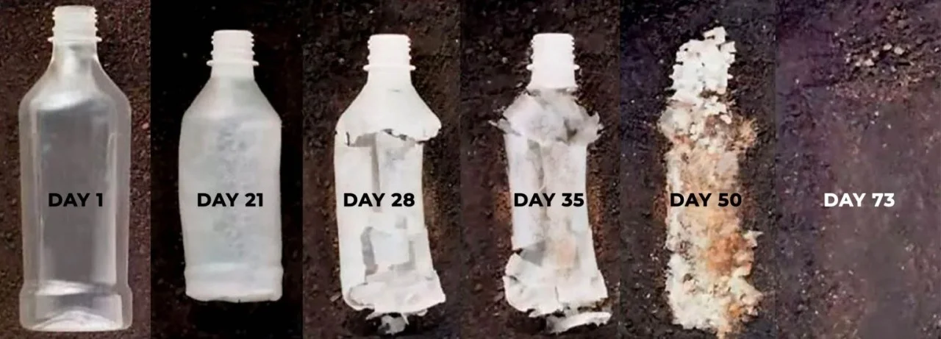
(Source : https://nuffoodsspectrum.in/2023/10/06/dfrl-mysuru-designs-biodegradable-water-bottle.html )

Element 3 : Marketing Strategy Pitch

The Problem: millions of eco-conscious commuters buy bottled water from supermarket aisles but lack the alternative choices and hence they feel guilty. They see rows of plastic bottles—some recycled, some not—but all derived from fossil fuels and destined to persist in their body as well as in the environment for centuries. Recycling is no longer enough for the "Ethical Urbanite" who knows that rPET still perpetuates the plastic cycle. And now the problem is gettinng worse because of in icreasing presence of microplatics in blood and mind. They also know that all kinds of plastic bottles shed microplastics that end up in our oceans and in our own bodies too. They are currently forced with a choice: either convenience or contamination.

The Solution: Highland Spring presents the answer under the : PurePlastic brand. This is more than just water; it is a material revolution. PurePlastic is the UK’s first premium mineral water packaged in 100% plant-based, compostable PLA (Polylactic Acid). Our bottle is designed to return to the earth, offering the only truly "guilt-free" convenience on the market.

The Value & Strategy : Our strategy targets the 43% of UK consumers willing to pay a premium for verified sustainability. By positioning PurePlastic as an "accessible luxury" (Price) and securing listings in high-trust retailers like Waitrose (Place), we transform a commodity purchase into an ethical statement.



Student Name: Dipak Modhavadiya
Student ID: 2506701

Module Name: Marketing Management

Module Code: LCMB7024

Lecturer’s Name: Jayalakshmi Gopalkrishnan

Poster – Marketing Strategy Pitch: PurePlastic

Term 1

Poster
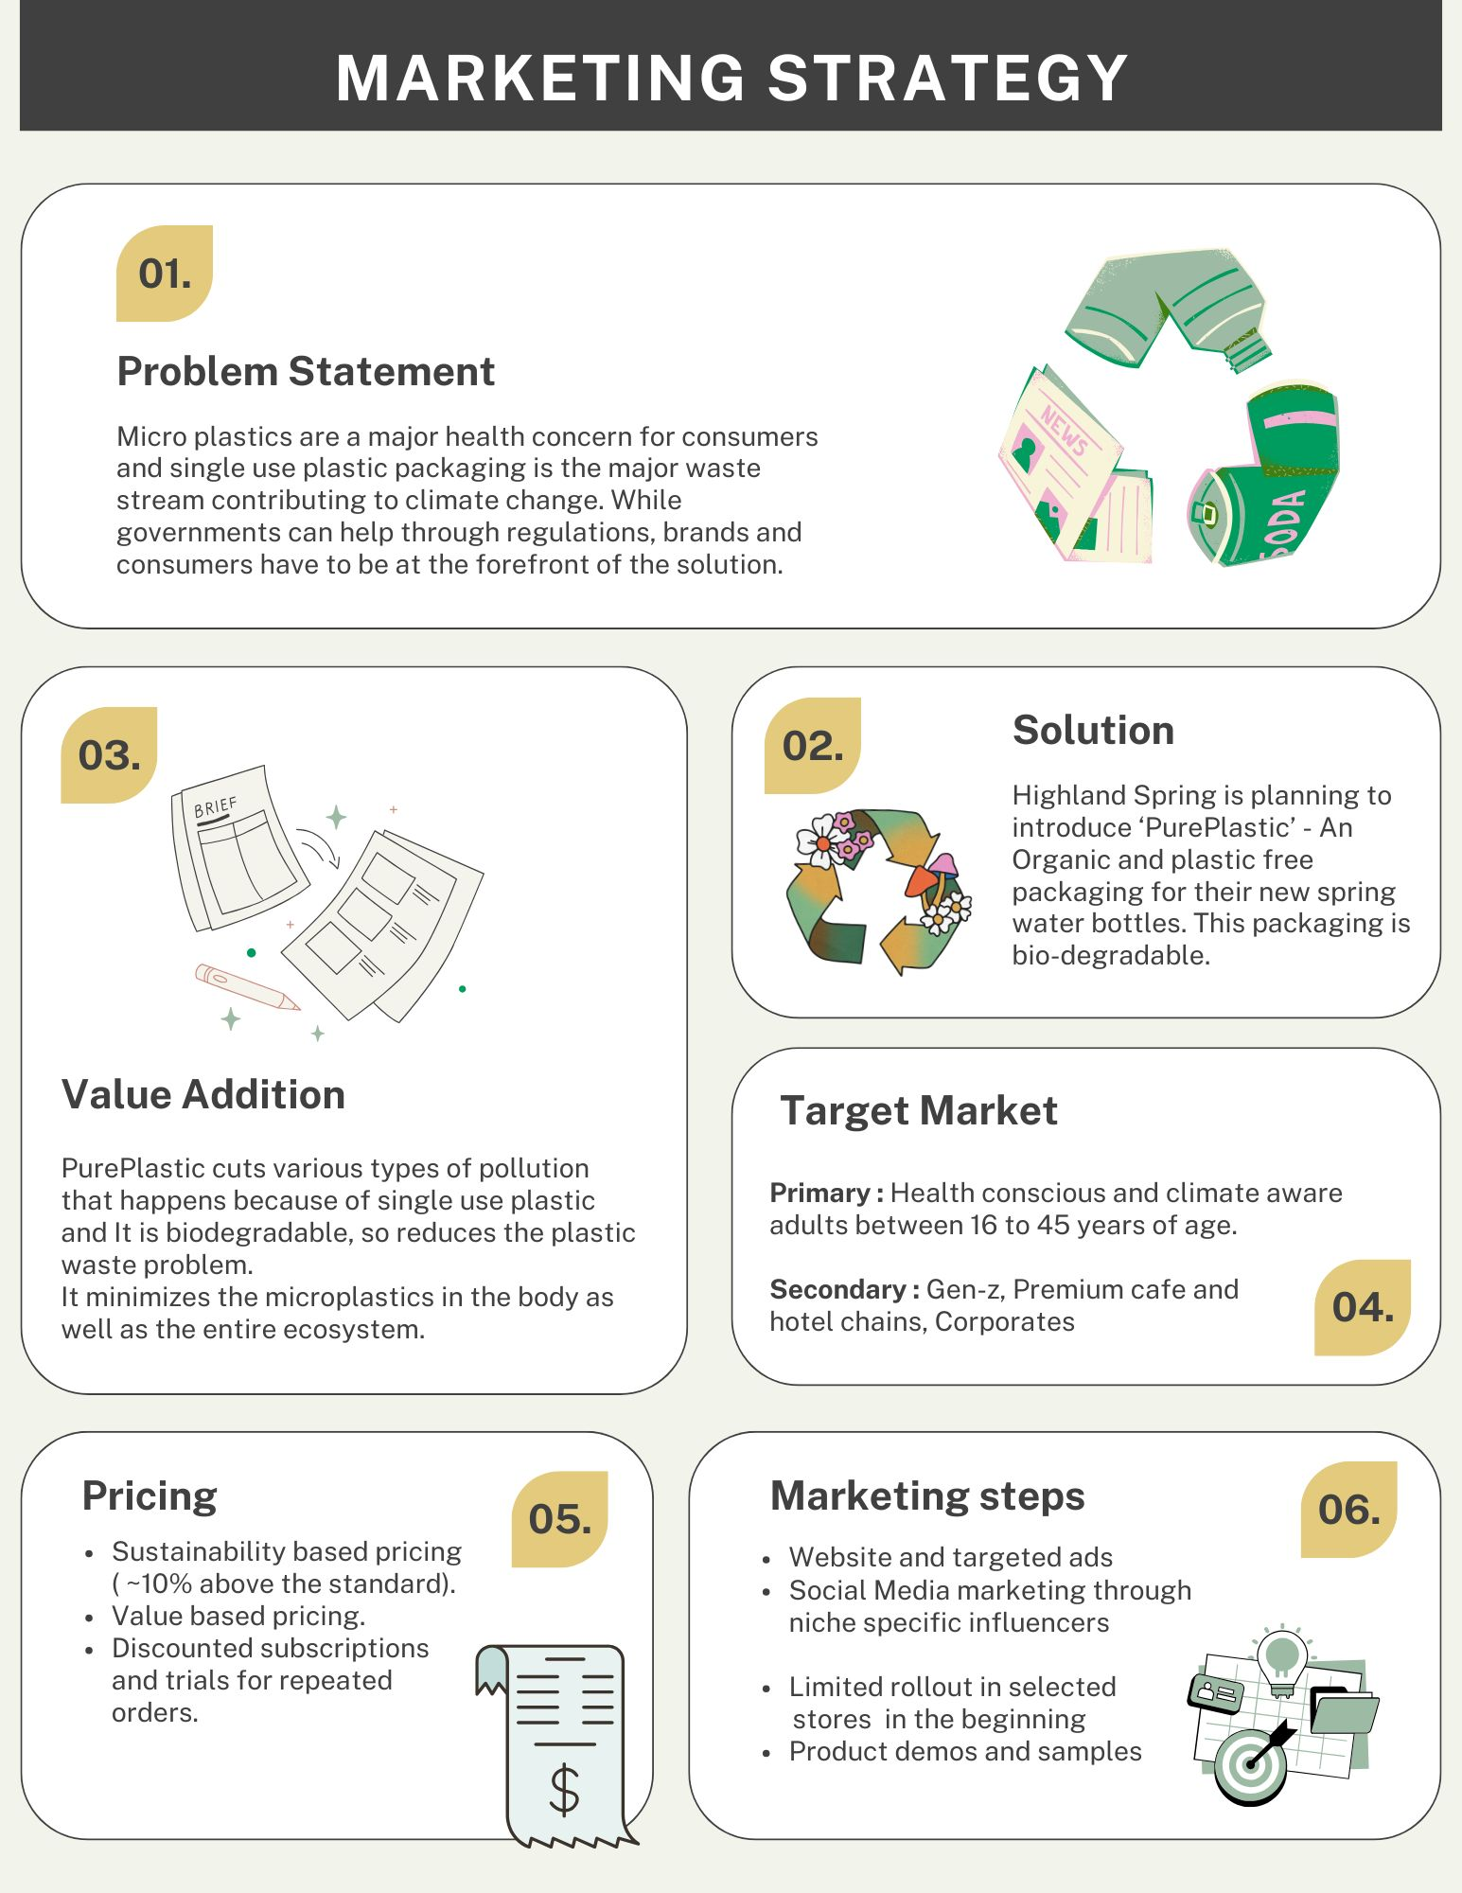

Reference List:
Compostable Packaging Market (2024 – 2030), Grand View Research. https://www.grandviewresearch.com/industry-analysis/compostable-packaging-market-report

UK Bottled Water Market (2024 - 2030) , Grand View Research. https://www.grandviewresearch.com/industry-analysis/uk-bottled-water-market-report

A briefing on plastic waste in the UK including legislation, statistics, government policies and proposals for change. By House of Commons Library (2024). https://commonslibrary.parliament.uk/research-briefings/cbp-8515

UK Attitudes towards Drinks Packaging Consumer Report 2023, by Mintel (2023). https://store.mintel.com/report/uk-attitudes-towards-drinks-packaging-market-report

7.0. Reflection
Developing the ‘PurePlastic’ concept for Highland Spring was an exercise that taught me how to balance commercial viability with ethical integrity. Initially, my approach was product-centric. As I wanted to create a "perfect" sustainable bottle. The STDP framework helped me to adopt a consumer-centric perspective and I realized that a biodegradable bottle is meaningless if the target audience perceives it as "greenwashing." This insight significantly altered my approach to Positioning. Instead of hiding the word "plastic," I chose to use it in the name itself. It also uses the consumer’s autopilot purchasing habits.
The 4Ps in Marketing Mix highlighted the importance of cohesion between strategic elements as I found it challenging to justify a premium price point (£1.50) in a commoditized market. So, by aligning the Price with the Place (premium retailers like Waitrose), I realised that now price acts as a signal of quality and authenticity. This process taught me that the 4Ps are not fragmented from each other but an interconnected ecosystem. Another thing is that a simple change in distribution strategy immediately impacts the required promotional messaging and overall stategy.
Preparing and Delivering the Pitch was a distinct challenge as presenting a 2,000-word academic analysis into a 3-minute persuasive pitch was hard for me. While the written assignment required analytical depth and referencing, the pitch needed to be short, but it had to hit all the touch points. I struggled initially with information overload, trying to explain the technical chemistry of Polylactic Acid (PLA). To overcome this, I focused on visual storytelling. Creating the poster forced me to distill the value proposition into a single image.This taught me the ability to communicate complex supply chain innovations through simple, relatable benefits. I learned that in a pitch context, vision and the problem-solution fit matters the most rather than just the technical features.
Critical Analysis and Future Development Reflecting on the process through Gibbs’ Reflective Cycle, I recognize that while my qualitative analysis of consumer trends was strong, my quantitative backing could be improved. In future projects, I will aim not to relying only on surveys but also incorporate more robust financial forecasting to validate the profitability. I also realized that I relied on secondary research, which was credible but it lacked the nuance of primary data.
Ultimately, this assignment was helpful to me in understanding how to apply theoretical marketing frameworks to real-world applications. I have developed the skills to identify market gaps and also build a holistic strategy from academic and commercial perspectives because of the same.

References
1. Highland Spring Group: Annual Results to 31 December 2024 (Highland Spring (2025). https://highlandspring.com/highland-spring-group-annual-results-to-31-december-2024/
2. Highland Spring reports 13.5% sales growth, (Insider.co.uk, 2025). https://www.insider.co.uk/company-results-forecasts/highland-spring-reports-135-sales-36044595
3. A Critical Review of Consumer Perception and Environmental Impacts of Bioplastics in Sustainable Food Packaging, (MDPI, 2025). : https://www.mdpi.com/2071-1050/17/4/1358
4. How does the European consumer perceive bioplastics? (European Bioplastics, 2023). https://www.european-bioplastics.org/how-does-the-european-consumer-perceive-bioplastics/
5. Top Sustainable Packaging Trends in 2025 for Eco-Conscious Brands, (venue Printing, 2025). https://www.avenue-printing.co.uk/top-sustainable-packaging-trends-in-2025-for-eco-conscious-brands/
6. How does the European consumer perceive bioplastics? (European Bioplastics ,2023). https://www.european-bioplastics.org/how-does-the-european-consumer-perceive-bioplastics/
7. UK Bottled Water Market Size & Outlook, 2025-2030, (Grand View Research, 2025). https://www.grandviewresearch.com/horizon/outlook/bottled-water-market/uk
8. UK Sustainable Packaging Market Size, Trends Report, 2033, (IMARC Group, 2025). https://www.imarcgroup.com/uk-sustainable-packaging-market
9. Consumer Perceptions of Bioplastics: Challenges and Opportunities, (Rheom Materials, 2024). https://www.rheom.com/blog/consumer-perceptions-of-bioplastics-challenges-and-opportunities
10. The 2025 Sustainable Packaging Consumer Report, (Shorr Packaging, 2025). https://www.shorr.com/resources/blog/sustainable-packaging-consumer-report/
11. UK Consumer Trends Influencing the Packaging Landscape 2025. (Smurfit Kappa, 2025). https://www.smurfitkappa.com/uk/newsroom/blog/consumer-packaging-trends
12. 4 Ps of Marketing: Product, Price, Place, and Promotion. AdLift (2024). https://www.adlift.com/blog/from-product-to-promotion-a-fresh-take-on-the-4-ps-of-marketing/
13. 10 Strategies for Marketing Sustainable Products. CarbonBright (2025). https://www.carbonbright.co/insight/10-strategies-for-marketing-sustainable-products
14. The Sustainable Consumer 2024: Consumer attitudes to sustainability. Deloitte (2024). https://www.deloitte.com/uk/en/Industries/consumer/perspectives/the-sustainable-consumer.html
15. 7 Sustainable Marketing Strategies. DesignRush (2025). https://www.designrush.com/agency/digital-marketing/trends/eco-marketing
16. Marketing Strategies for Promoting and Selling Eco Friendly Products. Green Socials (2025). https://www.green-socials.com/blog/marketing-strategies-for-promoting-and-selling-eco-friendly-products
17. Highland Spring Group: Committed to Net Zero. Highland Spring (2025). https://scottishcities.org.uk/highland-spring-group-committed-to-net-zero/
18. A Critical Review of Consumer Perception and Environmental Impacts of Bioplastics in Sustainable Food Packaging, MDPI (2025). https://www.mdpi.com/2071-1050/17/4/1358
19. Voice of the Consumer Survey 2024: Consumers willing to pay 9.7% sustainability premium, PwC (2024). https://www.pwc.com/gx/en/news-room/press-releases/2024/pwc-2024-voice-of-consumer-survey.html
20. Highland Spring Group: Committed to Net Zero - Rail Freight Investment. Scottish Cities Alliance (2022). https://scottishcities.org.uk/highland-spring-group-committed-to-net-zero/
21. The 2025 Sustainable Packaging Consumer Report, Shorr Packaging (2025). https://www.shorr.com/resources/blog/sustainable-packaging-consumer-report/
22. Sustainability & Responsible Sourcing Report, Waitrose & Partners (2023). https://www.waitrose.com/ecom/content/sustainability
23. Microplastics and our health: What the science says. (Harvard, 2025). https://med.stanford.edu/news/insights/2025/01/microplastics-in-body-polluted-tiny-plastic-fragments.html

