4.0 Chapter 4 – Data Analysis

4.1 Introduction
Chapter three explained the collection methods to be used by the researcher to obtain primary data. Chapter four aims to contribute to fulfilling the purpose of this dissertation which is to determine if there is a need for FB to incorporate Corporate Social Responsibility to improve brand perception. This chapter will analyse the primary data that has been collected (See appendix 2 for raw data) through the online questionnaires and present the findings to achieve objective two:
2. Conduct primary research in the form of an online questionnaire which will evaluate FB current brand perception and determine the CSR responsibilities most effective in improving FB brand perception
The questionnaire was shared to the researcher's contacts via WhatsApp who were asked to fill in the questionnaire and also forward the questionnaire on with contacts. The questionnaire link was available on the researchers Instagram account and stories were uploaded which asked followers to click the link and share to their story in an attempt to reach as many participants as possible. The total number of responses was one hundred and forty-one. The average response rate for a survey is 20.4%, (Deutskens et al, 2004; Baruch and Holtom, 2008). The survey response rate for this questionnaire cannot be determined because the number of people who shared the questionnaire was not recorded and neither was the number of followers for each story which it was uploaded to. It can be concluded that the response rate was below average, considering that the researcher alone shared the questionnaire with 958 potential participants and that the questionnaire was uploaded to five Instagram account story’s, all of which had a minimum of four hundred followers.

4.2 Data Analysis
Data analysis uses analytical and logical reasoning to extract knowledge from the data. The aim of analysing data is to find significance in the data so that the derived information can be used to make informed decisions. There are many approaches to qualitative and quantitative data analysis, which have been extensively explored in the literature on social sciences, (Welsh, 2002; Ding and Beichner, 2009; Smith and Firth, 2011).

4.3 Methods
The online questionnaire provided quantitative and qualitative data. The use of SPSS software programme is an effective form of study for quantitative data; alternatively, it is sufficient to use Nvivo to analyse the qualitative results. Analysis of the quantitative data was deemed as positivism by use of the statistical tests; the independent sample t-test, Mann-Whitney UTest and crosstabulation using Pearson’s Chi-square test. The SPSS T-test measures the variation in mean between two groups to a given value, analysing if the difference in mean is 0, (DeCoster and Claypool, 2004; Park, 2009). The Mann-Whitney U Test and the Chi-Square Test are non-parametric tests, this test can be applied to smaller sample sizes and the sample does not have to follow specific assumptions, (Chan, 2003; Hinton, 2014). The Mann-Whitney U test is a nonparametric version of the independent sample T-Test. The Mann-Whitney U Test deals with two unrelated samples containing ordinal data and the Chi-Square Test analyses the difference between the expected theoretical value and the observed theoretical value between two categorical variables, (Ruxton, 2006; McKnight and Najab, 2010; McHugh, 2013; MacFarland and Yates, 2016). To use SPSS, the quantitative data had to be coded from words to nominal data using both excel and SPSS. Likert scale questions which are where the participants stated their degree of agreement to a statement had to be coded from 1 to 5, e.g. Strongly disagree – 1, Disagree – 2, Neither Disagree or Agree – 3, etc.
NVivo was the software used to analyse the qualitative data collected by the questionnaire. NVivo was the chosen method of coding qualitative data since it can be learned within a short time frame and does not require prior knowledge, (Richards, 1999). NVivo has been used to run queries regarding the data obtained. Queries such as word frequency have been used to find out how many times a word has recurred as well as text searches for particular words. The programme also allows phrases and terms to be encoded and applied to the appropriate nodes that can be used to create project and concept maps.
This chapter starts with question two, as question one asked participants for their consent to use their data within this study. All the data which has been analysed within this chapter have received consent.

4.4 Demographics

4.4.1 Question 2
Question two asked participants to select the age group in which they fall, with the option of selecting, “prefer not to say” for any participants who did not wish to reveal this information. This question was asked because the researcher was interested to see whether age had any effect on how FB was perceived. Here is what the population look like.
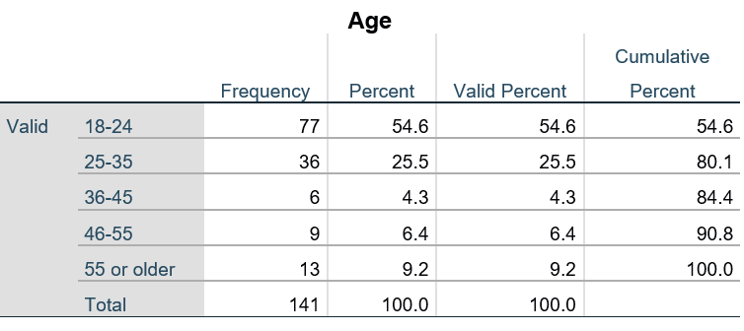
Table 4.2 Age Demographic
The data indicates that a significant percent of participants was between 18 and 24 years of age, this age group made up for 54% of all participants and the remaining 46% of participants were 25 years of age and older.

4.4.2 Question 3
Question three asked respondents how familiar they with FB. The options were, Extremely familiar, Very familiar, Somewhat familiar, Not so familiar, and Not at all familiar. 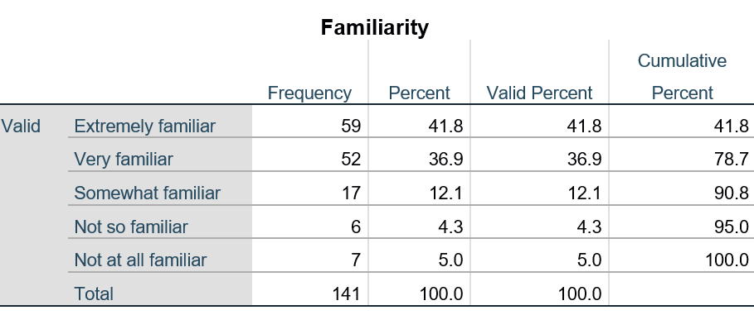
Table 4.2 Familiarity frequency table
The results found that 41.9% of the participants were extremely familiar, 36.9% were very familiar, 12.1% were somewhat familiar, 4.3% were not so familiar and 5% were not at all familiar. It is not a surprise to see that 95% of participants showed some familiarity to FB giving that in chapter two states FB is the world’s largest online social media platform.
The researcher explored the possible link between familiarity and age. The hypothesis was:
- H1 (Alternative Hypothesis). There is a difference in familiarity between age groups
- H0 (Null Hypothesis). There is no difference in familiarity between age groups.
The hypotheses were tested using a Chi-Square test to conduct a Crosstabulation on Age and Familiarity. The column headings are Extremely familiar, very familiar, somewhat familiar, not so familiar, and not at all familiar. The row headings are the age groups 18-24, 25-35, 36-45, 46-55 and 65 or older.

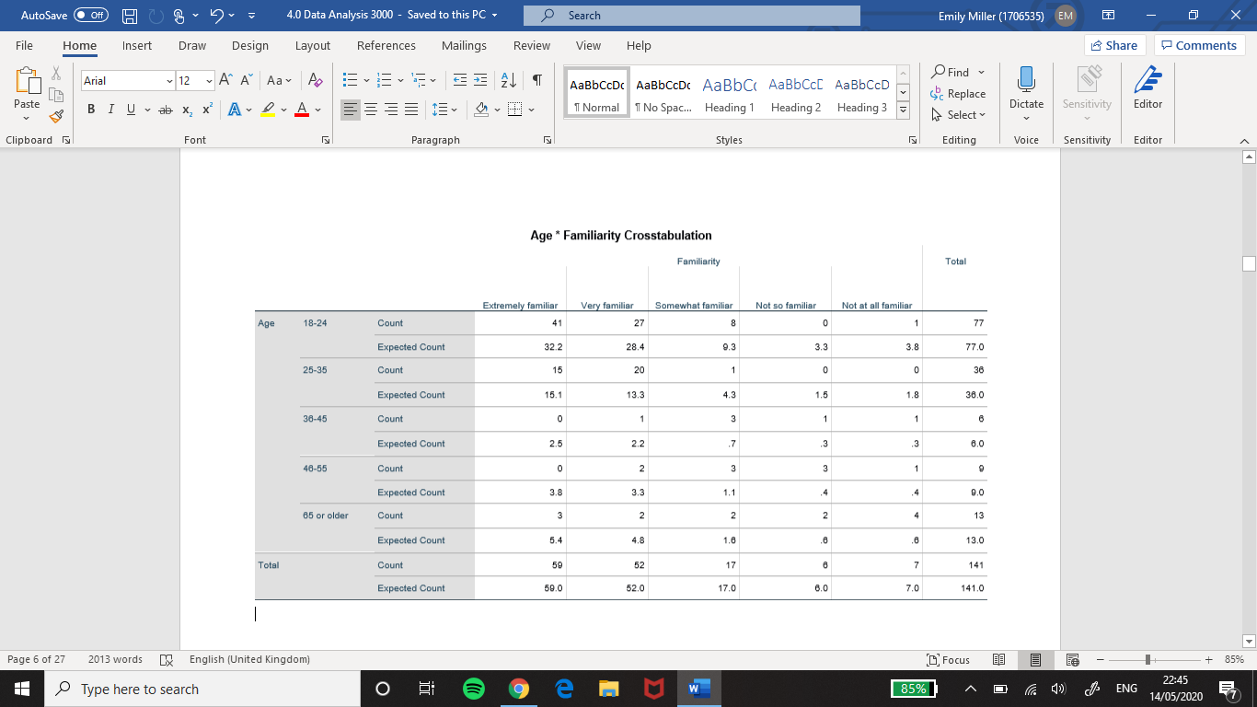
Table 4.3 Age and Familiarity crosstabulation

The crosstabulation of the two variables reveals the majority of the expected count (p-value) was less than 5% (0.05). This is a type-1 error that indicates a false positive null hypothesis, for this reason, H0 in this form will be rejected. This test cannot be used in its current form since there are too many values less than 5%. Collapsing the data by grouping the ages to under 35 and over 35 and Extremely familiar, very familiar to familiar, not so familiar, and not at all familiar to not familiar. Somewhat familiar will remain but be referred to as neither, this will reduce the number of groups for the categorical variables.
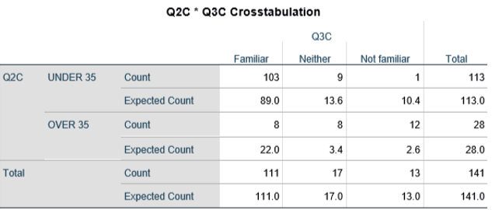
Table 4.4 Age and Familiarity collapsed crosstabulation
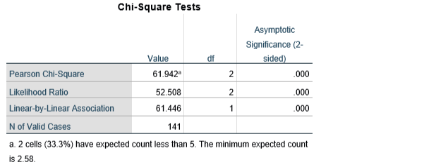
Table 4.5 Age and Familiarity collapsed Chi-Square Test
Chi-square tests are used to measure the p-value to determine if it is equal to or less than 0.05 (5%). If over 20% of the expected values are less than 0.05 the Chi-square test would not be valid. In this instance, 33.3% of the cells are less than 5% meaning the test is invalid, because of this the researcher must use Fisher's exact test to assess H0. This identifies if there are non-random associations between the two categorical variables, it is not an approximation of the p-value it is the exact calculation of the p-value. The result from this test was 3.25658705928824e-12 which is far less than 0.05. This proves H1, there is a difference. 103 people are familiar, and 13 said they are not familiar for under 35, whereas over 35, 8 people were familiar whereas 13 were not.

4.4.3 Question 4
Question four asked participants to describe their overall perception of FB. The options were, Extremely favourable, Very Favourable, Somewhat favourable, Not so favourable, Not at all favourable.
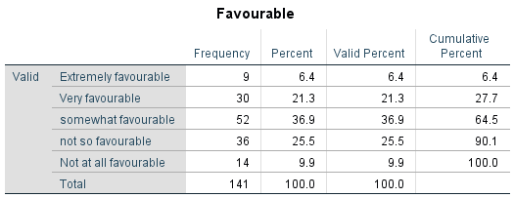
Table 4.6 Favourable frequency table
The table displays the frequency and percentage for each term that was selected. The results show that Somewhat favourable was the most selected term, having been selected by 52 out of the 141 respondents and the least selected term was Extremely favourable.
A Chi-square test was run to identify whether favourability is dependent on age. The hypothesis was:
- H1. Favourability is dependent on age.
- H0. Favourability is not dependent on age.
Extremely favourable, very favourable, were collapsed grouped under favourable. Somewhat favourable was referred to as neither. Not so favourable, and not at all favourable were grouped under Not favourable.
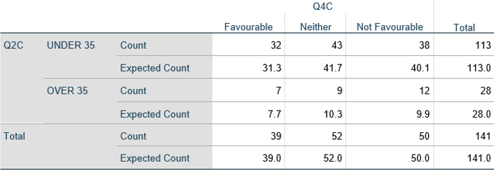
Table 4.7 Age and Favourability crosstabulation
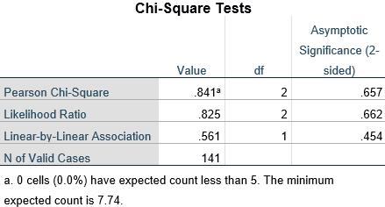
Table 4.8 Age and Favourability Chi-Square Test
The crosstabulation of the two variables shows all of the expected counts were more than 5%. This indicates H0 was correct, there is no difference between age and favourability of FB.
The second analysis was carried out to identify if there is a relationship between favourability and familiarity.
- H1. There is a relationship between favourability and familiarity.
- H0. There is no relationship between favourability and familiarity.
The headings Extremely familiar, very familiar, somewhat familiar were grouped under Familiar. Not so familiar and not at all familiar were grouped under Not familiar.
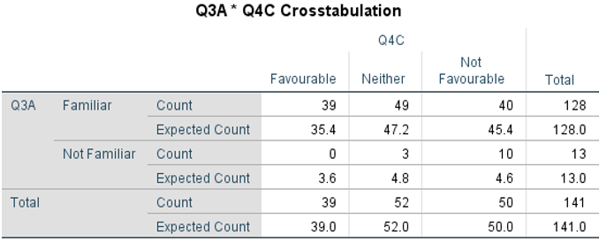
Table 4.9 Favourable and Familiar Crosstabulation
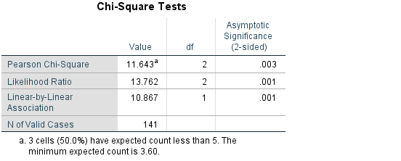
Table 4.10 Favourable and Familiar Chi-Square test
This test is invalid. 50% of the expected count was less than 5%, because of this Fisher's exact probability test will determine H0. The result was 0.000018678427711528592. This is substantially smaller than 0.05 and therefore H1 is found to be true.
However, it must be noted this result lacks reliability due to the disproportionate number of participants which fall into the categories familiar and not familiar. There are 128 participants in the category familiar and only 13 participants in the unfamiliar category.

4.4.4 Question 5
Question five asked participants to briefly explain their overall perception of FB. Out of the 141 participants, there were 131 responses. However, 130 responses were analysed as one response was antisemitism, which the researcher felt would be unethical to add this to their research and would not add value to their results. The qualitative data collected has been coded in NVivo. Responses were formed from an Excel document into a Word document which was imported into NVivo which was used to code the data into nodes. Similar perspectives were grouped together by highlighting sections of text and adding them to the appropriate nodes. Themes could be determined from the perception’s participants stated they had of FB. The nodes were used to create a visual representation of the relationship between each reference in the form of a concept map (figure 4.1).
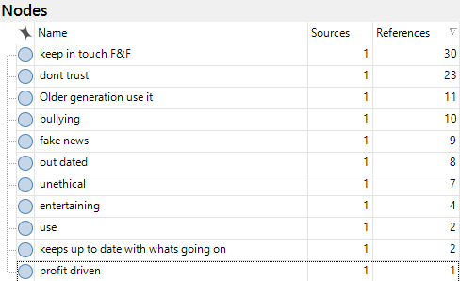
Table 4.21 Nodes Table
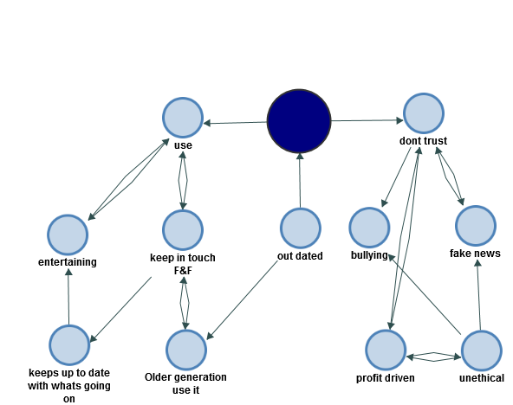
Figure 4.1 Nodes Concept Map
The nodes table reveals how many times participants shared similar perceptions. This analysis highlighted that FB is perceived as being a platform to keep in touch with Family and Friends. In Chapter one FB mission statement is disclosed, these results suggest that FB is achieving their mission statement, (Zuckerberg, 2017). The second most common reference was statements regarding a lack of trust in FB. This supports what was found in the literature review when it was reported that trust in FB had dropped by 66%, (Weisbaum, 2018). The third most common perception was, FB is used by the older generation which fits with what was found in Chapter one, (Viens, 2019).

4.4.5 Question 6
Question six was a Likert scale which asked participants to state how far they agreed with the following statements:
6A. FB does the minimum to maintain relationships with its users.
6B. FB goes above and beyond to satisfy their user’s needs.
Statements
6C. FB supports socially responsible causes which benefit society at large.
6D. FB complies with all consumer rights and acts in accordance with the law.
6E. FB is more focused on generating revenue than user satisfaction.
The hypothesis for this test was:
- H1) Age has an effect on how people perceive FB.
- H0) Age does not affect how people perceive FB.
A Mann-Whitney U test is the most appropriate test because the data is ordinal.
Participants rated the statements from strongly Disagree, Disagree, Neither Disagree or Agree, Agree and Strongly Agree. The data was collapsed to increase the significance of the results. Strongly disagree and Disagree became Disagree. Neither remained and Agree and Strongly agree became Agree.
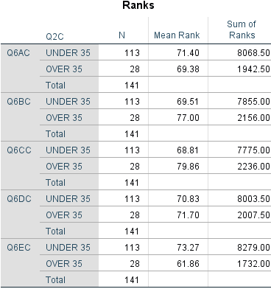
Table 4.12 Age and perception Ranks
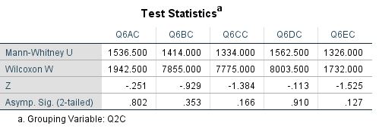
Table 4.13 Age and perception Mann-Whitney U Test
The asymptotic significances inform the researcher to retain H0 for each of the statements as each asymptotic significance is greater than 0.05.

4.4.5 Question 7
Question seven informed participants of the FB C-A scandal. Figure 4.2 demonstrates 111 participants said Yes, this does affect their perception while 30 participants answered, No. This indicates that when corporations such as FB carry out unethical and illegal activities this negatively impacts the way they are perceived.
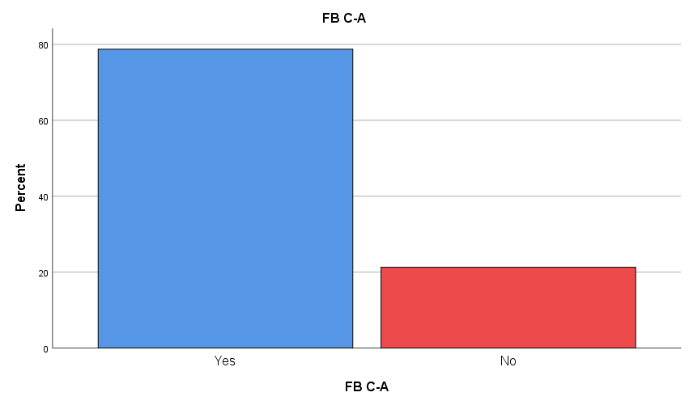
Figure 4.2 FB C-A Percentage bar graph
To be able to thoroughly analyse the responses to this question, question eight must be analysed which explains the reason why the respondents answered yes or no.

4.4.6 Question 8

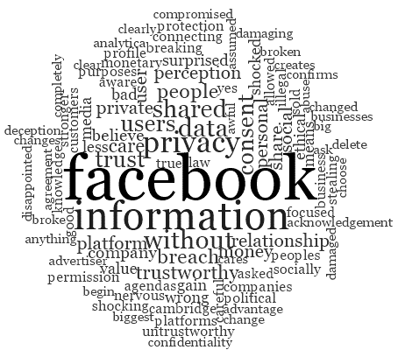
Figure 4.3 Question 8 Word Cloud
NVivo was used to create a word cloud for the qualitative data. A word cloud is a visual that enables the researcher to observe what the most frequently mentioned words are. The size of the words in the cloud are dependent on the frequency. If a word is larger this indicates the word was mentioned often. Figure 4.3 is the 100 most frequently used words it depicts the thoughts and feelings that respondents had to the information some of which are, disappointed, shocked, untrustworthy, damaging The words in the figure, show that the respondents do not hold FB in high regard.

4.4.6 Question 9
Question nine was a Linkert scale which asked participants how far they agree with the following statements:
Q9A. FB has a responsibility to improving the welfare of all its stakeholders.
Q9B. FB has an obligation to do what is right, just, and fair to avoid causing harm.
Q9C. FB has a duty to abide by society’s codification of what is right and what is wrong.
Q9D. FB has an economic responsibility.
The hypothesis for this test was:
- H1. People feel that FB have economical, legal, ethical, and philanthropic responsibility.
- H0. People feel that FB does not have economical, legal, ethical, and philanthropic responsibility.
An Independent T-test was performed to analyse the data collected for this question. The p-value from the results will be calculated to identify if the values are greater than 0.05. If this is found to be true H1. Would be accepted as there has been a significant statistical difference which has occurred, ().

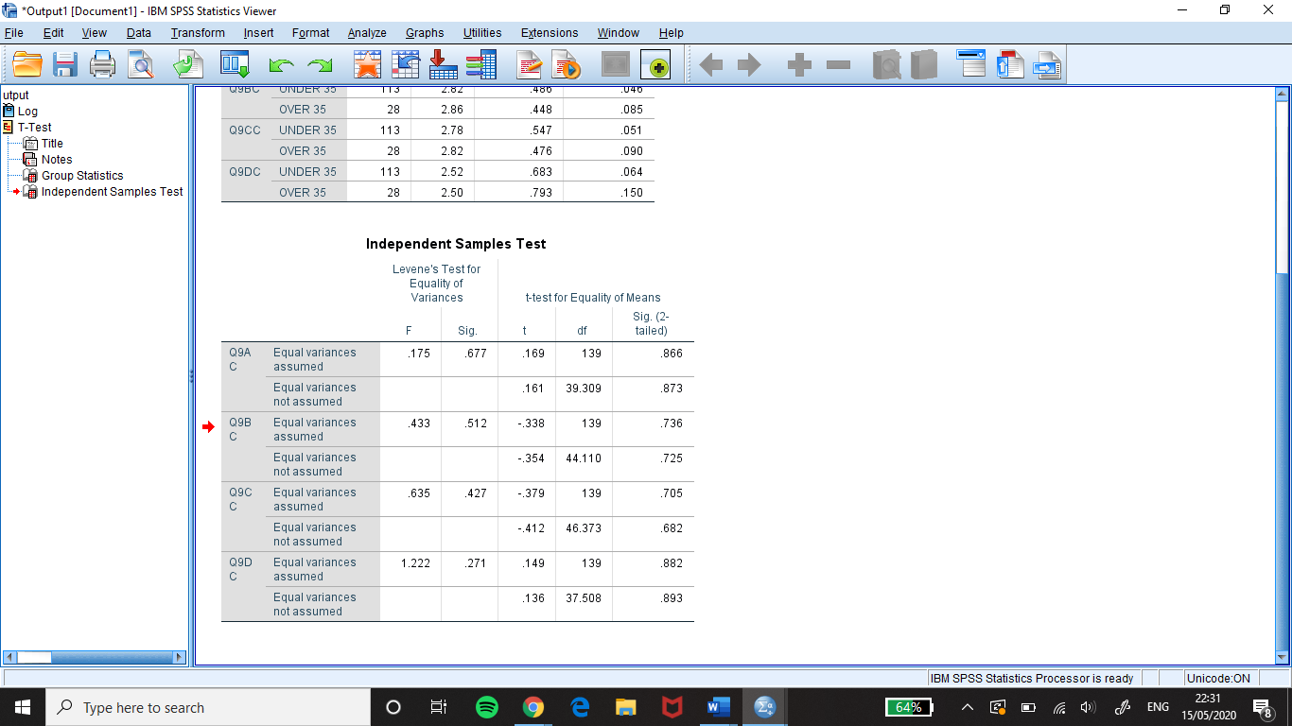
Table 4.14 Independent Sample T-test
Table 4.14 show that all the results in the p-value column (Sig. (2-tailed)) are greater than 0.05, meaning there is no significant difference and therefore retain H0. The responses provided for statement 9A and 9B support Freemans view of stakeholder theory and opposes Friedman’s Shareholder theory within Chapter two. Statement 9C shows there is a want from people for FB to stop breaking the rules and regulations and to abide by society’s codification. Statement Q9D results show that economic responsibility is held in high regard supporting the theory of Carroll’s pyramid in Chapter two.

4.4.8 Question 10
Question ten asked participants to select the responsibilities they felt was the most important for FB to act on. The responsibilities were economic, legal, ethical, and philanthropic. Each responsibility had to be coded and counted in excel as participants had the option of selecting more than one. Therefore, economic was assigned the number 1, Legal 2, Ethical 3, and Philanthropic 4.
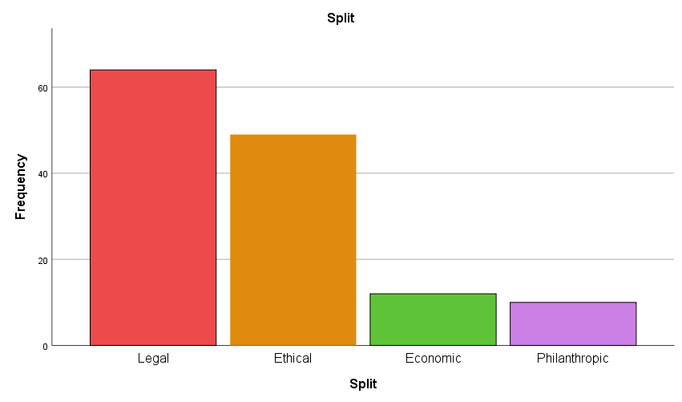
Figure 4.4 Responsibility frequency bar graph
Figure 4.4 was created in SPSS as a visual tool and depicts the frequency each responsibility was selected. The results show people feel FB greatest responsibility is a Legal responsibility which was selected 117 times. The next most important was an Ethical responsibility, selected 53 times, then an economic responsibility, selected 37 times and lastly a Philanthropic which was selected 31 times.
The researcher explored if there was a link between the age and the responsibilities participants choose. The hypothesis tested was:
- H1. There was a difference between the age of a participant and the responsibilities they felt FB had.
- H0. There was no difference between the age of a participant and the responsibilities they felt FB had.
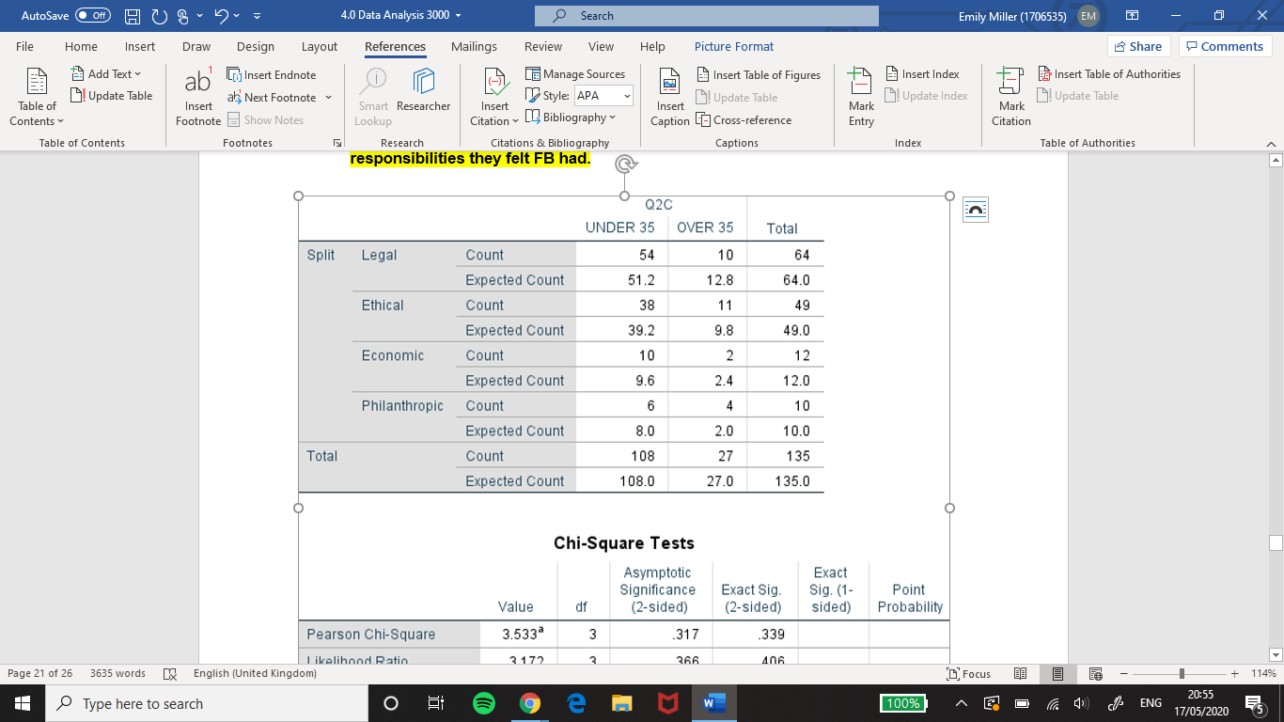
Table 4.15 Responsibility and Age Crosstabulation
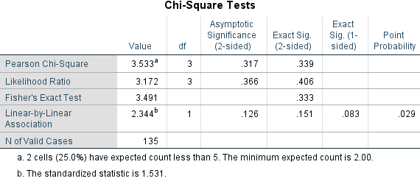
Table 4.16 Responsibility and Age Fishers Exact test
This Chi-square test would not be valid as 25% of the expected value are less than 5%. Fisher's exact test was calculated which gave the result .333, this greater than 0.05. This proves H0, there was no difference between the age of a participant and the responsibilities they felt FB had.

4.4.9 Question 11
Question 11 asked participants do they feel that FB could do more to act on the previously chosen responsibilities? 130 respondents choose Yes while 11 choose No.

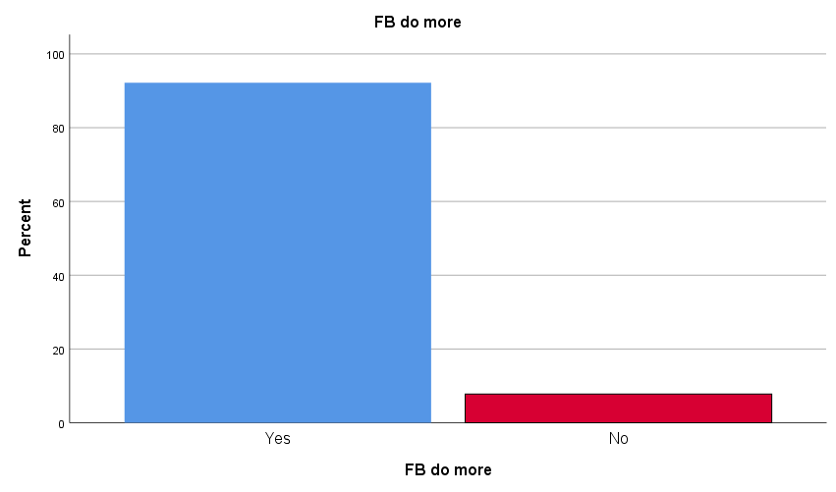
Figure 4.5 Q11 response bar graph
The respondents that choose No and gave a reason within Question 13 gave the reasons:
- “I like keeping connected”
- “I feel people can be a bit naive about data sharing and must understand that even though companies like FB do misuse them, it is part of society at the moment”.
- “I believe that they are not a safe site and have no privacy which is why I deleted it”
These three participants also said that their perception would not be changed if FB did more to act on their responsibilities for question 12.
Responses one, two and three take very different views. Response one indicates if FB did or did not incorporate CSR this would have no effect on their perception as they like the platform service either way. Response two believes that unethical corporate actions are part of the way all organisations are run and so it is something that should be accepted. Whereas response three takes the approach that such unethical corporate actions should not go unnoticed, and once FB has broken its users trust it cannot be rebuilt.

4.4.10 Question 12
Question 12 asked participants if FB acted on the responsibilities listed in question 10 would this improve their overall perception of FB? Figure 4.6 presents the findings. 93 participants selected Yes and 46 selected No.
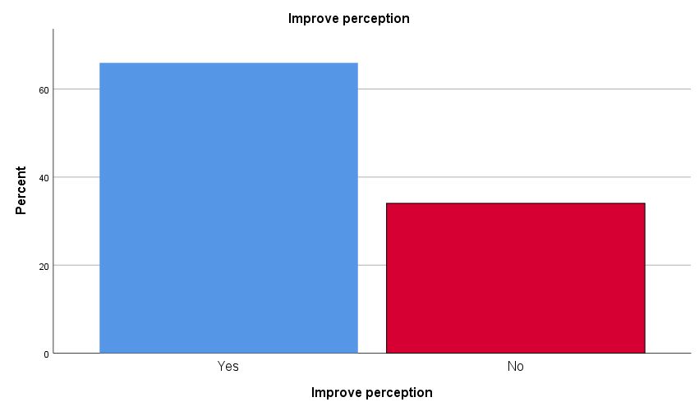
Figure 4.6 Question 12 Responses
A Chi-square test was used to find a link between the respondent’s answers to question 11 and question 12. The hypothesis was:
- H1. Participants who said that FB could do more to act on the responsibilities also said that this would improve their perception.
- H0. Participants who said that FB could do more to act on the responsibilities also said that this would not improve their perception.
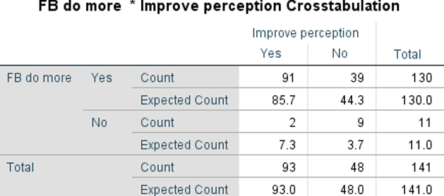
Table 4.17 Question 11 and Question 12 Crosstabulation
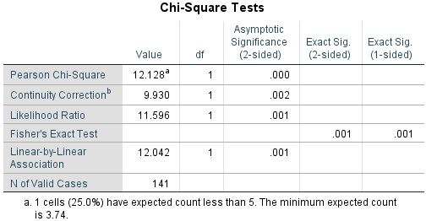
Table 4.18 Question 11 and Question 12 Chi-Square Test
The Chi-square test was not valid as 25% of the p-value is less than 5%. Fisher's exact test was used to assess H0. The result was 0.001 which is lesser than 0.05, this proves H1. Table 4.17 presents this as 91 participants agreed that FB could do more to act on their responsibilities and this would improve their perception of FB whereas, 39 participants said that FB could do more to act on the responsibilities but this would not change their perception.

4.4.11 Question 13
Question 13 asked participants to explain why they had chosen Yes or No to question 10. NVivo was used to run a text search query to identify the most common response. It was discovered if FB acted lawfully this would have the greatest impact on changing perception. Figure 4.7 show the responses which included the term “law”. This indicates if FB continues to involve themselves in activities such as the FB-CA scandal their brand perception will decrease.
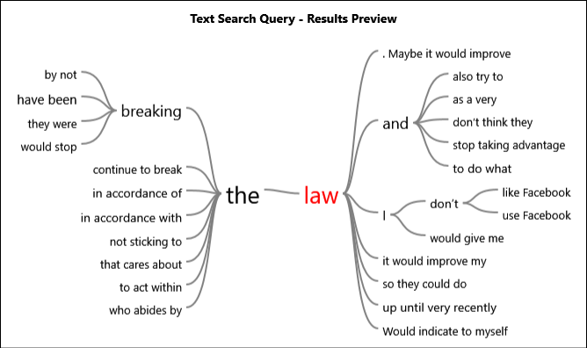
Figure 4.7 Text search query for Question 13

4.5 Triangulation of findings
The online questionnaire collected qualitative and quantitative data. The analysis of the data revealed that there was an agreed theme within the qualitative data which was also present within the quantitative data. Therefore, triangulation can be used. The theme to emerge was a legal responsibility was considered most valuable and could be most effective for improving brand perception if acted on.

4.6 Conclusion
By carrying out primary research in the form of an online questionnaire and analysing and presenting the results objective two has been successfully fulfilled. From the study it was found that participants perception was more unfavourable than favourable and the responsibility which participants felt FB had a duty to upkeep was a legal responsibility, this responsibility was also identified as the one which could improve perception If acted upon. Ethical responsibility was the second most chosen responsibility, but it was not expressed as being as effective for improving brand perception as legal responsibility.

