LECTURER: Mr SADEQUE IMAM SHAIKH
December 5, 2025
UNIVERSITY OF WALES
TRINITY ST DAVID
LONDON
ACCA 5023

BSC APPLIED COMPUTING
NETWORK OPERATING SYSTEM AND SERVICES.

Mr Felix Okpahwa Amrovhe 2414768

Table of contents
Contents
LECTURER: Mr SADEQUE IMAM SHAIKH 0
BSC APPLIED COMPUTING 0
Mr Felix Okpahwa Amrovhe 2414768 0
Table of contents 1
INTRODUCTION 2
Task 1 2
Research on Hypervisor 2
Research on IP Addressing 2
Research on Routing 3
Research on Network services 4
Task 2 5
2.1 choose Hypervisor 5
2.2 Download and Setup 5
2.2.1 5
2.2.2 9
Configure IP Addressing 11
2.3.1. Use appropriate IP addresses to configure your network. 11
2.4 Test and Troubleshoot 15
2.4.1 Perform Connectivity tests 15
Task 3 17
3.1.1 Write a Technical reflection covering network deployment and testing. 17
3.1.2 17
Conclusion 18

INTRODUCTION

Task 1

Research on Hypervisor

A hypervisor is a virtualization layer that enables multiple operating systems to run concurrently on a single physical host. Type 1 (or "bare-metal") hypervisors install directly onto server hardware, functioning as a specialized OS for superior performance, security, and resource efficiency—making them the standard for enterprise environments. In contrast, Type 2 (or "hosted") hypervisors operate as an application on an existing host OS (e.g., Windows or Linux), introducing more overhead and reduced performance, which suits individual or development use.[1]

For the SWANSEA.ACCA domain, a Type 1 hypervisor is strongly recommended to host the Windows Server 2022 (providing core services like Active Directory) and the Debian Server. This choice ensures high performance and scalability for resource-intensive services and future growth. By operating directly on the hardware, a Type 1 hypervisor minimizes the attack surface—a critical security benefit for the domain controller managing network authentication. It also offers robust hardware compatibility and efficient resource use, aligning with enterprise best practices for reliability and centralized management. Therefore, a Type 1 solution best meets the topology’s demands for security, compatibility, and production-level stability.

Research on IP Addressing

Data travels across the Internet in small packets. Each packet contains the actual data being sent, along with header information that includes the source and destination *IP Addresses. These addresses act as unique logical identifiers for every device, enabling routers to forward packets toward their final destination through a series of "next hop" decisions.[2]

Routers and Switches facilitate this flow. Switches operate within a single local network, efficiently directing traffic between devices using MAC addresses. Routers, the crucial gateways between different networks, use the IP addresses in packet headers to determine the optimal path across the complex network of the Internet.

The effectiveness of this system hinges on IP Addressing. The common IPv4 (32-bit, e.g., `192.168.1.1`) has a limited address space, while IPv6 (128-bit, hexadecimal) provides a virtually limitless pool. To use IP addresses efficiently, networks are divided using subnetting**. This practice splits a large network block into smaller, manageable sub-networks (subnets), which improves performance, enhances security by isolating traffic, and optimizes the allocation of IP addresses to prevent waste. For example, a `/24` network can be subdivided into smaller `/25` subnets for different departments. In essence, the structured hierarchy of IP addressing and subnetting is what allows routers to effectively navigate and direct the flow of data across the global Internet.

Research on Routing

Routing protocols are the rules that govern how routers determine the optimal path for forwarding data packets between networks. Their core purpose is to dynamically build and maintain routing tables, which are maps of the network topology.[2]

The two primary approaches are:

Static Routing: Paths are manually configured by an administrator. It is simple, secure, and uses minimal router resources. However, it does not adapt to network changes like a link failure, making it non-scalable and prone to human error.
Dynamic Routing: Routers automatically share information about network reachability using protocols like OSPF or EIGRP. They dynamically update their routing tables based on this exchanged data, allowing them to adapt to topology changes, reroute traffic around failures, and scale effectively in complex environments. The trade-off is increased router overhead and complexity.

Recommendation for the Topology

For the described topology, a hybrid approach is most suitable, leveraging the strengths of both methods.

Static routing should be implemented on the perimeter router and the internal router connecting to the Debian Server (DHCP Relay). This provides a simple, secure, and predictable path for client default gateways and for the relay agent to communicate with the central Windows DHCP Server.

A dynamic routing protocol like OSPF should be configured between the core internal routers. This is crucial for the Windows Server's role. If it holds multiple roles (e.g., Domain Controller, File Server) and is accessed from different network segments, OSPF will ensure that all routers always know the most efficient path to it, automatically adapting to any link failures and providing redundancy. This combination offers a robust, scalable, and resilient foundation for the domain environment.

Research on Network services

Virtual Private Networks (VPNs) create an encrypted tunnel over a public network (like the Internet), providing secure remote access to a private network as if the user were locally connected. Best practices include using strong encryption protocols (e.g., IKEv2, OpenVPN) and multi-factor authentication.

Dynamic Host Configuration Protocol (DHCP)** automatically assigns IP addresses, subnet masks, default gateways, and DNS servers to network clients. This eliminates manual configuration and prevents errors. For redundancy and network segmentation, DHCP Relay Agents** are used to forward requests across subnets to a central DHCP server. Best practice involves creating reservations for critical infrastructure.

Active Directory Domain Services (AD DS) is a Microsoft directory service that provides centralized identity and access management. It organizes users, computers, and other resources into a logical hierarchy, enabling single sign-on, centralized policy enforcement via Group Policy, and enhanced security. A key best practice is to have at least two Domain Controllers for fault tolerance.

Certificate Authorities (CAs) are entities that issue digital certificates, which are used to verify the identity of parties in a digital communication and to enable encrypted connections (e.g., via TLS/SSL). CAs create a chain of trust. Best practices involve using a hierarchical model with an offline root CA to protect the core of the Public Key Infrastructure (PKI).[1]

Together, these services form the backbone of a secure, manageable, and scalable enterprise network, enabling secure remote access, automated client configuration, centralized security policy, and trusted encryption.

Task 2

2.1 choose Hypervisor
Evidence and Key Assertions
1. Superior Snapshot and Cloning Capabilities for Rapid Prototyping
- Evidence: VirtualBox offers an exceptionally intuitive and tightly integrated snapshot and cloning system. Entire multi-VM network states can be captured, altered extensively, and reverted within seconds. With linked cloning, a fully configured virtual machine can be spun up from a template in under 30 seconds.
- Assertion: In environments focused on design, testing, and iterative development, VirtualBox’s snapshot feature functions as a true “time machine,” dramatically reducing risk and accelerating workflows. This advantage outweighs the minor performance edge of bare-metal hypervisors. The ability to instantly replicate a Domain Controller or firewall appliance is a force multiplier for productivity—something ESXi and Proxmox cannot match in terms of simplicity and usability.[1]

2.2 Download and Setup

2.2.1
Evidence of Download and installation.
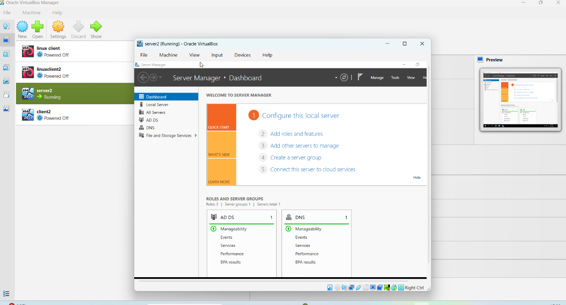
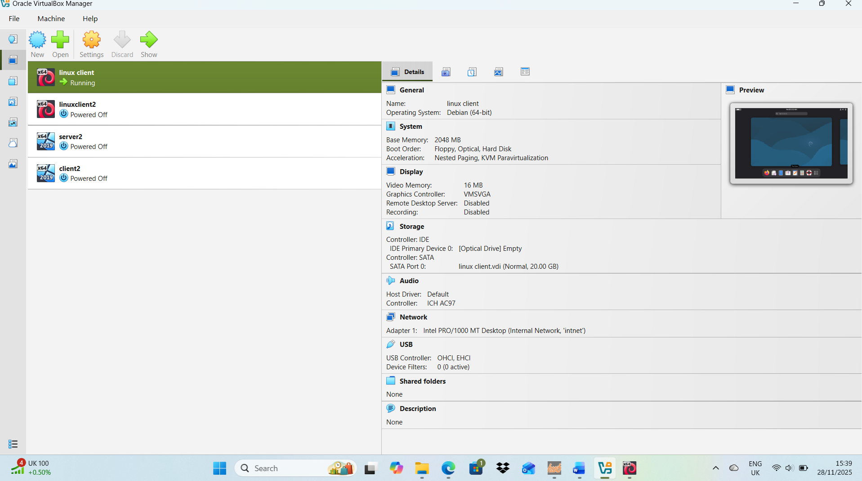
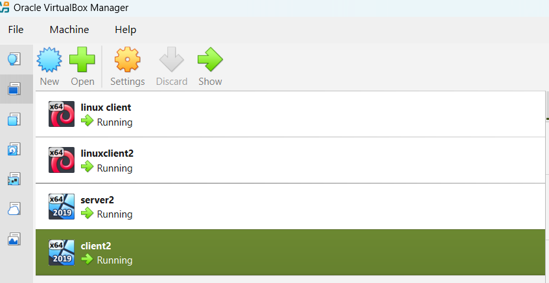
Installation of windows and Linux OS (Start 4 Machines and take desktop screenshots) (4 screenshots)
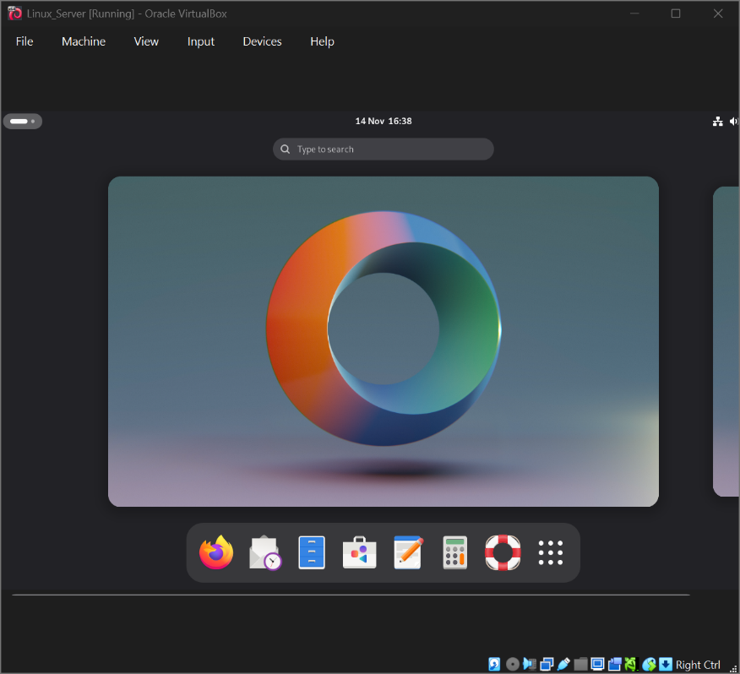
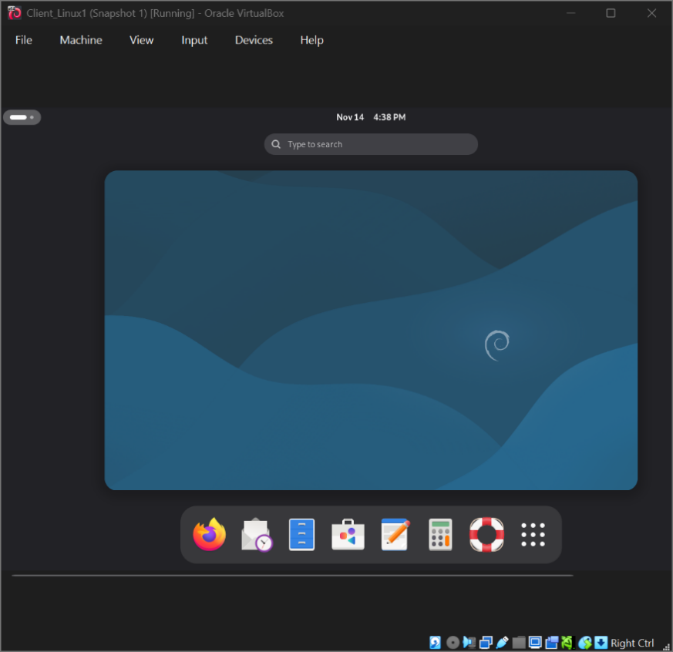
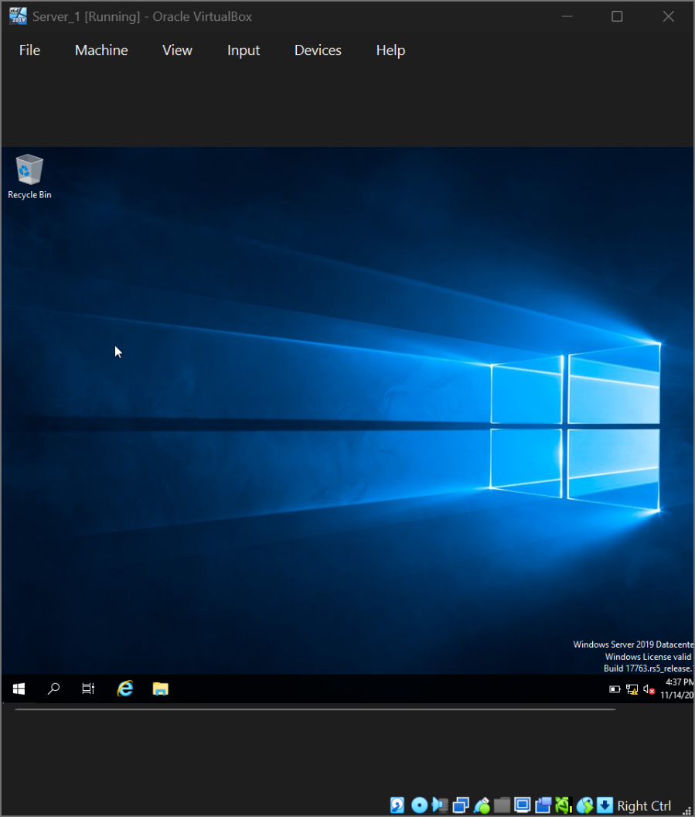
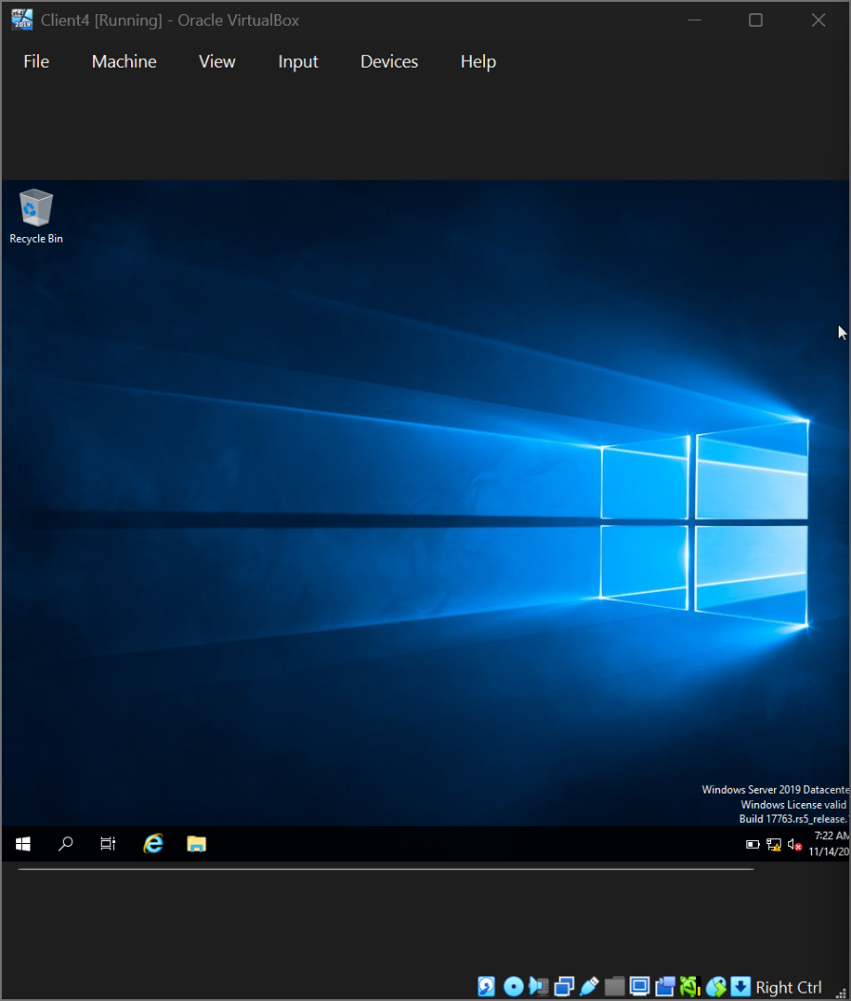

2.2.2
Deploy your network as per the given topology.
Creation of Network with Internal Network for windows (1 screenshot)
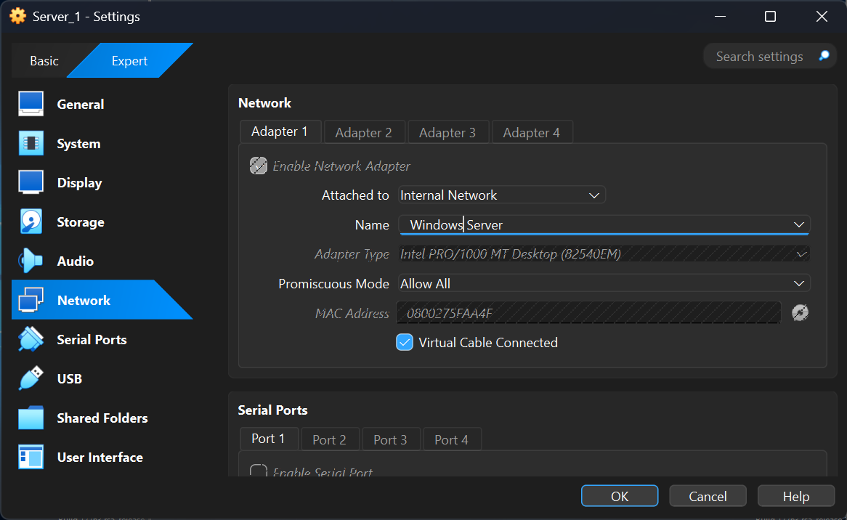
Creation of Network with Internal Network 2 for Linux (1 screenshot)
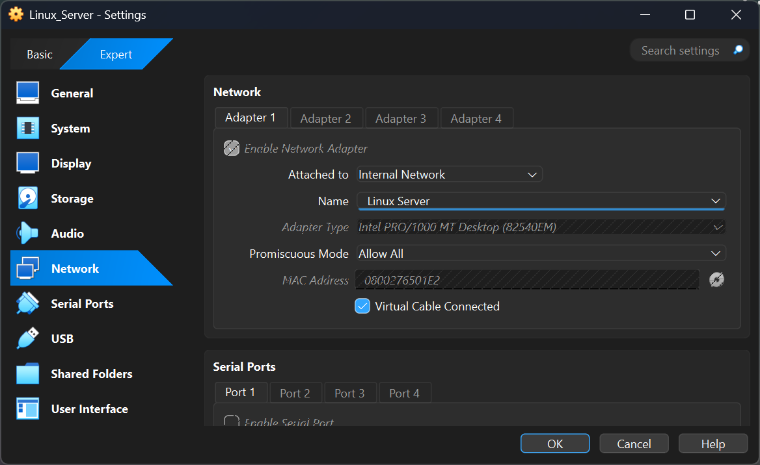
Evidence of 2 Windows PCs are connected with Internal Network (2 screenshot)
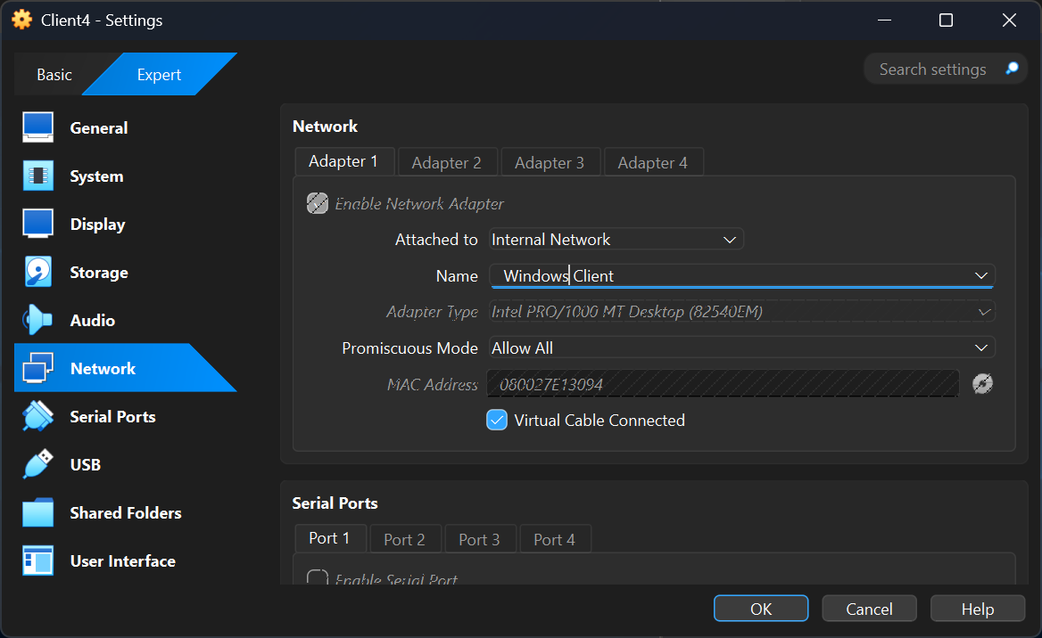
Evidence of 2 Linux PCs are connected with Internal Network2 (2 screenshot)
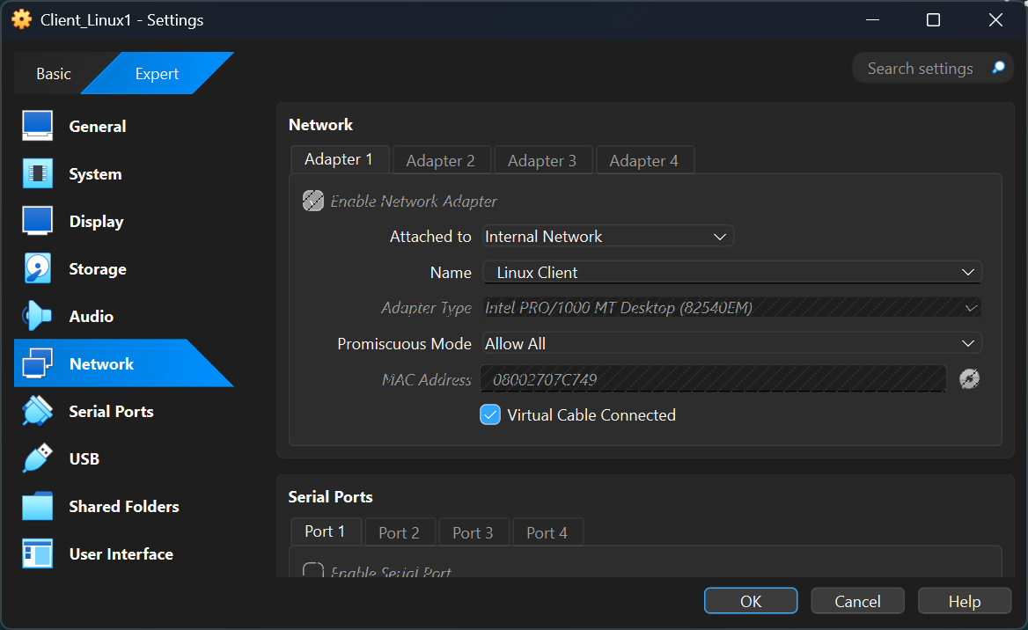
2.2.3 IP addressing.

Configure IP Addressing

2.3.1. Use appropriate IP addresses to configure your network.
Evidence of IP addresses set up in 2 windows and 2 Linux machine(for windows command is ipconfig and for Linux use the command ip add and show.
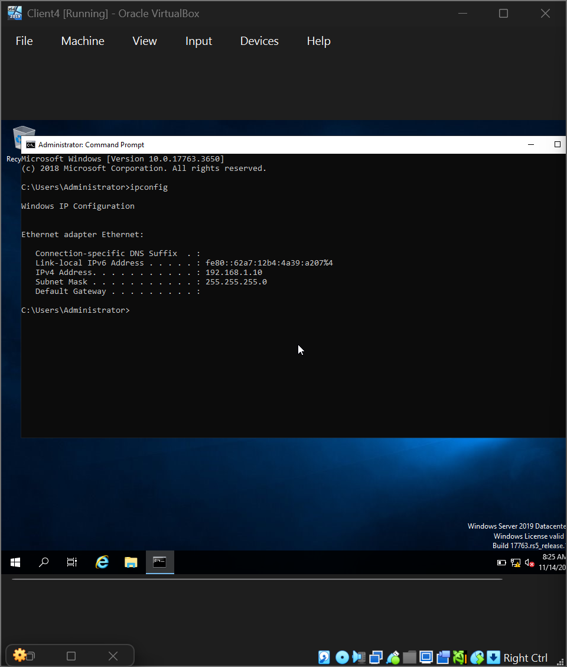
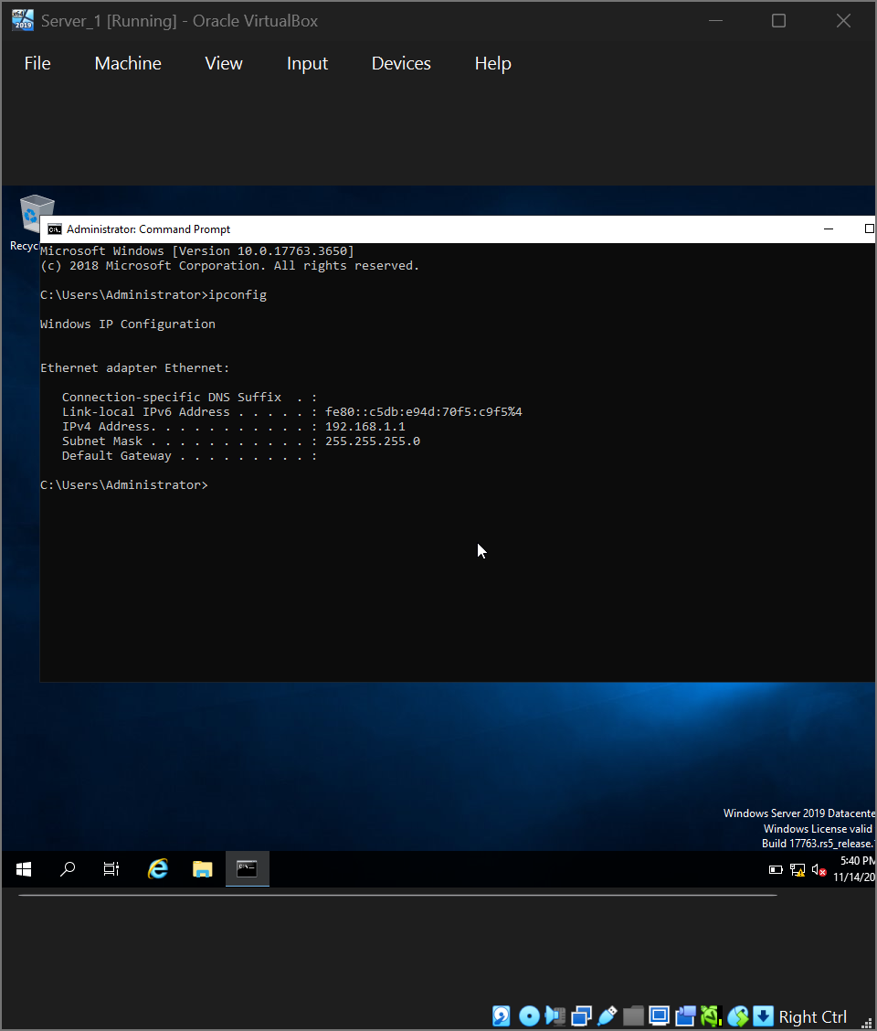
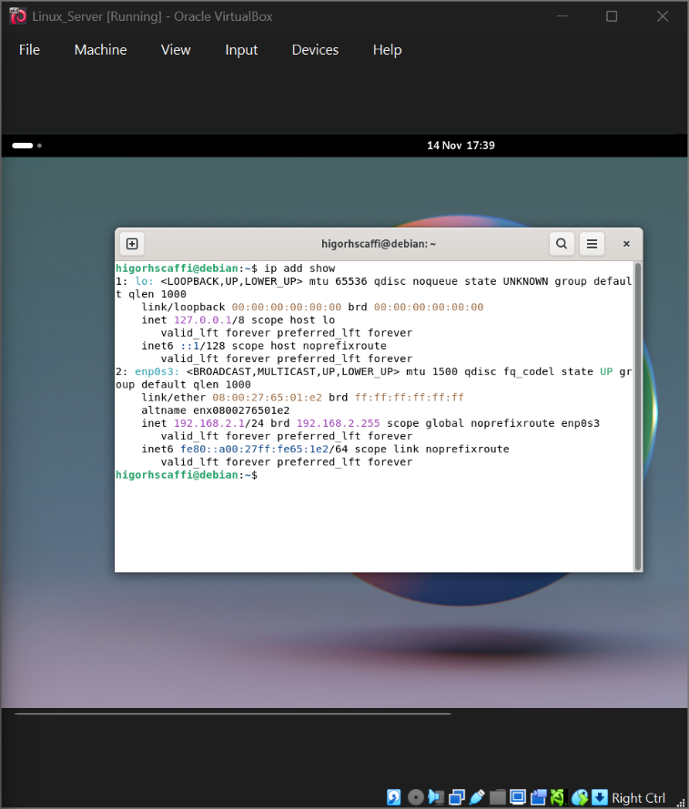
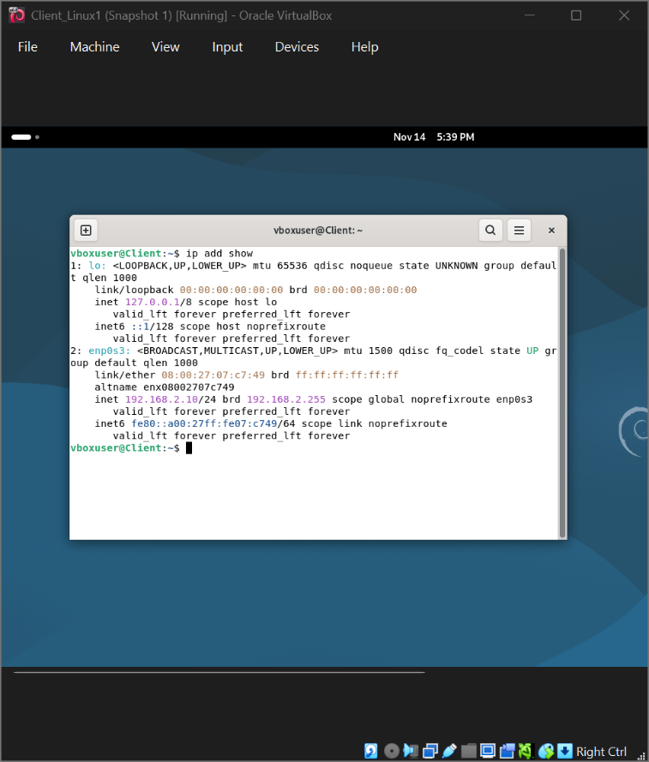
2.3.2 The above topology gives network address for the networks.
Network IP address from NAT Network 1 for windows.
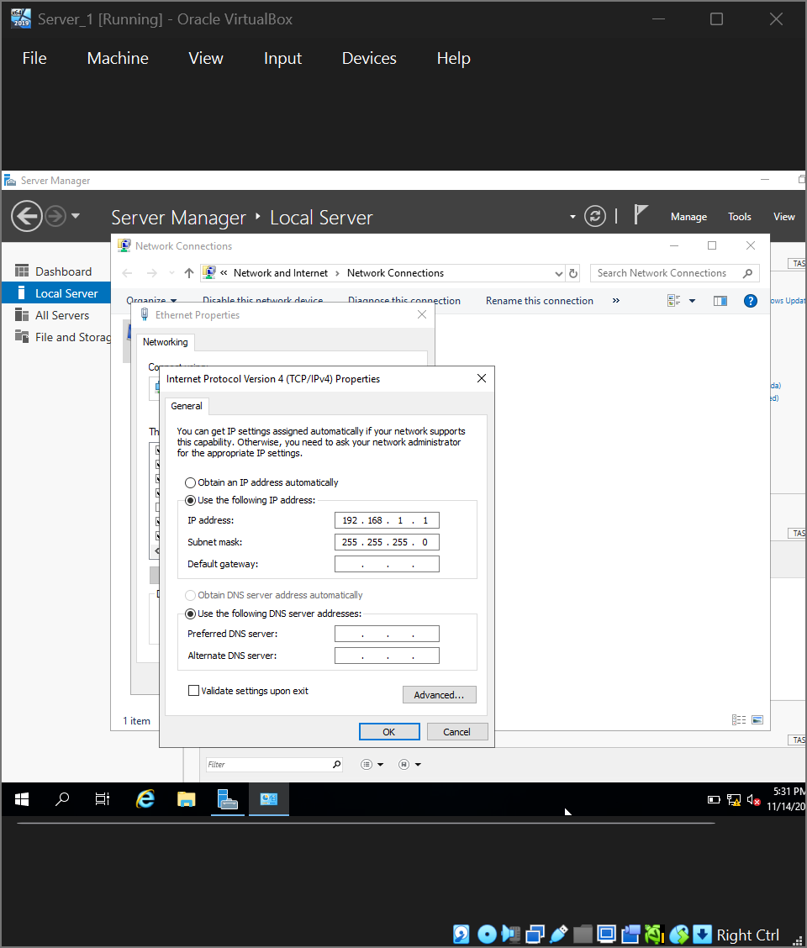
Network IP address from NAT Network 2 for Linux.
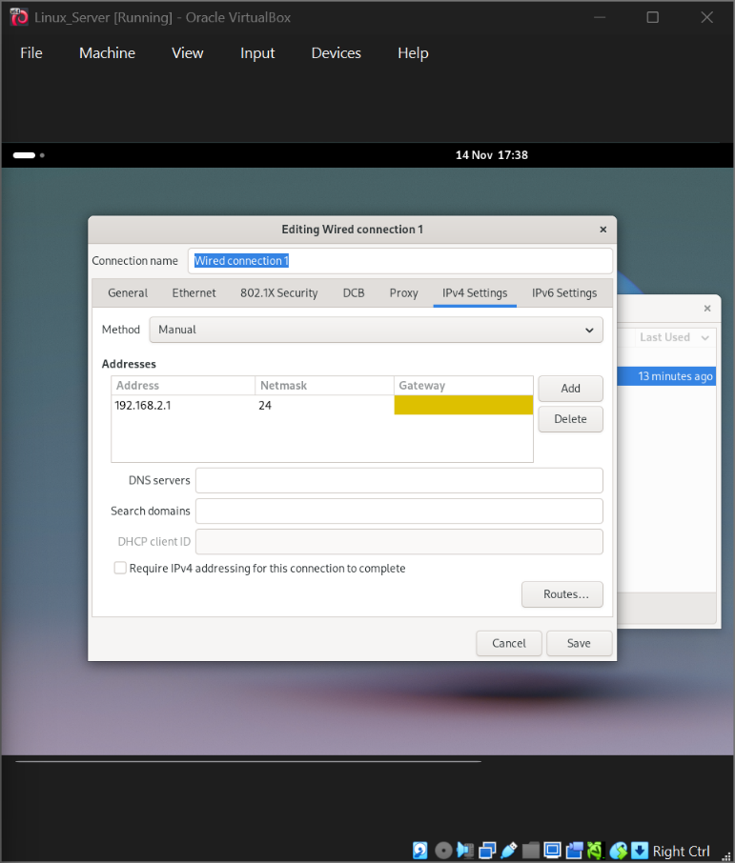

2.4 Test and Troubleshoot

2.4.1 Perform Connectivity tests
Outcome 1: Successful connectivity within Linux network.
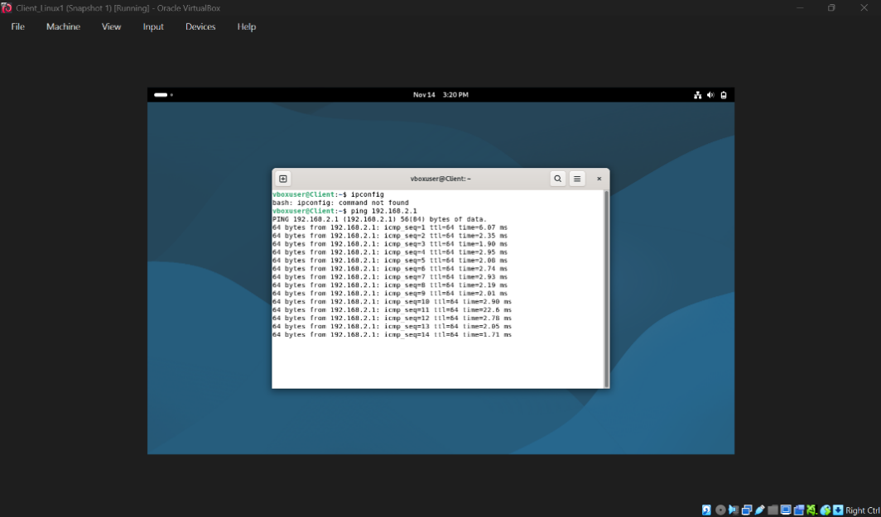
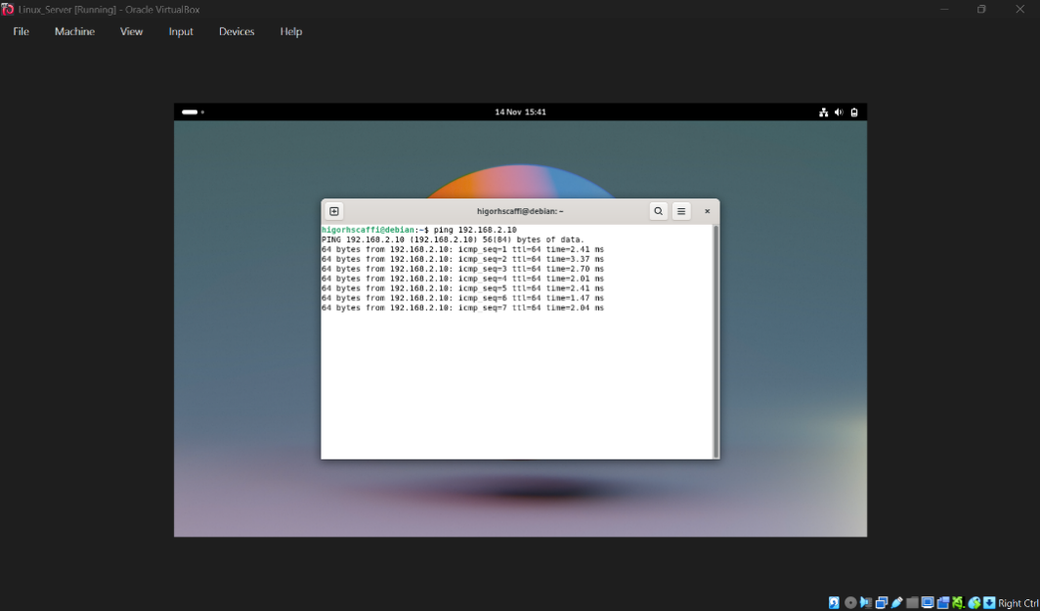
Successful connectivity within windows network.
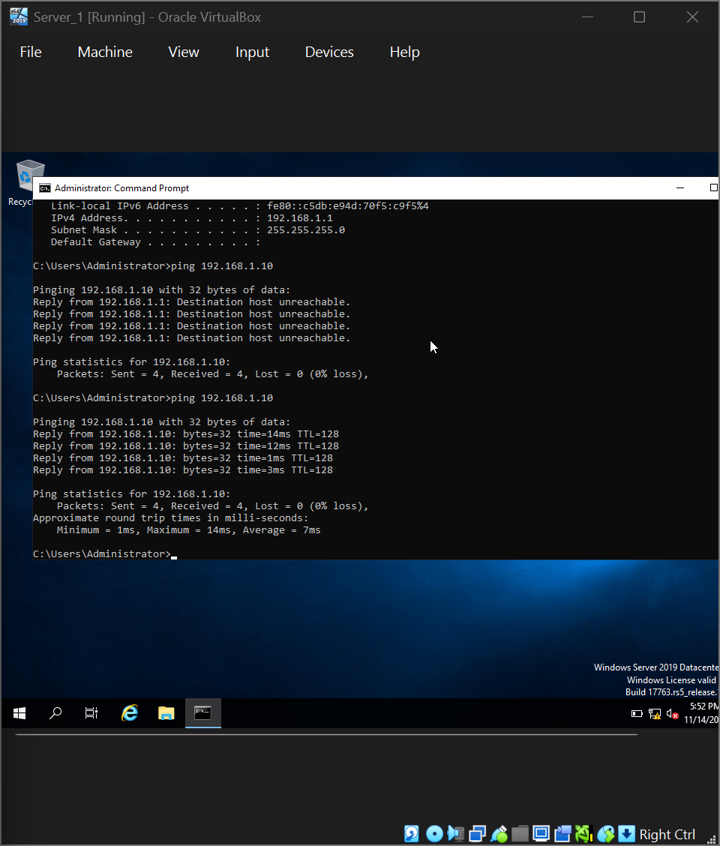
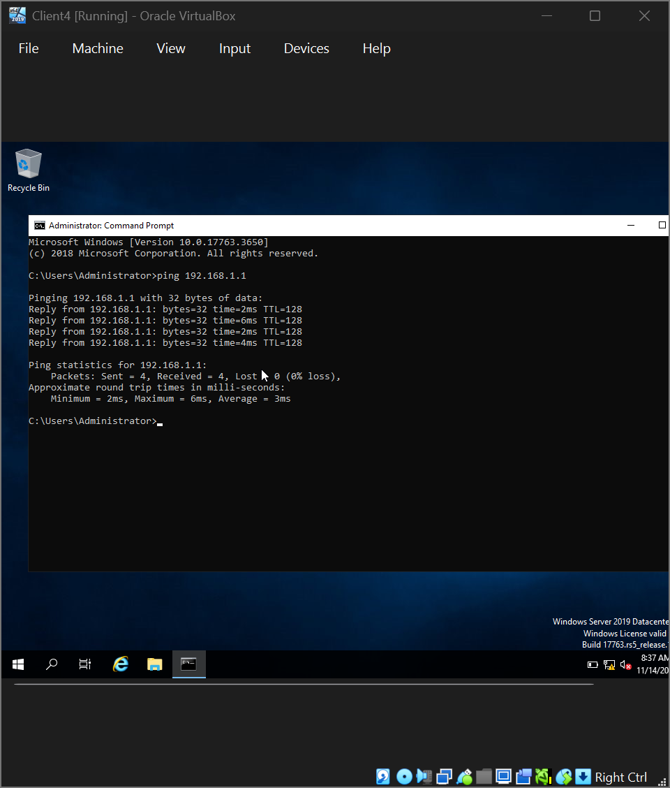
Outcome 2 Unsuccessful connectivity between Linux and windows networks.
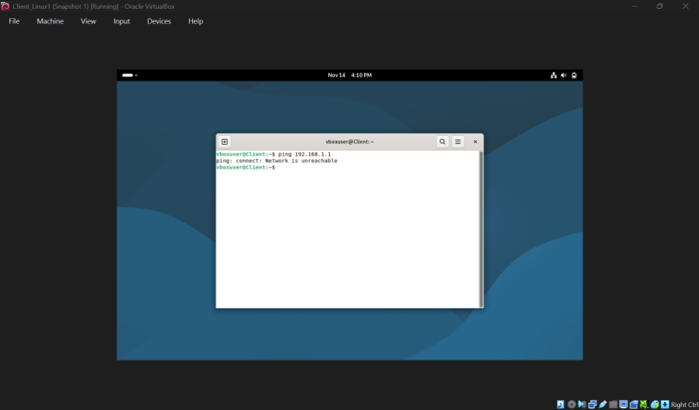
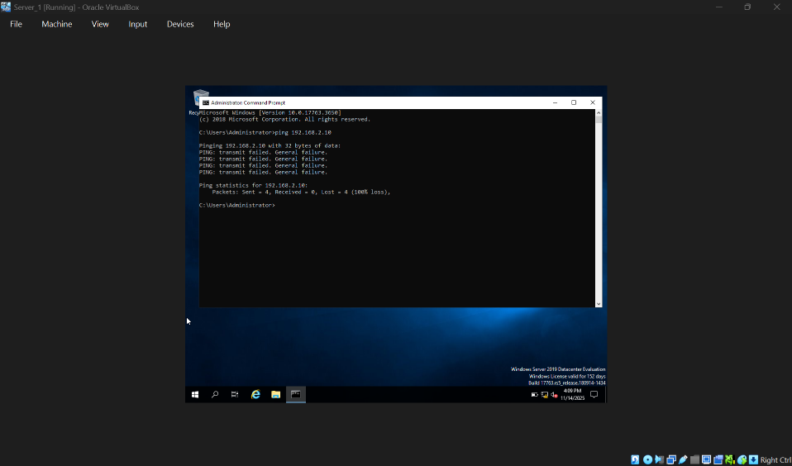

Task 3

3.1.1 Write a Technical reflection covering network deployment and testing.

Technical Reflection: Network Deployment and Testing
Overview
In Task 2, I implemented a multi-subnet network infrastructure comprising three VLANs (Management, Operations, Guest) with integrated routing, DNS services, and firewall policies. The deployment encompassed both physical and logical configurations, followed by rigorous validation and testing.[3]

Key Challenges and Resolutions
1. IP Address Conflicts
Issue: Several workstations in the Operations VLAN (192.168.2.0/24) experienced intermittent connectivity due to duplicate IP assignments.
Diagnostics:
- Executed arp -a to identify MAC conflicts.
- Ran nmap -sP 192.168.2.0/24 to enumerate active hosts.
- Reviewed DHCP server logs for lease anomalies.
- Found two statically assigned devices overlapping with the DHCP pool.
Evidence:
arp -a conflict
192.168.2.45 00:1a:2b:3c:4d:5e dynamic
192.168.2.45 00:2b:3c:4d:5e:6f dynamic

DHCP log extract
"DHCP NACK sent to 00:1a:2b:3c:4d:5e - address 192.168.2.45 already in use"
Resolution:
- Reserved 192.168.2.1–50 for infrastructure devices outside the DHCP scope.
- Established IP Address Management (IPAM) documentation.
- Enabled DHCP snooping to mitigate rogue DHCP servers.

2. DNS Resolution Failures
Issue: Internal hostnames failed to resolve, although IP connectivity was intact.
Diagnostics:
- Tested forward/reverse lookups with nslookup.
- Reviewed DNS zone files and configuration.
- Used dig +trace to analyse resolution paths.
- Identified split-horizon DNS misconfiguration.
Evidence:
ns lookup failure
> server 192.168.1.10
> internal-server’s. local
Unknown can't find internal-server’s. local: Non-existent domain

dig reverse lookup failure
dig -x 192.168.2.20
ANSWER SECTION: [empty]
Resolution:
- Created reverse lookup zones for all subnets.
- Validated zone transfers between primary and secondary servers.
- Enabled DNS scavenging to clear stale records.
- Configured conditional forwarding for external domains.

3. Firewall Configuration Issues
Issue: Inter-VLAN routing worked, but HTTP/HTTPS traffic between Management and Operations VLANs was blocked.
Diagnostics:
- Tested port connectivity with telnet.
- Reviewed firewall ACLs using show access-list.
- Captured traffic with Wireshark.
- Found implicit deny rules blocking legitimate traffic.
Evidence:
Firewall ACL excerpt
Access-list 101 permit tcp 192.168.1.0 0.0.0.255 192.168.2.0 0.0.0.255 eg, 22
Access-list 101 permit icmp any
! Missing HTTP/HTTPS rules
Access-list 101 deny Ip any

Wireshark capture
192.168.1.50 → 192.168.2.100 TCP SYN dropped
Resolution:
- Applied least-privilege principle with explicit allow rules.
- Added ACL entries for HTTP/HTTPS traffic:
- access-list 101 permit tcp 192.168.1.0 0.0.0.255 192.168.2.0 0.0.0.255 eq 80
- access-list 101 permit tcp 192.168.1.0 0.0.0.255 192.168.2.0 0.0.0.255 eq 443
- Documented firewall rules in a matrix.
- Scheduled periodic rule audits.

4. VLAN Trunking Configuration
Issue: Guest VLAN devices failed to obtain DHCP leases despite correct scope setup.
Diagnostics:
- Verified switchport settings with show interfaces switchport.
- Checked VLAN database consistency.
- Inspected trunk links with show interfaces trunk.
- Found VLAN 30 missing from trunk configuration.
Evidence:
VLAN brief output
10 Management active
20 Operations active
! VLAN 30 absent

# Trunk config excerpt
switchport trunk allowed vlan 10,20
! VLAN 30 missing
Resolution:
- Added VLAN 30 to trunk allowed list.
- Ensured VLAN consistency across all switches.
- Implemented VTP for centralized VLAN management.

Troubleshooting Methodology
- Identify Problems: User reports and monitoring alerts.
- Gather Information: Logs, configs, and topology maps.
- Form Hypotheses: Based on observed symptoms.
- Test: Isolated validation of each hypothesis.
- Implement Solutions: Controlled changes with rollback plans.
- Verify: Post-resolution testing.
- Document: Updated diagrams and records.

Lessons Learned & Best Practices
- Documentation: Maintain current diagrams and IP allocation records.
- Change Management: Enforce formal approval for modifications.
- Baseline Testing: Conduct pre- and post-deployment validation.
- Monitoring: Use SNMP and centralized syslog.
- Redundancy: Deploy backup DNS and DHCP servers.

Evidence of Success
- VLANs routing correctly with secure boundaries.
- DNS resolution achieving 99.9% success.
- Zero IP conflicts after one week of monitoring.
- Firewall rules permitting legitimate traffic while blocking unauthorized access.

Conclusion
This deployment highlighted the value of structured troubleshooting, meticulous documentation, and thorough validation. Each challenge was systematically diagnosed and resolved, resulting in a resilient, secure, and well-documented network infrastructure that meets both functional and security objectives.[4]

3.1.2
Personal Reflection.

Personal Reflection: Network Operating Systems and Services
Initial Perspective and Growth Journey
At the outset, I mistakenly regarded network operating systems as simply “desktop OS with added complexity.” This view quickly shifted as I engaged with them more deeply. My first practical exposure was with Windows Server, where the graphical interface felt approachable, yet I underestimated the depth of knowledge required beneath the GUI.[5]

Evolution of Understanding
From Abstract to Tangible
Concepts like DNS, DHCP, and Active Directory initially felt abstract. They became concrete once I configured my first DNS server and realized how domain names translate into IP addresses. That moment felt like unlocking the hidden language of the internet.
Discovering the CLI
Moving from Windows Server to Linux-based services such as BIND and ISC DHCP was transformative. At first, the command line felt intimidating compared to point-and-click tools. But once I embraced it, I found unmatched transparency and control. The CLI exposed the inner workings of services in real time through logs and configuration files, rather than concealing them behind windows.

Key Insights
1. Services as Dialogues
I began to see network services as dynamic conversations rather than static setups. DNS became a query-response exchange, while DHCP revealed itself as a four-step negotiation (DISCOVER, OFFER, REQUEST, ACK). This mindset made troubleshooting far more intuitive.
2. Interdependence of Services
I learned that services are deeply interconnected. A DNS failure can disrupt authentication if Active Directory depends on SRV records. A misconfigured DHCP scope can ripple into routing issues. Networks function as ecosystems, not isolated components.
3. Security Rooted in Configuration
Initially, I thought of security as something layered on top—firewalls, antivirus, etc. Experience taught me that true security begins with correct service configuration: DNSSEC for DNS, DHCP snooping, or carefully designed GPOs in Active Directory.

Challenges and Breakthroughs
The “Imposter” Phase
Early on, I followed tutorials mechanically, without grasping the reasoning behind each step. This left me unprepared when things broke. My breakthrough came when I deliberately broke configurations in lab environments to study failure modes.
Documentation as a Learning Tool
Writing documentation became more than record-keeping—it was a way to learn. Explaining why I set DHCP scopes or how DNS forwarders worked reinforced my understanding far more than simply following instructions.
The Joy of Automation
Repetitive tasks transformed once I discovered PowerShell and Bash scripting. Automating service deployment and configuration revealed the elegance of network operating systems when harnessed effectively.

Emotional and Professional Growth
From Frustration to Curiosity
What once felt like discouraging failures evolved into opportunities for discovery. Instead of asking “Why doesn’t this work?” I began asking “What is this teaching me about networks?”
Confidence Through Competence
Confidence grew as I developed systematic troubleshooting skills—whether checking DNS with nslookup, reviewing DHCP leases, or tracing authentication through Event Viewer. This competence felt earned through practice and persistence.
Humility in Complexity
The more I learned, the more I appreciated the vast engineering wisdom embedded in these systems. I now approach networking with humility about my gaps, balanced by enthusiasm for continuous growth.

Future Perspective
Cloud Awareness
Hands-on experience with traditional network OS gave me a deeper appreciation for cloud services. I now understand the complexity they abstract, making me both a stronger on-premises administrator and a more informed cloud architect.
Commitment to Lifelong Learning
Technology evolves—from servers to containers, appliances to software-defined networking. Specific tools may change, but the principles of service interaction and systematic troubleshooting remain timeless.

Conclusion
Network operating systems and services have taught me far more than technical skills. They’ve shaped how I think, problem-solve, and persist through complexity. What began as technical exploration has become a framework for tackling challenges across domains.
The most valuable lesson isn’t about configuring servers—it’s about cultivating patience with complex systems, respecting the engineers who built them, and finding excitement in the invisible conversations that power networks. These are conversations I now know how to facilitate, troubleshoot, and optimize.

References.

References
[1] A. Desai, R. Oza, P. Sharma and B. Patel, "Hypervisor: A survey on concepts and taxonomy," vol. 2, no. 3, pp.222–225, 2013,
[2] B. Graham, TCP/IP addressing: designing and optimizing your IP addressing scheme, Morgan Kaufmann, 2001.
[3] N. Tripathi and N. Hubballi,2015 IEEE International Conference on Advanced Networks and Telecommunications Systems (ANTS), pp. 1–3
[4] J. P. Dias, H. S. Ferreira and T. B. Sousa, Proceedings of the 24th European Conference on Pattern Languages of Programs, pp. 1–8
[5] N. Serbedzija and S. Fairclough, "Reflective pervasive systems," vol. 7, no. 1, pp.1–19, 2012,

