

MSc Public Health and Social Care in Practice
Module: Quality Assurance and Service Improvements
Module code: LCHS7006A

Service Improvement Analysis of the Mid Staffordshire NHS Foundation Trust Crisis: the Assessment of the Root Causes of the Failures and the Quality Assurance in Healthcare.

Name: Georgiana Izabela Rosu
ID:2212287
Lecturer: Arif Ahmed
Table of Contents
Introduction 3
Main Body 5
1. Background of the Quality Issue 5
2. Root Cause Analysis Using the Fishbone (Ishikawa) Diagram 5
3. The Donabedian Model: Structure–Process–Outcome Analysis 7
4. Strategic Analysis SWOT 8
5. Integration of Theories: Systems Thinking and Quality Management 10
6. Evidence-Based Recommendations 10
7. Implementation Through Quality Improvement Methodology (PDSA Cycle) 11
8. Synthesis 12
Recommendations 13
Conclusion 17
References 18

Introduction
In the period between 2005 and 2009, the Mid Staffordshire NHS Foundation Trust made itself the centre of one of the most critical failures in healthcare quality in the United Kingdom. The Trust witnessed much higher than anticipated mortality rates during this period, extensive neglect and poor basic care reports, and patient dissatisfaction were reported. The findings of subsequent public inquiries led by the Francis Report, among other issues, revealed long-standing systemic issues such as significant lapses in care standards, poor governance frameworks, low staffing rates, and a patient safety-driven culture. These incidents brought serious questions about the quality assurance systems in the National Health Service (NHS) and revealed the weak linking of the leadership and accountability systems in the health and social care environments.
Quality in healthcare refers to the provision of services that are safe, effective, patient-centred, timely, efficient, and equitable (Institute of Medicine, 2001; World Health Organization, 2018). It is a fundamental principle of healthcare systems, ensuring that patients receive care that improves health outcomes while minimising risks. Quality assurance in healthcare involves systematic processes that monitor, evaluate, and improve services to ensure consistent standards of care are maintained (World Health Organization, 2020 ; The Health Foundation, 2013). It focuses on preventing errors, enhancing accountability, and promoting patient safety across healthcare organisations.
Continuous Quality Improvement (CQI) evaluates and changes healthcare processes, systems, and results (Batalden and Davidoff, 2007; (W. Edwards Deming, 1986) .
CQI helps public health and social care agencies learn from mistakes, minimise variance, and implement evidence-based reforms. The Mid Staffordshire case highlights the consequences of failing to implement effective quality assurance and continuous improvement systems, demonstrating how lack of monitoring and learning can result in serious patient harm.
The problem that was identified under this report is that the standard of care was largely compromised by poorly trained leaders and inadequate staffing that led to the high patient mortality in the years 2005-2009. The public inquiry showed that patients were not adequately hydrated, nourished, managed when in pain, and treated with dignity. Family complaints were also not closely heeded, and the frontline personnel complained that they felt unsupported and stretched. Instead of a few clinical mistakes, the malfunctions were the organisational vulnerabilities. The Trust has made the quality results less important than the achievement of foundation status and financial balance, which served to indicate a lack of connection between strategic goals and patient-centred care.
High mortality rate among patients attributed to organisational dysfunction is a grave quality issue as seen from a public health point of view. It is the responsibility of healthcare organisations to offer effective, safe, and compassionate services. Failures of governance systems to identify and act upon weakening standards do not just harm individuals who lose trust in the government on a broad scale. The Mid Staffordshire case demonstrates how structural flaws (e.g. staff shortages), process flaws (e.g. ineffective monitoring and reporting systems), and adverse consequences (e.g. avoidable deaths) interplay in healthcare systems. These factors are consistent with the proven quality models, such as the Structure-Process-Outcome model, where safe outcomes are determined by the strong organisational underpinnings and well-performing clinical processes.
Moreover, the scandal led to the national discussion of the responsibility of leadership, regulatory control and organisational culture in the NHS. It has shown that quality enhancement cannot be attained only with the performance metrics or financial efficiency. Rather, effective clinical leadership, open governance, proper workforce planning, and allowing the culture to empower the employees to speak up without the threat of being reprimanded is what will lead to a sustainable improvement in service.
In this report, a critical analysis will be carried out to evaluate the root cause of the care failures at Mid Staffordshire NHS Foundation Trust through accepted quality management and service improvement models. It will use theoretical frameworks to analyse structural and systemic limitations, test strategic issues that affect the performance of the organisation, and present evidence-based suggestions on how to improve the service.

Main Body

1. Background of the Quality Issue
The clinical errors at Mid Staffordshire NHS Foundation Trust constituted between the years 2005 and 2009 were not just clinical errors but systemic organisational failures. The Trust suffered considerably disproportionately, and neglect, poor hygiene, lack of compassion, delayed treatment and poor pain management were reported. Inquiries, notably the Francis Report, found that ineffective leadership, target-oriented culture, underperforming governance and understaffing were direct causes of falling standards of care (Francis, 2013 ; The King’s Fund, 2011)
The fundamental causes of these failures are critically examined in this part through the existing quality management models. The choice of the Fishbone Diagram, Donabedian Model, and SWOT analysis is explained by the possibility to conduct the multi-level analysis (operational (identification of causes), systemic (relationships of structures, processes, and outcomes), and strategic (organisational environment and leadership context) analysis).
Overview of Continuous Quality Improvement
Continuous Quality Improvement (CQI) evaluates and improves procedures and results to enhance healthcare quality (Batalden and Davidoff, 2007). It is essential to modern healthcare systems, especially the NHS, which prioritises patient safety and service effectiveness (NHS England, 2019). CQI identifies inefficiencies, reduces mistakes, and ensures best practice in delivering care. Mid Staffordshire NHS Foundation Trust's care quality declined due to ineffective CQI systems. Over time, mortality rates rose without adequate monitoring or action (Francis, 2013 ; Braithwaite et al., 2017). Organisations without continuous improvement methods are more likely to have systemic failures because problems are not discovered or addressed early (Boaden et al.,2008; Øvretveit, 2009)).
However, healthcare CQI implementation is difficult. Lack of resources, leadership support, worker reluctance to change, and bad organisational culture are examples (Dixon-Woods et al., 2014 ; Grol, Wensing and Eccles, 201). Mid Staffordshire's culture of fear and target-driven performance hindered personnel from reporting issues, restricting improvement. Thus, CQI requires strong leadership, open communication, and investment in learning and development.

Swiss Cheese Model
Healthcare blunders are often explained using Reason (2000)'s Swiss Cheese Model. The idea is that firms have cheese slices with “holes” as defences.
Cross-layer,hole alignment causes failures and injuries.
Clinical procedures, personnel, leadership, and regulations are healthcare layers. Mid Staffordshire has multilayered (Grol, Wensing and Eccles, 2010) . Lack of staff hampered patient monitoring, poor governance missed requirements, and regulatory bodies did little (Francis, 2013). Patients perished when these flaws coincided.The model indicates that system defects cause errors. Healthcare systems need better leadership, communication, and workforce planning. Reason (2000) claims system-based methods increase patient safety more than error-focused ones.

2. Root Cause Analysis Using the Fishbone (Ishikawa) Diagram
2.1 Rationale for Model Selection
This is due to the fact that the selection model will be based on the principle of logical reasoning or rational choice. The rationale behind the choice of the model will be the rational choice or logical reasoning (Puyt et al., 2020)
The Fishbone Diagram (Ishikawa model) is employed broadly in healthcare quality improvement to consider factors contributing to adverse outcomes in a systematic way. It classifies causes into the following themes: leadership, workforce, systems, environment and policies. It is also strong because it allows visualisation of complexity and avoids simplifying organisational failures (Kaoru Ishikawa, 1985).
2.2 Application to the Case
The use of the Fishbone framework to highlight the problem in the Mid Staffordshire indicates that there were multiple causes interconnected:
Leadership and Management
- Get results-oriented on finances and not patient care.
- Weak board oversight
- Inaction in relation to complaints.
- Fear and defensiveness culture.
Staffing and Workforce
- Chronic nurse shortages
- Inadequate skill mix
- Ineffective training and supervision.
- Low staff morale
Systems and Processes
- Poor clinical governance structure.
- Inefficient mortality surveillance.
- Poor incident reporting
- Absence of quality assurance systems (Dixon-Woods et al., 2014)
Organisational Culture
- Target-driven environment
- Normalisation of bad standards.
- Employee unwillingness to raise issues (Dixon-Woods et al., 2014).
External Regulation
- Inadequate regulatory oversight.
- An excessive dependence on performance measures.
2.3 Critical Evaluation
Although the Fishbone model is effective in the categorisation of contributing factors, it fails to prioritise causes and provides no strength of causality. In complicated healthcare systems, the cause-and-effect interaction (e.g., the shortage of staff and the problem of culture) can contribute to risks. However, the model is useful in bringing out that individual incompetence was not the cause of high mortality but a failure of governance structures (McNicholas et al., 2019).
Importance of Teamwork and Communication
Effective teamwork is essential in healthcare as it improves coordination, reduces errors, and enhances patient outcomes (Salas et al., 2005). In the Mid Staffordshire case, poor teamwork contributed to fragmented care and lack of accountability among staff.
Communication is also a critical factor in patient safety. Studies show that ineffective communication is one of the leading causes of medical errors (Leonard et al., 2004). At Mid Staffordshire, poor communication between staff, departments, and management resulted in delayed responses to patient deterioration and failure to escalate concerns.
Therefore, improving teamwork and communication should be central to any quality improvement strategy.

Augmenting Root Cause Analysis with the 5 Whys Framework
The 5 Whys technique is a simple but effective method used to identify the root causes of problems by repeatedly asking “why” (Ohno, 1988). It complements the Fishbone Diagram by providing a deeper understanding of causal relationships.
Applying the 5 Whys to the Mid Staffordshire case:
- Why did patients experience poor care?
Because staff were unable to provide adequate attention.
- Why were staff unable to provide adequate care?
Because there were insufficient staffing levels.
- Why were staffing levels insufficient?
Because workforce planning was ineffective.
- Why was workforce planning ineffective?
Because leadership prioritised financial targets over patient care.
- Why did leadership prioritise financial targets?
Because of organisational pressure to achieve Foundation Trust status.
This analysis demonstrates that the root cause of the crisis was not individual failure but organisational and leadership decisions. The 5 Whys framework is valuable because it encourages deeper investigation beyond surface-level problems and helps identify systemic issues (Suárez-Barraza and Rodríguez-González, 2019).

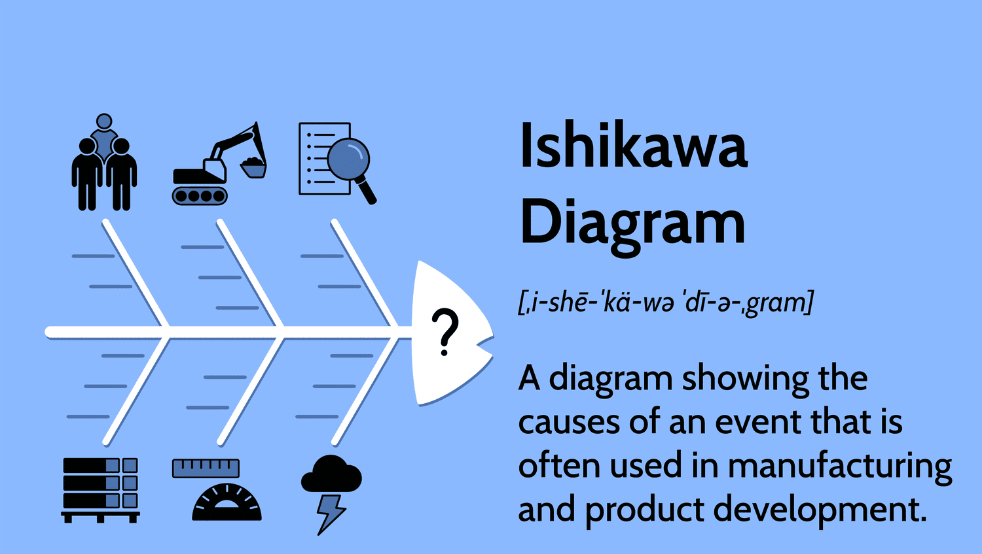
Figure and Source: Ishikawa Diagram (Coccia, 2018).

3. The Donabedian Model: Structure–Process–Outcome Analysis
3.1 The rationale behind the choice of the model is presented in
One of the most effective models of appraising the quality of healthcare is the Donabedian Model (Katowa-Mukwato et al., 2021). It suggests that three related domains can be used to measure the quality of healthcare:
- Organisation (environment, personnel, facility)
- Process (delivery of care)
- Outcome (patient outcomes, such as mortality)
The model is specifically suitable due to the fact that the Mid Staffordshire crisis was characterised by failures on all three levels.
3.2 Application to the Case
3.2.1 Structural Failures
Weaknesses involved in its structure were:
- Poor nurse- patient ratios.
- Poor leadership capability
- Weak governance frameworks
- Lack of clinical oversight by the board.
The studies continuously indicate that the level of nurse staffing is strongly associated with patient mortality. In this instance, organisational shortcomings posed a dangerous environment to care provision (Bashan and Kordova, 2021).
3.2.2 Process Failures
Process failures that existed were:
- Lack of good vital monitoring.
- Poor reaction to the degraded patients.
- Lack of documentation
- Failure to act on complaints
The processes indicate the way systems run in their day-to-day operations. Poor communication and reporting systems, even in cases where the risk was known to the staff, meant that there was no timely response (McNab et al., 2020).
3.2.3 Outcome Failures
The most apparent consequence was an increase in mortality, a decrease in patient satisfaction, and negative publicity (NHS Improvement, 2018; Royal College of Nursing, 2018). Nevertheless, Donabedian indicates that lag indicators of structural and process weaknesses are common in bad outcomes. Systemic problems had already developed by the time the mortality rates had risen (Donabedian, 1988).
3.3 Critical Evaluation
The Donabedian model is well structured and clear, which is its strength. Critics, however, suppose that it is based on the assumption of the linear relationship among structure, process and outcome, whereas healthcare systems are dynamic and complex. However, its use has shown that to make a change in outcomes, the structural and process underlying needs to be targeted, not just an attempt to measure the mortality rate (Jackson, 2019).
The situation with the Mid Staffordshire case is that concentrating on outcome measurements and not reinforcing governance and workforce systems allowed the situation to get out of hand.

4. Strategic Analysis SWOT
4.1 Rationale for SWOT
SWOT analysis assists in analysing both internal and external factors that affect the performance of an organisation. It is appropriate for strategic service improvement planning since it highlights areas that need to be intervened in, and also contextual constraints are noted (Teoli et al., 2019).
4.2 Application to Mid Staffordshire
Strengths
- NHS funding structure
- Availability of national policy advice.
- Building a clinical workforce.
Weaknesses
- Poor leadership culture
- Lack of proper staffing.
- Weak clinical governance
- Poor system of complaints.
Opportunities
- Patient safety reforms at the national level.
- Moving things forward with workforce development programmes.
- Application of quality improvement strategies (Benzaghta et al., 2021).
- More transparency and openness to accountability.
Threats
- Financial pressures
- Regulatory failures
- Public distrust
- Workforce burnout
4.3 Critical Evaluation
SWOT analysis comes in handy in terms of strategic orientation, but it is not very analytical in terms of cause-effect relationship. It can distrust elaborate healthcare dynamics. Nevertheless, it can be enhanced with the help of root cause models such as Fishbone and Donabedian, which improve the strategic planning as the operational weaknesses can be traced to the wider organisational context (Phadermrod et al., 2019).
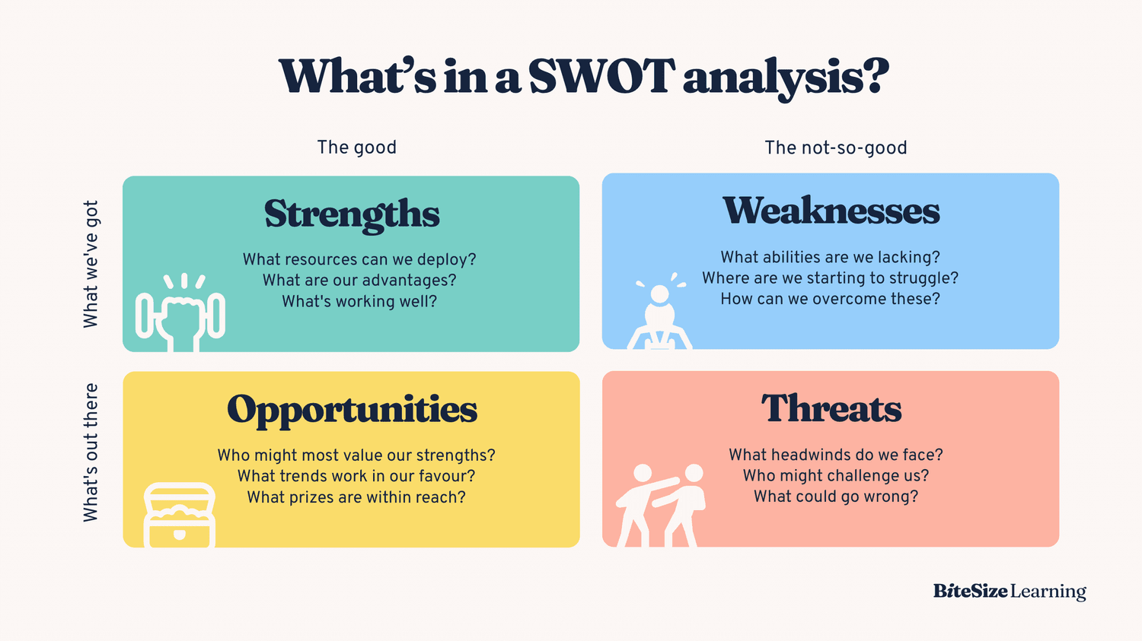
Figure and Source: SWOT Analysis (Ardha et al., 2023).

5. Integration of Theories: Systems Thinking and Quality Management
Models used are based on quality management principles in a bigger way:
- Systems Theory: The healthcare organisations are interdependent systems. One area (e.g., leadership) failure spills over to others (staff morale, patient care) (Puyt et al., 2020).
- Total Quality Management (TQM): It focuses on overall improvement and a patient-centred approach.
- Clinical Governance Frameworks: Stress accountability, transparency and evidence-based practice.
There was a lack of learning culture exhibited during the crisis. It can be seen that high-performing healthcare systems promote reporting, reflection, and continuous improvement. At Mid Staffordshire, concerns were suppressed by the defensive leadership and could not be addressed.
Healthcare management researches indicate that caring leadership and good safety culture significantly predict positive patient outcomes. Consequently, cultural change is a matter to be changed equally as much as the structural reform (Quezada et al., 2019).

6. Evidence-Based Recommendations
Based on the above analysis, the following recommendations can be suggested:
6.1 Enhance Clinical Leadership.
- Select clinical quality champions at the board level.
- Offer leadership development initiatives.
- Introduce patient safety measures into the executive performance reviews.
6.2 Enhance Workforce Planning and Staffing.
- Introduce safe staffing ratios for nurses.
- Improve skill mix and supervisory skills.
- Implement personnel health programs (Dixon-Woods et al., 2014)
6.3 Improve Governance and Surveillance.
- Form strong mortality review boards.
- Enhance quality dashboards in real time.
- Empower escalation routes of complaints.
6.4 Develop a Transparency Culture.
- Promote whistleblower protection.
- Carry out regular patient feedback audits.
- Encourage open practices of disclosure.

7. Implementation Through Quality Improvement Methodology (PDSA Cycle)
The Plan-Do-Study-Act (PDSA) cycle would be suitable to operationalise these recommendations.
Plan
Find the areas of the priority wards where there are staffing issues and develop specific interventions (e.g., safe staffing pilot programme) (Suárez-Barraza and Rodríguez-González, 2019).
Do
Carry out pilot intervention within a stipulated time frame.
Study
Measures have an effect on patient safety indicators, staff satisfaction and incident reporting.
Act
Implement effective interventions trust-wide and improve on feedback.
The PDSA model promotes learning in cycles, and less risk is taken in the implementation of change. Contrary to single-time initiatives of reform, it allows constant assessment and modification (McNicholas et al., 2019).
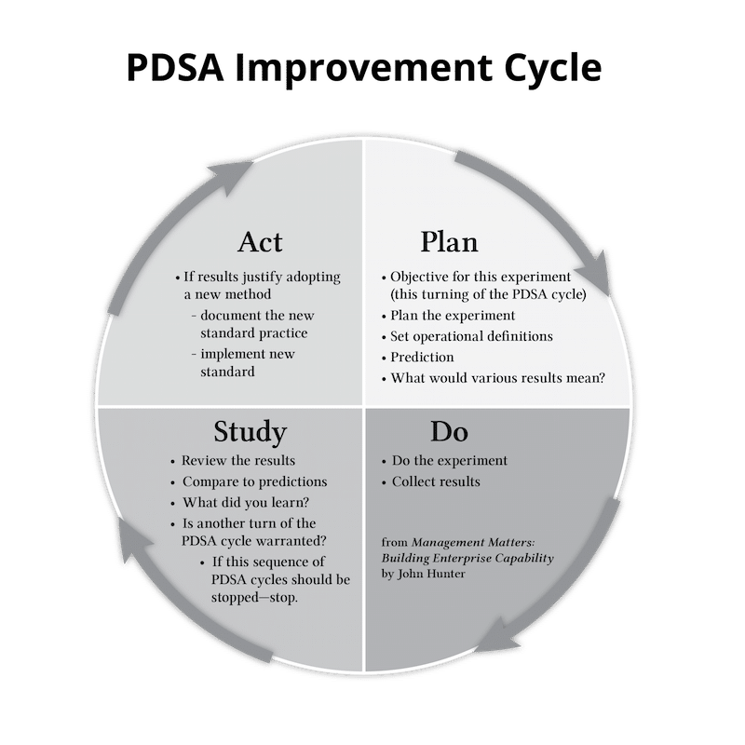
Figure and Source: PDSA Improvement Cycle (Puyt et al., 2020).

8. Synthesis
Fishbone, Donabedian, and SWOT are combined to offer a full analysis on an operational, systemic, and strategic level. The case of Mid Staffordshire demonstrates that structural vulnerabilities, inefficient processes, and leadership failures are the main causes of failures in healthcare quality, instead of single mistakes (Parchami Jalal et al., 2019).
Importantly, the improvement of the services provided in the form of sustainable service improvement demands cultural change and a change in structure. PDSA, as an example of a quality improvement tool, offers an efficient way of converting the theory into a measurable organisational change.


Figure and Source: Synthesis (Roy et al., 2021).

Recommendations
The case study on the care failures of Mid Staffordshire NHS Foundation Trust reveals that the high number of patients dying in the period of 2005 to 2009 could not be attributed to individual clinical errors and activities but rather to organisational flaws in leadership, staffing, governance, and organisational culture. The evidence-based suggestions below are based on the root cause analysis and have been reinforced by the known quality improvement tools and techniques such as PDSA, PDCA, Lean, and Six Sigma.
Enhancement of Leadership and Clinical Governance.
Rationale
The weak leadership and poor governance structures were found to be the major structural failures in the Fishbone and Donabedian analyses. The lack of an accountable attitude toward patient safety at the board level permitted a drop in the quality of care to remain unquestioned (Coccia, 2018).
Recommendation
- Form a Board-Level Quality and Safety Committee that is headed by a high-ranking clinical leader.
- Add compulsory patient safety and kind-hearted leadership education for senior executives.
- Incorporate the patient safety indicators into the executive performance evaluation and appraisal systems.
- Introduce open reporting mechanisms that have publicly available quality dashboards.
Implementation Using PDCA
Plan: Work out the governance reform framework and establish quality indicators (mortality reviews, incident reporting rates, staffing ratios) (Takemoto and Takemoto, 2018).
Do: Pilot improved the governance structure of the chosen departments.
Check: Measure the quality reporting, board involvement and escalations.
Act: Organise throughout the organisation and institutionalise.
The PDCA cycle also provides that the leadership reforms are not merely symbolic but quantifiable and brought to a constant improvement.
Safe Staffing and Workforce Planning
Rationale
Poor staffing deficiencies were at the heart of poor results. It has been shown that poor nurse-to-patient ratios are associated with higher mortality and poor outcomes. In the case of Mid Staffordshire, chronic understaffing affected fundamental care of patients, such as hydration and surveillance.
Recommendation
- Introduce nationally recommended evidence-based safe staffing ratios.
- Perform a workforce gap analysis based on the Six Sigma principles to mitigate the fluctuation in staffing distribution.
- Enhance recruitment and retention strategies, such as well-being programs.
- Implement mentorship programmes to help junior employees.
Application through Six Sigma (DMAIC Model)
Define: Determine wards that are at high risk and have a high mortality or incident rate.
Measure: Gather baseline data of staffing, mix of skills, and patient acuity (Roy et al., 2021).
Analyse: Determine trends that lead to unsafe staffing.
Improve: Redistribute organisational staff and hire new employees as necessary.
Control: Have systematic audits of the staffing and automated warnings of dangerous levels.
Six Sigma facilitates evidence-based personnel planning, which minimises volatility and improves patient safety.
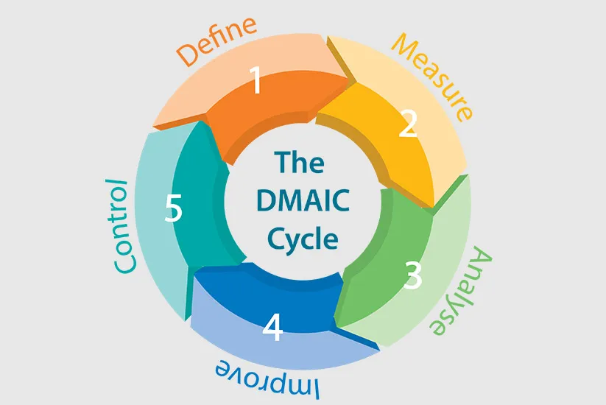
Figure and Source: The DMAIC Cycle
Integrating a Culture of Safety and Transparency
Rationale
The organisational culture was typified by defensiveness and fear, whereby the staff are not encouraged to raise issues. A good safety culture is linked to enhanced reporting, identification of risk, and patient outcomes (Dixon-Woods et al., 2014).
Recommendation
- Implement a Freedom to Speak Up system to safeguard the whistleblowers.
- Carry out a half-yearly safety culture survey to evaluate the confidence of staff in reporting.
- Create a multidisciplinary mortality review.
- Promote patient and family involvement by means of organised feedback.
Implementation Using PDSA
Plan: Strategy to plan staff reporting campaign and patient feedback integration.
Should: Introduce in pilot wards through leadership support.
Research: Track the variations in the rates of incident reporting and personnel survey results.
Act: Change strategy and go global.
The cyclic quality of PDSA helps cultural interventions to develop according to the staff responses and quantifiable influence (McNicholas et al., 2019).
Redesign Process using Lean methodology
Rationale
Poor documentation, the lack of response toward worsening patients, most of the time, and poor complaint management were major adverse factors. Lean methodology is aimed at waste elimination and streamlining of the workflow with patient-centred care (Katowa-Mukwato et al., 2021).
Recommendation
- Trace existing patient care pathways to determine inefficiencies.
- Standardise early warning scores on deteriorating patients.
- Automate the process of complaint escalation.
- Less administration that steals time to be spent on patients.
Lean Implementation Steps
- Carry out value stream mapping workshops with the frontline personnel.
- Determine the non-value-add activities.
- Reengineer processes by focusing on direct patient care.
- Keep track of time-to-intervention indicators of critical patients.
Lean promotes frontline involvement, so changes to the process are workable and long-lasting.
Constant Control and Quality Improvement
Rationale
Failure to recognise the increasing mortality rates timely manner was one of the most serious failures. Good quality assurance involves monitoring data in real-time and intervention (McNab et al., 2020).
Recommendation
- Create digitised dashboards for mortality, infection, staffing, and patient complaints.
- Create quality review departments and board meetings every month.
- Implement audits of outside peer review.
- Integration of electronic surveillance and accountability in government enhances timely alert to performance deterioration.
Securing Sustainability of Improvements
Interventions made in the short term can not be sustained without planning in the long run. Continuous professional development, succession planning of the leaders and inbuilt quality improvement training should be institutionalised.
To sustain improvement:
- Introduce quality improvement training to staff induction programmes.
- Concur organisational strategy with patient-centred values.
- Carry out an external quality assurance every year.
- The national standards performance (Teoli et al., 2019).
Alignment with CQC Standards
The Care Quality Commission (CQC) outlines key standards for healthcare quality, including safe, effective, caring, responsive, and well-led services (CQC, 2022). The failures at Mid Staffordshire demonstrate breaches across all these domains, particularly in safety and leadership.
To address these issues, organisations must ensure compliance with CQC standards by:
- Implementing safe staffing levels
- Ensuring effective governance structures
- Promoting a culture of transparency and accountability
Aligning improvements with CQC standards ensures that changes are not only effective but also compliant with national healthcare regulations.

Conclusion
This report has critically looked at the key care failure in Mid Staffordshire NHS Foundation Trust in 2005-2009, in which there was a lack of leadership, ineffective staffing, ineffective governance systems and target oriented culture that led to unacceptable high death rate of patients. It was revealed in the analysis that the crisis was not caused by a single clinical lack of competence, but structural, procedural, and cultural organisational failures within the structural, procedural, and cultural aspects of the Trust.
The use of the Fishbone Diagram has identified the interrelationships of the cause of failure, and this includes the shortage of leadership, absence of workforce, lack of proper monitoring systems and poor regulatory systems. The Donabedian Model also explained the role of structural failures, especially in staffing and governance, as direct causes of undermining the care processes, and eventually causing poor patient outcomes. SWOT analysis showed that internal weaknesses, particularly poor leadership and organisational culture, were much more powerful than external threats, which justifies the internal change instead of the surface adherence to performance objectives.
The report has also established that the need to improve sustainably on service delivery needs to be structured in terms of implementation strategies. PDSA, PDCA, Lean and Six Sigma quality improvement methodologies offer practical and empirical mechanisms to put the analysis into practice. These solutions can empower healthcare organisations to enhance the accountability of governance, maximise staffing, redesign the processes of care, and develop a culture of openness and patient-focused care.
Final thoughts The case of Mid Staffordshire is a valuable lesson that health and social care organisations cannot base the quality assurance on financial performance and regulatory indicators. Rather, it needs caring leadership, strong governance frameworks, constant oversight and a culture that puts patient safety first. Similar failures can be avoided only with system-wide reform, which will guarantee restoration of trust by the population.

References
Batalden, P.B. and Davidoff, F. (2007) ‘What is “quality improvement” and how can it transform healthcare?’, Quality and Safety in Health Care, 16(1), pp. 2–3. Available at: https://doi.org/10.1136/qshc.2006.022046
Bashan, A. and Kordova, S. (2021) ‘Global healthcare quality management: A systems approach’, International Journal of Healthcare Management, 14(2), pp. 1–10. Available at: https://doi.org/10.1080/20479700.2020.1728377
Benzaghta, M.A., Elwalda, A., Mousa, M.M., Erkan, I. and Rahman, M. (2021) ‘SWOT analysis applications: An integrative literature review’, Journal of Global Business Insights, 6(1), pp. 55–73. Available at: https://doi.org/10.5038/2640-6489.6.1.1148
Boaden, R., Harvey, G., Moxham, C. and Proudlove, N. (2008) Quality improvement: Theory and practice in healthcare. Coventry: NHS Institute for Innovation and Improvement.
Braithwaite, J., Herkes, J., Ludlow, K., Testa, L. and Lamprell, G. (2017) ‘Association between organisational and workplace cultures, and patient outcomes’, BMJ Open, 7(11), e017708. Available at: https://doi.org/10.1136/bmjopen-2017-017708
Care Quality Commission (CQC) (2022) Regulation and inspection framework. London: CQC. Available at: https://www.cqc.org.uk
Deming, W.E. (1986) Out of the crisis. Cambridge, MA: MIT Press.
Department of Health (2012) The power of information: Putting all of us in control of the health and care information we need. London: DH.
Dixon-Woods, M., McNicol, S. and Martin, G. (2014) ‘Ten challenges in improving quality in healthcare’, BMJ Quality & Safety, 23(10), pp. 876–884. Available at: https://doi.org/10.1136/bmjqs-2013-002005
Donabedian, A. (1988) ‘The quality of care: How can it be assessed?’, JAMA, 260(12), pp. 1743–1748. Available at: https://doi.org/10.1001/jama.1988.03410120089033
Francis, R. (2013) Report of the Mid Staffordshire NHS Foundation Trust Public Inquiry. London: The Stationery Office. Available at: https://www.gov.uk/government/publications/report-of-the-mid-staffordshire-nhs-foundation-trust-public-inquiry
Grol, R., Wensing, M. and Eccles, M. (2013) Improving patient care: The implementation of change in healthcare. 2nd edn. Oxford: Wiley-Blackwell.
Institute of Medicine (2001) Crossing the quality chasm: A new health system for the 21st century. Washington, DC: National Academies Press. Available at: https://doi.org/10.17226/10027
Ishikawa, K. (1985) What is total quality control? The Japanese way. Englewood Cliffs: Prentice Hall.
Jackson, G.L. (2019) ‘The Donabedian model of healthcare quality’, Journal of Healthcare Quality, 41(6), pp. 350–352. Available at: https://doi.org/10.1097/JHQ.0000000000000218
Juran, J.M. (1999) Juran’s quality handbook. 5th edn. New York: McGraw-Hill.
Kaplan, H.C., Provost, L.P., Froehle, C.M. and Margolis, P.A. (2010) ‘The model for understanding success in quality (MUSIQ)’, Quality and Safety in Health Care, 19(1), pp. 1–8. Available at: https://doi.org/10.1136/qshc.2009.038224
Leonard, M., Graham, S. and Bonacum, D. (2004) ‘The human factor: The critical importance of effective teamwork and communication in providing safe care’, Quality and Safety in Health Care, 13(Suppl 1), pp. i85–i90. Available at: https://doi.org/10.1136/qshc.2004.010033
McNab, D., Bowie, P., Ross, A. and Morrison, J. (2020) ‘Systematic review of healthcare process failures’, BMJ Open, 10(6), e034751. Available at: https://doi.org/10.1136/bmjopen-2019-034751
McNicholas, C., Lennox, L., Woodcock, T., Bell, D. and Reed, J. (2019) ‘Evolving quality improvement support strategies to improve PDSA cycle fidelity’, BMJ Quality & Safety, 28(4), pp. 356–365. Available at: https://doi.org/10.1136/bmjqs-2018-008981
NHS England (2019) The NHS Patient Safety Strategy. London: NHS England. Available at: https://www.england.nhs.uk/patient-safety/
NHS Improvement (2018) Safe staffing for nursing in adult inpatient wards. London: NHS. Available at: https://www.england.nhs.uk
Ohno, T. (1988) Toyota production system: Beyond large-scale production. Portland: Productivity Press.
Øvretveit, J. (2009) Does improving quality save money?. London: The Health Foundation.
Phadermrod, B., Crowder, R.M. and Wills, G.B. (2019) ‘Importance-performance analysis based SWOT analysis’, International Journal of Information Management, 44, pp. 194–203. Available at: https://doi.org/10.1016/j.ijinfomgt.2018.10.007
Puyt, R.W., Lie, F.B. and Wilderom, C.P.M. (2020) ‘The origins of SWOT analysis’, Long Range Planning, 53(3), 101988. Available at: https://doi.org/10.1016/j.lrp.2019.01.003
Reason, J. (2000) ‘Human error: Models and management’, BMJ, 320(7237), pp. 768–770. Available at: https://doi.org/10.1136/bmj.320.7237.768
Royal College of Nursing (RCN) (2018) Safe staffing levels. London: RCN. Available at: https://www.rcn.org.uk
Salas, E., Sims, D.E. and Burke, C.S. (2005) ‘Is there a “big five” in teamwork?’, Small Group Research, 36(5), pp. 555–599. Available at: https://doi.org/10.1177/1046496405277134
Suárez-Barraza, M.F. and Rodríguez-González, F.G. (2019) ‘Implementing the PDCA cycle in healthcare’, International Journal of Health Care Quality Assurance, 32(2), pp. 1–12. Available at: https://doi.org/10.1108/IJHCQA-08-2017-0142
The Health Foundation (2013) Quality improvement made simple. London: The Health Foundation. Available at: https://www.health.org.uk
The King’s Fund (2011) Improving NHS care quality: Lessons from Mid Staffordshire. London: The King’s Fund. Available at: https://www.kingsfund.org.uk
The King’s Fund (2020) Leadership and culture in the NHS. London: The King’s Fund. Available at: https://www.kingsfund.org.uk
Teoli, D., Sanvictores, T. and An, J. (2019) ‘SWOT analysis’, StatPearls. Available at: https://www.ncbi.nlm.nih.gov/books/NBK537302/
World Health Organization (2018) Delivering quality health services: A global imperative. Geneva: WHO. Available at: https://www.who.int
World Health Organization (2020) Quality of care: A process for making strategic choices in health systems. Geneva: WHO. Available at: https://www.who.int

